Potential ALP impact from the inclusion of low data points for the 26,27,28 and 1st March.
The 18’19 ALPs for EUC band 2 upwards show a lower winter and higher summer profile compared to the previous gas year. Given it was a cold year the result is unexpected.
The inclusion of low demand data points for the 26,27,28 and 1st March could result in the lower alps for 18’19 which I have illustrated below:
This chart shows Demand v CWV with the coldest dates (26,27,28 and 1st March) marked in red, where demand on those days behaves as expected.
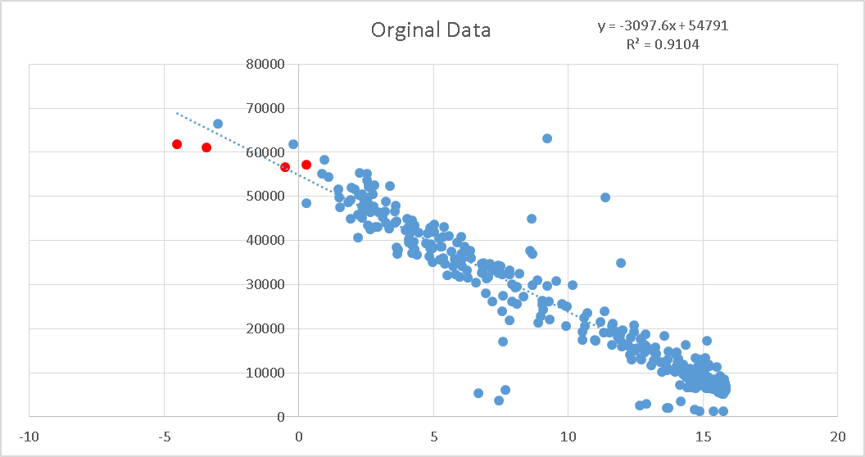
The same data is shown below but with the four days amended to replicate the issue seen in several EUC bands - where demand is 25% to 37% lower.
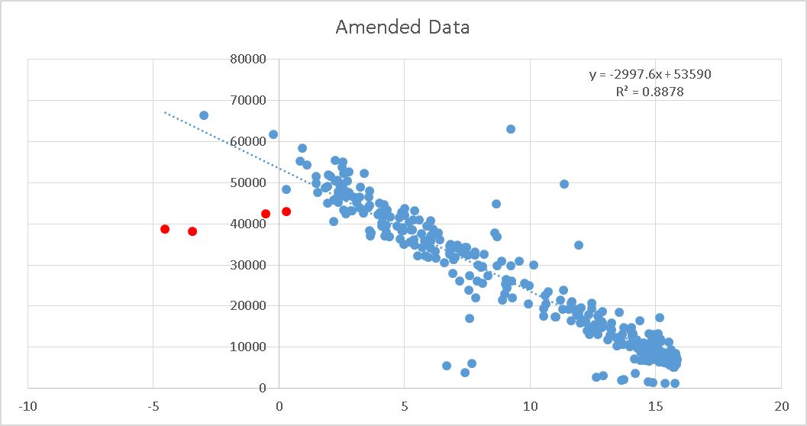
The resultant ALP profile is shown:
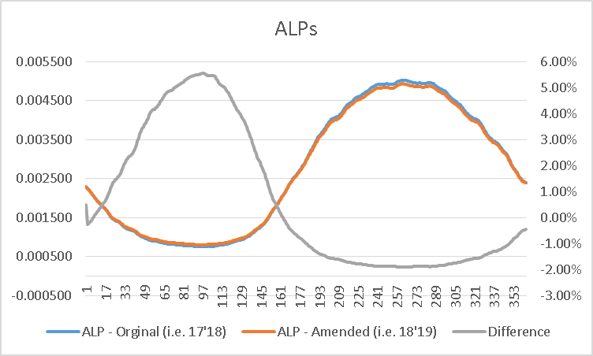
The behaviour, reduction in Winter ALPs, greater Summer ALPs is consistent with this year’s observations on ALPS which are against the direction for needed for lower UIG.
One approach is – given the observations pass validation – is to accept the resulting profiles.
However this results in model with worse fit and resulting changes in ALPS that are not reflective of normal demands.

