Operating Guidelines Document
The disclosure of Protected Information by Xoserve of data held in its role as the Central Data Service Provider (CDSP)
Contents
- Introduction
- Xoserve role and Information Disclosure Officer
- Overview of some relevant legal references
- Role of the DSC Contract Management Committee
- Disclosure of Protected Information decision determination
- Protected Information disclosure provisions under the UNC and the use of Confidentiality Agreements

Appendix 1 Procedure, and format, for submitting requests for the disclosure of Protected Information to the DSC Contract Management Committee
Appendix 2 Utilities Act section 105
Appendix 3 GT Licence Standard Condition 31 Supply Point Information Service

Document owner | Head of Customer Office
Version | 0.3 draft
Date | November 2018

Disclaimer – this document is a guide to assist in the general understanding of the environment within which Xoserve works. This document is for guidance only and is not a definitive ruling on whether or not data may be released. If a matter is unclear, legal views must be sought.
Please note: reference to the Uniform Network Code and Independent Gas Transporters Uniform Network Code are both referred to as the UNC.
- Introduction

UNC TPD V5.3 and IGT UNC K 23 define Protected Information. This paper is concerned with Protected Information relating to the affairs of a User or Transporters in the performance of the Code – information passed by parties to UK Link e.g. a meter reading, and information generated with UK Link in accordance with the UNC e.g. an Annual Quantity.

This document describes the principles (decision rules) that Xoserve will apply in the event of a request for disclosure of Protected Information from any party. The principles are designed to ensure compliance with all contracts and to provide guidance to the relevant party.

In the event that the existing rules are not perceived to permit the disclosure of Protected Information, Xoserve will support the party in seeking to find an equitable solution whilst ensuring any such disclosure meets the relevant principles.

Xoserve has previously supported the industry in raising modifications to the UNC, for example to permit the release of Protected Information to Meter Asset Managers, Meter Asset Providers and Price Comparison Websites.

UNC modification 0649S [action add reference when available] Update to UNC to formalise the Data Enquiry Service Permissions Matrix, and IGT UNC modification 115 Update to IGT UNC to formalise the Data Permissions Matrix were implemented in October 2018. These modifications transferred the authority for determining disclosure of Protected Information to parties as set out in the Data Permission Matrix [action add location when known] from the UNC to the DSC Contract Management Committee (CoMC). The procedure for submitting proposals to the CoMC is set out in Appendix A.

Where disclosure of Protected Information is permitted other activities may be required to enable the service provision. These may include, but are not limited to, establishing the commercial arrangements between Xoserve and the relevant party, developing the delivery mechanism etc. This document is limited to the matters associated with the decision regarding the disclosure of Protected Information. Commercial arrangements are a matter for the CoMC, where applicable, delivery arrangements are a matter for the DSC Change Management Committee.

- Xoserve role and Information Disclosure Officer

Xoserve operates the UK Link system (IT system) through which UNC parties transact (send and receive information). UK Link is the source of the data for Xoserve data provision services. As a starting point for the purpose of determining the disclosure of Protected Information for data provision services, all data in UK Link is treated as Protected Information as defined in the UNC. This means, in each case, a requirement to prove that any disclosure of Protected Information is permitted.

The Xoserve Head of Customer Office includes the role of Information Disclosure Officer (IDO) which has responsibility for ensuring it is determined whether the disclosure of Protected Information is permitted. This includes, where required, referral to other parties e.g. the CoMC. The IDO is also responsible for the maintenance of the information disclosure register, used to record details of each request for the disclosure of Protected Information and the outcome.

This activity is defined under Service Lines [enter reference]

Example service line – Service Area 18 (ASGT-NC and ASiGT-NC)
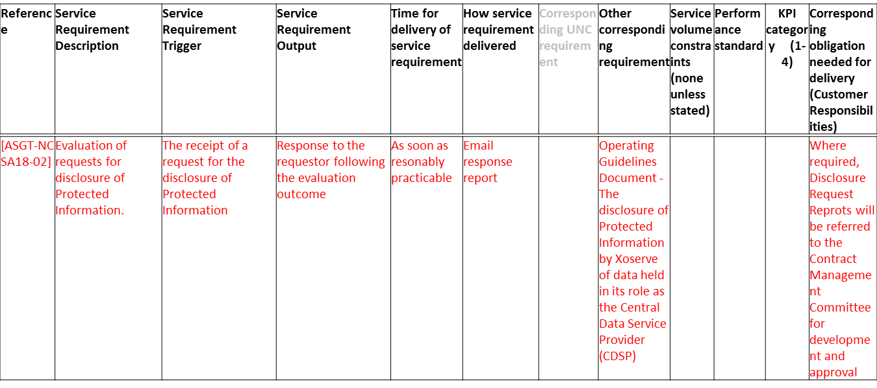

- Overview of some relevant legal references

The following is an overview, for guidance only, of the everyday legal references that are relevant to Xoserve in determining whether the disclosure of Protected Information is permissible. Note that this is not exhaustive and there may be other less familiar legal references that the requester may rely on that need to be considered e.g. the Statistics of Trade Act 1947 obligates certain information disclosure.

  - Utilities Act section 105 (see Appendix 2 for section text)

The Utilities Act section 105 sets out that any information that relates to an individual or business is protected information and cannot be disclosed. It then sets out that disclosure is permitted if required by for example, licence condition, or if agreed between parties e.g. under a contract such as the UNC.

  - GT Licence Standard Condition 31 (see Appendix 3 for licence text)

GT Licence Standard Condition 31 sets out information disclosure obligations to industry parties to facilitate the competitive market. Many of Xoserve’s existing services e.g. Data Enquiry Service stem from this licence condition. Under the Data Services Contract services that support this licence condition are classified as Agency Services GT Non-Code.

  - UNC Section V 5 IGT UNC Section K 24

UNC Section V5 and IGT UNC Section K 24 set out that information passed between Code parties such as Gas Transporters (GTs)/ Independent Gas Transporters (IGTs) and Users (Shippers) is Protected Information and cannot be disclosed to another party (Code or non-Code) unless the disclosure is set out in either V 5 (GTs) or K 24 (IGTs).

UNC Section V5.5 sets out the exceptions to obligations on GTs and Users to not disclose Protected Information. UNC V5.5 sets out the permission (and in some cases supporting conditions) to release data to certain consumers (pursuant to GT Standard Licence Condition 31 – see section 2.2) for example; Meter Asset Managers, Meter Asset Providers and Price Comparison Websites.

UNC Section V5.5 also sets out the authority of the CoMC with regard to decisions on disclosure of Protected Information.

UNC V5.5 also sets out exceptions where other parties “Competent Authority” are permitted to receive Protected Information. A Competent Authority might be BEIS (Department for Business, Energy and Industry Strategy).

IGT UNC section K 24 sets out the same obligations for IGTs as UNC V5.5 does for GTs.

- Role of the DSC Contract Management Committee

The DSC, CDSP Service Document Contract Management Arrangements section 6.3 establishes that the CDSP may consult with the DSC Contract Management Committee regarding information disclosure matters where the disclosure would; require commitment of material CDSP resources or incur material cost, or might have other adverse consequences for the CDSP or for Customers collectively.

Modification 0649S and 115 have delegated the authority for decisions regarding the disclosure of Protected Information to parties as defined in the Data Permission Matrix to the CoMC.

Where a disclosure matter is to be referred to the CoMC, the CDSP shall set out the proposal (in a similar format to that shown in Appendix 1) and submit this to the CoMC for consideration. The minutes of the DSC Contract Management Committee shall serve as the record of the decision and the CDSP shall notify the relevant parties and act in accordance with that decision.

- Disclosure of Protected Information decision determination

This sets out the process that will be followed when determining whether a request to disclose Protected Information can be permitted in accordance with information provision rules or where consultation may be required with CoMC. Where permission does not exist or a request cannot be met, then to proceed the restricting provision needs to be removed e.g. via a UNC modification.

The first consideration is to determine between non-Protected Information and Protected Information. Protected Information is that provided by parties to UK Link and information generated within UK Link at supply meter point level. Any request for disclosure at supply meter point level would be considered as Protected Information. Aggregate information e.g. reference on Xoserve’s website to their being circa 24m supply meter points in the UK, is not considered as Protected Information. There is always a grey area in these assessments and where there is any doubt between non-Protected Information and Protected Information, the matter will be referred to the CoMC.

Working on the basis the request is for disclosure of Protected Information the following sections apply.

  - Is the request for disclosure of Protected Information from a UNC party?

The first key decision is to determine whether the party requesting the information disclosure is a UNC party or not. A UNC party is a signatory to the UNC and has certain rights of access to data as a result. The following may be considered when determining if this request may be agreed.

    - Group company arrangements

Some organisations operate with several licenced subsidiary companies under one group company. The group company is not a signatory to the UNC. Only the individual subsidiary is the signatory to the UNC. A request from the group company must be treated as being from a non-UNC party.

    - Organisations who are no longer a UNC party

Organisations who are no longer a party to the UNC may still submit requests for information e.g. a request for a copy of an invoice etc. Where the request is associated with them and the period they were a party to the UNC the request can be treated as being from a UNC party, otherwise they must be treated as a non-UNC party.

    - Disclosure agreements between UNC Party and non-UNC Party(ies)

Under the terms of the UNC, a UNC party may permit another organisation rights for information disclosure. The UNC party will set out its permission in an agreement that is provided to the Xoserve Customer Lifecycle Team. The agreement will confirm the party/ies with whom Xoserve is permitted to disclose information and the specific area of information e.g. supply point data to validate reconciliations. Where an information disclosure request is received from an authorised party as set out in the agreement, that party will be treated as a UNC party and information may be disclosed to that party in accordance with the agreement.

Two parties may agree a disclosure agreement between themselves. In this circumstance each case needs to be considered individually to determine if the information may be disclosed. Does the party holding the information have the right to disclose it? Does the intended recipient have the right to receive the information? The disclosure agreement should set out specific data items that can be shared, the purpose for sharing the data and be time bound.

There is no requirement to refer decisions on disclosure agreements beyond Xoserve.

    - UNC parties undergoing some commercial change e.g. merger, acquisition, insolvency, etc

In this circumstance each case will need to be considered individually. The key issue is to determine a right to the data considering such things as; who holds the relevant licence at the time; do information disclosure agreements exist between the companies to share information; is a disclosure agreement required?

  - Requests for the disclosure of Protected Information from a UNC party

The following diagram sets out a decision tree for assessing requests for the disclosure of Protected Information.

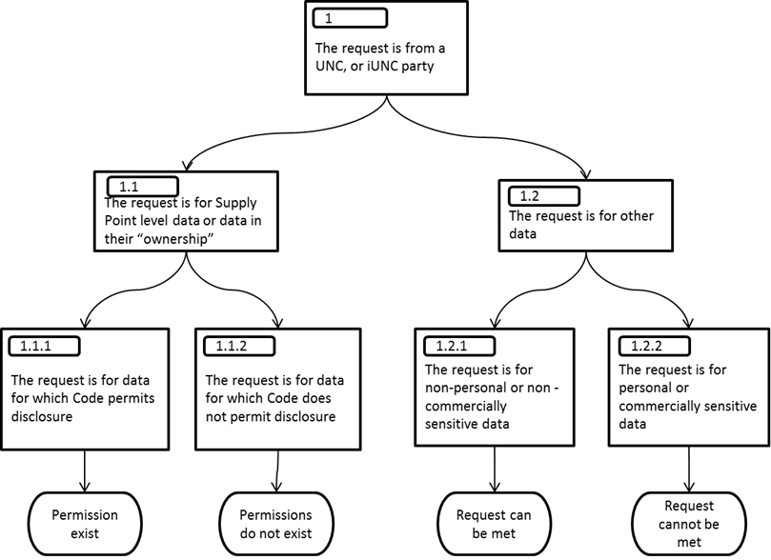

In the case of 1.1.1 it would be expected that the party requesting the disclosure of Protected Information provides the necessary supporting code references to Xoserve. Xoserve will validate the request and if there is any doubt consult the CoMC.

In the case of 1.2.2 personal data is data that identifies a living individual. For the avoidance of doubt an MRPN is considered to be personal data. Information relating to an end user’s AQ is considered to be commercially sensitive data. Xoserve will validate the request and if there is any doubt consult the CoMC.

Case Study 1

In 2006 a Distribution Network requested information for the period prior to the date they procured the network from National Grid. The request was referred to National Grid for approval before the service could be provided.

  - The request for the disclosure of Protected Information is from a Non UNC Party such as a Supplier, MAM or MAP

The following diagram sets out a decision tree for assessing the request for the disclosure of Protected Information disclosure requests.

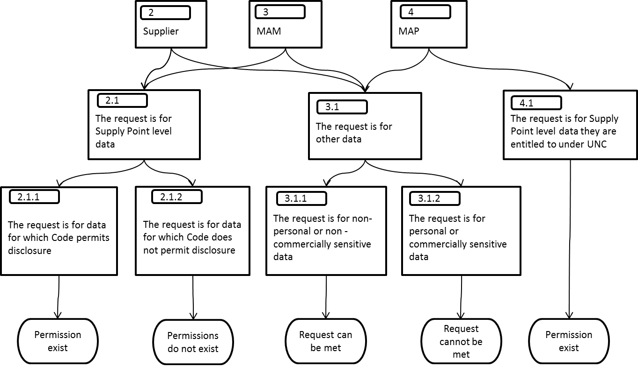

In the case of 2.1.1 it would be expected that the party requesting the disclosure of Protected Information provides the necessary supporting references, it should not be up to Xoserve to find these. Xoserve will review the information used to determine the disclosure of Protected Information in examples 2.1.1 and 2.1.2 and if there is any doubt consult the CoMC.

In the case of 3.1.1 and 3.1.2 personal data is data that identifies a living individual. As such an MRPN is considered to be personal data where the market sector code indicates a domestic premise. Information relating to an end user’s AQ is considered to be commercially sensitive data. Xoserve will review the information used to determine request for the disclosure of Protected Information set out in the examples 3.1.1 and 3.1.2 and if there is any doubt consult the CoMC.

In the case of 4.1 checks are made that the MAP meets the entitlement requirement as set out in UNC, e.g. there is a signed Confidentiality Agreement in place between GTs/IGTs, and the MAP.

  - The request for the disclosure of Protected Information is from Ofgem

The following diagram sets out a decision tree for assessing the request for the disclosure of Protected Information.

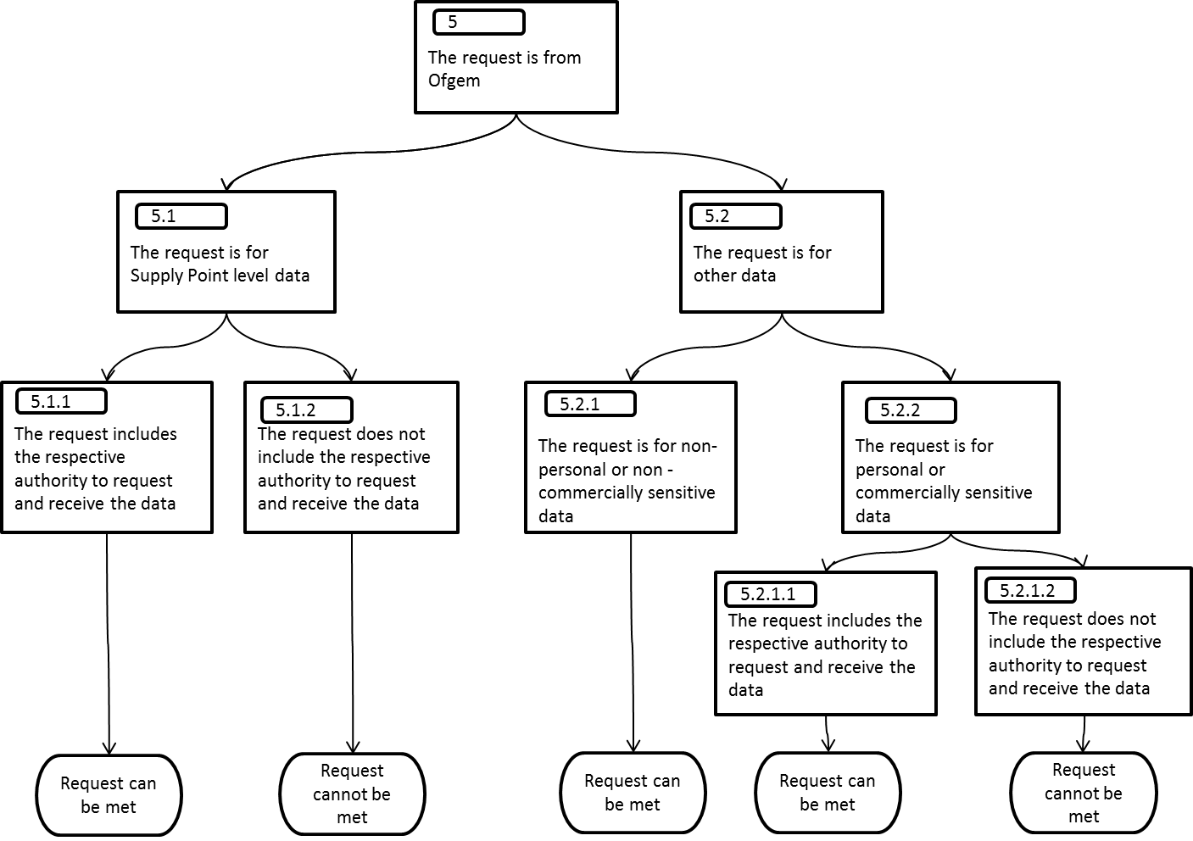

Ofgem has certain powers to request data e.g. under GT Licence Condition 26.

Each request from Ofgem received by Xoserve is shared with the relevant party. Xoserve and the relevant party will work together to either provide the data or explain the reasons why the data cannot be provided at that point in time.

Often where a service cannot initially be provided, with greater understanding of Ofgem’s requirements, the data request can be refined so that it can be satisfied. For example; if there is a request to provide personal data this may be satisfied by anonymising the data set to prevent any individual from being identified; or where commercially sensitive data is requested, the data set may be aggregated to remove any commercially sensitive data.

Where required, Xoserve will send a copy of the data provided to Ofgem to the relevant party.
5.5 The request for the disclosure of Protected Information is from a government department

The following diagram sets out a decision tree for assessing requests for the disclosure of Protected Information.

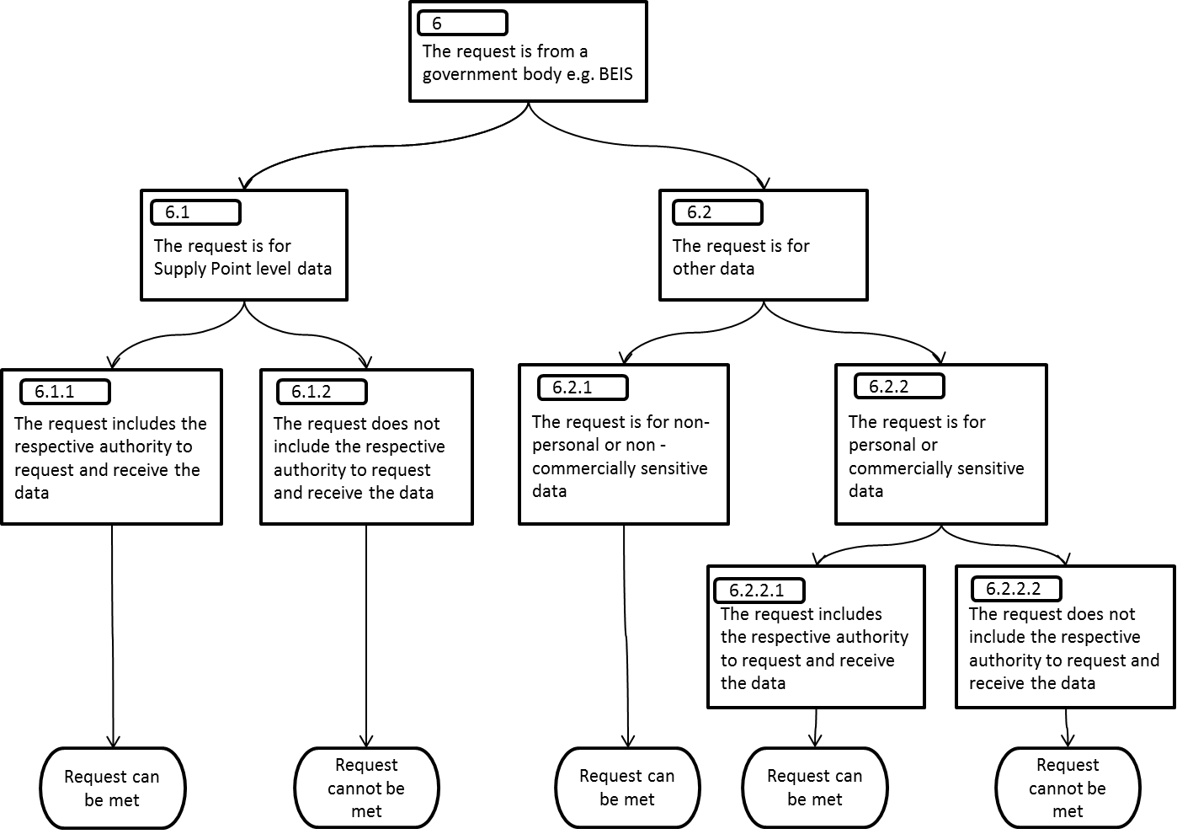

Government departments may meet the UNC definition of Competent Authority and thus have powers to request data.

Each request from a government department received by Xoserve is shared with the relevant party. Xoserve and the relevant party will work together to either provide the data or explain the reasons why the data cannot be provided at that point in time.

Often where a service cannot initially be provided, with greater understanding of the requirements, the data request can be refined so that it can be satisfied. For example; if there is a request to provide personal data this may be satisfied by anonymising the data set to prevent any individual from being identified; or where commercially sensitive data is requested, the data set may be aggregated to remove any commercially sensitive data.

Case Study 2

In June 2018 a government department contacted Xoserve requesting supply point level data for properties around for an urgent purpose). A call to the relevant GT (relevant party) and an internal check confirmed information disclosure rules were satisfied and the data could be provided. The data was provided within 1 hour of the request being received.

  - The request for the disclosure of Protected Information is from any other party

The following diagram sets out a decision tree for assessing requests for the disclosure of Protected Information.

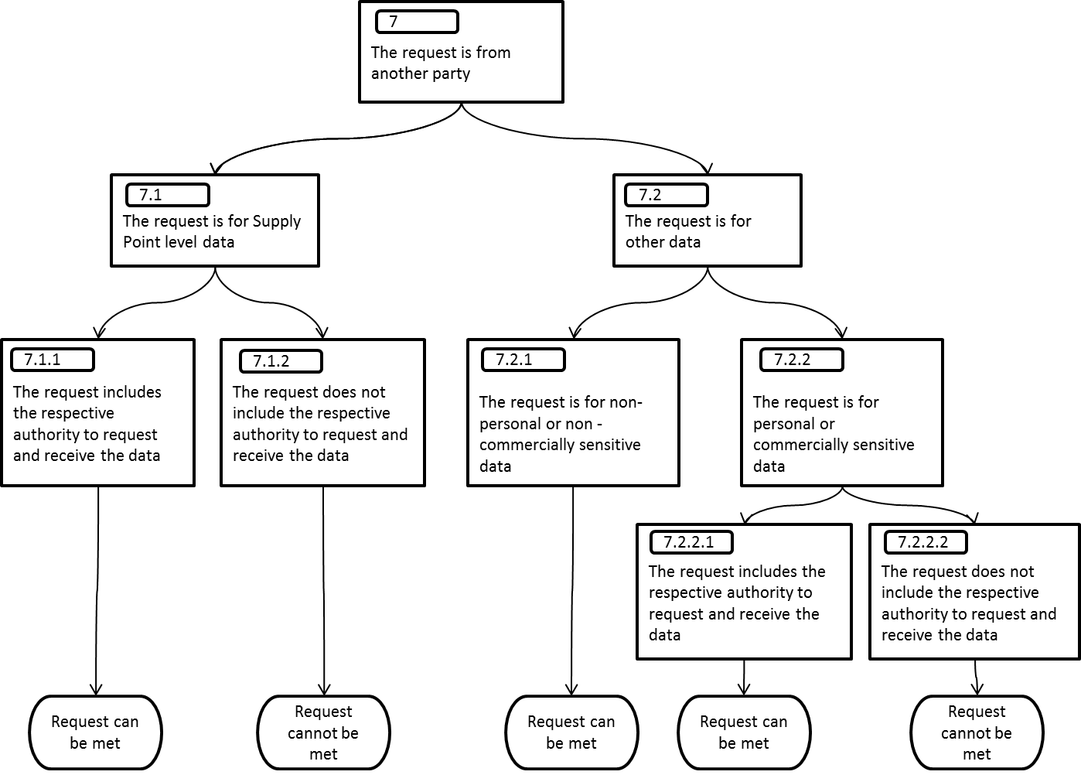

Xoserve will assess each request for the disclosure of Protected Information on a case by case basis and consider whether in its view (in accordance with compliance with these guidelines) the request can be met. Each assessment will consider whether the Protected Information is personal data, in which case relevant Data Protection Legislation or if the data is considered to be commercially sensitive. Where there is any uncertainty the matter will be referred to the relevant party which may be the DSC Contract Management Committee. Xoserve and the relevant party will work together to understand and assess the request and determine whether the disclosure request can be met.

Case Study 3
The provision of supplier data to Siemens as the PPMIP.
Xoserve was requested to provide data to a third party company, Siemens, that identified the Supplier but not any individual supply point data. Xoserve does not have the authority to provide data at the level requested and considered a UNC modification was a step too far, so consulted the CoMC under the Contract Management Arrangements (DSC, Section 6.3.2 (b)). The DSC Contract Management Committee approved the disclosure request and the April 2018 meeting minutes serve as the record for this decision.

- Protected Information disclosure provisions under the UNC and the use of Confidentiality Agreements

Modifications to the UNC have been used to create permissions under UNC section V 5 and IGT UNC section K 24. In certain cases the provision of data to a non-Code party is conducted under a commercial agreement with Xoserve as the principal to the contract. In certain of these cases, the provision of the service is dependent upon there being a Confidentiality Agreement in place between the GTs/IGTs and the service recipient. This provides the GTs/IGTs (as UNC principals) control over the service recipient (e.g. stating the permitted purpose of the data), that they cannot obtain through the contract between Xoserve and the service recipient. It will be a condition precedent of the commercial contract between Xoserve and the service recipient that a Confidentiality Agreement is in place at all times otherwise the service cannot be provided.

As an example, the following diagram illustrates the commercial structure of services to Price Comparison Websites.

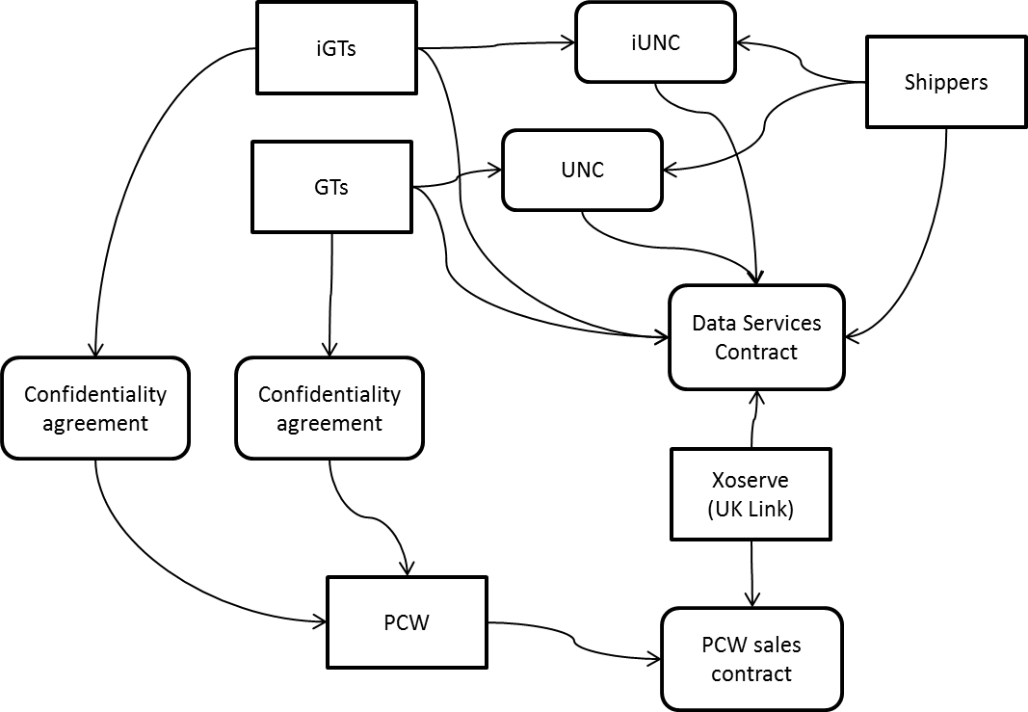

Appendix 1 Procedure for submitting information disclosure requests to the DSC Contract Management Committee
- Introduction

This document outlines the procedure by which Xoserve will submit requests for the disclosure of Protected Information to the CoMC for consideration – a Disclosure Request Report, and how approval (or not) is recorded.

- Process

Xoserve will assess the request for disclosure of Protected Information and prepare a:
- Change Proposal (incorporating a Disclosure Request Report) where industry consultation is required e.g. when a privacy impact assessment is required; or
- Disclosure Request Report where consultation beyond CoMC is not required.
A Change Proposal provides for use of the existing change processes including submission of documents for consultation e.g. a privacy impact assessment.
The Disclosure Request Report will largely following the content set out in section 4. The Disclosure Request Report will be submitted for:
- “development” (proposal to be developed via CoMC), or
- “approval” (decision required).

Where a Disclosure Request Report is submitted for approval, the CoMC will review the Disclosure Request Report and determine that:
a) The Disclosure Request Report is rejected and provide the reason for rejection..
b) There is insufficient information to determine a decision and specific actions are placed on the relevant party (e.g. Xoserve, the CoMC, request originator) for completion of the Disclosure Request Report and its re-submission
c) The Disclosure Request Report is approved
Where the Disclosure Request Report is approved, the decision recorded in the minutes of the meeting will serve as authorisation for Xoserve to disclose the relevant information.
Where the Disclosure Request Report is approved or rejected Xoserve will update the Operating Guidelines Document Information Disclosure Case Studies section.
In terms of the disclosure of Protected Information decision, Xoserve will proceed as required.
- Maintenance of the Data Permission Matrix
The Data Permission Matrix (DPM) is published as part of the UK Link Manual suite of documents. The DPM can be amended by a UNC modification to add a new User type, and by an approved Data Disclosure Report amending the data permitted to be disclosed to a User type. The DPM is version controlled and updated versions are published following conclusion of the relevant amendment process.
The DPM details a combination of service and data items within the service. However, it does not detail any conditionality within the data-set e.g. the Price Comparison Website API service only provides access to domestic data (as defined by the market sector code). To overcome this an additional Operational Guidelines Document has been prepared the “Data Permission Matrix Conditionality”. This is published alongside the DPM.
Any Change Proposal or Disclosure Request Report submitted under section 2 will include any conditionality statements. When the Change Proposal or Disclosure Request Report is approved, the Data Permission Matrix and Data Permission Matrix Conditionality Document will be amended as required and re-published.

- Disclosure Request Report content
Headings to be included
Request title – DSC CoMC Consent for Disclosure of Protected Information
Reason for submission to CoMC and CoMC actions
Introduction and background – to include details of the party making the request and the purpose of the disclosure
Data items associated with the disclosure request and justification
Whether a Privacy Impact Assessment required (or not) and reason (see below)
Privacy Impact Assessment (where required)
Description of the commercial model under which the service is to be provided and where relevant, the terms and conditions.
Anticipated method of delivery
Where submitted for approval, the next version of the Data Permission Matrix detailing the proposed amendments.
Any specific conditions that apply to the disclosure e.g. limited to domestic data only, limited to a specific method of delivery etc.
Any other specific matters highlight by CoMC

Tests for determining whether a Privacy Impact Assessment is required. If the answer to any of the following questions is “yes”, a Privacy Impact Assessment is to be completed.
- Will the project involve the collection of new information about individuals?
- Will the project compel individuals to provide information about themselves?
- Will information about individuals be disclosed to organisations or people who have not previously had routine access to the information?
- Are you using information about individuals for a purpose it is not currently used for, or in a way it is not currently used?
- Does the project involve you using new technology that might be perceived as being privacy intrusive? For example, the use of biometrics or facial recognition.
- Will the project result in you making decisions or taking action against individuals in ways that can have a significant impact on them?
- Is the information about individuals of a kind particularly likely to raise privacy concerns or expectations? For example, health records, criminal records or other information that people would consider to be private.
- Will the project require you to contact individuals in ways that they may find intrusive?
- Will the disclosure of information utilise new technology for Xoserve?
- Will the disclosure include information that identifies a vulnerable customer?
- Will the disclosure release mass data to a party?
- Will the disclosure include information that identifies an occurrence of theft of gas?
- Will the disclosure require a fundamental change to Xoserve business?

Appendix 2 Utilities Act Section 105

105 General restrictions on disclosure of information.E+W+S

(1) Information which—
(a)has been obtained under or by virtue of the provisions of this Act, Part I of the 1986 Act or Part I of the 1989 Act; and
(b) relates to the affairs of any individual or to any particular business,
shall not be disclosed during the lifetime of the individual or so long as the business continues to be carried on, except as provided below.
(2) Subsection (1) does not apply to a disclosure made with the consent of the individual or the person for the time being carrying on the business.
(3) Subsection (1) does not apply to a disclosure if—
(a) it is made for the purpose of facilitating the performance of any functions of the Secretary of State, the Authority, the Council or the Competition Commission under the 1986 Act, the 1989 Act or this Act;
(b) it is required by a notice under section 38(1A) of the 1986 Act or section 28(2A) of the 1989 Act;
(c) it is made by a licence holder and is required to be made by a condition of his licence; or
(d) it is made by one licence holder to another and is required by that other licence holder for purposes connected with the carrying on of relevant activities.

Appendix 3 GT Licence Standard Condition 31: Supply Point Information Service

1. The licensee shall establish, or procure the establishment of, and subsequently operate and maintain, or procure the subsequent operation and maintenance of, an information service (the “Supply Point Information Service”).

2. The licensee shall ensure that the Supply Point Information Service fulfils, for all premises connected to the licensee’s pipe-line system, including secondary sub-deduct premises, the following functions:

(a) the maintenance of a register containing the data set out in paragraph 3 (“relevant data”);

(b) the amendment of relevant data to reflect changes of supplier in respect of any such premises;

(c) in respect of domestic customers or persons acting on their behalf, other than gas shippers or their agents, the provision, in a timely and efficient manner, of such of the relevant data as is referred to in sub-paragraphs 3(a)(iii), 3(b)(iii) and 3(b)(iv) as is reasonably required and requested by that person;

(d) in respect of the following applicants:

- any relevant gas shipper or agent thereof;

- any person identified in the Network Code as an appropriate person for the receipt of data for balancing and change of supplier purposes; and

(iii) any customer (other than a domestic customer) of a gas supplier or person acting on his behalf entitled to such data for the purpose of facilitating changes of supplier in respect of that customer’s premises;

the provision, in a timely and efficient manner, of such of the relevant data as is reasonably required and requested by the applicant;

(e) the maintenance of an enquiry service for the provision to any customer of a gas supplier, on request and free of charge at the point of use to domestic customers, of such of the relevant data in respect of the supply of gas to premises which are (or which are about to be) owned or occupied by that customer; and

(f) the taking of such steps as will in the opinion of the licensee secure adequate publicity for the operation of the enquiry service mentioned in sub-paragraph 2(e).

3. The data referred to in sub-paragraph 2(a) above is:

(a) such technical and other data as is necessary to facilitate supply by any gas supplier to any premises connected to the licensees pipe-line system, including secondary sub-deduct premises, and to meet the reasonable requirements of gas shippers in respect of such premises for information for balancing and change of supplier purposes, including (where so required):

(i) the identity of the gas shipper responsible under the Network Code for the supply point at such premises;

(ii) the type of metering equipment installed at each such premises where the licensee has been supplied with details of such equipment; and

(iii) a unique and accurate address of each such premises so far as is reasonably practicable, having regard to the nature and source of the information provided to the licensee; and

(b) such information which is in the possession of the licensee as may be necessary and which is reasonably required for the purpose of –

- managing the supply of gas to the premises of the customer;

- assessing the accuracy of those components of the charges relating to the conveyance of gas to such premises which are specific to the premises of that customer;
(iii) enabling that customer to contract with another supplier for the supply of gas; or
- identifying the supplier to the customer’s premises.

4. In fulfilling its obligation in accordance with paragraph 1 the licensee shall not restrict, distort or prevent competition in the provision of meter services or gas supply.

Add reference to final mod report when done
Add location of DPM

