Disclosure Request Report
DSC CoMC Development for the Disclosure of Information
Alt Han Company (Alt Han Co) Request for Ongoing Provision of Supply Point Portfolio Information
Prepared by | Richard Johnson
Submitted for | Development
Development details | The CoMC is requested to consider AltHANCo’s request to receive a set of data items to support their initiative to identify properties which require an Alternative Home Area Network (AHAN) to support the implantation of smart metering.  CoMC is requested to develop AltHANCo’s request by considering risks and issues associated with AltHANCo’s request for the particular data items. A Privacy Impact Assessment has been developed at an industry workgroup for inclusion in this request.  Following this development and the implementation of UNC modification 0668S and iGT UNC modification 116 which will create AltHANCo and their service provider as a new User type on the Data Permission Matrix, Xoserve will bring this Disclosure Request Report back to the CoMC for approval. The data items they’ve requested; the data items would be assigned to AltHANCo within the new Data Permissions Matrix.
Reference | DRR 5
Date | 14th November 2018

- Introduction and background

AltHANCo is requesting data items that will help (with the use of other data being made available to their service provider) identify or exclude supply points where an Alternative Home Area Network is likely to be required. Data is not being requested for supply points connected to the National Transmission System.

Properties with a Smart Meter have a Communications Hub and an In Home Display (IHD). The network of these three devices (including the Smart Meter itself) is known as the Home Area Network (HAN).

Certain properties e.g. flats, where the meter and the IHD are far apart require an Alternative Home Area Network for smart metering. It is estimated some 200,000 buildings with 1,500,000 consumers are impacted by this issue.

AltHANCo is a company created by suppliers (under the requirements of the Smart Energy Code) to identify properties where an Alternative Home Area Network is required.

AltHANCo is tendering for an Alt Han Operations Service Provider to identify these properties so that Suppliers can effectively manage the smart meter roll-out.

AltHANCo has approached Xoserve for disclosure of information to their service provider on an enduring basis to support the identification of supply points where an Alternative Home Area Network may be required.

This service needs to be stood up by January 2019. The service is expected to last two years by when the analysis work is expected to be completed.

- Data items

Mods 0668S and its iGT equivalent, 116, were raised for the purpose of adding AltHANCo as a new User type to the Data Permissions Matrix introduced by 0649.

The data items requested by AltHANCo and further developed at the 0668S workgroup are:

Data Item | Justification | Additional conditionality
Supply Meter Point Reference Number | To uniquely identify the supply point | None
Supply meter point address | Information in the address will help include or exclude supply points e.g. the word flat, or business unit etc. | None
Meter location | Some location codes e.g. basement, will help identify relevant supply points | None
Market Sector Code | With other information e.g. meter capacity, will help include or exclude supply points | None
Meter capacity | Supply points with a larger capacity meter are unlikely to have a smart meter installed. | To be confirmed – dataset will exclude larger meter capacity supply meter point data as these are unlikely to have a smart meter installed
Meter Mechanism | Will help exclude certain supply points. If a smart meter is already installed there is already a working local area network | Will only provide the existence (or not) of a smart meter, not all other meter mechanism codes e.g. pre-payment meter
Meter Model | Certain meter models will suggest if a smart meter or not is likely to be installed at some point | To be confirmed
Annual Quantity range indicator | The annual quantity as a data item is not required, but an indication of the annual quantity is expected, with other data items, to help include or exclude supply points. Ranges proposed are 0 - 30,000, 30,001 – 73,200, 73,200 – 732,000, 732,001 and above | To be confirmed – the dataset will exclude supply meter points with larger AQs – value to be determined.

- Privacy Impact Assessment

Where the disclosure of information includes the processing of personal data a Privacy Impact Assessment may be required.

Xoserve has considered the various tests that may be applied to this initiative failed three tests, and therefore requires a Privacy Impact Assessment.

The tests (and answers) applied in determining whether a Privacy Impact Assessment was required were:

a) Will the project involve the collection of new information about individuals?
No

b) Will the project compel individuals to provide information about them?
No

c) Will information about individuals be disclosed to organisations or people who have not previously had routine access to the information?
Yes, information will be disclosed to the AltHANCo service provider (the appointment process is ongoing)

d) Are you using information about individuals for a purpose it is not currently used for, or in a way it is not currently used?
Yes, the information is to be used to consider whether the premise may require an alternative home area network.

e) Does the project involve you using new technology that might be perceived as being privacy intrusive? For example, this could be the use of biometrics or facial recognition.
No

f) Will the project result in you making decisions or taking action against individuals in ways that can have a significant impact on them?
No

g) Is the information about individuals of a kind particularly likely to raise privacy concerns or expectations? For example, health records, criminal records or other information that people would consider to be private.
No

h) Will the project require you to contact individuals in ways that they may find intrusive?
No

i) Will the disclosure of information utilise new technology for Xoserve?
No.

j) Will the disclosure include information that identifies a vulnerable customer?
No

k) Will the disclosure release mass data to a party?
Yes. Information will be provided for all supply meter points within a live confirmation (circa 24m)

l) Will the disclosure include information that identifies an occurrence of theft of gas?
No

m) Will the disclosure require a fundamental change to Xoserve Business?
No

- Commercial model

This service is a commercial service. Xoserve will contract with AltHANCo and/or their service provider via a commercial contract.

A confidentially agreement would also be required between the GTs, the iGTs and AltHANCo. There are two possible options we’ve identified, although the Xoserve legal team is investigating an idea

Contract Directly with AltHANCo

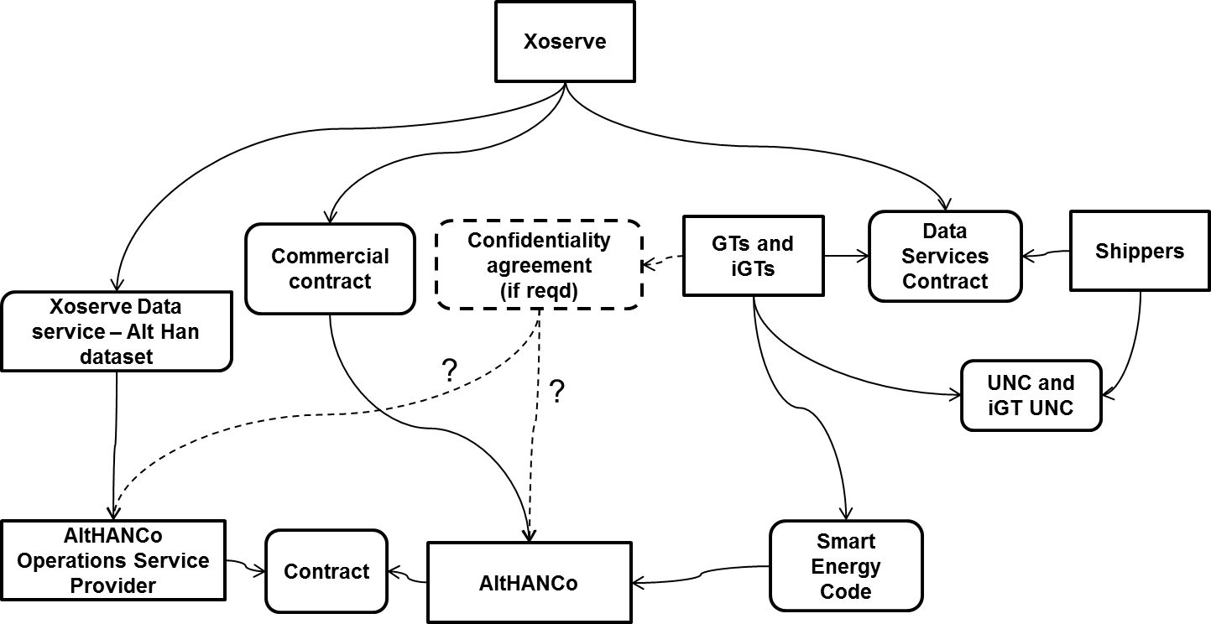

Contract with AltHANCo’s Service Provider:

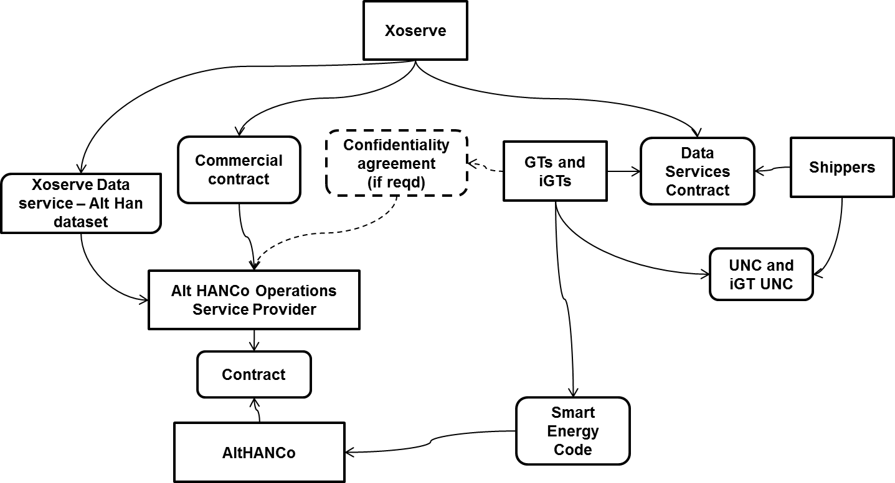

- Method of access to the dataset
Xoserve will send the data to AltHANCo or their service provider on a quarterly basis. The service is expected to last two years by when the analysis is expected to be completed.
The data will be transferred electronically using Huddle or a Shared Area. The dataset will either be provided to AltHANCo or directly to their service provider.

- Privacy Impact Assessment Risks
DESCRIPTION OF RISKS TO PRIVACY | RISK IDENTIED BY | RISK ASSOCIATED TO; INDIVIDUAL, COMPLIANCE, ORGANISATION / CORPORATE RISK | PROPOSED SOLUTION | RISKS ELIMINATED / REDUCED OR ACCEPTED. | IS THE SOLUTION A JUSTIFIED, COMPLIANT AND PROPORIONATE RESPONSE TO THE AIMS OF THE PROJECT
The AltHANCo service provider may use the data for other purposes. | Xoserve | Individual | Include Permitted Purpose clause and consequence of breach in commercial arrangements. Request AltHANCo also has similar terms in its contract with their service provider
AltHANCo has requested data for all 24m supply meter points. Should those supply meter points that Xoserve could determine will not need an AltHAN be excluded from the extract? | Distribution Workgroup | Individual | To be determined | See the paragraph below this table.

On 25th October 2018, Xoserve presented the following options for the provision of data to AltHANCo:
1. Xoserve determine the data required and filter out the Supply Meter Points AltHANCo don’t require, and send what remains.
2. Xoserve sends the full portfolio in every occurrence.
3. Xoserve sends the full portfolio in the first occurrence; for each subsequent occurrence, AltHANCo will inform Xoserve of what to exclude
The GTs believed it’s excessive to provide the full dataset each time as proposed by option 2 and raised concerns with the associated risks. When discussing option 1 and 3, the group agreed that over-filtering the data could be counter-productive but equally did not feel it necessary to send data that was explicitly not required by AltHANCo. The conditionality rules for what would be excluded from Xoserve’s side is yet to be decided as indicated in section 2 of this document. As a summary, AltHANCo would not require very large supply meter points as they would never have a Smart Meter.
The conclusion was a preference for a hybrid option combining both 1 and 3. This would involve removing the data which is known to not be required by AltHANCo for this analysis but sending the remainder of the dataset.
CoMC will therefore be requested to consider the hybrid option described in the above paragraph, and support Xoserve in the development of data retention rules for this option and a process whereby the CDSP (Xoserve) are provided evidence that AltHANCo or their service provider delete the data they do not require.

- CoMC determinations

CoMC is requested to:

- Identify any risks, regarding the data items and the mechanism of provision, to be included within the Privacy Impact Assessment and to consider mitigations

