DSC Change Completion Report (CCR)

Change Title | Unidentified Gas Task Force
Change reference number (XRN) | XRN 4695
Xoserve Project Manager | Fiona Cottam
Email address | Fiona.Cottam@xoserve.com
Contact number | 0121 229 2199
Target Change Management Committee date | 11 March 2020 (For Information Only)  DSC Contract Management Committee 18 March 2020 (For Approval)
Date of Solution Implementation | 31 March 2020
Section 1: Overview of Change Delivery
- Background to the Change
Following the implementation of the Project Nexus suite of process and systems changes in June 2017, the arrangements for daily allocation of gas changed, introducing the new concept of daily UIG as the balancing factor in each LDZ.
In early 2018, gas industry participants were still experiencing considerable issues due to the level and variability of daily UIG, which could vary significantly from day to day, across LDZs and between Nominations (forecasts) and Allocations (actuals). There was growing concern about the levels and costs of UIG, as well as uncertainty about the level of “final” UIG that would be seen at Line-in-the-Sand after (almost) all meter points had received a meter point reconciliation.

On 25th May 2018 Total Gas & Power raised UNC Modification 0658 (Urgent): “CDSP to identify and develop improvements to LDZ settlement processes”. The Modification was approved by Ofgem under Urgent arrangements with effect from 6th July 2018.
In parallel Change Proposal XRN 4695 “Investigating causes and contributors to levels and volatility of Unidentified Gas” was raised by Xoserve on behalf of Shippers on 6th June 2018 to commence work on mobilising a Task Force to investigate the causes of UIG.

- Objectives of the Task Force
UNC Modification 0658 introduced a new DSC Service Line with the following outputs: “Investigate and report on the causes of and contributors to Unidentified Gas; and suggest to industry measures by which the levels and/or volatility of Unidentified Gas might be reduced. As soon as reasonably practicable (and where reasonably practicable) to:
(i) report on measures which might reduce levels of Unidentified Gas to less than 4% of LDZ throughput by 31 December 2018 and
(ii) report on absolute levels of Unidentified Gas and measures which might reduce variation of Unidentified Gas to plus/minus 0.5% of absolute levels by 31 October 2019 and
(iii) make recommendations as required to the industry on actions to be taken to reduce levels and volatility of Unidentified Gas”.

XRN 4695 described the key activities of the Task Force as:
Cause and effect: Investigation of UIG to date to identify direct cause and effect. Development of a predictive model based on history to date, which can be shared with all interested parties. This will drive greater understanding, visibility and control of UIG across the industry.
Improve UIG model accuracy: Assessment of whether it is possible to improve the predictive accuracy of the NDM Algorithm through additional inputs or increased number of profiles and the use of relevant technology.
Personalised action plans (per customer): The development of specific actions plans for all customers who may be unknowingly contributing to UIG; that is helpful and supportive with increased pace of impact.

- Organisation of the Task Force
Following approval of the UNC Modification and Change Proposal, Xoserve quickly set up a Task Force, which was organised into two main streams:
- Advanced Analytics (AA) – use of an external Analytics Consultancy partner with in-depth experience in Machine Learning to undertake high-volume complex data investigations
- Issue Analysis (IA) – establishment of a team of in-house Subject Matter Experts to identify potential UIG causes and quantify their impact on daily and annual UIG, also to provide support and guidance to the external Analytics Consultancy. The in-house team was supplemented with extra resource to provide data analysis, project management and customer relationship expertise.

The Task Force followed an “Agile” project methodology consisting of multiple 2-week “sprints” of activity. The project streams (AA and IA) jointly reviewed progress at the end of each sprint and targeted effort for the coming sprint at the areas that were likely to be most fruitful.

- Overview of findings
The Issue Analysis stream identified approximately 45 possible causes of daily/annual UIG at one of more of the stages of UIG (Nomination, Allocation and/or Meter Point Reconciliation) and undertook initial assessments of all issues).
The investigations have resulted in 24 Findings packs, which are all published on the Xoserve.com UIG page. Xoserve has published Recommendations packs for 12 of those issues, which each contain a wide range of options to address the finding.

The Advanced Analytics stream undertook a wide range of investigations into the effectiveness of the NDM Algorithm and the possibility of a predictive model. The findings have been published on Xoserve.com, and a summary presentation supports this Report. A number of recent initiatives, such as the introduction of additional End User Categories and the use of additional weather data in the Composite Weather, can be traced back to the outputs of the Machine Learning analysis.

Machine Learning has identified that there is a correlation between daily Unidentified Gas levels and total LDZ Demand. As LDZ Demand is highly dependent on weather and business/consumer behaviours, it would be very difficult at present to predict UIG beyond the very short term.

- Summary of Recommendations
Xoserve presented all Recommendations so far at a special meeting of the UNC UIG Workgroup in January 2019, which was very well attended by Shippers, Networks, Ofgem and representatives from the AUGE and PAFA (Allocation of Unidentified Gas Expert and Performance Assurance Framework Administrator). Further recommendations were brought to later Workgroup meetings as they were available. A summary of the areas for which we made Recommendations is below. Please note that the impacts cannot be totalled up in all cases, and not all of the causes can ever be completely eliminated.

Log # | Description​ | Impact on base UIG​ | Impact on UIG volatility​
1​ | Use of Estimates for DM Sites (Actuals not loading) ​ | 0.09% est.​ | 0.9% est.​
3.1 | AQ Calculation Errors | N/A | N/A
3.2.1​ | Non Daily Metered (NDM) Sites in End User Category 09 (AQ >58.6m kWh)​ | Up to 0.4%​​ | Up to 0.7%​
3.2.2​ | NDM Sample sites with actual usage very different to UK Link AQ​ | 0.25%​ est.​ | 0.2% est.​
3.2.3 | Inaccurate/Out-of-date AQs – Sample Sites with different consumption patterns or levels compared with UK Link | 0.2% | 0.2%
3.2.5 | Inaccurate / Out of date AQs - change in the AQ mix and direction of travel following introduction of rolling AQ | Up to 3% of NDM AQ | N/A
3.2.8​ | NDM Sample sites registering consumption, with UK Link AQ=1​ | 0.35% est.​ | N/A​
12.1​ | Use of standard volume-to-energy conversion factor (AQ>732,000) (also referred to as “Correction Factor”) ​ | 0.1%​ | N/A​
12.2​ | Appropriateness of standard volume-to-energy conversion factor of 1.02664​ | 0.4%​ | 3% est.​
12.3​ | Use of non-standard volume-to-energy conversion factor (AQ<732,000) ​ | - 0.02%​ | N/A​
13.2.2 | Accuracy of NDM Algorithm – Use of Weather Data – Sensitivity of Components of the Composite Weather Variable | Up to 5% | Up to 20%
13.2.5 | Accuracy of NDM Algorithm – Use of Weather Data – Basic Machine Learning | N/A | Up to 23%
13.2.6 | Accuracy of NDM Algorithm - Advanced Machine Learning (findings in development) | Up to 70% reduction in annual UIG | Up to 20% reduction in daily UIG

- Benefits of the Task Force
The Task Force produced a large number of other outputs and delivered additional benefits, including:
- Identified and quantified more than 25 causes/contributing factors to UIG
- Made 95 separate recommendations to address known and possible UIG causes
- Identified key areas of Shipper performance against UNC obligations which were impacting UIG or adding to the risk of UIG
- Prompted a number of changes to industry processes including
  - Regular reporting of take-up of WAR Band EUCs (Mod 0652) ​
  - Increased focus on NDM sites over the DM Threshold (since January 2019) ​
  - Regular reporting of “AQ at Risk” to Performance Assurance Committee
  - Introduction of additional End User Categories for Domestic/I&C/Prepayment customers (October 2019) ​
  - Use of solar radiation in the Composite Weather Variable (October 2020) ​
- Drafted and published eight UNC Modifications as identified by the Recommendations, of which two have since been approved at UNC Mod Panel and a further four are in flight – Task Force have continued to support e.g. reviewing legal text and drafting PAC report formats
- Significantly raised industry awareness of causes of UIG, e.g. though publication of the “Data Trees” to show component parts of the calculations
- Produced new educational material and attended four Customer Expert days, to provide a “UIG Surgery”
- Developed a set of on-line UIG graphs, with download facility (go live in early March)
- Acted as a first point of contact for any Shipper, Supplier, Network and third party UIG questions and issues, prepared and participated in more than 25 customer phone calls, conferences or visits to individual organisations or trade bodies, and gave in-depth responses to many dozens of Shipper/Supplier/Consumer queries/enquiries/questions
- Gave regular updates to multiple forums, including DSC Change and Contract Committees, individual sector constituencies and Operational Forums run by Network Operators/Government/Regulator.

- Ongoing activities as a result of the Task Force,
The Task Force has increased gas industry understanding of causes and helped to focus on ways to reduce/mitigate the impacts. The following activities will continue after close-down of the Task Force:
- Additional reporting to Performance Assurance Committee, e.g. AQ at Risk due to lack of meter readings, sites over 58.6m Rolling AQ, not in Class 1
- UIG Mailbox for customer questions and requests for support (uigtaskforce@xoserve.com)
- Support for existing and future UNC Mods which the Task Force proposed (and any others that would positively impact UIG)
- Track the remaining Task Force recommendations to a conclusion (implementation or closure)
- Review the original UIG Issues Log to become a more streamlined tool for tracking progress in addressing key causes of UIG
- Support industry forums, e.g. Demand Estimation Sub-Committee to implement key findings from Machine Learning investigations, such as improvements to NDM Algorithm
- Support the new on-line UIG graphs and work with National Grid to enhance the UIG content of their Operational Data offering

In addition, for Financial Year 2020/21 Xoserve will set up a “Customer Performance Engagement Team” to proactively engage with Shippers and support them to improve key areas of performance which are contributing to UIG. That team will also produce regular UIG updates which focus on recent trends, future initiatives and highlight key areas of performance which need to be addressed.

- Links to Task Force documentation,
UIG Page on Xoserve.com | https://www.xoserve.com/services/issue-management/unidentified-gas-uig/
Task Force Findings and Recommendations | https://www.xoserve.com/services/issue-management/unidentified-gas-uig/#task-force-findings-etc

Section 2: Confirmed Funding Arrangements
Gas Industry Participant | BER Share of Cost | Actual Share of Cost | BER Cost Value | Actual Cost Value
Shippers: | 100% | 100% | £1,100,000 | £1,076,906  (forecast to 31/03/2020)
IGTs | 0% | 0%
DNOs | 0% | 0%
Transmission | 0% | 0%
DN’s & IGT | 0% | 0%

Breakdown of Expenditure
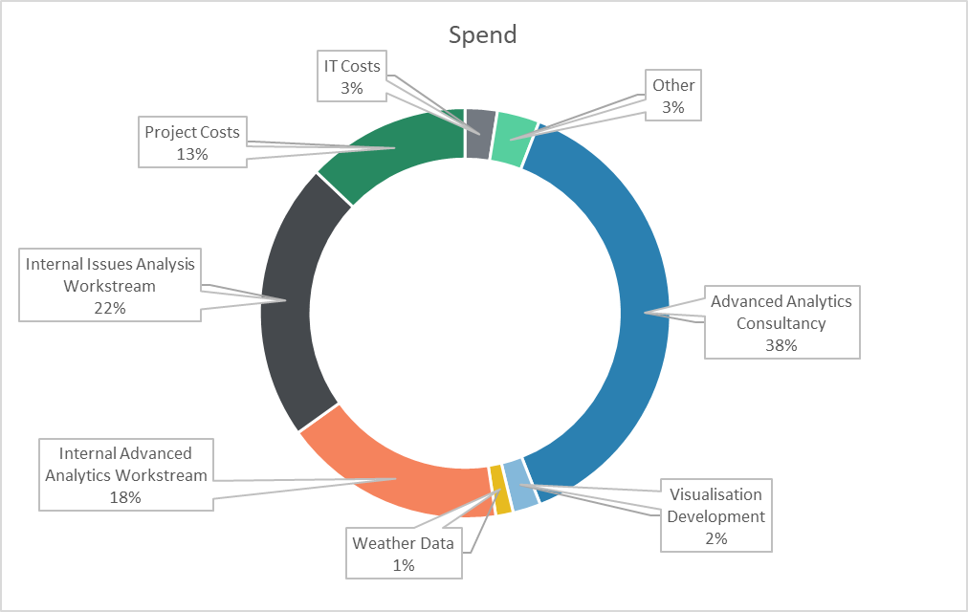

Section 3: Provide a summary of any agreed scope changes
Not applicable.
Section 4: Detail any changes to the Xoserve Service Description
It is proposed that the Non-Code Service Line that was introduced into the Data Services Contract to document the UIG Task Force is now removed from the contract:

Xoserve Service Area | Xoserve Service Line | (+/-) Projected Change in Annual Cost | (+/-) Actual Change in Annual Cost
Part B Direct Services - Non-Code Services | DS-NCS SA03-02 | N/A – Remove from DSC | N/A – Remove from DSC

Section 5: Provide details of any revisions to the text of the UK Link Manual
There were no revisions to the UK Link Manual.
Section 6: Lessons Learnt
The UIG Task Force team have identified the following Lessons Learnt:

Things that went well:
- High level of industry engagement with the Task Force – e.g. attendance at special UNC UIG Workgroup meetings, hits on the UIG page on Xoserve.com, especially Sprint Summaries
- High level of Xoserve executive management commitment to the assignment – release of resources, attendance at Sprint workshops etc.
- Use of external specialists, e.g. Machine Learning partner, data analysts, to bring the right resources into the assignment
- Setting up a major collaborative assignment at short notice
- Getting industry party sponsorship of proposed UNC Modifications
- Xoserve being trusted to operate independently to investigate a high priority industry issue
- Use of an “Agile” project approach to be able to respond to initial findings and set new priorities for each “sprint”

Areas for improvement:
- The Task Force could have turned the spotlight sooner onto areas where Shippers could improve UIG, e.g. meter read submission, AQ accuracy
- Should have worked to longer “sprints” for Issue Analysis stream, as developing detailed external communications every two weeks was a significant drain on resources, eating into analytical time
- Reporting lines could have been streamlined and the duplication of reporting to both DSC Change and Contract Management Committees could have been removed (with suitable industry agreement)
- The Investigation Tracker document became very cumbersome, due to trying to capture too much information for different audiences – this could have been streamlined mid-Project
- The Task Force needed more data experts to speed up data provision to the Advanced Analytics partner, especially in the early weeks

Please send completed form to: box.xoserve.portfoliooffice@xoserve.com

Document Version History
Version | Status | Date | Author(s) | Summary of Changes
0.1

Template Version History
Version | Status | Date | Author(s) | Summary of Changes
2.0 | Approved | 17/07/18 | Rebecca Perkins | Template approved at ChMC on 11th July
3.0 | Approved | 19/12/18 | Heather Spensley | Moved onto Xoserve’s new Word template in line with new branding

