Disclosure Request Report
Provision of Market Stabilisation Reporting data to RECCo

Prepared by: | David Addison
Submitted for: | DRR-MAR-01-22
Decision details: | CoMC is requested to approve this request to amend the Data Permission Matrix to include the data necessary to provide the Market Stabilisation Report to RECCo
Date: | 4th March 2022

- Introduction and background
Ofgem recently published a Statutory Consultation describing the introduction of a ‘Market Stabilisation Charge’ (MSC) which is intended to address the risks to domestic consumers in the short term from ongoing wholesale market volatility.
Consultation Document:
https://www.ofgem.gov.uk/sites/default/files/2021-12/StatCon%20Interventions%20to%20manage%20risks%20from%20current%20market%20volatility%20Final%20version_0.pdf
Ofgem published the decision document on 16th February 2022.
https://www.ofgem.gov.uk/publications/decision-short-term-interventions-address-risks-consumers-market-volatility
These measures will come into effect on 14 April 2022 on a temporary basis. It is expected that REC will be required to administer this charge and the invoicing to Suppliers.
The MSC will only come into effect where wholesale gas / electricity prices fall significantly. Ofgem have specified a threshold, which if met, will result in Ofgem publishing a charge – which will apply for the following week on a £/kWh basis. Ofgem have indicated that they will review the MSC on a monthly basis and further consult should there be a requirement for change.
It is expected that this regime will conclude by 1st April 2023. As such this is intended to be granted on a fixed basis by the Contract Management Committee, however, it should be noted that the data items in question will be subject to REC governance should any extension be required.
We have been approached by RECCo to provide supporting information to support this process.

- Data items
Where applicable, the Market Stabilisation Charge will be levied against the new Supplier based upon the AQ of the site at the point of the Switch.
This charge will only be applied against domestic Supply Points. The charge will be based upon the existing Market Sector Code retained in UK Link systems (rather than the value provided by the Incoming Shipper (in the case of prior to Central Switching Service (CSS) implementation and for Non CSS Supply Points) or Incoming Supplier (post CSS for CSS Sites). Non CSS Supply Points are Shared Supply Meter Points and Supplier Licence Exempt. LPG (which are also Non CSS Supply Points) are not subject to transfer so are not considered.
It is envisaged that the data required to support the MSC will be in the form of a summary report, and a ‘Supporting Information’ Report (the MSC SI Report) providing meter point level data that REC may wish to use to validation the summary data, and may provide to the Supplier to validate the MSC charge.
This DRR sets out the data items that will be included in the MSC SI Report, the summary report being a collation of this lower level report.
The following data items are expected to be included in the MSC SI Report (data items where text is red in ‘RECCo’ column are added as a result of this DRR’:
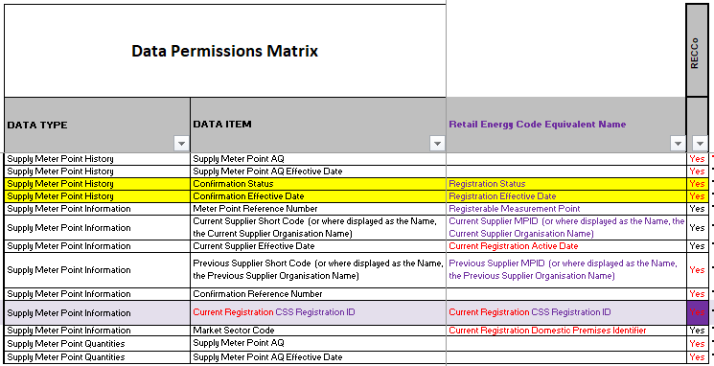
DATA TYPE | DATA ITEM | Reason
Supply Meter Point Quantities / History | Supply Meter Point AQ | Charge is based on £/kWh, where SMP AQ is the relevant AQ. NB: history data is also requested as at the point of provision the AQ may be superseded at month end, so may not be current AQ when the report is received by REC.
Supply Meter Point Quantities / History | Supply Meter Point AQ
Supply Meter Point Information | Meter Point Reference Number | Enables Suppliers to identify the relevant Registrations and validate the charges received as party of the MSC process.
Supply Meter Point Information | Current Supplier Short Code | The identity of the Incoming Supplier – who will receive the MSC Charge.
Supply Meter Point Information | Current Supplier Effective Date | The effective date of the Switch / Confirmation that has resulted in an MSC Charge being levied.
Supply Meter Point Information | Previous Supplier Short Code | The identity of the Outgoing Supplier – who will receive the MSC Credit.
Supply Meter Point History | Confirmation Status | It is conceivable that the ‘Current’ Supplier Registration has been superseded by further Registration, therefore access to ‘history’ data is nominally requested should this be the case.
Supply Meter Point History | Confirmation Effective Date
Supply Meter Point Information | Confirmation Reference Number | Enables Suppliers to identify the relevant Registrations and validate the charges received as party of the MSC process.
Supply Meter Point Information | Current Registration CSS Registration Id | Enables Suppliers to identify the relevant Registrations and validate the charges received as party of the MSC process.
Supply Meter Point Information | Market Sector Code | This data item is already available to RECCo, but is relevant for identifying domestic premises that are subject to the MSC.

- Privacy Impact Assessment
Where the disclosure of information includes the processing of personal data a Privacy Impact Assessment may be required.
Xoserve has considered the various tests that may be applied and considers that none of these are met and so a Privacy Impact Assessment is not required.
The tests (and answers) applied in determining whether a Privacy Impact Assessment was required were:
a) Will the project involve the collection of new information about individuals?
No, this is existing data which is already available in Xoserve systems.
b) Will the project compel individuals to provide information about them?
No, the data is already used part of existing processes.
c) Will information about individuals be disclosed to organisations or people who have not previously had routine access to the information?
No, data of this nature is already accessible to the recipient.
d) Are you using information about individuals for a purpose it is not currently used for, or in a way it is not currently used?
No, this data is already widely used for determining charges to participants in the gas industry.
e) Does the project involve you using new technology that might be perceived as being privacy intrusive? For example, the use of biometrics or facial recognition.
No.
f) Will the project result in you making decisions or acting against individuals in ways that can have a significant impact on them?
No.
g) Is the information about individuals of a kind particularly likely to raise privacy concerns or expectations? For example, health records, criminal records or other information that people would consider to be private.
No.
h) Will the project require you to contact individuals in ways that they may find intrusive?
No, there is no requirement to contact individuals.
i) Will the disclosure of information utilise new technology for Xoserve?
No. It is expected that this data will be SFTPed to RECCo.
j) Will the disclosure include information that identifies a vulnerable customer?
No.
k) Will the disclosure release mass data to a party?
No.
l) Will the disclosure include information that identifies an occurrence of theft of gas?
No.
m) Will the disclosure require a fundamental change to Xoserve Business?
No.

- Commercial model
The data will be released to RECCo as a CDSP Further Service under REC. A number of other services are provided using this framework – e.g. RPA Reporting; Annual MEM Reconciliation.

- Method of access to the dataset
Access to the dataset will be provided sending reports to RECCo via SFTP.
- CoMC determinations
CoMC is requested to approve this Disclosure Request Report.

