DSC Business Evaluation Report (BER)

Change Title | Gemini Change Programme Sustain
Xoserve reference number (XRN) | 5368
Correla Project Manager | Rachel Addison
Email address | rachel.addison@correla.com
Contact number | 0121 229 2528
Target Change Management Committee date | 13th April 2022
Section 1: In Scope
Change Proposal 5368 contains 7 main requirements. The key area of focus is to sustain and optimise the Gemini Platform by addressing some of the pain points identified by National Grid and wider industry customers. The BER seeks sanction for:
REQUIREMENTS | HIGH LEVEL DESCRIPTION
Single Sign On | Addressing a primary industry pain point, provide a single sign-on experience by integrating Citrix and Gemini credentials with a single identity management solution. Intoduction of Multi factor Authentication method along with Gemini Citrix access over internet replacing existing XP1 contingency mechanis
Enhanced API platform | Upgrade the API portal and automate extracts and formatting avoiding the need for CSV files, to address an industry pain point
Batch Processing Review Review | Control-M service provision and vendor recommendations (from recent contractual review negotiations) to simplify and improve performance
Test Automation | Building on this approach and FY20/21 successes, the sustain roadmap will further support automated testing activities via the tool of choice, TOSCA
Workflow Automation Feasibility and Analysis | A detailed review of Gemini system efficiency to scope areas where greater system automation can be implemented
BP22 Mobilisation | Review and prepare proposed delivery of continued works under BP22 for FY22/23
SiteMinder upgrade | Critical upgrade to SiteMinder to ensure resilience and maintain licencing and vendor support

The original BER with a value of £908,277 was approved at the August 2021 ChMC meeting. This adjusted BER is being submitted to seek approval for additional funds needed to deliver a scope variation to the Single Sign On (SSO) workstream.

Given the criticality of the application it is recommended that internet facing applications need protection from Distributed Denial of Service (DDoS) attacks and other malicious activities targeted at the application from the internet. Hence, National Grid have requested that a Web Application Firewall (WAF) & DDOS solution be implemented as part of the SSO workstream

Section 2: Out of Scope
- Delivery of any process automation is out of scope and so would require re-sanction should National Grid wish to progress with solution options identified at the end of the Feasibility and Analysis Phase
- Development of new APIs as part of API Platform Enhancement
- Implementation of a new Batch Processing Tool
- Any user ID validation and housekeeping as part of Single Sign On

Section 3: Funding required to deliver the change
The following section outlines the proposed costs

XRN Ref | HLSO £ | Design EQR | Build £ | Test £ | Implementation PIS £ | MT £ | 1st Year MTB £ | Delivery Total | CSSC Imact £ | Risk Margin £ | BER Total for Approval £ | Shipper £ | DN £ | IGT £ | NTS £ | Total
5368 | NA | NA | TBC | TBC | TBC | TBC | NA | £1,157,087 | NA | £ 31,500 | £1,188,587 | NA | NA | NA | £1,188,587 | £1,188,587

Key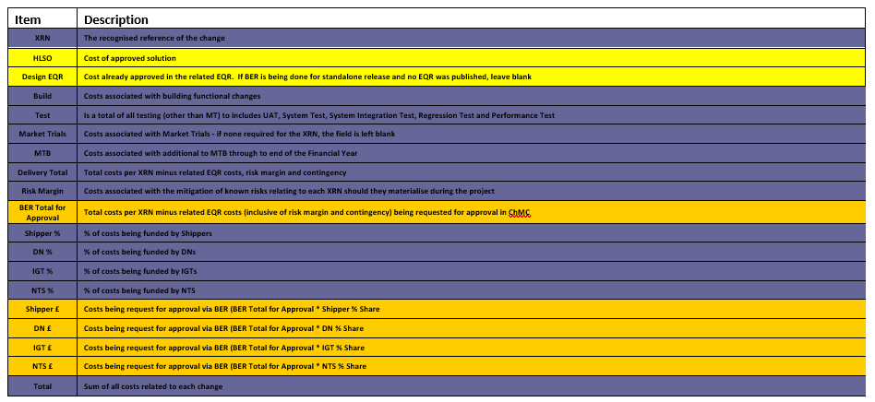
Section 4: Estimated impact of the service change on service charges
Impacts to Ongoing Costs:

XRN | Xoserve Service Area & Line | Impact | (+/-) Projected Change in Annual Cost
5368 | Gemini Service line 20 (UK Link Gemini System Services –Technical Changes) (Estimated) | Technical Operations | +£181,500
Total |  |  | £181,500
- Please note: Above mentioned price is subject to change and dependent on the completion of the solution design for the SSO change variation. Current projected change listed above is based on the maximum estimated increase expected per annum.

- Please note: The following Gemini Service Lines are required to be considered and re-visited as part of this BER:
  - Service Area 14 (Gemini Services)
  - Service Line 77
  - Service Line 78

Section 5: Project plan for delivery of the change
High Level Timeline:

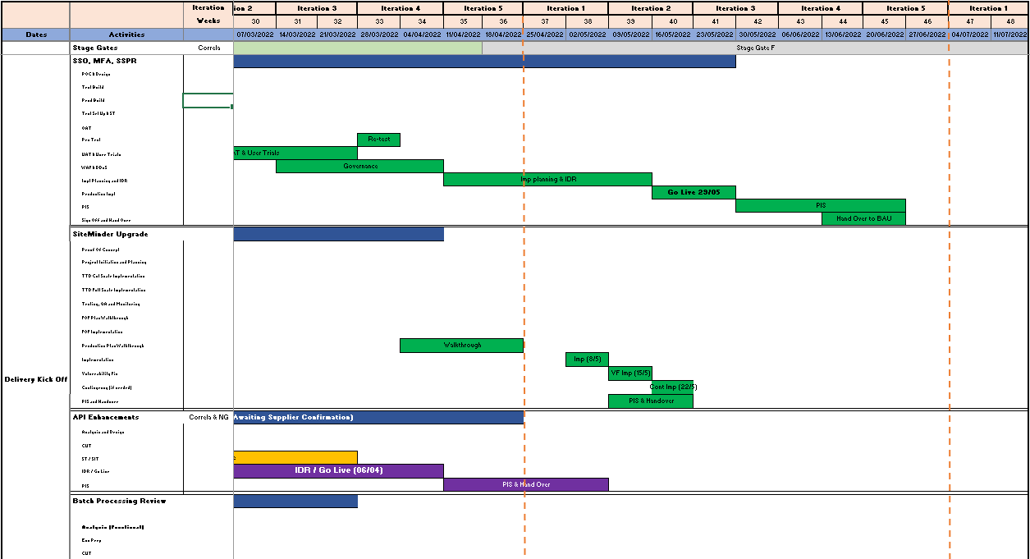

Section 6: Additional information relevant to the proposed service change
Risk Margin

XRN Ref | Risk Margin | Description
5368 | £31,500 | Change to requirements, Cost Estimation validation where applicable, potentials delays, technical impact assessment validation and any potential requirements for additional resources to support delivery of the solutions.

- Availability of sufficient suitably skilled National Grid resources to provide support throughout the project lifecycle.
- Availability of sufficient, suitably scaled development and testing environments. Relative priorities will need to be agreed with other projects if and when there are areas of conflict.
- An extended outage may be required when deploying the system changes into the Gemini system. This will be longer than the standard Sunday system outage and will need to be approved via ChMC.
- A number of the Business Requirements being delivered by this project have originated with users of the system. Correla on behalf of Xoserve will work with National Grid to develop a communication plan to share details of the changes being made.
- A period of User Trials has been included for some of the streams (SSO & API Platform enhancement) in the delivery plan. It is assumed external parties will participate in this phase in order to verify the system changes.

Please send completed form to: box.xoserve.portfoliooffice@xoserve.com
Document Version History
Version | Status | Date | Author(s) | Summary of Changes
0.1 | Draft | 28/06/2021 | Manisha Bhardwaj | For internal review
1.0 | For Representation | 29/06/2021 | Manisha Bhardwaj | Draft internall review (To be reviewed by NGG)
1.1 | For Representation | 26/07/2021 | Manisha Bhardwaj | For re-presentation at ChMc post internal review
2 | For Representation due to resanctioning | 23/03/22 | Hannah Reddy / Rachel Addison | For re-presentation at ChMc post internal review

Template Version History
Version | Status | Date | Author(s) | Summary of Changes
2.0 | Approved | 17/07/18 | Rebecca Perkins | Template approved at ChMC on 11th July
3.0 |  | 23/06/2021 | James Rigby | Table added to section 1  More detailed table in section 3  More detailed table in section 4  Inserted a project plan example in section 5  Table added in section 6

