DSC Business Evaluation Report (BER)

Change Title | Increase Frequency of FSG Payments
Xoserve reference number (XRN) | XRN5469
Correla Project Manager | Richard Hadfield
Email address | DSC+ Change Development Manager
Contact number | +441212292559
Target Change Management Committee date | July 2022
Section 1: In Scope
This BER requests approval of funding of this change request for an additional 1.0 FTE, at a cost of £36,900 from September 2022 to March 2023 (and £63,300 from April 2023 to April 2024, and per annum thereafter but subject to any future DSC+ schedule changes that affect the daily FTE rate card) be added to the Business Operations Invoicing Team in order to provide a faster payment service for “Failure to Supply Gas” (FSG GSoP1) payments.

XRN | Title | Type | Description | Link to Change Proposal | Impacts
5469 | Increase Frequency of FSG Payments | Xoserve change | To change the frequency of “Failure to Supply Gas” (FSG GSoP1) payments, from the current weekly/ad-hoc service, to a daily working day service. | XRN 5469 | Xoserve | Business Operations Invoicing Team

Section 2: Out of Scope
- This change will be delivered by the addition of FTE resource to the Business Operations Invoicing Team. System changes are not required and are therefore out of scope.
- Process/System changes for Distribution Network Operators (DNOs), Shippers and Suppliers are not required and are out of scope.
Section 3: Funding required to deliver the change
BER Costs

Key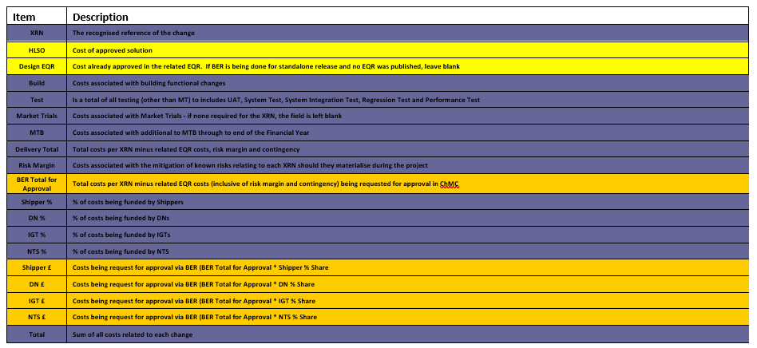
Section 4: Estimated impact of the service change on service charges
XRN | Xoserve Service Area & Line | Impact | (+/-) Projected Change in Annual Cost
5469 | <<”Collective Service, amendment to Service Line” TBC by XOSERVE>> | Business Operations Team additional FTE resource to deliver an enhanced service. | £63,300 p.a.
Total |  |  | £63,300 p.a.

Section 5: Project plan for delivery of the change
- July 2022 approval of BER
- August 2022 recruitment and training
- September 2022 start of new service (subject to successful recruitment and training)

Section 6: Additional information relevant to the proposed service change
Risk Margin

XRN Ref | Risk Margin | Description
RISK | N/A | DNO/Shipper business/system processes are not able to support an enhanced/faster daily working day FSG payments process. Mitigation: Xoserve communicate to Shippers about the move to daily working day payments, ahead of the actual change.
ASSUMPTION | N/A | There will be no Business Operations system changes required to support faster FSG payments.
ASSUMPTION | N/A | There will be no changes to DNO/Shipper business/system processes to support faster FSG payments.
ASSUMPTION | N/A | There will be no changes to the Business Operations current system invoice creation runs (daily).
ASSUMPTION | N/A | There will be no change to the current Business Operations SLA for processing FSG payments (by next working day).

Please send completed form to: box.xoserve.portfoliooffice@xoserve.com

Document Version History
Version | Status | Date | Author(s) | Summary of Changes
1.0 | For Review | 01.07.22 | Rajiv Patel | Finalise Review Version BER

Template Version History
Version | Status | Date | Author(s) | Summary of Changes
2.0 | Approved | 17/07/18 | Rebecca Perkins | Template approved at ChMC on 11th July
3.0 |  | 23/06/2021 | James Rigby | Table added to section 1  More detailed table in section 3  More detailed table in section 4  Inserted a project plan example in section 5  Table added in section 6

