DSC Business Evaluation Report (BER)

Change Title | March 23 Adhoc Release
Xoserve reference number (XRN) | XRN5575
Correla Project Manager | Phil Rockminster
Email address | Phillip.rockminster@correla.com
Contact number | Teams or +441212292706
Target Change Management Committee date | 9th November 2022
Section 1: In Scope
This BER requests approval for funding of the March 23 Adhoc Release (XRN5575).

The total delivery cost, including risk margin, to be approved in this BER is £263,809.

This is to be drawn down from the DSC General Change Budget.

The scope, approved at ChMC on 12th October 2022, for this release contains the following three XRNs that are to be funded from this BER:

XRN | Title | Type | Description | Link to Change Proposal | Impacts
5379 | DM Class 1 Read Service | Regulatory | The appointment of a Service Provider on behalf of Shippers, to provide the Class 1 read service from 1st April 2023 to meet the obligations of UNC Modification 0710S implementation and iGT Modification 148. | xrn5379-singular-cp.pdf (xoserve.com) | All
5143 | Transfer of NDM sampling obligations from Cadent, WWU, and NGN to the CDSP | Non-Regulatory | Transfer the EUC Bands 3-9 NDM Sampling UNC obligations, currently incumbent on Transporters (as per UNC TPD Section H1.6) to the CDSP. Note the CDSP already carries out NDM sampling for EUC Bands 1 and 2 so this change is simply an extension to the current CDSP process. | xrn5143-singular-cp.pdf (xoserve.com) | Shippers, DNOs
5472 | Creation of a UK Link API to consume daily weather data for Demand Estimation | Non-Regulatory | The change required is to move away from receiving weather data by FTP in a specific file format to 'pulling' the data needed from the Weather Data Service Provider, via APIs, into the relevant weather data table in UK Link. | xrn5472-singular-cp.pdf (xoserve.com) | All

Section 2: Out of Scope
- Any additional changes
- Market Trials
- For XRN5379, ongoing service and operate costs are being included within the annual charging statement to be issued in January 2023 for financial year 23/24 and are therefore not included in the scope of this BER
- For XRN5379, we are anticipating a Class 1 Read Service Provider implementation cost which are not included within scope of this BER, which focuses on the CDSP implementation costs for XRN5379. The procurement exercise to appoint the Class 1 Read Service Provider is ongoing but will be finalised before the end of the year. With this in mind, we cannot provide the firm Service Provider implementation cost until the procurement is finalised but can advise that this is not expected to exceed £165k. It is proposed that exact for this element will be brought to a future ChMC once known.

Section 3: Funding required to deliver the change
The following section outlines the proposed costs for XRN5575, including the previously agreed EQR for Design where applicable.

The BER costs for approval are highlighted in amber, the total for which is £263,809.

BER Costs

XRN  Ref | HLSO £ | Design  EQR | Build | Test | Impl’n  PIS | MT | 1st Year MTB | Delivery  Total | Risk  Margin | BER Total  For Approval | Shipper  % | DN  % | iGT  % | NTS  % | Shipper  £ | DN  £ | iGT  £ | NTS  £ | Total
5379 | £150,000 | £7,100 | £30,666 | £80,969 | £11,644 | £0 | £0 | £123,279 | £30,000 | £153,279 | 50% | 50% | 0% | 0% | £76,640 | £76,640 | £0 | £0 | £160,379
5143 | £75,000 | £0 | £9,958 | £8,800 | £0 | £0 | £0 | £18,758 | £15,000 | £33,758 | 0% | 100% | 0% | 0% | £0 | £33,758 | £0 | £0 | £33,758
5472 | £75,000 | £15,700 | £13,479 | £45,554 | £9,055 | £0 | £0 | £68,089 | £8,684 | £76,773 | 33% | 67% | 0% | 0% | £25,335 | £51,438 | £0 | £0 | £92,473
Total | £300,000 | £22,800 | £54,103 | £135,323 | £20,700 | £0 | £0 | £210,125 | £53,684 | £263,809 |  |  |  |  | £101,975 | £161,835 | £0 | £0 | £286,609

NB – the above includes additional £20k environmental costs incurred as a result of standing up development and test landscape to support this adhoc release.

Key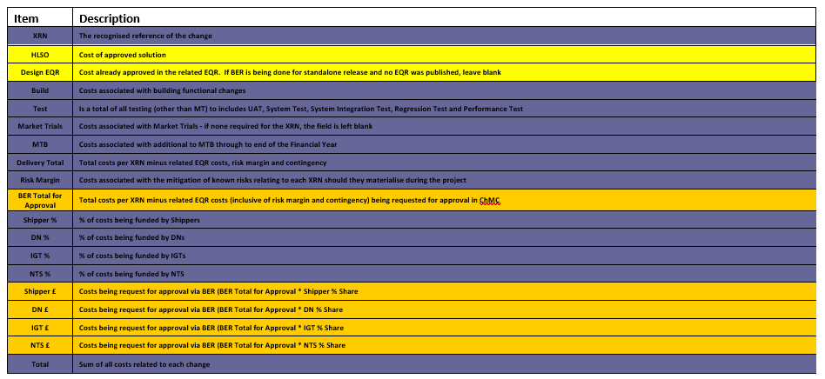

Section 4: Estimated impact of the service change on service charges
Impacts to Ongoing Costs

XRN | Xoserve Service Area | Impact | (+/-) Projected Change in Annual Cost
All | See risks below | See risks below | £0
Total |  |  | £0

Section 5: Project plan for delivery of the change
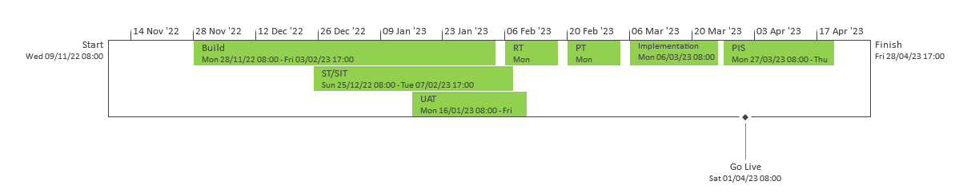

Section 6: Additional information relevant to the proposed service change
Risk margin included for approval in this BER:

XRN Ref | Risk Margin | Description
5472 | £8,684 | There is a risk that for XRN 5472 that during design, build, test it is determined that a MTB is required to support the ongoing service
5379 | £30,000 | There is a risk that new requirements are identified following the onboarding and transitioning to the appointed Daily Metered Service Provider
5143 | £15,000 | There is a risk that new requirements are identified following the onboarding and transitioning to the appointed Non-Daily Metered Service Provider

Delivery risks to be monitored throughout the delivery of this release:

- There is a risk that code changes made for different XRNs within the release will become interdependent because they will be affecting commons objects in the system(s). This could lead to delays to other XRNs if one particular change is deferred or descoped as the code objects will have to be reworked.
- Following the go live of REC, urgent changes may well be raised that could be added into this release prior to go live. Whilst these additions would result in an updated BER being presented, so there would be no cost impact to what has been approved, they could cause delays to the release as a whole.
- This release will have to accommodate the impact of Christmas holidays on resource availability and also the Christmas systems moratorium that could delay progression through the planned timeline in December 2022 & January/February 2023.
- There is significant instability within the current market and as winter approaches there is a risk of further crisis in the industry or significant events that could impact the delivery of this release.
- There is a risk that the delivery cost associated with the XRNs within this release are significantly different to those captured within this BER, once design has been completed. If this is the case then a revised BER will be submitted.
- There is a risk of regret spend associated with the build and test of XRN5143, this is due to the procurement process relating to the NDM not yet being concluded and therefore the charge methodology relating to this service is not yet known.

None of the above have a quantifiable cost that can be included in the risk margin for this delivery but all have been recorded here for visibility and acknowledgement of ChMC. They will be reported on through the monthly project progress reports to ChMC.

Document Version History
Version | Status | Date | Author(s) | Summary of Changes
0.1 | Draft | 11/10/2022 | Phil Rockminster | Draft of BER
0.2 | Draft | 17/10/2022 | Phil Rockminster | Updated with Correla review comments
0.3 | Draft | 24/10/2022 | Phil Rockminster | Updated with further Correla review comments
0.4 | Draft | 27/10/2022 | Phil Rockminster | Updated following Xoserve review
1.0 | Submitted to ChMC | 28/10/2022 | Phil Rockminster | Final updates prior to submission

