DSC Business Evaluation Report (BER)

Change Title | Regulatory Change FY22
Xoserve reference number (XRN) | XRN5579
Correla Project Manager | Rachel Addison
Email address | Rachel.Addison@correla.com
Contact number | 0121 229 2528
Target Change Management Committee date | 07/12/2022
Section 1: In Scope
National Grid have moved to a new agile way of working known as SAFe Agile. This framework includes Gemini system development and so requires a faster and more flexible governance process.

As a consequence National Grid have raised this umbrella Change Proposal intended to cover any changes raised by the National Grd Regulatory Change programme, these changes will have to be initiated during the remainder of FY22/23. Approval of this BER will reserve £1.18m of the Gemini Regulatory budget within BP22. Where a change is identified, a Change Variation will be raised under this BER and the relevant funds allocated from the approved reserve of £1.18m. This change will also better align the governance / sanction processes between National Grid and Correla

This BER is time limited to deliver change that is to be initiated within FY22/23. It is recognised that delivery of the changes may continue into FY23/24, and that separate approval will be sought for 23/24 related costs.

Section 2: Out of Scope
- Delivery of any regulatory change that is not expected to start until FY23/24.
Section 3: Funding required to deliver the change
XRN Ref | HLSO £ | Design EQR | Build £ | Test £ | Implementation PIS £ | MT £ | 1st Year MTB £ | Delivery Total | CSSC Imact £ | Risk Margin £ | BER Total for Approval £ | Shipper £ | DN £ | IGT £ | NTS £ | Total
 |  |  |  |  |  |  |  |  |  |  | 1,180,000 |  |  |  | 1,180,000 | 1,180,000

Key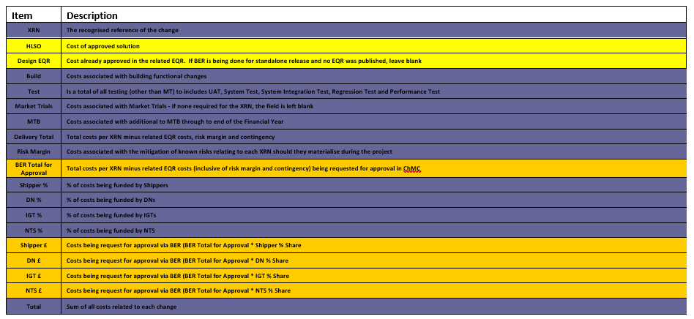
Section 4: Estimated impact of the service change on service charges
Any Change Variations raised under this BER will be assessed at the time of request and any expected increase, if applicable, will be communicated as part of the Change Variation control process.

Section 5: Project plan for delivery of the change
Delivery timescales will be provided in the response to any Change Variation.

Section 6: Additional information relevant to the proposed service change
Risk Margin

XRN Ref | Risk Margin | Description
5579 | £1,180,000 | Funds reserved for any potential regulatory change initiated during FY22/23

- Availability of sufficient and suitably skilled National Grid resources to provide support throughout the project lifecycle is essential to ensure successful delivery.
- Availability of sufficient and suitably scaled development and testing environments is required throughout the delivery phases. Relative priorities will need to be agreed with other projects if and when there are areas of conflict.

Please send completed form to: box.xoserve.portfoliooffice@xoserve.com

Document Version History
Version | Status | Date | Author(s) | Summary of Changes

Template Version History
Version | Status | Date | Author(s) | Summary of Changes
2.0 | Approved | 17/07/18 | Rebecca Perkins | Template approved at ChMC on 11th July
3.0 |  | 23/06/2021 | James Rigby | Table added to section 1  More detailed table in section 3  More detailed table in section 4  Inserted a project plan example in section 5  Table added in section 6

