Business Requirements Definition

for

Project Nexus

submitted to
Project Nexus Workgroup

Retrospective Updates

Author (for this version): | Xoserve
Version: | 0.8
Date: | 04/04/2012

This document contains confidential or privileged information; it should not be copied or disclosed to any third party without the express permission of Xoserve Ltd. All rights reserved.

Copyright © 2011 Xoserve Ltd
Contents

Page
1. Glossary 3
2. Document Purpose 4
3. Executive Summary 5
4. Benefits 9
5. Change Scope 10
6. Assumptions and Concerns 11
7. Overview of Business Processes 13
8. Business Requirements 16
9. Transitional Rules 26
10. Non-Functional 27
11. Document Control 28

Glossary

Term / Acronym | Definition
Allocation Profiles | Annual demand algorithms used in determining NDM allocation
Asset | Meter, Convertor, or a device attached to the meter for recording gas consumption
CSEPs | Connected System Exit Points (iGT sites)
Confirming Shipper | Shipper who’s Confirmation for ownership of a Supply Point will become effective (currently this is known at D-7 days of the Confirmation effective date).
Current Shipper | Registered User for an MPRN as per UNC
Cyclic Reading | A valid meter reading submitted in line with the meter reading frequency which is not a transfer reading, meter fix reading, meter removal reading or a read obtained via a Must Read.
DCC | DataCommsCo
DECC | Department of Energy and Climate Change
DESC | Demand Estimation Sub Committee
Dumb Metered | Meter which does not have a facility to transmit reads remotely
GFD | Gas Flow Day
GT | Gas Transporter
iGT | Independent Gas Transporter
LDZ | Local Distribution Zone
LSP | Larger Supply Point (AQ equal to or greater than 73,201 kWh)
NTS | National Transmission System
Previous Shipper | Any previous Registered Users for an MPRN
Proposing Shipper | Shipper requesting to take ownership of a Supply Point
Site | Supply Meter Point
SMIP | Smart Metering Implementation Programme
SSP | Smaller Supply Point (AQ equal to or less than 73,200 kWh)
Supply Point Register | A register of the large Gas Transporters meter points. The register includes address, asset and read history for the meter point.

Document Purpose
The purpose of this document is to ensure that the business requirements associated with the referenced change have been accurately captured and to clearly specify these requirements to the Project Nexus UNC Workgroup (PN UNC). Adequate information should be provided to enable the industry to approve the documented requirements for Cost benefit Analysis at a later stage.

The contents refer to the business scope of the change and provide descriptions of the business requirements and the relevant existing and future process maps.

Until the approved version, this document will contain draft business rules for the different options identified by PN UNC Workgroup regarding retrospective update processes. These options have been documented for further discussion and clarification at the Workgroup.

Intended Audience
- Gas Shippers/Suppliers
- Gas Transporters, large & iGTs
- Xoserve
- Customer Representative

Executive Summary

Introduction to the change
This document defines the timescales and processes associated with the retrospective updates to data held in the Supply Point Register and the financial adjustment as a result of the update for all gas meter points.

The document has been based on presentations and discussions at the Project Nexus UNC Workgroup and considering the high level principles agreed at the Retro Updates Principle Workgroup in June 2010. The options have been documented for further discussion and clarification. Until the final workgroup approved version, all areas within the document are yet to be agreed and finalised.

All square brackets [] indicates values that can be parameterised for the purposes of the BRD although will require confirming for system design or system design or system development. The highlighted text represents areas for clarification which must be resolved by the Workgroup prior to the business rules being finalised.

Business Principles
The following general principles were agreed for retrospective updates;
- All data updates are recorded correctly, for the correct effective date, where possible and subject to validation.
- Only the current Shipper can update data with the exception of meter reads whereby only the Shipper who submitted the read can replace it.
- Financial adjustments following a replacement read are automatically processed for both the previous and current Shipper
- Financial adjustments following an asset or Meter/Supply Point update during the current Shippers period of ownership are automatically processed
- Financial adjustments following an asset update or Meter/Supply Point update during the previous Shippers period of ownership are only processed following a request and if the update has been submitted by the current Shipper and processed

Implementation Timescales
Implementation of the developed solution will be confirmed once all requirements are captured following the Project Nexus Requirements Definition Phase.

Change Drivers and Business Goals

Drivers
- To improve the accuracy and quality of the data held on the Supply Point Register
- To provide accurate data to an Enquiring, Proposing Shipper or a new Shipper on transfer of ownership
- To enable the processing and receipt of any financial adjustments as a result of a data update
- Accurate energy allocation and transportation charging

Business Goals
- To develop a robust regime to allow historical data to be accurately corrected on the Supply Point Register to ensure the data held by the GTs reflects the actual position of a Supply Meter Point at any point in time.

Change Background
The changes have been identified as a result of Xoserve’s Project Nexus consultation for the replacement of UKLink systems and following DECC’s consultation on Smart metering and Supplier licence obligation for the installation of advanced meters.

Areas Identified in the Initial Requirements Register (IRR)

Ref | Requirement | Outcome
9.1 | Shippers should be allowed to submit retrospective updates, in particular for the SSP market. | Included
9.2 | The ability to amend incorrect meter read data after the submission of a later meter read. | Included
9.3 | Allow for retrospective data to be updated. | Included
9.4 | Easier submission of data update requests. | Non Functional Workgroup
9.5 | More flexible processing of meter reads. | Included
9.6 | Make validation rules fit business requirement. | Included
11.7 | Review data updates and who is able to submit updates at any point in time. | Included
13.3 | Data updates from non registered shippers | Closed
13.10 | A thorough review of data flows and data validation. | Included in Non-functional
13.12 | The process for shippers to revise standing data for sites on their portfolio should be streamlined and allow for the registered shipper to complete data changes quickly. | Non-Functional Workgroup
13.18 | Systemised data changes. | Non-Functional Workgroup
13.22 | Direct amendment of data held in xoserve’s database. | Non-Functional Workgroup
13.29 | The ability to update inaccurate data items for all supply points, domestic and industrial/commercial should be enhanced. | Included

UNC and Licence Impacts
- UNC Section M3.7.3
- UNC Section S4.3 & 4.4

UNC Process Impacts
- Query process
- Invoicing process

Interaction with Project Nexus High Level Principles
In June 2010 the following high level principles were agreed at the Project Nexus Principle Workgroup. The principles covered;
- Standing data, relating to sites and to meters attached to sites
- Transactional data, such as consumptions

Shippers would have the ability to update/amend/correct both standing and transactional data, within a set time-frame. After expiry of that time limit, probably aligned to the Reconciliation cut-off date (which has not yet been set) no further amendments would be accepted.

The following aspects of retrospective updates were raised, but required further discussion or consideration before any conclusion could be reached.
- Any validation of data updates to prevent/detect errors
- Any direct linkage to financial adjustments or to other data items, such as AQ
- The ability of Shippers to amend data for periods outside of their ownership
- The ability of Gas Transporters to amend data
- Amendments by parties other than the incumbent (e.g. previous/subsequent Shippers or GTs) require further consideration, because of the impact on the incumbent’s records, and the potential for those records to be out of line with the GTs.

Related Documents

Document Title | Location
Meter Read Submission and Processing and Settlement Arrangements BRD | Joint Office Website
Reconciliation BRD | Joint Office Website

Benefits

Industry Benefits
The following benefits will need to be aligned with the Transporter relevant objectives;

Accurate data held on the Supply Point Register

Shippers would receive correct Supply Point data to provide end consumers with accurate quotes

Accurate data submitted to Shippers on transfer of ownership

Accurate energy allocation and transportation charges

Disadvantages

The requirement to allow retrospective updates and financial adjustments may involve complex processes

Automated financial adjustments may discourage Shippers to submit an update which would result in a debit adjustment.

Change Scope

In Scope
Function:
- Retrospective update of;
  - Asset data
  - Meter reads
  - Address data
  - Meter Point data
- Who can update
- How the update is carried out
- Timeframe
- Processing of financial adjustments

Market Sector:
- All directly connected gas meter points
- DM Mandatory CSEPs
- NDM CSEPs (aspiration for all sites to be treated the same)

Out of Scope
Function:
- Any data items derived by the GT
- Replacement of any daily read before end of GFD+5 (close out)

Market Sector:
- None

Assumptions and Concerns

Project Assumptions

The business rules will need to be appropriate for dumb metered sites as well as remotely read sites

The processes described in the Settlement and Reconciliation Workgroups are approved

The proposed validations carried out by the GT at read receipt will ensure that any significant erroneous reads are rejected.

Process Assumptions

There will not be any retrospective adjustment to the Annual Quantity (AQ)

A Shipper will submit a request to retrospectively update data on the Supply Point Register.

All data updates will be subject to the relevant GT validations. Validations performed on the meter read will be those described under the ‘Meter Read Submission and Processing and Settlement Arrangements’ BRD. Any failures will be rejected back to the Shipper requesting the update with the reason for rejection.

All financial adjustments, once confirmed and calculated, will be billed on the next available invoice.

The principle agreed by PN UNC is that the Supply Point Register should accurately reflect the historical and current position of a Supply Meter Point and therefore all data updates are recorded correctly, where known and where feasible.

The rules described in this document apply to all sites

Where an adjustment to energy is carried out the share of unallocated energy will need to be amended. The methodology for this share will be the same as the ‘Reconciliation Scaling Adjustment’ which is described in the ‘Reconciliation BRD’.

Any financial adjustments will follow the ‘line in the sand’ principles, i.e. adjustments will only be processed as far back as ‘Line in the Sand’.

By submitting an update to data Shippers warrant that validation of the data has been carried out. The Shipper will record their investigation details and retain the evidence, not Xoserve.

If a previous Shipper subsequently re-confirms the site this does not change the requirements for processing a financial adjustment, i.e. the appropriate process for the previous Shipper will need to be followed.

Existing processes for submitting updates will be used where possible, e.g. RGMA flows, Query process.

Shippers will need to agree how they communicate with current/previous Shippers. Xoserve will not be required to pass on details between Shippers with regards to the data updates described in this document.

Where the GT or a third party identifies a ‘missing meter’, the details will be recorded and the MPRN will follow the relevant ‘un-registered/shipperless sites’ process

Dependencies

The baselined processes described within the Settlement Workgroup, AQ and Reconciliation Workgroup are unchanged.

Approval of the requirements by PN UNC

Approval by Ofgem following the appropriate UNC Modification process.

Risks / Issues

Complex processes are introduced to provide the facility to retrospectively amend data and carry out financial adjustments

Constraints
None identified at present.

Design Considerations
None identified at present.

Overview of Business Processes

Current Processes and Process Maps
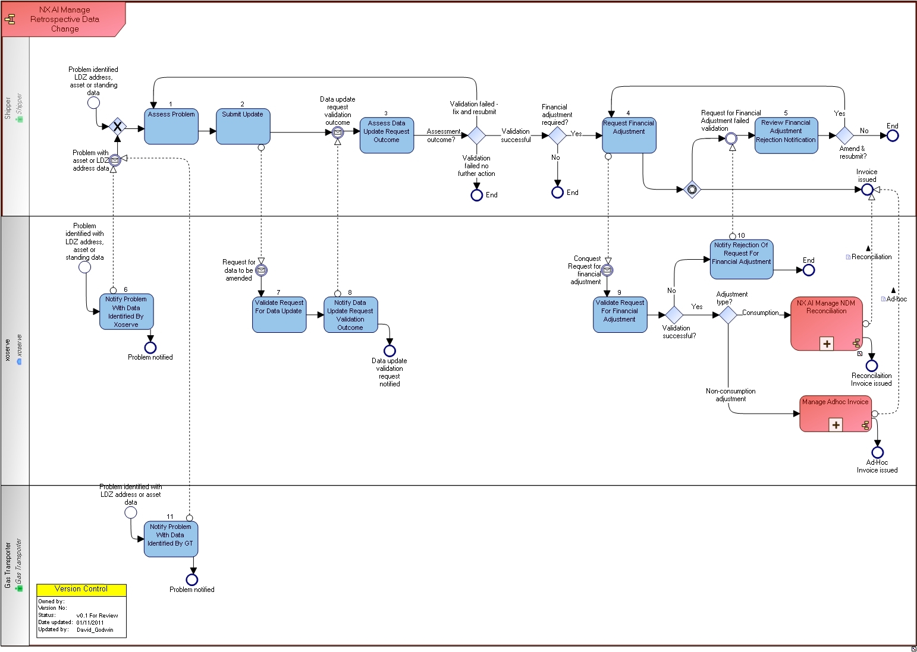
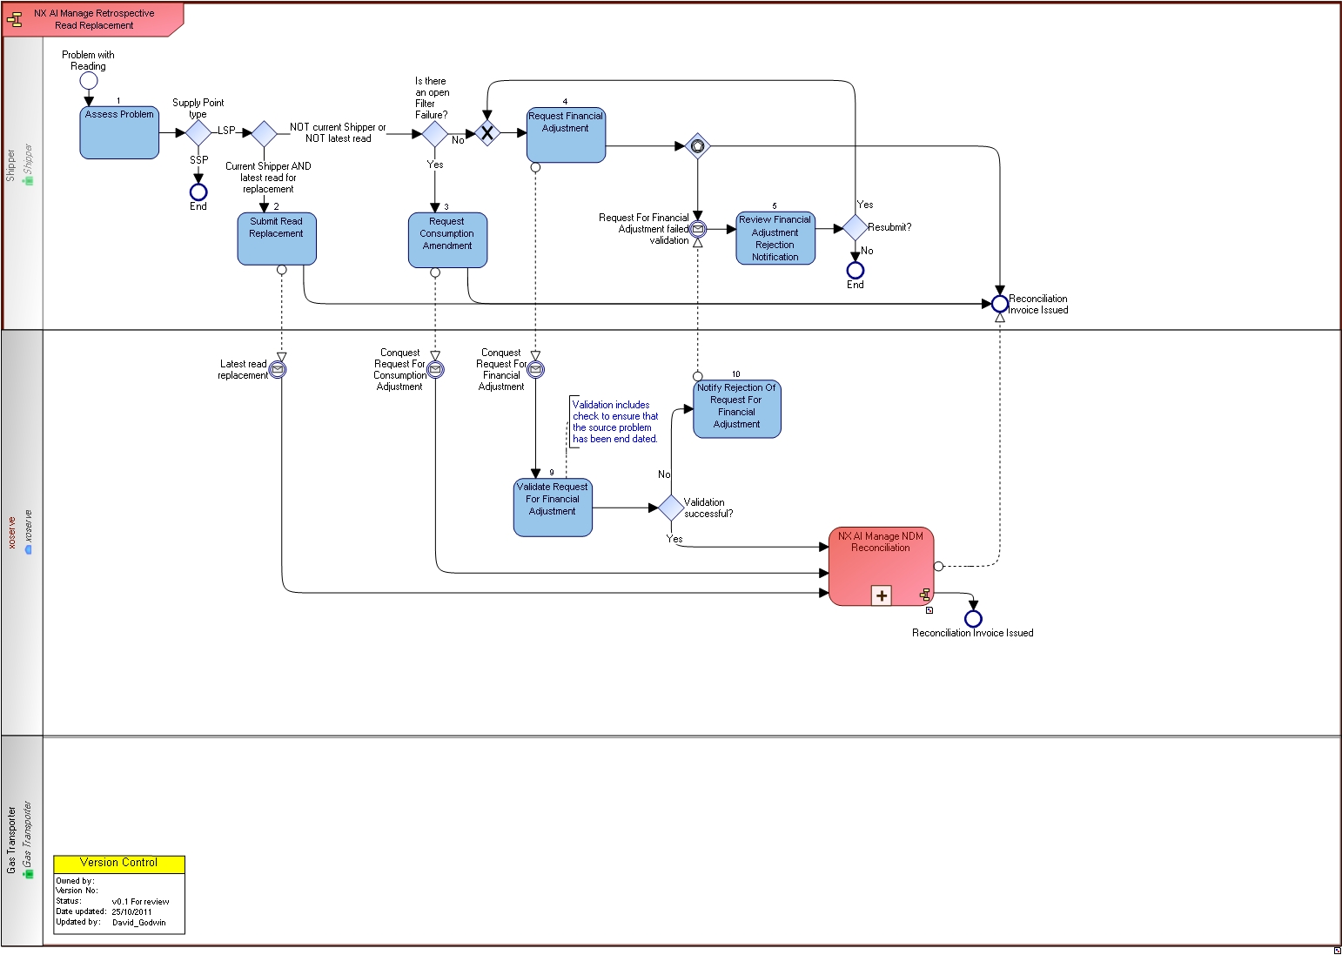

To-Be Processes and Process Maps

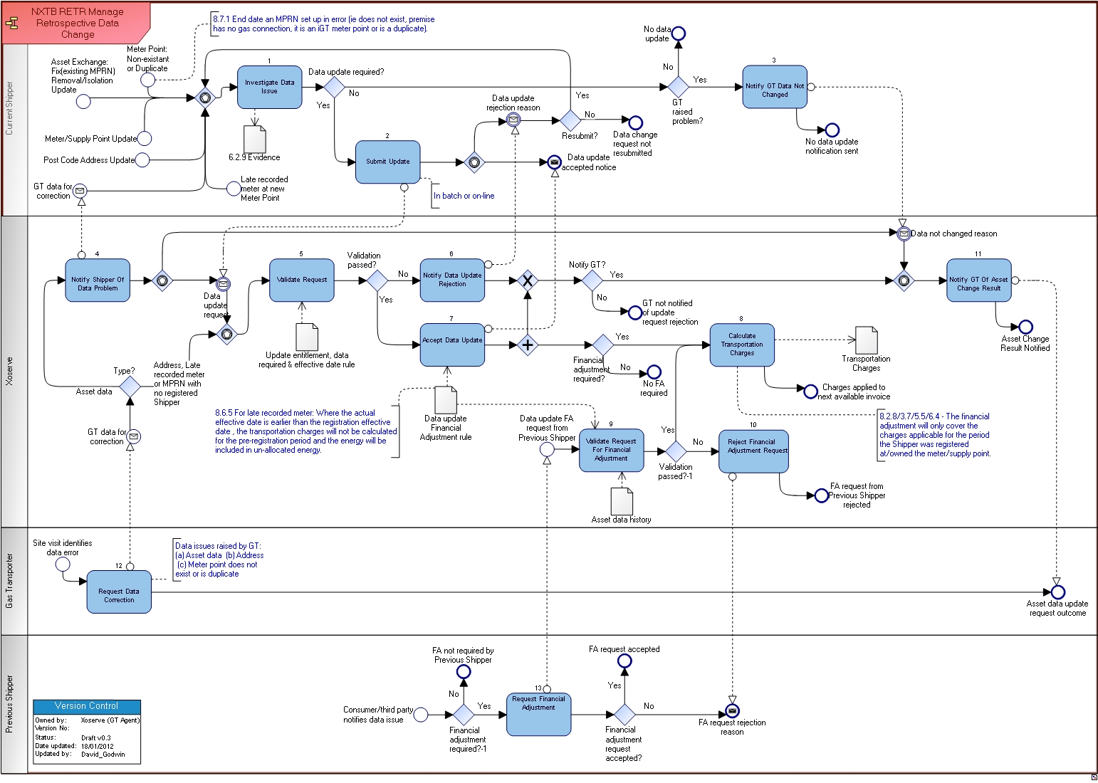

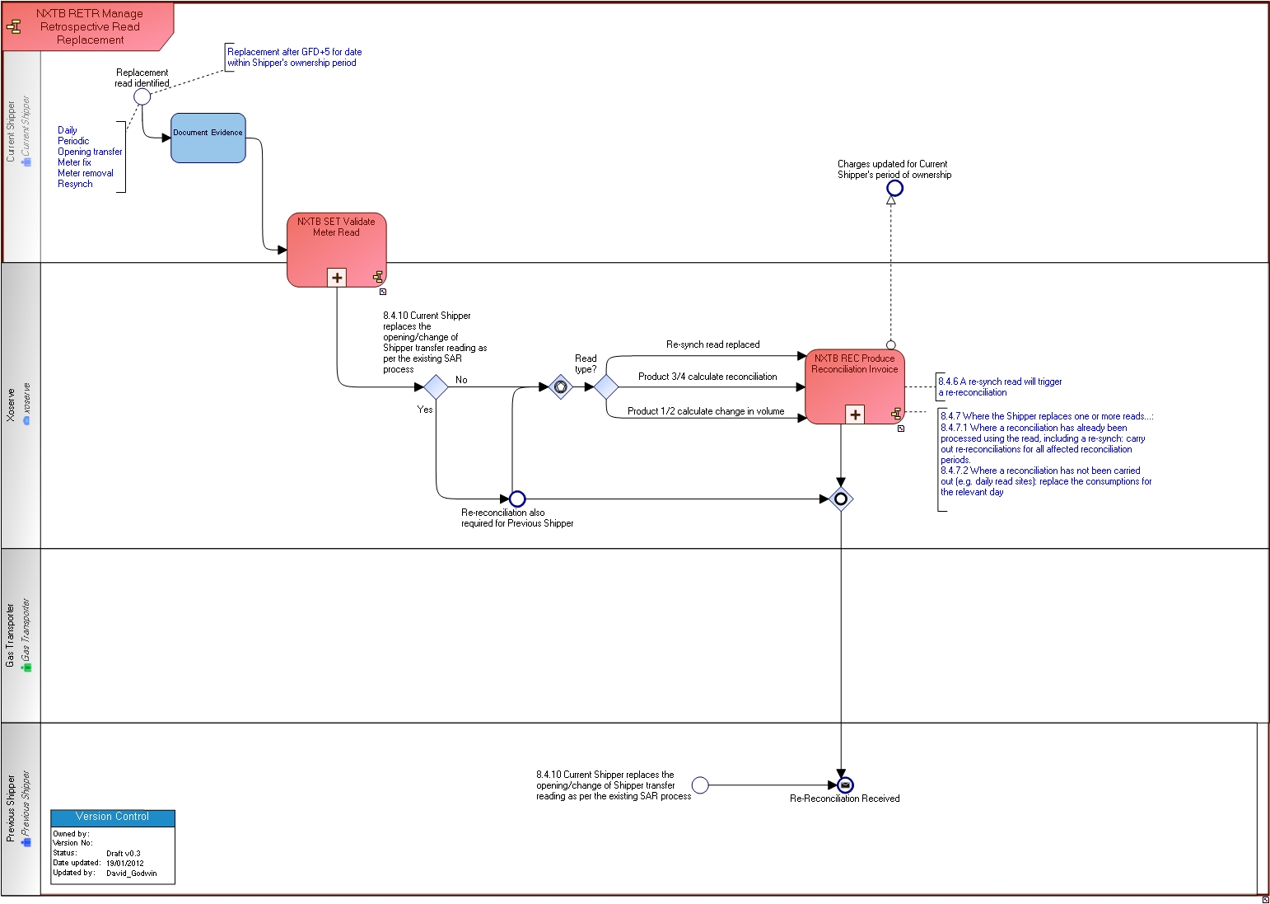

Business Requirements
Throughout this section reference is made to four new processes designed in the Project Nexus Settlement Workgroup for the submission and processing of meter readings and settlement arrangements. These four processes are summarised below;

Product 1, ‘Daily Metered Time Critical’
- Daily reads obtained and submitted to the GT daily before 10.00 am.
- Actual or estimated reads may be submitted by the Shipper
- The latest read loaded at GFD+5 will be used for allocation and energy balancing purposes.

Product 2, ‘Daily Metered Not Time Critical’
- Daily reads obtained and submitted to the GT daily.
- If the reads are submitted before 10.00 am they will be used for allocation purposes otherwise a read must be received before end of the GFD+1.
- Actual or estimated reads may be submitted by the Shipper
- The latest read loaded at GFD+5 will be used for final allocation and energy balancing purposes.

Product 3, ‘Batched Daily Readings’
- Daily readings are obtained for each day but are not submitted daily
- The daily reads are received in batches to a pre-notified frequency
- Actual or estimated reads may be submitted within the batch by the Shipper
- Reconciliation will be carried out based on the daily reads received
- Allocation and energy balancing is based on Allocation profiles and AQ.

Product 4; ‘Periodic Readings’
- An actual meter reading is submitted periodically. The read will be used for reconciliation purposes.
- Reconciliation is carried out using the methodology determined within the Reconciliation Workgroup
- Allocation and energy balancing is based on Allocation profiles and AQ.

Figure 2 below provides a summary of the processes by Settlement Product;
Figure 2: Summary of the 4 Settlement processes

Product Description | Read Used for Allocation | Read used for Energy Balancing | Estimation Methodology | Shipper Read Submission | Timing of AQ calculation | Reads used for AQ calculation | Reconciliation
Product 1: Daily Metered Time Critical Readings | Daily Read | Daily Read | D-7 | Daily by 10 am on GFD+1 | Monthly | Optimum read: 2 reads a minimum of 9 months & max of 36 months apart | Meter Point level following a re-synch or estimate
Product 2: Daily Metered not Time Critical Readings | GT estimate (unless read rec’d before 10.00 am) | Daily Read | D-7 | Daily by end of GFD+1 | Monthly | Optimum read: 2 reads a minimum of 9 months & max of 36 months apart | Meter Point level following a re-synch or estimate
Product 3: Batched Daily Readings | Allocation profiles | Allocation profiles | Allocation profiles (methodology to be agreed by DESC) | Daily Reads in Batches | Monthly | Optimum read: 2 reads a minimum of 9 months & max of 36 months apart | Daily Rec at Meter Point level on receipt of a batch of daily reads
Product 4: Periodic Readings | Allocation profiles | Allocation profiles | Allocation profiles (methodology to be agreed by DESC) | Periodically | Monthly | Optimum read: 2 reads a minimum of 9 months & max of 36 months apart | Meter Point level at receipt of a read

Data Items
The attached document is a summary of the requirements for retrospectively updating data.

The document is split into three categories (shown as tabs on the spreadsheet) as detailed below;

1. Data amendments that may trigger a financial adjustment (under tab ‘FA’)
The spreadsheet summarises the data items that may trigger a financial adjustment, the potential impacts and whether a financial adjustment is automatically processed.

2. Data amendments that will not trigger a financial adjustment (under tab ‘No FA’)
A summary of data items identified that do not affect transportation charges.

3. Data items where a retrospective update to the data is not permitted (under tab ‘No RU’).
There are a number of data items which can not be amended retrospectively.

The data items listed on the spreadsheet for categories 2 & 3 may not be complete; more may be identified during the analysis stage. Although these are included on the spreadsheet the details are not described within this document as charges are not affected and so a financial adjustment is not applicable.

See separate spreadsheet: Retro Updates data items v0.6

Retrospective Update to Asset Data

A facility to allow for retrospective updates to data held on the Supply Point Register relating to the asset.

Note:
- This section does not include the set up and meter fix of a new MPRN, this scenario is covered under section 8.6.
- The relevant data items and scenarios are defined in the document under section 8.1.

Asset data includes:
  - Meter
  - Convertor
  - Datalogger
  - AMR equipment

Scenarios for this section (8.2) include:
- Asset exchange
- Asset fix (existing MPRN)/re-established
- Asset removal/isolation
- Updates to the asset

Only the current or Confirming Shipper can submit a request to update the data relating to the asset.

Where a previous Shipper identifies the update they will need to liaise with the current Shipper. Asset updates will not be accepted from a Shipper who is no longer the Registered User.

The update will be validated by the GT and a notification issued on whether the request was accepted or rejected. Accepted requests will be processed.

The update will be carried out for the correct effective date, where known, even if this is during a previous Shippers ownership. Where the actual effective date is not known the Shipper will take a decision on the effective date of the update, based on their investigations and the data/reads held.

Any financial adjustments will be automatically processed for the current Shipper.

The adjustment will only cover the charges applicable for the period the Shipper was registered at the Meter Point.

The charges will be processed on the next available invoice.

The GT will not notify the previous Shipper(s) of the update.

Any financial adjustments for a previous Shipper will need to be requested separately and will only be processed if the update has been carried out.

Where the GT identifies the asset data held on the Supply Point Register is incorrect a notification will be issued to the current Shipper providing the details. The Shipper will notify the GT of the outcome of their investigations and whether the asset update has been carried out. A report will be issued to the relevant GT If the update has not been carried out and a response has not been sent from the Shipper to the GT within [3] months.

Retrospective Update to Meter Point/Supply Point

A facility to allow for retrospective updates to data held on the Supply Point Register relating to the Meter Point/Supply Point.

Note:
- This section does not include updates to address data which is covered under section 8.5.
- The relevant data items are defined in the document under section 8.1.

Meter Point/Supply Point data for this section (8.3) includes:
  - Conversion factor
  - Meter Point status (live/dead)

Only the current or Confirming Shipper can submit a request to update the data.

Where a previous Shipper identifies the update they will need to liaise with the current Shipper.

The update will be validated by the GT and a notification issued on whether the request was accepted or rejected. Accepted requests will be processed.

The update will be carried out for the correct effective date, which will be the MPRN creation date, even if this is during a previous Shippers ownership. Where the actual effective date is not known the Shipper will take a decision on the effective date of the update, based on their investigations.

Any financial adjustments will be automatically processed for the current Shipper.

The adjustment will only cover the charges applicable for the period the Shipper was registered at the Meter Point.

The charges will be processed on the next available invoice.

The GT will not notify the previous Shipper(s) of the update.

Any financial adjustments for a previous Shipper will need to be requested separately and will only be processed if the update has been carried out.

Where the GT identifies the details held on the Supply Point Register are incorrect a notification will be issued to the current Shipper providing the details. The Shipper will notify the GT of the outcome of their investigations and whether the asset update has been carried out. A report will be issued to the relevant GT If the update has not been carried out and a response has not been sent from the Shipper to the GT within [3] months.

Replacement of Meter Readings

A facility to replace one or more meter readings requested after GFD+5 regardless of whether any subsequent reads have been loaded.
Note:
- The relevant data items are defined in the document under section 8.1.
- All replacement reads will be subject to GT validations as described in the Meter Reading Submission and Processing and Settlement BRD.
- Reads that can be replaced are;
  - Daily meter reads
  - Periodic meter reads
  - Opening transfer meter reads

A Shipper can only replace reads they have been submitted in their period of ownership i.e. not reads provided by the GT, e.g. Must Reads, or reads provided by another Shipper.

A notification will be issued to the Shipper advising if the read has been accepted or rejected. Accepted requests will be processed.

Product 3 & 4 sites: Where a Shipper replaces a periodic read this will trigger a re-reconciliation

Product 1 & 2 sites: Where a Shipper replaces a daily read(s) the consumption from the new read will be used to re-calculate the charges for the relevant days, subject to 8.4.7.

Where a Shipper replaces a re-synch read this will trigger a re-reconciliation.

Where the Shipper replaces one or more reads within their ownership;

Where a reconciliation has already been processed using the read, including a re-synch: carry out re-reconciliations for all affected reconciliation periods.

Where a reconciliation has not been carried out: replace the consumptions for the relevant day.

The financial adjustment will only affect the charges for the requesting Shippers period of ownership.

Where a read has been replaced the old read will be flagged as ‘invalid’ and will not be used in any other process from the date it was processed e.g. AQ calculation.

Where the current Shipper replaces the opening/change of Shipper transfer reading (as per the existing Shipper Agreed Reads (SAR) process);

A re-reconciliation is automatically processed for both Shippers for the relevant periods.

Address – Post Code Updates

A facility to enable the Shipper or the GT to update address details including the post code for an MPR.
Note:
The relevant data items are defined in the document under section 8.1.

Where the address update is requested by the GT the update will be carried out, subject to validation. For accepted requests a notification will be issued to the current Shipper advising them of the update.

Except for the GT, only the current or Confirming Shipper can submit a request to update the data relating to the meter point address.

Where a previous Shipper identifies the update they will need to liaise with the current Shipper.

The request will be validated by the GT and a notification issued on whether the request was accepted or rejected. For accepted requests the update will be processed.

The update will be carried out for the correct effective date, where known, even if this is during a previous Shippers ownership. Where the actual effective date is not known the Shipper will take a decision on the effective date based on their investigations and the data held.

Where an update to the Post Code results in a change to the LDZ or Exit Zone this may affect the transportation charges applied. The financial adjustment will be automatically processed for the current Shipper.

Any adjustment will be processed for the current Shippers period of ownership only and issued on the next available invoice.

A notification will not be issued to any previous Shippers of the update.

Any financial adjustment for previous Shippers(s) will need to be requested separately and will only be processed if the update has been carried out.

Late Recorded Meter

A facility to accurately record the details of the asset and Meter Point following a request by the Shipper or the GT. This scenario only relates to new Meter Points where there has been no previous history of the MPRN.
Note:
A summary of the relevant data items are defined in the document under section 8.1.

Only the current or Confirming Shipper can submit a request to amend the data.

Where a previous Shipper identifies the update they will need to liaise with the current Shipper.

The Shipper will notify the GT of the MPRN and relevant address and asset details including the correct date when the meter was installed and the meter reading when installed.

The request will be validated by the GT and a notification issued on whether the request was accepted or rejected. Accepted requests will be processed.

The details will be accurately recorded on the Supply Point Register, where known. Where the correct/actual effective date is not known the Shipper will take a decision on the effective date based on their investigations and the data/reads held.

Transportation charges will be automatically calculated and invoiced to the current Shipper based on the meter reading (actual or estimated) and effective date of the Shippers ownership (effective date of registration).

For clarification, where the actual effective date is earlier than the registration effective date, the transportation charges will not be calculated for the pre-registration period and the energy will be included in un-allocated energy.

The charges will be processed on the next available invoice.

The GT will not notify the previous Shipper(s) of the update.

Any financial adjustments for a previous Shipper will need to be requested separately and will only be processed if the update has been carried out.

Meter Point does not Exist/Duplicate Meter Point

Facility to end date an MPRN which has been set up in error, either it does not exist, premise exists but there is not a gas connection, it is an iGT meter point or it has been identified as a duplicate. .

The notification may be submitted by the current Shipper or the GT and will be subject to validation.

A notification will be issued to the requester advising if the request was accepted or rejected. Accepted requests will be processed.

Where a previous Shipper identifies the update they will need to liaise with the current Shipper.

Where the GT has submitted the request and there is no Registered Shipper the request will be processed, subject to validation. Where a Shipper is registered at the Meter Point the Shipper will be notified of the details by the GT and no further action taken by the GT.

The end date of the Meter Point will be the same date as the MPRN start date.

Any financial adjustments to transportation charges will be automatically processed to the current Shipper.

The adjustment will be processed on the next available invoice.

The GT will not notify the previous Shipper(s) of the update.

Transportation charges for a previous Shipper will be processed following a request and only where the update has been carried out.

Treatment of existing Reads and Consumptions following a Retrospective Update
Note: This section describes the general principles for the treatment of meter reads and consumptions that exist after the retrospective update to meter asset data that may affect reads and/or consumptions calculated from the reads. Further analysis will be required and any clarifications or issues identified as a result of the analysis will be discussed and agreed at PN UNC.

The following table summarises the data items and if there is a potential impact on historical reads and consumptions.

 | Column A | Column B | Column C
Data Item where a Retrospective Update is carried out | No Impact to Reads or Consumption | Impact to Consumption only | Impact to Reads & Consumption
Metric/Imperial Indicator |  | ✓
Read Factor |  | ✓
Read Units |  | ✓
Conversion factor |  | ✓
Number of Dials |  |  | ✓
Date of Meter installation |  |  | ✓
Date of Meter Exchange | ✓
Date of Asset Removal |  |  | ✓
Meter Status (e.g. clamp/capped) |  |  | ✓
Meter model, meter type | ✓
Meter Mechanism | ✓
Meter location | ✓
Meter serial number | ✓
Manufacturer/  Year of manufacturer | ✓
Address, not changing LDZ | ✓
Address, changing LDZ |  | ✓
Supplier ID | ✓
Meter Asset Manager, Gas Act Owner, MRA | ✓
Market Sector Code | ✓
Emergency Contact or End Consumer details | ✓
Business rules described in paragraph: | 8.8.1 | 8.8.2 | 8.8.3

Note: If multiple data items have been updated, the tests described in 8.8.1, 8.8.2 & 8.8.3 would apply, and the rules from the highest impacted Column (where A is the lowest and C is the highest) would prevail. See 8.8.5 for further clarification.

Where meter asset data is updated that does not impact the historical reads or consumptions held (Column A); the reads and consumptions will be assumed to be correct. No consumption adjustments are required for any Shipper.

Where meter asset data is updated that impacts the consumptions only (Column B) from the reads loaded since the effective date of the update;

The consumptions are incorrect and are recalculated based on the updated information.

The recalculated consumptions will be subject to [‘Market Breaker’] validations and any that fail will not be loaded and the Shipper advised and the read invalidated.

A financial adjustment will be automatically processed for the current Shipper for their period of ownership only.

Where meter asset data is updated that impacts both the meter reads and consumptions held (Column C) since the effective date of the update;

The reads and consumptions, and any reconciliations calculated from the reads, will be marked as invalid.

Reads marked as invalid will not be used for AQ calculation

Where the Shipper submits replacement meter reads the consumptions are re-calculated based on the updated information

The recalculated consumptions will be subject to [‘Market Breaker’] validations and any that fail will not be loaded, the Shipper advised and the read invalidated.

A financial adjustment will be automatically processed for the current Shipper for their period of ownership only.

Where there has been a change of Shipper since the retrospective update and the transfer read has not been replaced: Shipper must submit a read for the transfer day + 1 calendar day which will be used as a ‘back-stop read’ for the purposes of AQ calculation and reconciliation. AQ review will not consider any reads previous to this date.

Any reads between the two reads submitted will be invalidated.

If an asset update is carried out where the reads are not impacted but the Shipper identifies that the reads are incorrect, the Shipper must replace the reads after processing the asset update using the read replacement facility.

If multiple data items have been updated the tests described above in 88.1, 88.2 & 88.3 would apply, the rules from the highest impacted Column (where A is the lowest and C is the highest) would prevail. E.g. if meter location and metric/imperial indicator were to be changed on the same update, these would impact Columns A and B respectively. As B is the higher of those two columns, the business rules for Column B would apply in that instance.

Transitional Rules
Transitional rules may be required to deal with the period immediately before and after the implementation of these rules. If any are identified during the analysis stage they will be raised and discussed at PN UNC.

Non-Functional

Submission of Updates

Updates can be submitted via existing batch methods or directly via on-line portal.

Document Control

Version History

Version | Status | Date | Author(s) | Summary of Changes
0.1 | Initial Draft | 18/10/2011 | Xoserve | First draft
0.2 | Draft | 20/11/2011 | Xoserve | Amendments following PN UNC on 01/11/2011
0.3 | Draft | 07/12/2011 | Xoserve | Amendments following PN UNC on 06/12/2011
0.4 | Draft | 12/01/2012 | Xoserve | Amendments following PN UNC on 10/01/2012
0.5 | Draft | 26/01/2012 | Xoserve | Amendments following PN UNC on 24/01/2012
0.6 | Draft | 07/02/2012 | Xoserve | Amendments following PN UNC on 07/02/2012
0.7 | Draft | 13/03/2012 | Xoserve | Amendments following PN UNC on 13/03/2012
0.8 | Draft | 05/04/2012 | Xoserve | Amendments following PN UNC on 03/04/2012. Published for industry review.

Reviewers

Name | Version | Date
AMR Workgroup attendees

Approval

Name | Role | Date
AMR Workgroup
PN UNC

