SPAA Schedule 25 – Management of Prepayment Activities – CDSP reporting to Siemens Ltd as the Prepayment Meter Infrastructure Provider (PPMIP)
- Proposal

The DSC Contract Management Committee is requested to approve the arrangements to be established between Xoserve as the CDSP, SPAA Ltd and Siemens Ltd as the Prepayment Meter Infrastructure Provider (PPMIP) in order for Siemens Ltd to release unallocated payments to gas Suppliers where Prepayment Metering arrangements were in place.

  - The PPMIP requires access to data held by the CDSP and provided to the CDSP under the terms of the UNC. If MPRN level data were being requested it is likely a modification to the UNC would be made to permit the release of data. However, for this service only percentage level data by Supplier is to be provided to the PPMIP.

  - The report provided to the PPMIP will be as follows and as can be seen, the data is being provided as percentage only:

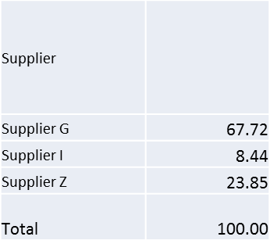

  - Xoserve, as the CDSP is unable to determine whether it has permission to provide this data to the PPMIP. The source data originates under UNC and Supplier name (not a pseudonym) is to be provided. The CDSP is requesting approval from the DSC Contract Management Committee to proceed with the proposal as detailed within this paper.

- Background

  - The PPMIP holds unallocated payments where Prepayment Metering arrangements were in place. In certain cases, the PPMIP is unable to identify the relevant Supplier to allocate, and consequently return the payments to.

  - Within ¹SPAA Schedule 25 – Management of Prepayment Activities, a mechanism has been agreed for the unallocated payments to be shared back to Suppliers. This will be supported through a report provided by the CDSP that reflects the market share (as a percentage) of Prepayment Meters a Supplier has in its portfolio during a specified reporting period.

  - The Market Share for each Supplier will be calculated by the number of days in which they had Prepayment Metering arrangements in place (as shown on UK Link), divided by the total number of days that all Suppliers had such metering arrangements in place for the reporting period.

  - The Market Share will be provided in a single percentage figure and will always total 100 as detailed within the example report within section 1.2.

- Contracting and delivery model

  - Xoserve will contract with SPAA Ltd as the administrator of the SPAA Schedule for the provision of this service. The Market Share figures will be sent directly to Siemens as the PPMIP and will not be sent to SPAA or provided to any other party. Xoserve acknowledges that there will need to be a form of agreement between Xoserve and Siemens to ensure the protection of the information that is shared with Siemens. The deliverables within the SPAA Ltd contract will be the confirmation that Xoserve have provided the information to the PPMIP and that the PPMIP has received it. SPAA Ltd will be charged for the provision of the services.

4. Next Steps

4.1 The DSC Contract Management Committee is requested to approve the proposal and following such approval, Xoserve will commence the development of the commercial and delivery arrangements for the service.

.

