Review Workgroup Scoping Document
0670R – Review of the charging methodology to avoid the inefficient bypass of the NTS

Introduction
This document follows on from the Terms of Reference included in the UNC Request and is intended to provide further clarity on the expectations of the working group in terms of scope, timing and objectives.
All related information will be made available on by the Joint Office of Gas Transporters website: https://www.gasgovernance.co.uk/0670
Date referred from Panel: 18 October 2018

Purpose of Request
To conduct a review and assessment of the charging methodology that is a feature of the overall Gas Transportation Charging framework to avoid the inefficient bypass of the NTS (currently the NTS Optional Commodity Charge). This review would assess the objectives, identify requirements, identify principles on which to base any solution, analyse potential options and propose an enduring proportionate solution.
The NTS Optional Commodity Charge (OCC) product was introduced in 1998 to avoid inefficient bypass of the NTS by large sites located near to entry terminals and has not changed since. UNC0621 and most of the alternatives from the Charging Review have NTS Optional Charging arrangements that end in 2021.

Scope
The scope of the review should be limited to the merits of the charging arrangements that discourage inefficient bypass of the NTS and identifying the most effective way to incorporate these into the Transportation Charging framework. Consideration should be given to the wider impacts to GB markets.
Working group participants will review and define the objectives and principles first, rather than trying to refashion any existing potential solutions. This will be aim of the initial workgroup meetings and it is intended that once signed off, these principles should form the basis of any proposed solutions moving forwards helping to create a common platform for later assessment and discussion. If there are substantively differing views on the merits of such arrangements this will be considered in the review workgroup and materials.
Once working group topics are sufficiently signed off, they should not be revisited unless there is a fundamental change in the GB charging framework that triggers further discussion, in order to maintain progress under tight timescales and to encourage active participation and contributions.
The level of detail required at each stage should be appropriate, given timescales for delivery and take a pragmatic approach to elements that may be influenced by other UNC Modification decisions. Expectations will be agreed during working group meetings prior to the delivery of any material.
The Review Workgroup has been suggested for a period of 6 months. A high-level project plan has been produced (see Figure 1) and will be kept under continual review, with gates determining milestones. Should dependencies on the milestones change the plan will be adjusted accordingly.

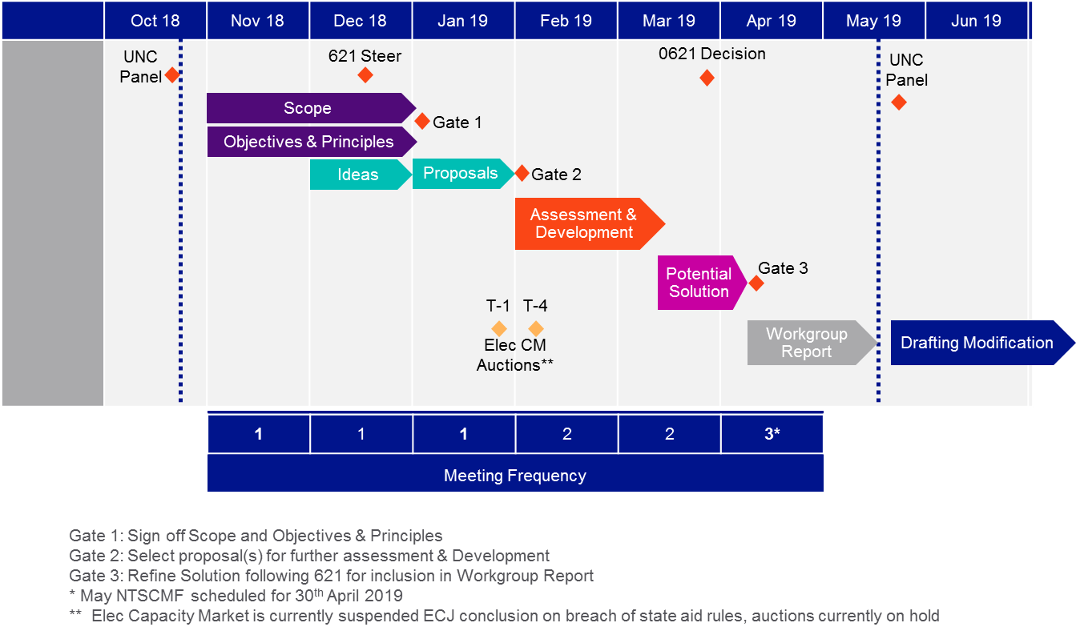
Figure 1: High-Level Timeline

Topics of discussion at the workgroup meetings:

Understanding the objectives

Understand/develop the principles on which to base any solution

Assessment of alternative means to achieve objective

Development of Solution (including business rules if appropriate)

Assessment of potential impacts of the Request

Assessment of implementation costs of any solution identified during the Request

Assessment of legal text

Output
To produce a Review Workgroup Report, for submission to the UNC Modification Panel on 16 May 2019, containing the assessment and recommendation(s) of the Workgroup.
If required, to update the UNC Modification Panel of progress.

Produce a Workgroup Report for submission to the Modification Panel, containing the assessment and recommendations of the Workgroup including a draft modification where appropriate.

Composition of Workgroup

The Workgroup is open to any party that wishes to attend or participate.

A Workgroup meeting will be quorate provided at least two Transporter and two User representatives are present.

Meeting Arrangements
Meetings will be administered by the Joint Office of Gas Transporters and conducted in accordance with the Code Administration Code of Practice (https://www.gasgovernance.co.uk/cacop).
Meetings will be held as part of NTSCMF, Hosted by the Joint Office of Gas Transporters (Joint Office) at one of the available locations (Solihull/London), on a monthly basis initially. Frequency of meeting should be kept under review, with the potential to move to fortnightly from February 2019 subject to progress made in the review workgroups and availability of the Joint Office to facilitate.
Fortnightly meetings may necessitate the provision of documents in a reduced timeframe in order to prepare materials and further progress at such meetings.

Reference Library
Participants will begin the review looking at the principles first, rather than trying to refashion any existing potential solution options. The assessment of these objectives and principles will determine the full scope of the review.
However, background information for those wishing to review previous material on the subject, it will be made available as part of a reference library, either as documents or links to relevant webpages.
Regardless of age, any material reviewed within the workgroup will be made available on the 0670 Workgroup webpage.

Questions from Panel
The following questions were raised by the UNC Modification Panel (18th October 2018) during the request proposal and should be taken into consideration by the workgroup:
• Consider the current revenue allocation to SO, should such a charge exist in the future is this still appropriate? (Note this is a licence condition)
• Consider interactions with Modification 0621 and update Panel once an Ofgem decision on Modification 0621 is received
• Impact of the proposal on the charging regime
• Consider the definition of inefficient bypass

