Workgroup report 621D
Key differences compared to 621
- Using the square root of distance rather than distance in calculating Average Distance
- Removal of the NTS optional charge (short haul tariff) from October 2019 rather than October 2021
- Storage discount of 86% rather than 50% (as for 621A)
- Requiring NTS to provide quarterly forecasts of Maximum Allowed Revenue

CWD with Square root of distance
The graph below show analysis provided by National Grid which shows the variability of Exit prices in the enduring period with the current LRMC model and CWD as proposed by 0621, CWD with the square root of distance rather than distance as proposed by 0621D and the postage stamp model proposed by 0621J. As can be seen the square root version results in prices with less variation that using distance but have more than the unvarying prices from the postage stamp model.
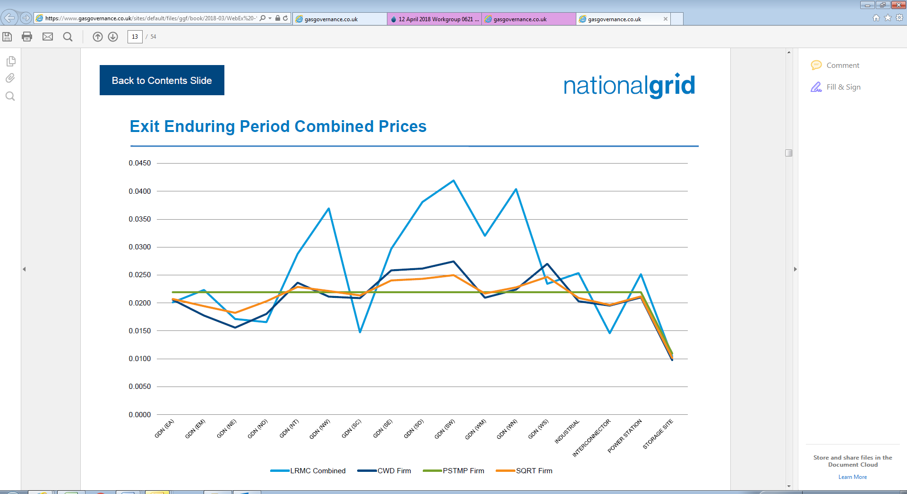
Source: Page 13 https://www.gasgovernance.co.uk/sites/default/files/ggf/book/2018-03/WebEx%20-%20LRMC%20CWD%20Postage%20Stamp%20Comparisons%200621.pdf
Concern was expressed in the workgroup that the CWD model resulted in prices that were too high in LDZs more distant from the entry points. The square root model addresses this by increasing charges in the east and reducing charges in the south compared to the CWD model in 0621. Prices in the north and west are largely unaffected.

The effect of using the square root of distance rather than distance can be seen by putting figures in the model and noting the results, this shows that as DEn increases then the average distance increases but not in proportion to the increase in DEn. This reflects the practical reality that the further an exit point is from an entry point the less likely it is to receive gas from that entry point.

The three models proposed under 621 and alternatives are special cases of:

ADEx,y = ΣEn (CAPEn,y * DEn ^{r}) / ΣEn CAPEn,y
where
ΣEn is the sum over all Entry Points
and where for the Gas Year and for each Entry Point
CAPEn,y is the Forecast Contracted Capacity
DEn is the distance (in kilometres) from the Exit Point (Ex) to that Entry Point.

Setting r = 1 gives CWD in 0621
½ gives CWsqrtD in 0621D
0 gives postage stamp in 621J (note DEn⁰ =1)

Clearly when r = 0 in the postage stamp model ADEx,y = 1 for all x and y
Partially differentiating ADEx,y with respect to DEn gives
$∂$ ADEx,y$∝$ r DEn ^{r-1}
$∂$Den
This shows that for 621 where r = 1 then r DEn ^{r-1} =1 and changes in DEn will result in a directly proportional change in ADEx,y;
for 0621D where r = ½ there will be a less than proportionate change in ADEx,y;
and for 0621J, where r = 0, there will be no change in ADEx,y

Optional Charge removal from October 2019
The impact of the removal of the Optional Charge in the Transition and Enduring periods is the same at a high level in that those previously on the Optional Charge will pay more and consequently others will pay less but the precise impacts on the benefitting Shippers will differ.
Transition period
- Removal of Optional charge will mean that all Shippers (excluding those shipping to storage sites) pay Entry TO, Entry SO, Exit TO and Exit SO charges
- To compensate the Entry TO, Entry SO, Exit TO and Exit SO charges would fall to Shippers.
- We assume that Shippers will pass on the reduction in commodity charges to customers both to NTS direct connects and those on DN networks.

It is difficult to estimate the precise financial impact but based on National Grid figures provided to NTSCMF on 26th September 2017 the Shippers on using the Optional Charge contribute £48.5 million but, in doing so avoid paying nearly £195 million in standard commodity charges. This represents a potential cross subsidy to those OCC Users of about £146 million per annum at the expense of those sites which are unable to benefit from the option of the OCC. Assuming that the impact is split equally between exit and entry means that approximately £73M would not need to be recovered from each of exit SO and TO and entry SO and TO commodity charges. These charges are charged by Shippers and hence included in the total charge to customers however it is useful to look at the effect relative to transportation charges made by DN networks. £73M is approximately 75% of SO exit commodity revenue so for illustrative purposes the effect on end customers can be seen by setting this to 25% of its current value and then doubling the effect assuming that this reasonably reflects the entry benefit. The effect of this on DN customers will vary by size, for example a domestic customer will benefit by nearly £2 or about 1.6% of the total exit transportation charges attributed to them whereas a Very Large Daily Metered Customer (VLDMC) connected to a DN network could see a reduction equivalent to 16% of the total exit transportation charges attributed to them. The reason for this difference between domestic and very large industrial customers is primarily because larger customers pay a higher proportion of their charges to NTS than do domestic customers and they also pay a significant amount in commodity charges.
0621 restricts the Optional Charge to 60km and therefore the cross subsidy under 0621 will be reduced but it is still likely to be substantial. Work by National Grid presented at 0621 workgroup on 12th April suggests that the Optional Charge would recover about £15M in the transition period. Based on the volumes provided the revenues that would be received if the Optional Charge did not exist can be calculated and hence the cross subsidy.
The non IP flows provided were
 | GWh (from NG) | Price (non OC) (from 621 model) | Rev if not OC £M | Rev if OC (from NG) | Cross subsidy £M
Exit | 102,698 | 0.0185 | 18.999 | 7.254 | 11.745
Entry | 150,673 | 0.0301 | 45.353 | 7.352 | 38.001
Total |  |  |  |  | 49.746

The cross subsidy under 621 is therefore £50M. This means that 0621 reduces the Optional Charge cross subsidy by about two thirds compared to 0621D removing it entirely.
Enduring period
- All revenue is recovered from capacity charges
- Entry and Exit capacity charges are lower than they would otherwise be (assuming NTS Shippers do not change behaviours)
- The benefit will be proportional to NTS capacity, the effect on DN customers will be related to the amount of NTS exit capacity they are charged by the DN

For 621D the size of the financial benefit impact compared to the current position will be the same as in the transition period; however the effect will differ as in the enduring period all revenue will be connected from capacity charges. Based on TO exit revenue of approximately £400M, then £73M equates to approximately 18%. Doubling this to reflect the entry benefit as well would result in a 36% reduction in Exit Capacity Charges compared to current values. The benefit is equivalent to approximately 1%for a domestic customer and nearly 10% for a VLDMC customer.
In the enduring period the Optional Charge ceases in 0621 so 0621D and 0621 have the same effect.
Summary of benefits
The table below shows the effects of removing the Optional Charge compared to the current charges in the UNC and against the estimated effects of 621. The comparisons are based on customers in Wales South WA2 exit zone, however as TO and SO exit and TO and SO entry commodity charges are the same throughout GB the effect in the transition period will be broadly the same throughout GB. The proposer of 621D has illustrated the effects in the enduring period using the WA2 exit zone as broadly speaking the forecast enduring exit capacity charges for WA2 are similar to the current charges. In some LDZs the new model (CWD for 621 and CWsqrtD for 621D) will result in substantial changes in Exit Capacity Charges and in some LDZs the increase will far exceed the benefit from the removal of the Optional Charge cross subsidy and therefore may not be obvious when looking at the aggregate effects of 621D . Nevertheless, although the changes might be relatively small for individual customers, it is important to remember that all DN connected customers will benefit from this change and without the removal of the Optional Charge they would all be paying more.
The DN charges calculator is available on the Joint Office website for those who wish to perform their own calculations.

Estimate of the reduction in charges resulting from changes to NTS charges
compared to DN transportation charges Exit Zone WA2 April 2018 charging model
 | Transition |  | Enduring
 | 621D transition compared to current | 621D transition compared to 621 transition | 621D and 621 enduring compared to current
Domestic | -1.6% | -0.5% | -1.2%
Primary school | -1.7% | -0.5% | -1.9%
Large secondary school | -2.1% | -0.6% | -2.4%
Indicative VLDMC sized customer | -15.8% | -4.7% | -9.4%
Example domestic customer with AQ 12500kWh and peak day capacity (SOQ) of 109kWh/day
putting these figures into the DN charging calculator gives:
GAS TRANSMISSION CHARGES
CHARGE TYPE |  | BASIS |  | RATE  (APR - SEP) | RATE  (OCT - MAR) | ANNUAL  CHARGE
TO ENTRY COMMODITY |  | PENCE PER KWH |  | 0 | 0 | 0
SO ENTRY COMMODITY |  | PENCE PER KWH |  | 0 | 0 | 0
TO EXIT COMMODITY |  | PENCE PER KWH |  | 0.0202 | 0.0202 | 2.53
SO EXIT COMMODITY |  | PENCE PER KWH |  | 0.0101 | 0.0101 | 1.26
TO EXIT CAPACITY |  | PENCE PER KWH PER DAY |  | 0 | 0 | 0
TOTAL ANNUAL CHARGE (EXCL TO ENTRY CAPACITY) |  |  |  |  |  | 3.79
GAS DISTRIBUTION CHARGES
CHARGE TYPE |  | BASIS |  | RATE  (APR - SEP) | RATE  (OCT - MAR) | ANNUAL  CHARGE
LDZ SYSTEM COMMODITY CHARGES |  | PENCE PER KWH |  | 0.0276 | 0.0276 | 3.95
LDZ SYSTEM CAPACITY CHARGES |  | PENCE PER PEAK DAY KWH PER DAY |  | 0.1616 | 0.1616 | 74.12
LDZ CUSTOMER CAPACITY CHARGES |  | PENCE PER PEAK DAY KWH PER DAY |  | 0.0039 | 0.0039 | 39.55
LDZ CUSTOMER FIXED CHARGES |  | PENCE PER DAY |  | 32.8954 | 32.8954 | 0
CSEP ADMINISTRATION CHARGE |  | PENCE PER SUPPLY POINT PER DAY |  | 0 | 0 | 0
ECN CHARGE |  | PENCE PER PEAK DAY KWH PER DAY |  | 0.01 | 0.01 | 3.98
TOTAL ANNUAL CHARGE |  |  |  |  |  | 121.6
For transition 621D compared to current we assume the saving is equal to the SO charge being reduced by 75%
and for the exit benefit and then doubling this for the entry benefit
this gives a saving of £1.26*.75*2 = £1.89 or 1.6%
For enduring the calculation is a 36% saving on the current exit capacity charge or 3.98*.36 = £1.43 or 1.2%

Note that the above effects are estimates of the effect of the removal of the Optional Charge in isolation.
There will clearly be a negative impact on those sites that benefit from the Optional Charge. The identities of these sites are regarded as confidential but we understand that they include the Irish Interconnector and power generators. There is no justification for GB consumers to cross subsidise customers benefiting from the Irish interconnector. Although charges will increase to power generators connected to the NTS and on the optional charge they will reduce to power generators connected to the NTS and not on the optional charge and those connected to DN networks so it is impossible to be definite about any effect on electricity prices. What is clear is that it will remove one distortion between charges to NTS connected generation and DN connected generation.

Discount to storage operators
Lift text from 0621A

NTS forecasts of Maximum Allowed Revenue

Para 5.12 of TPDV requires NTS to publish monthly revenue collection and para 5.13 of TPDV requires a quarterly revenue forecast to provided in the months ending November, February, May and August). The reality currently is that such forecasts are provided twice a year and are not aligned to the given deadline.
Under the new arrangements price volatility with respect to allowed revenue movements will continue to occur. Under GD1 NTS revenue has moved annually by up to 16%. A 16% increase/(decrease) in allowed revenue year on year would have an equal 16% increase/(decrease) in NTS unit rates year on year, all other things being equal. Given this volatility it is important that all users are provided relevant and accurate revenue forecasts. These forecasts should be at sufficient granularity so as to allow Shippers to perform sensitivity analysis over the forecasts, so as to factor in appropriate risk premiums into their contracts. Such details also allows all customers to more accurately forecast cash flows and understand the rationale behind future price changes.
The proposer believes that this change will be beneficial because it will

- Clarify the reporting timelines which benefits all customers through certainty of information flow, and benefits from reducing administration costs which result updating systems and processes on an ad hoc basis.
- Reduce the current monthly requirement which is not adhered to for a more reasonable quarterly provision which in reality results in a greater frequency than is currently provided.
- Amend the timetable to align to key outturn points in the regulatory calendar. For example a current revenue forecast made in May is unlikely to reflect the full regulatory year outturn and therefore contains more assumptions than would a report provided after RRP submission. The same point can be made around Ofgem directions made each year in November . These changes would increase the accuracy of the forecasts. In addition to the provision of these formal forecasts, it is acknowledged that for price notifications which occur, there will continue to be a need for NTS to further set out the allowance to that its tariffs seek to recover. This is in addition and does not constitute an alternative to the requirement to provide a quarterly revenue reforecast.

See page 13 of https://www.gasgovernance.co.uk/sites/default/files/ggf/book/2018-04/0621%20Analysis%20Slides%20120418.pdf
Mean used. Revenue recovery charges Entry 0.0291 Exit 0.0180 Oct 19, Entry 0.0311 Exit 0.0191 Oct 20
TO exit revenue £324.5M 18/19, £397.2M 19/20 and £411.6M in 20/21
https://www.gasgovernance.co.uk/DNcharges
https://www.gasgovernance.co.uk/ntscharges/LTrevenue shows forecasts provide in Oct 2015, May 2016, Nov 2016, May 2017, Nov 2017
https://www.gasgovernance.co.uk/sites/default/files/ggf/page/2017-12/LT%20MAR%20Forecasts%20at%20Nov%2017.xlsx demonstrates that TO maximum allowed revenue between 2017/18 and 2018/19 move from £712.5m to £828.5m, 16%.

