|  |  |  |  |  |
| --- | --- | --- | --- | --- |
| **UNC Workgroup Report - PART I** | | | | At what stage is this document in the process? |
| UNC 0621, 0621A, 0621B, 0621C, 0621D, 0621E, 0621F, ~~0621G,~~ 0621H, 0621J, 0621K, 0621L:  Amendments to Gas Transmission Charging Regime | | | |  |
| **Purpose of Modification:**  The purpose of this modification proposal is to amend the Gas Transmission Charging regime in order to better meet the relevant charging objectives and customer/stakeholder provided objectives for Gas Transmission Transportation charges and to deliver compliance with relevant EU codes (notably the EU Tariff Code). | | | | |
| Description: Description: YES_GREEN | This suite of Modifications has been to Workgroup for assessment, as recommended by the Proposers. | | | |
| Description: Description: High_Impact | High Impact: All parties that pay NTS Transportation Charges and/or have a connection to the NTS, and National Grid NTS | | | |
|  | **Proposer** | **Description: Description: email_us_go_online** | **Description: Description: call_us** | |
| 0621 | Colin Williams | colin.williams@nationalgrid.com | 01926 655916 or 07785 451776 | |
| 0621A | Benoit Enault | benoit.enault@storengy.co.uk | 01606 815372 | |
| 0621B | Jeff Chandler | jeff.chandler@sse.com | 01738516755 | |
| 0621C | Graham Jack | graham.jack@centrica.com | 07979 564929 | |
| 0621D | Richard Pomroy | richard.pomroy@wwutilities.co.uk | 02920278552 | |
| 0621E | Richard Fairholme | richard.fairholme@uniper.energy | 0776 6512365 | |
| 0621F | Pavanjit Dhesi | pavanjit.dhesi@interconnector.com | 07866620832 | |
| 0621H | Anna Shrigley | anna.shrigley@eni.com | 02078633651 or 07932114602 | |
| 0621J | Charles Ruffell | charles.ruffell@rwe.com | 07989 493580 | |
| 0621K | George Grant | ggrant@stagenergy.com | 0131 550 3380 | |
| 0621L | Christiane Sykes | christiane.sykes@shell.com | 02075464737 or 07967 770374 | |

|  |  |  |  |  |  |  |  |  |  |  |  |  |  |  |
| --- | --- | --- | --- | --- | --- | --- | --- | --- | --- | --- | --- | --- | --- | --- |
| Contents  Timetable 2  1 Report Structure and How to use the Report 3  2 Introduction 3  3 Comparison Table 4  4 Key Issues 4  5 Relevant Objectives 25  6 Stakeholder Objectives 72  7 Impacts and Other Considerations 73  8 Implementation 74  9 Workgroup Conclusions 74  10 Recommendations to Panel 75  11 Appendix 1: Impacts of Proposal on NTS Capacity Auctions 76  Timetable   |  |  | | --- | --- | | **The Proposer recommends the following timetable:** | | | Workgroup Report presented to Panel | 17 May 2018 | | Draft Modification Report issued for consultation | 18 May 2018 | | Consultation Close-out for representations | 25 June 2018 | | Final Modification Report available for Panel | 09 July 2018 | | Modification Panel decision | 19 July 2018 | |  |  | |
|
|
|
|
|
|
|
|
|

Report Structure and How to use the Report

Workgroups have been well attended and met frequently to develop and discuss these proposals. Managing the number of Alternatives and updates to these, combined with the timescales for delivery of the Workgroup Report to the Modification Panel, in line with Ofgem’s Direction in early March 2018 has constrained the debate on all aspects of all Modifications.

In order to manage the number of Alternatives and the range of opinions and to ensure that opinions are not summarised it is necessary to produce this Workgroup Report in a different way to what is normally presented.

The Workgroup Report is divided into 2 parts. Part I is the overarching Workgroup Report containing all the key material relating to Modification 0621 and the ten Alternative Modifications (0621A, 0621B, 0621C, 0621D, 0621E, 0621F, 0621H, 0621J, 0621K and 0621L). The content for this section comprises the following:

* How to use the report, including navigation;
* Comparison Tables – an ‘at a glance’ comparison of the key elements of Modification 0621 and the alternative Modifications ;
* Key Issues – provides Workgroup analysis and views of the key regime changes and differences in the proposed approaches;
* Relevant Objectives – contains the Workgroup assessment on how the Modifications better facilitate the objectives;
* Workgroup Conclusions and Recommendations.
* Defined terms [put defined terms from Mods in as appendix 2]



Part II provides an individual Workgroup Report for each Modification containing all the information specific to that Modification. The content each Part II report comprises the following:

* Modification (including Solution)
* Analysis – where provided by each Proposer or National Grid to illustrate the impact of the Modification
* Relevant Objectives – as provided by each proposer in the final version of their Modification.
* Legal Text – This is published as a separate document but the Workgroup’s views on the text is captured here.

Introduction

National Grid submitted Modification 0621 to the UNC Modification Panel in June 2017 with the aim of designing an amendment to the gas charging regime which was to better meet the relevant charging objectives and customer/stakeholder provided objectives and deliver compliance with the forthcoming EU Tariff Code (Regulation 2017/460).

Modification 0621 and all of its alternative Modifications 0621A, 0621B, 0621C, 0621D, 0621E, 0621F, 0621H, 0621J, 0621K and 0621L aim to replace the current charging methodology, which is based on Long Run Marginal Cost (LRMC).

Modification 0621 and nine alternative Modifications 0621A, 0621B, 0621C, 0621D, 0621E, 0621F, 0621H, 0621K and 0621L all propose Capacity Weighted Difference (CWD) as the replacement methodology; Modification 0621J proposes Postage Stamp (PS) instead. Modification 0621G was withdrawn on 20 April 2018.

Whilst the underlying methodology of CWD or PS is proposed across the modifications, these proposals also change additional charges that make up the overall charging framework for GB Transportation Charges.

Comparison Table

**Introduction**

The comparison table has been developed to show how the alternative Modifications differ from the UNC Modification Proposal 0621. In the simplified and full version, blue cells show variation in treatment of that element from UNC Modification Proposal 0621.

Note: the full comparison table has been used to aid in the formulation of the key issues section and the production of the legal text, especially where alternatives differ from the original National Grid 0621 proposal.

Simplified Comparison Table

[insert table or link to it]

Full Comparison Table

[insert table or link to it]

Key Issues

The table below sets out the key issues and differences as highlighted by the comparison table (4.1 to 8). Additional issues have also been identified through Workgroup discussions and these added to the table (4.9 onwards). The Workgroup have provided an assessment of each of these issues in order to provide rationale for the approach taken. The report also captures Workgroup members’ views where relevant on the issues and any impacts on the Relevant Objectives.

|  |  |  |
| --- | --- | --- |
| Issue Reference | Charging Regime Element | Issue Description |
| 4.1 | Reference Price Methodology | * Use of Capacity Weighted Distance (CWD) and Postage Stamp over the current LRMC methodology |
| 4.2 | Forecasted Contracted Capacity | * Transition and enduring arrangements * Obligated Capacity (during the 2 or 3 year transition period) and then National Grid forecast |
| 4.3 | Multipliers | * Multiplier of 1.0 (year 1) and approach to setting it in future years (stay as 1.0 or subject to consultation) |
| 4.4 | Interruptible Discount | * 10% (year 1) and approach to setting it in future years (stay as 10% or subject to consultation), and Exit interruptible at 100%. |
| 4.5 | Specific Capacity Discounts | * Storage Discount - 50% or 86% * Interconnector Points – none or 50% (for 2 years)/average weighted matched forecast (thereafter) |
| 4.6 | Revenue Recovery (Interim) | * 2 years and being Flow based for non-IPs (except non-own-use at storage) / capacity or flow based based for IPs (depending on the modification) * Exclusions for IPs – none or historical contracts * Exclusions for Non IPs – Storage or Storage and Historical Contracts |
| 4.7 | Revenue Recovery (Enduring) | * Capacity based for all * Exclusions for IPs – none or historical contracts * Exclusions for Non IPs - Historical Contracts at Storage or Historical Contracts |
| 4.8 | NTS Optional Charge | * 2 years/Enduring/3years/none * Existing formula structure with cost base indexed to RPI.  60km cap. Alternative to Transmission Services * Revenue Recovery Charge and Non Transmission services charge. * Additional Capacity discount |
| 4.9 | Legislative Compliance with EU Commission regulation 2017/460 | * Proposers advocate compliance for their proposals * Concerns raised on specific areas on compliance |
| 4.10 | Periodic process to determine Parameters and information publication | * No periodic consultation process outside of UNC change process proposed * All values under Article 26 of EU Commission regulation 2017/460 subject to UNC change process if or when considered necessary |
| 4.11 | General Non-Transmission Services Charges | General Non Transmission Services Charges are net of any:   * St Fergus Compression charge * DN Pensions Deficit charges * NTS Meter Maintenance charges * Shared Supply meter point administration charges * Interconnection Point Allocation charges   General Non-Transmission Services Charges - Flow based for non-IPs (except non-own-use at storage) Flow based for non-IPs (except non-own-use at storage) |
| 4.12 | K Principles and adjusting revenues in subsequent years | * Transmission Services K to be split between Entry and Exit   + Entry K to feed into Entry charges   + Exit K to feed into Exit charges * Non Transmission K to be aggregate value – no split between Entry and Exit |
| 4.13 | Security of Supply (SoS) and NBP impacts | * Some concerns expressed * Expectation will be considered in more detail as part of the Ofgem led Impact Assessment |
| 4.14 | Consequences of note | * Capacity Reserve prices for Exit Points close to Entry points under CWD or PS proposals are higher than under LRMC * Geographic Distribution (mostly Exit) increases charges in specific parts of GB * Outlier charges – under CWD more than PS certain points (notably St Fergus) are still higher relative to other Entry capacity reserve prices * Price differential between known fixed prices under Historical contracts compared to new capacity subject to updated RPM charges and impacts this may have. |
| 4.15 | Interaction between UNC0621 (incl. A, B, C, D, E, F, H, J, K, L), UNC0636 (incl. A, B, C, D) and UNC0653 | * Comments and concerns regarding the interaction between different modifications changing the same parts of UNC * Highlighting some modifications that are in progress and how these may be addressed. |
| 4.16 | QSEC & AMSEC 2019 Interactions | * Highlighting how the decision date may impact the charging arrangements for capacity, specifically for QSEC and AMSEC 2019 |
| 4.17 | DN Impacts | * Analysis, observations and concerns on potential charge changes |
| 4.18 | Independent Assurances on the development of any new Charging Models | * Commentary on illustrative models available and recognising need or assurances prior to using any charging model in setting actual charges post ready to implement post decision on any of the proposals. |
| 4.19 | Comparisons between the Modifications | * Summary of comparisons between the modifications on key areas and potential outcomes of the proposals * Assumptions made * Reference material for models and data * Summary of outcomes and observations |

**4.1 Reference Price Methodology (RPM)**

The aim of the RPM and overall framework of charging is to recover the Transmission Services Revenue from Capacity based charges.

Analysis and critique of the current methodology and potential alternatives have been conducted through the NTSCMF and UNC0621 workgroups. The results of this assessment were published in January 2017 (<https://www.gasgovernance.co.uk/ntscmf/subg1page>) and the updated analysis presented April 2018 (<https://www.gasgovernance.co.uk/0621/200418>). From January 2017 the Workgroup considered that the current LRMC methodology is no longer suitable and not be continued under the Gas Charging Review (that became UNC0621), this view was considered in the context of

* the EU Tariff Code,
* measurement against relevant charging objectives and
* stakeholder objectives.

This continues to be the view and is reflected in the analysis.

The overall conclusion from this Workgroup is support for this approach to move away from LRMC.

A number of drivers have been considered for the change to the reference price methodology. This includes moving away from a forward-looking investment focused model (that does not deliver revenue recovery via capacity) to one that is more a revenue recovery-based approach based on usage/capacity reservations. Workgroup supported this move away from an incremental focused model as the network is not expanding. CWD still provides some geographical diversity in charges whereas postage stamp provides uniform charges across the network.

All the proposals, with the exception of UNC0621J, have adopted CWD as the basis to underpin the methodology.

UNC0621J adopts a postage stamp (PS) model to underpin the methodology.

Moving away from LRMC was supported by the Workgroup. The critique of the LRMC methodology highlighted that even small changes to the inputs to the methodology can drive significant variations in the charges. These arose mainly from the boundary issues of supply merit order requirement in the LRMC methodology that is not a feature of either CWD or PS. If adjusting the supply merit order and applying revenue adjustments, as highlighted in the analysis <https://www.gasgovernance.co.uk/ntscmf/subg1page>) then the resulting methodology is similar to a CWD approach, albeit more complicated. There is an expectation that CWD or PS will provide more stable and predictable charges than LRMC, to the extent that the inputs are stable that would positively contribute to the relevant objectives on competition and cost reflectivity

* Competition – stability, predictability, volatility – addressing these key stakeholder objectives will promote competition (relevant objective (a)). Whilst not all may agree this furthers this objective based on the outcomes of the calculations and different treatment within the proposals, the ambition of the methodologies is to further this objective. In all modifications, the RPM is looking to improve these three key areas and also extended to the additional charges within the Charging framework, with particular emphasis on Transmission Services where most of the changes proposed under all modifications are being made.
* Cost Reflectivity - LRMC is considered a cost reflective model that does use cost assumptions as one of the inputs. This approach assumes the NTS is expanding and is an investment focused model. In a network that is not expanding, seeing reduced demand and lower competition in auctions it has been considered that this approach is less suited to the current arrangements.

Therefore, it was considered an alternative approach was more appropriate than attempting to modify the LRMC methodology.

Two proposals for the RPM are presented across the modifications.

**Justification of a revenue allocation (usage) focused RPM**

Currently the LRMC model is an investment focused model. The intention behind TAR NC is not investment focused but to have a reasonable level of cost reflectivity and predictability in transmission tariffs where revenue recovery is predominantly via capacity charges based on specific cost drivers such as capacity and the geographic distribution of points.

National Grid proposes that under the proposed methodology it should:

* Send signals to lead to efficient future usage of the system (ie to encourage efficient entry and exit of gas from the network. The amount of monies levied overall will not change however the distribution of charges will be spread differently. Improvements to stability and predictability of charges with lower volatility compared to current arrangements could be beneficial to consumers as certainty of future prices may improve.
* Recover costs already incurred. As a revenue recovery model the charges recover the allowed revenue for each year. The allowed revenue can be seen as the costs for the NTS for the forthcoming year, read as the costs. This is the same in overall as LRMC as ultimately, whilst there are cost inputs under LRMC the charges for any charging framework overall recover National Grid’s allowed revenues.
* Place more emphasis on revenue recovery of Transmission Services allowed revenue through the Capacity charges. These are based on cost drivers of capacity and distance. Whilst these cost drivers result in more “average” charges than current LRMC (so the differential between the highest and lowest charges is reduced) they still retain some geographic differential to reflect the distance between points and the capacity expected at each. The charges under CWD are not to incentivise specific actions by network users such as investment (based on industry feedback – link to paper on LRMC, PS and CWD comparison) as investment signals via pricing was now considered less relevant for industry stakeholders.
* Mean Users contribute to the costs of the NTS through the charging framework so that the charges paid by Users of the NTS is more equitable than current arrangements where the costs can be vastly different with some Users paying large amounts and some paying very little for the same access (e.g. via the current discount or interruptible arrangements).

National Grid proposes that the majority of the revenue recovery is to be through capacity as the goal of the methodology. Whilst this is the overall ambition it also recognises the transition as a step towards achieving this taking on board concerns on establishing an accurate forecast of capacity and using a transition period as a means to help inform this. The expectation of the proposed methodology is Shippers will book capacity closer to what is needed and also not give an incentive (where it is not considered necessary – see multipliers) between long term and short term against a backdrop of falling demand and lack of scarcity of capacity.

Additional RO’s: The charges under the proposals will predominantly recover the costs already incurred through the geographic distribution of charges using capacity and distance. The historical costs will feature in the allowed revenues for each year and therefore will be recovered through charges.

The use of CWD and the overall methodology and framework for charging should lead to closer capacity signals to what shippers need on the network. Ultimately the better the information and the confidence to the market and National Grid of those capacity signals, in the long term will mean the network caters for the known need rather than not being able to utilize capacity bookings as a meaningful input to any decision making.

Under the current methodology, the cost reflectivity and cost recovery are aspects that have come under scrutiny in the discussions in developing the alternatives. Cost reflectivity and how much it should be reflected in any charging approach has been a topic of discussion.

Cost reflectivity is subjective. CWD uses two specific cost drivers (capacity and distance) and the methodology proposed uses these to collect the majority of the charges with less cost reflective revenue recovery charges (based on these cost drivers) recovering a much smaller amount.

The ambitions of the methodology are:

The goal proposed by National Grid is to deliver 100% via capacity in as short as possible a time frame, hence the short transition. When it comes to the enduring the approach to charges for Transmission will be:

* First pass in the enduring will be based on running the calculations and including a forecast shortfall for any interruptible or specific discounts (essentially a two-step calculation in one).
* This delivers the best chance to recover the transmission revenue via capacity reserve charges via a single setting of the capacity charges. Any adjustment within year (i.e. driven by a variance between forecast and actual capacity bookings) will be via a capacity “top-up” charge
* The capacity top up charge will be a separate charge levied against Fully Adjusted Capacity that will not impact the CWD generated reserve prices.
* These charges do not look to promote specific behaviours, or provide an obvious incentive to book in a certain way (between long term and short term) besides encouraging bookings to be closer to need rather than the current system whereby there is an incentive to overbook without liability / exposure.

The proposals under the revenue allocation methods of Capacity Weighted Distance and Postage Stamp, in addition to how the revenue recovery charges are proposed are intended, across the modifications to be better for competition by making the charges more equitable than under the current charging LRMC + Commodity charging arrangements. This will further relevant objective (c) by making charges and also contributions more equitable across Users of the NTS. Current arrangements, where the calculated LRMC (including relevant adjustments) for Entry and Exit may not be the prices paid due to the specific discount arrangements and interruptible pricing. The proposed charging changes propose an improvement in this regard with all Users making a more equitable contribution.

**4.2 Forecasted Contracted Capacity**

**Inputs to RPM**

The CWD methodology requires three main inputs:

1. FCC;
2. A target revenue; and
3. Distances on the network.

Two values are required for the FCC, depending on the modification where CWD is proposed. A gross FCC value for the total capacity at each Entry and Exit point and a net value (where used) deducting any Historical Contracts (those that attract a fixed price under the current regime). These values feed into to two steps of the CWD based calculations. All except UNC0621L and J require the two values.

1. A weighted average distance (WAD) for each Entry and Exit Point. This takes into account the Gross Capacity for all points. This does not net off Historical Contracts. Therefore the WAD is the same irrespective of treatment of Historical Contracts when considering reserve prices and revenue recovery. This produces a WAD that is based on the total forecast capacity at each Entry and Exit point and the average shortest distances (using NTS pipeline distances) from each Entry to all Exit and each Exit to all Entry points.
2. A Weighted Average Cost (WAC) that is used to attribute an amount of money to recover at a specific Entry and Exit Point.
   1. This step nets off any fixed price capacity and the revenue associated to them under UNC0621, A, B, C, D, E, F, H, J, K. The focus here is to set prices for capacity where updated prices can apply to recover the target revenue at each point from the target capacity at each point with the intention to not under or over recover.
   2. Where revenue is involved, in order to set charges such that it is aiming to recover the Transmission Capacity charges it is necessary to accommodate the fixed priced contracts and their known revenues.
3. UNC0621L does not net off these values at this step. This method accepts there will be an under recovery from calculating prices that would not be applies to the levels of fixed prices and this will be dealt with under the revenue recovery charges.
4. An example of the WAD and WAC comparing UNC0621 and UNC0621L is shown below to illustrate the variances between the two steps in the calculation. This is for Entry only. Exit is not impacted by Fixed Price contracts on whether they are included or excluded into the WAC for the purposes of allocating revenues to a specific Exit point in setting Exit Capacity Reference and Reserve prices.



The above approaches put forward a methodology that aims to minimise the under or over recovery by recovering more from capacity based charges. This is more evident in the Enduring periods (where used – UNC0621B does not have an step change in the methodology – i.e. the enduring is from 1 Oct 19).

In addition to the above steps there are a number of additional components that ultimately calculate the reference price and the reserve price.

The Postage Stamp methodology requires two main inputs

1. FCC;
2. A target revenue

Under the proposal that used Postage Stamp (UNC0621J):

The FCC is the amount of capacity, net of any capacity with a fixed price, to give the amount of capacity over which a target revenue is to be collected that would be setting prices aiming to have no under or over recovery charges.

The target revenue is the total revenue net of known revenue from fixed prices.

Under all these proposals it is accepted there will inevitably be an under or over recovery to manage over the course of the year and all proposals provide for Transmission Services Revenue Recovery charges.

This ensures compliance with relevant objective (c) for completion and (aa) for calculating to charges best calculated to promote competition. All proposals provide a framework to set charges to minimise under or over recover and also provide a framework to manage these where they will occur. This is to ensure that charges in any given year can be set in advance without any need for retrospective changes and also provide a mechanism (proposed differently across the modifications) to manage anticipated under or over recovery to minimise the amounts to be carried across from year to year. This will help minimise or mitigate the potential swings that could happen from managing under or over recovery.

**Forecasted Contracted Capacity**

The NTS CMF produced a paper[[1]](#footnote-1) on the initial thoughts for the FCC and the FCC will need to be further developed by National Grid as part of the implementation of UNC 0621 or one of its Alternatives. FCC is a required value per Entry and Exit point under CWD. For PS, only an aggregate value for Entry and Exit is required. The FCC is required in order to calculate capacity reserve prices.

As mentioned above, the FCC is used in two steps in the calculation, in determining the WAD and WAC under CWD and the main denominator for Postage Stamp.

**Transition**

All the Modifications that have a transition period propose Obligated capacity as the FCC:

* Values are published/publicly available and understood by stakeholders;
* Values are stable and the process for change is known; and
* Objectivity of the values is less of a concern as they are fixed as per the Licence.

Relevant Objective (d) Competition: this approach uses more stable charges, more predictable outcomes and therefore better facilitates this objective. This also applies to 0621B, which proposes that the transitional approach is also the enduring solution.

The driver behind any under recovery will be the relative difference between the actual bookings and the FCC. Due to Obligated levels being generally higher than expected capacity bookings, this will drive an under recovery in the transition period, to be recovered through Transmission Services revenue recovery charges.

To reduce the Transmission Services revenue recovery charges, it may be necessary to set the FCC closer to actual bookings, which is the purpose of the enduring approach.

**Enduring**

For the enduring approach the proposals, with the exception of UNC0621B, are to use a National Grid forecast for the FCC. As mentioned earlier, this forecast is to be produced nearer the time the enduring arrangements become effective. An obligation to produce this has been included into the solution along with the required explanation and rationale behind the proposed forecast.

Some Workgroup members have concerns on the ability of National Grid to produce an accurate Entry and Exit point specific capacity forecast and the potential to compromise the stability / predictability of revenue recovery charges (within year changes) and / or K values (year + 2 under RIIO). Some Workgroup members expressed concerns over the potentially high number of changes to revenue recovery charges and if this would require a Licence change.

In the future Workgroup members want changes to revenue recovery charges within a Gas Year no more frequently than under the current charging arrangements (i.e. once per year).

**Fixed Prices in the GB regime and EU Commission regulation 2017/460 (EU Tariff Code)**

In the GB regime there are fixed priced contracts. These are Long term entry contracts for which the future years liability can be secured in advance by committing to booking this capacity. This is only available under the AMSEC and QSEC auctions, therefore it is Entry only. The fixed prices are a feature of the GB regime. UNC changes and price changes have avoided applying retrospective changes to contracted prices. For Entry there is no feature that allows contracted commitments to be reduced, like there is on Exit.

EU Tariff Code Article 35 introduces the concept of Existing Contracts. In GB the proposals introduce the concept of Historical Contracts. These are the contracts where the prices are fixed as outlined above. In the absence of any change to the UNC, and fixed prices are to be honoured in the proposals. Whilst there are some differing treatment on Historical contracts and Existing Contracts under the proposals for revenue recovery charges, all recognise the new terminology. Therefore the contracts struck between EU Tariff Code coming into force (Existing Contracts) and the implementation/effective date of UNC0621 or its alternatives need to be defined. These have been classified as Interim Contracts and combined with Existing Contracts these make up Historical Contracts.

Without Article 35 (which only looks at Existing Contracts) any changes to the GB charging regime would need to take into account any fixed price contracts in some way. It should be noted that this is a GB proposal that happens to also be EU Tariff Code compliant.

This fulfils relevant objective (e) on compliance to cater for Existing Contracts but also takes into account relevant objective (aa) and to set charges are cost reflective, relevant to each methodology. For CWD that charges are reflective of the cost drivers that allocate the revenue to each point to determine the reference prices. This also helps to avoid undue discrimination whereby any fixed prices contracted under the current charging framework are honoured without retrospective price changes to the fixed price component. This requires some additional clarity on any fixed priced capacity that may not be covered under Existing Contracts.

Therefore there is a need to introduce ‘Interim Contracts’ as a new term to accommodate fixed priced contracts under the current regime prior to any changes under UNC0621 and its alternatives and after Entry into force of EU Tariff Code.

**FCC & Historical Contracts**

The point specific capacity inputs to the CWD capacity calculations are either gross of net of Historical Contract capacity volumes depdending on the step in the calculation they are used. For the purposes of WAD they are gross, and where revenue is involved it is net (except for UNC0621L). The FCC for the WAD is gross in all proposals. When attributing the WAC, the process of allocating revenues to each point for the purposes of setting capacity charges, is therefore the non-Historical capacity bookings in the enduring period and Obligated in the transition period net of Historical Contract volumes and prices (except UNC0621L that proposes not to net off Historical Contract voume and revenues in the WAC step of the CWD model). This is the same across all the proposals using CWD, except UNC0621J which uses Postage Stamp where aggregate capacity net of aggregate Historical Capacity is used when taking into account the revenue to be recovered from a target capacity. .

This is to follow two principles:

* Capacity charges should be set to recover the target revenue from a target capacity. For any capacity for which the revenue is known (i.e. Historical) the revenue and capacity should be netted off. This retains the focus of the RPM that capacity charges are set to recover the required revenue. Exit does not have any Historical Contracts. If there were any they would be treated as Entry ones are.
* Historical Contracts are those that have procured the capacity under the clear price auction (as defined in the UNC) under the current regime where it has not been reasonable to say that these prices would change.

Not all in the Workgroup agree with this approach. As it stands all the proposals, except UNC0621L, follow the same approach . In respect of Entry Reserve prices, this approach results in higher capacity charges compared with an alternative approach outlined in UNC0621L, where capacity inputs in the appropriate step would not be reduced by Historical Contracts. This alternative approach would increase the Transmission Revenue recovery charges.

Some in the Workgroup, expressed concerns that, depending on the levels of interim contracts, this could mean that capacity booked, particularly in the enduring period (e.g. by new infrastructure projects), could face higher reserve prices.

Relevant Objectives (d) Competition: Some Workgroup participants felt that the impact was positive as this approach preserves the UNC contractual arrangements in place prior to any changes as a result of these Modifications.

However, some Workgroup participants felt that this approach was negative, as this could result in users paying very different prices for the same product, depending on when they procured it. This is not a new situation but the potential price difference under a new charging methodology could be much higher as it would be based on revenue allocation in the future.

**4.3 Multipliers**

**Article 13 of EU Tariff Code (Level of multipliers and seasonal factors)**

The Workgroup recognised that the proposal to include provision for capacity product specific multipliers (applied to the Reference Price to determine Reserve Prices) was proposed in order to comply with Article 13 of Regulation 2017/460. The EU tariff code permits multipliers within ranges for different capacity products. These ranges have the potential to increase or decrease prices relative to the annual reference price.

National Grid stated that it has proposed to apply multipliers of one (1.0) for all capacity products on the basis that it had not identified a need to incentivise procurement of one capacity product over another (i.e. to incentivise long term over short term or vice versa) and therefore this aspect of the pricing methodology would not influence Users’ capacity procurement strategy if the payable price is ultimately the same. The Workgroup supported the proposed multipliers and noted that they were within the range permitted by Regulation 2017/460 Article 13(1). All proposals have the same multipliers of one (1.0).

Whilst multipliers (as a definition with associated ranges) are only mandated at Interconnection Points under the EU Tariff Code, the proposals apply this approach to all Entry and Exit points. Where possible, the approach of UNC0621 (and the Alternatives) is to have the same approach and methodology at all points. This furthers Relevant Objective (aa) in that these charges are intended to avoid undue preference by levying charges to Users of the NTS on an equitable basis with no alternative treatment on this aspect between Interconnection Points and Non Interconnection Points. This is also considered positive for relevant objective (aa) and (c) on the grounds of competition with the same treatment across all Entry and Exit Points. Therefore this is a proposal that better meets these specific objectives for GB that also happens to be compliant with EU Tariff Code Articles 2 and 13 providing a positive impact for Relevant Objective (e).

[For information - Earlier versions of the UNC0621 proposal advocated that the post-year 1 multiplier values were directly subject to, and therefore potentially revised, as a consequence an annual consultation process managed by National Grid. The obligation under Article 26 of EU Tariff Code is on the National Regulatory Authority. Concerns were expressed by some members of the Workgroup, and the regulatory view was that this could be looked at ahead of year 2 of the new regime (i.e. prior to October 2020). National Grid revised its Proposal such that the Multiplier value of 1.0 is enduring to the extent that it may be subject to subsequent Modification made pursuant to the UNC Modification Rules. Workgroup participants support the revised (latter) approach. All proposals have the same approach. This could therefore change over time however it would be subject to the UNC change process to amend the approach or the value]

**4.4 Interruptible Discount**

The Workgroup explored the impacts on pricing stability of historical zero priced interruptible capacity products. It also considered the requirements contained in Regulation 2017/460 (Article 16) in relation to the extent of the future discount which can be applied to determine Reserve Prices for Interruptible Capacity. The discount is a product of the predicted probability of interruption allows the economic value, of the interruptible capacity product, to be taken into consideration.  National Grid presented analysis (covering the previous ten years) to the Workgroup, to support the basis for the proposed discounts and although the probability was found to be very low, it was agreed that it was not zero. Workgroup participants, therefore gained a greater level of understand in relation to the proposed level of discount.

National Grid recognised the views of some Workgroup participants, that attractiveness of the Interruptible capacity product is dependent upon it having a material discount to the equivalent Firm product. On this basis, National Grid put forward a banding approach such that the interruptible discount derived from the calculation prescribed by Regulation 2017/460 Article 16 was rounded up to the nearest 10%. This recognises the “economic value” aspect of Article 16.

Earlier versions of the Proposal advocated that the post-year 1 interruptible discount were directly subject to, and therefore potentially revised by, an annual consultation process managed by National Grid. In response to reservations about this approach expressed by the Workgroup, National Grid revised its Proposal such that the interruptible discount of 10% (at Entry Points and at Exit Points) is proposed to be enduring to the extent that it may be subject to subsequent Modification Proposal.

The Workgroup recommended that the proposer of 0621K provided further justification for the use of 100% discount for exit interruptible, noting that in all other proposals have a lower figure of 86% (storage discount) + 10% (interruptible discount) or 50%+10%.

Whilst interruptible, under EU tariff code requirements, are only required at Interconnection Points, the proposals apply this approach to all Entry and Exit points (noting the alternative values under UNC0621K). Where possible, the approach of UNC0621 is to have the same approach and methodology at all points. This furthers Relevant Objective (aa) in that these charges are intended to avoid undue preference by levying charges to Users of the NTS on an equitable basis with no alternative treatment on this aspect between Interconnection Points and Non Interconnection Points. This is also considered positive for relevant objective (aa) and (c) on the grounds of competition with the same treatment across all Entry and Exit Points. Therefore this is a proposal that better meets these specific objectives for GB that also happens to be compliant with EU Tariff Code Articles 2 and 13 providing a positive impact for Relevant Objective (e).

Options proposed:

1.     10% discount (UNC0621, A, B, C, D, E, F, H, I, J, L)

2.     100% discount (UNC 0621K)

Articles 2 & 16 of Regulation 2017/460 place limitations on parameters for the calculation of reserve prices for standard capacity products for interruptible capacity for interconnection points. Modification 0621 extends these parameters to include all entry and exit points, however, the regulation allows for different parameters for non-interconnection points and therefore different discounts to be applied for non-interconnection points whilst still remaining fully compliant with the regulations (which would cover UNC0621K’s proposal of 100% interruptible at storage).

**4.5 Specific Capacity Discounts**

**Storage**

The Workgroup recognised that the requirement for application of at least a 50% discount to the Reserve Price at Storage Connection Points was proposed in order to comply with Article 9 of Regulation 2017/460.

Options proposed:

1. 50% discount (UNC0621, E, H, L); or
2. 86% discount (UNC0621A, B, C, D, F, J, K)

Where 50% is proposed, it is stated that this is proposing the minimum level of discount prescribed by Article 9(1) in order to avoid double charging and to deliver compliance with the Regulation. Where the proposals are at 50% it is believed this is sufficient to cover this obligation under TAR NC even if the “benefit” may be less than 50%. Where it is 50%, whilst it may not be material in influencing the charges of other users as revenues are redistributed, it still does mean there are parts of charges not paid by some parties that will and therefore paid by others.

Under UNC0621 the proposals are minimising any amounts redistributed across users where charges are not levied on some parties and resulting revenues are therefore picked up in other charges.

Where 86% is proposed, it is stated that this level of discount is proposed based on that prescribed by Article 9(1) in order to avoid double charging and to sufficiently reflect storage’s contribution to system flexibility and security of supply (as given in Article 9(1)) and to deliver compliance with the Regulation.

**Summary of Storengy Paper concerning Security of Supply and NBP benefits of Mod621A**

Storengy published a paper on the benefits of Mod621A on 17 April 2018. The paper can be found here (link to be inserted).

Security of supply impacts

Storengy states that without an enhanced discount for NTS capacity products at storage points, the additional costs incurred by Storage Users would prohibit the ability of such Users to “capture” price spread opportunities, thereby limiting cycling activity. In turn, the value of storage is diminished and undermines its commercial viability. It is argued that such an outcome would compromise the contribution which storage makes to security of supply, which, theoretically could be compensated by high cost and inefficient investment in the gas network.

Other impacts

Storengy identified a number of additional impacts, including:

* NBP impacts – high transmission costs at storage would limit storage utilisation which in turn would increase gas price volatility
* Balancing costs – high transmission costs at storage would increase the cost of balancing for shippers and for National Grid, in its role as SO.
* Electricity market impacts - high transmission costs at storage would increase the cost of flexible gas supplies and feed through to electricity prices, on the expectation that gas generation is the marginal supplier of power.

Relevant Objectives reference: Cost reflectivity is the primary objective from the proposer UNC0621A, B, C, J, K for proposing 86% discount. The proposals put forward a way that recognises Storage points do not have access to the NTS Optional Charge (or ‘shorthaul’) arrangements.

UNC0621D’s proposal of 86% is proposed on the basis of the likely marginal cost associated with flowing gas in and out of storage.

**LNG**

The Workgroup recognised the proposal to include the potential provision for application of discount to the Reserve Price at LNG Connection Points. Article 9 of Regulation 2017/460 says this may be applied. All Modifications propose a 0% discount, effectively as a placeholder for compliance purposes, as, unlike the case of Storage Connection Points, there is no minimum level of discount prescribed in the Regulation.

Workgroup participants supported the proposed level of LNG discount. This level can be changed in the future through a UNC Modification.

**Interconnection Points (IPs)**

UNC0621F proposes a discount to physically bidirectional interconnection points which is equal to the discount applied to storage points. The proposer believes this is necessary to avoid a current market distortion and to ensure effective competition in the provision of seasonal flexibility whether via access to continental storage through physically bi-directional interconnection points, or via storage.

[For the transition the same discount as applied to storage is applied against the obligated capacity levels given this is used for forecasting bookings. For the enduring the discount is only applied to the proportion of anticipated entry bookings at the physically bi-directional IPs which, over the same year, equals the anticipated exit bookings at the IP. Any additional entry/or exit bookings would receive no discount and thus would be treated in the same as any other entry or exit point. By combining these two discount levels in proportion to the anticipated bookings to determine a weighted capacity reserve price, it ensures an enduring solution that can adapt to, and reflects in an appropriate way, future variations in how the interconnectors may be used.

One workgroup member suggested a counter to the justification in terms of the relevant objectives of the proposal is that access across the physically bidirectional interconnector provide more optionality for Users over domestic Storage which could be seen as reducing competition across GB users and potentially discriminating.

Relevant objectives for the proposed discount - effective Competition between Interconnector Users and Storage Users.

The proposer argues effective competition will be enhanced through the equal charging treatment of storage and physically bi-directional interconnection points. It will remove a market distortion for shippers using continental storage via the interconnectors to meet GB’s seasonal flexibility. It will create more of a level playing field for different sources of seasonal flexibility available to shippers, and ultimately to GB consumers. It increases the choice of shippers when procuring seasonal flexibility - they can consider Continental Storage accessed via physically bi-directional IPs or GB-located storage, without the distortion of differential National Grid charges. This is particularly relevant to the GB market and GB consumers following the closure of the Rough storage facility. Improved access to Continental Storage, on a levelized and competitive charging basis, would be a step in the right direction to meet the market’s current structural needs.

It also ensures compliance with the Regulation (EC) No 715/2009 by removing a distortion to cross border trade.

Some workgroup members questioned whether Interconnection Points qualify under the prescribed rules under Article 9 (2) of EU tariff code. This provides for discounts to be applied if chosen to do so for “infrastructure developed with the purpose of ending the isolation of Member States in respect if their gas transmission systems. This will likely have different interpretations as to whether discounts may be compliant under Article 9(2) of EU Tariff Code.

**4.6 Transmission Revenue Recovery Charges (transition)**

Historical / Existing Contracts

The Workgroup was in agreement around some of the National Grid interpretation of Article 35 of Regulation 2017/460 that while entry capacity was relevant, exit capacity was not, on account of exit capacity already being subject to a variable price. It was concluded that Existing Contracts therefore relate to entry capacity booked prior to 06 April 2017 (which is the entry into force date of TAR). It was recognised that there is a disconnect between the entry into force date of TAR, and the implementation date of the related UNC Modification proposal. National Grid therefore created the category of ‘Interim Contracts’ to cover entry capacity booked between these two dates (see section titled Fixed Prices in the GB regime and EU Commission regulation 2017/460 (EU Tariff Code). Together the Existing Contracts and Interim Contracts can be referred to as Historical Contracts. National Grid also stated its belief that Article 35 does not, in general, cover revenue recovery charges, again on account of this being a variable charges under the current regime (e.g. Transmission Revenue recovery charges levied as commodity do vary within year and from year to year). There was more debate around this point, but the Workgroup was in broad agreement with National Grid’s view.

The existing/historical contracts matter because they are subject to fixed prices and that they are subject to different rules than Exit meaning these contracts cannot be reduced whereas on Exit capacity obligations can be reduced under the UNC. There was some Workgroup debate around the treatment of Existing Contracts, including a paper produced by ENI (link) which recognised the status and contribution of Existing Contracts, and argued for special consideration under the new regime. National Grid confirmed in its Modification that Historical Contracts (see section Forecasted Contracted Capacity) do not feed into the CWD or Postage Stamp models (as part of the capacity inputs to specific steps in the calculations) for producing prices. This recognises the revenue and associated capacity subject to fixed prices. Additionally, a rule was added in around Revenue Reconciliation charges, so that the historical entitlement at Storage sites will not attract a capacity reconciliation charge. The justification for this is that uniquely, Storage sites have a zero commodity charge at present (and it is not considered a variable charge under the current methodology) and where linked to the fixed price capacity it is considered relevant to exclude this particular category, therefore the reconciliation charge will continue to be zero for this capacity. It was noted that this ‘exempt’ capacity at storage sites will naturally fall away to zero with time.

[Other Modifications have included further special rules for the treatment of Existing/Historical contracts with regards to Transmission Services Revenue Reconciliation]

Use of Transition period (relevant to all proposals except UNC0621B)

The Transition period for UNC621, A, C, D, F, H, J, K and L is between October 2019 and September 2021, inclusive. UNC0621E is the same for Entry, with Exit between October 2019 and September 2022 . UNC0621B does not have a transition period.

Ideally the methodology proposed under these proposals that have a transition period from 2019 for an FCC would produce reserve prices that will recover most of the transmission services revenue. This is the objective when it moves into the enduring proposals. The main benefit identified in having a transition period is to allow time to see behavioural responses, and benefit from using the date provided,, in the fundamental changes to the charging framework and to develop a more informed capacity forecast. Without this there are risks of relying on a capacity forecast for both the calculation of reference and reserve prices and for the Transmission Services Revenue Recovery charges where there is a likelihood of significant behavioural change due to the changes proposed. Without date to review and assist in the production of a forecast, this could be acting against relevant objectives (aa) where charges may be set too materially inaccurate. With a process and a path towards the development and use of a forecast that will take into account the date from the transition period (or as much as can be taken in time to set charges from 2021) this will further relevant objective (aa) in that it will look to avoid undue discrimination by setting charges that are more informed than they would otherwise be. Most Workgroup participants agreed with this proposal.

Moving from low capacity charges, high commodity charges to a framework with high capacity charges and low, or zero commodity charges is a fundamental shift in the charging methodology.

Moving to a completely new methodology from that currently in place, resulting in prices that can be materially different with the addition of a transition period allows market participants time to adapt.

The scope and depth of changes is significant and in terms of the impact on Users of the NTS, a transition period would provide time to understand the impacts and to provide data to better inform a forecast.

Buying behaviours will change and, with the removal of zero prices, this is unpredictable.

[Refer to some text for 621B which does not have a transition period]

[refer to some text for 621E which has a longer transition for Exit]

**Relevant Objectives for the Transition Period**

Relevant objective (d). Competition is based on having stable and predictable charges which can only be generated if National Grid has reliable data on which to build a capacity forecast. This data is expected to be generated during the transition period as behavioural responses emerge. E.g. reaction to the removal of zero reserve prices.

Revenue Recovery Charges are required in order to manage the collection of National Grid’s allowed revenue within year.

For any anticipated revenue shortfall from capacity charges (or any other dedicated charges) the revenue recovery charges are required and typically adjusted within year with the aim that there is no or little under or over recovery by the end of the year. Changes to these recovery charges are only on an ex-ante basis with the exception of the Entry Rebate.

Transition

Under all proposals the Transmission Services Revenue Recovery charge is commodity based at Non-IPs. Due to the uncertainty on the capacity forecast in the transition period as this new methodology comes into place, it was considered helpful to not place too many burdens on the capacity forecast as the risk of under or over recovery could be more significant without gaining more certainty on the capacity values expected. This would have the potential to add more risks on revenue recovery in the event the forecast is incorrect and capacity bookings are expected to change from 2019.

[add in sensitivity analysis on FCC % variations to demonstrate the effects].

[link to use of Transition period – in this doc]

Given it is an established method and understood and considered to be effective in managing revenue recovery, the use of a flow based commodity Transmission Services charge is to be applied at Non Interconnection Points. This is similar to the TO Commodity charges in place currently. This will not be applied to any storage flows (except own-use gas).

At Interconnection Points it is not possible to levy a commodity charge for the purposes of revenue recovery for Transmission Services. However the prospect of not levying a revenue recovery charge is material and would place additional revenue recovery on non-Interconnection Points. National Grid proposes a capacity charge in the interim period for Interconnection Points that will be applied to all Fully Adjusted Capacity.

**4.7 Transmission Services Revenue Recovery Charges (Enduring)**

Revenue Recovery charges should be the exception rather than the norm for the enduring period for most modifications. It is necessary to have these in order to manage revenue recovery taking note that the capacity reserve prices can only be changed once per year.

Under UNC0621 all Fully Adjusted capacity will pay the Transmission Services Revenue Recovery (or “top up” charge) in the enduring regime, with the exception of historical storage contracts. In the Alternatives there are differing treatments for the Transmission Services revenue charges with some variations on how these are applied particularly on Historical or Existing Contracts.

The top up charge is necessary in order to manage the difference between the FCC’s used and the anticipated bookings (and in the case of B and L for the impact of any specific capacity discounts and interruptible treatment). Any anticipated under recovery driven by any capacity discounts (e.g. storage, interruptible) will be managed by an ex ante adjustment in the RPM to adjust the reserve prices.

As a result, it is expected that the Transmission Services Revenue Recovery charges should be minimal and over the whole capacity demand base (except historical storage) it will be a small charge.

**4.8 NTS Optional Charge**

All proposals except UNC0621D propose an NTS Optional Charge. Views expressed in the Workgroup on the benefits of having such a charge have included it being required:

* To encourage use of the NTS and therefore avoid inefficient bypass;
* To attract gas to the GB market
  + Conducive to cross border trade;
* To potentially help overcome some of the counter intuitive outcomes from the RPM, such as exit prices close to entry points being high.

Some of the Workgroup expressed the view that the product cannot be justified or the suggested benefits do not justify the product being required or permitted

Through the Workgroups, the majority of participants support the inclusion of a NTS Optional Charge although its application results in some varying treatment across some of the modifications.

UNC0621B and UNC0621C propose a methodology for the NTS Optional Charge that is enduring and does not have a defined end for the methodology proposed. All other Modifications (except UNC0621D) propose NTS Optional Charge arrangements that will end at the end of the transition period prescribed (i.e. ending 30 September 2021 or 30 September 2022 for UNC0621E).

The options in the proposals:

1. Same formula structure as today, costs indexed by RPI each year, exemption from Transmission and Non Transmission revenue recovery charges for eligible volumes, distance cap of 60km. Under this proposal the product does not “time-out”. (This is UNC0621B).
2. Same formula structure as today, costs indexed by RPI each year, exemption or discounts to Transmission and Non Transmission revenue recovery charges for eligible volumes, distance cap of 60km. End date of product at the end of the transition period. (This is UNC0621, A, E, F, H, J, K)
3. Discounted Transmission Services Capacity charge Transmission Services Revenue recovery charges payable on eligible quantities. Exemption from General Non Transmission Services Revenue Recovery Charges. (This is UNC0621C).
4. No NTS Optional Charge (This is UNC0621D).

Updating costs for RPI

The cost inputs to the NTS Optional Charge are based on historical values from 1998. It is proposed these are indexed to 2019 for the first year and then by RPI into each subsequent year where these are used in the NTS Optional Charge proposals (UNC0621, A, B, E, F, H, J, K). As there is a limited cost base to update costs with confidence, the use of RPI was used as it is a publicly available value. RPI was considered more preferable than CPI as RPI is a feature of the RIIO-T1 price control.

This is on an average cost basis and does not take into account geographic variation of costs that would be incurred if building a bypass or costs of existing infrastructure that could be utilised to bypass the NTS.

Use of a distance cap (link to the 0621 presentation on distance cap that profiled the range of distances).

Several of the Modifications, propose the use of a distance cap of 60km. The cap (measured in km) is a straight line distance between the two nominated points. No other distances are being proposed for the distance cap. The use of the distance cap is to keep the product “short” in nature without having known routes for NTS Optional Charge ‘just missing out’ (e.g. if there were currently two routes utilised of 55 and 57km, a cap of 56 would mean the 57km route just misses out – a scenario proposals are looking to avoid). The range of routes showed [link] that there is a plateau beyond 60km and was a reasonable limit to adopt.

Some have expressed views that there should not be a distance cap or that 60km is arbitrary. Other views have been raised which question the logic behind the 60km value not being linked to investment costs, although no proposals put forward a distance cap different to 60km. The 60km value does not represent an analysis of what is an efficient or viable investment to bypass the NTS. It is trying to make the charging arrangements more equitable by reducing the amount not paid by NTS Optional Charge users and borne by Non NTS Optional Charge users. In the development of the changes to the NTS Optional Charge, a review of costs was considered, however simply adjusting (increasing) the costs did not address the issue whereby high commodity charges incentivise use of NTS Optional Charge and this in turn increases the commodity which again incentivises use of the NTS Optional Charge. The use of a distance cap does limit the access to the NTS Optional charge to what could be considered a more reasonable distance. Originally it was not envisaged to be taken over the large distances it is currently being utilised for.

On the use of a distance cap, some Workgroup participants thought that it would adversely impact large customers and including Interconnection Points who avail themselves of the NTS Optional Charge.

Enduring arrangements

A review of the whole NTS Optional Charging arrangements was considered beneficial if there was sufficient time. Rather than continue the current arrangements, and consider how it could work in a mostly capacity based regime, most of the Workgroup supported a more comprehensive review. For those Modifications that do not have an NTS Optional Charge beyond the transition period, it is required that a UNC review will be proposed to look at the future of the NTS Optional Charge to be effective from the end of the transition period. This will be a separate UNC change outside of UNC0621. Whilst this is expected to be raised in mid-2018, some concerns have been expressed in the Workgroup where, under proposals that have no NTS Optional Charge beyond the end of the transition period, there is no certainty of an NTS Optional Charge in the respective UNC0621 Modifications. The conclusion of any separate Modification on the review of the NTS Optional Charge would only deliver a new arrangement if implemented. Without such a change to the UNC, the NTS Optional Charge ends at the end of the transition phase.

UNC0621B and UNC0621C propose to have enduring arrangements for the NTS Optional Charge. UNC0621B and UNC0621C proposes an approach from 2019 and this will continue for all years to follow.

UNC0621D proposes that the current NTS Optional Charge will end on implementation of this proposal and by definition is an enduring solution.

In all proposals except UNC0621C where there is an NTS Optional Charge, the current NTS Optional Commodity charge will end on implementation to be replaced by the NTS Optional Charge and all Users will be required to apply for the charge to be effective from 01 October 2019.

For UNC0621C, Users will be deemed to apply for the charge to be effective from 01 October 2019.

Methodology for the NTS Optional Charge

All proposals except UNC0621C propose that National Grid produces and maintains a methodology statement for the NTS Optional Charge formula. This methodology statement will be referenced in UNC. UNC0621D does not require a methodology as it does not propose an NTS Optional Charge.

UNC0621C has the methodology for the NTS Optional charging as part of its solution and the inclusion of the method will be in the UNC.

Under UNC0621 the NTS Optional Charge caters for the differences to the Revenue Recovery charges. The following diagrams illustrate how this applies to the scenarios

* Non IP to Non IP
* Non IP to IP
* IP to Non IP
* IP to IP

This is intending to show the NTS Optional Charge works for these potential NTS Optional Charge routes under UNC0621

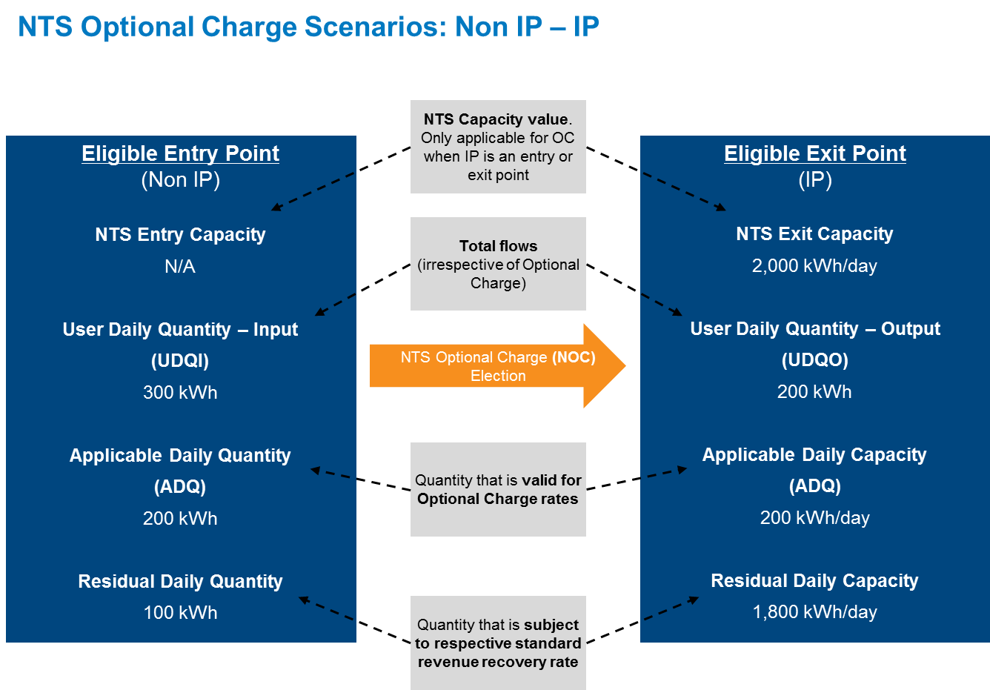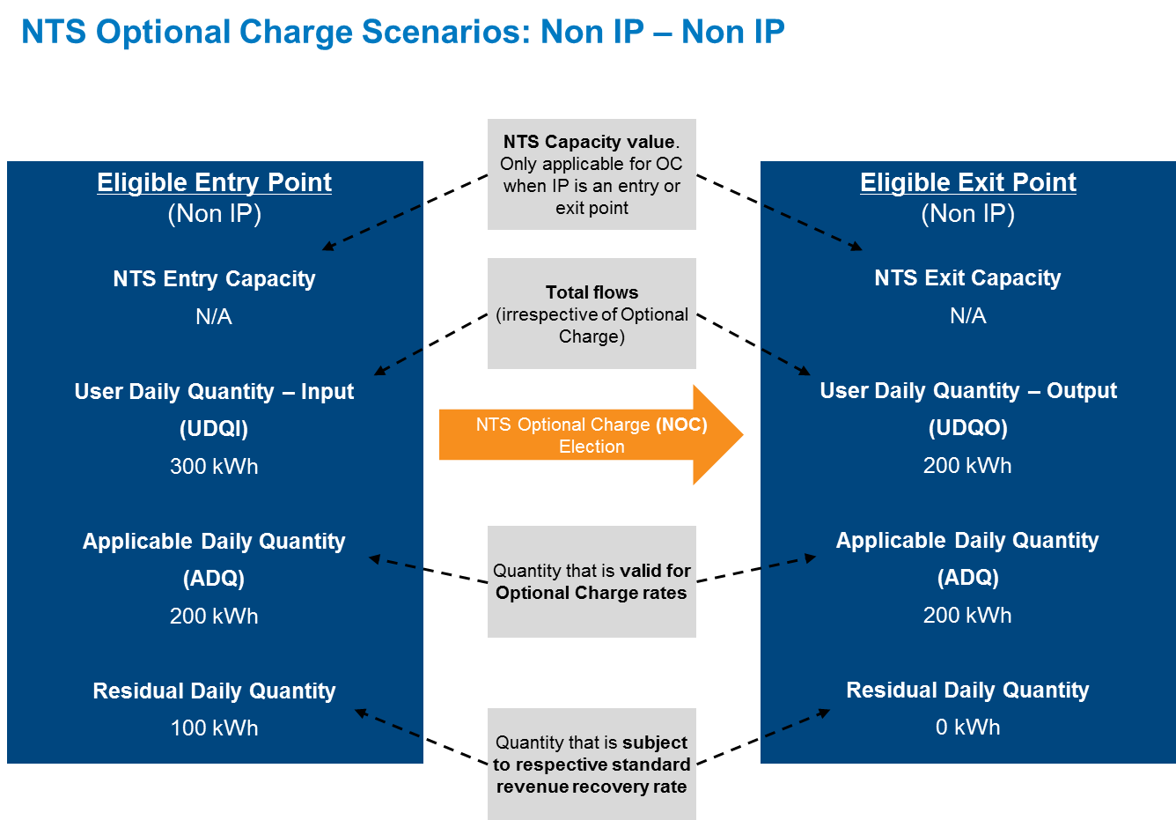

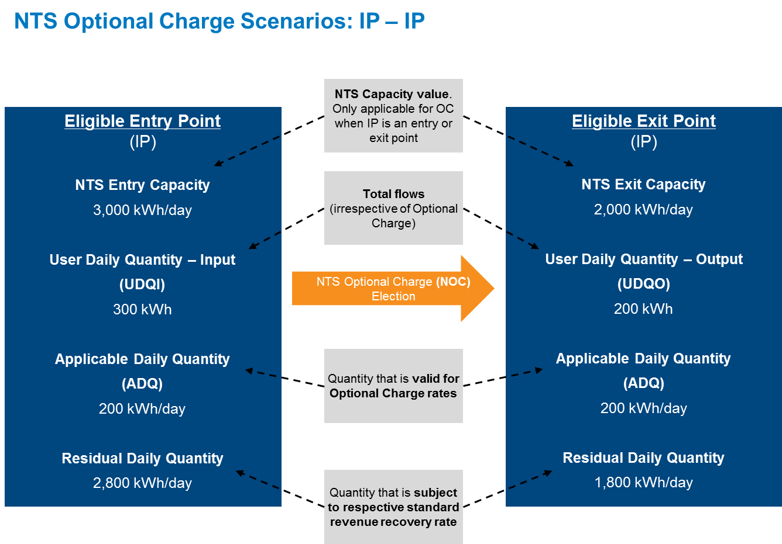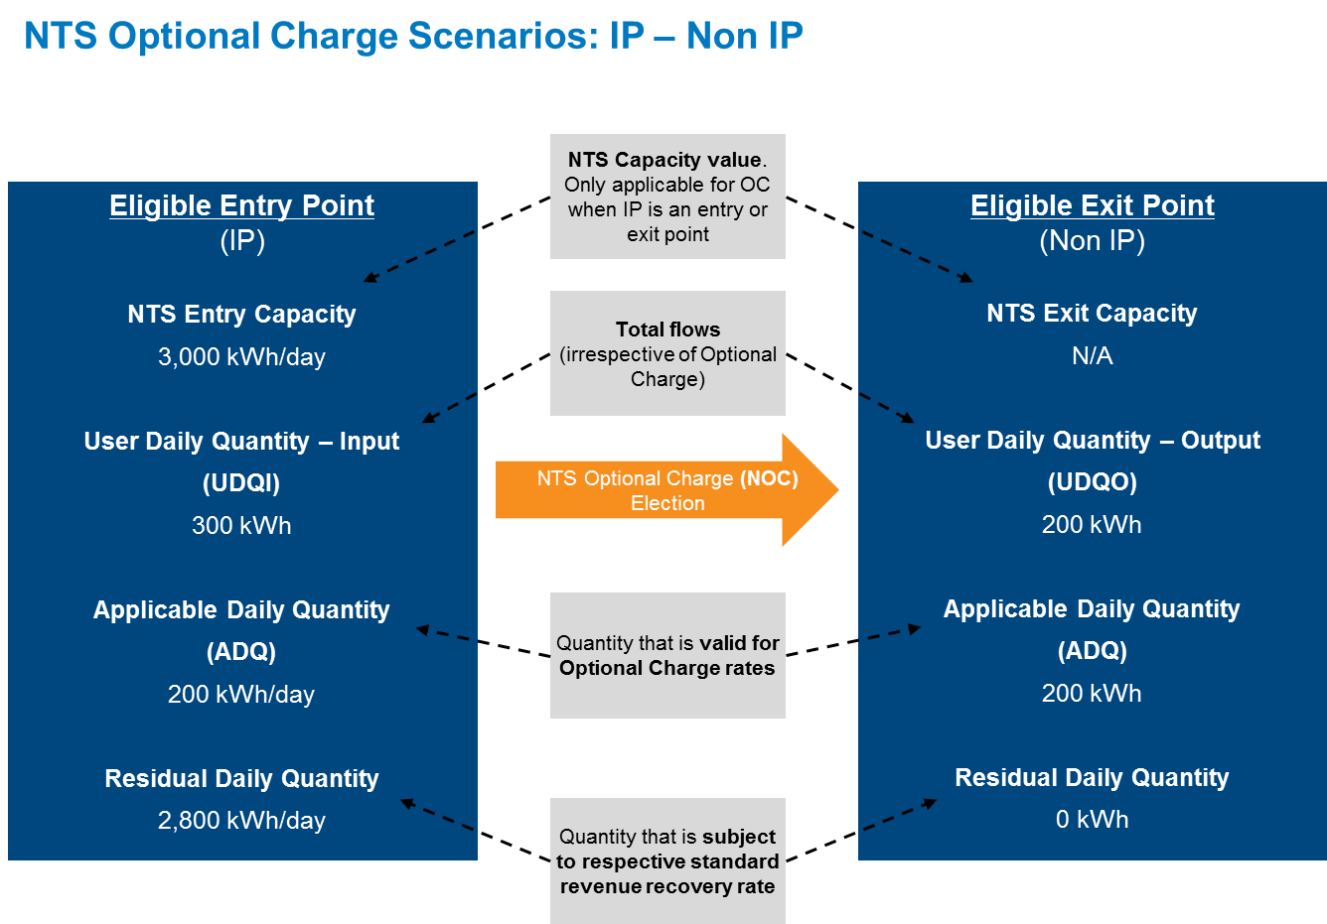

**4.9 Legislative Compliance**

The Workgroup recognised and acknowledged that elements of the Proposal are driven by a need for the GB arrangements to comply with EU Regulation 2017/460. Principle areas of the proposed methodology subject to such compliance issues are:

* the Reference Price Methodology (*Articles 6 to 8*);
* the categorisation of Transmission and Non-Transmission Services (*Article 4*);
* the transition to a capacity based charging regime (*Article 4(3)*); and
* the application and extent of site and capacity product specific discounts (*Articles 9 and 16*).

The broad Workgroup consensus was that the Proposals could be considered compliant with Regulation 2017/460. However specific concerns expressed by one or more individual members of the Workgroup are recorded in the relevant section/s of this impact assessment where there are questions regarding compliance on certain aspects of the proposals across the modifications or to any specific proposal..

It is accepted that there are a number of areas that are open to interpretation where such questions are focused. Some of these questions relate to the netting off of fixed price contracts (Historical Contracts) at certain steps in the capacity calculations and to the proposed method of dealing with zero prices (where they can occur). On these two items:

* Fixed Price contracts. (also see specific paragraphs under section 4.2 on Fixed Prices in the GB regime and EU Commission Regulation 2017/460 (EU Tariff Code)). EU tariff Code makes no prescribed treatment on how any contracts covered under Article 35 should be treated. As previously noted, for GB, it is essential to recognise fixed price contracts (also referred to as Historical or Existing or Interim Contracts across the modifications) as part of the overall methodology to recognise the fixed price applied. The netting of as part of the WAC calculation is necessary (under UNC0621, A, B, C, D, E, F, H, J) so that the charges set via the RPM recovery the required revenue) and to do not calculate prices that will not be applied to some capacity. UNC0621L proposes a slightly different approach for specific reasons outlined in the proposal that will calculate some prices that will not be applied to Historical Contracts. In either approach, this treatment of Historical Contracts is part of the overall RPM. Similar to the calculation step in most of the modifications (noted exclusions in UNC0621B and L) where there is a calculation step to adjust the reference price to cater for anticipated shortfalls from interruptible and storage capacity discounts), this is therefore accounted for as part of the Reference Price methodology.
* Zero Prices. Like with the steps mentioned under Fixed Prices, the treatment of zero prices is catered for as part of the overall RPM. EU Tariff Code arguably did not envisage zero prices as it assumes all capacity that is “priced” has these prices applied. However it would be difficult to envisage the necessary considerations in a generic code to cater for all of the specifics needed to work for GB. For GB, due to either the obligated capacity or the potential capacity (net of Historical Contracts), the WAC could be zero therefore the prices could be zero. In these events capacity may still be bought and it would need a price. To this end a methodology that uses the WAD of points (therefore the gross capacity i.e. does not net off Historical Contract or Fixed Price capacity volumes) to generate a price. This is done as part of the overall methodology and the same approach applied to Entry and Exit/..

Under both these categories it is considered by the proposers that this is therefore treating all points with the same RPM to both entry and exit. The fact there are a number of steps that are followed, ultimately are part of one overall process to determine the reference prices to apply.

This aims to further relevant objective (aa) in that it does not unduly discriminate and takes into account fixed prices and their treatment too. There are some consequences of doing this and any concerns on this and supporting material are noted in the relevant part of this workgroup report.

**4.10 Periodic process to determine Parameters and information publication**

For Multipliers (all set at ‘1’), Interruptible adjustments (10%) and LNG discounts (0%), in all the proposals these values will be in the UNC. Any subsequent changes to these values will require a UNC change.

The reasoning behind this is that the until such time as it is considered necessary or required to review/update these values, changes would be subject to the known UNC Modification process which has solid, transparent, governance process to consider changes to the UNC.

This furthers relevant objective (aa) and (c) whereby it does not unduly discriminate and positively demonstrates competition across all parties. The use of the UNC governance arrangements means that should there be future merit in changing any of these elements proposals can be made through the established and well developed UNC change process.

**4.11 Non-Transmission Services Charges**

Non Transmission Services Revenue is recovered through a number of charges. These are:

(i) St Fergus Compression Charge;

(ii) NTS Meter Maintenance Charges;

(iii) DN Pensions Deficit Charges;

(iv) Shared Supply Meter Point Administration Charge;

(v) Interconnection Point Allocation Charge;

(vi) General Non-Transmission Services Charges.

These charges are not Transmission Services as they are not considered to fall under the definition 4.1 of TAR NC. The charges can be attributed to Transmission or Non Transmission, subject to approval by the NRA (in this case Ofgem). The proposals are that these are treated as Non Transmission Services. This is the same under all the proposals.

The Calculation and application of all the above charges are to be the same as under the current methodology. The General Non Transmission Services Charges (Entry and Exit) are to be calculated in the same manner as the current SO Commodity Charges in that the other charges are forecasted then deducted from the target Non Transmission Services Revenue to derive the amount to be recovered through the General Non Transmission Services Charges (GNTSC).

There is limited change in approach between the current SO charging methodology and the proposed Non-Transmission Services charging methodology. Workgroup participants supported the proposals including the exemption from the General Non Transmission charges under the NTS Optional Charge rules.

**4.12 ‘K’ Principles and adjusting revenues in subsequent years**

‘K’ is the under or over recovery from a previous revenue or formula year (i.e. April to March) that is added to or subtracted from the allowed revenue for the year in which charges are being set. Under the RIIO-T1 price control there is a two year lag, i.e. if K was an under recovery in the formula year 18/19 it would be added to the allowed revenue for the formula year 2020/21. If K was an over recovery it would reduce the allowed revenue. The recovery of any value under ‘K’ will therefore be added or subtracted to the part of the revenue to be recovered in the relevant year. K will continue to be split between Entry and Exit for Transmission Services, like it is in the current Transmission charges. Therefore an over recovery on Exit will reduce Exit charges in a subsequent year but not impact Entry. Likewise Entry will not influence Exit in the same manner.

All the proposals put forward the same approach.

Workgroup participants supported the proposals as they also reflected comments and feedback through the development of the proposals that Entry K values should only influence Entry charges and Exit K values should only influence Exit charges.

The enduring aim of the methodology proposed by all Modifications with the exception of UNC0621B is to recover the majority of Transmission Services Revenue through capacity charges. There is an aspiration to keep the Transmission Services revenue recovery charges as low as possible.

* With the overall changes to the charging framework, the industry feedback was to allow aspects of the methodology to bed in for a period;
* Ultimately a move to 100% capacity requires a forecast or a methodology to produce a forecast of capacity bookings. This would benefit from having data on behavioural changes to capacity bookings, especially with the removal of zero priced capacity and changes to interruptible pricing. National Grid has proposed a two year period for the transition whereby there is a fixed approach for setting the charges (i.e. obligated capacity), then the transition to an enduring approach that will use a forecast of capacity and will, in addition to developing a strawman and method for creating a forecast, also benefit from taking into account the capacity bookings up to that point and the behavioural changes from the new methodology.
* A transition with a specified end point provides certainty of when the changes take effect. Given the aspirations of National Grid’s proposal, in line with the EU Tariffs Code to achieve a majority of Transmission revenue via capacity, this provides a short and predictable path to deliver this objective.

**4.13 SoS and NBP impacts 0621**

Workgroup raised some concerns on this and all expected this to be explored and developed further as part of the Impact Assessment and responses to the Impact Assessment. Some parties have proposed some views for consideration in this workgroup report and these are outlined below.

See section 4.5 for a summary of Storengy Paper concerning Security of Supply and NBP benefits of Mod621A. This highlights the impacts on security of supply and the National Balancing Point (NBP) price and any potential unintended consequences.

Several Workgroup participants requested analysis relating to the impact of Modifications 0621/A/B/C/D/E/F/G/H/J on security of supply. Several Workgroup participants felt that aspects of the changes proposed by National Grid in its Modification 0621 were likely to have effects or consequences which could contribute to an improvement in the security of supply such as….

Others proposed consequences of the proposed changes which were likely to have a detrimental effect on security of supply were suggested, such as increasing charges for onshore storage facilities which may lead to economic decisions to close such facilities. Other consequences were proposed with regard to charges at entry points, in particular St Fergus, where potential charge increases may lead to economic decisions which could affect the viability of the facilities at the entry point, with concomitant effects on those North Sea fields supplying gas to the GB market through such facilities.

Changes to charges at Interconnection Points could also clearly affect the NBP with more liquidity provided where flow to the GB market was favourable compared with other destinations and vice versa.

The Workgroup as whole recognised that any quantified analysis of this nature would not be provided by National Grid and therefore requested that the Regulator to assess this factor in its Regulatory Impact Assessment.

**4.14 Potential consequences**

Outcomes of the methodology all combined for Transmission has some effects that some parties have raised as concerns on aspects of the resulting charges. Some that have been identified are:

* Geographic distribution of prices. Under CWD the geographic distribution plays a part, however it creates more of a level playing field with the ranges of charges between points being narrower than under CWD. In some cases this does mean prices rise from current levels and others fall.
* Prices of points, specifically Exit points that are close to Entry points. Similar to above, for some prices do rise from current levels.
* Whilst the size of the band of prices is narrower under CWD than LRMC, there are some prices that are potentially more significantly higher than others, even if in keeping with the methodology applied. Perhaps more noted in the enduring for Entry (St Fergus).
* Comparisons between the Existing or Historical Contract prices and all others generated under the RPM.

**4.15 Interaction between UNC0621 (incl. A, B, C, D, E, F, H, J, K, L), UNC0636 (incl. A, B, C, D) and UNC0653**

A number of Workgroup participants are concerned about the overlapping and interacting timescales of Modifications UNC 0621 and its alternatives and other Modifications that are in progress, including Modifications UNC 0636/A/B/C/D and UNC 0653.

At the UNC Modification Panel meeting held on 19 April 2018, Ofgem requested that the 0621 Workgroup further consider the interactions between UNC 0621 (incl. A, B, C, D, E, F, G, H, J), UNC 0636 (incl. A, B, C, D) and UNC 0653. The Workgroup also considered the interactions of 0636 with UNC 0621 L and M as these were referred to the Workgroup after the Modification Panel on 19th April.

The Workgroup has considered the interactions and these can be found below:

The main concern with regards to UNC 0621 and its alternatives is that subsequent change to the UNC baseline following a decision on any other Transmission charging related Modification could cause complications and/or delays with regards to the Authority decision on UNC 0621 that is required to enable compliance with the TAR Regulation in EU law. If, for example, UNC 0636 was decided upon after the Final Modification Report (FMR) for UNC 0621 and its Alternatives is submitted, there is no defined process of what changes, if any, to the Modifications/Workgroup Report/FMR that may be required to inform Ofgem in its decision making.

UNC 0621 and its Alternative Modifications propose new NTS Optional Charging arrangements from 01 October 2019. After 30 September 2019 the NTS Optional Commodity Charge ends and is replaced with the NTS Optional Charge (NOC). Most of these Modifications have the same formula structure to the current NTS Optional Commodity Charge with exemptions from Revenue Recovery charges on eligible volumes. UNC 0621C proposes a new approach to managing inefficient bypass through the charging framework (via the use of an Optional Charge), that is materially different in structure to the proposals of UNC0621 and UNC0636 (and the Alternatives).

UNC0636 proposes changes to the NTS Optional Commodity charge prior to 01 October 2019, potentially with effect from 01 October 2018 (a year earlier).

UNC0653 proposes an alternative charging arrangement for the NTS Optional Charge, similar to that proposed in UNC0621C. It is anticipated that UNC0653 may follow the same timeframes as UNC 0636 for consultation and decision, but with a different implementation date of 01 October 2019 (for UNC 0653).

UNC 0621 and UNC 0636 (and the Alternatives) are proposing to change the same part of UNC Section Y, UNC Section B and EID, although to differing degrees, with UNC 0621 proposing a more fundamental change than UNC 0636.

The analysis for UNC 0621 shows the potential impacts comparing to **current** arrangements. It is not possible to show what the changes would be from any of the UNC 0636 Modifications as there has been no decision reached on this proposal at the time of consideration (early May 2018). In the event of a decision to implement one of the UNC 0636 Modifications, this does not change the analysis carried out for UNC 0621 in terms of what the charges would change **to** upon any implementation of UNC0621. It would, however, change the baseline from the UNC (legal text and/or analysis) and charges that it would change **from**, which could mean any proposed change would have to be developed on the new baselined UNC rules (i.e. post UNC 0636, A, B, C, D or UNC 0653 decision).

Given the combinations of options that could be assessed, it is not considered practical to assess these (i.e. all of the five UNC 0636 Modifications each, with all 11 UNC 0621 Modifications). The overall proposals between UNC 0636 and its Alternatives are very different to the overall proposals for UNC 0621 and its Alternatives. It would only be prudent to assess if, or when, UNC 0636 was decided upon (post 0636 consultation). It is recognised that this would be difficult given the major differences between the proposals of UNC 0621 and its alternatives and UNC 0636 and its alternatives and it may not add material value in producing any comparisons.

Some Workgroup participants considered that this could also impact the required ACER consultation required under the Tariff Code depending on the timing of any decision on UNC 0636, but others indicated that this would not be the case as this process is planned for later in the year (following the ‘minded to’ decision by Ofgem).

Similar situations have occurred before notably with the Funding Governance and Ownership and the Nexus changes. If required any changes could potentially be accommodated through the UNC Panel and Modification process as required, subject to Ofgem/UNC Modification Panel views. Options to address this could include:

* Suspend consideration of UNC 0636 or UNC 0621 until a decision has been made on the other proposal;
* Require the Legal text amendments to be updated to reflect the changed baseline then re-submitted without or with little Workgroup development;
* Sending back to Workgroups and follow the UNC change process to update the Workgroup report, including Legal text.

This situation is rare where separate Modifications are proposing to change the same parts of the UNC with different dates for implementation and in particular overlapping consultation periods. The UNC Modification rules do not provide clarity on how to deal with a situation where there are overlapping Modification timetables (including consultation periods and decision timeframes).

The summary of each proposal can be seen through the analysis presented in the respective Workgroup reports and supporting analysis/papers. UNC 0636 can be reviewed independent of UNC 0621. If UNC 0636, A, B, C or D were implemented then it would not change the summaries provided under UNC 0621, A, B C, D, E, F, H, J, K and L). The two Modifications are independent. The only change would be **the baseline it was changing from**. UNC 0636 proposes only changes to the NTS Optional Commodity Charge. UNC 0621 proposes changes to the whole charging framework. Therefore, some Workgroup participants considered that to analyse the differences between current and post UNC 0636 would only present a comparison of one part of the many aspects of UNC 0621 (which is a package of interacting changes).

When comparing UNC 0636 and UNC 0621, at a high level, the NTS Optional Charge aspects, (which is only one part of the UNC 0621 proposals) the following can be noted:

* National Grid has calculated that rates for eligible volumes would generally be lower under UNC 0621 than UNC 0636 except for UNC 0636B and certain Optional Charges under UNC 0636C and UNC 0636D where they will be higher (e.g. where the nominated Entry or Exit point is an Interconnection Point). Some Workgroup participants considered that the proposals and assessment against the relevant objectives for UNC 0621 may need to be reviewed in light of any changes implemented from UNC 0636 as the justification of the proposed changes could be materially different.
* Accessible “routes” would be limited to 60km under UNC 0621 (noting the exception to the different approach under UNC 0621C). This will reduce the eligible quantities compared to all proposals for UNC 0636.
* UNC 0621C cannot be compared in this way given the different method of including the NTS Optional Charge into the overall methodology proposals. It is not a comparable model to UNC 0636 but is very similar to UNC 0653.

|  |
| --- |
| **Workgroup View** |
| Some of Workgroup participants thought that if any of the UNC 0636 proposals were to be implemented this could seriously jeopardise GB’s ability to comply with EU Commission Regulation 2017/460 (also referred to as EU Tariff Code).  A Workgroup participant, highlighted that Modifications 0636 and 0636D were raised to address concerns around compliance with EU Commission Regulation requirements in relation to a single consultation process (with adjacent market parties and regulators). The participant further highlighted, that these proposals would also exclude interconnection points from the effects of changes to the Optional Commodity Charge until the final ACER consultation is complete.  An alternative view was that there were legal interactions between the two Modifications and any issues could be dealt with by Ofgem as part of their decision-making process.  However, some Workgroup participants disagreed with the above view, as Modification UNC0636 is seeking to promote compliance with existing EU Regulations whereas Modification 0621 will be implemented from October 2019 to ensure compliance with EU Commission Regulation 2017/460. |

**4.16 QSEC & AMSEC 2019 Interactions**

All 0621 Modifications have an effective date of 31st May 2019 (or earlier as directed by an Authority decision). The Workgroup highlighted that the QSEC auction (for GB Entry points) is impacted by the Ofgem decision timeline with a final decision expected in [March 19] (and a ‘minded too’ decision expected [October 18]).

QSEC timelines are:

* Preparation of prices - Jan
* Auctions invite - Feb
* Auction period - March (over a max 10 rounds)
* Allocation of capacity – May (could be earlier, but depends on any capacity substitution)

It should also be highlighted that the AMSEC auction is also impacted as this has similar timelines and would affect any monthly capacity purchased from Oct 2019. Workgroup participants discussed how to treat the QSEC 2019. The key issues highlighted were (subject to an Authority decision date):

* Shippers would not have clarity on the capacity offered / purchased in the auction in terms of capacity treatment i.e. (interim – Historic Capacity) or new capacity which has different ‘terms’.

Shippers would not have clarity on the price of the capacity (either fixed or floating).

An unintended consequence of this may be a reluctance of Shippers to buy capacity on a long-term basis through this auction, or it may encourage Shippers to buy increased amounts of capacity, to the possible detriment to other smaller or new entrants in later years.

There was a suggestion that the effective date should be 31 May, but others felt the effective date needed to be introduced well ahead of the QSEC auction. This would ensure clarity over the ‘terms’ of the auction were clear to Shippers wishing to participate in the QSEC.

Another suggestion was to delay the 2019 QSEC auction, however this would need to be considered in detail as this may impact other auction timelines and have unintended consequences.

The Workgroup considered that the timing of Ofgem’s decision is critical to the timeline as detailed and this matter was highlighted to Ofgem.

If an early decision is received from Ofgem before the timeline as described in the UNC above, it would provide clarity for the forthcoming QSEC auction. The Workgroup concluded that if no clear Ofgem decision were forthcoming, it may be necessary to propose a new Modification to clarify what is being bid for as part of the QSEC 2019 auction.

**4.17 DN Impacts**

The four DNs jointly updated Workgroup on 26 April 2018 and again on 02 May 2018. Revisions to the material was submitted on 04 May 2018 and can be found here:

<https://www.gasgovernance.co.uk/0621/Analysis>

DN customer Impacts Summary

Currently Shippers on GDN networks pay NTS exit commodity charges and GDN capacity charges that include recovery of NTS exit capacity charges. The enduring impact from Modification UNC0621 on GDN customers resulting from the removal of NTS exit commodity charges is likely to be a redistribution of charges to those with ‘peakier’ demands from those with less peaky demands.

The reason for this is in the enduring period from October 2021 (or 2022 according to UNC0621E) NTS charges will be recovered by GDNs through capacity charges as NTS exit commodity charges to Shippers will cease, and all NTS exit revenue from customers on GDN networks will be recovered by means of NTS exit capacity charges to GDNs. GDNs in turn recover this from their charges to Shippers and by means of capacity charges.

However in both the transition and enduring periods there will be substantial redistribution of charges between LDZs due to the move to the new NTS charging model, and these changes may swamp the effect described above. In addition to this, GDNs have allowances set in their price control for the NTS exit capacity and are allowed to collect the allowance with any under-recovery being subject to a two year lag. Therefore the long term effect on GDN customer charges is a complex interaction of the effects described above.

There is an obligation on GDNs to *plan and develop* a system to meet the expected demand on a peak day.  GDNs ensure they meet these demands via Exit Capacity[[2]](#footnote-2), Storage and Interruption services.

DN impacts

For DNs as opposed to customers on DN networks the impact is only related to the NTS exit capacity charges because the current NTS exit commodity charges are paid by Shippers.

Therefore DNs will typically see an increase in the charges they receive from NTS as we move into the enduring period as the commodity charges disappear. DNs have allowances in their price control to enable them to recover these costs. Any discrepancy between the allowances and the charges will lead to working capital impacts on DNs as there is currently two year lag between before these differences are reflected in charges. Therefore any errors in NTS forecasts or large k factors will have an impact on DNs. Currently DNs do not experience k factor impacts as these are recovered by means of commodity charges.

DN key concerns

1. Better facilitating the charging objectives.
2. Reducing charging volatility
3. Communication of this change
4. Sufficient assurance around the models and time given to the process
5. Better facilitating the charging objectives.

NTS and GDNs have the same charging objectives. Of particular concern is cost reflectivity. Two key aspects of this are:

* The lack of constraint in the CWD model compared with physical reality.
* The increased proportion of revenue recovered from GDNs due to the assumed basis for Forecast Contract Capacity (FCC) in the enduring period.
* There has been no cost justification for moving from recovering 50% of exit capacity revenue from GDN’s to 80% as proposed in the enduring[[3]](#footnote-3).
* There has been no substantial analysis of whether differing user groups are cross subsidising others (either Geographically or by load type).
* It appears that charges and total revenue level may not be appropriate and proportionate to the stable and long term forecastable DN bookings made.

1. Reducing charging volatility

DNs have seen no evidence to suggest that charges will be less volatile. There are interactions between the publication of prices and forecasts by NTS and the DN price setting process. The timeline for agreeing the methodology used for FCC in the enduring period is a cause for concern. The interaction with the forthcoming price control is of further concern.

1. Communication of this change

Clearly articulating the change to all parties, especially the changes for Scotland and the North and especially to those that have not been engaged with the process is hugely challenging.

1. Sufficient assurance around the models and time given to the process

There is a need for independent assurance and validation to ensure the model calculations reflect the intent set out in the UNC and that the inputs made into that model reflect the underlying data they represent.

**4.18 Independent Assurances on the development of any new Charging Models**

For the calculation of Transmission Services Capacity and Transmission Services Revenue Recovery charges some illustrative models have been developed and shared with industry and form the foundation the analysis presented and referred to in this document. The latest versions of these can be found here:

Independent assurance has been requested to be done. This has only been done to the extent of:

* Developed by National Grid;
* Shared with industry with version history and discussed at industry forums (NTSCMF including sub-workgroups) and UNC0621 workgroup meetings;
* Comments and feedback has been encouraged and received from industry stakeholders to help refine and develop the models;
* Self-contained transparent calculations.

These models are intended to provide sensitivity analysis on the being able to model multiple scenarios and to be illustrative of the potential changes.

At such time as when these models would need to be used in calculating actual charges they will need to undergo an assurance process to provide confidence they are calculating in line with the UNC and any methodology that is approved.

**4.19 Comparisons between the Modifications**

**Summary of comparisons between the modifications on key areas and potential outcomes of the proposals**

The analysis summarised in this section shows:

|  |  |
| --- | --- |
| Area | Detail |
| Entry Combined Revenues | * Sum of Transmission Services Entry Revenue from Calculated Capacity reserve prices and any Transmission Services Entry Revenue Recovery Charges * Shown by Entry category (Beach Terminal, Interconnection Point, Onshore Field, LNG Importation, and Storage * For Transition and Enduring |
| Exit Combined Revenues | * Sum of Transmission Services Exit Revenue from Calculated Capacity reserve prices and any Transmission Services Exit Revenue Recovery Charges * Shown by Exit Category (each GDN area, Industrial, Interconnector, Power Station and Storage). * For Transition and Enduring |
| Under Recovery Amounts | * Anticipated under recovery amounts for each proposal in monetary value * For Transition and Enduring |
| Revenue from Capacity | * Anticipated % from Capacity Reserve price based charges from each modification * Unadjusted (not adjusted for Storage and Interruptible) for Transition and Enduring * Adjusted (adjusted for Storage and Interruptible) for Enduring only |
| Counterfactual comparisons | * Comparison of UNC0621 to Counterfactual (as outlined in comparison table v0.11 * Entry and Exit comparison * Combined Revenues * Under Recovery amounts * Transition and Enduring |

The charts for this analysis are shown in Appendix 2 of this workgroup report.

**Assumptions made**

For Entry Combined Revenues and Exit Combined Revenues the assumptions are:

* These show values for 2017/18 (Current) and each modelled year
* The combined revenue is the calculated as the applicable firm capacity price multiplied by the anticipated booking scenario, minus the existing contract volumes (for entry) plus revenue recovery revenue which is the applicable revenue recovery price multiplied by either; the anticipated capacity bookings (for IPs) or average, daily historical flows (for Non-IPs)
* NOTE: these values enable comparisons between alternates, but since the revenue for existing contracts is excluded, revenues are calculated by point and there is a simplified treatment for the optional charge revenue, the aggregate revenue values should be treated with caution, but the relativities of the values should be consistent.

For Under Recovery Amounts and Revenue from Capacity

* The under recovery shown is the total, IP and Non-IP under recovery for entry and exit. The capacity prices are calculated as per each modification (including any treatment of Historical Fixed Price contracts). Revenues for Historical Fixed Price contracts are included in the overall revenue recovery. These values are extracted directly from each models run outputs prior to any NTS Optional Charge.
* The values cannot be directly linked back to the revenue sheets (referred to in the Entry Combined Revenues and Exit Combined Revenues) but are expected to be a better representation of the under-recovery than could be derived from these values.

For Counterfactual comparisons the assumptions for each graph are as per the Revenues or Under Recovery amounts highlighted above.

**NOTES:**

* For UNC0621C the NTS Optional Charge is a different arrangement to all other proposals and is a capacity discount for any eligible quantities. Whilst not modelled here it is expected that it will, for eligible volumes result in additional under recovery to be recovery through the Transmission Services Revenue Entry and Exit Recovery charges. The amount of additional under recovery will depend on the eligible volumes in excess of Existing Contracts (where applicable) and the nominated route whereby it is possible that there could be a capacity discount on Entry and an increase on Exit or vice versa.
* The summary charts and analysis have been provided at very short notice to the workgroup. The workgroups have discussed variations on similar analysis over the course of developing and discussing the modification proposals. This analysis could only be put together once all the modifications had been finalised (04 May 2018). As such the workgroup has had no time to reflect on these charts and therefore consider if any modifications would be amended.
* Whilst the analysis here is presented based on the final modifications as of 04 May 2018 it is not anticipated that any of the key issues, messages or commentary and opinions in this report would materially impacted.
* Alternative proposals have been developed, raised and amended alongside UNC0621 in the development process.
* Reflections on this and all the data available, either from the Models or Analysis worksheets or UNC0621 or NTSCMF workgroup discussions can be provided as part of the consultation responses and therefore feed into the Final Modification Report (FMR).

**Reference material for models and data**

The data behind the charts in Appendix 2 is available on the Joint Office website:

<https://www.gasgovernance.co.uk/0621/Analysis>

Relevant Objectives

For every Relevant Objective an assessment has been made by the relevant proposer stating whether the impact of the Modification Solution is negative, neutral (“none”) or positive. The text provided by the proposer should explain the Impacts of their Modification. It is not enough for the Proposer to simply state that, for instance, a Modification has a positive impact on competition between shippers (Objective d); a full rationale of specifically how competition is furthered must be demonstrated.

The Workgroup must also provide an assessment against all the Relevant Objectives. Modification 0621 and each Alternative Modification will be assessed against each Relevant Objective in turn to determine if the Workgroup agrees or disagrees that the Modification demonstrates that the Relevant Objectives are furthered as set out in the Modification Proposal(s).

Where this is the case, the Workgroup Report has changed the status to indicate that the Relevant Objective is ‘impacted’. Where the Workgroup has differing views to that proposed in the Modification, the Workgroup Report captures a statement of the summary of the reasons why the Workgroup consider the impact to be different (positive or none or negative).

Where supporting evidence is provided, this has been cross-referenced to the analysis of the impacts against the Relevant Objectives. This approach does not preclude Workgroup 0621 participants from providing additional views and evidence as part of the consultation process.

**Table One - A summary of each Modification and the Proposer’s assessment against each Relevant Objective.**

The table below provides a summary of the Proposer’s assessment against each Relevant Objective. It also includes details of the version of the Modification (and the Relevant Objectives contained within it) which has been considered as part of the Workgroup’s assessment of the Relevant Objectives. Where the Modifications were amended subsequent to Workgroup assessment.

|  |  |  |  |  |  |  |  |  |  |  |  |
| --- | --- | --- | --- | --- | --- | --- | --- | --- | --- | --- | --- |
| **Relevant Objective** | **0621** | **0621A** | **0621B** | **0621C** | **0621D** | **0621E** | **0621F** | **0621H** | **0621J** | **0621K** | **0621L** |
| v4.0 (6/4/2018) | v3.0 (17/3/2018) | V5.0 (4/5/2018) | V5.0 (4/5/2018) | V4.0 (30/4/2018) | V3.0 (4/5/18) | v4.0 (13/4/2018) | V3.0 (4/5/2018) | V3.0 (4/5/2018) | v1.0 (26/4/2018) | V2.0 (4/5/2018) |
| **National Grid** | **Storengy** | **SSE** | **Centrica** | **WWU** | **Uniper** | **IUK** | **ENI** | **RWE** | **Gateway** | **Shell** |
| a) Efficient and economic operation of the pipe-line system. | None | Positive | Positive | Positive | Positive | None | None | None | None | Positive | None |
| b) Coordinated, efficient and economic operation of  (i) the combined pipe-line system, and/ or  (ii) the pipe-line system of one or more other relevant gas transporters. | None | None | None | None | None | None | None | None | None | None | None |
| c) Efficient discharge of the licensee's obligations. | Positive | Positive | Positive | Positive | Positive | Positive | Positive | Positive | Positive | Positive | Positive |
| d) Securing of effective competition:  (i) between relevant shippers;  (ii) between relevant suppliers; and/or  (iii) between DN operators (who have entered into transportation arrangements with other relevant gas transporters) and relevant shippers. | Positive | Positive | Positive | Positive | Positive | Positive | Positive | Positive | Positive | Positive | Positive |
| e) Provision of reasonable economic incentives for relevant suppliers to secure that the domestic customer supply security standards… are satisfied as respects the availability of gas to their domestic customers. | None | None | None | None | None | None | None | None | None | None | None |
| f) Promotion of efficiency in the implementation and administration of the Code. | None | None | None | None | None | None | None | None | None | None | None |
| g) Compliance with the Regulation and any relevant legally binding decisions of the European Commission and/or the Agency for the Co-operation of Energy Regulators. | Positive | Positive | Positive | Positive | Positive | Positive | Positive | Positive | Positive | Positive | Positive |

Workgroup Assessment of Impacts of the modification on the Relevant Objectives.

|  |  |
| --- | --- |
| Impact of the modification on the Relevant Objectives: | |
| **Relevant Objective** | **Identified impact** |
| a) Efficient and economic operation of the pipe-line system. | Positive – 0621A/B/C/D/K |
| b) Coordinated, efficient and economic operation of  (i) the combined pipe-line system, and/ or  (ii) the pipe-line system of one or more other relevant gas transporters. | None |
| c) Efficient discharge of the licensee's obligations. | Positive – All Modifications |
| d) Securing of effective competition:  (i) between relevant shippers;  (ii) between relevant suppliers; and/or  (iii) between DN operators (who have entered into transportation arrangements with other relevant gas transporters) and relevant shippers. | Positive – All Modifications |
| e) Provision of reasonable economic incentives for relevant suppliers to secure that the domestic customer supply security standards… are satisfied as respects the availability of gas to their domestic customers. | None |
| f) Promotion of efficiency in the implementation and administration of the Code. | None |
| g) Compliance with the Regulation and any relevant legally binding decisions of the European Commission and/or the Agency for the Co-operation of Energy Regulators. | Impacted – All Modifications |

1. **Efficient and economic operation of the pipe-line system**

**0621A:** Based on analysis carried out by Storengy and WWA there is a clear relationship between the physical operation of storage facilities and the pipe-line system.[[4]](#footnote-4) The strong, positive correlation between aggregate gas demand and storage withdrawals/injections means that National Grid, in its role as SO, benefits from gas storage, at no cost. The flexibility provided by gas storage provides direct support to National Grid in its role as system balancer through contributing to linepack management and reduced activity and costs associated with National Grid’s participation in the balancing market (OCM) or any other contractual arrangements it may choose to enter into as part of its network balancing toolbox.

The level of discount should be consistent with the contribution to system flexibility (EU Tariff Code) and the proposer of 0621A believes that the application of the minimum 50% discount does not fulfil this requirement. A discount of 50%, according to the EU Tariff Code simply avoids storage users being “double charged” for the use of the system. On this basis, the proposer contends that a discount of 86% not only better reflects the contribution made by storage facilities in relation to the efficient and economic operation of the pipe-line system, but also preserves the ability for gas storage to provide an economic means for balancing the pipeline system. The additional costs imposed on storage users through the application of the minimum 50% discount, and in particular the related significant escalation in the cost of off peak capacity, would result in undesirable market impacts, such as increased between day and within day price volatility. These market impacts conflict with this objective by inflating the costs associated with balancing the system.

**0621B:** The NTS Optional Charge is an important aspect to maintain efficient and economic operation of the pipeline system. Without a suitable NTS Optional Charge product allowing a reduction to Transmission and Non-Transmission charges, one can expect the increased use of private bypass pipelines. For example, a private pipeline of 400m could connect St Fergus to Peterhead. Once built, a private bypass pipeline would allow a shipper to avoid all future Transmission and Non-Transmission charges. The revenue then forgone by National Grid would have to be recovered across a smaller remaining customer base. In general, this would increase costs to some NTS customers and result in a duplicate of pipeline infrastructure - hardly an efficient outcome.

Based on analysis carried out by Storengy and WWA there is a clear relationship between the physical operation of storage facilities and the pipe-line system. The strong, positive correlation between aggregate gas demand and storage withdrawals/injections means that National Grid, in its role as SO, benefits from gas storage, at no cost. The flexibility provided by gas storage provides direct support to National Grid in its role as system balancer through; contributing to linepack management ;and reduced activity and costs associated with National Grid’s participation in the balancing market (OCM) or any other contractual arrangements it may choose to enter into as part of its network balancing toolbox.

The level of discount should be consistent with the contribution to system flexibility (EU Tariff Code) and the proposer believes that the application of the minimum 50% discount does not fulfil this requirement. A discount of 50%, according to the EU Tariff Code simply avoids storage users being “double charged” for the use of the system. On this basis, the proposer contends that a discount of 86% not only better reflects the contribution made by storage facilities in relation to the efficient and economic operation of the pipe-line system, but also preserves the ability for gas storage to provide an economic means for balancing the pipeline system. The additional costs imposed on storage users through the application of the minimum 50% discount, and in particular the related significant escalation in the cost of off peak capacity, would result in undesirable market impacts, such as increased between day and within day price volatility. These market impacts conflict with this objective by inflating the costs associated with balancing the system.

**0621C:** The whole charging package contained in this proposal 0621C has been designed to encourage fair and efficient access to the pipe-line system. The expected more stable and predictable charges compared with what is generated from the current methodology should encourage more stable and predictable use of the system by shippers - something that should in turn help National Grid generate accurate capacity usage forecasts for setting charges in future. The removal of free capacity products is an important aspect of the proposal as is the inclusion of a meaningful and sustainable solution for the Optional Charge (or ‘shorthaul’). Without ‘shorthaul’ there will likely be an increased incentive for the use of some system bypass pipelines because some of the charges being generated by CWD produce counter-intuitive outcomes – high exit charges for large sites located close to entry points (the same argument could be made had the reference price methodology been Postage Stamp.) By improving the predictability of the use of the system, National Grid should be better placed and better prepared to operate it in a more efficient manner. By encouraging efficient use of the system by shippers (e.g. by avoiding inefficient bypass) National Grid will ensure that its operations can be economically optimised so that costs are kept as low as possible on a pence/ kWh flowed basis.

At the same time, this Proposal 0621B recognises that the current level of ‘shorthaul’ discounts applied to Transmission Owner (TO) charging has become distorted in recent years by their structural link to the rising level of TO Commodity charges. The Proposal is therefore designed to promote efficiency and economy in the use of the NTS pipeline system by reducing the level of discounts to a more appropriate level, whilst addressing the underlying structural design of TO ‘shorthaul’ charging methodology and thus providing a robust, enduring basis for dis-incentivising inefficient NTS by-pass.

**0621D:** The amendments in particular the removal of the optional charge will facilitate efficient and economic operation of the pipeline system in compliance with Gas Act section 9.

**0621K:** Based on analysis carried out by Storengy and WWA there is a clear relationship between the physical operation of storage facilities and the pipe-line system.[[5]](#footnote-5) The strong, positive correlation between aggregate gas demand and storage withdrawals and injections means that National Grid, in its role as SO, benefits from gas storage at no cost. The flexibility provided by gas storage provides direct support to National Grid in its role as system balancer through; contributing to linepack management and reduced activity and costs associated with National Grid’s participation in the balancing market (OCM) or any other contractual arrangements it may choose to enter into as part of its network balancing toolbox.

The level of discount should be consistent with the contribution to system flexibility (EU Tariff Code) and the proposer believes that the application of the minimum 50% discount does not fulfil this requirement. A discount of 50%, according to the EU Tariff Code simply avoids storage users being “double charged” for the use of the system. On this basis, the proposer contends that a discount of 86% better reflects the contribution made by storage facilities in relation to the efficient and economic operation of the pipe-line system.

With regards the proposed 100% discount for Off Peak capacity at storage Exit Points, this is justified on the basis that pipeline capacity is constructed and paid for by storage users through the acquisition of Firm Capacity, in particular Entry Capacity. The 86% discount reflects the additional benefits provided by the operation of the storage, however, given that storage Users only inject gas into facilities at times of Off-Peak, any charge for the purchase of this product results in National Grid recovering surplus revenue. Firstly, the capacity costs have been recovered, through revenue collected from firm capacity sales, and that the additional infrastructure can be used on a bi-directional basis, Secondly, access to zero priced interruptible exit capacity has facilitated storage cycling with facilities filling and emptying [on average 3 times] a year. Storage cycling operates counter to capacity demands for which the pipeline system is designed to meet. Storage exits gas from the pipeline system into storage at times of relative low demand (i.e. when there is spare pipeline system capacity) and injects gas back into the network at times of relative high demand (i.e. when there is high demand for pipeline system capacity). This cycling therefore does not utilise network capacity designed to meet peak demand; indeed, it reduces the level of pipeline capacity that is required by other Users and needs to be provided by National Grid.

|  |
| --- |
| Workgroup Statement for standard R.O. a) |
| Some Workgroup participants expressed concerns on the wording from UNC0621K as to the adoption of a 100% discount (UNC0621K exit interruptible) and discrimination issues with storage getting a higher discount for exit off-peak capacity, not made available to other users.  See key issue discussion section 4.4 |

**c) Efficient discharge of the licensee's obligations.**

**0621/0621A/0621B/0621D/0621E/0621F/0621H/0621J/0621K/0621L:**

The proposed changes to TPD B, EID B and Transition Document (where applicable) support the implementation of the new charging methodology and arrangements. Standard Special Condition A5(5) of the NTS Licence sets outs the relevant methodology objectives and Proposers believe that these objectives are better facilitated for the reasons detailed below (‘Impact of the modification on the Relevant Charging Methodology Objectives’).

**0621C:** The proposal will ensure that necessary enhancements and changes are made to the charging methodology holistically, enabling Users to comprehend the implications for the whole suite of gas transmission charging. This is much more preferred and efficient than had the changes been made in a fragmented or incomplete manner.

**0621D:** The proposer believes that the removal of the Optional Charge from October 2019 better facilitates A5(5).

**0621L:** Removing existing contract volumes and revenue prior to calculation of Reference Prices leads to higher reference prices for the remaining unsold capacity. It is proposed to include existing contracts in the calculation to ensure that there is no undue distortion between existing capacity holders and parties purchasing capacity in the future, thus facilitating the Licensee’s obligations by setting the reference price at a level best calculated to avoid undue preference in the supply of transportation services.

Furthermore, including existing contracts in the CWD calculation ensures the share of allowed revenue collected from each entry and exit point is proportionate to its contribution to the costs of the provision of system capacity. Where existing capacity bookings make up approximately 50% of all capacity bookings, including such contracts avoids undue preference in the supply of transportation services by ensuring that transmission services revenue is obtained on an equal basis from all entry and exit points.

|  |
| --- |
| Workgroup Statement c) |
| Workgroup participants identified the following impacts on this relevant objective c) as part of the key issues discussions under the following topics:   * Storage – Specific Capacity Discount (Section 4.5) UNC0621A, B, C, J, K propose a higher discount (86%) on the grounds of cost reflectivity.   Workgroup noted that removing fixed price (Historical) Revenue and contract volumes as prescribed in this report as part of the calculation of reference prices does lead to relatively higher reference prices for the remaining unsold capacity. It is a feature of the GB regime that it has always been possible for there to be a disparity between the price paid by existing capacity holders and parties buying capacity in the future.  In the enduring period this difference is expected to increase notably from moving from Transition into Enduring (where this is a feature of the proposal). Workgroup debated at length whether the size of the difference was appropriate or whether it was undue preference. These issues are highlighted in the following graph:  Whilst existing contracts may have lower charges, they are locked in to paying these prices because they cannot profile their capacity especially once the enduring period begins. Existing capacity is held on quarterly blocks and future bookings cannot be changed, whereas other new capacity bookings can be purchased daily and profiled to meet requirements. This could have an effect on competition.  Some Workgroup participants were of the view that this constituted undue preference whilst others did not agree.  Workgroup participants acknowledged that this is not just a pricing issue and that further analysis is appropriate in this area but the timescales did not allow for this to be robustly assessed, noting there are other issues at play here that are not a feature of the method to calculate Transportation charges.  It is hoped that it will be covered in the Regulatory Impact Assessment to be carried out by Ofgem. |

**d) Securing of effective competition between relevant shippers and between DN operators (who have entered into transportation arrangements with other relevant gas transporters) and relevant shippers (0621D).**

**0621/0621A/0621D/0621E/0621F/0621H/0621K/0621L:** The proposed changes to TPD B, EID B and Transition Document (where applicable) support the implementation of the new charging methodology and arrangements. To the extent that the application of a new Reference Price Methodology is expected to provide a more stable and predictable price setting regime, Shippers will have a greater level of confidence in their forecasts of prospective use of network costs and therefore set their own service costs more accurately (potentially with a lower risk margin) thereby enhancing effective competition.

**0621B:** The proposed changes to TPD B, EID B and Transition Document (where applicable) support the implementation of the new charging methodology and arrangements*.* Charges derived from the Capacity Weighted Distance (CWD) methodology will only be stable and predictable if the FCC (Forecasted Contracted Capacity) values are stable. FCC values based on Obligated capacity, are published in advance in National Grid’s (NG’s) licence and change infrequently, they will be more stable than values based on forecasts derived by National Grid using a methodology that is yet to be defined and exposed to annual change. More predictable and stable charges will facilitate competition because, all else being equal, greater cost certainty will lower risk and will result in lower cost of capital for Shippers which will reduce barriers to entry and facilitate competition. Therefore, a stable Forecasted Contracted Capacity (FCC) based on Obligated baseline values in the licence is expected to improve competition compared with an FCC based on forecasts*.*

**0621C:** The proposal is expected to result in more stable and predictable capacity charges which will be conducive to enhancing competition in gas shipping and gas supply. This is further helped by not applying capacity-based Transmission Services revenue recovery charges to Historical capacity (except for Interim Contracts at Interconnection Points), providing shippers with confidence that once a contract for capacity has been struck it will, as far as legal requirements permit, be honoured. The discount to capacity charges for gas storage has been set to help keep these important facilities economically viable and available to shippers.

Our Optional Charge/ short-haul solution will allow shippers to compete more effectively at proximate offtakes, including power stations, without having to build their own (inefficient) by-pass pipelines. The solution will provide for this during both the transitional and enduring periods.

**0621D:** The removal of the Optional Charge better facilitates competition between Distribution Network (DN) operators and relevant Shippers because it removes a cross subsidy in favour of large gas consumers directly connected to the NTS. This is a considerable disincentive to connect to DN networks.

**0621F:** Additionally, effective competition will be enhanced through the equal charging treatment of storage and physically bi-directional interconnection points. It will remove a market distortion for shippers using continental storage via the interconnectors to meet GB’s seasonal flexibility. It will create more of a level playing field for different sources of seasonal flexibility available to shippers, and ultimately to GB consumers. It increases the choice of shippers when procuring seasonal flexibility - they can consider Continental Storage accessed via physically bi-directional IPs or GB-located storage, without the distortion of differential National Grid charges.

This is particularly relevant to the GB market and GB consumers following the closure of the Rough storage facility. It is widely recognised that the GB market now has a relatively low level of seasonal storage within national boundaries. Improved access to Continental Storage, on a levelized and competitive charging basis, would be a step in the right direction to meet the market’s current structural needs.

**0621H:** This is further helped by not applying capacity-based Transmission Services revenue recovery charges to historical capacity, providing shippers with confidence that once a long-term contract price for capacity has been struck it will be honoured. This proposal will in particular provide the right solution for long-term historical capacity contracts that cannot be utilised.  Such contracts will not be forced to pay any additional charges that were not expected to be paid when these contracts were concluded and when the charging regime and market context were radically different. The implementation of this proposal will ensure the fair treatment of historical capacity holdings in the new regime, avoid a serious distortion of competition and ensure that the market is efficient and certain:

* efficient, because it will allow historical capacity holders to make appropriate contributions towards revenue recovery based on the original contractual arrangements; and
* certain, because it will ensure sanctity of contracts and avoid exposing users to unacceptable levels of unforeseen regulatory risk.

This approach will encourage future long-term capacity bookings because shippers will be more willing to book long-term capacity in the future and, in turn, this will stabilise charges and make them more predictable.

**0621J:** There has been no objective justification for the inclusion of a distance driver in the determination of tariffs for Transmission Services. TAR NC describes CWD but does not require it to be implemented only to serve as a counterfactual.. The GB NTS is a highly meshed pipeline system, with multiple entry and exit points. Shippers book entry capacity and exit capacity independently and nominate flows without specifying specific routes and therefore it is extremely difficult to allocate flows to specific assets. Reference Prices set to recover allowed revenue should not provide undue advantages to any particular set of network users. This will best facilitate efficient use of the network. Where there are differences in the charge faced by similar users there should be a clear reason and an understandable link from those variances to the benefit the user receives. We cannot identify any additional benefits associated with location that justify using anything other than the single cost driver of Capacity as utilised in the Postage Stamp methodology.

Tables 1 and 2 below show the distribution of tariffs set under the Postage Stamp method and CWD. The distribution in the Postage Stamp prices arises from application of an 86% storage discount; for the CWD method the distribution is caused by the inclusion of distance as a cost driver together with a storage discount.

Table 1a: Minimum, Maximum and Weighted Average Reference Prices based on Postage Stamp

|  |  |  |
| --- | --- | --- |
| **POSTAGE STAMP 2019/20** | **Entry (p/kWh/day** | **Exit (p/kWh/day)** |
| Minimum Price | 0.0020 | 0.0016 |
| Maximum price | 0.0142 | 0.0111 |
| Weighted Average Price | 0.0108 | 0.0101 |

Table 1b: Minimum, Maximum and Weighted Average Reference Prices based on CWD

|  |  |  |
| --- | --- | --- |
| **CWD 2019/20** | **Entry (p/kWh/day** | **Exit (p/kWh/day)** |
| Minimum Price | 0.0046 | 0.0043 |
| Maximum price | 0.0243 | 0.0180 |
| Weighted Average Price | 0.0126 | 0.0106 |

Table 2a: Minimum, Maximum and Weighted Average Reference Prices based on Postage Stamp

|  |  |  |
| --- | --- | --- |
| **POSTAGE STAMP 2021/22** | **Entry (p/kWh/day** | **Exit (p/kWh/day)** |
| Minimum Price | 0.0086 | 0.0031 |
| Maximum price | 0.0611 | 0.0220 |
| Weighted Average Price | 0.0597 | 0.0215 |

Table 2b: Minimum, Maximum and Weighted Average Reference Prices based on CWD

|  |  |  |
| --- | --- | --- |
| **CWD 2021/22** | **Entry (p/kWh/day** | **Exit (p/kWh/day)** |
| Minimum Price | 0.0154 | 0.0073 |
| Maximum price | 0.0847 | 0.0352 |
| Weighted Average Price | 0.0597 | 0.0215 |

Table 3: Shows exit points close to an entry point see significant reserve price increases caused by the high average distance.

|  |  |  |  |  |
| --- | --- | --- | --- | --- |
| **Exit Point** | **Average Distance (km)** | **Distance to nearest entry point (km)** | **Current Reserve Price (p/kWh/d)** | **CWD Reserve Price 2019/20 (p/kWh/d)** |
| **Aberdeen** | 611 | 63 | 0.0001 | 0.0164 |
| **St Fergus PS** | 670 | 0 | 0.0001 | 0.0175 |
| **Kinknockie** | 656 | 16 | 0.0001 | 0.0172 |
| **Pembroke PS** | 547 | 7 | 0.0001 | 0.0166 |
| **Upper Neeston Milford Haven Refinery** | 553 | .15 | 0.0001 | 0.0168 |

Table 4 below shows that some exit points relatively far from an entry point have relatively low reserve prices, caused by the low average distance.

|  |  |  |  |  |
| --- | --- | --- | --- | --- |
| **Exit Point** | **Average Distance (km)** | **Distance to nearest entry point (km)** | **Current Reserve Price (p/kWh/d)** | **CWD Reserve Price 2019/20 (p/kWh/d)** |
| **Rugby** | 273 | 141 | 0.0142 | 0.0093 |
| **St Neots PS** | 303 | 156 | 0.0117 | 0.0097 |
| **Stratford-upon-Avon** | 296 | 126 | 0.0172 | 0.0100 |
| **Tur Langton** | 281 | 150 | 0.0118 | 0.0092 |
| **Willington PS** | 306 | 158 | 0.0184 | 0.0098 |

The postage stamp methodology ensures shippers pay same price for the same service across entry and exit, removing distortions that arise as a result of CWD creating artificial and unjustified differences in charges. In turn, this will support effective competition between suppliers and shippers in the gas market and in the wider electricity energy and capacity markets.

**0621L:** By excluding existing contracts from the CWD calculation, the magnitude of the discrepancy between the average price paid for existing capacity holders and the postage stamp price for future capacity bookings, can be seen in the table below. From 2021, at the start of the enduring regime, this marked difference risks distorting competition between shippers as it gives a competitive advantage to shippers holding existing capacity. This distortion could run long in to the future and as late as 2035.

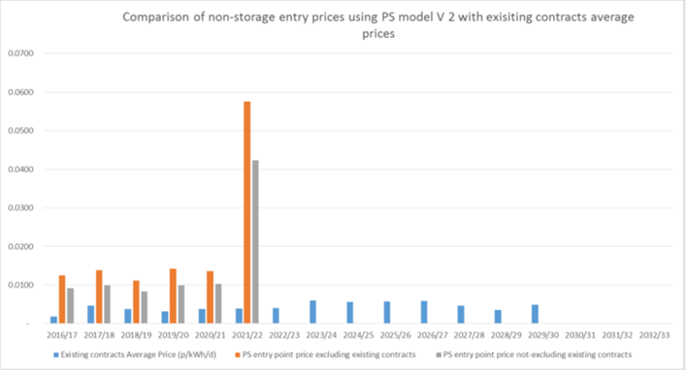

|  |
| --- |
| Workgroup Statement - standard R.O. d) |
| Workgroup participants identified the following impacts on this relevant objective as part of the key issues discussions under the following topics:   * Forecasted Contracted Capacity (Section 4.2) The use of the transition period is justified in order to provide more stable charges and more predictable outcomes. * FCC and Historical Contracts (Section 4.2) The approach preserves the UNC contractual arrangements in place prior to any changes as a result of these Modifications though some highlighted the negative consequence of a larger difference when paying different prices for the same product, particularly in the enduring. * Revenue Recovery in transition period (Section 4.6) The use of the transition period is justified in order to provide more stable charges and more predictable outcomes allowing time for data to be generated to help inform a credible capacity forecast.   Notwithstanding the above, some Workgroup participants still felt there were issues caused by stable charges and predictable outcomes being wholly dependent on stable inputs to the charging model used in the RPM. Some Workgroup participants felt that 0621B achieves better stability as the inputs are known and there is no step change from interim to enduring period.  Whilst existing contracts may have lower charges, they are locked in to paying these prices because they cannot profile their capacity especially once the enduring period begins. Existing capacity is held on quarterly blocks and future bookings cannot be changed, whereas other new capacity bookings can be purchased daily and profiled to meet requirements. This could have an effect on competition. Some Workgroup participants were of the view that this could impact competition whilst others did not agree.  Workgroup participants debated the effect on competition of the expiry of existing contracts.  Workgroup participants noted their significant concern that the forecast for FCC for the enduring period is to be developed at a later date using an as yet unknown methodology, so this question cannot be answered at this stage. Charges from the beginning of the enduring period are essentially unknown at this stage, and will not be known until around 6 months before. This has significant consequences for pricing of contracts in the electricity market capacity mechanism (T-1 or T-4). It was highlighted that an early insight into this forecast would be beneficial and Workgroup noted that this should be monitored under the NTSCMF. |

**g) Compliance with the Regulation and any relevant legally binding decisions of the European Commission and/or the Agency for the Co-operation of Energy Regulators.**

**0621/0621A/0621B/0621D/0621E/0621F/0621H/0621J/0621L/0621K:** The proposed changes to TPD B, EID B and Transition Document (where applicable) support the implementation of the new charging methodology and arrangements including those elements required to comply with the EU Tariff Code.

**0621C:** A key driver for change is the requirement to fully implement the EU Tariff Network Code by 31 May 2019 and this proposal will ensure that the obligation is fulfilled.

**0621E: Longer Transition Period at Exit (2019-2022)**

Under the current charging arrangements, parties can make a reasonable assessment of future gas transportation costs as the structure, nature and trend of charges is generally well understood. In Modification 0621, National Grid Gas has proposed a transition period of 2019-2021, moving from capacity / commodity to full capacity based charges. Although the base capacity prices will differ from now (due to the implementation of the CWD model), the use of a FCC value of 100% of obligated capacity will result in a commodity based revenue recovery charge, like the current arrangements. Analysis conducted during the Modification development process has shown that the move to full capacity based charges will result in significant changes to payable charges for certain points on the network with some large locational shifts in charge levels.

At the time parties participated in the recent Electricity “T-4” Capacity Auction (February 2018), which requires parties to bid four years ahead of electricity capacity delivery, neither the inputs to the CWD model nor the overall structure of the charging regime were finalised, meaning that it was almost impossible for parties to make an accurate assessment of the full capacity based Exit charges that would be payable in 2021. To avoid unfairly penalising parties for commercial decisions made on the best available facts, it is therefore proposed that the transition arrangements at Exit continue until 30 September 2022. This would mean that the existing capacity / commodity arrangements at Exit would effectively continue into the gas year for which the recent T-4 auction applied (2021-22).

In the proposer’s view, this aspect of the proposal would therefore better facilitate Relevant Objective (c) (*That, so far as is consistent with sub-paragraphs (a) and (b), compliance with the charging methodology facilitates effective competition between gas shippers and between gas suppliers*), as it would maintain a “level playing field”, by avoiding imposing unforeseeable costs on Generator Users, which had they been known at the time of the T-4 auction, could have been fully factored into Capacity Market bids. As this was not realistically possible for any party, there is a risk of significant, unavoidable costs being levied which could harm competition between Shippers and ultimately have unintended consequences for both gas and electricity consumers.

**0621E - Specific Proposals:**

**Longer Transition Period at Exit (2019-2022)**

Under the current charging arrangements, parties can make a reasonable assessment of future gas transportation costs as the structure, nature and trend of charges is generally well understood. In Mod 0621, NGG has proposed a charging transition period of 2019-2021, moving from capacity / commodity to full capacity based charges. Although the base capacity prices will differ from now (due to the implementation of the CWD model), the use of a FCC value of 100% of obligated capacity will result in a commodity-based revenue recovery charge, similar to the current arrangements. Analysis conducted during the Mod development process has shown that the move to full capacity based charges will result in significant changes to payable charges for certain points on the network with some large locational shifts in charges. In addition, the key change between “transition” and “enduring” is a shift from “low capacity / high commodity” to “high capacity / low (or zero) commodity”, which particularly impacts flexible but low load factor generation plant - many of which are now contracted in the Electricity Capacity Market for Gas Year 2021-22.

At the time parties participated in the recent Electricity “T-4” Capacity Auction (February 2018), which requires parties to bid four years ahead of electricity capacity delivery (i.e. Gas Year 2021-2022), neither the inputs to the CWD model nor the overall structure of the charging regime were finalised, meaning that it was impossible for parties to make an accurate assessment of the full capacity based Exit charges that would be payable in 2021, based on best available information at the time.

To avoid unfairly penalising parties for decisions made on the best available facts at the time the T-4 auction took place (Feb 2018), it is therefore proposed that the transition arrangements at Exit continue until 30 September 2022. This would mean that the existing capacity / commodity split arrangements at Exit would continue into the gas year for which the recent T-4 auction applied (2021-22) and therefore reduce the potential for unexpected, significant changes to charges. Going forward, parties will be much better informed of likely gas transportation costs so they can be factored into Capacity Market bids appropriately.

In the proposer’s view, this aspect of the proposal would therefore better facilitate Relevant Objective (c) (*That, so far as is consistent with sub-paragraphs (a) and (b), compliance with the charging methodology facilitates effective competition between gas shippers and between gas suppliers*), as it would maintain a “level playing field”, by avoiding imposing reasonably unforeseeable costs on Generator Users, which had they been known at the time of the T-4 auction, could have been fully factored into Capacity Market bids. As this was not realistically possible for any party in February 2018 (due to ongoing Mod development) there is a risk of significant, unavoidable costs being levied which could harm competition between Shippers and ultimately have unintended consequences for both gas and electricity consumers (e.g. if certain Generation plant were to close earlier than previously expected).

**Historical Contracts**

In the proposer’s view, it is necessary to maintain the existing approach of applying a commodity-based revenue recovery charge for revenue recovery purposes to Entry Capacity committed to by Shippers before implementation of these charging reforms in October 2019. Full-capacity based revenue recovery charges for existing contracts, as proposed under NGG’s Mod 0621 would, in the proposer’s view, impose undue costs on Shippers, which could not have reasonably been foreseen at the time the contracts were struck many years ago. Furthermore, such a change would likely have a “chilling” effect on long-term entry capacity bookings as it would create regulatory uncertainty for Shippers about the possible future treatment of such contracts, as NGG’s proposal, if implemented would set a new precedent. Moves between transmission charging models in the past has not resulted in material changes to charges for Entry capacity already booked.

Maintaining a capacity / commodity split for Existing Contracts would ensure fair treatment of all Shippers, incentivising those who can adjust their capacity bookings to reflect flows to do so (e.g. new bookings) but not unduly penalising those who cannot (i.e. existing bookings). Implementation, therefore, could be considered to better facilitate Relevant Objective (c) (“*That, so far as is consistent with sub-paragraphs (a) and (b), compliance with the charging methodology facilitates effective competition between gas shippers and between gas suppliers”*).

**0621F:** Key objectives of the third energy package are to facilitate efficient gas trade and competition across borders. Given that physically bi-directional IPs compete with GB storage and that the unequal treatment distorts cross border trade, the Modification 0621F solution is necessary to ensure GB compliance with:

* Tariffs for access to networks under Regulation (EC) No. 715/2009:

Article 13.1 of *Tariffs for access to networks* in Regulation (EC) 715/2009 which says *“Tariffs, or the methodologies used to calculate them, shall be applied in a non-discriminatory manner.”* And *“Tariffs, or the methodologies used to calculate them shall facilitate efficient gas trade and competition”*

And 13.2 which requires *”Tariffs for network access shall neither restrict market liquidity nor distort trade across borders of different transmission systems”*

* Commission Regulation (EU) 2017/460 (the Tariff Network or TAR Code)

Under Article 7(e), TSOs must ensure that the reference prices do not distort cross-border trade.

It should be noted that a discount for physically bi-directional IPs is entirely consistent with the Tariff Network Code given TSOs can make adjustments to the application of the reference price methodology in accordance with Article 6.4 or Article 9.

Under Article 6.4(a), TSOs can make adjustments to reference prices at any given entry or exit point to meet the competitive level of the reference price.

**0621H:** This proposal also ensures a proper application of article 35 of the EU Tariff Code by providing for Historical Contracts that their capacity price remains unadjusted for the entire duration of the relevant contracts.

|  |
| --- |
| Workgroup Statement |
| Workgroup participants noted that all the proposers state their Modifications are compliant.  Workgroup participants noted that participating organisations may have sought legal advice on compliance but these are unlikely to be shared with the group. Please note that the Workgroup is not qualified to make judgements on the legal compliance. The Workgroup felt that the decision as to whether a Modification is compliant or not must be taken by the Regulator, Ofgem.  The approach taken here is to summarise concerns raised and any further supporting views from the proposers.  Some Workgroup participants have requested clarification from National Grid and all other proposers on legislative compliance of the Modification proposals with reference to the EU Tariff Network Code.  A Workgroup participant provided considerable material which was reviewed by the Workgroup and highlighted the following key points:   * Art. 6.3: The RPM includes existing contracts for exit price calculations but excludes them for entry price calculations. Effectively different FCC values are used for entry and exit price calculations (All Modifications except 0621L) * Art. 6.4: Amending data inputs by netting off existing contracts at entry points is not one of the adjustments allowed. Where there is a zero price the adjustment from zero does not fit with one of those allowed. This is less of an issue for 0621B since this uses Obligated Capacity (All Modifications except 0621L).Art. 7 b) and e) (All Modifications except 0621B and 0621J) From the start of the enduring period there will be more uncertainty in forecast charges due to no definition of how FCC will be set. * Art. 8. A zero value for FCC effectively excludes that part of the network from the CWD calculations so the reference prices do not reflect the network. (All Modifications though less of an issue for 0621B and 0621L) * Art. 8.1 A FCC value of zero effectively eliminates certain combinations of Entry/Exit flows even though flow scenarios between the points are possible. The ‘relevant flow scenarios’ change from transition to enduring period this needs further explanation (All Modifications though less of an issue for 0621B and 0621L) * Art. 13 Multipliers and Seasonal factors and Article 16 Interruptible capacity pricing Note that all the Modifications apply these at points beyond IPs. * Art. 35 Protection for Existing Contracts. This is applied differently in the different Modifications in relation to revenue recovery (see comparison table and key issue section xx).   In response to these points made one workgroup participant provided the following information:   * Art. 6.3 and Art 8 and 8.1 points. The same RPM is proposed at all points. As outlined in the relevant sections on FCC, Fixed Prices and RPM, it is necessary to cater for fixed priced capacity and the proposal has a WAD and WAC approach. The WAD is always gross so includes all capacity so does not exclude parts of the network when determining the WAD. For revenue allocation (under WAC) it does account for the fixed price capacity in a way to set reserve prices to minimise revenue under or over recovery and to not set prices that are not going to be applicable to some capacity volumes. If there were any qualifying Exit contracts these would be treated the same. The fact that there are no Exit Fixed Prices does not mean the methodology is different across Entry and Exit, but that a feature of GB is there are no Exit Fixed prices. Where there is a zero value this is addressed as part of the RPM. The zero value is a potential under the GB regime for obligated capacity and for any forecast it may be the case that no additional capacity may be procured. However as the WAD’s are always gross it will not exclude any part of the network from a WAD perspective only from a revenue allocation perspective. * Art 6.4 point. Accommodating the fixed price contracts is a feature of the RPM and the additional adjustments listed are therefore not used. * Art 13 point. As identified in the relevant sections of this proposal, all modifications propose a treatment beyond just IPs. In these cases it is proposed that this treatment is suitable for GB and it happens to also be compliant with EU Tariff Code. * Art 35 point. EU Tariff Code makes no prescriptive steps on how to treat any revenue or capacity under Article 35. Under the proposals (as described under 4.1, 4.2 and 4.9) charges are being set to recover, as an overall ambition, the majority of the revenue from Transmission Services Capacity Charges). Some have the ambition to set charges such that this is 100% (accepting there will be some need for a revenue recovery charge as outlined in this report). Under UNC0621, A, C, D, E, F, H, J) the proposals are such that without the treatment proposed, charges would not achieve this goal and therefore drive an under recovery as part of the charges being set. UNC0621K will have an under recovery in this respect as outlined in this report Different interpretations of Article 35 are evident across the modifications most notably on the Transmission Services Revenue Recovery charges. All modifications without exception recognise that Fixed Prices are a feature of GB and need to be accommodated in the overall methodology as a feature of the RPM and for any revenue recovery charges such that the fixed price element (which does have some differing interpretations) is honoured.   Other Workgroup participants expressed views that the Modifications were compliant with TAR NC and highlighted the following as further justification:   * Comparison to counterfactual (basic CWD) – see comparison table for comparison to UNC0621 (and alternatives). This justifies aspects of the UNC0621 (and alternatives) proposals to make the CWD methodology work and prevent a massive under recovery. Essentially it is an approach which reflects the significant volume of existing entry capacity contracts. * Existing contracts and Article 35 interpretation (see key issues section xx for further justification for different approaches for different Modifications). |

**Table two - A summary of each Modification and the Proposer’s assessment against each Charging Methodology Relevant Objectives.**

The table below which provides a summary of the Proposer’s assessment against each Charging Methodology Relevant Objective. It also includes details of the version of the Modification (and the Relevant Objectives contained within it) have been considered as part of the Workgroup’s assessment of the Charging Methodology Relevant Objectives.

|  |  |  |  |  |  |  |  |  |  |  |  |
| --- | --- | --- | --- | --- | --- | --- | --- | --- | --- | --- | --- |
| **Relevant Objective** | **0621** | **0621A** | **0621B** | **0621C** | **0621D** | **0621E** | **0621F** | **0621H** | **0621J** | **0621K** | **0621L** |
| v4.0 (6/4/2018) | v3.0 (17/3/2018) | V5.0 (4/5/2018) | V5.0 (4/5/2018) | V4.0 (30/4/2018) | V3.0 (4/5/18) | v4.0 (13/4/2018) | V3.0 (4/5/2018) | V3.0 (4/5/2018) | v1.0 (26/4/2018) | V2.0 (4/5/2018) |
| **National Grid** | **Storengy** | **SSE** | **Centrica** | **WWU** | **Uniper** | **IUK** | **ENI** | **RWE** | **Gateway** | **Shell** |
| a) Save in so far as paragraphs (aa) or (d) apply, that compliance with the charging methodology results in charges which reflect the costs incurred by the licensee in its transportation business; | Positive | Positive | Positive | Positive | Positive | Positive | Positive | Positive | Positive | Positive | Positive |
| aa) That, in so far as prices in respect of transportation arrangements are established by auction, either:  no reserve price is applied, or  that reserve price is set at a level -  (I) best calculated to promote efficiency and avoid undue preference in the supply of transportation services; and  (II) best calculated to promote competition between gas suppliers and between gas shippers; | Positive | Positive | Positive | Positive | Positive | Positive | Positive | Positive | Positive | Positive | Positive |
| b) That, so far as is consistent with sub-paragraph (a), the charging methodology properly takes account of developments in the transportation business; | Positive | Positive | Positive | Positive | Positive | Positive | Positive | Positive | Positive | Positive | Positive |
| c) That, so far as is consistent with sub-paragraphs (a) and (b), compliance with the charging methodology facilitates effective competition between gas shippers and between gas suppliers; and | Positive | Positive | Positive | Positive | Positive | Positive | Positive | Positive | Positive | Positive | Positive |
| d) That the charging methodology reflects any alternative arrangements put in place in accordance with a determination made by the Secretary of State under paragraph 2A(a) of Standard Special Condition A27 (Disposal of Assets). | None | None | None | None | None | None | None | None | None | None | None |
| e) Compliance with the Regulation and any relevant legally binding decisions of the European Commission and/or the Agency for the Co-operation of Energy Regulators. | Positive | Positive | Positive | Positive | Positive | Positive | Positive | Positive | Positive | Positive | Positive |

Workgroup Assessment of Impacts of the modification on the Relevant Charging Methodology Objectives.

|  |  |
| --- | --- |
| Impact of the modification on the Relevant Charging Methodology Objectives: | |
| **Relevant Objective** | **Identified impact** |
| a) Save in so far as paragraphs (aa) or (d) apply, that compliance with the charging methodology results in charges which reflect the costs incurred by the licensee in its transportation business; | Positive – All Modifications |
| aa) That, in so far as prices in respect of transportation arrangements are established by auction, either:   1. no reserve price is applied, or 2. that reserve price is set at a level -   (I) best calculated to promote efficiency and avoid undue preference in the supply of transportation services; and  (II) best calculated to promote competition between gas suppliers and between gas shippers; | Positive – All Modifications |
| b) That, so far as is consistent with sub-paragraph (a), the charging methodology properly takes account of developments in the transportation business; | Positive – All Modifications |
| c) That, so far as is consistent with sub-paragraphs (a) and (b), compliance with the charging methodology facilitates effective competition between gas shippers and between gas suppliers; and | Positive – All Modifications |
| d) That the charging methodology reflects any alternative arrangements put in place in accordance with a determination made by the Secretary of State under paragraph 2A(a) of Standard Special Condition A27 (Disposal of Assets). | None |
| e) Compliance with the Regulation and any relevant legally binding decisions of the European Commission and/or the Agency for the Co-operation of Energy Regulators. | Impacted – All Modifications |

**0621/0621B/0621D/0621E/0621F/0621H/0621J/0621K:**

This modification proposal does not conflict with:

1. *paragraphs 8, 9, 10 and 11 of Standard Condition 4B of the Transporter's Licence; or*
2. *paragraphs 2, 2A and 3 of Standard Special Condition A4 of the Transporter's Licence;*

as the charges will be changed at the required times and to the required notice periods.

1. **Save in so far as paragraphs (aa) or (d) apply, that compliance with the charging methodology results in charges which reflect the costs incurred by the licensee in its transportation business;**

**0621/0621D/0621E/0621H/0621L:** Proposers believe that the proposed utilisation of a new Reference Price Methodology which re-distributes National Grid’s costs on a geographic basis, weighted by capacity will enhance cost reflectivity and competition between gas suppliers and between gas shippers when compared to the current application of a Long Run Marginal Cost Methodology (LRMC). The proposed model is better suited to the current and expected future usage of the NTS and the current model is more suitable for an expanding network requiring an investment based RPM.

A sub-group of the NTS Charging Methodology Forum identified that as the inputs into the LRMC model are varied the resulting price changes are not intuitive and the changes can cause unpredictable results, and the changes to prices can be volatile (link to material). As a result, similar offtake points (in terms of offtake volumes and distances from points of entry) may incur materially different charges. Use of a methodology which delivers more comparable costs would better facilitate these objectives.

**0621A:** Storengy as proposer of 0621A believes that the proposal better reflects the costs incurred by the licensee. In particular, in relation to gas storage the application of an 86% discount combined with the non-application of Revenue Recovery Charges during the transition and enduring phases, better facilitates this objective. The requirement for a minimum 50% discount for storage related capacity in the EU Tariff Code insulates storage users from double charging and nothing more, however, given that storage facilities are embedded in the network and are unable to benefit from Optional Commodity Rates, its application results in a non-equitable allocation of costs.

As set out in the WWA paper (see footnote 8) the fact that flows to and from offtakes located close to storage facilities are cheaper, in terms of transportation costs, than the cost of flowing gas to the same offtakes, but via storage (including a 50% discount), suggests that a 50% discount is not cost reflective. The application of an 86% discount ensures that the costs incurred under these two flow scenarios are equivalent, and that the costs of transporting gas to and from storage are as cost reflective as the costs of transporting gas directly between non-storage entry points and non-storage exit points.

Further, the application of an 86% discount ensures that the benefits, or negative costs which are delivered by storage in terms of investment savings attributable to the transmission owner are to some degree represented in the cost of using storage (see WWA and Storengy reports, footnote 8).

The fact that the benefits of embedded entry points located within DN networks receive discounted DN transportation costs, or even credits, suggests that a discount which is set to singularly remove double charging is inconsistent with the approach taken in other pipeline networks. The additional level of discount provides a mechanism for recognising the benefits afforded by embedded entry points (and exit points) and is in line with the cost reflective charging methodologies approved and employed at the DN level

Finally, in relation to the application of Revenue Recovery Charges, the proposal recommends that no charges are applied to storage in either the transition or the enduring periods (note that Modification 0621 proposes that such charges should be applied to non-Historical Capacity holdings in the enduring period on a capacity top-up basis). Currently, storage flows are exempt from the application of TO Commodity Charges (the mechanism employed to recover revenues not recovered from the sale of capacity products). From 2019, Modification 0621 proposes the continuation of this approach. On the basis that it is accepted that storage flows and indeed storage related capacity bookings should not be double charged then it must be the case that whatever Revenue Recovery Charge mechanism is employed that storage users should be exempt from its application. This approach is consistent with the findings of Ofgem in its Gas Transmission Charging Review (<https://www.ofgem.gov.uk/gas/transmission-networks/gas-transmission-charging-review>) on the basis that flows to and from storage (or capacity booked at an entry to deliver gas to, or an exit point to ultimately offtake from) have already made a contribution to historical cost recovery (see WWA report footnote 8).

**0621B:** The Proposer believes that the proposed utilisation of a new Reference Price Methodology which redistributes National Grid’s costs on a geographic basis, weighted by capacity will enhance this objective compared to the current application of a Long Run Marginal Cost Methodology (LRMC) only when an NTS Optional Charge is employed.

However, there are unintended consequences which affect the distribution of charges to NTS customers and to the end consumer. For example, regardless of which FCC is chosen, the RPM does not demonstrate Cost Reflectivity for Exit points that are physically close to Entry points. This lack of cost reflectivity is a concern given the material impact on these customers. This concern can be partly mitigated by continued use of the NTS Optional Charge. Without an NTS Optional charge the CWD and postage stamp methodologies will not further cost reflectivity compared with the LRMC methodology.

The CWD methodology also generates high charges for exit and entry in the North of GB where there is spare capacity, but has relatively lower charges for exit in the South and South West of GB where there is less spare capacity. This lack of cost reflectivity may result in inefficient investment and customers will incur additional costs because it signals connection where additional investment would be required and dis-incentivises connection where spare capacity exists.

A postage stamp capacity based methodology will not reflect costs either with its uniform charge, irrespective of capacity constraints. Use of a Postage Stamp methodology at this time would be too extreme a departure from the current LRMC given the need for a) an element of locational signal at exit, b) points given current PARCA requests and c) future coal powered generator replacement.

A hybrid CWD methodology which seeks to retain an element of flow based charges will be more cost reflective and have a less distortive effect than a pure capacity based recovery regime which exacerbates the unintended consequences described above and in Relevant Objectives aa) (I) and c).

**0621C:** The Capacity Weighted Distance (CWD) basis for allocating costs and setting reference prices is expected to provide a platform for more stable and predictable capacity reserve prices compared with the current Long Run Marginal Cost methodology. Some shortcomings with the CWD approach have been identified, in particular the production of some relatively high exit capacity prices close to some entry points. However, the inclusion of optional charging (or ‘shorthaul’) arrangements in this 0621C proposal provide a means of correcting such anomalies and provide a more intuitively correct outcome when considering the cost-reflectivity of the charges.

The current Long Run Marginal Cost (LRMC) reference price methodology was designed to provide economic signals on where it would be economic for customers to acquire capacity on the NTS, i.e. it provided locational price signals. This approach was relevant during the period when the network was expected to expand so that informed and efficient network usage would be encouraged. Today, however, expansion of the network is likely to be limited and gas demand has been following a generally downward trend in most recent years. Therefore, an LRMC approach is not best suited to the current usage and requirements of the NTS and will not provide such a relevant, cost-reflective approach to charging as it has in the past.

A new approach to paying for these costs, reflecting how the NTS is now used, is therefore required; a methodology that more fairly distributes costs among the users of the system and that recognises that historical decisions on how the network was developed over many years should not in future unduly dictate how charges are set in future. A Postage Stamp methodology has its appeal – it’s simple and generally equalises entry and exit charges for users. However, a Postage Stamp method could be considered a relatively extreme departure from an LRMC approach and would be a step too far at this point in time because there will remain some additional use of the NTS in future (witness the number of PARCA windows being opened) for which an element of locational price signal would remain relevant and cost-reflective.

A Capacity Weighted Distance (CWD) charging methodology sits somewhere between LRMC and Postage Stamp. It significantly flattens capacity charges across the range of entry points and range of exit points whilst still maintaining a degree of locational price signal. A CWD reference price methodology has therefore been adopted in this 0621C proposal to provide a balanced cost-allocation approach, one which recognises the changing use of the NTS yet one that retains some locational price signals. It is the view of the Proposer of 0621C that CWD provides a more reasonable basis for setting cost-reflective reference prices during this phase of the NTS’ life but it requires and relies on the addition of an Optional Charge (or ‘shorthaul’) solution to make it work.

The inclusion of a workable Optional Charge (or ‘shorthaul’) solution is critical to ensuring the cost-reflectivity of either a CWD or Postage Stamp methodology. Both of these Reference Price Methodologies would produce counter-intuitive capacity charges for some combinations of entry and exit points, e.g. high entry and exit charges when the exit point is in close proximity to the entry point, such as St Fergus and Peterhead power station or Bacton UKCS and the Interconnector UK exit point. It is therefore essential to incorporate a meaningful and enduring Optional Charge solution to resolve such anomalies in order to provide a holistic solution that results in cost-reflective charges. This 0621C Modification proposal provides such a solution with a new Optional Charge approach that is based on the cost allocation principles contained in the CWD reference price methodology. The result is a consistent, holistic solution that works for both the transitional period and, critically, for the enduring period without resort to any artificial restrictions such as ‘shorthaul’distance caps.

The proposed discount for storage facilities should act to equalise the cost of transporting gas from an entry point to an exit point via a storage facility with the cost of transporting the gas directly from the entry point to the exit point. The effect is to remove any spurious transportation cost because gas is temporarily held in storage. This can be likened to storing gas as linepack in the NTS.

**0621F:** By removing double charging of bi-directional IP flows a market distortion will be removed. The solution ensures a level playing field for users of GB storage and seasonal flexibility via physically bi-directional IPs.

**0621H:** The proposed changes to the balance of reserve prices among capacity products of different durations will ensure that a much fairer price is paid by shippers generally compared with the current situation where short-term entry and exit capacity can be readily purchased free of charge. This will help to significantly reduce the situation where parties that choose, or for business reasons are required, to purchase capacity on a long-term basis are disadvantaged and who, because of revenue under-recovery provisions such as has been witnessed with TO commodity charges, end up paying well in excess of their fair share of transmission costs. This rebalancing of charges and fairer allocation of costs is conducive to better promoting competition between gas suppliers and between gas shippers.

**0621J:** Neither CWD nor Postage Stamp are cost reflective as both, by design, are set to recover National Grid’s historical costs rather than setting forward looking charges that aim to signal the marginal cost of providing capacity at different network locations. The Proposer believes that the proposed utilisation of a new Reference Price Methodology which allocates and recovers National Grid’s costs on a uniform basis ensures revenue recovery is fair and proportionate across all users of the network and will enhance competition between gas suppliers and between gas shippers when compared to the current application of a Long Run Marginal Cost Methodology (LRMC). The proposed Postage Stamp model is better suited to the current and expected future usage of the NTS where marginal costs are low or close to zero and entry capacity and exit capacity charges are set to ensure revenue recovery.

**0621K:** Gateway as proposer of 0621K believes that the proposal better reflects the costs incurred by the licensee. In particular, in relation to gas storage the application of an 86% discount combined with the non-application of Revenue Recovery Charges during the transition and enduring phases, better facilitates this objective. The requirement for a minimum 50% discount for storage related capacity in the EU Tariff Code insulates storage users from double charging and nothing more, however, given that storage facilities are embedded in the network and are unable to benefit from Optional Commodity Rates, its application results in a non-equitable allocation of costs, As set out in the WWA paper (see footnote 8) the fact that flows to and from offtakes located close to storage facilities are cheaper, in terms of transportation costs, than the cost of flowing gas to the same offtakes, but via storage (including a 50% discount), suggests that a 50% discount is not cost reflective. The application of an 86% discount ensures that the costs incurred under these two flow scenarios are equivalent, and that the costs of transporting gas to and from storage are as cost reflective as the costs of transporting gas directly between non-storage entry points and non-storage exit points.

Further, the application of an 86% discount ensures that the benefits, or negative costs which are delivered by storage in terms of investment savings attributable to the transmission owner are to some degree represented in the cost of using storage (see WWA and Storengy reports, footnote 8).

The fact that the benefits of embedded entry points located within DN networks receive discounted DN transportation costs, or even credits, suggests that a discount which is set to singularly remove double charging is inconsistent with the approach taken in other pipeline networks. The additional level of discount provides a mechanism for recognising the benefits afforded by embedded entry points (and exit points) and is in line with the cost reflective charging methodologies approved and employed at the DN level

Finally, in relation to the application of Revenue Recovery Charges, the proposal recommends that no charges are applied to storage in either the transition or the enduring periods (note that Modification 0621 proposes that such charges should be applied to non-Historical Capacity holdings in the enduring period on a capacity top-up basis). Currently, storage flows are exempt from the application of TO Commodity Charges (the mechanism employed to recover revenues not recovered from the sale of capacity products). From 2019, Modification 0621 proposes the continuation of this approach. On the basis that it is accepted that storage flows and indeed storage related capacity bookings should not be double charged then it must be the case that whatever Revenue Recovery Charge mechanism is employed that storage users should be exempt from its application. This approach is consistent with the findings of Ofgem in its Gas Transmission Charging Review (<https://www.ofgem.gov.uk/gas/transmission-networks/gas-transmission-charging-review>) on the basis that flows to and from storage (or capacity booked at an entry to deliver gas to, or an exit point to ultimately offtake from) have already made a contribution to historical cost recovery (see WWA report footnote 8).

The 100% discount for Off Peak capacity at storage Exit Points ensures that the cost of providing this capacity is correctly reflected in the product tariff. The combination of the level of revenue recovered via the application of tariffs on frim capacity products for a single pipeline which is used and paid for on a bi-directional basis with the use of this capacity during non-peak demand periods means that the cost of provision for National Grid is zero. In fact, it is argued by WWA and Storengy (see footnote 8) that the existence and symbiotic nature of the relationship between storage flows and aggregate demand results in investment savings for National Grid, which are not recognised in the charging methodology.

**0621L:** Where the distance matrix is an input to the RPM and assuming distance is a cost driver, excluding certain valid routes from the matrix (e.g., Milford Haven and Isle of Grain in the enduring period), changes the Weighted Average Distance of all points and makes the prices less reflective of the network flow scenarios and therefore less cost reflective. As these contracts expire these routes will be reintroduced in to the flow scenarios and the weighted average distance and consequently, price will change as a result of contract expiry. Including existing contracts in the CWD calculation ensures tariffs remain cost reflective and more predictable.

|  |
| --- |
| Workgroup Statement: CHARGING R.O. a) |
| Workgroup discussed at length whether any of the Modification proposals were more cost reflective than the current GB UNC methodology noting that the changes being proposed are driven by revenue allocation, appropriate to a non-expanding network. This is discussed in key issue Section 4.1 and 4.2. (check).  A Workgroup participant provided considerable material which was reviewed by the Workgroup and highlighted the following key points:   * Article 7(b) & (e). If allowed revenue is a proxy for cost incurred then removing part of it by netting off existing contracts is inconsistent with cost reflectivity. Reference prices are high at exit points close to entry points which demonstrates they are not reflective of the cost of using only a small part of the network. (All Modifications).   In response a workgroup participant commented that, as outlined in this report in sections 4.1 and 4.2, the difference is not in the WAD, but the WAC. Therefore it does not remove part of the network but will reduce or remove revenue recovery from new capacity from some parts where fixed price contracts are at such a level that that they exceed any forecast as per the FCC definitions. Cost reflectivity is subjective. Setting charges to under recovery would not be cost reflective in the proposed methodology. Cost reflectivity in a revenue allocation model can be considered the distribution of revenues consistent with the RPM. Where the RPM is CWD or PS, it will take a more average effect and result in comparably higher prices than under LRMC. It should be noted that LRMC can be considered cost reflective as it does have costs as one input. However the LRMC adopted in GB has a number of adjustments that reduce the cost reflectivity either to achieve the Entry/Exit split for Entry and the revenue recovery adjustment for Exit. As such the cost reflectivity is diluted in the LRMC adopted in GB currently. To compare the two approaches is a challenge and each should be considered against what the methodology is aiming to achieve.  Another concern highlighted was the use of the transition and enduring and whether the charges can be considered cost reflective in both periods.  One participant suggested where there is a transition and an enduring there is an ambition to deliver the enduring in a reasonably short timescale. The RPM in each is the same in the transition as in the enduring, recognising some differing treatment for Transmission Services revenue recovery charges. Only the inputs change to account for the need to learn from behavioural changes to inform a capacity forecast. Therefore in commenting on the methodology, these are broadly the same between Transition and Enduring with improved capacity inputs so could be shown as cost reflective in the intent and improved relative to the improved cost drivers (notably of capacity) stepping between transition to enduring.  Other Workgroup participants expressed views that compliance with Art. 35 bring about a question as to how to best accommodate fixed price contracts within the RPM. Different interpretations are reflected and compliance with different articles of the EU Tariff Code can be read as conflicting.  All of the Modifications except UNC0621L have a target revenue net of known revenues in setting the Capacity Reserve Prices. This approach also requires the netting off of the capacity associated with that known revenue in order to produce reserve prices that will be applied to the capacity over which it is to be levied. UNC0621L proposes to calculate prices inclusive of this revenue and capacity, as outlined in its proposal which will result in some prices not being applied to some capacity and any shortfall from this specific treatment is accommodated through the revenue recovery charges. |

**aa) That, in so far as prices in respect of transportation arrangements are established by auction, either:**

**(i) no reserve price is applied, or**

**(ii) that reserve price is set at a level -**

**(I) best calculated to promote efficiency and avoid undue preference in the supply of transportation services; and**

**(II) best calculated to promote competition between gas suppliers and between gas shippers; and**

**0621/0621A/0621D/0621E/0621H/0621K/0621L:**

Proposers believe that the proposed utilisation of a new Reference Price Methodology which re-distributes National Grid’s costs on a geographic basis, weighted by capacity will enhance cost reflectivity and competition between gas suppliers and between gas shippers when compared to the current application of a Long Run Marginal Cost Methodology (LRMC). The proposed model is better suited to the current and expected future usage of the NTS and the current model is more suitable for an expanding network requiring an investment based RPM.

A sub-group of the NTS Charging Methodology Forum identified that as the inputs into the LRMC model are varied the resulting price changes are not intuitive and the changes can cause unpredictable results, and the changes to prices can be volatile (link to material). As a result, similar offtake points (in terms of offtake volumes and distances from points of entry) may incur materially different charges. Use of a methodology which delivers more comparable costs would better facilitate these objectives.

**0621A:** The application of an 86% discount and exemption from Revenue Recovery Charges for storage Users better achieves this objective. Firstly, as described in the Storengy and WWA reports (footnote 8) gas storage provides shippers with access to physical flexibility to manage any physical portfolio imbalances which occur for a variety of reasons. Gas storage is an essential tool for a large number of shippers which contract directly with storage operators, but also provides wider benefits to all shippers as a result of enhanced security of supply and well-understood, significant, positive externalities. These wider benefits dampen price volatility and reduce the likelihood of network constraints, gas deficit issues and cost escalation (see WWA and Storengy reports, footnote 8).

In terms of cost distribution, analysis carried out by WWA and presented at the 28 March Modification 0621 workgroup[[6]](#footnote-6) the impact on charges of applying an 86% discount is marginal. During the transition phase the entry Cxxxx Revenue Recovery Charge CRRC(applied to non-IPs) and the entry capacity top up charge (applied to IPs) does not increase when compared with a 50% discount. At exit, the exit CRRC increases by 0.98% and the IP exit capacity top-up charge increases by 0.54%. In the enduring phase (October 2021) there is no perceptible increase in capacity charges as a result of the increase of the discount from 50% to 86%. On this basis, there is no cross-subsidy between storage and non-storage users, beyond perhaps that as a result of the security of supply and broader societal benefits (externalities) non-storage users are net beneficiaries of the 86% discount.

### 0621B:

### Promoting Efficiency and Economic principles associated with network charging

There are a number of economic principles which are typically associated with the definition of network charges.  These are largely focused on ensuring efficient market outcomes.  First, it is typically argued that network charges should be cost reflective. This means that they should reflect the (forward looking) costs which users impose on the network through a change in their use.  This is important to achieving an economically efficient outcome: if charges are cost reflective, users will internalise the network costs which they cause when making a decision about how to use the network.  This will in turn ensure that overall value chain costs are optimised.

The fact that it is forward looking costs which should be reflected is critically important.  If there is a historical cost which exists, but cannot be changed in any way going forward by different use of the network by shippers, there is no value in terms of economic efficiency in sending a signal to shippers about that cost.  Cost reflectivity should therefore only relate to new costs which would be created in the future or existing costs which can be avoided in the future as a result of a particular change in use.

This argument points to network prices being set according to forward looking marginal costs, as these are the costs incurred or avoided by incremental use.  It has been argued that marginal cost related signals may be less relevant for some networks than others.  This is not supported by economic theory, which suggests it is always relevant to send marginal cost related prices.

However, it is important that marginal cost as a concept is interpreted correctly.  When there is an excess capacity in some locations as a result of reduction in network use over time, then the marginal cost of use may be close to or at zero.  If there is spare capacity everywhere, the marginal cost everywhere may be zero.  At this point, marginal cost based signals look very similar to commoditised flow based/ postage stamp charges. Second, it is obviously important that network companies can recover their allowed revenue.  It is also clear that efficient cost reflective charges, as defined above, may not recover all costs which have been incurred.  Therefore, additional charges are required to recover costs.

It is typically argued that such charges should have as an objective creating minimal changes in behaviour relative to a set of efficient charges.  This is because, as previously established, there is no efficiency related reason to target historical costs at a particular set of users.  By definition, they cannot be “un-incurred” and so there is no point in targeting them at a certain set of users as to do so will change behaviour in a way which reduce efficiency.

### Basis for locational signals

CWD is not a marginal cost based methodology. It is a way of allocating total costs locationally (in this sense it is an average cost approach).  This is clear from the calculation steps involved: entry and exit points are given a weighting dependent on capacity and distance, and then *total allowed revenue* is recovered proportionately to these weights.  There is no separate step of calculating cost reflective charges and then applying additional charges to recover total costs.

The fact that CWD is not based on marginal costs does not necessarily mean it is inappropriate. Empirically, CWD may have desirable properties in the correct conditions such as stability and predictability. However, the absence of a marginal cost basis means the chances of it deviating from a reasonable estimate of “stable” marginal costs is non-trivial.  If it does so, economic theory suggests it will result in inefficient outcomes.  The same can be said for a capacity based Postage Stamp model too where there is not spare capacity everywhere. Therefore, the more revenue collection that is allocated to up front capacity charges, rather than residual commodity charges risks greater distortion, 0621B avoids this.

For example, if CWD happens to allocate significant cost to an entry point where there is spare capacity, this might increase the risk of cheap available gas at that entry point being priced out of the market, to the detriment of customers.  If that entry point were a cross-border point, there is also a good case that the application of CWD could risk distorting efficient inter-state trade (one of the criteria for tariffs set out in NC TAR - the Tariff Network Code).

When comparing against the alternative modifications in an impact assessment, this potential downside of pure capacity CWD and Postage Stamp would need to be assessed against the benefit of an increase in the stability of charges, and a potential reduction in the cost of capital for shippers or reduction in risk premiums charged to customers.

### Basis for revenue recovery

#### Objectives in relation to cost recovery

First, it is important to understand the objective behind the definition of cost recovery charges.

In its GTCR documentation (<https://www.ofgem.gov.uk/gas/transmission-networks/gas-transmission-charging-review>), Ofgem states that “*we do not believe that the current use of non-locational commodity charges, levied for the purposes of managing under- and over-recovery of transmission services revenue should be continued as we do not consider them to be cost reflective in the context of TAR NC as their derivation does not incorporate the required cost drivers”.*

Ofgem states that the approach is “*to move towards a more cost reflective tariff regime”* and interprets TAR NC as meaning that “*transmission tariffs should reflect costs incurred… including all historical network costs”.*  Ofgem appears to believe there can be a cost driver which links network use to these historical costs.

It is interesting to compare this to statements Ofgem has made elsewhere.  In particular, in their Targeted Charging Review (TCR) document in electricity, <https://www.ofgem.gov.uk/system/files/docs/2017/03/tcr-consultation-final-13-march-2017.pdf>

Ofgem states that: “*Cost-reflectivity is less directly relevant for residual charges; however, it is important that residual charges do not unduly distort the signals provided by the forward-looking charges which are intended to be cost-reflective… residual charges do not relate to specific costs that any user imposes*”.

In the TCR debate, Ofgem is similarly clear that cost reflectivity is not a valid objective when considering charges which recover residual revenue.  Instead, Ofgem proposes three different principles for assessing approaches to residual charging: “*reducing distortions, fairness and proportionality and practicality considerations”*. In power, Ofgem has suggested a capacity recovery charge because this minimises the distortions arising from behind the meter generation and embedded vs transmission connected generation. A gas commodity charge arguably achieves these goals for residual revenue recovery, because there are no similar concerns relating to behind the meter gas production or storage.

Ofgem’s TCR position is closer to an approach which economic theory suggests should result in greater efficiency and hence improved overall welfare for GB customers.  There is clearly a risk that charging historical costs to users who then change their behaviour *increases* the overall cost of serving gas to meet GB demand.

#### Capacity or commodity

Ofgem’s position in relation to gas network charges is not entirely consistent with what economic theory might suggest.  From an economic efficiency perspective, a key difference between capacity and commodity prices lies in differences in their ability to be passed through to wholesale prices by shippers, and hence the likelihood of the charges resulting in changes in behaviour which result in inefficiency.

Consider the situation at entry points, and suppose shippers face an additional uniform commodity charge of £X/MWh at entry points which does not reflect forward looking costs but helps to recover allowed revenue.

Each shipper will face the same charge of £X for each MWh of gas they move through the entry point.  Therefore, when considering the price at which they would sell gas at the NBP, each shipper’s cost would be £X higher per MWh than it otherwise would be.  Compared to the situation with no commodity charge at entry, NBP prices should be expected to be £X/MWh higher.  In other words, the entry commodity charge has been 100% passed through to buyers at the NBP.  As a result, there has been no change in the competitive position of any shipper, and there should be no change to the way in which gas is supplied to GB customers**.** If the supply mix was efficient before the charge, it would be as efficient after the charge.

Now contrast this to a capacity price with a uniform incremental element of £Y per unit of contracted capacity to recover revenue.

Having purchased capacity for a year, including this incremental element, the cost of capacity is sunk to a shipper.  They should use the capacity they have purchased whenever the price of gas at the NBP is greater than their cost (or opportunity cost) of gas.  They cannot pass through the cost of £Y to wholesale gas prices.

Profit made selling when the NBP price is greater than their cost will help cover the cost of the capacity charge.  If some shippers do not make enough profit (e.g. because they have higher cost supplies) they will cease to be able to afford the capacity charge and will not purchase capacity.  This will effectively result in the exit of higher cost / lower profit supplies from the GB supply mix.  In other words, because capacity charges cannot be passed straight through to the NBP price, they can change the supply merit order and the way in which demand is satisfied, and could reduce economic efficiency as a result. It is also worth noting that a capacity charge increases risks to shippers compared to a commodity charge, because its recovery is outside their control. Arguably, they are not as well placed to manage this risk as customers, resulting in an increase in the cost of capital charged for its management.

Alternatively, if capacity is purchased on the day of use to reflect incremental need, higher capacity costs arising from the CWD model will feed into the marginal cost of supply and the wholesale NBP price will increase.

The higher capacity charges in Modification 0621 are less efficient than the 0621B charges as illustrated in the examples below:

**Increased costs to customers. Capacity Mechanism**

Risk of capacity substitution means that exit capacity at electricity generators may be purchased in advance. The increased capacity costs at exit will increase fixed costs that are bid into the electricity Capacity Mechanism Auction. Comparing 621 with 621b, post transition, and using Pembroke as an example would result in an increase In cost of 0.0325-0.00184 p/kwh/d which equates to £2.3 /kW based on 96 GWh/day. If this plant were marginal and set the clearing price then, all else being equal, the increase in cost across a typical 50 GW auction volume would be £115m/year charged to and paid by increases to customer bills. There may be a fall in power cost of £0.25 MWh due to the reduction in TO commodity charges of 0.7 p/th. This could reduce power costs by £75 m/yr based on 300 TWh/yr resulting in a net increase in costs to power customers of £40 m/yr.

**Increased costs to customers. More expensive NBP price**

St Fergus will have the most expensive entry capacity charge in a 621 Enduring capacity only regime at 0.0811 p/pkWh/day. St Fergus currently receives gas every day from Norway as shown below.

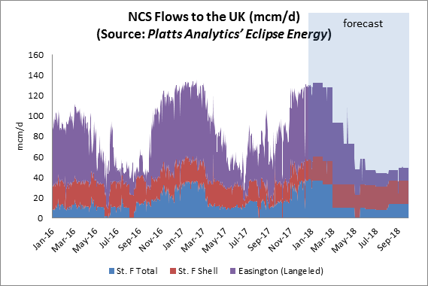

In the future, If flows are incremental and discretionary on the day, then all else being equal, one can expect the marginal capacity cost to feed into the cost of wholesale gas at the NBP.  The difference between 621 and 621B, post transition, including commodity revenue recovery charge is. 0.0811-0.0612 = 0.02 p/kWh/d. Applied to annual gas demand of 900 TWh. [https://www.gov.uk/government/uploads/system/uploads/attachment\_data/file/632523/Chapter\_4.pdf](https://protect-eu.mimecast.com/s/ihGyCpYjMcLZBjHJK9su)

This equals a cost increase of £179m/year to customers.

**Increased costs to customers. More expensive DN capacity charge**

After the Transition period, higher capacity charges for DNs in 0621 compared with 0621B will increase charges to domestic customers. Although this will be offset to a degree by a reduction in flow based revenue recovery charges the higher fixed costs will have a disproportionate effect on low use, vulnerable energy customers.

**0621C:** The proposed changes to the balance of reserve prices among capacity products of different durations will ensure that a much fairer price is paid by shippers generally compared with the current situation where short-term entry and exit capacity can be readily purchased free of charge. This will help to significantly reduce the situation where parties that choose, or for business reasons are required, to purchase capacity on a long-term basis are disadvantaged and who, because of revenue under-recovery provisions such as has been witnessed with TO commodity charges, end up paying well in excess of their fair share of transmission costs. This rebalancing of charges and fairer allocation of costs is conducive to better promoting competition between gas suppliers and between gas shippers.

**0621F:** By removing double charging of bi-directional IP flows a market distortion will be removed. The solution ensures a level playing field for users of GB storage and seasonal flexibility via physically bi-directional IPs.

**0621H:** The proposed changes to the balance of reserve prices among capacity products of different durations will ensure that a much fairer price is paid by shippers generally compared with the current situation where short-term entry and exit capacity can be readily purchased free of charge. This will help to significantly reduce the situation where parties that choose, or for business reasons are required, to purchase capacity on a long-term basis are disadvantaged and who, because of revenue under-recovery provisions such as has been witnessed with TO commodity charges, end up paying well in excess of their fair share of transmission costs. This rebalancing of charges and fairer allocation of costs is conducive to better promoting competition between gas suppliers and between gas shippers.

**0621J:** Neither CWD nor Postage Stamp are cost reflective as both, by design, are set to recover National Grid’s historical costs rather than setting forward looking charges that aim to signal the marginal cost of providing capacity at different network locations. The Proposer believes that the proposed utilisation of a new Reference Price Methodology which allocates and recovers National Grid’s costs on a uniform basis ensures revenue recovery is fair and proportionate across all users of the network and will enhance competition between gas suppliers and between gas shippers when compared to the current application of a Long Run Marginal Cost Methodology (LRMC). The proposed Postage Stamp model is better suited to the current and expected future usage of the NTS where marginal costs are low or close to zero and entry capacity and exit capacity charges are set to ensure revenue recovery.

**0621K:** The application of an 86% discount and exemption from Revenue Recovery Charges for storage users better achieves this objective. Firstly, as described in the Storengy and WWA reports (footnote 8) gas storage provides shippers with access to physical flexibility to manage any physical portfolio imbalances which occur for a variety of reasons. Gas storage is an essential tool for a large number of shippers which contract directly with storage operators, but also provides wider benefits to all shippers as a result of enhanced security of supply and well-understood, significant, positive externalities. These wider benefits dampen price volatility and reduce the likelihood of network constraints, gas deficit issues and cost escalation (see WWA and Storengy reports, footnote 8).

In terms of cost distribution, analysis carried out by WWA and presented at the 28 March Modification 0621 Workgroup[[7]](#footnote-7) the impact on charges of applying an 86% discount is marginal. During the transition phase the entry CRRC (applied to non-IPs) and the entry capacity top up charge (applied to IPs) does not increase when compared with a 50% discount. At exit, the exit CRRC increases by 0.98% and the IP exit capacity top-up charge increases by 0.54%. In the enduring phase (October 2021) there is no perceptible increase in capacity charges as a result of the increase of the discount from 50% to 86%. On this basis, there is no cross-subsidy between storage and non-storage users, beyond perhaps that as a result of the security of supply and broader societal benefits (externalities) non-storage users are net beneficiaries of the 86% discount.

With regards to the proposed 100% discount for Off Peak capacity, as has been previously stated, storage facilities ability to cycle and hence, provide flexible gas will be significantly impacted if this product attracts the proposed charge in Modification 0621. This reduction in availability of flexible gas will add to Suppliers costs, increase price volatility which will ultimately be passed on to consumers, In the extreme, security of supply issues may arise should a supply or demand stress impact the market when storage levels are depleted.

In terms of inter-User costs, the following data has been extracted from the CWD Model v2.2. Assuming an 86% discount, in the enduring regime the average cost per unit of Off Peak capacity is 0.00226 p/kwh (0.066 p/th). The model assumes a level of Off Peak capacity booking for storage Exit Points (and all Exit Points) of @73 GWh/d. At the same time it assumes a total storage Exit Capacity booking of 141 GWh/d (combined firm and interruptible). Historical bookings are 1,379 GWh/d and Obligated levels are 621 GWh/d.

If it is assumed that Historical flows (which feeds the Enduring Exit Capacity booking scenario) is a reasonable proxy for future flows and bookings (albeit it is likely to be conservative in the opinion of the Proposer) then total annual bookings are @52 TWh/yr. With an aggregate storage working gas volume of @14TWh (figure estimated by Storengy & Gateway), this suggests that storage cycle 3 times per year, on average. Again, this is based on historical data and the Proposer expects that the cycling frequency will increase in future. Using the average tariff for Off Peak capacity, with an 86% discount for storage, the overall increased cost burden for storage Users equates to £1.15m per year (assuming that all 52 TWh of Exit Capacity bookings are Off Peak). For reference purposes, the average cost of Off Peak capacity at storage Exit Points, under Mod 621 with a 50% discount , is 0.008 p/kwh/d (0.234 p/th). This generates a total cost burden of £4.1m per year for the same level of Exit Capacity booking as described above.

In summary, a combination of an 86% discount on capacity prices and a 100% discount for Off Peak capacity at storage Exit Points will result in an increased cost to non-storage Users of approx. £1.15m per annum in the enduring regime.[[8]](#footnote-8) This will be recovered via an adjustment to the initial reserve prices.

This small additional cost (noting the overall revenue allowance of £424m) is more than offset by the benefits which accrue to all Users of the operation of storage. Without access to Off Peak capacity with a 100% discount storage facilities will cycle less, which in turn will place upward pressure on gas prices as described previously. The cycling of storage is highly price-sensitive; an Exit Price higher than the current Off-Peak arrangements will limit the ability for storage users to “capture” market spreads and inevitably reduce the amount capacity bookings. As a result the real net impact of a 100% discount on TO Revenue will actually be lower than the figure calculated above

**0621L:** Where the distance matrix is an input to the RPM and assuming distance is a cost driver, excluding certain valid routes from the matrix (e.g., Milford Haven and Isle of Grain in the enduring period), changes the Weighted Average Distance of all points and makes the prices less reflective of the network flow scenarios and therefore less cost reflective. As these contracts expire these routes will be reintroduced in to the flow scenarios and the weighted average distance and consequently, price will change as a result of contract expiry. Including existing contracts in the CWD calculation ensures tariffs remain cost reflective and more predictable.

|  |
| --- |
| Workgroup Statement: CHARGING R.O. aa) |
| Workgroup participants felt … |

1. **That, so far as is consistent with sub-paragraph (a), the charging methodology properly takes account of developments in the transportation business;**

**0621/0621D/0621E/0621F/0621H/0621J/0621L:** The update to the Transmission Services methodology proposal takes into account developments which have taken place in the transportation business, in particular that the network is no longer expanding.

**0621A:** The update to the Transmission Services methodology proposal takes into account developments which have taken place in the transportation business, in particular that the network is no longer expanding. The development of storage assets connected to the transmission grid has also been factored into the WWA analysis presented at the 28 March Workgroup (see footnote 9). Considering the lead time required for the development of such assets, assumptions on storage flows for the modelling of the impact of a discount of 86% on the CRRC capacity top up charges are robust for 5 years, at the very minimum.

**0621B:** The update to the Transmission Services methodology proposal takes into account developments which have taken place in the transportation business. Given the future uncertainty over sources of supply and variable demand on any given day the hybrid approach to CWD charging in 0621B provides an element of forward looking marginal price signals and recovery of allowed revenue for NG on a fair, non-discriminatory basis, where users pay for the benefits they obtain by using the network. The RPI indexation applied to the NTS Optional Charge also furthers this Objective.

**0621C:** From a legal and regulatory perspective, the new methodology will ensure that the requirements of EU network codes can be fully adhered to, thus ensuring that the required transportation developments, especially, at Interconnection Points, are realised. From an operational perspective, the transportation business will need to change to meet changing demand patterns and changing sources of gas supply, presenting it with a challenge for the long-term transportation of gas to consumers and with a need to provide more flexibility to meet more unpredictable within-day changes to supply and demand patterns. The new charging approach under this proposal provides a significantly more balanced suite of capacity purchase options that will lead to more predictable costs for shippers and more appropriate payments in respect of the use of the day to day and within-day use of the system.

**0621D:** The proposer believes that this premise will require National Grid to make changes to its policy on the availability of flexible capacity and its reinforcement policy otherwise there is an inconsistency between a charging methodology that assumes an unconstrained network and polices on flexible capacity and reinforcement that assert that capacity is constrained.

**0621K:** The update to the Transmission Services methodology proposal takes into account developments which have taken place in the transportation business, in particular that the network is no longer expanding. Storage has reduced the need for network expansion and its operation will continue to support the operation on the gas network going forward. The discount package reflects the benefits provided by storage to the transportation business and will limit the requirement for future investment in the network. This is particularly the case if current trends continue, resulting in further demand for system flexibility, as opposed to any growth in peak demand.

1. **That, so far as is consistent with sub-paragraphs (a) and (b), compliance with the charging methodology facilitates effective competition between gas shippers and between gas suppliers**

**0621/0621A/0621D/0621E/0621F/0621H/0621J/0621K/0621L:** Proposers believe that the proposed utilisation of a new Reference Price Methodology which re-distributes National Grid’s costs on a geographic basis, weighted by capacity will enhance cost reflectivity and competition between gas suppliers and between gas shippers when compared to the current application of a Long Run Marginal Cost Methodology (LRMC). The proposed model is better suited to the current and expected future usage of the NTS and the current model is more suitable for an expanding network requiring an investment based RPM.

A sub-group of the NTS Charging Methodology Forum identified that as the inputs into the LRMC model are varied the resulting price changes are not intuitive and the changes can cause unpredictable results, and the changes to prices can be volatile. As a result, similar offtake points (in terms of offtake volumes and distances from points of entry) may incur materially different charges. Use of a methodology which delivers more comparable costs would better facilitate these objectives.

**0621A:** The application of an 86% discount and exemption from Revenue Recovery Charges for storage users better achieves this objective. Firstly, as described in the Storengy and WWA reports (footnote 8) gas storage provides shippers with access to physical flexibility to manage any physical portfolio imbalances which occur for a variety of reasons. Gas storage is an essential tool for a large number of shippers which contract directly with storage operators, but also provides wider benefits to all shippers as a result of enhanced security of supply and well-understood, significant, positive externalities. These wider benefits dampen price volatility and reduce the likelihood of network constraints, gas deficit issues and cost escalation (see WWA and Storengy reports, footnote 8).

In terms of cost distribution, analysis carried out by WWA and presented at the 28 March Modification 0621 Workgroup[[9]](#footnote-9) the impact on charges of applying an 86% discount is marginal. During the transition phase the entry CRRC (applied to non-IPs) and the entry capacity top up charge (applied to IPs) does not increase when compared with a 50% discount. At exit, the exit CRRC increases by 0.98% and the IP exit capacity top-up charge increases by 0.54%. In the enduring phase (October 2021) there is no perceptible increase in capacity charges as a result of the increase of the discount from 50% to 86%. On this basis, there is no cross-subsidy between storage and non-storage users, beyond perhaps that as a result of the security of supply and broader societal benefits (externalities) non-storage users are net beneficiaries of the 86% discount.

**0621B:** To minimise the impact of competitive distortion described above a flow based commodity revenue recovery charge is preferable to high capacity based charges as would be the case in 0621B. Particularly, it avoids reduced supply competition and reduced security of supply due to storage curtailment from increased capacity costs.

Even with an 86 % discount to storage capacity costs and exemption from all enduring revenue recovery charges and non-transmission charges, overall transportation charges will increase for Hornsea and Aldbrough storage assets in 0621 and 0621J, post transition, compared with 0621B, this has 2 impacts:

Ultimately, it is likely that the increased capacity based transportation charges will adversely affect profitability of storage assets.  SSE states in its annual reports that storage has been loss making for the last two years. For gas storage operators it is a question of how long assets can be maintained without the prospect of making economic returns. With the closure of Rough and the decline of UKCS production any further closure of GB storage will reduce competition in supply and adversely impact security of supply.

In the short term, use of on the day bookings of high cost capacity will result in incremental capacity costs being internalised in operational dispatch. This means that gas price will have to rise higher or fall lower before storage operation can become economic. Higher volatility can be expected to lead to higher customer prices because of increased price risk and imbalance penalties for shippers and suppliers. This increased risk will increase the cost of capital for Shippers and will be detrimental for competition by rising barriers to entry.

**Note:** The following text is repeated from relevant objective aa) for efficiency and undue preference. The unintended consequences of a pure capacity charge in the enduring period will also have an impact on competition, relevant objective c).

### Promoting Efficiency and Economic principles associated with network charging

There are a number of economic principles which are typically associated with the definition of network charges.  These are largely focused on ensuring efficient market outcomes.  First, it is typically argued that network charges should be cost reflective. This means that they should reflect the (forward looking) costs which users impose on the network through a change in their use.  This is important to achieving an economically efficient outcome: if charges are cost reflective, users will internalise the network costs which they cause when making a decision about how to use the network.  This will in turn ensure that overall value chain costs are optimised.

The fact that it is forward looking costs which should be reflected is critically important.  If there is a historic cost which exists, but cannot be changed in any way going forward by different use of the network by shippers, there is no value in terms of economic efficiency in sending a signal to shippers about that cost.  Cost reflectivity should therefore only relate to new costs which would be created in the future or existing costs which can be avoided in the future as a result of a particular change in use.

This argument points to network prices being set according to forward looking marginal costs, as these are the costs incurred or avoided by incremental use.  It has been argued that marginal cost related signals may be less relevant for some networks than others.  This is not supported by economic theory, which suggests it is always relevant to send marginal cost related prices.

However, it is important that marginal cost as a concept is interpreted correctly.  When there is an excess capacity in some locations as a result of reduction in network use over time, then the marginal cost of use may be close to or at zero.  If there is spare capacity everywhere, the marginal cost everywhere may be zero.  At this point, marginal cost based signals look very similar to commoditised flow based/ postage stamp charges. Second, it is obviously important that network companies can recover their allowed revenue.  It is also clear that efficient cost reflective charges, as defined above, may not recover all costs which have been incurred.  Therefore, additional charges are required to recover costs.

It is typically argued that such charges should have as an objective creating minimal changes in behaviour relative to a set of efficient charges.  This is because, as previously established, there is no efficiency related reason to target historic costs at a particular set of users.  By definition, they cannot be “un-incurred” and so there is no point in targeting them at a certain set of users as to do so will change behaviour in a way which reduce efficiency.

### Basis for locational signals

CWD is not a marginal cost based methodology. It is a way of allocating total costs locationaly (in this sense it is an average cost approach).  This is clear from the calculation steps involved: entry and exit points are given a weighting dependent on capacity and distance, and then *total allowed revenue* is recovered proportionately to these weights.  There is no separate step of calculating cost reflective charges and then applying additional charges to recover total costs.

The fact that CWD is not based on marginal costs does not necessarily mean it is inappropriate.  Empirically, CWD may have desirable properties in the correct conditions such as stability and predictability. However, the absence of a marginal cost basis means the chances of it deviating from a reasonable estimate of “stable” marginal costs is non-trivial.  If it does so, economic theory suggests it will result in inefficient outcomes.  The same can be said for a capacity based Postage Stamp model too where there is not spare capacity everywhere. Therefore, the more revenue collection that is allocated to up front capacity charges, rather than residual commodity charges risks greater distortion, 621B avoids this.

For example, if CWD happens to allocate significant cost to an entry point where there is spare capacity, this might increase the risk of cheap available gas at that entry point being priced out of the market, to the detriment of customers.  If that entry point was a cross-border point, there is also a good case that the application of CWD could risk distorting efficient inter-state trade (one of the criteria for tariffs set out in NC TAR).

When comparing against the alternative modifications in an impact assessment, this potential downside of pure capacity CWD and Postage Stamp would need to be assessed against the benefit of an increase in the stability of charges, and a potential reduction in the cost of capital for shippers or reduction in risk premiums charged to customers.

### Basis for revenue recovery

#### Objectives in relation to cost recovery

First, it is important to understand the objective behind the definition of cost recovery charges.

In its GTCR documentation, Ofgem states that “*we do not believe that the current use of non-locational commodity charges, levied for the purposes of managing under- and over-recovery of transmission services revenue should be continued as we do not consider them to be cost reflective in the context of TAR NC as their derivation does not incorporate the required cost drivers”.*

Ofgem states that the approach is “*to move towards a more cost reflective tariff regime”* and interprets TAR NC as meaning that “*transmission tariffs should reflect costs incurred… including all historical network costs”.*  Ofgem appears to believe there can be a cost driver which links network use to these historical costs.

It is interesting to compare this to statements Ofgem has made elsewhere.  In particular, in their Targeted Charging Review (TCR) document in electricity, <https://www.ofgem.gov.uk/system/files/docs/2017/03/tcr-consultation-final-13-march-2017.pdf>

Ofgem states that: “*Cost-reflectivity is less directly relevant for residual charges; however, it is important that residual charges do not unduly distort the signals provided by the forward-looking charges which are intended to be cost-reflective… residual charges do not relate to specific costs that any user imposes*”.

In the TCR debate, Ofgem is similarly clear that cost reflectivity is not a valid objective when considering charges which recover residual revenue.  Instead, Ofgem proposes three different principles for assessing approaches to residual charging: “*reducing distortions, fairness and proportionality and practicality considerations”*. In power, Ofgem has suggested that a capacity recovery charge because this minimises the distortions arising from behind the meter generation and embedded vs transmission connected generation. A gas commodity charge arguably achieves these goals for residual revenue recovery, because there are no similar concerns relating to behind the meter gas production or storage.

Ofgem’s TCR position is closer to an approach which economic theory suggests should result in greater efficiency and hence improved overall welfare for GB customers.  There is clearly a risk that charging historic costs to users who then change their behaviour *increases* the overall cost of serving gas to meet GB demand.

#### Capacity or commodity

Ofgem’s position in relation to gas network charges is not entirely consistent with what economic theory might suggest.  From an economic efficiency perspective, a key difference between capacity and commodity prices lies in differences in their ability to be passed through to wholesale prices by shippers, and hence the likelihood of the charges resulting in changes in behaviour which result in inefficiency.

Consider the situation at entry points, and suppose shippers face an additional uniform commodity charge of £X/MWh at entry points which does not reflect forward looking costs but helps to recover allowed revenue.

Each shipper will face the same charge of £X for each MWh of gas they move through the entry point.  Therefore, when considering the price at which they would sell gas at the NBP, each shipper’s cost would be £X higher per MWh than it otherwise would be.  Compared to the situation with no commodity charge at entry, NBP prices should be expected to be £X/MWh higher.  In other words, the entry commodity charge has been 100% passed through to buyers at the NBP.  As a result, there has been no change in the competitive position of any shipper, and there should be no change to the way in which gas is supplied to GB customers**.  If the supply mix was efficient before the charge, it would be as efficient after the charge.**

Now contrast this to a capacity price with a uniform incremental element of £Y per unit of contracted capacity to recover revenue.

Having purchased capacity for a year, including this incremental element, the cost of capacity is sunk to a shipper.  They should use the capacity they have purchased whenever the price of gas at the NBP is greater than their cost (or opportunity cost) of gas.  They cannot pass through the cost of £Y to wholesale gas prices.

Profit made selling when the NBP price is greater than their cost will help cover the cost of the capacity charge.  If some shippers do not make enough profit (e.g. because they have higher cost supplies) they will cease to be able to afford the capacity charge and will not purchase capacity.  This will effectively result in the exit of higher cost / lower profit supplies from the GB supply mix.  In other words, because capacity charges cannot be passed straight through to the NBP price, they can change the supply merit order and the way in which demand is satisfied, and could reduce economic efficiency as a result. It is also worth noting that a capacity charge increases risks to shippers compared to a commodity charge, because its recovery is outside their control. Arguably, they are not as well placed to manage this risk as customers, resulting in an increase in the cost of capital charged for its management.

Alternatively, if capacity is purchased on the day of use to reflect incremental need, higher capacity costs arising from the CWD model will feed into the marginal cost of supply and the wholesale NBP price will increase.

The higher capacity charges in 621 are less efficient than the 621B charges as illustrated in the examples below:

**Increased costs to customers. Capacity Mechanism**

Risk of capacity substitution means that exit capacity at electricity generators may be purchased in advance. The increased capacity costs at exit will increase fixed costs that are bid into the electricity Capacity Mechanism Auction. Comparing 621 with 621b, post transition, and using Pembroke as an example would result in an increase In cost 0.0325-0.00184 p/kwh/d which equates to £2.3 /kW based on 96 GWh/day. If this plant were marginal and set the clearing price then, all else being equal, the increase in cost across a typical 50 GW auction volume would be £115m/year charged to and paid by increases to customer bills. There may be a fall in power cost of £0.25 MWh due to the reduction in TO commodity charges of 0.7 p/th. This could reduce power costs by £75 m/yr based on 300 TWh/yr resulting in a net increase in costs to power customers of £40 m/yr

**Increased costs to customers. More expensive NBP price**

St Fergus will have the most expensive entry capacity charge in a 621 Enduring capacity only regime at 0.0811 p/pkWh/day. St Fergus currently receives gas every day from Norway as shown below.



In the future, If flows are incremental and discretionary on the day, then all else being equal, one can expect the marginal capacity cost to feed into the cost of wholesale gas at the NBP.  The difference between 621 and 621B, post transition, including commodity revenue recovery charge is.0.0811-0.0612) = 0.02 p/kWh/d. Applied to annual gas demand of 900 TWh. [https://www.gov.uk/government/uploads/system/uploads/attachment\_data/file/632523/Chapter\_4.pdf](https://protect-eu.mimecast.com/s/ihGyCpYjMcLZBjHJK9su)

This equals a cost increase of £179m/year to customers.

**Increased costs to customers. More expensive DN capacity charge**

After the Transition period, higher capacity charges for DNs in 621 compared with 621B will increase charges to domestic customers. Although this will be offset to a degree by a reduction in flow based revenue recovery charges the higher fixed costs will have a disproportionate effect on low use, vulnerable energy customers.

**0621C:** The expected greater predictability and stability of charges will help gas shippers to better plan their future deliveries of gas to the market, will lead to less uncertainty for new entrants and generally provide a better basis for promoting competition in gas shipping and gas supply. The proposed discount for storage facilities will help to ensure that these important assets can remain economically viable and provide gas shippers with options for efficiently attracting and delivering gas to the market. The retention of these facilities will also help to encourage competition.

**0621F:** The proposer believes effective competition will be enhanced through the equal charging treatment of storage and physically bi-directional interconnection points. It will remove a market distortion for shippers using continental storage via the interconnectors to meet GB’s seasonal flexibility. It will create more of a level playing field for different sources of seasonal flexibility available to shippers, and ultimately to GB consumers. It increases the choice of shippers when procuring seasonal flexibility - they can consider Continental Storage accessed via physically bi-directional IPs or GB-located storage, without the distortion of differential National Grid charges.

This is particularly relevant to the GB market and GB consumers following the closure of the Rough storage facility. It is widely recognised that the GB market now has a relatively low level of seasonal storage within national boundaries. Improved access to Continental Storage, on a levelized and competitive charging basis, would be a step in the right direction to meet the market’s current structural needs.

**0621H:** Moreover, the expected greater predictability and stability of charges will help gas shippers to better plan their future deliveries of gas to the market, will lead to less uncertainty for new entrants and generally provide a better basis for promoting competition in gas shipping and gas supply.

**0621J:** There has been no objective justification for the inclusion of a distance driver in the determination of tariffs for Transmission Services. TAR NC describes CWD but does not require it to be implemented only to serve as a counterfactual. The GB NTS is a highly meshed pipeline system, with multiple entry and exit points. Shippers book entry capacity and exit capacity independently and nominate flows without specifying specific routes and therefore it is extremely difficult to allocate flows to specific assets. Reference Prices set to recover allowed revenue should not provide undue advantages to any particular set of network users. This will best facilitate efficient use of the network. Where there are differences in the charge faced by similar users there should be a clear reason and an understandable link from those variances to the benefit the user receives. We cannot identify any additional benefits associated with location that justify using anything other than the single cost driver of Capacity as utilised in the Postage Stamp methodology.

Tables 1 and 2 below show the distribution of tariffs set under the Postage Stamp method and CWD. The distribution in the Postage Stamp prices arises from application of an 86% storage discount; for the CWD method the distribution is caused by the inclusion of distance as a cost driver together with a storage discount.

Table 1a: Minimum, Maximum and Weighted Average Reference Prices based on Postage Stamp

|  |  |  |
| --- | --- | --- |
| **POSTAGE STAMP 2019/20** | **Entry (p/kWh/day** | **Exit (p/kWh/day)** |
| Minimum Price | 0.0020 | 0.0016 |
| Maximum price | 0.0142 | 0.0111 |
| Weighted Average Price | 0.0108 | 0.0101 |

Table 1b: Minimum, Maximum and Weighted Average Reference Prices based on CWD

|  |  |  |
| --- | --- | --- |
| **CWD 2019/20** | **Entry (p/kWh/day** | **Exit (p/kWh/day)** |
| Minimum Price | 0.0046 | 0.0043 |
| Maximum price | 0.0243 | 0.0180 |
| Weighted Average Price | 0.0126 | 0.0106 |

Table 2a: Minimum, Maximum and Weighted Average Reference Prices based on Postage Stamp

|  |  |  |
| --- | --- | --- |
| **POSTAGE STAMP 2021/22** | **Entry (p/kWh/day** | **Exit (p/kWh/day)** |
| Minimum Price | 0.0086 | 0.0031 |
| Maximum price | 0.0611 | 0.0220 |
| Weighted Average Price | 0.0597 | 0.0215 |

Table 2b: Minimum, Maximum and Weighted Average Reference Prices based on CWD

|  |  |  |
| --- | --- | --- |
| **CWD 2021/22** | **Entry (p/kWh/day** | **Exit (p/kWh/day)** |
| Minimum Price | 0.0154 | 0.0073 |
| Maximum price | 0.0847 | 0.0352 |
| Weighted Average Price | 0.0597 | 0.0215 |

Table 3: Shows exit points close to an entry point see significant reserve price increases caused by the high average distance.

|  |  |  |  |  |
| --- | --- | --- | --- | --- |
| **Exit Point** | **Average Distance (km)** | **Distance to nearest entry point (km)** | **Current Reserve Price (p/kWh/d)** | **CWD Reserve Price 2019/20 (p/kWh/d)** |
| **Aberdeen** | 611 | 63 | 0.0001 | 0.0164 |
| **St Fergus PS** | 670 | 0 | 0.0001 | 0.0175 |
| **Kinknockie** | 656 | 16 | 0.0001 | 0.0172 |
| **Pembroke PS** | 547 | 7 | 0.0001 | 0.0166 |
| **Upper Neeston Milford Haven Refinery** | 553 | 0.15 | 0.0001 | 0.0168 |

Table 4 below shows that some exit points relatively far from an entry point have relatively low reserve prices, caused by the low average distance.

|  |  |  |  |  |
| --- | --- | --- | --- | --- |
| **Exit Point** | **Average Distance (km)** | **Distance to nearest entry point (km)** | **Current Reserve Price (p/kWh/d)** | **CWD Reserve Price 2019/20 (p/kWh/d)** |
| **Rugby** | 273 | 141 | 0.0142 | 0.0093 |
| **St Neots PS** | 303 | 156 | 0.0117 | 0.0097 |
| **Stratford-upon-Avon** | 296 | 126 | 0.0172 | 0.0100 |
| **Tur Langton** | 281 | 150 | 0.0118 | 0.0092 |
| **Willington PS** | 306 | 158 | 0.0184 | 0.0098 |

The Postage Stamp methodology ensures shippers pay same price for the same service across entry and exit, removing distortions that arise as a result of CWD creating artificial and unjustified differences in charges. In turn, this will support effective competition between suppliers and shippers in the gas market and in the wider electricity energy and capacity markets .

**0621K:** The application of an 86% discount and exemption from Revenue Recovery Charges for storage users better achieves this objective. Firstly, as described in the Storengy and WWA reports (footnote 8) gas storage provides shippers with access to physical flexibility to manage any physical portfolio imbalances which occur for a variety of reasons. Gas storage is an essential tool for a large number of shippers which contract directly with storage operators, but also provides wider benefits to all shippers as a result of enhanced security of supply and well-understood, significant, positive externalities. These wider benefits dampen price volatility and reduce the likelihood of network constraints, gas deficit issues and cost escalation (see WWA and Storengy reports, footnote 8).

In terms of cost distribution, analysis carried out by WWA and presented at the 28 March Modification 0621 Workgroup[[10]](#footnote-10) the impact on charges of applying an 86% discount is marginal. During the transition phase the entry CRRC (applied to non-IPs) and the entry capacity top up charge (applied to IPs) does not increase when compared with a 50% discount. At exit, the exit CRRC increases by 0.98% and the IP exit capacity top-up charge increases by 0.54%. In the enduring phase (October 2021) there is no perceptible increase in capacity charges as a result of the increase of the discount from 50% to 86%. On this basis, there is no cross-subsidy between storage and non-storage users, beyond perhaps that as a result of the security of supply and broader societal benefits (externalities) non-storage users are net beneficiaries of the 86% discount.

With regards to the proposed 100% discount for Off Peak capacity, as has been previously stated, storage facilities ability to cycle and hence, provide flexible gas will be significantly impacted if this product attracts the proposed charge in Modification 0621. This reduction in availability of flexible gas will add to Suppliers costs, increase price volatility which will ultimately be passed on to consumers, In the extreme, security of supply issues may arise should a supply or demand stress impact the market when storage levels are depleted.

In terms of inter-User costs, the following data has been extracted from the CWD Model v2.2. Assuming an 86% discount, in the enduring regime the average cost per unit of Off Peak capacity is 0.00226 p/kwh (0.066 p/th). The model assumes a level of Off Peak capacity booking for storage Exit Points (and all Exit Points) of @73 GWh/d. At the same time it assumes a total storage Exit Capacity booking of 141 GWh/d (combined firm and interruptible). Historical bookings are 1,379 GWh/d and Obligated levels are 621 GWh/d.

If it assumed that Historical flows (which feeds the Enduring Exit Capacity booking scenario) is a reasonable proxy for future flows and bookings (albeit it is likely to be conservative in the opinion of the Proposer) then total annual bookings are @52 TWh/yr. With an aggregate storage working gas volume of @14TWh (figure estimated by Storengy & Gateway), this suggests that storage cycle 3 times per year, on average. Again, this is based on historical data and the Proposer expects that the cycling frequency will increase in future. Using the average tariff for Off Peak capacity, with an 86% discount for storage, the overall increased cost burden for storage Users equates to £1.15m per year (assuming that all 52 TWh of Exit Capacity bookings are Off Peak). For reference purposes, the average cost of Off Peak capacity at storage Exit Points, under Mod 621 with a 50% discount , is 0.008 p/kwh/d (0.234 p/th). This generates a total cost burden of £4.1m per year for the same level of Exit Capacity booking as described above.

In summary, a combination of an 86% discount on capacity prices and a 100% discount for Off Peak capacity at storage Exit Points will result in an increased cost to non-storage Users of approx. £1.15m per annum in the enduring regime.[[11]](#footnote-11) This will be recovered via an adjustment to the initial reserve prices.

This small additional cost (noting the overall revenue allowance of £424m) is more than offset by the benefits which accrue to all Users of the operation of storage. Without access to Off Peak capacity with a 100% discount storage facilities will cycle less, which in turn will place upward pressure on gas prices as described previously. The cycling of storage is highly price-sensitive; an Exit Price higher than the current Off-Peak arrangements will limit the ability for storage users to “capture” market spreads and inevitably reduce the amount capacity bookings. As a result the real net impact of a 100% discount on TO Revenue will actually be lower than the figure calculated above

**0621L:** Where the distance matrix is an input to the RPM and assuming distance is a cost driver, excluding certain valid routes from the matrix (e.g., Milford Haven and Isle of Grain in the enduring period), changes the Weighted Average Distance of all points and makes the prices less reflective of the network flow scenarios and therefore less cost reflective. As these contracts expire these routes will be reintroduced in to the flow scenarios and the weighted average distance and consequently, price will change as a result of contract expiry. Including existing contracts in the CWD calculation ensures tariffs remain cost reflective and more predictable.

**e) Compliance with the Regulation and any relevant legally binding decisions of the European Commission and/or the Agency for the Co-operation of Energy Regulators.**

**0621/0621A/0621D/0621E/0621F/0621J/0621K/0621L:** The EU Tariff Code compliance is taken into account in these Modification proposals. Accordingly, implementation of these Proposals would ensure that the GB arrangements are compliant with the EU Tariff Code.[[12]](#footnote-12)

**0621B:** The proposer of 0621B believes the Modification is fully compliant with the Commission Regulation (EU) 2017/460, of 16 March 2017, establishing a network code on harmonised transmission tariff structures for gas. One area that may benefit from further clarification is Article 4(3), Transmission and non-transmission services and tariffs.

The default position is that the transmission services revenue shall be recovered by capacity based tariffs but “as an exception” and subject to the approval of the national regulatory authority, a part of the transmission service may be recovered by (a) flow based charge; or (b) complementary revenue recovery charge (being identified as “commodity based transmission tariffs”) provided that they meet the requirements contained in Article 4(3)(b), summarised below:

* the complementary revenue recovery charge shall be :

1. Levied for the purpose of managing revenue under recovery.
2. Calculated on the basis of forecasted flows
3. Applied to points other than IPs
4. Applied after the NRA has made an assessment of cost -reflectivity and on cross -subsidisation between IPs and non-IPs.

* To the extent that use of such commodity based transmission tariff is approved there is no time period for which this must apply – i.e. there is nothing that would prohibit long term use of a commodity based transmission tariff and make the 621 proposal more favourable/compliant with the Regulations;

There is a reference to the application of a commodity based transmission tariff being potentially permitted for a part of the transmission services.  Whilst this is a matter of interpretation (“part” could mean the entire part for example) this suggests that a commodity based transmission tariff would be used together with a capacity based transmission tariff, as is the intention of 0621B.

The “exception” for the GB gas market is important because without it customers will be exposed to the increased costs highlighted in the above relevant objectives and to reduced levels of supply and decreased security of supply.

Case for exception for GB (c.f. TAR Article 4(3b))The “exception” for the GB gas market is important because without it customers will be exposed to the increased costs highlighted in the above relevant objectives and to reduced levels of supply and decreased security of supply.

The GB gas transmission system is exceptional in the context of EU Member States in several ways.

The most significant difference is that the system was designed and expanded to meet the peak entry requirements related to UKCS gas production. DUKES 2017 reports that gas production has fallen to “just over a third of the peak level recorded in 2000”. Similarly, exit capacity is generally unconstrained, although scope exists for local or temporary congestion to become an issue in the future (e.g. due to new CCGT investment or outages).

This context of permanent excess capacity presents specific issues for structuring charges in a manner to recover historic costs in the least distortive manner.

For this reason, it is logical to adopt an approach to setting transmission tariffs in GB that is exceptional when compared to other jurisdictions covered by the TAR NC. In particular, it is reasonable to consider the role of commodity charges as permitted by Article 4 (3b). Modification 621B presents a pragmatic compromise – the slightly dampened locational price signal in capacity charges proposed in 621B (relative to 621) reduces the risk of distorting trade between the UK and Norway (as a consequence of punitively high entry charges at St Fergus in particular) whilst preserving a locational signal which might be factored into the next wave of CCGT investment.

Levying a commodity charge is the fairest means to manage revenue under-recovery in this context as it is fairer on domestic customers and can be efficiently passed through to other market participants as an uplift in the gas price or as a marginal increase in the cost of electricity generation (without affecting the merit order of CCGT).

**0621C:** The proposed new charging methodology has been derived by taking account of the various provisions of the EU Tariff network code to ensure compliance with it. It strikes an appropriate balance between those code provisions whilst also ensuring that the transition from the current to the new charging regime can be effected in a way that provides users with some time to adjust to the new charging arrangements before the full suite of enduring provisions come into force. The proposed methodology adequately protects existing contractual rights and obligations, especially in respect of Historical entry capacity contracts as required under Article 35.

**0621F:** Key objectives of the third energy package are to facilitate efficient gas trade and competition across borders. Given that physically bi-directional IPs compete with GB storage and that the unequal treatment distorts cross border trade, the proposer believes the Modification 0621F solution is necessary to ensure GB compliance with:

* Tariffs for access to networks under Regulation (EC) No 715/2009:

Article 13.1 of *Tariffs for access to networks* in Regulation (EC) 715/2009 which says *“Tariffs, or the methodologies used to calculate them, shall be applied in a non-discriminatory manner.”* And *“Tariffs, or the methodologies used to calculate them shall facilitate efficient gas trade and competition”*

And 13.2 which requires *”Tariffs for network access shall neither restrict market liquidity nor distort trade across borders of different transmission systems”*

* Commission Regulation (EU) 2017/460 (the TAR Code)

Under Article 7(e), TSOs must ensure that the reference prices do not distort cross-border trade.

It should be noted that a discount for physically bi-directional IPs is entirely consistent with the TAR Code given TSOs can make adjustments to the application of the reference price methodology in accordance with Article 6.4 or Article 9.

Under Article 6.4(a), TSOs can make adjustments to reference prices at any given entry or exit point to meet the competitive level of the reference price.

**0621H:** The EU Tariff Code full compliance is taken into account in this modification proposal. Accordingly, implementation of this Proposal would ensure that the GB arrangements are compliant with the EU Tariff Code, including a proper application of article 35 thereof, thus adequately protecting existing contractual rights and obligations.

**0621J**: In particular, we believe that implementing Postage Stamp:

1. enables network users to reproduce the calculation of reference prices and

their accurate forecast;

b) takes into account the actual costs incurred for the provision of transmission services considering the level of complexity of the transmission network;

c) ensures non-discrimination and prevents undue cross-subsidisation including by taking into account the cost allocation assessments set out in Article 5;

d) ensures that significant volume risk related particularly to transports across an entry-exit system is not assigned to final customers within that entry-exit system;

**0621L:** TAR NC Article 6.3 stipulates that the same reference price methodology shall be applied to all entry and exit points in a given entry-exit system. Including Existing Contracts for exit reference price calculations and excluding them for entry reference price calculations is inconsistent with this Article and so this proposal to include Existing Contracts for entry and exit reference price calculations ensures changes to the UK charging regime are compliant with NC TAR.

TAR NC Article 6.4 stipulates that adjustments to the application of the reference price methodology to all entry and exit points may only be made as a result of benchmarking, equalisation, rescaling or to account for tariff discounts. Amending data inputs by netting off existing contracts at entry points is not one of the permissible adjustments. By including existing contracts in the CWD calculation, this proposal ensures compliance with the NC TAR.

Moreover, where existing contracts are netted off and the model results in a zero price, using the price from the nearest point, which in the case of entry points can be a considerable distance, represents an adjustment to the application of the reference price, which is not in accordance with this Article. Including existing contracts in the FCC and RPM resolves these issues and ensures the proposal is NC TAR compliant.

TAR NC Article 7(b) & (e) states that he reference price methodology shall comply with Article 13 of Regulation (EC) No 715/2009 and…shall aim at: b) taking into account the actual costs incurred for the provision of transmission services considering the level of complexity of the transmission network. By including existing contracts in the RPM and FCC, reference prices will reflect costs incurred.

|  |
| --- |
| Workgroup Statement – Charging Relevant Objective e)  (note this is the same as for Standard Relevant Objective g)) |
| Workgroup participants noted that all the proposers state their Modifications are compliant.  Workgroup participants noted that participating organisations may have sought legal advice on compliance but these are unlikely to be shared with the group. Please note that the Workgroup is not qualified to make judgements on the legal compliance. The Workgroup felt that the decision as to whether a Modification is compliant or not must be taken by the Regulator, Ofgem.  The approach taken here is to summarise concerns raised and any further supporting views from the proposers.  Some Workgroup participants have requested clarification from National Grid and all other proposers on legislative compliance of the Modification proposals with reference to the EU Tariff Network Code.  A Workgroup participant provided considerable material which was reviewed by the Workgroup and highlighted the following key points:   * Art. 6.3: The RPM includes existing contracts for exit price calculations but excludes them for entry price calculations. Effectively different FCC values are used for entry and exit price calculations (All Modifications except 0621L) * Art. 6.4: Amending data inputs by netting off existing contracts at entry points is not one of the adjustments allowed. Where there is a zero price the adjustment from zero does not fit with one of those allowed. This is less of an issue for 0621B since this uses Obligated Capacity (All Modifications except 0621L).Art. 7 b) and e) (All Modifications except 0621B and 0621J) From the start of the enduring period there will be more uncertainty in forecast charges due to no definition of how FCC will be set. * Art. 8. A zero value for FCC effectively excludes that part of the network from the CWD calculations so the reference prices do not reflect the network. (All Modifications though less of an issue for 0621B and 0621L) * Art. 8.1 A FCC value of zero effectively eliminates certain combinations of Entry/Exit flows even though flow scenarios between the points are possible. The ‘relevant flow scenarios’ change from transition to enduring period this needs further explanation (All Modifications though less of an issue for 0621B and 0621L) * Art. 13 Multipliers and Seasonal factors and Article 16 Interruptible capacity pricing Note that all the Modifications apply these at points beyond IPs. * Art. 35 Protection for Existing Contracts. This is applied differently in the different Modifications in relation to revenue recovery (see comparison table and key issue section xx).   In response to these points made one workgroup participant provided the following information:   * Art. 6.3 and Art 8 and 8.1 points. The same RPM is proposed at all points. As outlined in the relevant sections on FCC, Fixed Prices and RPM, it is necessary to cater for fixed priced capacity and the proposal has a WAD and WAC approach. The WAD is always gross so includes all capacity so does not exclude parts of the network when determining the WAD. For revenue allocation (under WAC) it does account for the fixed price capacity in a way to set reserve prices to minimise revenue under or over recovery and to not set prices that are not going to be applicable to some capacity volumes. If there were any qualifying Exit contracts these would be treated the same. The fact that there are no Exit Fixed Prices does not mean the methodology is different across Entry and Exit, but that a feature of GB is there are no Exit Fixed prices. Where there is a zero value this is addressed as part of the RPM. The zero value is a potential under the GB regime for obligated capacity and for any forecast it may be the case that no additional capacity may be procured. However as the WAD’s are always gross it will not exclude any part of the network from a WAD perspective only from a revenue allocation perspective. * Art 6.4 point. Accommodating the fixed price contracts is a feature of the RPM and the additional adjustments listed are therefore not used. * Art 13 point. As identified in the relevant sections of this proposal, all modifications propose a treatment beyond just IPs. In these cases it is proposed that this treatment is suitable for GB and it happens to also be compliant with EU Tariff Code. * Art 35 point. EU Tariff Code makes no prescriptive steps on how to treat any revenue or capacity under Article 35. Under the proposals (as described under 4.1, 4.2 and 4.9) charges are being set to recover, as an overall ambition, the majority of the revenue from Transmission Services Capacity Charges). Some have the ambition to set charges such that this is 100% (accepting there will be some need for a revenue recovery charge as outlined in this report). Under UNC0621, A, C, D, E, F, H, J) the proposals are such that without the treatment proposed, charges would not achieve this goal and therefore drive an under recovery as part of the charges being set. UNC0621K will have an under recovery in this respect as outlined in this report Different interpretations of Article 35 are evident across the modifications most notably on the Transmission Services Revenue Recovery charges. All modifications without exception recognise that Fixed Prices are a feature of GB and need to be accommodated in the overall methodology as a feature of the RPM and for any revenue recovery charges such that the fixed price element (which does have some differing interpretations) is honoured.   Other Workgroup participants expressed views that the Modifications were compliant with TAR NC and highlighted the following as further justification:   * Comparison to counterfactual (basic CDW) – see comparison table for comparison to UNC0621 (and alternatives). This justifies aspects of the UNC0621 (and alternatives) proposals to make the CWD methodology work and prevent a massive under recovery. Essentially it is an approach which reflects the significant volume of existing entry capacity contracts. * Existing contracts and Article 35 interpretation (see key issues section xx for further justification for different approaches for different Modifications). |

Stakeholder Objectives

Industry participants formulated this set of stakeholder objectives as a desirable set of outcomes during late 2016 at NTSCMF to be considered alongside a) the relevant Objectives in UNC and b) the license objectives.

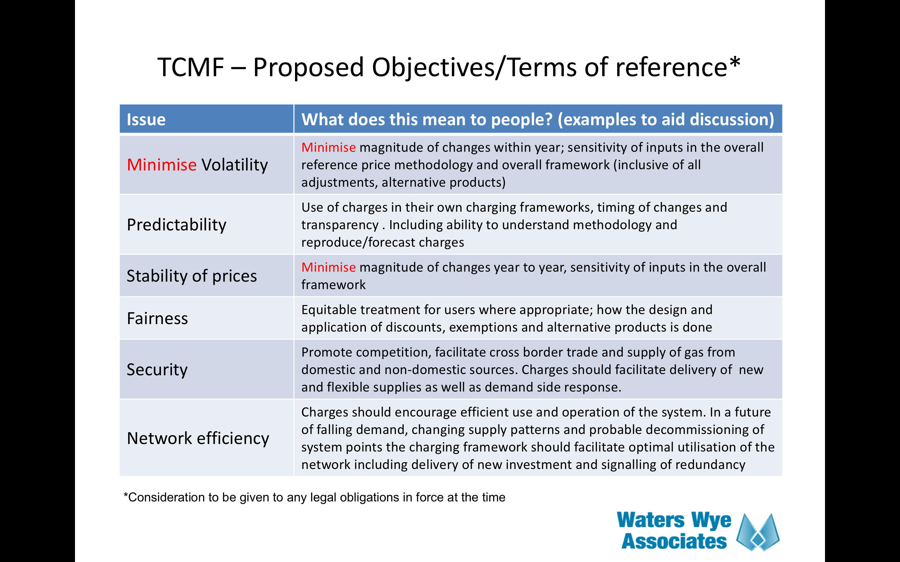

(discussed at Sept and Oct 2016 NTSCMF)

<https://www.gasgovernance.co.uk/sites/default/files/ggf/NTS%20Charging%20Review%20Objectives%20v3%20%28from%20WWA%29.pdf>

Discussion of these objectives highlighted that xxx

Workgroup participants felt that, in general, these objectives are met by all the Modifications under consideration and can be viewed as extensions of the UNC Relevant Objectives. In particular minimising volatility, predictability and stability of prices all relate to competition (Standard R.O. d) and Charging R.O. c)). Security relates to both Ofgem’s Statutory objectives and to compliance (Standard g) and Charging e)) and cross border trade correlates to TAR NC Article 7e). Fairness correlates to Article 7c) Cost Allocation Assessment and Article 7c d). Network Efficiency correlates to Standard R.O. a) and potentially Charging R.O. b).

Most proposals are expecting security (especially cross border trade) to be assessed by the regulatory Impact Assessment)

Impacts and Other Considerations

#### Does this modification impact a Significant Code Review (SCR) or other significant industry change projects, if so, how?

These Modifications do not impact a current SCR.

Most Workgroup participants and many UNC Panel Members considered Modification 0621 should itself have been presented as a Significant Code Review.

#### Consumer Impacts

There will be impact on different consumer groups but the allowed revenue collected by National Grid NTS will not change. Please see section 4.17 for details on the DN customer impacts.

#### Cross Code Impacts

None.

#### EU Code Impacts

EU Tariff Code compliance is considered as part of this Proposal. Further information can be found on this topic within the section 5 on relevant objectives since Relevant Objective g) covers “Compliance with the Regulation and any relevant legally binding decisions of the European Commission and/or the Agency for the Co-operation of Energy Regulators”.

#### Central Systems Impacts

There will be impacts on Gemini and UK Link invoicing systems.

At Workgroup on 04 April 2018 National Grid gave an update[[13]](#footnote-13) which summarised that the system changes were being progressed in two parts, A and B. Part A comprises some changes required to systems and processes driven from Modification UNC0621 and MIPI enhancements (NORD07). Part B comprises changes required to systems and processes from Modifications UNC0621, UNC0597, UNC0611 and others in development related to the Treatment of Capacity at Combined ASEPs. Requirements for all UNC0621 Alternative Modifications will be analysed during the Part B Analysis and Design phase. Part A is due for implementation in November 2018 and Part B is due for implementation in September 2019, though is to be confirmed.

The Workgroup requested an update from Xoserve, the CDSP which was communicated to Workgroup on 20 April 2018. Analysis of system changes associated to Part B of the National Grid led GB/EU Charging 2019 project began week commencing 30April 2018. For the avoidance of doubt the requirements of all the respective Alternative Proposals have been fed into the Analysis and Design process.

This Part B analysis stage will take approximately two months to complete and will consider the UNC0621 Modification (and all its alternatives) alongside other associated requirements, (however it should be noted that any system changes arising from the alternative Modifications will require scope assessments in terms of timescales and cost). At the end of this stage the change implications (additional to the original Modification UNC0621) of each of the Modifications will be understood, enabling a set of baselined requirements to be taken into the build phase of the project.

A March 2019 Authority decision as to which Modification is to be implemented means National Grid and Xoserve will need to progress build and test activities at risk. This approach is consistent with previous EU changes (2015) where Xoserve needed to be mindful of timescales and delivery due to compliance. Change of scope will be considered as the team moves through the project lifecycle, the closer to the implementation date any final decision are made could impact costs and user impacts.

National Grid Transmission continues to work closely with Xoserve to agree and progress appropriate risk mitigations.

Progress of the GB/EU Charging 2019 project will be routinely communicated to the industry within the DSC Change Management Committee[[14]](#footnote-14) in conjunction with National Grid Transmission Business Change project updates in order to ensure parties are kept fully informed.

Implementation

Whichever of these Modifications is implemented and the resulting methodology change will take effect for prices from October 2019, in order to achieve compliance with the EU Tariff Code.

The transition between the application of the prevailing and proposed methodology/rules in respect of Reserve Prices for capacity auctions is expected to take effect as illustrated in the Appendix 1 of this Proposal.

Workgroup Conclusions

In light of the Ofgem Direction on National Grid Gas, dated 08 March 2018, Workgroup understood the need to send the Workgroup report to May UNC Modification Panel for consideration. However, many Workgroup participants were concerned that the timescales allowed for consideration of the impact assessments were not sufficient to complete a robust assessment.

Workgroup therefore asks Panel to consider whether the Workgroup report can be sent out for consultation.

Workgroup recommendation for further analysis and assessment

Workgroup participants were concerned that there were areas that would ordinarily have been completed prior to submission which they agreed in this case the Workgroup had not had sufficient time and opportunity to complete. This includes a robust and more detailed assessment of the impacts on competition of the move from transition to enduring (acknowledging that some participants’ views on the impacts are unlikely to change).

Workgroup acknowledged that having not explored this area fully, it was not known whether the results would be significant.

Workgroup participants strongly recommend that Ofgem considers inclusion of the following questions and topics in its Regulatory Impact assessment:

* The Impact of Modification UNC0621 and any alternatives need to be assessed against the counterfactual of the current methodology. – what is the current methodology at the time of final modification report submission?
* The impact on the GB gas market in terms of:
  + NBP liquidity (Impact on the volatility and price); including in relation to other hubs in North-West Europe, especially TTF;
  + GB competitiveness in relation to North-West European markets;
  + Wholesale prices, including volatility and risk of extreme prices;
  + Wholesale market competition;
  + Competition in supply.
  + Attractiveness of GB as a destination for gas, within EU and globally;
  + Security of Supply and price;
  + Impact on the availability of flexible gas and on the operation of the NTS;
  + Impact on gas balancing costs.
* Impact on the volatility and price level of the electricity market
* Impact on Security of Supply and on required network investment to pass N-1 test
* Cross market impacts with electricity; impact on volatility and prices for wholesale electricity, capacity mechanism, balancing costs and any issues arising from different approaches to charging
* Environmental impacts, if any?

Recommendations to Panel

Workgroup therefore asks Panel to consider whether the Workgroup report can be sent out for consultation.

11 Appendix 1: Impacts of Proposal on NTS Capacity Auctions



12 Appendix 2: Comparisons between the Modifications

**Entry Combined Revenues**

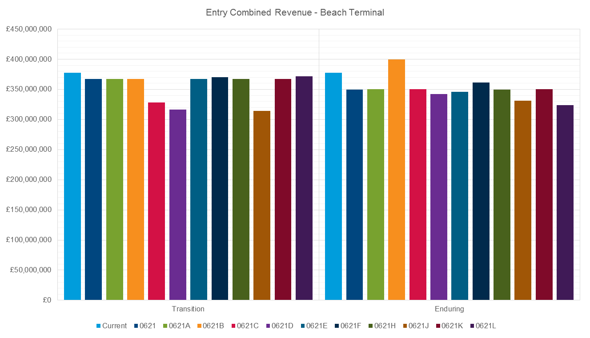

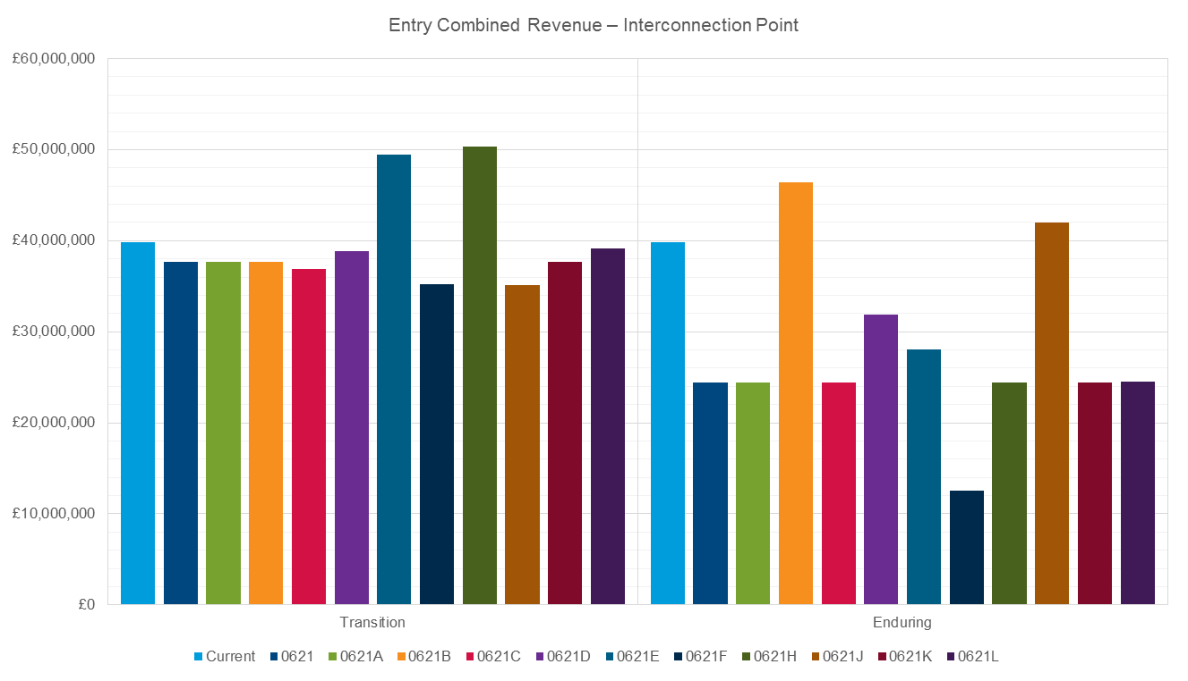

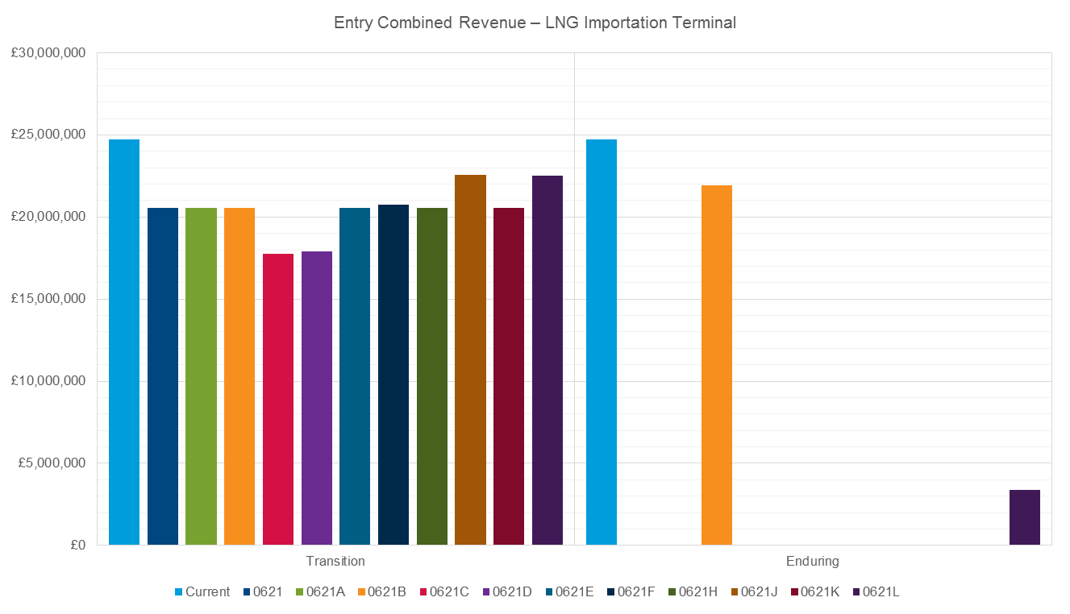

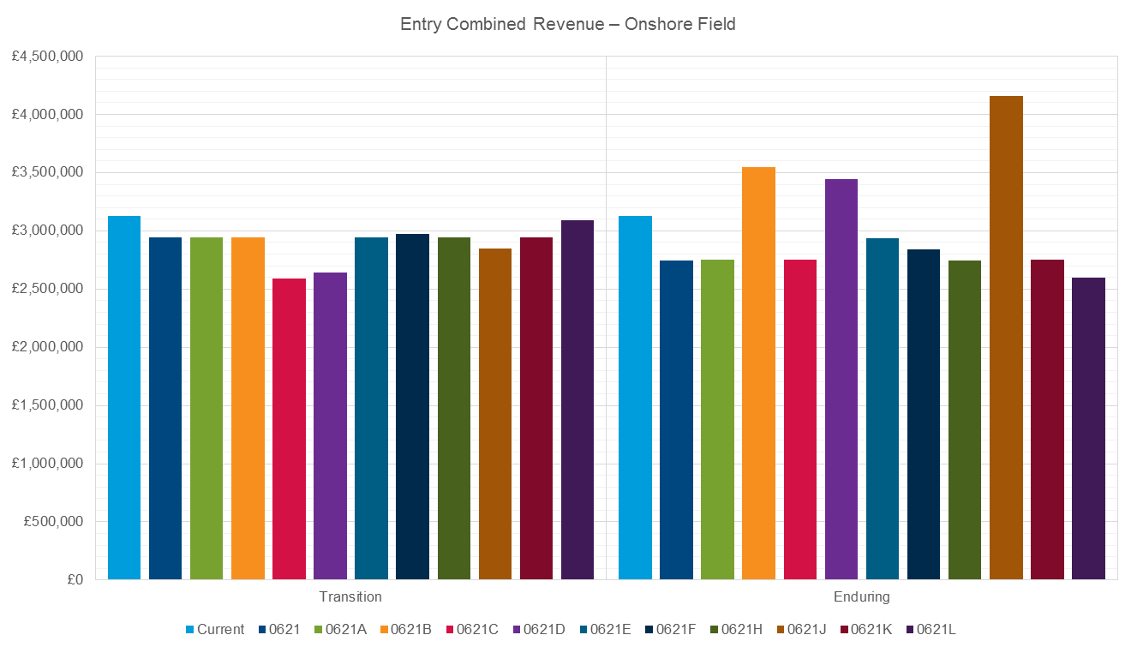

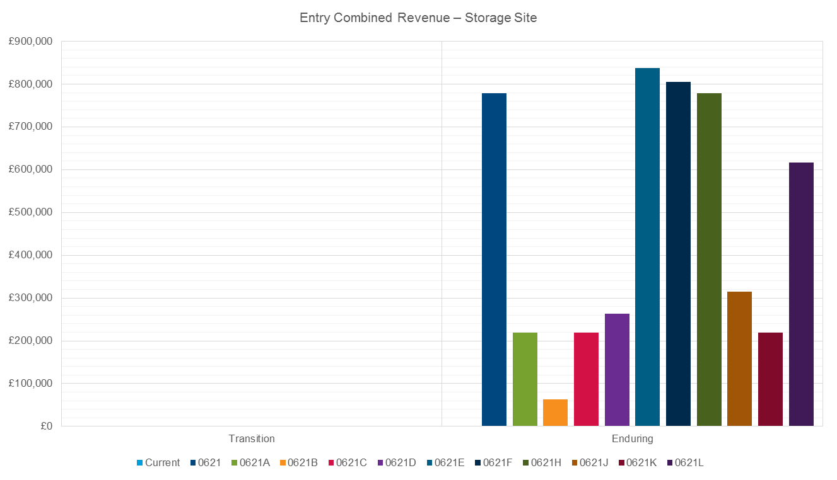

**Exit Combined Revenues** 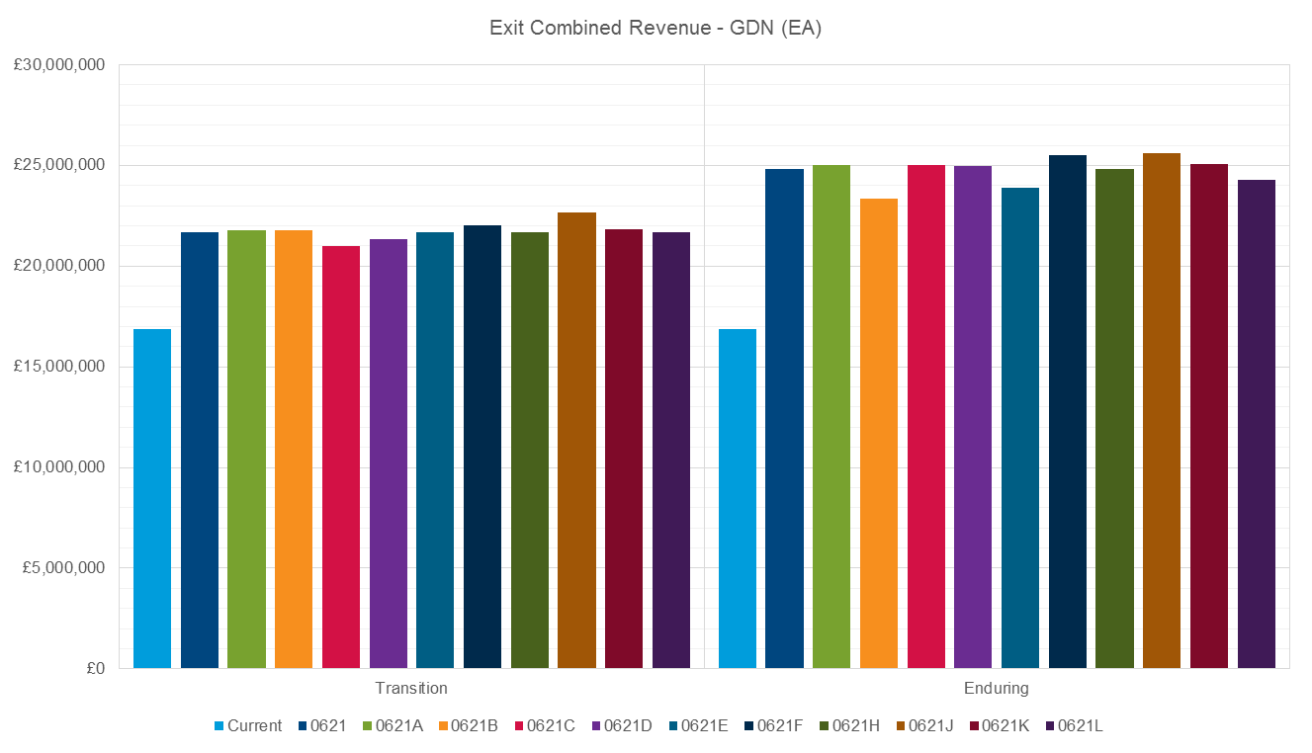

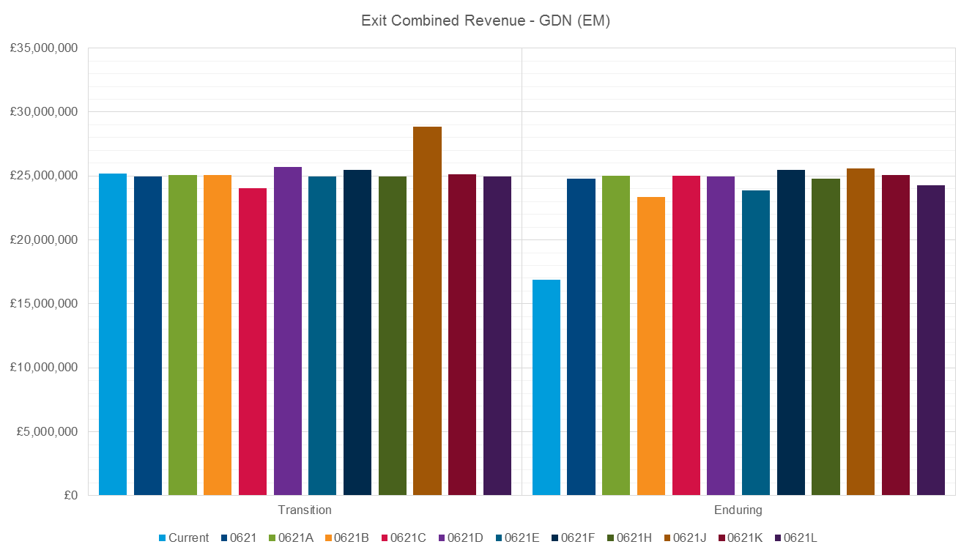

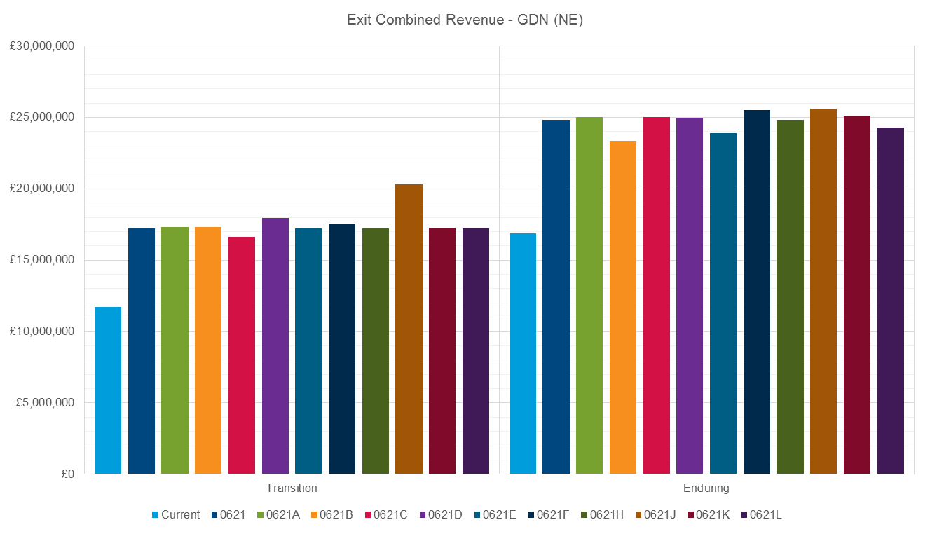

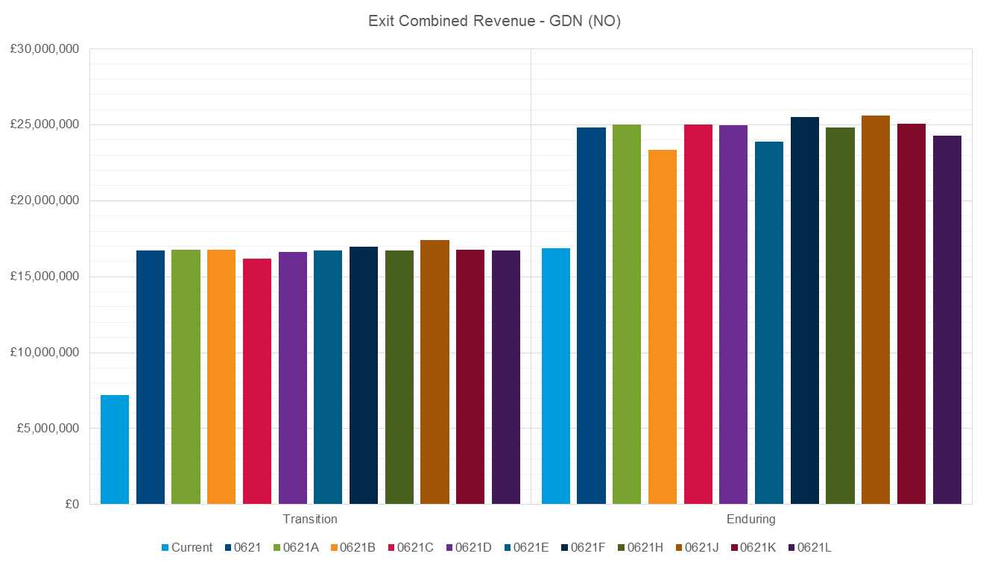

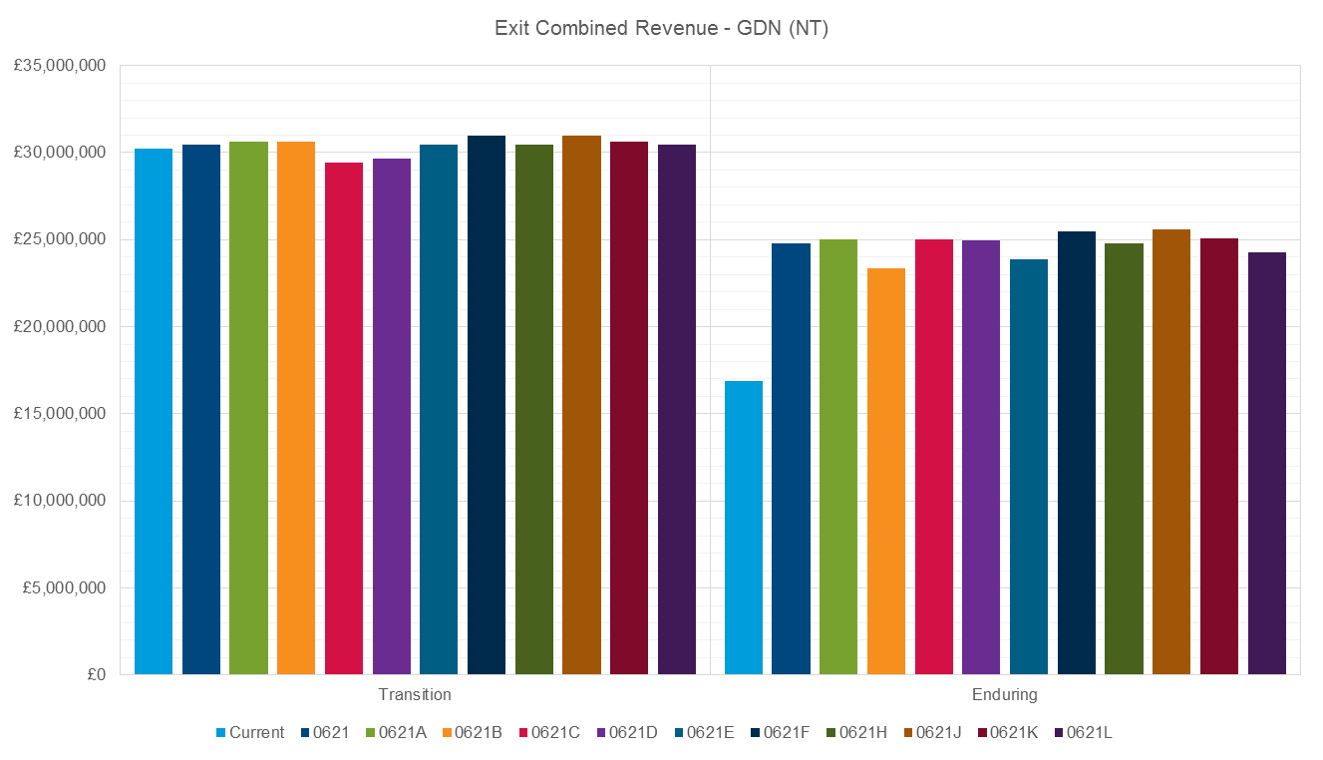

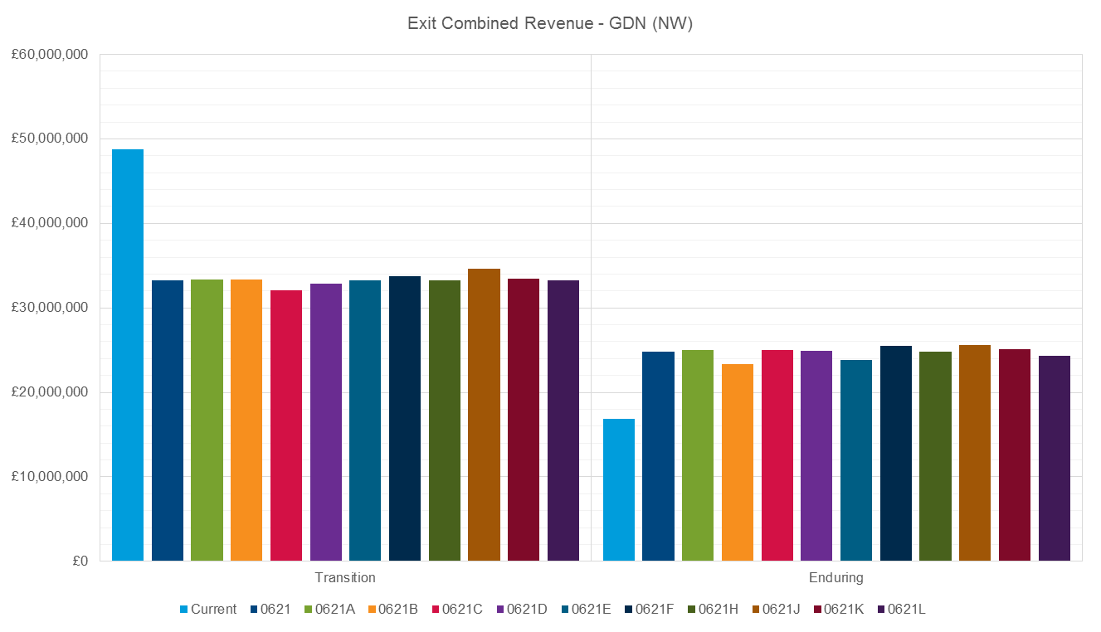

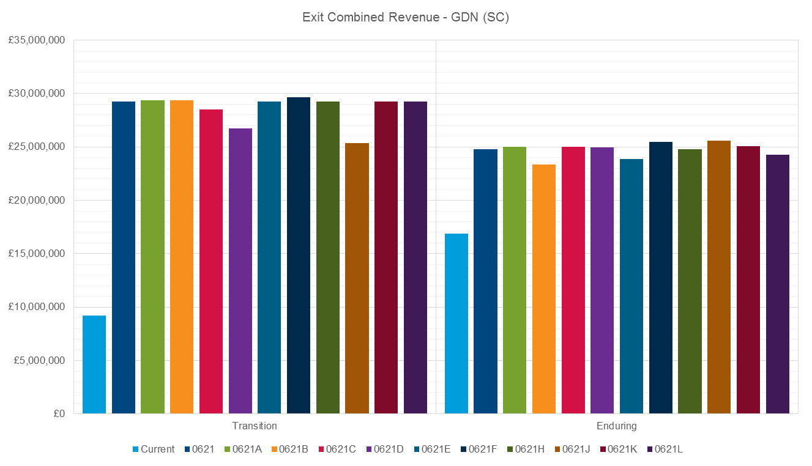

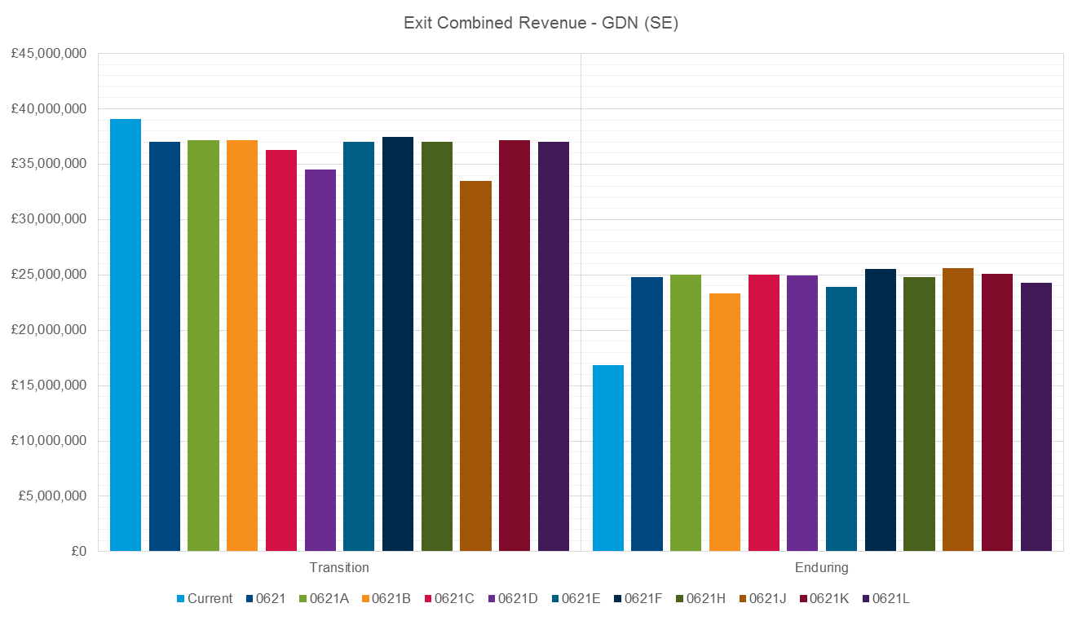

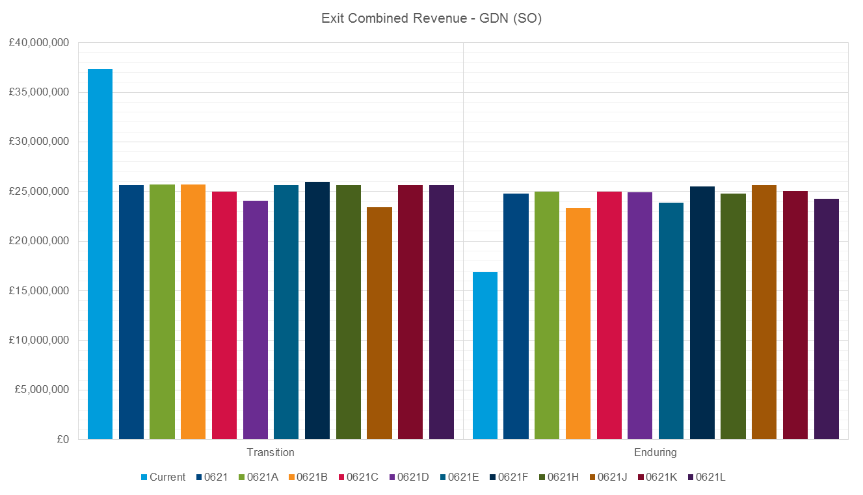

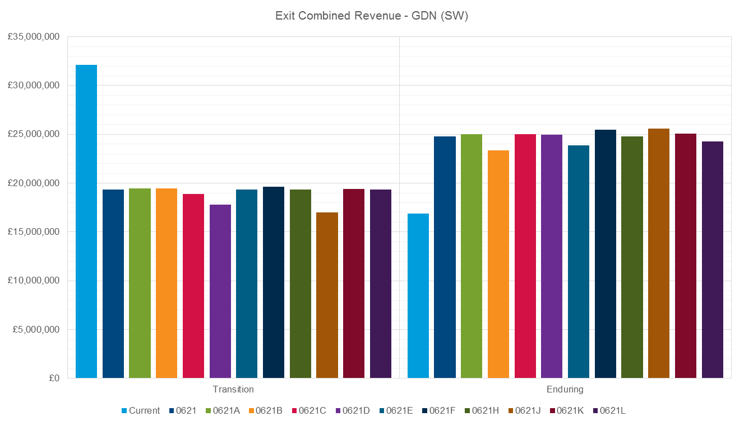

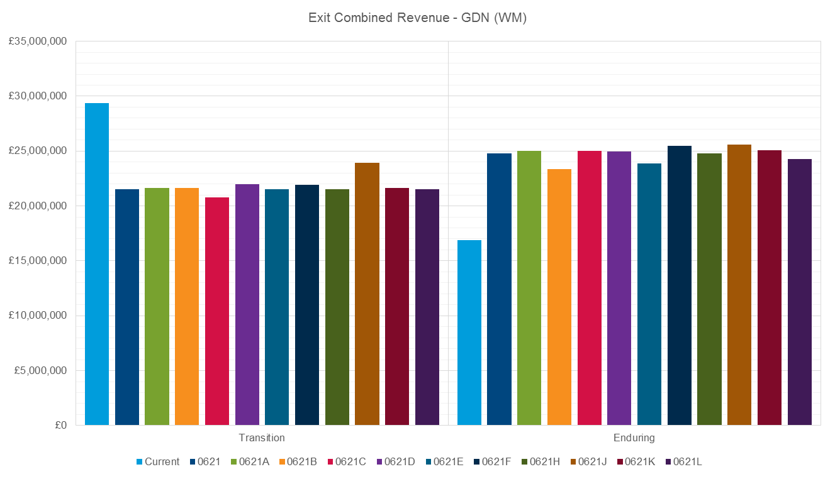

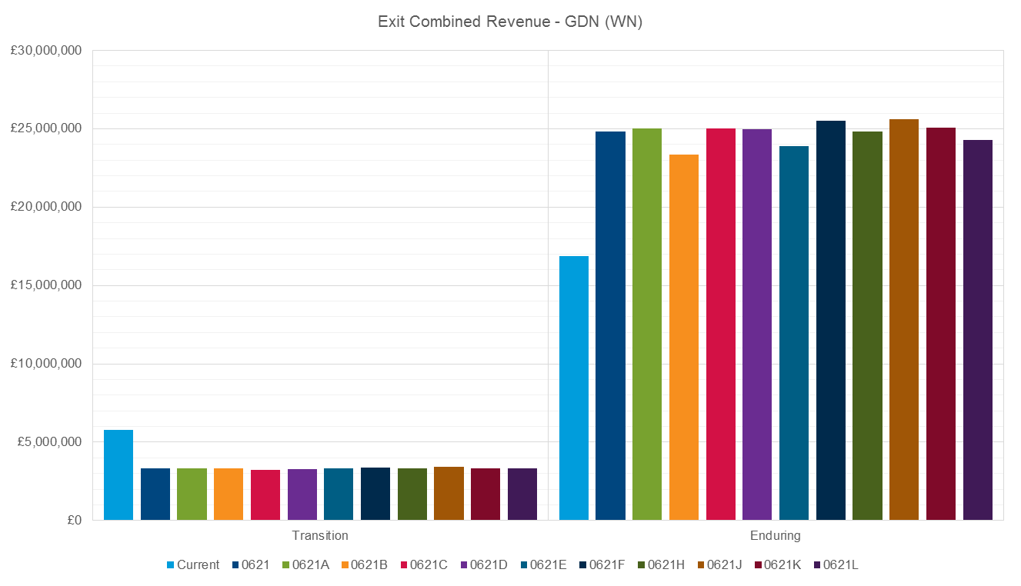

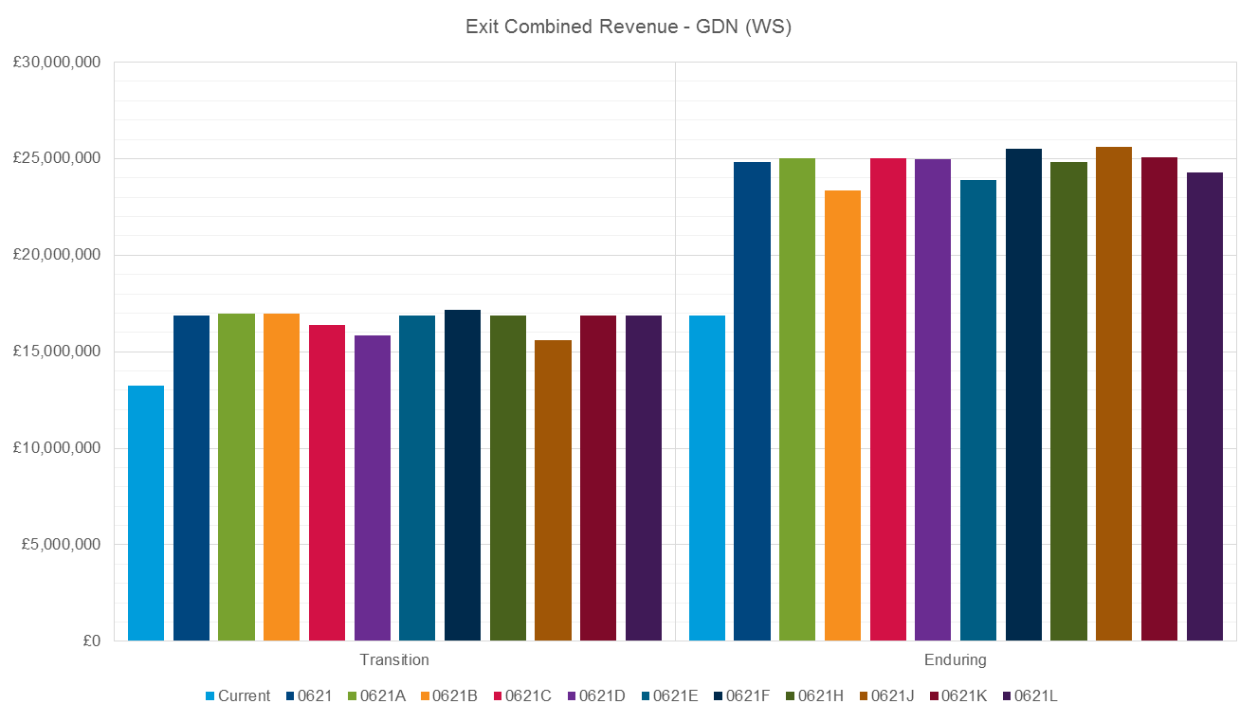

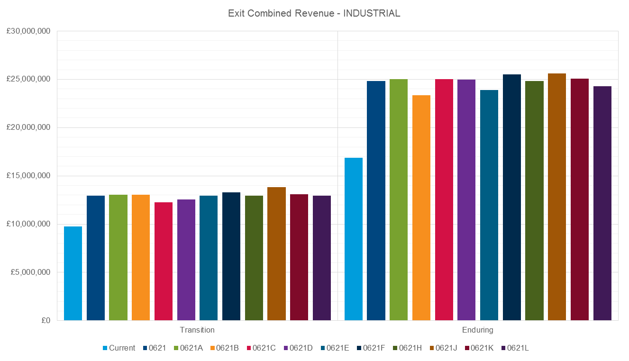

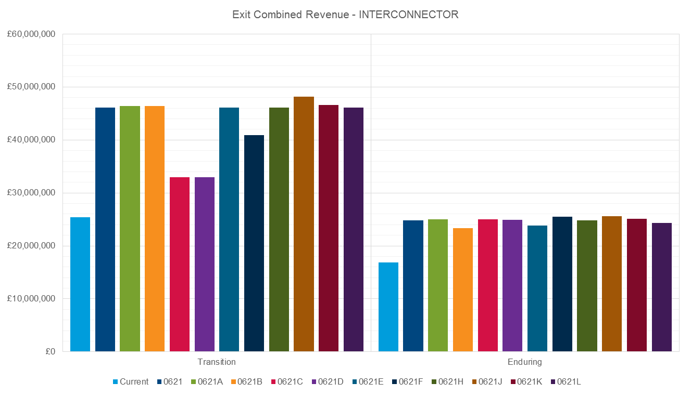

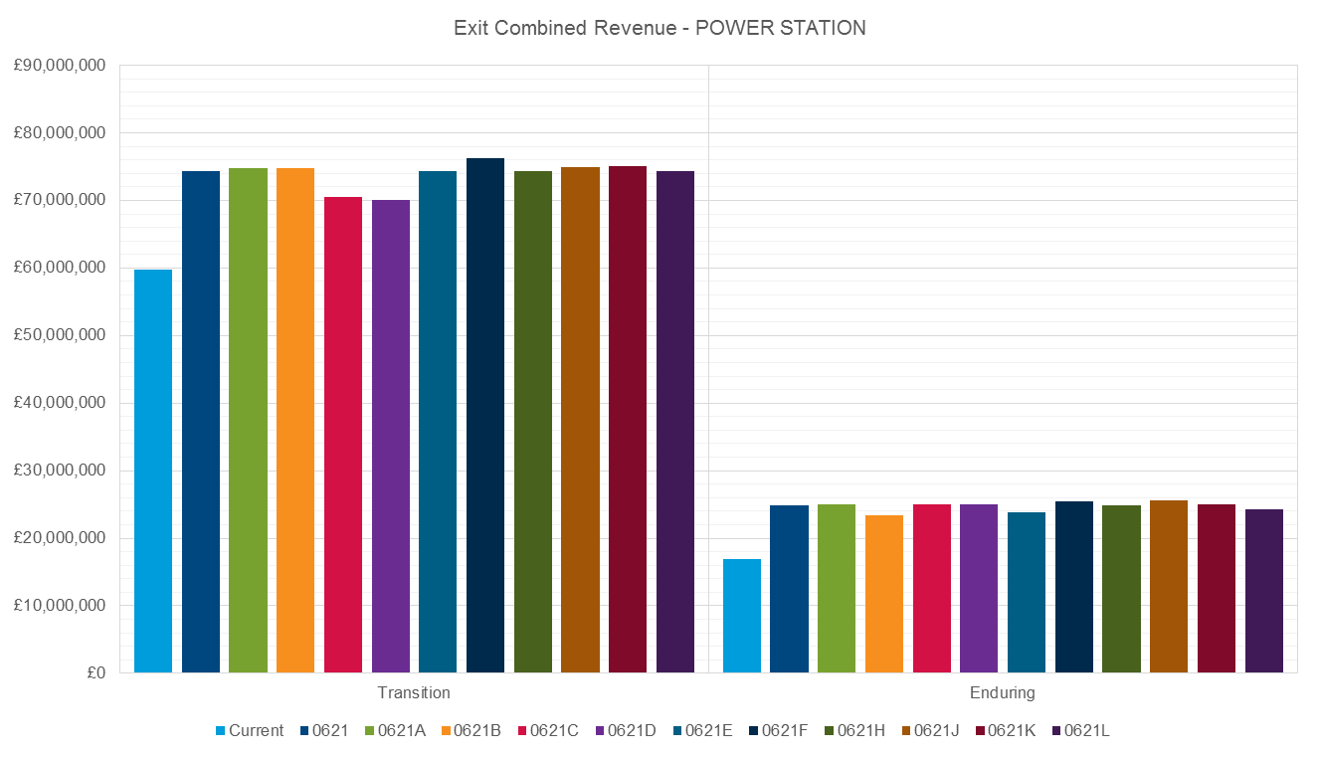

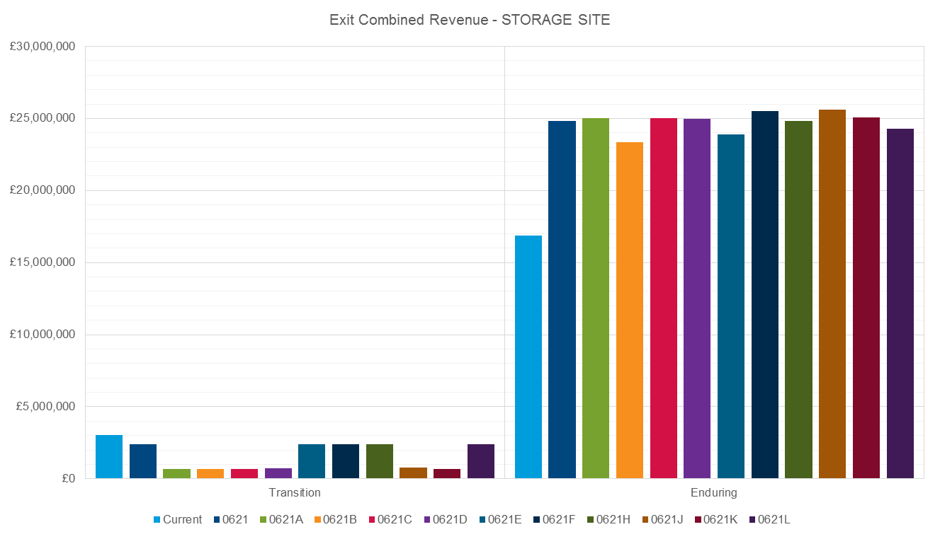

**Under Recovery Amounts**

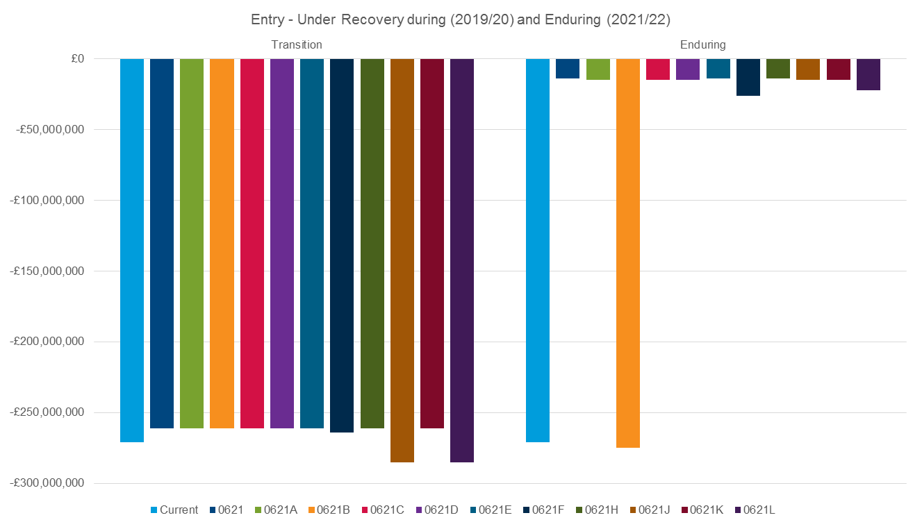

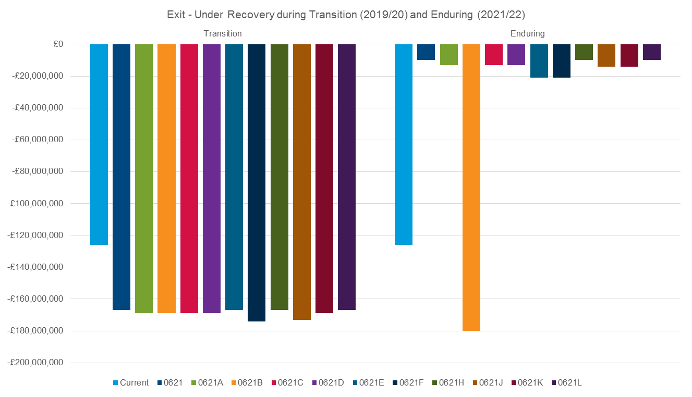

**Revenue from Capacity**

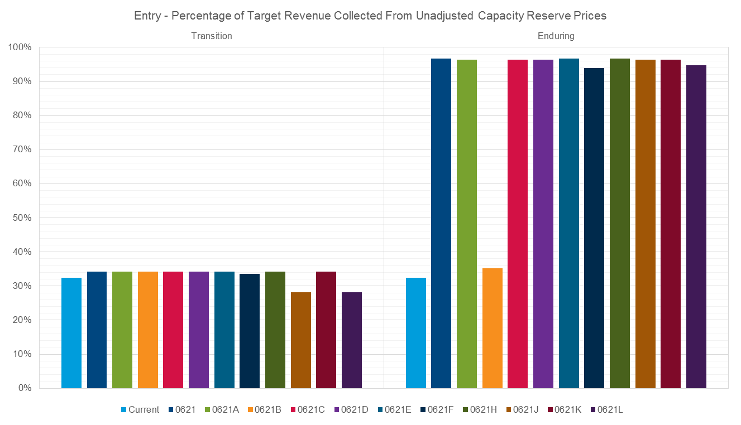

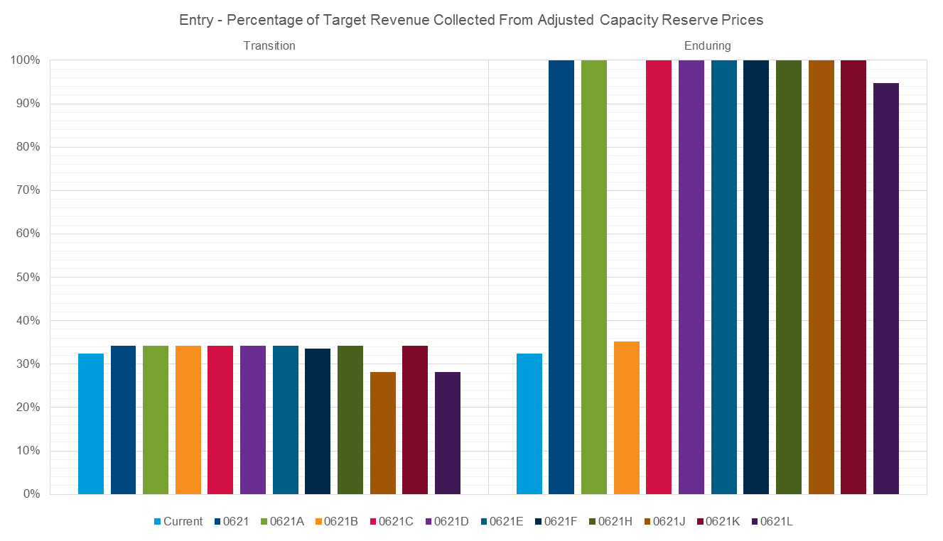

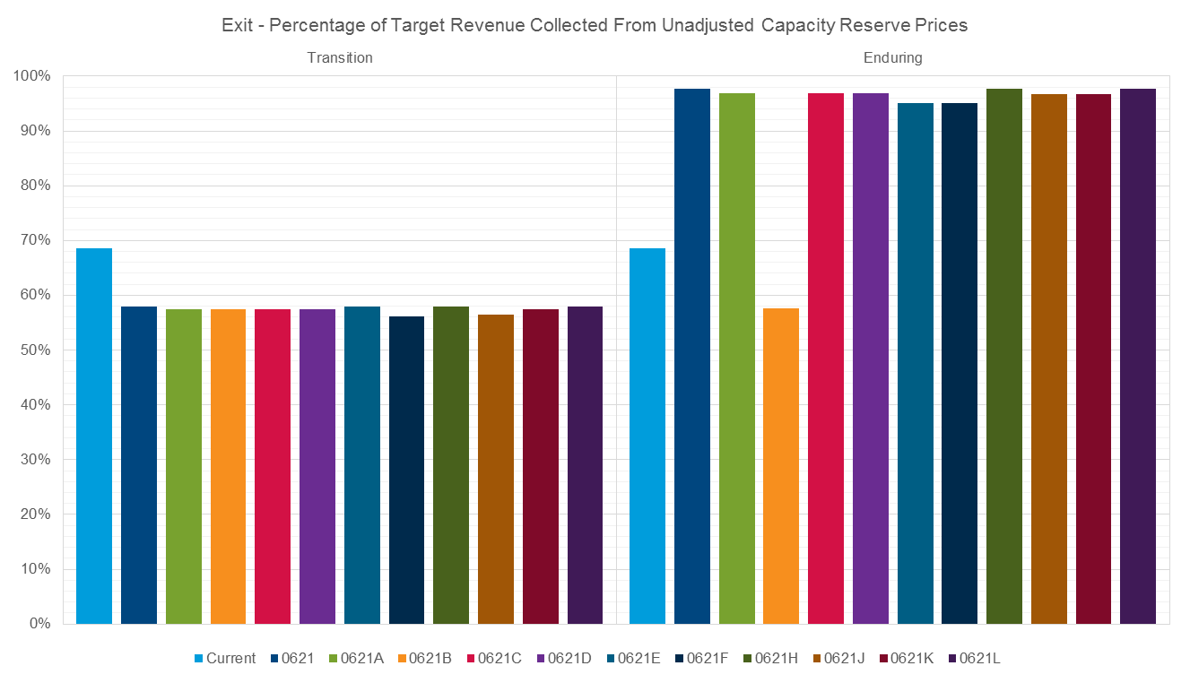

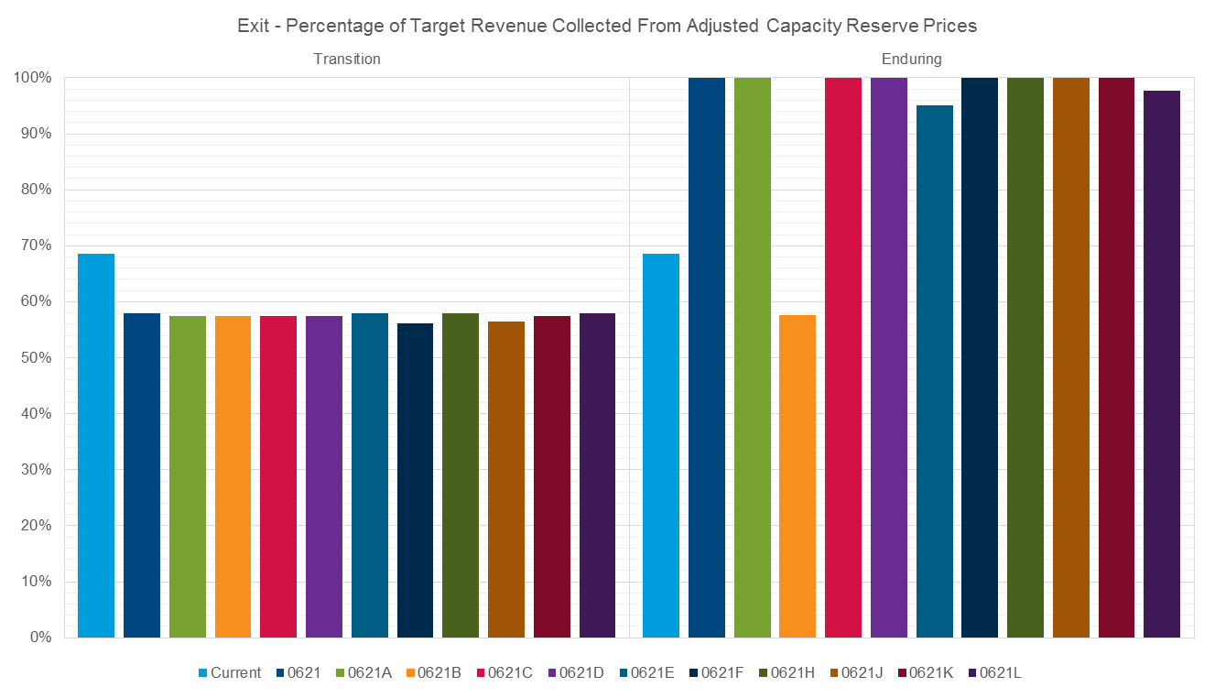

**Counterfactual comparisons**

Entry Comparison of UNC0621 to Counterfactual (as outlined in comparison table v0.11)

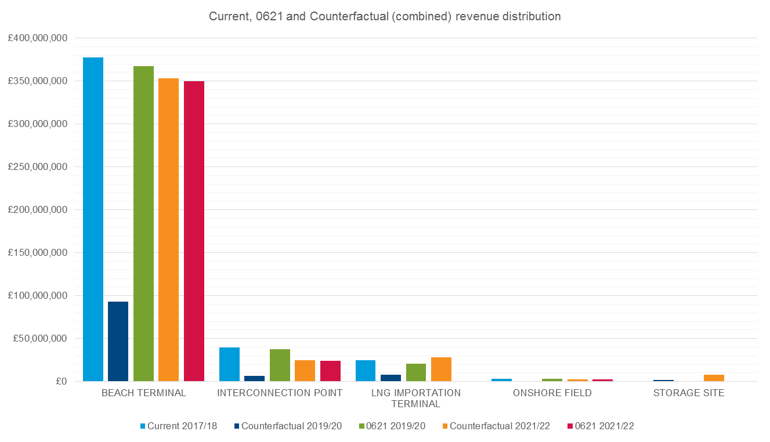

Exit Comparison of UNC0621 to Counterfactual (as outlined in comparison table v0.11)

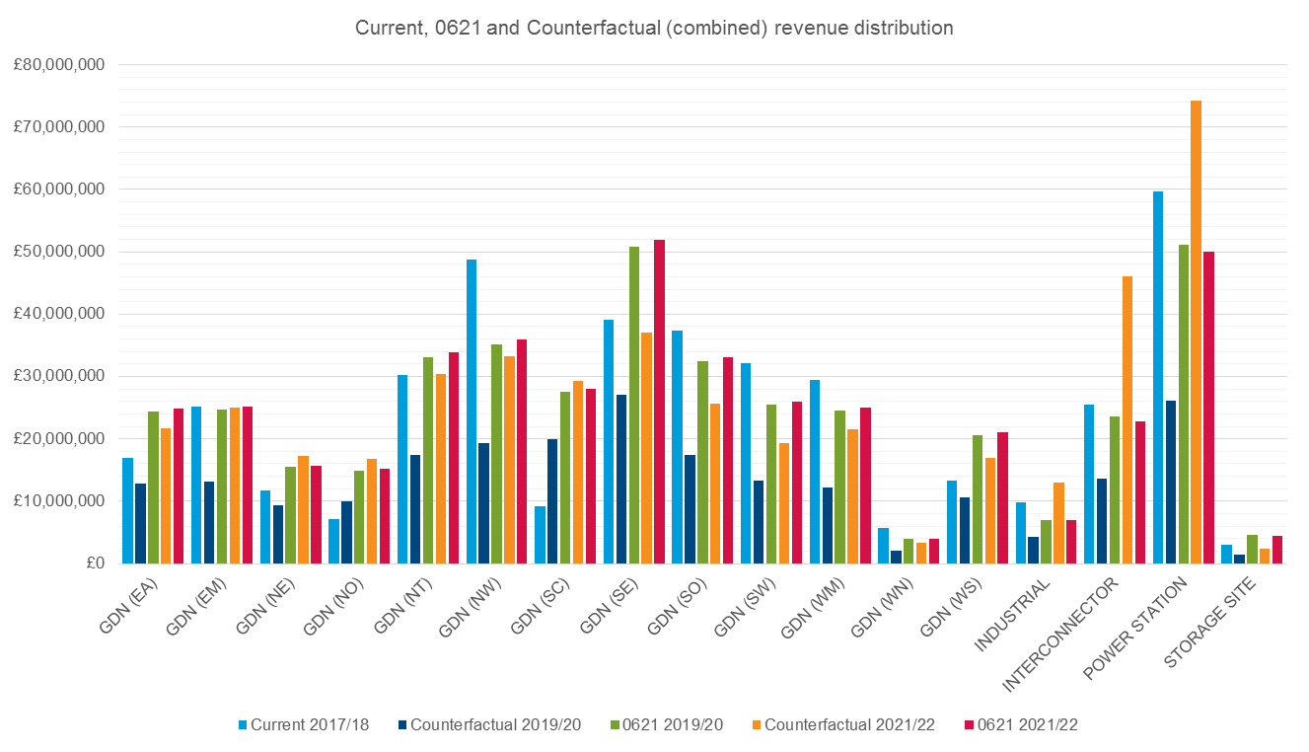

Counterfactual (Entry and Exit) Under Recovery Amounts

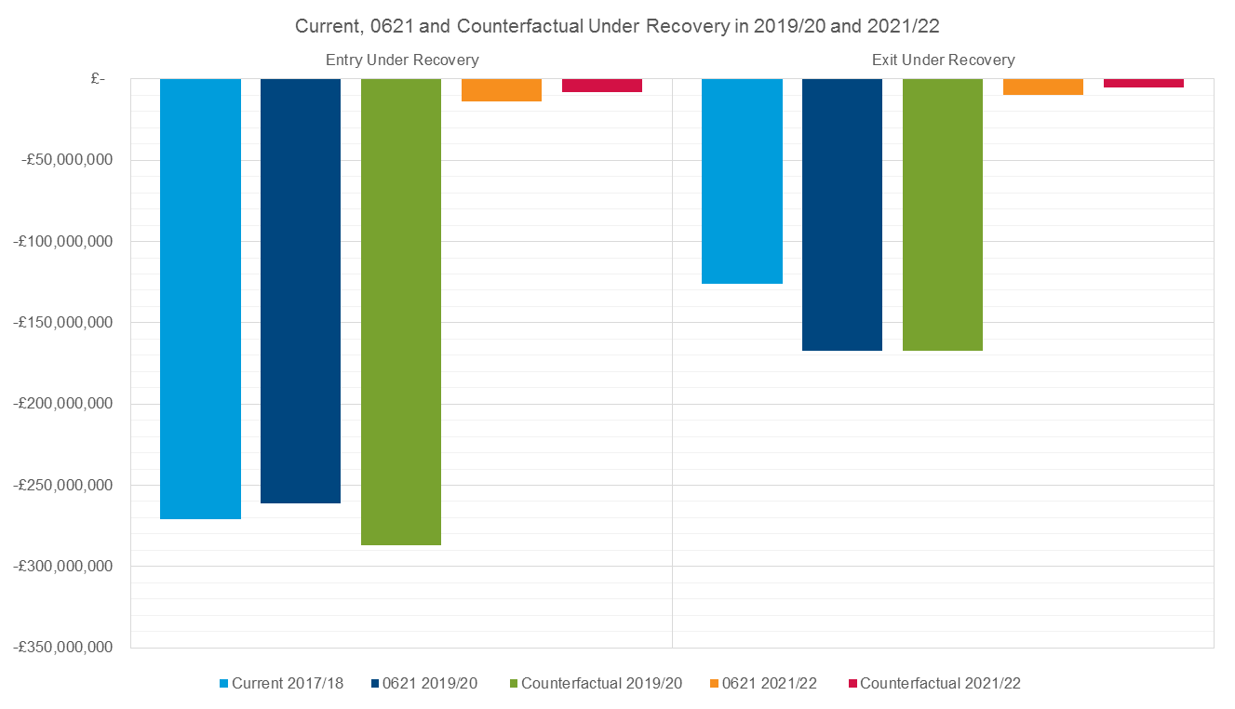

Counterfactual comparison for % Revenue Recovery from Capacity Reserve Prices

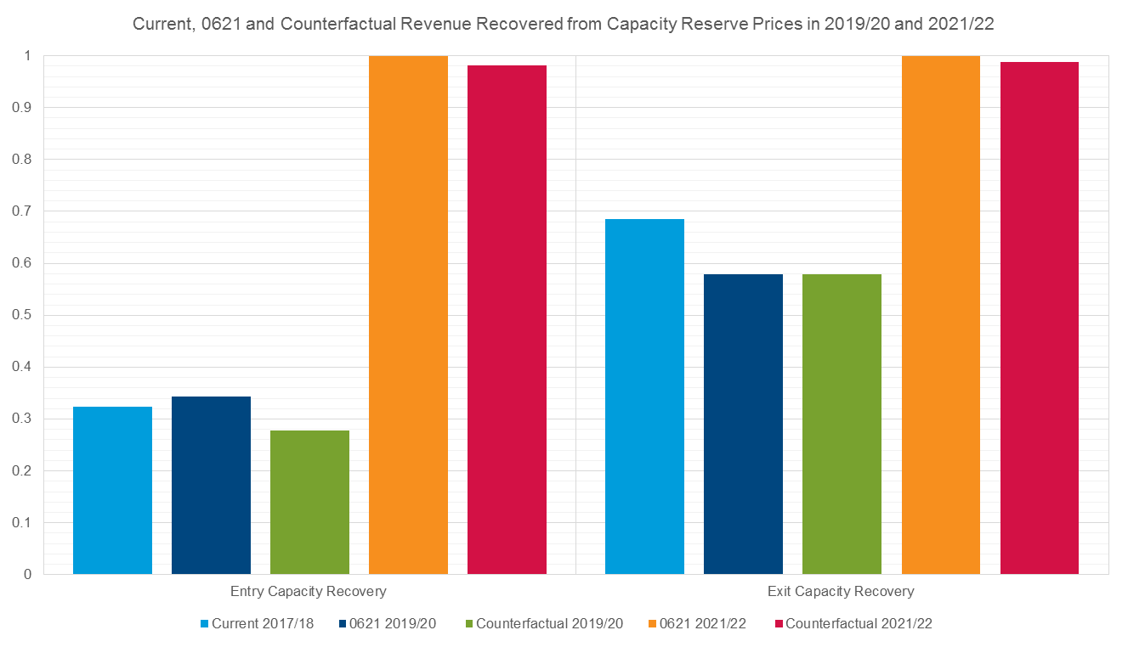

1. Link to FCC paper.<https://www.gasgovernance.co.uk/sites/default/files/ggf/Forecasting%20Contracted%20Capacity%20v0%205_0.pdf> [↑](#footnote-ref-1)
2. A GDN will ensure they have enough capacity (mainly enduring and annual capacity products) booked from the NTS to cover the expected 1 in 20 demand at either an offtake or an LDZ level. [↑](#footnote-ref-2)
3. See Slide 4 <https://www.gasgovernance.co.uk/sites/default/files/ggf/book/2018-05/GDN%20Impacts_Revised%20040518.pdf> [↑](#footnote-ref-3)
4. WWA and Storengy papers can be found here. https://www.gasgovernance.co.uk/ntscmf/170717 [↑](#footnote-ref-4)
5. WWA and Storengy papers can be found here. <https://www.gasgovernance.co.uk/ntscmf/170717> [↑](#footnote-ref-5)
6. <https://www.gasgovernance.co.uk/0621/280318> [↑](#footnote-ref-6)
7. <https://www.gasgovernance.co.uk/0621/280318> [↑](#footnote-ref-7)
8. Note that in the transition period the cost will be far lower due to the reduced reserve price levels [↑](#footnote-ref-8)
9. <https://www.gasgovernance.co.uk/0621/280318> [↑](#footnote-ref-9)
10. <https://www.gasgovernance.co.uk/0621/280318> [↑](#footnote-ref-10)
11. Note that in the transition period the cost will be far lower due to the reduced reserve price levels [↑](#footnote-ref-11)
12. The proposer of 0621D accepts National Grid’s statement but understands that not all the proposals in 0621 are required for EU Tariff Code compliance and that a clear statement of which parts are required would be helpful. This would be particularly useful if the Authority decided to direct implementation of those provisions required for EU Tariff Code compliance [↑](#footnote-ref-12)
13. Workgroup 0621 meeting on 04 April 2018 <https://www.gasgovernance.co.uk/sites/default/files/ggf/book/2018-04/EUGB%20Charging%202019%20Slides%20for%20CMF%204%20April%202018%20Version%201_0_0.pdf> [↑](#footnote-ref-13)
14. DSC Change Management Committee <https://www.gasgovernance.co.uk/DSC-Change> [↑](#footnote-ref-14)