UNC Modification |  | At what stage is this document in the process?
UNC 0621A:  Amendments to Gas Transmission Charging Regime |  | 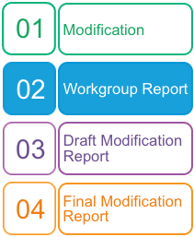
Purpose of Modification:
The purpose of this Modification proposal is to amend the Gas Transmission Charging regime in order to better meet the relevant charging objectives and customer/stakeholder provided objectives for Gas Transmission Transportation charges and to deliver compliance with relevant EU codes (notably the EU Tariff Code).
 | The Workgroup recommends that this Modification should be:  - subject to self-governance  The Panel will consider this Workgroup Report on 17 May 2018. The Panel will consider the recommendations and determine the appropriate next steps.
 | High Impact:  All parties that pay NTS Transportation Charges and / or have a connection to the NTS, and National Grid NTS
 | Medium Impact:  N/A
 | Low Impact:  N/A

Contents  1 Summary 3  2 Governance 3  3 Why Change? 4  4 Code Specific Matters 11  5 Solution 11  6 Impacts & Other Considerations 14  7 Relevant Objectives 29  8 Implementation 34  9 Legal Text 34  10 Recommendations 34  Timetable |  Any questions?
  The Proposer recommends the following timetable:
  Initial consideration by Workgroup | 07 July 2017 (NTSCMF)
  Workgroup Report presented to Panel | 17 May 2018
  Draft Modification Report issued for consultation | 18 May 2018
  Consultation Close-out for representations | 25 June 2018
  Final Modification Report available for Panel | 09 July 2018
  Modification Panel decision | 19 July 2018
Contact:
Joint Office of Gas Transporters
 |  enquiries@gasgovernance.co.uk
 | 0121 288 2107
Proposer:
Benoit Enault
 | Benoit.enault@storengy.co.uk
 | 01606 815 372
Transporter:
National Grid
Systems Provider:
Xoserve
 | commercial.enquiries@xoserve.com
Other:
Nick Wye
 | nick@waterswye.co.uk
 | 01789 266 811

- Summary

What
This Modification proposes to introduce a new Gas Transmission Charging regime that produces stable and predictable transportation charging and is compliant with the forthcoming EU Tariff Code (Regulation 2017/460).

Why
The Transportation Charging Methodology currently in place for the calculation of Gas Transmission charges, and the methodology to recover Transmission Owner (TO) and System Operator (SO) revenue through Entry and Exit charges, have been in place for a number of years. Whilst there have been some changes in the last ten years, the basic approach to calculating Entry and Exit Capacity charges and the approach to revenue recovery has not substantially changed.

A critique of the current Long Run Marginal Cost (LRMC) methodology has identified that it is too volatile, unpredictable and does not provide stability of charges for Users.

How
This Modification proposes to introduce changes to the charging framework by way of making changes to UNC TPD Section Y. It will also be necessary to make changes to the Transition Document and update other sections of the UNC TPD (Sections B, E and G) and EID Section B).
This Modification proposes to move from a Reference Price Methodology (RPM) that calculates the capacity prices using the LRMC method to one that is based on a Capacity Weighted Distance (CWD) approach. It also proposes to review other aspects of the charging framework to consider if change is necessary to better meet the required objectives.
It introduces some terminology from the EU Tariff Code, specifically ‘Transmission Services Revenue’ and ‘Non-Transmission Services Revenue’. The revenues will map across to TO and SO revenues thereby not changing the total revenue to be collected through Transportation charges. The more material change will be the amendments to the charging methodologies in calculating the charges that will be applied to recover the allowed revenues from NTS network Users through the Transportation charges.
This proposal also introduces, for some aspects of this methodology change, some transitional arrangements and mechanisms to review and refine components of the charging framework over time so they continue to better facilitate the relevant methodology objectives and support the evolution of the GB charging regime.
- Governance

Justification for Authority Direction
This Modification proposal is recommended to be sent to the Authority for direction as it is likely to have a material effect on commercial activities relating to the shipping, transportation and supply of gas because, if implemented, it is likely to have a material impact on the allocation of charges across NTS networks Users.

Requested Next Steps
This Modification should:
- be assessed by a Workgroup

- Why Change?
Drivers
  - The methodology which is currently in place for the calculation of Gas Transmission Transportation charges, and the methodology to recover TO and SO revenue through Entry and Exit charges, has been in place for a number of years. Whilst there have been some changes in the last ten years, the basic approach to calculating NTS Entry and Exit Capacity charges and the approach to revenue recovery arrangements have not substantially changed. What has been seen is change in the patterns of capacity booking behaviours, and the impact on the charges as a result due to the interactivity inherent within the methodology, that were not anticipated. Additional regulatory drivers for changes to the charging framework are:

    - The EU Tariff Code;

    - Ofgem’s Gas Transmission Charging Review

  - As a result of changing behaviours, such as increased uptake in short term zero-priced capacity, there is an increase in reliance on commodity charges to recover TO revenue. Zero priced capacity has arguably resulted in overbooking of capacity, surplus to User’s requirements. The high TO commodity charges, driven largely by the zero priced capacity can also result in unstable and unpredictable charges. Other charges, such as the NTS Optional Commodity charge (also referred to as “Shorthaul”), have also seen a significant increase in its use which has impacted on other charges in a way that was not originally envisaged.

Mapping Revenues
  - Within the collection of revenue there are some changes to the terminology used to assign the revenue for the purposes of ultimately calculating charges. These changes are required by the EU Tariff Code. This relates to mapping TO Revenue and SO Revenue to Transmission Services Revenue and Non Transmission Services Revenue. This does not affect the actual allowed revenue National Grid will be required to recover through the charges.

  - There are a number of targeted charges in the current methodology and it is necessary to consider which revenue they will contribute towards:

    - The Distribution Network (DN) Pensions Deficit Charge and NTS Meter Maintenance Charge, under the EU Tariff Code (Article 4), do not fall into the specific criteria for Transmission Services. This Modification proposes that these will be classified as Non-Transmission Services charges thereby contributing towards Non-Transmission Services Revenue.

    - The St. Fergus Compression charge will be a Non-Transmission Services charge. The methodology used to calculate the St. Fergus Compression Charge is not proposed to be reviewed at this stage.

    - The methodologies to calculate these charges (DN Pensions Deficit, NTS Meter Maintenance and St. Fergus Compression) are not proposed to be reviewed at this time. Whilst these could be considered as either Transmission Services or Non-Transmission Services, providing it is approved by the National Regulatory Authority (NRA), it is proposed this is a pragmatic way to charge for these items.
Pricing Methodology
  - The current RPM (including the adjustments applied in order to calculate capacity charges) produces charges that are volatile and unpredictable. This causes challenges for investment decisions and in predicting operational costs for connected parties year on year and as such, is a key area to be addressed.

  - Through an assessment of RPM’s, the main alternative considered from the current method was the CWD model. By design this approach is generally more predictable, less volatile and more stable in nature and is more suited to a system that is about use and revenue recovery associated to use rather than linked to investment (marginal pricing).

  - The proposed use of CWD in the RPM resolves this issue by narrowing the range of prices and as such making them more predictable. This makes the RPM more relevant to how the NTS is used and expected to be used. It would better suit the current and future expectations for the NTS and maximising its use (driven through market behaviour) rather than using a RPM built on the foundation of continued expansion whilst continuing to provide some

locational diversity in charges through the use of locational capacity and the average distances applied under the CWD approach.

  - As a result of changing the RPM, any adjustments, discounts and other charges must be reviewed in order to avoid unintended consequences and to ensure that a clear impact assessment (including any Ofgem Impact Assessment) can be carried out on the total impact of these adjustments, discounts and other charges to NTS customers and to the end consumer.

  - This Proposal considers EU compliance with the EU Tariff Code which has a deadline to implement the changes of 31 May 2019. Price changes would apply from 01 October 2019.

  - This Proposal also seeks to establish a framework for review and update of key inputs to the newly established RPM which will further the objectives of the RPM.

  - This Proposal aims to simplify the charging methodology, limiting aspects of the methodology whereby some charges can materially impact other charges and also eliminating the influence between Transmission and Non Transmission Services.
Forecasted Contractual Capacity (FCC)
  - The proposed changes to the charging regime may result in changes to commercial behaviours in the procurement of capacity rights. Given this uncertainty, a transitional approach for the period commencing 01 October 2019 is proposed based on capacity values documented in the National Grid Licence.

  - Beyond 30 September 2021, National Grid proposes an approach that ensures FCC is reviewed annually and updates considered, and updated in the appropriate transportation charging statement and charging models. This review of FCC values will, at an appropriate point, take account of any behavioural changes in capacity procurement observed under the revised charging regime with the aim of aligning the FCC closer to actual bookings. At the same time the FCC is reviewed and updated, beyond 30 September 2021, there will be an additional adjustment to the reserve prices in order to account for the anticipated under collection driven by the application of any discounts (e.g. interruptible and specific capacity discounts).
Multipliers
  - Adjustments or separate charges can be applied in the calculation of the Entry and Exit Capacity Reserve Prices. These can serve a number of functions such as to acknowledge any potential risk associated with the type of Entry or Exit Capacity, to facilitate the recovery of revenues where relevant or beneficial to do so, and to encourage behaviours along with ensuring National Grid fulfils any relevant obligations.

  - Multipliers are applied to the Reference Price to produce the Reserve Price. Under the EU Tariff code (Article 13), the Multipliers for Interconnection Point (IP) quarterly standard capacity products and for IP monthly standard capacity products should be no less than 1 and no more than 1.5. For IP daily standard capacity products and IP within-day standard capacity products, the Multipliers should be no less than 1 and no more than 3. For the IP daily standard capacity products and IP within-day standard capacity products, the multipliers may be less than 1 but higher than 0 or higher than 3, where duly justified.

  - Beyond 30 September 2020, Multipliers for IPs need to be consulted on each year (as per Article 28 of the EU Tariff code).
Discounts
  - The pricing of Interruptible (Entry) / off-peak (Exit) capacity will change from the current pricing approach. It will be consistent with the EU Tariff Code Article 16 and applied to all points. The changes proposed permit an adjustment to the relevant firm entry or exit Reserve Price in the calculation of a non-zero Reserve Price and the calculation of that Reserve Price for interruptible products.

  - The adjustment applied will be proportional to the probability of interruption and will be forward looking based upon an expectation of interruption over the coming year. An adjustment factor (‘A’ factor) may also be applied to reflect the estimated economic value of the product which will be factored into the assessment. Together, the probability of interruption and the ‘A’ factor make up the adjustment to be applied to the Reserve Price of the equivalent standard firm capacity product.

  - Within the EU Tariff Code there are requirements to apply further discounts for storage capacity, where that discount must be at least 50%. This minimum discount is specific to storage in order to avoid double charging. Storengy proposes an enduring storage discount value but recognises that EU Tariff Code requirements for the charging regime to be reviewed, as a whole, at least every 5 years.

  - Any specific ‘site type’ discounts contemplated by the EU Tariff Code (Article 9) are applied to the Reserve Price to produce a final Reserve Price for the particular Firm Entry or Exit Capacity product at that particular point. The adjustment for Entry Points and Exit Points will be based on the values specified in the Transportation Statement.
Revenue Recovery
  - Storengy’s proposals incorporate a mechanism to manage the consequence of under or over recovery of revenues from Transmission Services Capacity Charges. The approach advocated is an initial period where these Revenue Recovery charges are applied at most points as a flow based (commodity) charge which then transitions to a capacity based charge on an enduring basis.

  - Whilst Storengy recognises that use of commodity (as opposed to capacity) charges must be the exception within the overall charging proposals to be compliant with the EU Tariff Code, Storengy believes this approach is appropriate in this case. This is on the basis that it is beneficial to managing the under or over recovery of Transmission Services revenue until such time as National Grid, and industry, can have confidence in the production and use of a capacity forecast that can be used both for the purposes of setting capacity reserve prices and for managing revenue recovery, where needed.

  - Storengy believes that the proposed transition is as short as practicable and provides a means to mitigate the risks associated with Transmission Services revenue being wholly capacity based from October 2019. Without evidence of the change in behaviours for capacity bookings

under the new regime, and given National Grid’s experience to date in the use of commodity to manage revenue recovery, the temporary use of commodity as revenue recovery charge

  - will be an effective way to manage the revenue under / over recovery in compliance with Article 17(1) of the EU Tariff Code. It will also afford National Grid time to develop a capacity booking forecast capability learning from any changing capacity booking behaviours in the market.

  - From October 2021, the charging framework moves away from the commodity charge to a greater dependency on a capacity forecast and a significantly reduced revenue recovery charge that would be capacity based achieving 100% capacity basis for recovery of Transmission Services revenue.

    - From October 2021, the calculation of the capacity prices will, at the time of calculation, take into account the revenue shortfall from any discounts referred to in paragraphs 3.17 to 3.20 of Section 3) in order to adjust the reserve prices such that the amount forecast to be under collected as a result of these discounts is reduced. For the avoidance of doubt, the calculation of capacity charges from 1 October 2019 to 30 September 2021 will not have this additional step.

    - The approach in 3.24.1, applicable from October 2021, means that less revenue will be required to be collected from the Transmission Services Revenue Recovery charges than if it were not carried out. It is most relevant to do this step from October 2021 at the same time as the FCC is updated.
NTS Optional Charge
  - Storengy proposes to retain a charge that discourages inefficient bypass of the NTS. The general principle is to retain an incentive to utilise the NTS rather than construct a dedicated pipeline to exit points that are sufficiently close to an entry point. Such a product should consider the most appropriate method of applying such a charge and in its derivation should consider such elements as the costs of building an alternative pipeline and a reasonable limit over which this may be considered economic to construct and how the charge functions with the rest of the charging framework to be in keeping with the general principle of the NTS Optional Charge.

    - Within the transition period, Storengy proposes to effectively retain this through the use of, in principle, the existing NTS Optional Commodity (‘NTS shorthaul’) charge as an alternative charge to the transitional Transmission Services entry and exit Revenue Recovery charges and Non Transmission Services Entry and Exit Charges.

    - We continue to believe it is appropriate to dis-incentivise the construction of dedicated pipelines to exit points which are sufficiently close to an entry point.

  - Recognising the proposed transition to an entirely capacity based Transmission Services charges in October 2021 (after the end of the transition period), Storengy proposes that the application of the NTS Optional Charge expires at the end of the transition period. For the calculation and application of an equivalent charge on an enduring basis after the transition

period (i.e. from 01 October 2021), we anticipate a future change proposal to be raised to achieve this.

  - As a means of applying the NTS Optional charge in the transition period, there are two key differences that will apply:

    - Inclusion of a 60km distance cap.

As the existing charge is based on a fixed formula (as opposed to a percentage discount for example), the number of Entry / Exit Point combinations for which the optional charge is less than the standard change is far in excess of the numbers initially intended. Consequently, the entry to exit point distances within scope are also far in excess of the distances initially envisaged.

Storengy believes that the distance cap proposed constrains the availability of the incentive to those exit points sufficiently close to entry points (to genuinely consider construction of a dedicated pipeline) in line with the original aims of the optional charge.

    - Indexation of the costs incorporated into the charge formula.

The existing formula incorporates four numeric values which are driven by the estimated cost of laying and operating a dedicated pipeline of NTS specification in 1997. Storengy proposes that these cost inputs are updated to October 2017 values via indexation using the Retail Prices Index. Prospectively, Storengy believes it is appropriate to update these costs (via indexation) for the relevant charging period and proposes to use the Retail Prices Index for this purpose (i.e. for October 2019 the cost inputs will be updated using RPI from the 12 month period ending 31 March 2019 and for October 2020 updated using RPI from the 12 month period ending 31 March 2020).

  - Other aspects of the existing NTS Optional Commodity charge derivation are proposed to be retained within the new NTS Optional Charge:

    - The existing range of pipe sizes taken into account;

    - The maximum daily capacity, as derived from the maximum hourly volume as specified in the Network Exit Agreement, as an input to the formula; and

    - The maximum daily capacity load being subject to a 75% load factor adjustment; and

    - The existing determination of ‘eligible quantities’ (including the current bespoke arrangement at the Bacton ASEP (introduced by UNC Modification 0534) is principally retained

Existing Contracts and Interim Contracts (Collectively referred to as Historical Contracts)
  - Storengy proposes provisions to apply for Entry Capacity (for 01 October 2019 or beyond) allocated up to the Effective Date

    - This will include Existing Contracts, as outlined in Article 35 in EU Tariff Code where the “contract or capacity booking concluded before the entry into force of the EU Tariff Code – 6 April 2017, such contracts or capacity bookings foresee no change in the levels of capacity and/or commodity based transmission tariffs except for indexation, if any”.

    - This will also include Interim Contracts, as defined in this Proposal. Beyond the Effective Date sufficient clarity of the charging regime to apply from 01 October 2019 is apparent and therefore no specific treatment (for capacity subsequently booked) is proposed.

    - The capacity procured under these contracts impact the application of the CWD charging model (specifically when determining Reference Prices at Entry Points) and calculation of Transmission Services Revenue Recovery Charges.

Aspects of the GB Charging Regime where there are no proposals for change:
The following is a list of items for which changes are not being proposed at this time but could be the next steps in the evolution of the GB charging regime.
- Auction Structure – All timings for auctions will be as per prevailing terms (including any changes implemented to comply with CAM).
- Entry/Exit Split – No change is proposed to the current 50:50 split.
- Gas Year/Formula Year – the Formula Year (April to March) and Gas Year (October to September) will be retained.
- DN Pensions Deficit Charge – No change to the calculation or the application of the charge.
- St. Fergus Compression Charge – No change is proposed to the calculation or the application of the charge.
- NTS Metering Charge - No change is proposed to the calculation or the application of the charge
- Shared Supply Meter Point Administration Charges - No change is proposed to the calculation or the application of the charge
- Allocation Charges at Interconnectors - No change is proposed to the calculation or the application of the charge
- Categorisation of Entry and Exit Points – Maintain the link to the Licence for categorisation.
- Seasonal Factors – Not used in current methodology and propose not to introduce.
- Fixed Pricing – As per Modification 0611, Amendments to the firm capacity payable price at IPs.
- Allowed Revenue – No change as per the Licence.
- Principles and application of Interruptible – As per prevailing terms. In respect of IPs, the terms implemented pursuant to Modification 0500, EU Capacity Regulations - Capacity Allocation Mechanisms with Congestion Management Procedures.
- Code Specific Matters

Reference Documents
There are summary documents available on each of the topics (mentioned in the solution section of the Modification proposal) which have been discussed at NTSCMF and sub-groups related to the gas charging review, which are available at: http://www.gasgovernance.co.uk/ntscmf/subg1page and http://www.gasgovernance.co.uk/ntscmf/subg1model.
A CWD Model and User Guide have been produced which can be found at: http://www.gasgovernance.co.uk/ntscmf.

A Postage Stamp model is also available to be able to do a comparison of the prices in each of these models (found at the same location).
A Non-Transmission Services model has been produced which can be found at: http://www.gasgovernance.co.uk/ntscmf
Uniform Network Code (UNC) Section Y:
http://www.gasgovernance.co.uk/sites/default/files/TPD%20Section%20Y%20-%20Charging%20Methodologies_29.pdf

UNC European Interconnection Document (EID):

http://www.gasgovernance.co.uk/EID

EU Tariff Code:

http://www.gasgovernance.co.uk/sites/default/files/EU%20Tariff%20Code%20-%20final%20clean.pdf
Implementation Document for the Network Code on Harmonised Transmission Tariff Structures for Gas (Second Edition)
https://www.entsog.eu/public/uploads/files/publications/Tariffs/2017/TAR1000_170928_2nd%20Implementation%20Document_Low-Res.pdf
Uniform Network Code (UNC) Section B:
http://www.gasgovernance.co.uk/sites/default/files/TPD%20Section%20B%20-%20System%20Use%20&%20Capacity_55.pdf
NTS Transportation Statements:
http://www.gasgovernance.co.uk/ntschargingstatements
Customer and Stakeholder Objectives:
http://www.gasgovernance.co.uk/sites/default/files/NTS%20Charging%20Review%20Objectives%2006Sep16%20v1.0.pdf
Gas Transmission Charging Review (GTCR) and associated update letters:
https://www.ofgem.gov.uk/gas/transmission-networks/gas-transmission-charging-review

Knowledge/Skills
An understanding of the Section Y Part A within the UNC, NTS Transportation Statements, the EID within the UNC, Section B within the UNC, the EU Tariff code, GTCR documentation and the customer / stakeholder objectives developed within NTSCMF would be beneficial.

Definitions
Term (Abbreviation) | Description
Capacity Weighted Distance (CWD) Model | The CWD approach fundamentally requires three main inputs:  - A revenue value is required, which will be the target revenue required to be recovered from Transmission Services;  - A distance matrix for the average connecting distances on the NTS; and  - A capacity value for each Entry and Exit point that will be the Forecasted Contracted Capacity (FCC) (which is mentioned later in this section).  The CWD model produces the Transmission Services Reference Prices and with additional adjustments produces the Transmission Services Reserve Prices.
Effective Date | The earlier of:  - the last day of the month in which Ofgem issues its letter directing implementation of this Proposal; and  - 31 May 2019
Existing Contracts (ECs) (for the purposes of this Modification) | Arrangements relating to Long Term Entry capacity allocated before 6 April 2017 (Entry into Force of EU Tariff Code)
Forecasted Contracted Capacity (FCC) | The capacity input to the RPM that will be used in the Transmission Services capacity charges calculation that will be determined via a CWD methodology. An FCC value is required for every Entry and Exit point.
Historical Contracts (HCs) | The combination of Existing Contracts (ECs) (for the purposes of this Modification) and Interim Contracts (ICs) and in relation to Transmission Services Revenue Recovery Charges at Storage includes adjustments to available capacity (including transfers) executed up to and including the Effective Date.
Interim Contracts (ICs) | Arrangements relating to Long Term Entry capacity allocated between 6 April 2017 and the Effective Date excluding Interconnection Point Entry Capacity.
Long Run Marginal Costs (LRMC) Model | The current underlying RPM used in the calculation of the Entry and Exit Capacity Prices. Whilst there are different approaches in Entry and Exit as to how secondary adjustments are applied, the underlying LRMC principles are there in both. The LRMC approach is an investment focused methodology where the intention is to have strong locational signals to facilitate decision making. More information is available in TPD Section Y of the UNC.
Multipliers | The factor applied to the respective proportion (runtime) of the Base Reference Price in order to calculate the Reference Price for non-yearly standard capacity product
Network Distances (for the purposes of modelling in the RPM) | A matrix of distances used in the RPM that are the pipeline distances on the NTS.
Non-Transmission Services | The regulated services other than transmission services and other than services regulated by Regulation (EU) No 312/2014 that are provided by the transmission system operator;
Non-Transmission Services Revenue | The part of the allowed or target revenue which is recovered by non-transmission tariffs
Reference Price | Price for a capacity product for firm capacity with a duration of one year, which is applicable at entry and exit points and which is used to set capacity based transmission tariffs. This will produced in p/kWh/a (pence per kWh per annum).
Reference Price Methodology (RPM) | The methodology applied to the part of the transmission service revenue to be recovered from capacity based transmission tariffs with the aim of deriving Reference Prices. Applied to all entry and exit points in a system.  The RPM therefore is the framework to spread certain costs / revenues (relevant to the methodology in place) to the Entry and Exit points and thereby on to network users.
Reserve Price | Reserve Price for Yearly standard capacity = the Reference Price  Reserve Price for Non- yearly standard capacity is calculated by applying any Multipliers (if applicable).  This will be produced in p/kWh/d (pence per kWh per day).
Target Revenue | This is the revenue required to be recovered from a particular set of charges.
Transmission Services | The regulated services that are provided by the transmission system operator within the entry-exit system for the purpose of transmission.
Transmission Services Revenue | The part of the allowed or target revenue which is recovered by transmission tariffs.
Transportation Statement | The Transportation Statement containing the Gas Transmission  Transportation Charges
- Solution

This Modification proposal seeks to amend TPD Section Y, Part A (The Gas Transmission Transportation Charging Methodology) of the UNC, by changing the methodology for the calculation of gas transmission transportation charges. Changes to the Transition Document, TPD Sections B (System Use and Capacity), E (Daily Quantities, Imbalances and Reconciliation), G (Supply Points) and European Interconnection Document (EID) Section B (Capacity) are also required.

Mapping of the revenue to Transmission Services revenue and Non-Transmission Services revenue (see paras 3.3 and 3.4 in section 3)
Transmission Services Charges
It is proposed that Transmission Services charges will be collected via:
- Transmission Services Capacity charges made up of;
  - Transmission Entry Capacity charges (including NTS Transmission Services Entry Capacity Retention Charge);
  - Transmission Exit Capacity charges;
- Transmission Services Entry Revenue Recovery charges;
- Transmission Services Exit Revenue Recovery charges;
- NTS Optional charges; and
- NTS Transmission Services Entry Charge Rebate.
Non Transmission Services Charges
It is proposed that Non-Transmission Services charges will be collected via:
- General Non Transmission Services Entry and Exit Charges;
- St Fergus Compression Charges;
- NTS Metering Charges;
- DN Pensions Deficit charges;
- Shared Supply Meter Point Administration charges; and
- Allocation Charges at Interconnectors

Transmission Services Charges

Reference Price Methodology (see paras 3.5 to 3.11 in section 3)
It is proposed that a CWD approach is used in the RPM.
One RPM will be used for the calculation of Reference Prices for all Entry Points and Exit Points on the system. The RPM produces Entry and Exit Capacity Reference Prices for the applicable gas year which in turn through the relevant adjustments and calculation steps will determine the Entry and Exit Capacity Reserve Prices.

Final Reference Prices
It is proposed that the calculation of the final Reference Price for a given Entry Point or Exit point cannot be zero. If application of the CWD methodology derives a zero price as a result of the FCC value or the Existing Contracts (EC) influencing the CWD calculation (see below), then the Reference Price to be used for such points will be based upon the price for the closest (in terms of Weighted Average Distance as opposed to geographically) non-zero priced Entry Point (for an Entry Point) or the closest non-zero priced Exit Point (for an Exit Point).
The price for the relevant Entry Point or Exit Point will equal to the Reference Price for the closest relevant Entry Point or (respectively) Exit Point adjusted in line with pro-rata relationship between the two Weighted Average Distances.

Calculations within the CWD Model
Proposed CWD Model for calculating Entry and Exit Capacity Base Reference Prices:
The proposed CWD approach fundamentally requires three main inputs:
- Target Entry or Exit Transmission Services Revenue - Revenue which is Allowed Revenue net of known Existing Contracts (EC) revenue and Interim Contracts (IC) revenue.
- Network Distances – derived from a distance matrix for the average connecting distances on the NTS
- Capacity (FCC) - FCC (by point) net of Existing Contracts (EC) capacity and Interim Contracts (IC) capacity booked to recover the target Entry or Exit Transmission Services revenue.

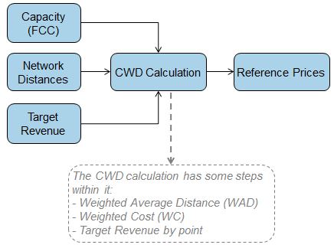

Key steps in the CWD calculations:
 | Entry Capacity Calculation | Exit Capacity Calculation
Weighted Average Distance (WAD) | (Sumproduct Exit Point FCC x Distance to Entry Point)  /  Sum Exit Point FCC | (Sumproduct Entry Point FCC# x Distance to Exit Point)  /  Sum Entry Point FCC#
Weighted Cost (WC) | Entry Point FCC* x WAD  /  (Sumproduct Entry Point FCC* x WAD) | Exit Point FCC x WAD  /  (Sumproduct Exit Point FCC x WAD)
Target Revenue by point (TRP) | Entry Target Revenue x WC | Exit Target Revenue x WC
Reference Price (RefP) | Entry TRP / Entry Point FCC* | Exit TRP / Exit Point FCC
#Entry Point FCC – this is Gross Entry Point FCC (not reduced by capacity associated with Existing Contracts and Interim Contracts)
*Entry Point FCC – this is the Entry Point FCC net of capacity associated with Existing Contracts and Interim Contracts.

Entry Point Reference Prices are calculated in the following steps in the CWD model:
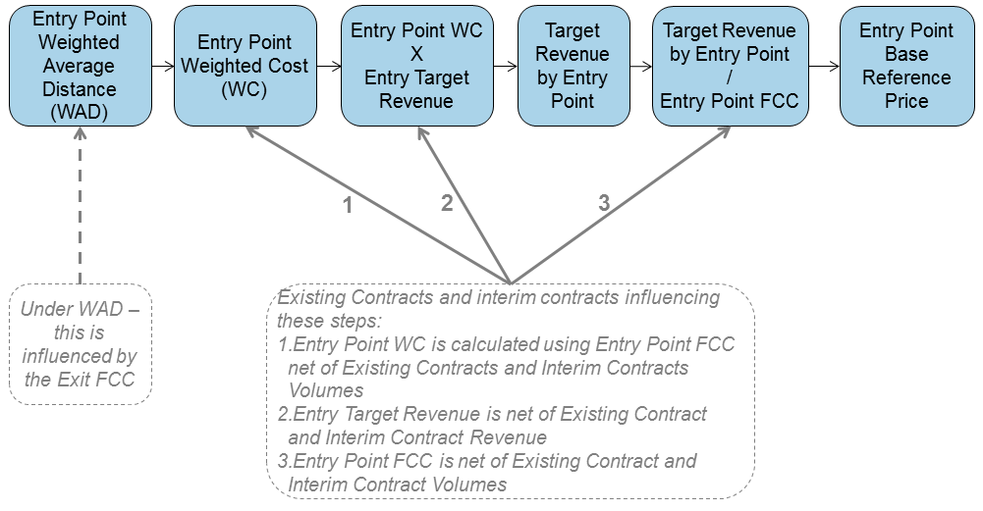

Exit Point Reference Prices are calculated in the following steps in the CWD model:
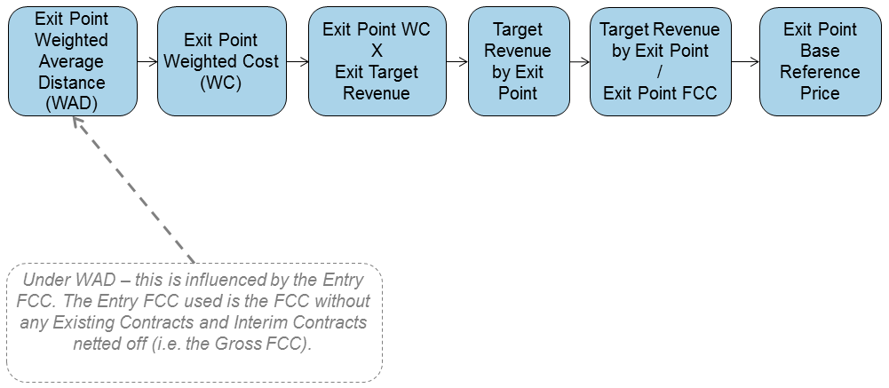

Forecasted Contracted Capacity (FCC) (see paras 3.12 and 3.13 in section 3)
It is proposed that:
- for the period commencing 01 October 2019 until 30 September 2021 (inclusive), the FCC for an Entry Point or an Exit Point will be equal to the ‘Baseline capacity’ specified within National Grid’s Licence (Special Condition 5F Table 4B for Entry Points, and Special Condition 5G Table 8 for Exit Points) for the relevant Entry Point or Exit Point; and

- for the period commencing 01 October 2021 onwards, the FCC for an Entry Point or an Exit Point will be equal to a forecast value determined by National Grid taking account of capacity booking

trends observed at respective Entry Points and Exit Points from 1st October 2019. The approach to determine a capacity forecast will be developed and shared with industry and the intention is that it be transparent and to keep the approach flexible to develop the best possible forecast to be applied to the relevant year from 2021 onwards in the calculation of the capacity charges.

Reserve Prices produced from Reference Prices (see paras 3.14 to 3.16 in Section 3)
It is proposed that Reserve Prices for capacity will be produced in p/kWh/d. The Reserve Prices will be calculated each year based on the latest available set of inputs and once published, these will be the Reserve Prices applicable for the relevant gas year regardless of when the capacity product is procured. For example, capacity procured in 2019 for a period in October 2025 will be subject to the Reserve Prices determined for gas year 2025/26 plus, where applicable, any auction premium (the difference between the allocated price and Reserve Price in the relevant auction) initially contracted for.
It is proposed that the Reserve Price for Firm capacity at an Entry Point or an Exit Point is determined by application of any applicable Multipliers to the relevant Reference Price.
It is proposed that Multipliers
- shall not be zero for any capacity type or product;
- are not to be used for the purposes of managing revenue recovery;
- shall be calculated on an ex-ante basis ahead of the applicable year.

It is proposed that for the period commencing 01 October 2019 the Multiplier applied to the Reference Prices for all Entry Point and Exit Points in order to determine the Reserve Price will be 1.

Interruptible (Entry) and Off Peak (Exit) Capacity (see paras 3.17 to 3.18 in Section 3)
It is proposed that the Reserve Price for Interruptible Capacity at an Entry Point and Off Peak Capacity at an Exit Point is derived by application of an ex-ante discount to the Reserve Prices for the corresponding Firm capacity products (the day ahead firm price at the relevant Entry Point and the daily firm price at the relevant Exit Point).
It is proposed that when determining the level of discount applied in respect of Interruptible and Off Peak Capacity from 01 October 2019, the likelihood of interruption and the estimated economic value of the Interruptible or Off Peak capacity products are used to determine a discount value (as per Article 16 of EU Regulation 2017/460). It is further proposed to adopt a ‘banding approach’ for the period commencing 01 October 2019 and for subsequent years, such that the proposed discount value will be rounded up to the nearest 10%:
It is proposed that for the period commencing 01 October 2019 the discount applied in respect of Interruptible and Off Peak Capacity:
- at Entry Points is 10%; and
- at Exit Points is 10%.

Specific Capacity Discounts (see paras 3.19 to 3.20 in section 3)
It is proposed that Specific Capacity Discounts will be applied to the Reserve Prices in respect of Firm and Interruptible/Off Peak Capacity at the Points detailed below.
It is proposed that in respect of storage sites, (locations where the type of Entry point/Offtake is designated as a ‘Storage Site’ in National Grid’s Licence (Special Condition 5F Table 4B for Entry Points, and Special Condition 5G Table 8 for Exit Points) the applicable Specific Capacity Discount for a given gas year will be equal to 86%.
It is proposed that in respect of Liquefied Natural Gas (LNG) sites, (locations where the type of Entry point is designated as a ‘LNG Importation Terminal’ in National Grid’s Licence (Special Condition 5F Table 4B)) for the period commencing 01 October 2019, the applicable Specific Capacity Discount for a given gas year will be equal to 0%.
It is proposed that no other Specific Capacity Discounts are applied.

Additional Calculation Step under CWD for Reference / Reserve Prices applicable from 01 October 2021 (see para 3.24 in section 3)
It is proposed that the following step is only applicable for Capacity Reference Prices from October 2021 (on an enduring basis) concurrent with when the FCC determination approach is updated to be based on a more informed forecast. Once the Reserve Prices have been calculated taking into account all the required Multipliers, Specific Capacity Discounts and Interruptible / Offpeak adjustment there will be an under recovery driven by the levels of discounts or adjustments (e.g. Interruptible / Off Peak adjustment and Specific Capacity Discounts). This anticipated under recovery will result in the need for an adjustment to be applied to the CWD calculation in order to recalculate Reference Prices, and therefore Reserve Prices, such that the under recovery is estimated to be zero or close to zero. This will minimise the size of the Transmission Services Entry and Exit Revenue Recovery charges. This will be applied to the Entry and Exit Capacity calculations to recalculate the Entry and Exit Capacity Reference Prices and Reserve Prices for all Entry and Exit points.

Minimum Reserve Price
It is proposed that Reserve Prices for Firm and Interruptible / Offpeak capacity (determined following the application of any relevant Multipliers, Specific Capacity Discounts, or Interruptible / Offpeak adjustments) will be subject to a minimum value (collar) of 0.0001p/kWh/d.

Summary of Reserve Price Derivation
The following diagram summarises the proposed approach to the derivation of Reserve Prices (from the applicable Reference Price) for both Firm and Interruptible / Off Peak Capacity products (including Capacity at Storage and LNG sites).

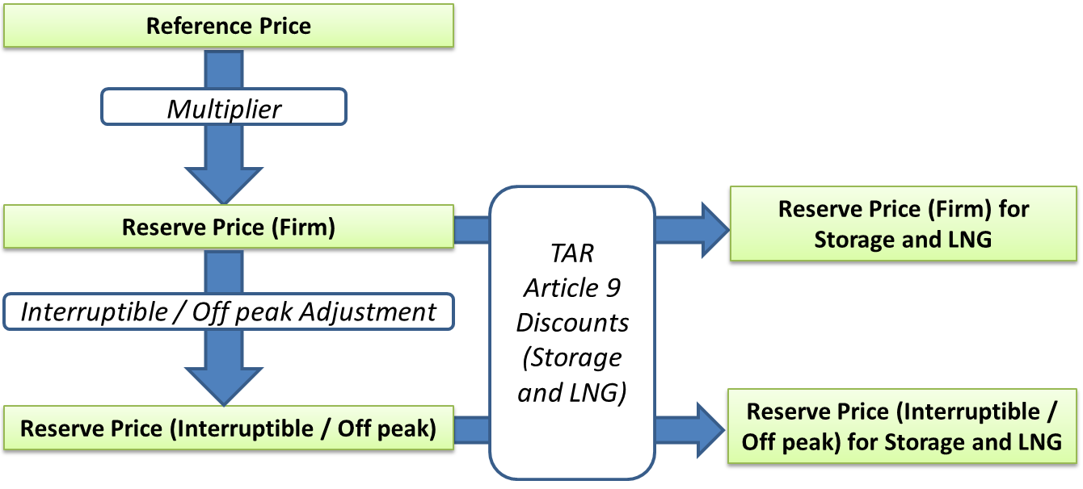

Capacity Step Prices
For the purposes of capacity step prices used in the QSEC Auction, these will be an additional 5% of the applicable Reserve Price or 0.0001 p/kWh/Day, whichever is the greatest, per step.

Transmission Services Revenue Recovery Charges (see paras 3.21 to 3.24 in section 3)
It is proposed that where a proportion of revenue could be under/over recovered (i.e. compared to the target Transmission Services revenues) as a consequence of application of Reserve Prices applicable for the following gas year, a revenue recovery mechanism is applied.
The Transmission Services Revenue Recovery charges (Transmission Services Entry Revenue Recovery charge and Transmission Services Exit Revenue Recovery charge) will be calculated after the Reserve Prices have been determined and will be calculated as follows for Entry and Exit in the same way:

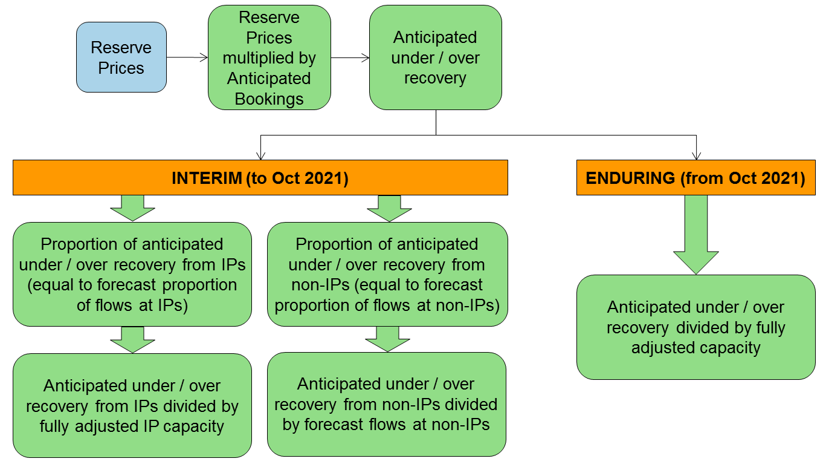

It is proposed that the ‘Anticipated Bookings’ value will be based on National Grid’s forecast of capacity bookings and therefore used to forecast the anticipated under or over recovery. It is proposed that the Transmission Services Revenue Recovery charge rate may be adjusted at any point within the gas year.
For the avoidance of doubt, such change would be subject to the existing notice requirements for variation of Transportation Charge rates.
It is proposed that for the period commencing 01 October 2019 until 30 September 2021 (inclusive) the Transmission Services revenue recovery mechanism is calculated in a number of steps and applied differently at Interconnection Points and Non Interconnection Points:
- The required revenue to be applied to the Transmission Services revenue recovery mechanism will be determined in the same manner for Entry and for Exit in the steps highlighted above. The steps below apply independently to both Entry and to Exit to produce Transmission Services Entry Revenue Recovery charges and Transmission Services Exit Revenue Recovery charges.

- The total anticipated flows on the NTS (excluding Storage flows unless it is flowed as “own use” gas at the Storage point) will be used as the main denominator.

  - For Non interconnection points, the anticipated Non Interconnection Point flows as a proportion of the total anticipated flows on the NTS will be applied to the required revenue from the Transmission Services revenue recovery mechanism to determine the revenue to be collected from Non Interconnection points. This amount divided by the applicable Non Interconnection Point flows shall determine the Transmission Services Entry and Exit revenue recovery charges for Non Interconnection Points for the relevant period. This charge shall be applied to all Non Interconnection Point flows except Storage flows not considered “own use” gas at the storage point. The Transmission

Services Entry and Exit revenue recovery charges for Non Interconnection Points will be produced in p/kWh.

  - For interconnection points, the anticipated Interconnection Point flows as a proportion of the total anticipated flows on the NTS will be applied to the required revenue from the Transmission Services revenue recovery mechanism to determine the revenue to be collected from Interconnection Points. This amount divided by an aggregate forecast of fully adjusted capacity at Interconnection points shall determine the Transmission Services Entry and Exit revenue recovery charges for Interconnection Points for the relevant period. This charge shall be applied to all Interconnection Point fully adjusted capacity. The Transmission Services Entry and Exit revenue recovery charges at Interconnection Points for this period will be produced in p/kWh/d.

It is proposed for the period commencing 01 October 2021 onwards, the Transmission Services revenue recovery mechanism is capacity based and applied as additional capacity charges to all fully adjusted capacity except capacity booked at Storage points, which has not been booked for “own use gas” purposes, . The Transmission Services Entry and Exit revenue recovery charges for this period will be produced in p/kWh/d. For the avoidance of doubt, any Entry Capacity (except at Storage facilities and not booked for own use gas purposes) or Exit Capacity (except at Storage facilities and not booked for own use purposes) booked for the applicable year (irrespective of when this capacity was procured from National Grid) would be subject to Revenue Recovery charges.

NTS Optional Charge (see paras 3.25 to 3.28 in Section 3)

It is proposed that for the period up until and including 30 September 2021, the NTS Optional Charge is available for eligible flows or eligible capacity at Specified Entry Point and Specified Exit Points. This is available to Users (by election) as an alternative to the Transmission Services Revenue Recovery charges (entry and exit) and general Non-Transmission Services Entry and Exit Charge where the straight line distance from the Specified Entry Point to the Specified Exit Point is 60km or less.

A Specified Entry Point can be any System Entry Point except those located at Storage Connection Points. Whereas one Specified Entry Point can be associated with more than one Specified Exit Point, it is not permitted to associate more than one Specified Entry Point to an individual Specified Exit Point.

The method of determining the NTS Optional Charge for the relevant years will be to apply the following formula structure and indexation approach to provide an updated formula to be applicable in the relevant year. The formula is designed to take into account the estimated costs of laying and operating a dedicated pipeline of an appropriate specification and also takes into account a range of flow rates and pipeline distances.

w*(M^x)*D + y*(M^z)

where:
w means a value derived from the estimated costs (of laying and operating a dedicated pipeline of NTS specification) between the relevant points and for the 12 month period commencing 01 October 2017 is equal to 2006;

M means the Maximum NTS Exit Point Offtake Rate (MNEPOR) converted into kWh/day at the site as specified in the relevant Network Exit Agreement;
x means a value derived from the estimated costs (of laying and operating a dedicated pipeline of NTS specification) between the relevant points and for the 12 month period commencing 01 October 2017 is equal to -0.835;
D means the straight line (‘as the crow flies’) distance from the site or non-National Grid NTS pipeline to the Specified Entry Point in km (up to a maximum distance of 60km);
y means a value derived from the estimated costs (of laying and operating a dedicated pipeline of NTS specification) between the relevant points and for the 12 month period commencing 01 October 2017 is equal to 587;
z means a value derived from the estimated costs (of laying and operating a dedicated pipeline of NTS specification) between the relevant points and for the 12 month period commencing 01 October 2017 is equal to -0.654; and
^ means to the power of
It is proposed that the methodology that supports the derivation of the above formula and its parameters will be included in a separate Methodology Statement.
Indexation approach
It is proposed that the estimated costs (of laying and operating a dedicated pipeline of NTS specification) which underpin the calculation that derives the values w, x, y and z above are subject to indexation to the Retail Prices Index (RPI) for the relevant charge period consistent with RIIO-T1 Licence RPI calculations. The cost base will be updated using publicly published RPI figures from the previous completed formula year (i.e. October 2019 will be updated using April 2018 to March 2019 data) and the formula for determine the RPI will be as follows:

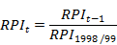
RPI_{t} means the arithmetic average of the monthly Retail Price Index published or determined with respect to each of the twelve months from 1 April to 31 March in formula Year t

It is proposed that the updated formula for the relevant year (within the period for which the NTS Optional charge is applicable i.e. up to 30 September 2021) is specified in the Transportation Statement.

It is proposed that the NTS Optional Charge rate (in place for an individual Supply Point Registration) will be subject to change annually (as a consequence of the indexation described above). For the avoidance

of doubt this charge rate change will take effect in absence of any subsequent Supply Point Administration activity.

It is proposed that by 01 August 2020 National Grid notify each User at a Point with an existing NTS Optional Charge rate (as at 01 July 2020) of the prevailing tariff/rate and the NTS Optional Charge rate (which will apply from 01 October 2020).

Transition
The existing NTS Optional Commodity Rate (OCR) will no longer be available from 01 October 2019. It is proposed that existing Users subject to the OCR will not be automatically transferred to the proposed NTS Optional Charge.
It is proposed that by 01 August 2019 National Grid notify each User at a Point with an existing OCR (as at 01 July 2019) of the removal of the OCR and the availability of the NTS Optional Charge for points that meet the criteria (i.e. where the straight line distance from the site or non-National Grid NTS pipeline to the Specified Entry Point is up to 60km). For the avoidance of doubt, in absence of an accepted application for the NTS Optional Charge in respect of a Point, the standard Revenue Recovery Charges will be payable from 01 October 2019 as described above.

Application (all Points)
It is proposed that the flow utilised for the basis of the NTS Optional charge (‘NTS Optional Flow’) is the lower of the input flow (at the specified Entry Point) or the output flow (at the specified Exit Point). Where a single Entry Point is the specified Entry Point for multiple identified Exit Points and the aggregate volume flowed at the identified Entry Point is less than the aggregate volume flowed at the identified Exit Points, the NTS Optional Flow for each will be the pro rata proportion of the aggregate volume flowed at the identified Entry Point (i.e. in proportions equivalent to the Exit Volumes).

Application: Non-Interconnection Points
It is proposed that NTS Optional Flow will be subject to the NTS Optional Charge as an alternate to both the flow-based Entry Revenue Recovery Charge (at the identified Entry Point) and the flow-based Exit Revenue Recovery Charge (at the identified Exit Point). Any flow at the identified Entry Point or the identified Exit Point that is not classified as NTS Optional Flow is subject to (respectively) the flow-based Transmission Services Exit Revenue Recovery Charge or flow-based Transmission Services Entry Recovery Charge.

Application: Interconnection Points
It is proposed that the quantity of capacity deemed to have been used (‘NTS Optional Capacity’) for this NTS Optional Flow will be equal to the NTS Optional Flow volume.
It is proposed that NTS Optional Capacity will be subject to the NTS Optional Charge as an alternate to (where applicable) the capacity based Entry Revenue Recovery Charge (at the identified Entry Point) and the capacity based Exit Revenue Recovery Charge (at the identified Exit Point). Any capacity at the identified Entry point or the identified Exit point that is not classified as NTS Optional Capacity is subject

to (respectively) the capacity-based Transmission Services Exit Revenue Recovery Charge or capacity-based Transmission Services Entry Recovery Charge.

Application: Bacton ASEPs
It is proposed that at the Bacton ASEPs only, the input flow at the ASEP will be equal to the sum of the UKCS ASEP and the IP ASEP. In order to determine the proportion of NTS Optional Flow which is subject to application in respect of non-Interconnection Points and which is subject to application in respect of Interconnection Points, the NTS Optional Flow shall be apportioned between the UKCS ASEP and the IP ASEP in pro rata proportion to the input flow (i.e. in proportions equivalent to the input flow at the UKCS ASEP and the IP ASEP).

NTS Transmission Services Entry Charge Rebate
The charge mechanism reduces any Transmission Services entry over recovery. The process may be triggered at the end of the formula year. It is proposed that this will be applied as a Transmission Services entry capacity credit.

NTS Transmission Services Entry Capacity Retention Charge
NTS Entry Capacity Substitution is where National Grid moves unsold non-incremental Obligated Entry Capacity from one (donor) ASEP to meet the demand for incremental Obligated Entry Capacity at a different (recipient) ASEP. It is proposed that where a User elects to exclude capacity at potential donor ASEPs from being treated as substitutable capacity without having to buy and be allocated the capacity it is required to take out a “retainer”.
The retainer is valid for one year, covering all QSEC auctions (including ad-hoc auctions) held in this period. National Grid will exclude the relevant quantity from the substitution process, but the retainer will not create any rights to the User to be allocated or to use the capacity. The retainer will not prevent Users (including the User taking out the retainer) from buying that capacity at the ASEP in question in the period covered by the retainer.
The retainer is subject to a one-off charge which is payable via an ad hoc invoice raised within 2 months of the QSEC auction allocations being confirmed. If a User wishes to protect capacity for more than one year then a further retainer must be obtained each year and a charge will be payable each year for which a retainer is taken out.

Where any capacity covered by a retainer is allocated, a refund of the retention fee may be made; for example, for a retainer taken out for Gas Year 2013/14 in January 2010, a refund can be triggered by an allocation at the relevant ASEP made during a QSEC auction in 2010, 2011 and 2012, and an AMSEC auction in 2013 and 2014.

NTS Entry Capacity Retention Charges, in regard to non-incremental Obligated Entry Capacity, are calculated based on the minimal capacity charge rate of 0.0001 pence per kWh per day applying over a time period of 32 quarters; this equates to 0.2922 p/kWh of Entry Capacity retained.

NTS Entry Capacity Retention Charges and refunds in regard to non-incremental Obligated Entry Capacity are treated as Transmission Services.

Non-Transmission Services Charging
It is proposed that revenue due for collection via General Non-Transmission Services Entry and Exit Charges will be equal to the Non-Transmission Services revenue minus the DN Pensions Charges, NTS Meter Maintenance Charges, St. Fergus Compressor Charges, Shared Supply Meter Point Administration Charges and Allocation Charges at Interconnectors.
The revenue due for collection via General Non-Transmission Services Entry and Exit Charges will be recovered through a flow based charge as a flat unit price for all Entry Points and Exit Points. It is proposed that the St. Fergus Compressor Charges and General Non-Transmission Services Entry and Exit Charge rates may be adjusted at any point within the gas year.
It is proposed that this is applied to all flows excluding eligible flows (in respect of the NTS Optional Charge) and Storage flows unless it is flowed as “own use” gas at the Storage point.
The General Non-Transmission Services charge will be produced in p/kWh.

Treatment of under/over recovery (K) – after each formula year
It is proposed that a separate under or over revenue recovery (otherwise known as the “K” value) will be calculated for Transmission Services and Non-Transmission Services for the formula year. This will be different to the TO and SO “K” values however the principle of reconciling Transmission Entry and Exit revenues separately will remain.
It is proposed that the approach and calculation will be specified in the UNC, to be approved by Ofgem. In addition to Transmission and Non Transmission being reconciled this Modification also proposes to have reconciliation between Entry and Exit under Transmission Services.

Transmission Services Revenue:
It is proposed to maintain 50/50 split between Entry and Exit (for the purposes of allocating revenues to the charges to recover Transmission Services Entry and Exit Revenues). It is also proposed to maintain the reconciliation of Entry and Exit for Transmission Services, as per the current approach for TO

charges. This would continue to mean that Entry and Exit, under Transmission Services, when reconciled would not result in Entry impacting Exit or vice versa.

The applicable years Transmission Service Revenue will be split 50:50 between revenue to collect on Entry Capacity charges and revenue to collect on Exit Capacity charges. This value will then be added to any under/over recovery (Transmission Services K value) which was calculated in y-2 (two years ago) and split between Entry and Exit in the correct proportion, to make the applicable revenue which will be used in the CWD model to calculate the capacity charges.

Non Transmission Services Revenue:
It is proposed that all those charges in respect of Non-Transmission Services shall contribute towards Non Transmission Services revenue recovery. All charges are set on an ex-ante basis.
It is proposed that any under or over recovery attributed to the charges other than the Non-Transmission Services Entry and Exit Charge shall not be subject to reconciliation with any K value (Non Transmission Services K value) adjusting the Non Transmission Services Revenue recovery charge. Non Transmission Services revenue charge will be added to the Non Transmission Services K value which was calculated in y-2 (two years ago) which will be used to calculate the applicable years Non Transmission Services Revenue which will be used for calculation of the Non Transmission Services Charges.

Transportation Charges: Information Publication
It is proposed that information in respect of Transportation Charges will be published in accordance with the following table:
 | Data Item | Publication | Issued by*:
Transmission Services | Forecasted Contracted Capacity | Charging Model | 01 August
Transmission Services | CWD Distances | Charging Model | 01 August
Transmission Services | Capacity Reference Prices | Transportation Statement | 01 August
Transmission Services | Multipliers | Transportation Statement | 01 August
Transmission Services | Capacity Reserve Prices | Transportation Statement | 01 August
Transmission Services | Interruptible Adjustment (Entry) | Transportation Statement | 01 August
Transmission Services | Interruptible Adjustment (Exit) | Transportation Statement | 01 August
Transmission Services | Specific Capacity Discounts (Storage) | Transportation Statement | 01 August
Transmission Services | Specific Capacity Discounts (LNG) | Transportation Statement | 01 August
Transmission Services | Revenue Recovery Charge (Entry) | Transportation Statement | 01 August
Transmission Services | Revenue Recovery Charge (Exit) | Transportation Statement | 01 August
Transmission Services | NTS Optional Charge Formula | Transportation Statement | 01 August
Non Transmission Services | Non-Transmission Services Charges | Transportation Statement | 01 August
Non Transmission Services | DN Pension Deficit Charges | Transportation Statement | 01 August
Non Transmission Services | NTS Metering Charges | Transportation Statement | 01 August
Non Transmission Services | St Fergus Compression Charges | Transportation Statement | 01 August
Non Transmission Services | SSMP Administration Charges | Transportation Statement | 01 August
Non Transmission Services | Allocation Charges at Interconnectors | Transportation Statement | 01 August
*Issued by means the date by which the listed information will be consolidated and published in the relevant publication. The information in this table will be published and made available in steps via the relevant notice and supporting material which may be before the date listed.
- Analysis

- Context
Storengy UK has tabled modification UNC0621A as an alternative to the modification proposal UNC0621 “Amendments to Gas Transmission Charging Regime”.
The package of proposals laid out in UNC0621 will result in market impacts for a number of participants, not least storage users since these assets runs on margins (or time spreads) rather than on the outright price of gas.
The objective of UNC0621A is to mitigate the negative side-effects on the market (and consumers) that will result from UNC0621 This section explains why UNC0621A will facilitate a better market outcome, to the benefit of all consumers, when compared to UNC0621.

- Security of Supply (SoS) and NBP Impact

- Impact on the SoS and on required network investment to pass N-1 test
National Grid modelled the closure of storage facilities in its 2017 edition of the Future Energy Scenarios. It concluded that if daily storage supply capability were reduced by half (compared to a base case with Rough), “the margin of supply over demand declines to the point where new capacity would be needed by the early 2020s” in two of their four scenarios, “Steady State” and “Slow Progression”.
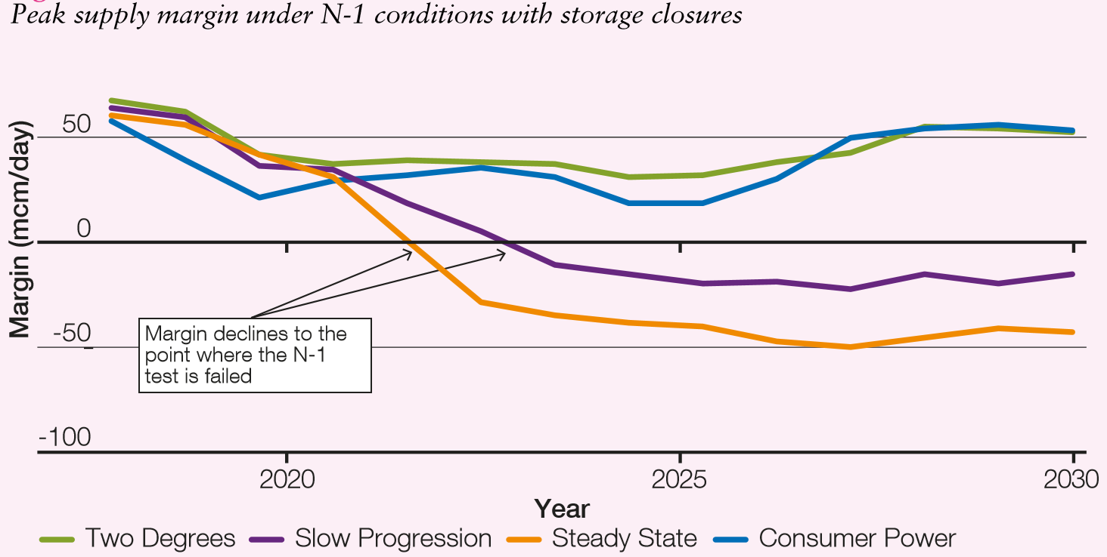
Figure 1: peak supply margin under N-1 conditions – Source National Grid
As the current UNC0621 proposal is set to increase annual costs for storage users by several millions pounds, the added burden will not only deter projects from moving forward, but will also put existing storage assets at risk of mothballing or closure, making failure of the N-1 test increasingly probable.
The cost of developing additional NTS Entry capacity is estimated using the Notice of Revised NTS Entry Capacity QSEC Reserve and Step Prices. The cost of adding an incremental 200 GWh/d (equivalent to 18 mcm/d) of NTS Entry Capacity to satisfy the N-1 test is in a range between £10m to £400m, with an average at £125m.
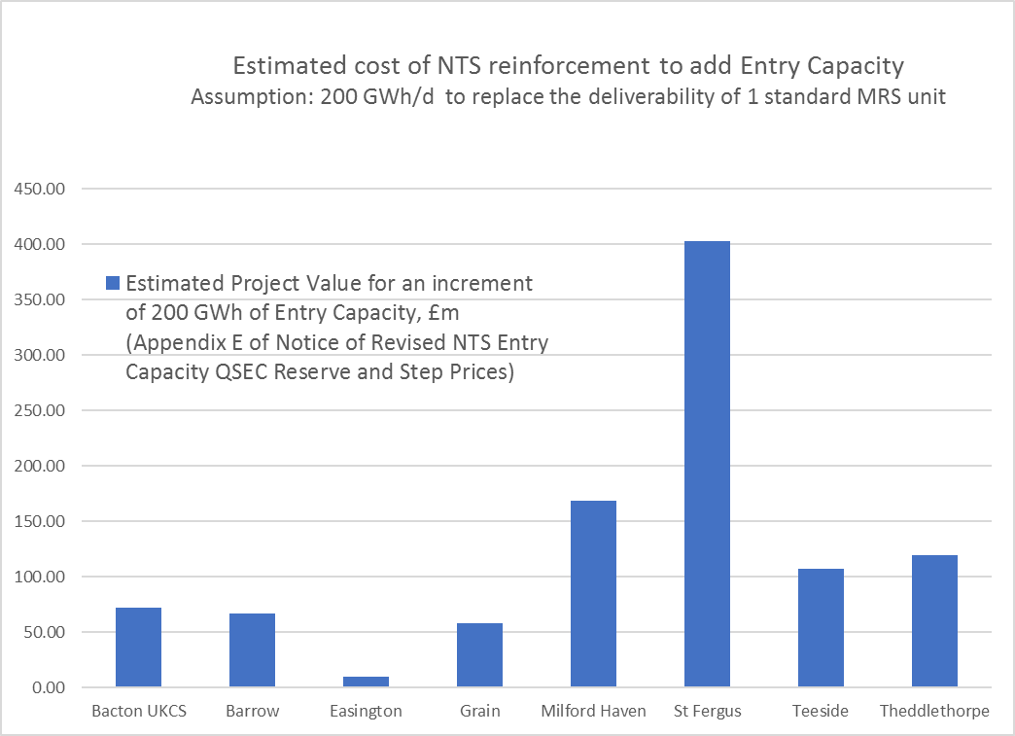
Figure 2: Estimated Project Value for 200 GWh of incremental Entry Capacity – Source Storengy UK based on National Grid figures

The cost of replacing Medium Range Storage (MRS) storage with new import capacity would far exceed the value of the 86% discount proposed for storage in UNC0621A. Based on simulations run using Transmission Services Model (v2.2), in the interim period the “Revenue from anticipated Capacity Booked” at storage points would only reduce by £1.6m on the exit side compared to the 50% discount proposed in UNC0621. On the entry side, no loss of revenue would occur because of the long term bookings already in place at storage points.
By reducing the cost burden added to gas storage compared to the UNC0621 proposal, UNC0621A reduces the probability of requiring NTS investment to replace storage deliverability with new entry capacity that would cost several tens of millions of pounds.

- Impact on SoS caused by the MRS lower ability to refill
The higher variable fees (NTS costs for injection and withdrawal of gas) incurred by storage users proposed in UNC0621 will limit their ability to capture short-term volatility in prices, which importantly are highly correlated with demand variations. Based on the model simulations provided by the Proposer of UNC0621, NTS entry costs for storage with a 50% discount would be around 0.15 p/th in the interim period, rising to around 0.50p/th from GY21/22. Additionally, the costs of Exit Capacity would jump from virtually zero, as storage users typically rely on off-peak capacity, to 0.20 – 0.35 p/th (assuming booking of interruptible capacity depending on site), which would bring the cost of cycling (injecting and withdrawing) gas on the NTS to 0.80 p/th, on top of the operators’ own variable costs.
MRS re-injection during the winter is triggered by very small spreads across varying time periods. If storage variable costs for cycling the gas were to include NTS fees at this level, the refilling of storage space over the periods of lower demand during the winter will become uneconomic. The fast-cycle storage assets may still be physically present, but their stock will have been used only once in the winter, prevented by punitive charging from re-stocking and thus unable to contribute as expected to late winter cold snaps.
On figure 3, it can be observed that the multiple refills of the Stublach storage, which allowed the stock position to be re-built by more than 60 mcm (orange arrow) before each cold spell.
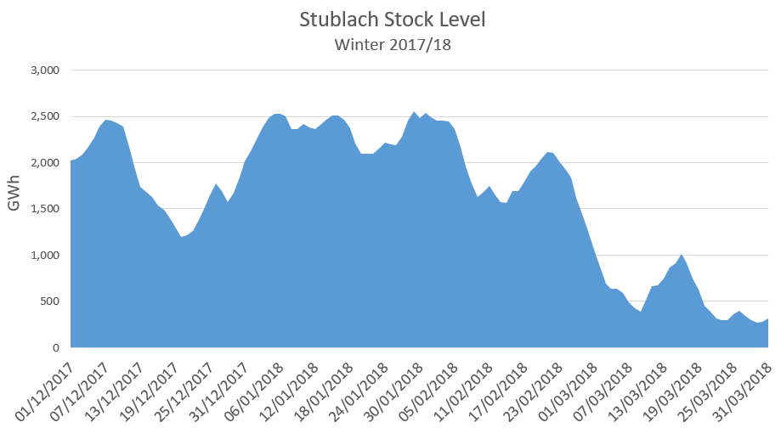

Figure 3: Stock of Stublach Gas Storage between 1st December 2017 and 31st March 2018 – Source Storengy UK

In addition to Entry capacity required to compensate for the possible loss of storage capacity (as seen above), it can be expected that new Entry Capacity would be required to make up for the reduced ability of MRS to refill in winter – and thus to deliver gas during the later cold spells of the winter flow gas in the event that UNC0621 was implemented. The alternative UNC0621A aims to preserve the ability of storage to perform its grid balancing function.

- Impact on the volatility and price level at the NBP
The UNC0621 will change the dynamics of access to the NBP for flexibility. The NBP is in competition with other European markets for LNG imports. Over the summer when LNG is relatively more abundant, the LNG market seeks the cost effective access to storage capacity. GB must ensure that the charging regime does not favour continental storage over local flexibility from UK assets. NBP liquidity and access to local storage flexibility is essential for security of supply, both in terms of physical resilience and price volatility.
There must be a level playing field in the flexibility market, especially with countries competing with GB for LNG in summer: according to ENTSOG current storage discounts applied in Spain are 100% and in France 85%, on average.
If GB charging results in storage being uncompetitive compared to storage on the continent, there is a risk that the LNG imports into Europe at times of lower demand (e.g. in Summer) bypass GB to head directly to continental hubs with better storage conditions. The NTS would become more dependent on just-in-time deliveries of gas and expose it to the vagaries of continental gas pricing; gas security protectionist measures; and the physical reliability of connecting infrastructure.. UNC0621A is more consistent with the level of storage discount offered on other LNG importing hubs.
In order to meet the higher capacity charges introduced by UNC0621, market prices will have to increase to higher extremes to allow the use of UK storage, this is likely to cause higher volatility and higher price time-spreads, and potentially higher costs to GB consumers as energy companies seek to compensate for the uncertainty. UNC0621A addresses that issue by reducing the cost of accessing the flexibility required to dampen price volatility.

- Unintended Consequences

- Impact on gas balancing costs
As National Grid state in their 2018 Summer Outlook, medium range storage “provides a valuable balancing option to the market close to real time”.
In practice, this option is valuable if price signals correctly incentivise market participants to balance the network efficiently.
Since 2011, the Default System Marginal Price (SMP) reflects the cost of linepack flexibility, considered to be a function of NTS compressors and pipeline space. The Default SMP for the gas year 2017/18 was set at 0.0452 p/kWh (1.32 p/th), which provides an incentive for network users to balance the grid without intervention of the TSO. This cost is regularly updated and has been higher than the short-term marginal cost of balancing using gas storages.

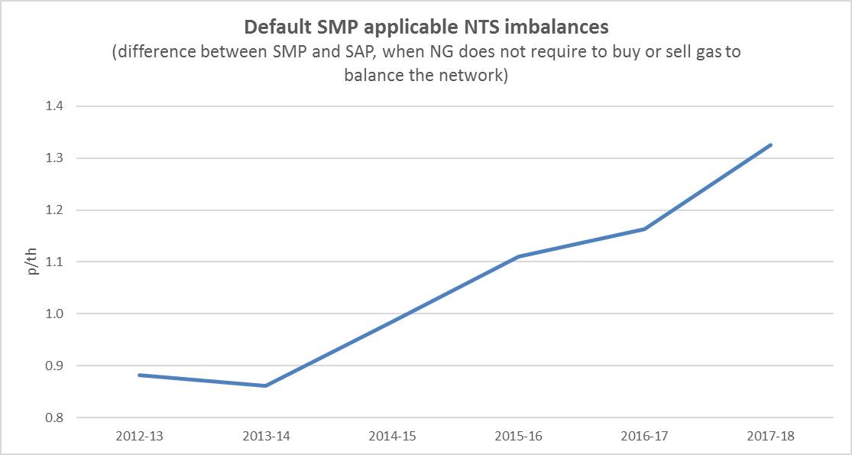
Figure 1: Default SMP the since GY2012 – Source National Grid MIPI Data
In a market based balancing regime, shippers balance their position to avoid exposure to the System Marginal Price. To achieve a balanced system, they rely on short-term flexible gas:
- using gas storage assets, and/or
- anticipating or deferring some imports or local production, and/or
- by adjusting demand.
Total marginal costs for these operations must be lower than SMP if the marginal price is to give any incentive to balance. As argued by National Grid in the final Modification Proposal for the UNC0333A back in 2011, “Reducing this incentive (to balance) will lead to greater industry costs through imbalance charges and residual balancing actions”. To ensure this incentive remains, the market must be given the means to provide flexibility to the grid at a lower cost than the linepack flexibility of the network.
Storengy as proposer of UNC0621A also notes that linepack flexibility does not attract capacity charging. As UNC0621 would make flexible gas less competitive compared to linepack, new arrangements could result in increased linepack requirements. This would mean more compressors and pipeline space must be added to the NTS in order to compensate for the reduction in the flexibility of flexible assets that have been pushed out of the competitive flexibility market.
If the short-term marginal cost of storage flows is significantly increased, because of UNC0621, the incentive for the competitive market to balance the grid will reduce. This will have negative consequences on the balancing costs, which are charged to gas shippers and passed on to consumers. UNC0621A mitigates the impact of UNC0621 as short-term marginal costs to balance the network would be lower for storage, closer to the existing level.

- Impact on the availability of flexible gas and on the operation of the NTS
The National Grid Future Energy Scenarios 2017 suggest, “the reduction in the availability of flexible supply would also increase the complexity of operating the NTS”.
The re-shuffle of short-term marginal costs will affect the availability of flexible gas. This is particularly true of changes resulting from UNC0621: lower discounts for short-term capacity combined with a larger share of the revenue eventually recovered through capacity rather than commodity charges. Any short-term decision not to flow after having bought the capacity will need to account for the relatively higher sunk cost of stranded capacity. This is in contrast with the current regime where the main cost driver (commodity) must be paid only after an actual flow. In turn, greater inflexibility of gas flows linked to short-term capacity bookings could make flexible gas much less reactive to price movements (see above).
As seen in the above, the Default SMP is at risk of becoming the next most competitive source of balancing for participants, when short-term import flexibility (imported gas from UKCS, NCS, LNG…) is exhausted or does not respond, particularly in winter. Market participants may adopt a wait-and-see approach to balancing during the day, adjusting their position through storage (including booking the daily NTS capacity) late in the day only if and when it becomes clear (through observed linepack depletion, price spikes on the OCM), that the cost of cash-out may be higher than the Default SMP.
UNC0621A corrects some of the negative impact introduced by UNC0621 caused by the change from a pay-as-flowed to a pay-as-booked-in-advance. Gas Storage users re-nominate multiple times within-day to balance the network. Lower costs applied to storage compared to UNC0621 will allow a better response of flexible gas to short-term market signals.

- Impact on the volatility and price level of the electricity market
Given the very large share of gas in the electricity mix, the impact on the volatility and price level of gas will feed into the power prices. Furthermore, as coal is being phased out and renewable production grows, gas is expected to provide increased flexibility to the electricity market.
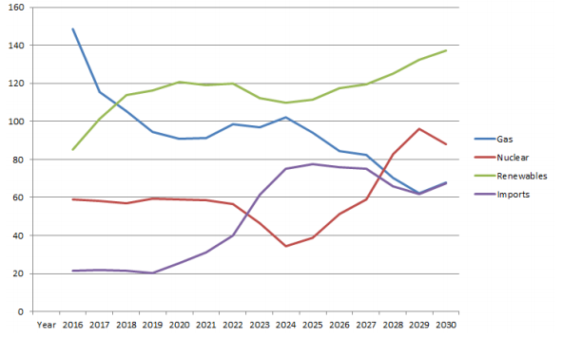
Figure 5: Projection of electricity generation by source (2016 estimates) – Source BEIS
The increase in volatility and reduced liquidity which would be caused byUNC0621, may in turn affect electricity price volatility and price level. The impact would be lower with UNC0621A, which helps mitigate the impact of the new charging regime on gas balancing.

Workgroup Statement
Statements from the Workgroup regarding this material would have been captured if further time had been available.
The Model for this Modification and supporting analysis spreadsheet can be found at: xxx
A guide to using the model can be found and the guide: xxx.
An Analysis Results Summary can be found at: xxx

- Relevant Objectives
Impact of the Modification on the Relevant Objectives:
Relevant Objective | Identified impact
a) Efficient and economic operation of the pipe-line system. | Positive
b) Coordinated, efficient and economic operation of  (i) the combined pipe-line system, and/ or  (ii) the pipe-line system of one or more other relevant gas transporters. | None
c) Efficient discharge of the licensee's obligations. | Positive
d) Securing of effective competition:  (i) between relevant shippers;  (ii) between relevant suppliers; and/or  (iii) between DN operators (who have entered into transportation arrangements with other relevant gas transporters) and relevant shippers. | Positive
e) Provision of reasonable economic incentives for relevant suppliers to secure that the domestic customer supply security standards… are satisfied as respects the availability of gas to their domestic customers. | None
f) Promotion of efficiency in the implementation and administration of the Code. | None
g) Compliance with the Regulation and any relevant legally binding decisions of the European Commission and/or the Agency for the Co-operation of Energy Regulators. | Positive
Demonstration of how the Relevant Objectives are furthered:

- Efficient and economic operation of the pipe-line system
Based on analysis carried out by Storengy and WWA there is a clear relationship between the physical operation of storage facilities and the pipe-line system. The strong, positive correlation between aggregate gas demand and storage withdrawals/injections means that National Grid, in its role as SO, benefits from gas storage, at no cost. The flexibility provided by gas storage provides direct support to National Grid in its role as system balancer through; contributing to linepack management ;and reduced activity and costs associated with National Grid’s participation in the balancing market (OCM) or any other contractual arrangements it may choose to enter into as part of its network balancing toolbox.
The level of discount should be consistent with the contribution to system flexibility (EU Tariff Code) and the proposer believes that the application of the minimum 50% discount does not fulfil this requirement. A discount of 50%, according to the EU Tariff Code simply avoids storage users being “double charged” for the use of the system. On this basis, the proposer contends that a discount of 86% not only better reflects the contribution made by storage facilities in relation to the efficient and economic operation of the pipe-line system, but also preserves the ability for gas storage to provide an economic means for balancing the pipeline system. The additional costs imposed on storage users through the application of the minimum 50% discount, and in particular the related significant escalation in the cost of off peak capacity, would result in undesirable market impacts, such as increased between day and within day price volatility. These market impacts conflict with this objective by inflating the costs associated with balancing the system.

c) Efficient discharge of the licensee's obligations.
The proposed changes to TPD B, EID B and Transition Document (where applicable) support the implementation of the new charging methodology and arrangements. Standard Special Condition A5(5) of the NTS Licence sets outs the relevant methodology objectives and Storengy believes that these objectives are better facilitated for the reasons detailed below (‘Impact of the Modification on the Relevant Charging Methodology Objectives’).

d) Securing of effective competition between relevant shippers;
The proposed changes to TPD B, EID B and Transition Document (where applicable) support the implementation of the new charging methodology and arrangements. To the extent that the application of a new Reference Price Methodology is expected to provide a more stable and predictable price setting regime, Shippers will have a greater level of confidence in their forecasts of prospective use of network costs and therefore set their own service costs more accurately (potentially with a lower risk margin) thereby enhancing effective competition.

g) Compliance with the Regulation and any relevant legally binding decisions of the European Commission and/or the Agency for the Co-operation of Energy Regulators.
The proposed changes to TPD B, EID B and Transition Document (where applicable) support the implementation of the new charging methodology and arrangements including those elements required to comply with the EU Tariff Code.

Impact of the Modification on the Relevant Charging Methodology Objectives:
Relevant Objective | Identified impact
a) Save in so far as paragraphs (aa) or (d) apply, that compliance with the charging methodology results in charges which reflect the costs incurred by the licensee in its transportation business; | Positive
aa) That, in so far as prices in respect of transportation arrangements are established by auction, either:  - no reserve price is applied, or  - that reserve price is set at a level -  (I) best calculated to promote efficiency and avoid undue preference in the supply of transportation services; and  (II) best calculated to promote competition between gas suppliers and between gas shippers; | Positive
b) That, so far as is consistent with sub-paragraph (a), the charging methodology properly takes account of developments in the transportation business; | Positive
c) That, so far as is consistent with sub-paragraphs (a) and (b), compliance with the charging methodology facilitates effective competition between gas shippers and between gas suppliers; and | Positive
d) That the charging methodology reflects any alternative arrangements put in place in accordance with a determination made by the Secretary of State under paragraph 2A(a) of Standard Special Condition A27 (Disposal of Assets). | None
e) Compliance with the Regulation and any relevant legally binding decisions of the European Commission and/or the Agency for the Co-operation of Energy Regulators. | Positive
This Modification proposal does not conflict with:

- paragraphs 8, 9, 10 and 11 of Standard Condition 4B of the Transporter's Licence; or
- paragraphs 2, 2A and 3 of Standard Special Condition A4 of the Transporter's Licence;
as the charges will be changed at the required times and to the required notice periods.

Demonstration of how the Relevant Objectives are furthered:
- Save in so far as paragraphs (aa) or (d) apply, that compliance with the charging methodology results in charges which reflect the costs incurred by the licensee in its transportation business;
Storengy believes that the proposal better reflects the costs incurred by the licensee. In particular, in relation to gas storage the application of an 86% discount combined with the non-application of Revenue Recovery Charges during the transition and enduring phases, better facilitates this objective. The requirement for a minimum 50% discount for storage related capacity in the EU Tariff Code insulates storage users from double charging and nothing more, however, given that storage facilities are embedded in the network and are unable to benefit from Optional Commodity Rates, its application results in a non-equitable allocation of costs.
As set out in the WWA paper (see footnote 8) the fact that flows to and from offtakes located close to storage facilities are cheaper, in terms of transportation costs, than the cost of flowing gas to the same offtakes, but via storage (including a 50% discount), suggests that a 50% discount is not cost reflective. The application of an 86% discount ensures that the costs incurred under these two flow scenarios are equivalent, and that the costs of transporting gas to and from storage are as cost reflective as the costs of transporting gas directly between non-storage entry points and non-storage exit points.
Further, the application of an 86% discount ensures that the benefits, or negative costs which are delivered by storage in terms of investment savings attributable to the transmission owner are to some degree represented in the cost of using storage (see WWA and Storengy reports, footnote 8).
The fact that the benefits of embedded entry points located within DN networks receive discounted DN transportation costs, or even credits, suggests that a discount which is set to singularly remove double charging is inconsistent with the approach taken in other pipeline networks. The additional level of discount provides a mechanism for recognising the benefits afforded by embedded entry points (and exit points) and is in line with the cost reflective charging methodologies approved and employed at the DN level
Finally, in relation to the application of Revenue Recovery Charges, the proposal recommends that no charges are applied to storage in either the transition or the enduring periods (note that Modification 0621 proposes that such charges should be applied to non-Historical Capacity holdings in the enduring period on a capacity top-up basis). Currently, storage flows are exempt from the application of TO Commodity Charges (the mechanism employed to recover revenues not recovered from the sale of capacity products). From 2019, Modification 0621 proposes the continuation of this approach. On the basis that it is accepted that storage flows and indeed storage related capacity bookings should not be double charged then it must be the case that whatever Revenue Recovery Charge mechanism is employed that storage users should be exempt from its application. This approach is consistent with the findings of Ofgem in its Gas Transmission Charging Review on the basis that flows to and from storage (or capacity booked at an entry to deliver gas to, or an exit point to ultimately offtake from) have already made a contribution to historical cost recovery (see WWA report footnote 8).
aa) That, in so far as prices in respect of transportation arrangements are established by auction with reserve prices set in accordance with the proposed discounts, either:
(i) no reserve price is applied, or
(ii) that reserve price is set at a level -
(I) best calculated to promote efficiency and avoid undue preference in the supply of transportation services; and
(II) best calculated to promote competition between gas suppliers and between gas shippers; and
c) That, so far as is consistent with sub-paragraphs (a) and (b), compliance with the charging methodology facilitates effective competition between gas shippers and between gas suppliers
Storengy believes that the proposed utilisation of a new Reference Price Methodology which re-distributes National Grid’s costs on a geographic basis, weighted by capacity will enhance cost reflectivity and competition between gas suppliers and between gas shippers when compared to the current application of a Long Run Marginal Cost Methodology (LRMC). The proposed model is better suited to the current and expected future usage of the NTS and the current model is more suitable for an expanding network requiring an investment based RPM.
A sub-group of the NTS Charging Methodology Forum identified that as the inputs into the LRMC model are varied the resulting price changes are not intuitive and the changes can cause unpredictable results, and the changes to prices can be volatile. As a result, similar offtake points (in terms of offtake volumes and distances from points of entry) may incur materially different charges. Use of a methodology which delivers more comparable costs would better facilitate these objectives
The application of an 86% discount and exemption from Revenue Recovery Charges for storage users better achieves this objective. Firstly, as described in the Storengy and WWA reports (footnote 8) gas storage provides shippers with access to physical flexibility to manage any physical portfolio imbalances which occur for a variety of reasons. Gas storage is an essential tool for a large number of shippers which contract directly with storage operators, but also provides wider benefits to all shippers as a result of enhanced security of supply and well-understood, significant, positive externalities. These wider benefits dampen price volatility and reduce the likelihood of network constraints, gas deficit issues and cost escalation (see WWA and Storengy reports, footnote 8).
In terms of cost distribution, analysis carried out by WWA and presented at the 28 March 2018 Modification 0621 Workgroup the impact on charges of applying an 86% discount is marginal. During the transition phase the entry CRRC (applied to non-IPs) and the entry capacity top up charge (applied to IPs) does not increase when compared with a 50% discount. At exit, the exit CRRC increases by 0.98% and the IP exit capacity top-up charge increases by 0.54%. In the enduring phase (Oct 2021) there is no perceptible increase in capacity charges as a result of the increase of the discount from 50% to 86%. On this basis, there is no cross-subsidy between storage and non-storage users, beyond perhaps that as a result of the security of supply and broader societal benefits (externalities) non-storage users are net beneficiaries of the 86% discount.
b) That, so far as is consistent with sub-paragraph (a), the charging methodology properly takes account of developments in the transportation business;
The update to the Transmission Services methodology proposal takes into account developments which have taken place in the transportation business, in particular that the network is no longer expanding. The development of storage assets connected to the transmission grid has also been
factored into the WWA analysis presented at the 28 March Workgroup (see footnote 9). Considering the lead time required for the development of such assets, assumptions on storage flows for the modelling of the impact of a discount of 86% on the CRRC capacity top up charges are robust for 5 years, at the very minimum.
e) Compliance with the Regulation and any relevant legally binding decisions of the European Commission and/or the Agency for the Co-operation of Energy Regulators.
The EU Tariff Code compliance is taken into account in this Modification proposal. Accordingly, implementation of this Proposal would ensure that the GB arrangements are compliant with the EU Tariff Code
- Legal Text

Text Commentary
The timescales for the provision of legal text were agreed at the 01 May 2018 meeting of Workgroup 0621:
- Provision of full Legal Text for UNC0621 plus completed table specifying the changes to be incorporated for each Alternatives Proposal by 5pm Tuesday 08 May 2018.
- Provision of full Legal Text for all Alternative Proposals by 5pm Monday 14 May 2018.
- Provision of Legal Text commentary for all Proposals by 5pm Friday 18 May 2018.

Text
To be provided later.

As described in Standard Special Condition A5: ‘Obligations as Regard Charging Methodology’ of the NTS Licence, paragraph 5.
http://www.gasgovernance.co.uk/sites/default/files/EU%20Tariff%20Code%20-%20final%20clean.pdf
https://www.ofgem.gov.uk/gas/transmission-networks/gas-transmission-charging-review
See https://www.gasgovernance.co.uk/ntscmf/subg1model
Paper produced by Waters Wye Associates setting out the basis for the discount can be found here https://www.gasgovernance.co.uk/sites/default/files/ggf/book/2017-12/WWA_GSOGMod621Alernate_coretextv2.0.pdf
The approach advocated is consistent with the principles introduced by UNC Modification 0534 ‘Maintaining the efficacy of the NTS Optional Commodity ('shorthaul') tariff at Bacton entry points’ which was implemented with effect from 01 August 2016.
Future Energy Scenarios July 2017
TAR NC Implementation Document – Second Edition September 2017
National Grid 2018 Summer Outlook
https://www.gasgovernance.co.uk/sites/default/files/ggf/Final%20Modification%20Report%200333%200333A%20including%20formal%20text%20v3.0.pdf
Future Energy Scenarios July 2017
WWA and Storengy papers can be found here. https://www.gasgovernance.co.uk/ntscmf/170717
https://www.gasgovernance.co.uk/0621/280318

