UNC Modification |  | At what stage is this document in the process?
UNC 0XXX:  Change to the Reconciliation Calculations |  | 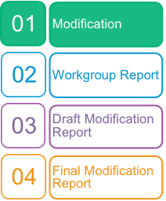
Purpose of Modification:
This Modification aims to incentivise Shippers to purchase the correct amount of gas, in advance of the gas day and support de-risking Shipper imbalance costs.
 | The Proposer recommends that this modification should be:  - considered a material change and not subject to self-governance  - assessed by a Workgroup  This modification will be presented by the Proposer to the Panel on XX. The Panel will consider the Proposer’s recommendation and determine the appropriate route.
 | High Impact:  Shippers
 | Medium Impact:  CDSP
 | Low Impact:

Contents  1 Summary 3  2 Governance 37  3 Why Change? 38  4 Code Specific Matters 39  5 Solution 39  6 Impacts & Other Considerations 40  7 Relevant Objectives 41  8 Implementation 41  9 Legal Text 42  10 Recommendations 42  Timetable |  Any questions?
  The Proposer recommends the following timetable:
  Initial consideration by Workgroup | XX
  Workgroup Report presented to Panel | 15 November 2018
  Draft Modification Report issued for consultation | 15 November 2018
  Consultation Close-out for representations | 07 December 2018
  Final Modification Report available for Panel | 11 December 2018
  Modification Panel decision | 20 December 2018
Contact:
Joint Office of Gas Transporters
 |  enquiries@gasgovernance.co.uk
 | 0121 288 2107
Proposer:
George MacGregor
 | georgemacgregor@utilita.co.uk
 | 07392 197 760
Transporter:
Insert name
 | email address
 | telephone
Systems Provider:
Xoserve
 | commercial.enquiries@xoserve.com
Other:
Insert name
 | email address
 | telephone

Summary
What
This Modification seeks to incentivise Shippers to accurately forecast and submit their Non-Daily Metered Nominations. It seeks to achieve this by changing the Imbalance and Reconciliation processes, specifically the way cashing out is calculated.
The options proposed within this modification seek to incentivise Shippers to accurately forecast and submit their Non-Daily Metered Nominations by changing the way cashing out is calculated.
Why
Shippers are currently dis-incentivised to forecast accurately for gas volumes and rely on NDM Deemed forecasts. This Modification seeks to incentivise Shippers to accurately forecast and contract volume. Ultimately, this will make for a more efficient settlement system as shippers who attempt to contract the correct volume of gas are simultaneously de-risking their cost to serve. The aggregate effect of this is to reduce imbalance at the NTS level.
Xoserve estimate Shippers’ daily offtakes using the NDM Deemed Allocation. Shippers provide their daily NDM nomination information to Xoserve via UKLink. Xoserve calculate the difference between this nomination and the NDM Deemed Allocation and the Shipper is then subject to an Imbalance Payment.
Imbalance payments pay out the difference between the Shipper’s Nomination and the NDM Deemed Allocation at SMSP/SMBP.
Shippers can then submit actual NDM meter reads into UKLink. The difference between the actual meter reads and the NDM Deemed allocation is then calculated and a reconciliation payment is made to the Shipper. These payments are made at SAP.
The fact that different system prices are used for these calculations creates a financial disincentive for Shipper’s to submit accurate forecasts. Purchasing over or under your NDM Deemed allocation creates artificial winners and losers, due to the usage of different system prices in Imbalance and Reconciliation processes.
These proposals aim to drive the correct behaviours in the market and reward those forecast correctly. This change therefore supports effective market competition.
The examples below illustrate the behaviour currently incentivised.
Example One- For Information Only
The graph below shows the behaviour encouraged by using different system prices at Imbalance and Reconcilation.
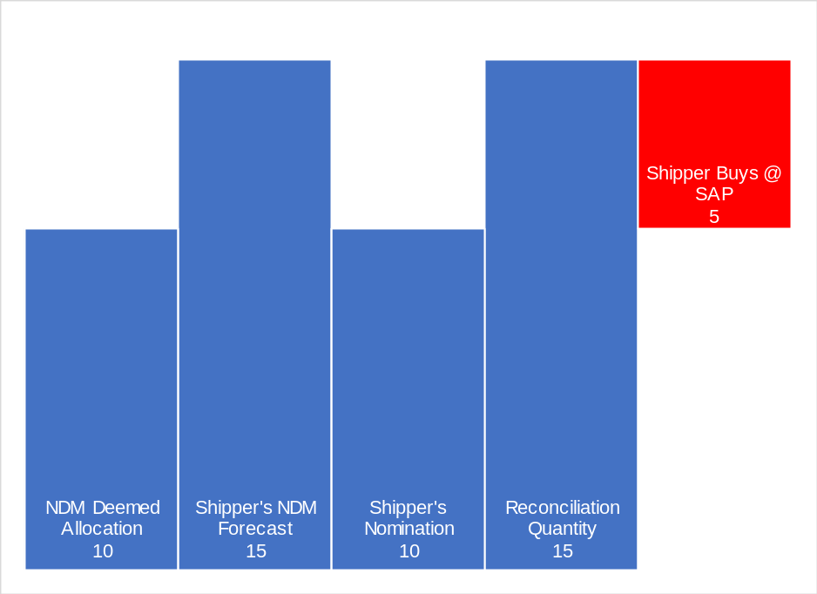
- An initial NDM Deemed Allocation is calculated by Xoserve using the forecasting alogorithm
- The Shipper creates their own forecast and believes they will require more than the Deemed Allocation
- The Shipper acquires and contracts as per the NDM Deemed Allocation
- There is no difference between the Shipper’s contracted volume and the NDM Deemed Allocation, therefore no Imbalance payment is made.
- Meter Reads are submitted and a Daily Reconcliation Quantity is calculated
- The reconciliation quantity shows the Shipper’s own forecast was correct
- The Shipper Buys the Reconciliation quantity at System Average Price

Example Two- For Information Only
The example below shows the current processes if a Shipper were to contract above their NDM Deemed Allocation. Submission of Reconciliation metered volumes shows this volume forecast to be accurate, however the use of SMP and SAP at distinct stages results in a monetary loss to the Shipper.
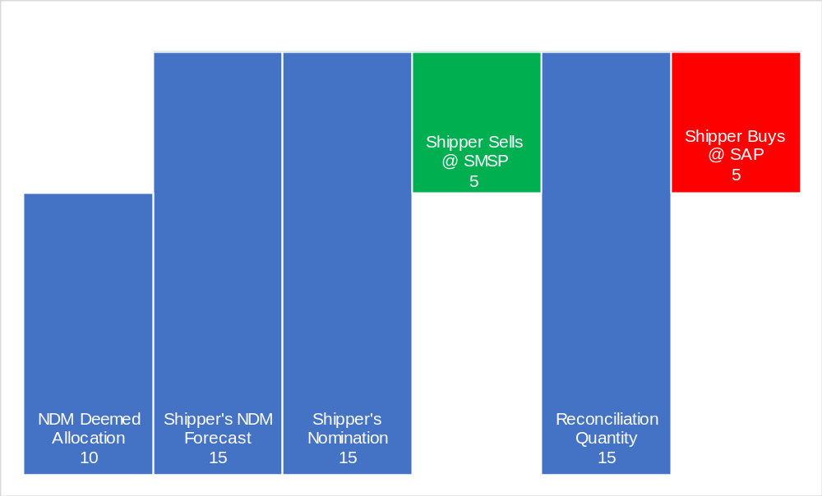
- An initial NDM Deemed Allocation is calculated by Xoserve using the forecasting alogorithm
- The Shipper creates their own forecast and believes they will require more gas than the NDM Deemed Allocation suggests
- The Shipper contracts volume as per their own Forecast
- The Imbalance process results in the Shipper being cashed out to their initial NDM Deemed Allocation level. In this example the Shipper is “long” and therefore sells the volume difference at System Marginal Sell Price.
- Meter Reads are submitted and a Daily Reconcliation Quantity is calculated. The reconciliation quantity shows the Shipper’s own forecast was correct.
- The reconciliation quantity is the same volume as sold during the Imbalance process, however the Shipper must pay at SAP.
This means that two separate payments have been made:
- The difference between the NDM Deemed Allocation and the Shipper’s Nomination, paid to the Shipper at SMSP.
- The difference between the NDM Deemed Allocation and the final Reconcilition Quantity, paid by the Shipper at SAP.

 | kWh | p/kWh | Cost
NDM Deemed Allocation | 10
Shipper's NDM Forecast | 15
Shipper's Nomination | 15
Shipper Sells @ SMSP | 5 | 1.4 | 7
Reconciliation Quantity | 15
Shipper Buys @ SAP | -5 | 1.5 | -7.5
Differential |  |  | -0.5
In this example, as a result of the Shipper’s accurate forecast, the volumes settled in each process are equal but opposite. However, the Shipper takes a financial hit equal to the difference between SMSP and SAP multiplied by the reconciled volume.
Example Three- For Information Only
The example below shows the current processes if a Shipper were to submit a forecast below their NDM Deemed Allocation. Submission of Reconciliation metered volumes shows this volume forecast to be accurate, however the use of SMP and SAP results in a monetary loss to the Shipper.
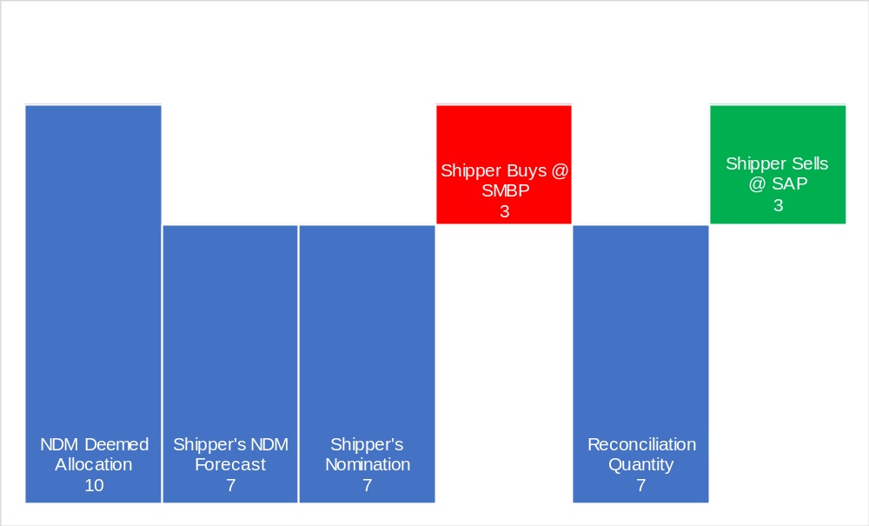
- An initial NDM Deemed Allocation is calculated by Xoserve using the forecasting alogorithm
- The Shipper creates their own forecast and believes they will require less gas than the NDM Deemed Allocation suggests
- The Shipper acquires and Nominates volume as per their own Forecast
- The Imbalance process results in the Shipper being cashed out to their initial NDM Deemed Allocation level. In this example the Shipper is “short” and therefore Buys at SMBP.
- Meter Reads are submitted and a Daily Reconcliation Quantity is calculated. The reconciliation quantity shows the Shipper’s own forecast was correct.
The reconciliation quantity is the exact same volume as paid out as a result of the Imbalance process, however here the Shipper Sells at SAP.
 | kWh | p/kWh | Cost
NDM Deemed Allocation | 10
Shipper's NDM Forecast | 7
Shipper's Nomination | 7
Shipper Buys @ SMBP | -3 | 1.6 | -4.8
Reconciliation Quantity | 7
Shipper Sells @ SAP | 3 | 1.5 | 4.5
Differential |  |  | -0.3

Materiality
We have performed analysis to provide context and an indication of the materiality of the issue which our proposal seeks to address. The following analysis should give a feel for the risk introduced by using actual system prices (SSP/SBP vs SAP) for the Imbalance and Reconciliation processes.
We have gathered 851 days worth of system price and volume allocation data from National Grid’s Transmission operational data (http://mip-prod-web.azurewebsites.net/DataItemExplorer/Index). System Average, Buy and Sell prices are all taken from National Grid and are the actual system prices for each date. The allocation data is also real data and represents the total amount of gas allocation (in kTh) for each given date (converted from Grid’s kWh value at the standard 29.3071 kWh/therm).
We have then constructed two theoretical market participants’ processes, a Small Supplier and a Large Supplier. The Small Supplier has a 1% market share and the Large Supplier has a 15% market share, for the purposes of our model these percentages equate to a share of the total allocation, as provided by the National Grid data. Building further upon this, we then construct three reconciliation scenarios for each Supplier: a 1%, 5% and 10% reconciliation run. To calculate the risk introduced, we first take the maximum absolute variance between SBP-SAP and SSP-SAP. This variance represents the theoretical maximum impact the use of SSP/SBP for one process and SAP for another could have.
This maximum absolute variance is then multiplied by the total allocation for the day, to create a theoretical maximum impact of the issue across the entire market. This maximum is then apportioned based on the market share we assigned to the Large and Small Supplier. Finally, this value is then broken down into various potential reconciliation quantities to give a feel for a potential impact. This then produces a maximum value for each reconciliation scenario on each date.
We have summarised the results in the table below. An average monthly risk has been calculated by taking an average across every day (851 days) of results and multiplying this by 30.5 (average no. days in a month) to give a feel for average monthly risk. The results are provided in the table below.
Average Monthly Risk
Large Supplier - 1% Reconciled | £84,324
Large Supplier - 5% Reconciled | £421,622
Large Supplier - 10% Reconciled | £843,245
Small Supplier - 1% Reconciled | £5,622
Small Supplier - 5% Reconciled | £28,108
Small Supplier - 10% Reconciled | £56,216
The full set of data and analysis is included as Appendix A: Imbalance Reconciliation Materiality Data
How
This Modification proposes three options for consideration:
Solution A1 – Adjust Reconciliation payments to be made at SMSP/SMBP
In the case of purchasing more gas than the National Grid forecast volume:
- If the Reconciliation Meter Reading is above the National Grid forecast volume then:
  - The Reconciliation Calculation shall require Shippers to pay SMSP multiplied by the difference between the National Grid forecast volume and the lower of:
    - the purchased gas; or
    - the Reconciliation Meter Reading
  - where the Reconciliation Meter Reading is greater than the purchased gas. The Reconciliation Calculation shall require shippers to pay the difference between the purchased gas and the Reconciliation Meter Reading multiplied by the SAP.
- If the Reconciliation Meter Reading is below the National Grid forecast volume then:
  - The Reconciliation Calculation shall require Shippers to pay the difference between the National Grid forecast volume and the Reconciliation Meter Reading multiplied by the SAP.
In the case of purchasing less gas than the National Grid forecast volume:
- If the Reconciliation Meter Reading is below the National Grid forecast volume then:
  - The Reconciliation Calculation shall require Shippers to pay SMBP multiplied by the difference between the National Grid forecast volume and the higher of:
    - the purchased gas; or
    - the Reconciliation Meter Reading
  - where the Reconciliation Meter Reading is less than the purchased gas. The Reconciliation Calculation shall require Shippers to pay the difference between the purchased gas and the Reconciliation Meter Reading multiplied by the SAP.
- If the Reconciliation Meter Reading is above the National Grid forecast volume then:
  - The Reconciliation Calculation shall require Shippers to pay the difference between the National Grid forecast volume and the Reconciliation Meter Reading multiplied by the SAP.

Governance

Justification for Authority Direction
Authority Direction – this modification impacts the settlement calculations and would therefore have a material impact on competition.

Requested Next Steps
This modification should be:
- be considered a material change and not subject to self-governance;
- be assessed by a Workgroup.
This change must be fully impact assessed by a Workgroup to ensure that all unintended consequences of the modification are identified and addressed, where required. Furthermore, the modification sets out the required outcomes, the outcomes can be achieved through several options described in the Modification and there may be other alternative solutions – therefore a Workgroup will need to assess the options and support the development of the solution.

Why Change?
What the drive is and which parties are impacted:
The driver of this modification is to incentivise Shippers to accurately contract NDM volumes. The Parties most heavily impacted by the Modification will be Shippers and the CDSP (due to system changes required.)
Why this is a Code matter:
Changes would be required to Imbalance and Reconciliation processes, both of which are defined in the UNC.
What the effects are should the change not be made:
The old Imbalance and Reconciliation processes remain unchanged and Shippers remain dis-incentivised to accurately forecast

Code Specific Matters

Reference Documents
N/A

Knowledge/Skills
Imbalance Process
Reconciliation Process

Solution
Solution A
Legal text to be completed through workgroup development.
Worked Examples - For Information Only
Solution A – Worked Examples – For Information Only
Solution A Scenario A – Shipper Purchases above NDM Deemed Allocation
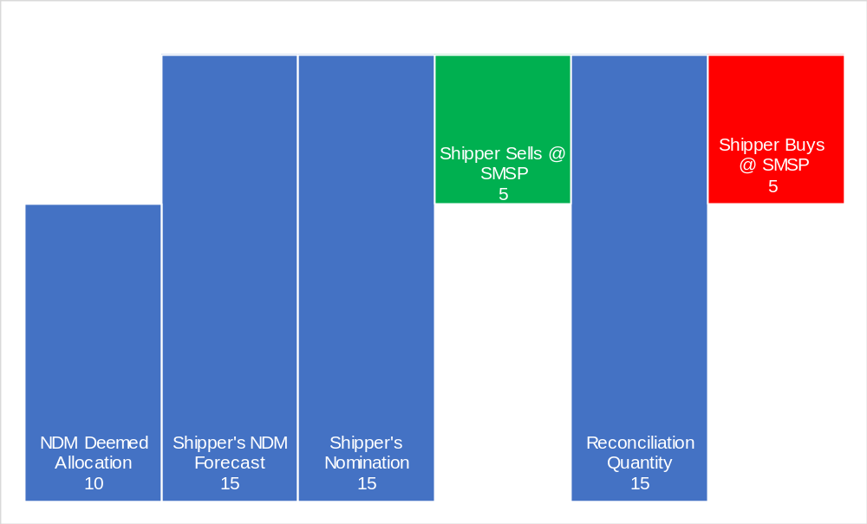
In the diagram above the Shipper is cost neutral for the gas it purchased in advance of the Gas Day.
- The NDM Deemed Allocation is produced by Xoserve using the forecasting algorithm
- The Shipper creates their own forecast and believes they will require more gas than the NDM Deemed Allocation suggests
- The Shipper acquires and Nominates volume as per their own Forecast
- The Imbalance process results in the Shipper being cashed out to their initial NDM Deemed Allocation level. In this example the Shipper is “long” and therefore Sells at SMSP.
- Meter Reads are submitted and a Daily Reconcliation Quantity is calculated. The reconciliation quantity shows the Shipper’s own forecast was correct.
- The reconciliation quantity is the exact same volume as paid out as a result of the Imbalance process. The shipper Buys at SMSP.
 | kWh | p/kWh | Cost
NDM Deemed Allocation | 10
Shipper's NDM Forecast | 15
Shipper's Nomination | 15
Shipper Sells @ SMSP | 5 | 1.4 | 7
Reconciliation Quantity | 15
Shipper Buys @ SMSP | -5 | 1.4 | -7
Differential |  |  | 0

Solution A Scenario B – Shipper Purchases above NDM Deemed Allocation but below Reconciled Usage – For Information Only
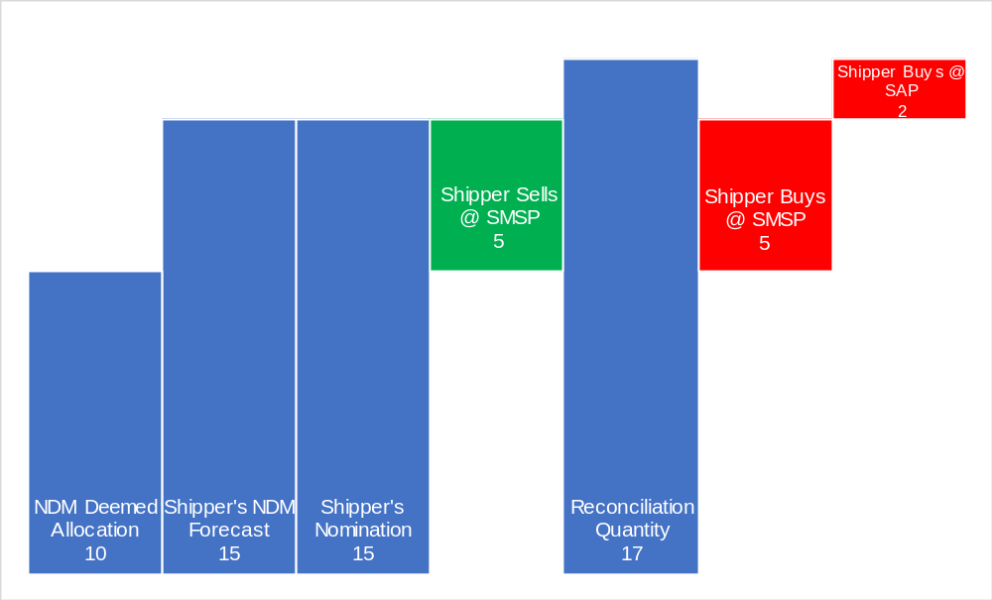
In the graph above the Shipper is not punished for purchasing above the NDM Deemed Allocation however they are still penalised for underforecasting.
- The NDM Deemed Allocation is produced by Xoserve using the forecasting algorithm
- The Shipper creates their own forecast and believes they will require more gas than the NDM Deemed Allocation suggests
- The Shipper acquires and Nominates volume as per their own Forecast
- The Imbalance process always results in the Shipper being cashed out back to their initial NDM Deemed Allocation level. In this example the Shipper is “long” and therefore Sells SMSP.
- Meter Reads are submitted and a Daily Reconcliation Quantity is calculated. The reconciliation quantity shows the Shipper’s own forecast was too low.
- The reconciliation quantity is the higher than the volume as paid out as a result of the Imbalance process. The shipper Buys SMSP up to the level of their submitted NDM Nomination. The volume above that forecasted by the Shipper is paid by them at SAP.
 | kWh | p/kWh | Cost
NDM Deemed Allocation | 10
Shipper's NDM Forecast | 15
Shipper's Nomination | 15
Shipper Sells @ SMSP | 5 | 1.4 | 7
Reconciliation Quantity | 17
Shipper Buys @ SMSP | -5 | 1.4 | -7
 |  |  | 0
Shipper Buys @ SAP | -2 | 1.5 | -3
Differential |  |  | -3

Solution A Scenario C – Shipper Purchases above NDM Deemed Allocation but Reconciled Usage is in-between – For Information Only
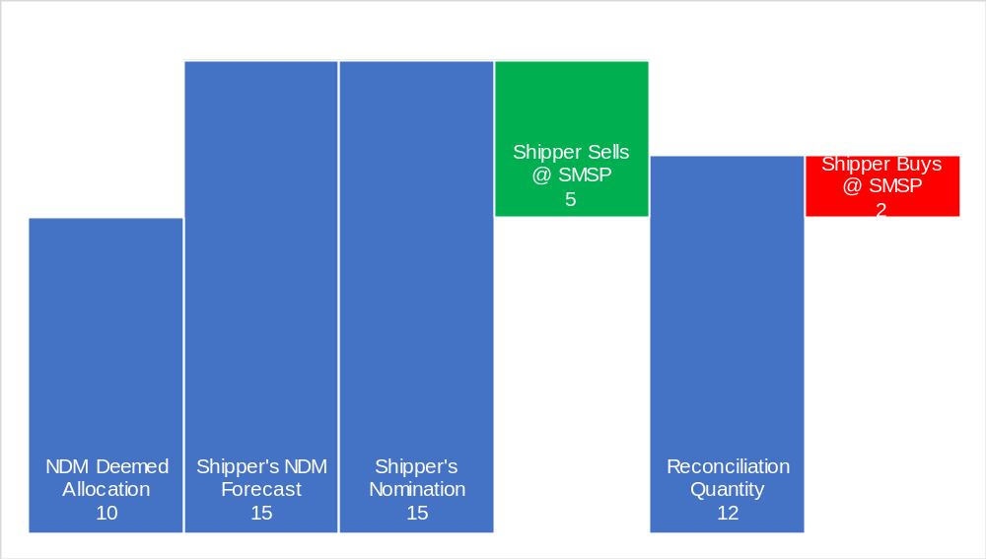
In the diagram above the Shipper is penalised for over purchasing gas but not penalised for purchasing more gas than the National Grid forecast.
- The NDM Deemed Allocation is produced by Xoserve using the forecasting algorithm
- The Shipper creates their own forecast and believes they will require more gas than the NDM Deemed Allocation suggests
- The Shipper acquires and Nominates volume as per their own Forecast
- The Imbalance process always results in the Shipper being cashed out back to their initial NDM Deemed Allocation level. In this example the Shipper is long and therefore Sells at SMSP.
- Meter Reads are submitted and a Daily Reconcliation Quantity is calculated. The reconciliation quantity shows the Shipper’s own forecast was too high.
- The reconciliation quantity is the lower than the volume as paid out as a result of the Imbalance process but higher than the NDM Deemed Allocation. The shipper Buys at SMSP up to the Reconciliation Quanity
 | kWh | p/kWh | Cost
NDM Deemed Allocation | 10
Shipper's NDM Forecast | 15
Shipper's Nomination | 15
Shipper Sells @ SMSP | 5 | 1.4 | 7
Reconciliation Quantity | 12
Shipper Buys @ SMSP | -2 | 1.4 | -2.8
Differential |  |  | 4.2

Solution A Scenario D – Shipper Purchases Below NDM Deemed Allocation – For Information Only
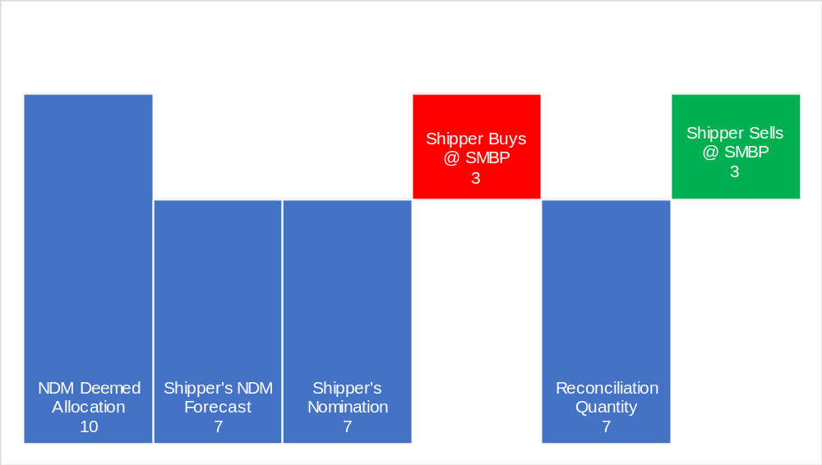
In the diagram above the Shipper is penalised for under purchasing gas but not penalised for purchasing less gas than the National Grid forecast.
- The NDM Deemed Allocation is produced by Xoserve using the forecasting algorithm
- The Shipper creates their own forecast and believes they will require less gas than the NDM Deemed Allocation suggests
- The Shipper acquires and Nominates volume as per their own Forecast
- The Imbalance process always results in the Shipper being cashed out back to their initial NDM Deemed Allocation level. In this example the Shipper is short and therefore must pay at SMBP.
- Meter Reads are submitted and a Daily Reconcliation Quantity is calculated. The reconciliation quantity shows the Shipper’s own forecast was correct.
- The reconciliation quantity is the same as the Shipper’s own NDM forecast and their initial submitted nomination. The shipper Sells SMBP.
 | kWh | p/kWh | Cost
NDM Deemed Allocation | 10
Shipper's NDM Forecast | 7
Shipper's Nomination | 7
Shipper Buys @ SMBP | -3 | 1.6 | -4.8
Reconciliation Quantity | 7
Shipper Sells @ SMBP | 3 | 1.6 | 4.8
Differential |  |  | 0

Solution A2 – Adjust Imbalance Payments to be made at SAP
This solution proposes that all Imbalance payments are made at SAP (regardless of whether the Shipper is long/short or has over/under forecasted.) This would be a slightly less punitive model than Solution A1.
Solution A2 – Worked Examples – For Information Only
Solution A2 Scenario A – Shipper Purchases above NDM Deemed Allocation – For Information Only
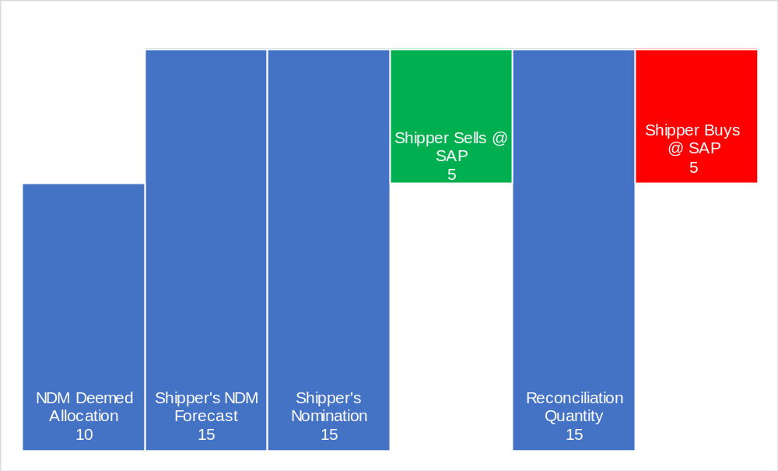
In the diagram above the Shipper is cost neutral for the gas it purchased in advance of the Gas Day.
- The NDM Deemed Allocation is produced by Xoserve using the forecasting algorithm
- The Shipper creates their own forecast and believes they will require more gas than the NDM Deemed Allocation suggests
- The Shipper acquires and Nominates volume as per their own Forecast
- The Imbalance process results in the Shipper being cashed out to their initial NDM Deemed Allocation level. In this example the Shipper is “long” and therefore Sells at SAP.
- Meter Reads are submitted and a Daily Reconcliation Quantity is calculated. The reconciliation quantity shows the Shipper’s own forecast was correct.
- The reconciliation quantity is the exact same volume as paid out as a result of the Imbalance process. The shipper Buys at SAP.
 | kWh | p/kWh | Cost
NDM Deemed Allocation | 10
Shipper's NDM Forecast | 15
Shipper's Nomination | 15
Shipper Sells @ SAP | 5 | 1.5 | 7.5
Reconciliation Quantity | 15
Shipper Buys @ SAP | -5 | 1.5 | -7.5
Differential |  |  | 0

Solution A2 Scenario B – Shipper Purchases above NDM Deemed Allocation but below Reconciled Usage – For Information Only
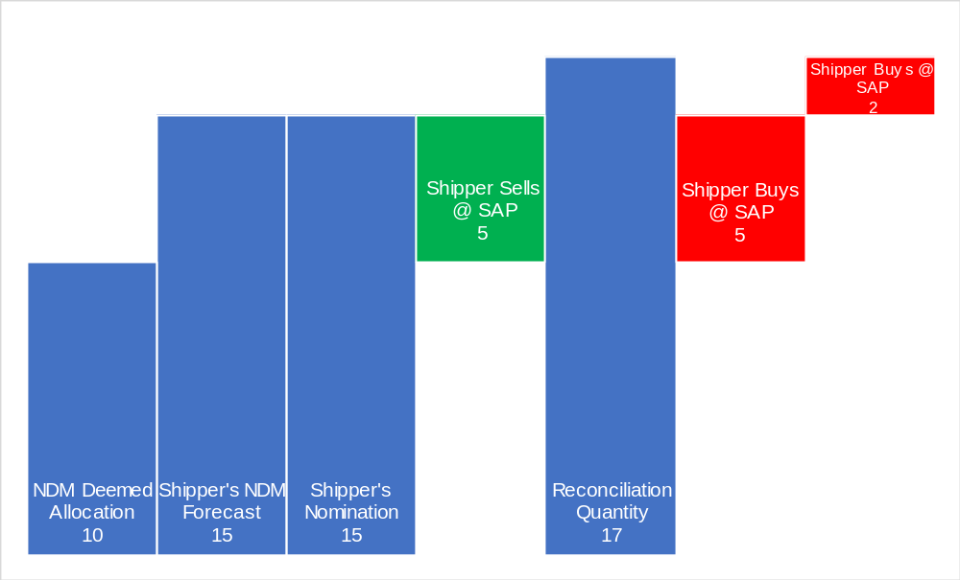
In the graph above the Shipper is not punished for purchasing above the NDM Deemed Allocation however they are still penalised for underforecasting.
- The NDM Deemed Allocation is produced by Xoserve using the forecasting algorithm
- The Shipper creates their own forecast and believes they will require more gas than the NDM Deemed Allocation suggests
- The Shipper acquires and Nominates volume as per their own Forecast
- The Imbalance process always results in the Shipper being cashed out back to their initial NDM Deemed Allocation level. In this example the Shipper is “long” and therefore Sells SAP.
- Meter Reads are submitted and a Daily Reconcliation Quantity is calculated. The reconciliation quantity shows the Shipper’s own forecast was too low.
- The reconciliation quantity is the higher than the volume as paid out as a result of the Imbalance process. The Shipper buys all of the volume at SAP.
 | kWh | p/kWh | Cost
NDM Deemed Allocation | 10
Shipper's NDM Forecast | 15
Shipper's Nomination | 15
Shipper Sells @ SAP | 5 | 1.5 | 7.5
Reconciliation Quantity | 17
Shipper Buys @ SAP | -5 | 1.5 | -7.5
Shipper Buys @ SAP | -2 | 1.5 | -3
Differential |  |  | -3

Solution A2 Scenario C – Shipper Purchases above NDM Deemed Allocation but Reconciled Usage is in-between – For Information Only
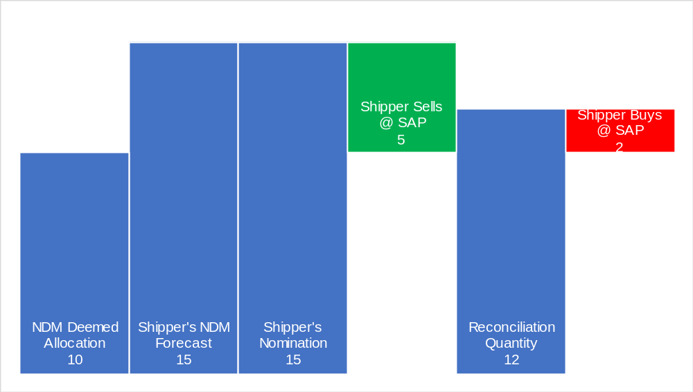
In the diagram above the Shipper is penalised for over purchasing gas but not penalised for purchasing more gas than the National Grid forecast.
- The NDM Deemed Allocation is produced by Xoserve using the forecasting algorithm
- The Shipper creates their own forecast and believes they will require more gas than the NDM Deemed Allocation suggests
- The Shipper acquires and Nominates volume as per their own Forecast
- The Imbalance process always results in the Shipper being cashed out back to their initial NDM Deemed Allocation level. In this example the Shipper is long and therefore Sells at SAP.
- Meter Reads are submitted and a Daily Reconcliation Quantity is calculated. The reconciliation quantity shows the Shipper’s own forecast was too high.
- The reconciliation quantity is the lower than the volume as paid out as a result of the Imbalance process but higher than the NDM Deemed Allocation. The shipper Buys at SAP up to the Reconciliation Quanity
 | kWh | p/kWh | Cost
NDM Deemed Allocation | 10
Shipper's NDM Forecast | 15
Shipper's Nomination | 15
Shipper Sells @ SAP | 5 | 1.5 | 7.5
Reconciliation Quantity | 12
Shipper Buys @ SAP | -2 | 1.5 | -3
Differential |  |  | 4.5

Solution A2 Scenario D – Shipper Purchases Below NDM Deemed Allocation – For Information Only
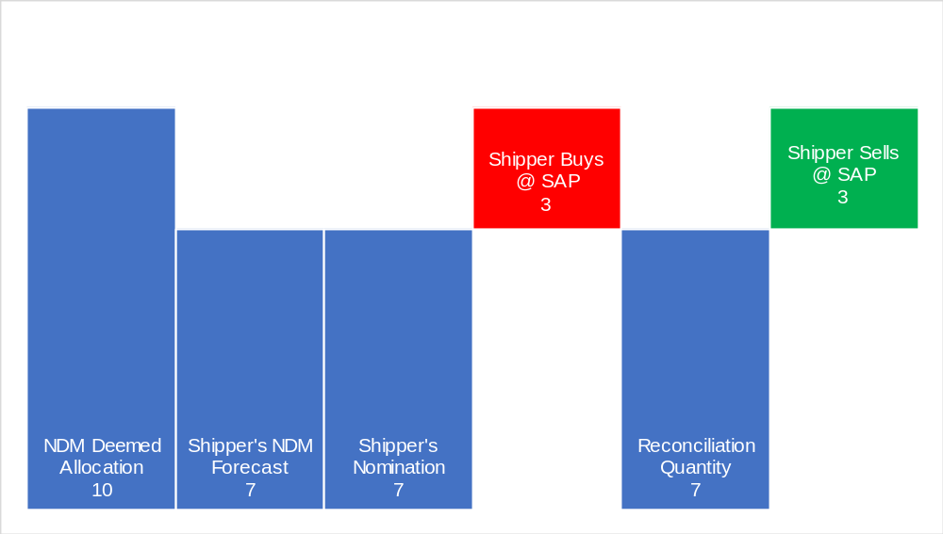
In the diagram above the Shipper is penalised for under purchasing gas but not penalised for purchasing less gas than the National Grid forecast.
- The NDM Deemed Allocation is produced by Xoserve using the forecasting algorithm
- The Shipper creates their own forecast and believes they will require less gas than the NDM Deemed Allocation suggests
- The Shipper acquires and Nominates volume as per their own Forecast
- The Imbalance process always results in the Shipper being cashed out back to their initial NDM Deemed Allocation level. In this example the Shipper is short and therefore must pay at SAP.
- Meter Reads are submitted and a Daily Reconcliation Quantity is calculated. The reconciliation quantity shows the Shipper’s own forecast was correct.
- The reconciliation quantity is the same as the Shipper’s own NDM forecast and their initial submitted nomination. The shipper Sells at SAP.
 | kWh | p/kWh | Cost
NDM Deemed Allocation | 10
Shipper's NDM Forecast | 7
Shipper's Nomination | 7
Shipper Buys @ SAP | -3 | 1.5 | -4.5
Reconciliation Quantity | 7
Shipper Sells @ SAP | 3 | 1.5 | 4.5
Differential |  |  | 0

Solution B – Mirror Electricity Settlement/Imbalance Arrangements and set SBP equal to SSP within each Settlement Period
This solution would seek to mirror the Electricity imbalance arrangements and seek to set a single marginal price for all transactions based on the net imbalance of the system.
- When the system as a whole is short, take the current SBP as the single cash out price
- When the system as a whole is long, take the current SSP as the single cash out price.
This solution provides a greater incentive for shippers to balance their own position but it will result in a more volatile cash out price. We believe this solution would have the greatest impact on the gas market, as it would introduce a new set of incentives to market participants.
For the purposes of this solution we envisage a settlement period being one gas day.
Legal Text to be developed through workgroup development.

Solution B – Example One – For Information Only
In this example, the entire gas system is short, therefore all transactions are made at SMBP.
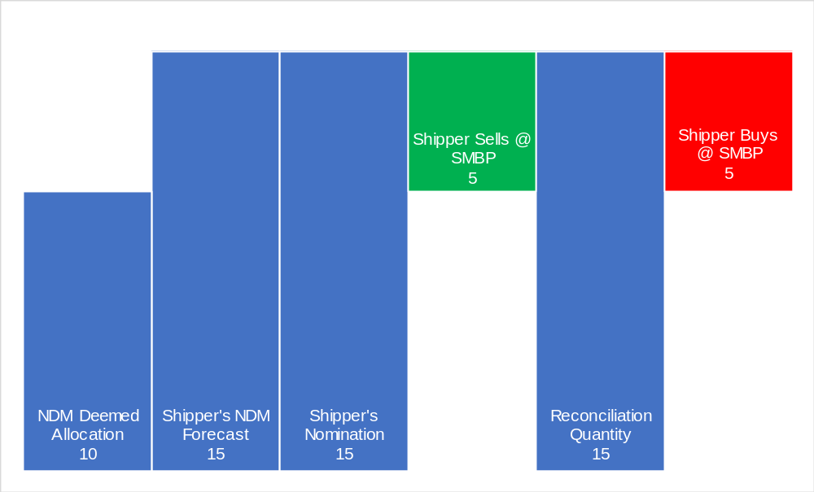
- The NDM Deemed Allocation is produced by Xoserve using the forecasting algorithm
- The Shipper creates their own forecast and believes they will require more gas than the NDM Deemed Allocation suggests
- The Shipper acquires and Nominates volume as per their own Forecast
- The Imbalance process results in the Shipper being cashed out to their initial NDM Deemed Allocation level. In this example the entire system is short, therefore the shipper sells at SMBP.
- Meter Reads are submitted and a Daily Reconcliation Quantity is calculated. The reconciliation quantity shows the Shipper’s own forecast was correct.
- The reconciliation quantity is the exact same volume as paid out as a result of the Imbalance process. The shipper Buys at SMBP.

 | kWh | p/kWh | Cost
NDM Deemed Allocation | 10
Shipper's NDM Forecast | 15
Shipper's Nomination | 15
Shipper Sells @ SMBP | 5 | 1.6 | 8
Reconciliation Quantity | 15
Shipper Buys @ SMBP | -5 | 1.6 | -8
Differential |  |  | 0

Solution B – Example 2 – For Information Only
In this example, the entire gas system is long, therefore all transactions are made at SMSP.
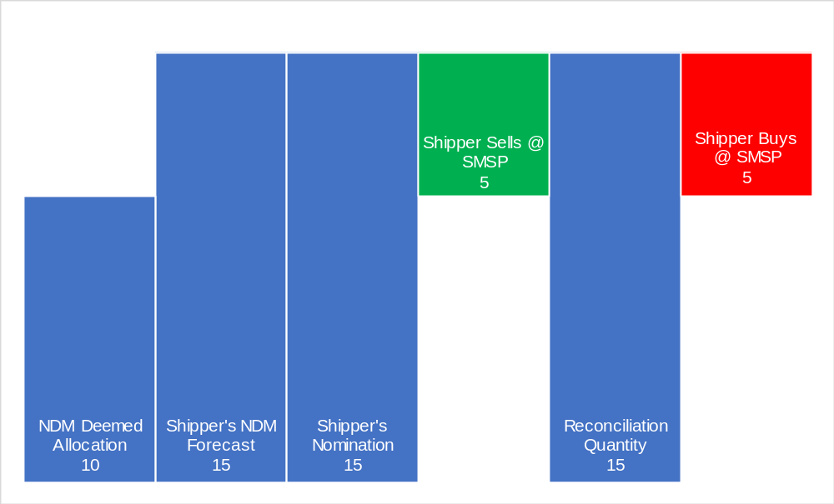
- The NDM Deemed Allocation is produced by Xoserve using the forecasting algorithm
- The Shipper creates their own forecast and believes they will require more gas than the NDM Deemed Allocation suggests
- The Shipper acquires and Nominates volume as per their own Forecast
- The Imbalance process results in the Shipper being cashed out to their initial NDM Deemed Allocation level. In this example the entire system is “long” and therefore the Shipper sells at SMSP.
- Meter Reads are submitted and a Daily Reconcliation Quantity is calculated. The reconciliation quantity shows the Shipper’s own forecast was correct.
- The reconciliation quantity is the exact same volume as paid out as a result of the Imbalance process. The shipper Buys at SMSP.
 | kWh | p/kWh | Cost
NDM Deemed Allocation | 10
Shipper's NDM Forecast | 15
Shipper's Nomination | 15
Shipper Sells @ SMSP | 5 | 1.4 | 7
Reconciliation Quantity | 15
Shipper Buys @ SMSP | -5 | 1.4 | -7
Differential |  |  | 0

Solution C - Imbalance Reconciliation Process
This solution would see no changes to the existing Imbalance and Reconciliation processes.
A new process could be introduced which would calculate a credit or debit to the Shipper:
- Take the Shipper’s Imbalance Quantity and the SMP at which the imbalance was cashed-out (SMPB or SMPS)
- Take the Shipper’s Reconciliation Quantity and Imbalance Quantity. Provided both are in the same direction (long/short) then take the lower of the two quantities as the Imbalance Reconciliation Quantity.
- Calculate the difference between the applicable SMP and SAP
- Multiply the difference between the Reconciliation Quantity and the Imbalance Quantity by the price differential between SMP and SAP

There would be no anticipated changes required to the following processes:
- Daily energy imbalance
  - SMP Buy/Sell used for energy imbalance calculation
  - Daily energy imbalance (closed-out) position – not updated as a consequence of meter point reconciliation
- UIG (charged at SAP)
- Meter point reconciliation charged at SAP
This solution requires no changes to any of the processes above yet incentivises shippers to forecast accurately.

Legal text to be developed through workgroup development.
Solution C – Example One – For Information Only
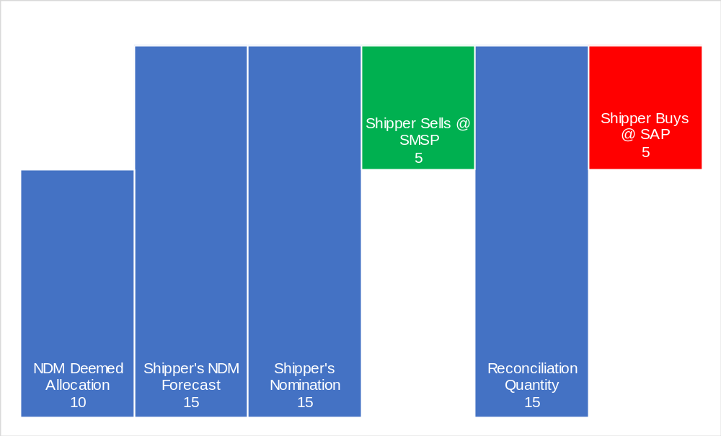
The existing Imbalance and Reconciliation processes would still occur, as in current arrangements:
- An initial NDM Deemed Allocation is calculated by Xoserve using the forecasting alogorithm
- The Shipper creates their own forecast and believes they will require more gas than the NDM Deemed Allocation suggests
- The Shipper contracts volume as per their own Forecast
- The Imbalance process results in the Shipper being cashed out to their initial NDM Deemed Allocation level. In this example the Shipper is “long” and therefore sells the volume difference at SMSP
- Meter Reads are submitted and a Daily Reconcliation Quantity is calculated. The reconciliation quantity shows the Shipper’s own forecast was correct.
- The reconciliation quantity is the same volume as sold during the Imbalance process, however the Shipper must pay at SAP.
 | kWh | p/kWh | Cost
NDM Deemed Allocation | 10
Shipper's NDM Forecast | 15
Shipper's Nomination | 15
Shipper Sells @ SMSP | 5 | 1.4 | 7
Reconciliation Quantity | 15
Shipper Buys @ SAP | -5 | 1.5 | -7.5
Differential |  |  | -0.5
The new imbalance reconciliation process would not impact any of the existing processes and therefore the above would occur as it does under current arrangements.
Applying the New Imbalance Reconciliation Process
- Take the Shipper’s Imbalance Quantity, direction and associated system price
Shippers Imbalance Quantity = 5 Units
Associated System Price = SMSP
- Take the Shipper’s Reconciliation Quantity and associated system price
Shippers Reconciliation Quantity = 5 Units
Associated System Price = SAP
- Calculate the price differentials (between the daily SMP (buy/sell) and SAP)
System Marginal Sell Price (SMSP) = 1.4
System Average Price (SAP) = 1.5
(SAP – SMSP) = 0.1
- Calculate the Imbalance Reconciliation Quantity, using the Shipper’s Imbalance Quantity and Reconciliation Quantity:
Shipper’s Reconciliation Quantity = 5 Units
Shipper’s Imbalance Quantity = 5 Units
Therefore, Imbalance Reconciliation Quantity = 5 Units
- Multiply the Imbalance Reconciliation Quantity by the price differential:
Shipper’s Imbalance Reconciliation Quantity = 5 Units
Price Differential = 0.1
Imbalance Reconciliation Payment = 5 x 0.1 = 0.5
 | kWh | p/kWh | Cost
NDM Deemed Allocation | 10
Shipper's NDM Forecast | 15
Shipper's Nomination | 15
Shipper Sells @ SMSP | 5 | 1.4 | 7
Reconciliation Quantity | 15
Shipper Buys @ SAP | -5 | 1.5 | -7.5
Differential |  |  | -0.5
Imbalance Reconciliation Quantity | 5 | 0.1 | 0.5
Outturn |  |  | 0

Solution C Example Two – For Information Only
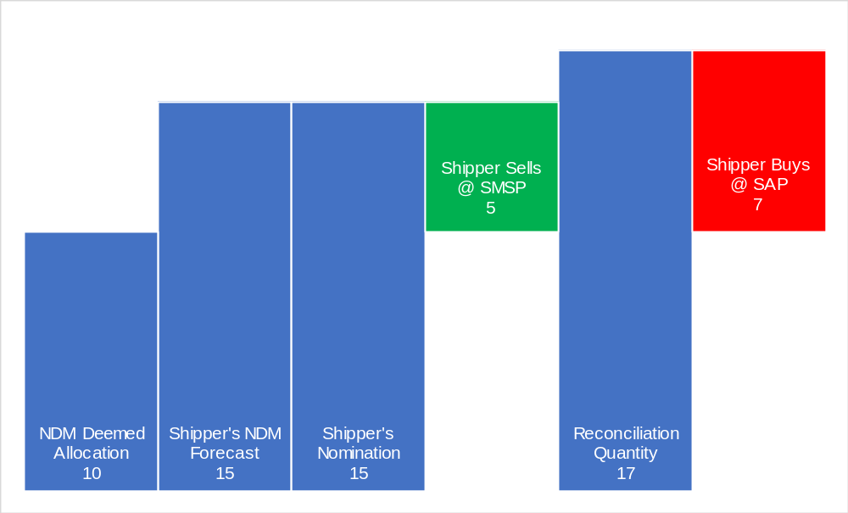
Standard Imbalance and Reconcilation Process Still Applies
- The NDM Deemed Allocation is produced by Xoserve using the forecasting algorithm
- The Shipper creates their own forecast and believes they will require more gas than the NDM Deemed Allocation suggests
- The Shipper acquires and Nominates volume as per their own Forecast
- The Imbalance process always results in the Shipper being cashed out back to their initial NDM Deemed Allocation level. In this example the Shipper is “long” and therefore Sells SMSP.
- Meter Reads are submitted and a Daily Reconcliation Quantity is calculated. The reconciliation quantity shows the Shipper’s own forecast was too low.
- The Shipper then Buys the Daily Reconcilation Quantity at SAP
 | kWh | p/kWh | Cost
NDM Deemed Allocation | 10
Shipper's NDM Forecast | 15
Shipper's Nomination | 15
Shipper Sells @ SMSP | 5 | 1.4 | 7
Reconciliation Quantity | 17
Shipper Buys @ SAP | -7 | 1.5 | -10.5
Differential |  |  | -3.5
The new imbalance reconciliation process would not impact any of the existing processes and therefore the above would occur as it does under current arrangements.
Applying the New Imbalance Reconciliation Process
- Take the Shipper’s Imbalance Quantity, direction and associated system price
Shippers Imbalance Quantity = 5 Units
Associated System Price = SMSP
- Take the Shipper’s Reconciliation Quantity and associated system price
Shippers Reconciliation Quantity = 7 Units
Associated System Price = SAP
- Calculate the price differentials (between the daily SMP (buy/sell) and SAP)
System Marginal Sell Price (SMSP) = 1.4
System Average Price (SAP) = 1.5
(SAP – SMSP) = 0.1
- Calculate the Imbalance Reconciliation Quantity, using the Shipper’s Imbalance Quantity and Reconciliation Quantity:
Shipper’s Reconciliation Quantity = 7 Units
Shipper’s Imbalance Quantity = 5 Units
Therefore, Imbalance Reconciliation Quantity = 5 Units
- Multiply the Imbalance Reconciliation Quantity by the price differential:
Shipper’s Imbalance Reconciliation Quantity = 5 Units
Price Differential = 0.1
Imbalance Reconciliation Payment = 5 x 0.1 = 0.5
 | kWh | p/kWh | Cost
NDM Deemed Allocation | 10
Shipper's NDM Forecast | 15
Shipper's Nomination | 15
Shipper Sells @ SMSP | 5 | 1.4 | 7
Reconciliation Quantity | 17
Shipper Buys @ SAP | -7 | 1.5 | -10.5
Differential |  |  | -3.5
Imbalance Reconciliation Quantity | 5 | 0.1 | 0.5
Outturn |  |  | -3
Here, the Shippers final outturn is equivalent to 2 units at SAP (i.e. the difference between Imbalance volumes and Reconciliation volumes at SAP, 2*1.50 = 3). This means that the Shipper is financially neutral for correctly forecasting and nominating their usage above the NDM Deemed Allocation but is still penalised as reconciliation shows they were short on the gas day.
Solution C – Example Three – For Information Only
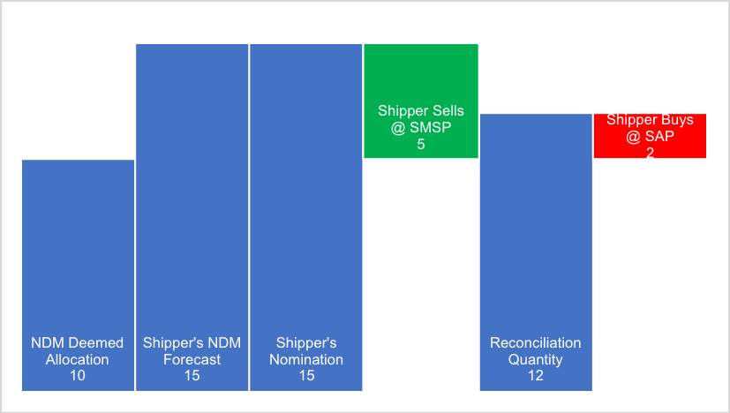
- The NDM Deemed Allocation is produced by Xoserve using the forecasting algorithm
- The Shipper creates their own forecast and believes they will require more gas than the NDM Deemed Allocation suggests
- The Shipper acquires and Nominates volume as per their own Forecast
- The Imbalance process always results in the Shipper being cashed out back to their initial NDM Deemed Allocation level. In this example the Shipper is long and therefore Sells at SMSP.
- Meter Reads are submitted and a Daily Reconcliation Quantity is calculated. The reconciliation quantity shows the Shipper’s own forecast was too low.
- The reconciliation quantity is the lower than the volume as paid out as a result of the Imbalance process but higher than the NDM Deemed Allocation. The Shipper Buys at SAP up to the Reconciliation Quanity
 | kWh | p/kWh | Cost
NDM Deemed Allocation | 10
Shipper's NDM Forecast | 15
Shipper's Nomination | 15
Shipper Sells @ SMSP | 5 | 1.4 | 7
Reconciliation Quantity | 12
Shipper Buys @ SAP | -2 | 1.5 | -3
Differential |  |  | 4
The new imbalance reconciliation process would not impact any of the existing processes and therefore the above would occur as it does under current arrangements.
Applying the new Imbalance Reconciliation Process
- Take the Shipper’s Imbalance Quantity, direction and associated system price
Shippers Imbalance Quantity = 5 Units
Associated System Price = SMSP
- Take the Shipper’s Reconciliation Quantity and associated system price
Shippers Reconciliation Quantity = 2 Units
Associated System Price = SAP
- Calculate the price differentials (between the daily SMP (buy/sell) and SAP)
System Marginal Sell Price (SMSP) = 1.4
System Average Price (SAP) = 1.5
(SMSP – SAP) = 0.1
- Calculate the Imbalance Reconciliation Quantity, using the Shipper’s Imbalance Quantity and Reconciliation Quantity:
Shipper’s Reconciliation Quantity = 2 Units
Shipper’s Imbalance Quantity = 5 Units
Therefore, Imbalance Reconciliation Quantity = 2 Units
- Multiply the Imbalance Reconciliation Quantity by the price differential:
Shipper’s Imbalance Reconciliation Quantity = 2 Units
Price Differential = 0.1
Imbalance Reconciliation Payment = 2 x 0.1 = 0.2
 | kWh | p/kWh | Cost
NDM Deemed Allocation | 10
Shipper's NDM Forecast | 15
Shipper's Nomination | 15
Shipper Sells @ SMSP | 5 | 1.4 | 7
Reconciliation Quantity | 12
Shipper Buys @ SAP | -2 | 1.5 | -3
Differential |  |  | 4
Imbalance Reconciliation Quantity | 2 | 0.1 | 0.2
Outturn |  |  | 4.2
Here, the Shipper’s final outturn is equivalent to 3 units at SMSP (i.e. the difference between Imbalance Quantity and Reconciliation Quantity at SMSP, 3 * 1.4 = 4.2). This means that the Shipper is financially neutral for correctly forecasting and nominating their usage above the NDM Deemed Allocation but is still penalised as reconciliation shows they were long on the gas day.

Solution C – Example Four – For Information Only
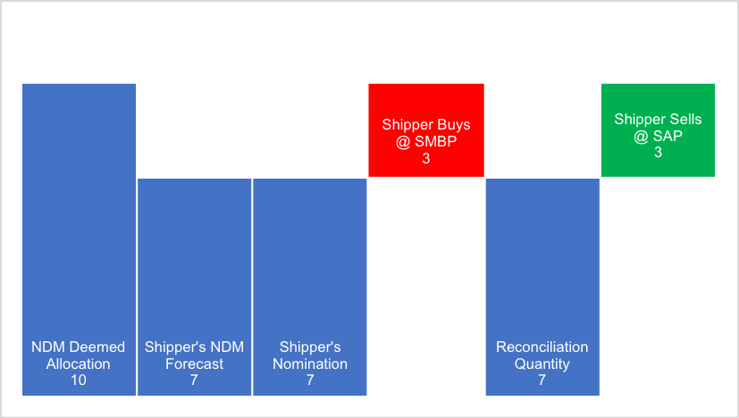
- An initial NDM Deemed Allocation is calculated by Xoserve using the forecasting alogorithm
- The Shipper creates their own forecast and believes they will require less gas than the NDM Deemed Allocation suggests
- The Shipper acquires and Nominates volume as per their own Forecast
- The Imbalance process results in the Shipper being cashed out to their initial NDM Deemed Allocation level. In this example the Shipper is “short” and therefore Buys at SMBP
- Meter Reads are submitted and a Daily Reconcliation Quantity is calculated. The reconciliation quantity shows the Shipper’s own forecast was correct
- The reconciliation quantity is the same as the Shipper’s own NDM forecast and their initial submitted nomination. The shipper Sells at SAP.
 | kWh | p/kWh | Cost
NDM Deemed Allocation | 10
Shipper's NDM Forecast | 7
Shipper's Nomination | 7
Shipper Buys @ SMBP | -3 | 1.6 | -4.8
Reconciliation Quantity | 7
Shipper Sells @ SAP | 3 | 1.5 | 4.5
Differential |  |  | -0.3
The new imbalance reconciliation process would not impact any of the existing processes and therefore the above would occur as it does under current arrangements.
Applying the New Imbalance Reconciliation Process
- Take the Shipper’s Imbalance Quantity, direction and associated system price
Shippers Imbalance Quantity = 3 Units
Associated System Price = SMBP
- Take the Shipper’s Reconciliation Quantity and associated system price
Shippers Reconciliation Quantity = 3 Units
Associated System Price = SAP
- Calculate the price differentials (between the daily SMP (buy/sell) and SAP)
System Marginal Sell Price (SMBP) = 1.6
System Average Price (SAP) = 1.5
(SMBP – SAP) = 0.1
- Calculate the Imbalance Reconciliation Quantity, using the Shipper’s Imbalance Quantity and Reconciliation Quantity:
Shipper’s Reconciliation Quantity = 3 Units
Shipper’s Imbalance Quantity = 3 Units
Therefore, Imbalance Reconciliation Quantity = 3 Units
- Multiply the Imbalance Reconciliation Quantity by the price differential:
Shipper’s Imbalance Reconciliation Quantity = 3 Units
Price Differential = 0.1
Imbalance Reconciliation Payment = 3 x 0.1 = 0.3
 | kWh | p/kWh | Cost
NDM Deemed Allocation | 10
Shipper's NDM Forecast | 7
Shipper's Nomination | 7
Shipper Buys @ SMBP | -3 | 1.6 | -4.8
Reconciliation Quantity | 7
Shipper Sells @ SAP | 3 | 1.5 | 4.5
Differential |  |  | -0.3
Imbalance Reconciliation Quantity | 3 | 0.1 | 0.3
Outturn |  |  | 0
Here, the Shipper’s final outturn is cost neutral. This means that the Shipper is financially neutral for correctly forecasting and nominating their usage below the NDM Deemed Allocation.

- Impacts & Other Considerations

Does this modification impact a Significant Code Review (SCR) or other significant industry change projects, if so, how?
No

Consumer Impacts
No direct impacts

Cross Code Impacts
None – Are you sure there wont be any iGT UNC impacts?

EU Code Impacts
None

Central Systems Impacts
It is likely that changes will be required to Central Systems subject to confirmation by the CDSP..
- Relevant Objectives
Impact of the modification on the Relevant Objectives:
Relevant Objective | Identified impact
a) Efficient and economic operation of the pipe-line system. | Positive/Negative/None
b) Coordinated, efficient and economic operation of  (i) the combined pipe-line system, and/ or  (ii) the pipe-line system of one or more other relevant gas transporters. | Positive/Negative/None
c) Efficient discharge of the licensee's obligations. | Positive/Negative/None
d) Securing of effective competition:  (i) between relevant shippers;  (ii) between relevant suppliers; and/or  (iii) between DN operators (who have entered into transportation arrangements with other relevant gas transporters) and relevant shippers. | Positive/Negative/None
e) Provision of reasonable economic incentives for relevant suppliers to secure that the domestic customer supply security standards… are satisfied as respects the availability of gas to their domestic customers. | Positive/Negative/None
f) Promotion of efficiency in the implementation and administration of the Code. | Positive/Negative/None
g) Compliance with the Regulation and any relevant legally binding decisions of the European Commission and/or the Agency for the Co-operation of Energy Regulators. | Positive/Negative/None
This modification promotes competition between Shippers by incentivising accurate forecasting and enabling a more cost effective balancing system.
Typically Shipper Modifications further Relevant Objective d), it is unlikely you will be able to demonstrate positive impacts on the Transporters operation of their networks without providing more detail on the potential positive impacts.
- Implementation
No implementation timescales are proposed and would be dependent on the system impacts.
- Legal Text

Text Commentary
For workgroup development

Text
For workgroup development
- Recommendations

Proposer’s Recommendation to Panel
Panel is asked to:
- Agree that Authority Direction should apply; and
- Refer this proposal to a Workgroup for assessment.

