Disclosure Request Report
DSC CoMC Development for the Disclosure of Information
Alt Han Company (Alt Han Co) Request for Ongoing Provision of Supply Point Portfolio Information
Prepared by | Richard Johnson
Submitted for | Approval – Approved at Change Management Committee on 20th March 2019
Development details | The CoMC is requested to consider AltHANCo’s request to receive a set of data items to support their initiative to identify or exclude properties, which require an Alternative Home Area Network (AHAN) to support the implantation of smart metering.  CoMC has developed AltHANCo’s request by considering risks and issues associated with AltHANCo’s request for the particular data items. A Privacy Impact Assessment has been developed at the CoMC..  UNC modification 0668S and iGT UNC modification 116 have created AltHANCo as a new User type on the Data Permission Matrix. The next step is for the CoMC to approve the data items, and any conditionality, to be added to the Data Permission Matrix.,
Date | 20th March 2019

- Introduction and background

AltHANCo is requesting data items that will help them identify or exclude supply points where an Alternative Home Area Network is likely to be required. Data is not being requested for supply points connected to the National Transmission System.

Properties with a Smart Meter have a Communications Hub and an In Home Display (IHD). The network of these three devices (including the Smart Meter itself) is known as the Home Area Network (HAN).

Certain properties e.g. flats, where the meter and the IHD are far apart require an Alternative Home Area Network for smart metering. It is estimated some 200,000 buildings with 1,500,000 consumers are impacted by this issue.

AltHANCo is a company created by suppliers (under the requirements of the Smart Energy Code) to identify properties where an Alternative Home Area Network is required.

AltHANCo is tendering for an Alt Han Operations Service Provider to identify these properties so that Suppliers can effectively manage the smart meter roll-out.

AltHANCo has approached for Xoserve for disclosure information to support the identification of supply points where an Alternative Home Area Network may be required; such analysis is expected to be conducted by the AltHANCo Service Provider.

- Data items

Modifications 0668S and its iGT 116 have been implemented adding AltHANCo as a new User type to the Data Permissions Matrix.

The data items requested by AltHANCo have been assessed by the CoMC and are set pout below, with any additional conditionality / rules,

Data Item | Justification | Additional conditionality
Supply Meter Point Reference Number | To uniquely identify the supply point | None
Supply meter point address | Information in the address will help include or exclude supply points e.g. the word flat, or business unit etc. | None
Meter location | Some location codes e.g. basement, will help identify relevant supply points | None
Meter capacity | Supply points with a larger capacity meter are unlikely to have a smart meter installed. | Any supply meter points with a meter asset with capacity above 11 cubic metres will be excluded from the dataset
Meter Mechanism | Will help exclude certain supply points. If a smart meter is already installed there is already a working local area network | Anything but SM1, SM2, NS will be masked.
Meter Model | Certain meter models will suggest if a smart meter or not is likely to be installed at some point | None
Annual Quantity range indicator (Rolling AQ) | The annual quantity as a data item is not required, but an indication of the annual quantity is expected, with other data items, to help include or exclude supply points. Ranges proposed are 0 - 30,000, 30,001 – 73,200, 73,200 – 200,000 | Supply meter points with an AQ greater than 200,001 will be excluded from the dataset

Other conditionality:

- Class 1 supply meter points to be excluded
- Any supply meter point with an AMR fitted to be excluded
- All twin stream supply meter points to be excluded
- Special Meter Supply Points (Unique Sites) to be excluded; however, LPG sites would be included
- Any Supply Meter Point with a Corrector to be excluded
- Any Supply Meter Point with a Meter Point Status of DE or EX to be excluded
The illustration on the next page summarises the data items that Xoserve will exclude from its datasets to AltHANCo.

- Development History
At Distribution Workgroup on 25th October 2018, Xoserve presented the following options for the provision of data to AltHANCo:
1. Xoserve determine the data required and filter out the Supply Meter Points AltHANCo don’t require, and send what remains.
2. Xoserve sends the full portfolio in every occurrence.
3. Xoserve sends the full portfolio in the first occurrence; for each subsequent occurrence, AltHANCo will inform Xoserve of what to exclude
The GTs believed it’s excessive to provide the full dataset each time as proposed by option 2 and raised concerns with the associated risks. When discussing option 1 and 3, the group agreed that over-filtering the data could be counter-productive but equally did not feel it necessary to send data that was explicitly not required by AltHANCo. The conditionality rules for what would be excluded from Xoserve’s side is yet to be decided as indicated in section 2 of this document. As a summary, AltHANCo would not require very large supply meter points as they would never have a Smart Meter.
The conclusion was a preference for a hybrid option combining both 1 and 3. This would involve removing the data which is known to not be required by AltHANCo for this analysis but sending the remainder of the dataset.

- Commercial model

This service is a commercial service. The data flows indicate that for the purposes of this service in respect of the personal data:-
Between the DSC Parties and Xoserve:-
- DSC Parties are Joint Data Controllers
- Xoserve is the Data Processor
Between Xoserve and AltHanCo
- Xoserve is acting as Data Controller on behalf of the Joint Data Controllers
- AltHanCo is a controller in common with Xoserve (DSC Parties)

Xoserve will contract directly with AltHANCo.

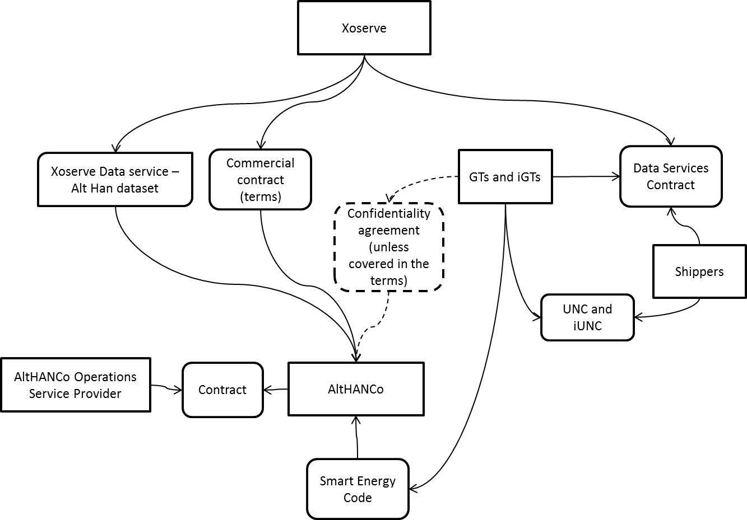

- Privacy Impact Assessment

A full privacy impact assessment has been completed as a result of 3 of the screening questions being given a yes answer.

The screening questions (and answers) applied in determining whether a full Privacy Impact Assessment was required are below:-

a) Will the project involve the collection of new information about individuals?
No

b) Will the project compel individuals to provide information about them?
No

c) Will information about individuals be disclosed to organisations or people who have not previously had routine access to the information?
Yes, information will be disclosed to AltHANCo and AltHANCo may use a sub-processor to complete required analysis of the data.
d) Are you using information about individuals for a purpose it is not currently used for, or in a way it is not currently used?
Yes, the information is to be used to consider whether the premise may require an alternative home area network.

e) Does the project involve you using new technology that might be perceived as being privacy intrusive? For example, this could be the use of biometrics or facial recognition.
No

f) Will the project result in you making decisions or taking action against individuals in ways that can have a significant impact on them?
No

g) Is the information about individuals of a kind particularly likely to raise privacy concerns or expectations? For example, health records, criminal records or other information that people would consider to be private.
No

h) Will the project require you to contact individuals in ways that they may find intrusive?
No

i) Will the disclosure of information utilise new technology for Xoserve?
No.

j) Will the disclosure include information that identifies a vulnerable customer?
No

k) Will the disclosure release mass data to a party?
Yes. Information will be provided for all supply meter points within a live confirmation (circa 24m)

l) Will the disclosure include information that identifies an occurrence of theft of gas?
No

m) Will the disclosure require a fundamental change to Xoserve Business?
No

- Method of access to the dataset
It is expected that Xoserve will send the data to AltHANCo on a quarterly basis. The service is expected to last two years by when the analysis is expected to be completed.
The data will be transferred electronically using Huddle or a similar shared area arrangement.

7. Which third party will be granted access to the data?
Alt HAN Company Ltd
8 Fenchurch Place
London
EC3M 4AJ
Company Number: 10002859

8. Where will the data be stored?
The dataset to be provided by Xoserve will be extracted from the UK Link business warehouse data store. It will be stored on an internal Xoserve shared area and then transferred to the Huddle facility. Huddle is a type of secure document collaboration and client portal software.
AltHANCo will download the data from Huddle who will then make the data available for their service provider for use in the performance of their services to AltHanCo.
The Contract between Xoserve and AltHanCo will include the requirement that data is stored securely, that data may only be used for the permitted purpose, that the data must be destroyed or returned at the end of the contract term.
- What is the purpose for sharing the data?
The purposes and justifications are set out in the earlier sections of this report.
Lawful basis for processing
The lawful basis under GDPR and the Data Protection Act 2018 for the distribution networks to share the data with AltHanCo is ‘legitimate interests’. It is in the legitimate interests of:
(1) energy suppliers because they have a legal obligation under Standard Conditions 49.2 and 49.6 of the Gas Supply Licence to ensure Alt HAN activities are carried out, including activities which:
(a) are designed to determine which premises or groups of premises may benefit from the installation of Alt HAN Equipment;
(b) involve the establishment and maintenance of a database of such premises;
(c) are designed to establish which types of Alt HAN Equipment are likely to be the most cost-effective;
(2) energy consumers living in properties that can’t connect to standard Smart metering technology - who should not be discriminated against because of their property type and have the same access to the benefits of Smart Meters as other UK homes. The main properties affected are high density buildings such as tower blocks (with single meter rooms in basements) and some large properties. As stated above, it is estimated some 200,000 buildings with 1,500,000 consumers are impacted by this issue.
In order to rely on ‘legitimate interests’ the distribution networks must carry out a Legitimate Interests Assessment, covering the purpose, necessity and balancing tests.
- Purpose test – the purpose has been covered above within this document.

- Necessity test, i.e. will this processing help achieve the stated purpose? Is the processing proportionate to that purpose? Can the same purpose be achieved without the processing or by processing less data, or by processing the data in another more obvious or less intrusive way?
It is recognised that in approximately 3.5% of GB premises standard 2.4GHz and 868MHz Home Area Network (HAN) technologies will not connect all smart metering devices and that Alternative HAN (Alt HAN) technologies will be necessary to allow energy suppliers to complete their rollouts. Proportionately, the number of properties about which data will be provided in the first dataset will be high (approximately NUMBER). However, as above, the data set is going to exclude all those properties which will definitely not need Alt HAN technology and then subsequent datasets will be refined to minimise data transfers.
- Balancing test i.e. consider the impact on individuals’ interests and rights and freedoms and assess whether this overrides the legitimate interests.

The data being shared does not include any special category data or criminal offence data and it is not data which people are likely to consider particularly ‘private’. The datasets may include data relating to vulnerable people (indicating potential fuel poverty) but the purpose of processing is to enable customers in these circumstances to have better information about their fuel use and therefore improve energy efficiency.

- Privacy Impact Assessment Risks
DESCRIPTION OF RISKS TO PRIVACY | RISK ASSOCIATED TO; DATA SUBJECTS, COMPLIANCE WITH DATA PROTECTION LEGISLATION, ORGANISATION / CORPORATE RISK | PROPOSED MITIGATION | RISKS ELIMINATED / REDUCED OR ACCEPTED. | IS THE SOLUTION A JUSTIFIED, COMPLIANT AND PROPORIONATE RESPONSE TO THE AIMS OF THE PROJECT
There is a risk that AltHANCo may use the data for other purposes. | Data Subject | Include Permitted Purpose clause and consequence of breach in commercial arrangements. Request AltHANCo also has similar terms in its contract with any sub processor | Reduced and acknowledged at Contract Management Committee on 20th March 2019 | Yes – decision made at Contract Management Committee on 20th March 2019
There is a risk that AltHANCo will receive more data that necessary for the purpose and the activities (all 24m meter supply points) | Data Subject | Proposal – determination of those that are not needed and exclude from the reports | Reduced and acknowledged at Contract Management Committee on 20th March 2019 | Yes – decision made at Contract Management Committee on 20th March 2019
There is a risk that individuals will not be able to effectively access their rights under GDPR in repsect of data held by AltHan Co– namely rights of access, deletion, rectification because there is no agreed process between the parties as to how this will work. | Data Subject | Include contractual obligations requiring action from Alt Han Co to assist Xoserve/ GT’s/IGTs to comply with individual rights requests  Set up a process to be followed by DSC parties and Xoserve on receipt of individual rights request which involves data sent to AltHanCo | Reduced and acknowledged at Contract Management Committee on 20th March 2019 | Yes – decision made at Contract Management Committee on 20th March 2019
There is a risk that individuals will not be informed that their data may be transferred to AltHanCo because this is not currently included in relevant privacy notices | Data Subject | Privacy Notices of the DSC parties to be reviewed in line with their own internal processes and updated as required | Reduced and acknowledged at Contract Management Committee on 20th March 2019 | Yes – decision made at Contract Management Committee on 20th March 2019
Action Plan
Mitigation Action | Responsibility | Status
- Review of privacy notices | DSC Parties
- Set up Process for dealing with individual rights | Xoserve & Working Group
- Draft contract with provisions identified above | Xoserve
- Minimise the data sent to AltHanCo (as per description above) | Xoserve

- CoMC determinations

CoMC were requested to:

- Review and consider the Privacy Impact Assessment
- Approve the outcome of the Privacy Impact Assessment (including any action plan)
- Approve this Disclosure Request set out in this Report

Approval acquired on 20th March 2019 at Contract Management Committee.

