Business Requirements Document

Ofgem Switching Programme
GT/iGT Consequential Change Requirements Overview

Author (for this version): | Xoserve
Version: | 0.2
Status: | Final Draft
Date: | 22nd March 2019

This document contains confidential or privileged information; it should not be copied or disclosed to any third party without the express permission of Xoserve Ltd. All rights reserved.

Copyright © 2019 Xoserve Ltd
Contents
1 Introduction 4
1.1 Document Purpose 4
1.2 Related Documents 4
2 Executive Summary 5
2.1 Introduction to the Change 5
2.2 Change Background 5
2.3 Process Issues 5
2.4 Scope 6
3 Design Considerations 8
4 Business Process 9
4.1 Create Supply Meter Point 9
4.2 SMP Updates including Initial Registration 10
4.3 Forced Registrations 11
4.4 Supplier Switching 12
4.5 Switching (Non-CSS) Sites (Confirmation) 13
4.6 Switching Sites (Enquiry and Nomination) 14
4.7 Manage Supply Meter Point Updates 15
4.8 Manage Meter Assets 16
4.9 Registration Sequence Diagram 17
5 Business Requirements Definition 18
5.1 Stakeholder Management 18
5.2 Supply Meter Point Creation and Maintenance 18
5.3 Nomination Process - Request for Transportation Offers / Network Assessment 19
5.4 Initial Registration of a Shipper and Supplier 19
5.5 Change of Shipper and Change of Supplier 20
5.6 Change of Shipper Only – No change of Supplier 21
5.7 Change of Supplier – No Change of Shipper 21
5.8 Provision of Settlement Details 22
5.9 Transporter Forced Registrations 23
5.10 Supply Point Amendments Updates 24
5.11 Market Sector Code Updates 24
5.12 RGMA Process 25
5.13 Shipper Withdrawal Process 25
5.14 Address Updates 25
5.15 Reporting 26
5.16 Transitional Requirements 26
5.17 Perceived File Format Changes 26
6 Non-Functional Business Requirements 28
7 Document Control 29
7.1 Version History 29

Introduction

Document Purpose
The purpose of this business requirements document (BRD) is to ensure that the high level business requirements associated with the design baseline 4 phase of the switching programme changes have been captured, and to clearly specify these requirements to Gas Transporters and Independent Gas Transporters to provide an understanding of the consequential change impacts.
To provide adequate information to enable the industry to undertake analysis of the impacts to GT / iGT systems and business processes.
The contents refer to the business scope of the change and provide descriptions of the business requirements and the relevant ‘As Is’ and ‘To Be’ process maps.

Related Documents
The underlying source documents and further details about the Switching Programme can we found on Ofgem’s website:
https://www.ofgem.gov.uk/gas/retail-market/market-review-and-reform/smarter-markets-programme/switching-programme

Executive Summary

Introduction to the Change
This document defines the consequential changes that are required to be undertaken for Gas Transporters and independent Gas Transporters facing processes to support the implementation of the new Central Switching Service.
The details contained within the document are currently based on the Ofgem switching programme E-2-E design products that have been produced to support faster and more reliable switching within the energy market and provide an indicative view of the changes that will be required within Xoserve’s systems to support.

Change Background
This change relates to the consequential changes required to the gas shipper / supplier switching process required to support the wider Ofgem Switching Programme. This programme is an Ofgem initiative within a broader set of energy market reforms that aim to encourage consumers engagement with the energy market (especially switching), and to improve their experiences of doing so through a faster more reliable centralised set of industry processes.
The overarching ambition of the Switching Programme is to “improve customers' experience of switching, leading to greater engagement in the retail energy market by designing and implementing a new switching process that is reliable, fast and cost-effective. In turn this will build consumer confidence and facilitate competition, delivering better outcomes for consumers”.
UNC modification review workgroup (630R) was formed back in October 2017 to conduct a review and assessment of the consequential impacts to the UNC, DSC and associated UK Link processes as a result of the Ofgem Switching Programme (OSP). This workgroup has now concluded and its output has been used to inform this Business Requirements Document (please note that this document supersedes the version created under this workgroup).

Process Issues
The implementation of the new central switching service leads to a number of consequential changes having to be made within UK Link, as summarised below:
- Moving to a Supplier led switching process via CSS and removing the Shipper led confirmation process within UK Link for in-scope Supply Meter Points
- Provision and capture of settlement parameters for an incoming Supplier registration from the incoming Shipper
- Stakeholder changes required to support new CSS processes
- Synchronisation of meter point and registration data between UK Link and CSS
- Capture of Meter Asset Provider details for all installed meters
- SPA data updates for Supply Meter Points
Below is a heat map which represents the areas of Xoserve that are impacted by the Ofgem Switching Programme. This provides a visual view of the scope and scale of change across the current CDSP value chain / processes. This has been updated to reflect the position at the end of the high level consequential design phase of the project.
The sections that are highlighted red within this heat map signify high complexity impact changes to his area; the yellow areas will create medium impact, minimal impacts have been identified within the green areas and grey indicates that no impact.
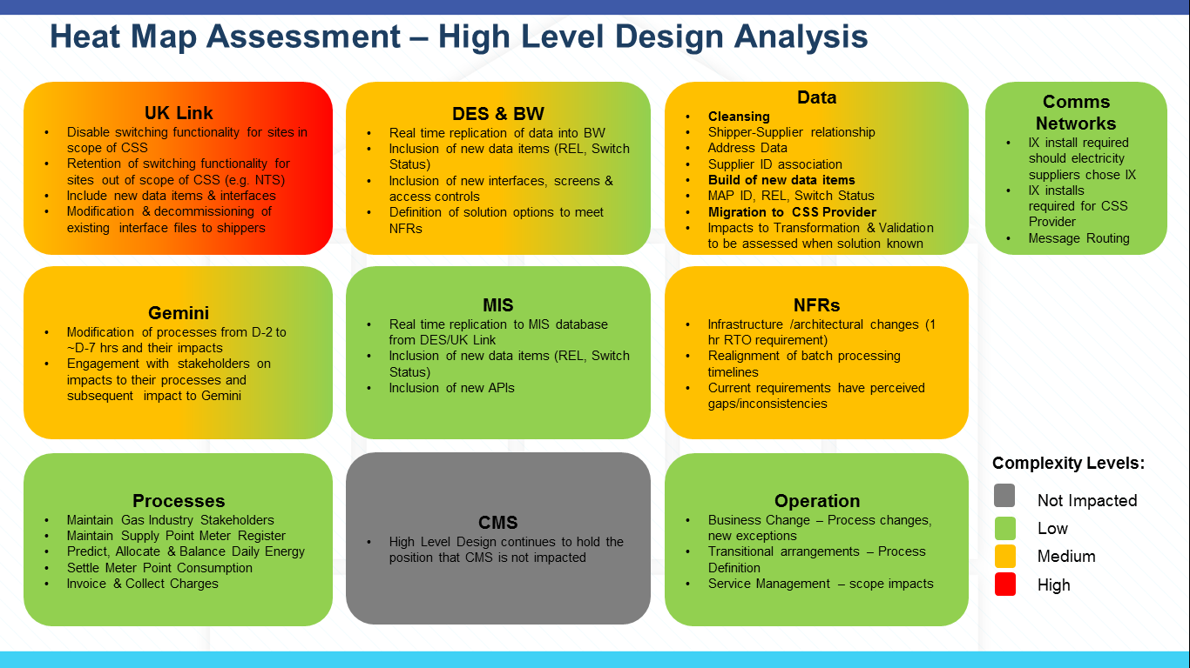

Scope

In Scope
The following areas are included with the scope of this requirements document:
- Consequential changes to the interactions between GT / iGTs and the CDSP resulting from the implementation of the new Central Switching Service

Out of Scope
Requirements relating to the following areas have been deemed as out of scope of this document:
- Consequential changes to the Gemini system (this will be covered by a separate BRD)
- Consequential changes to Data Enquiry (this will be covered by a separate BRD)
- Consequential changes to Shippers (this will be covered by a separate BRD)
- Any process being managed or maintained by the new CSS
- Any processes that are not impacted by the implementation of the new CSS
- Any other areas of change that are not a direct consequence of the new CSS implementation
- Supply Meter Points that are deemed out of scope of the new Central Registration Service, this is currently expected to include the following Supply Meter Point site types:
  - Sites directly connected to the National Transmission System (NTS Sites)
Please note that the current Nomination and Confirmation processes and associated file formats will continue to be used for these sites operating under the current processes.

Design Considerations
Design considerations will continue to be captured as industry design continues to progress.
The following are currently being considered as part of our design:
- Utilise API functionality for the provision of industry data, for both new data provision and alongside traditional file formats.
- Rationalising impacted file formats i.e. combining multiple impacted files into one.
- Continued use of traditional batch processing and consequential file format provision

Business Process

Create Supply Meter Point
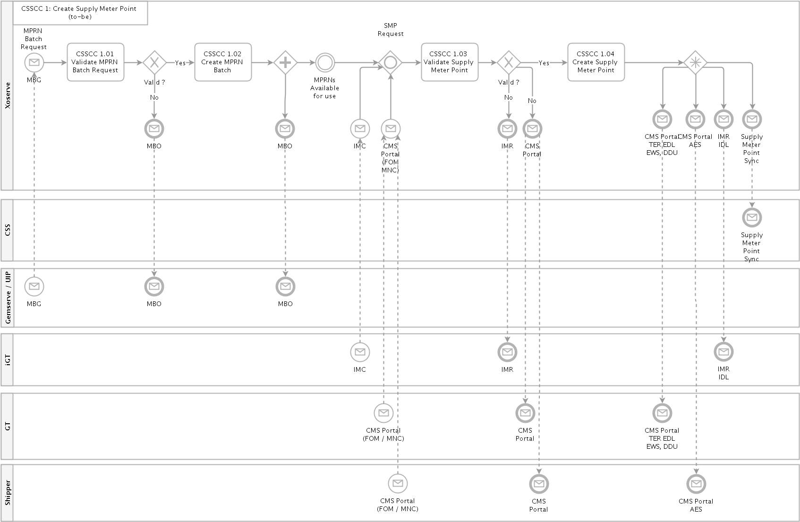

SMP Updates including Initial Registration
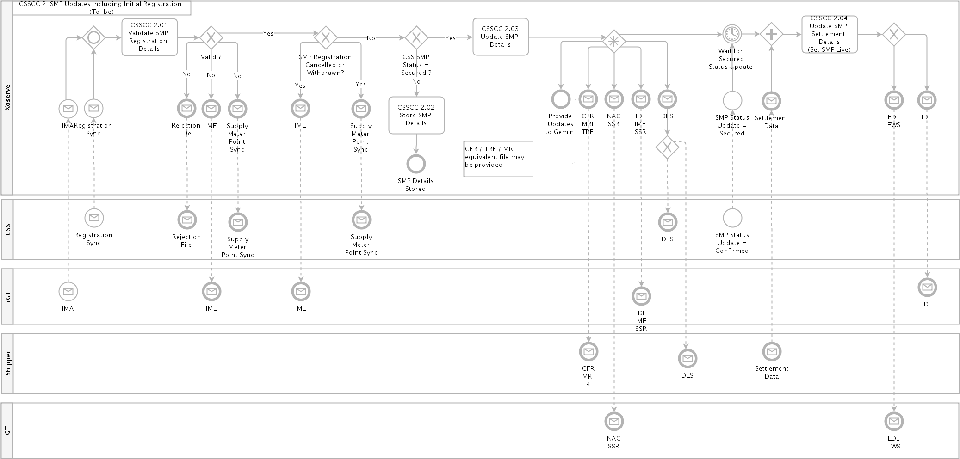

Forced Registrations
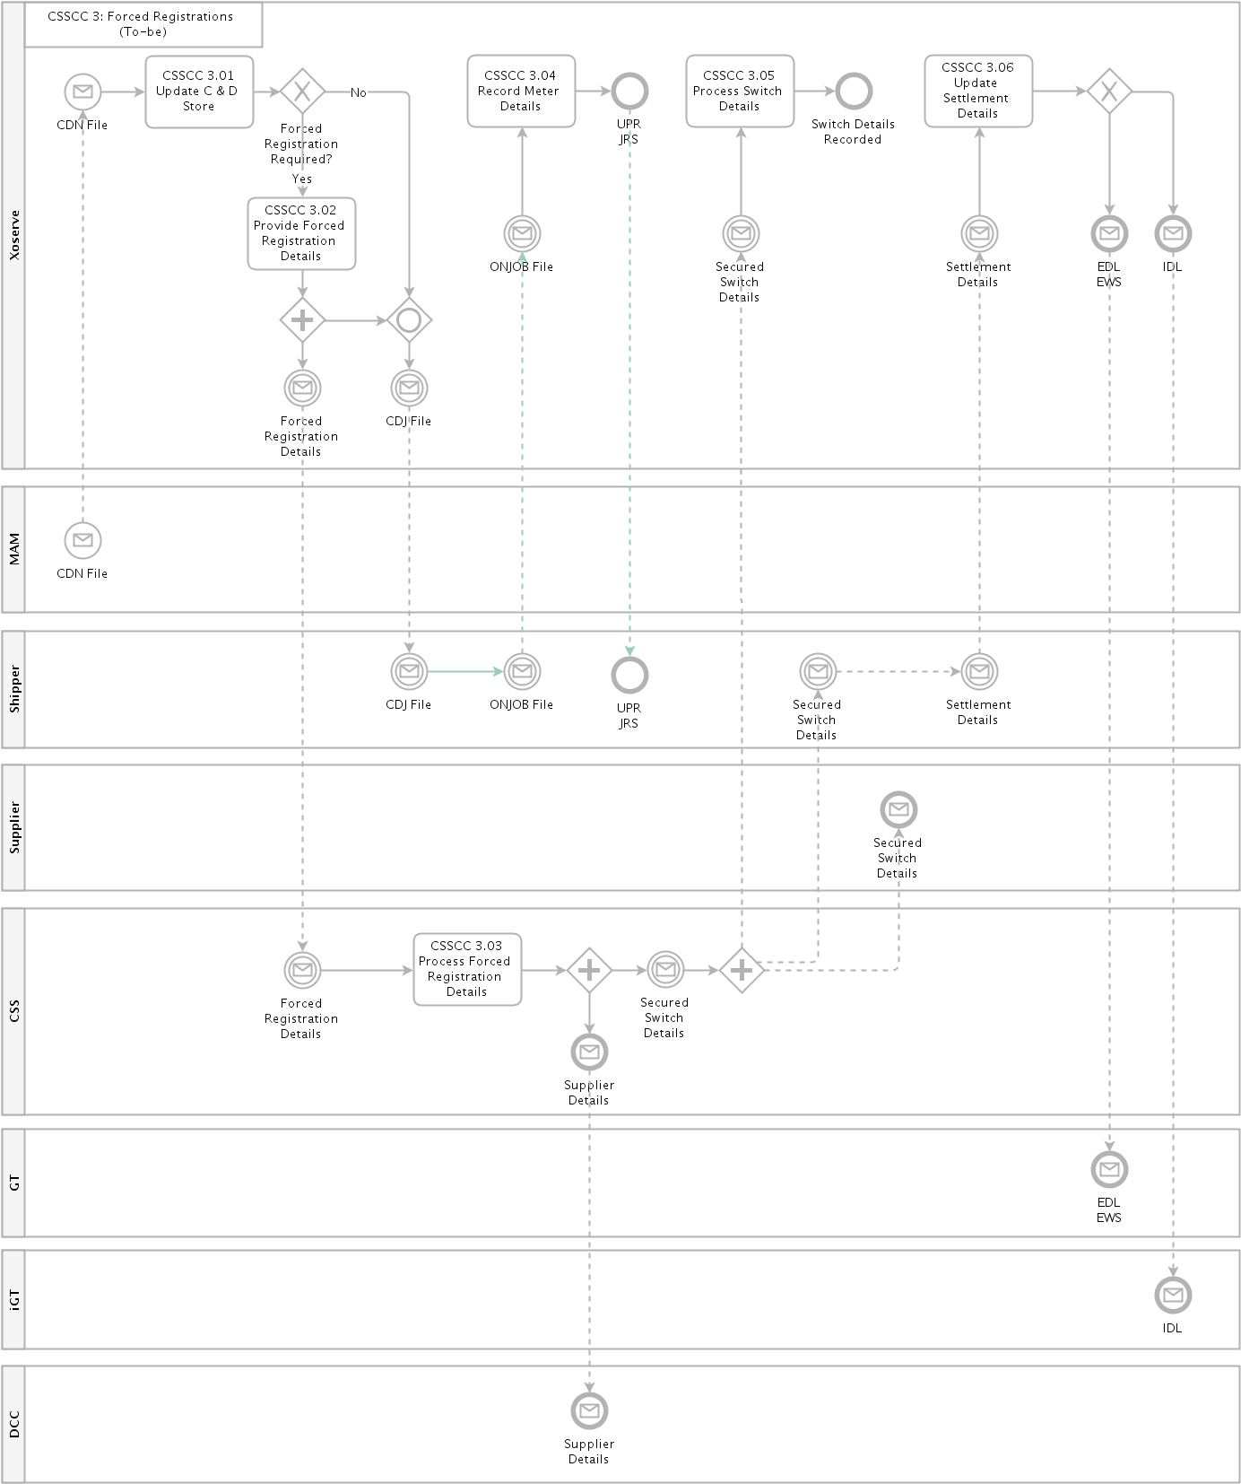

Supplier Switching
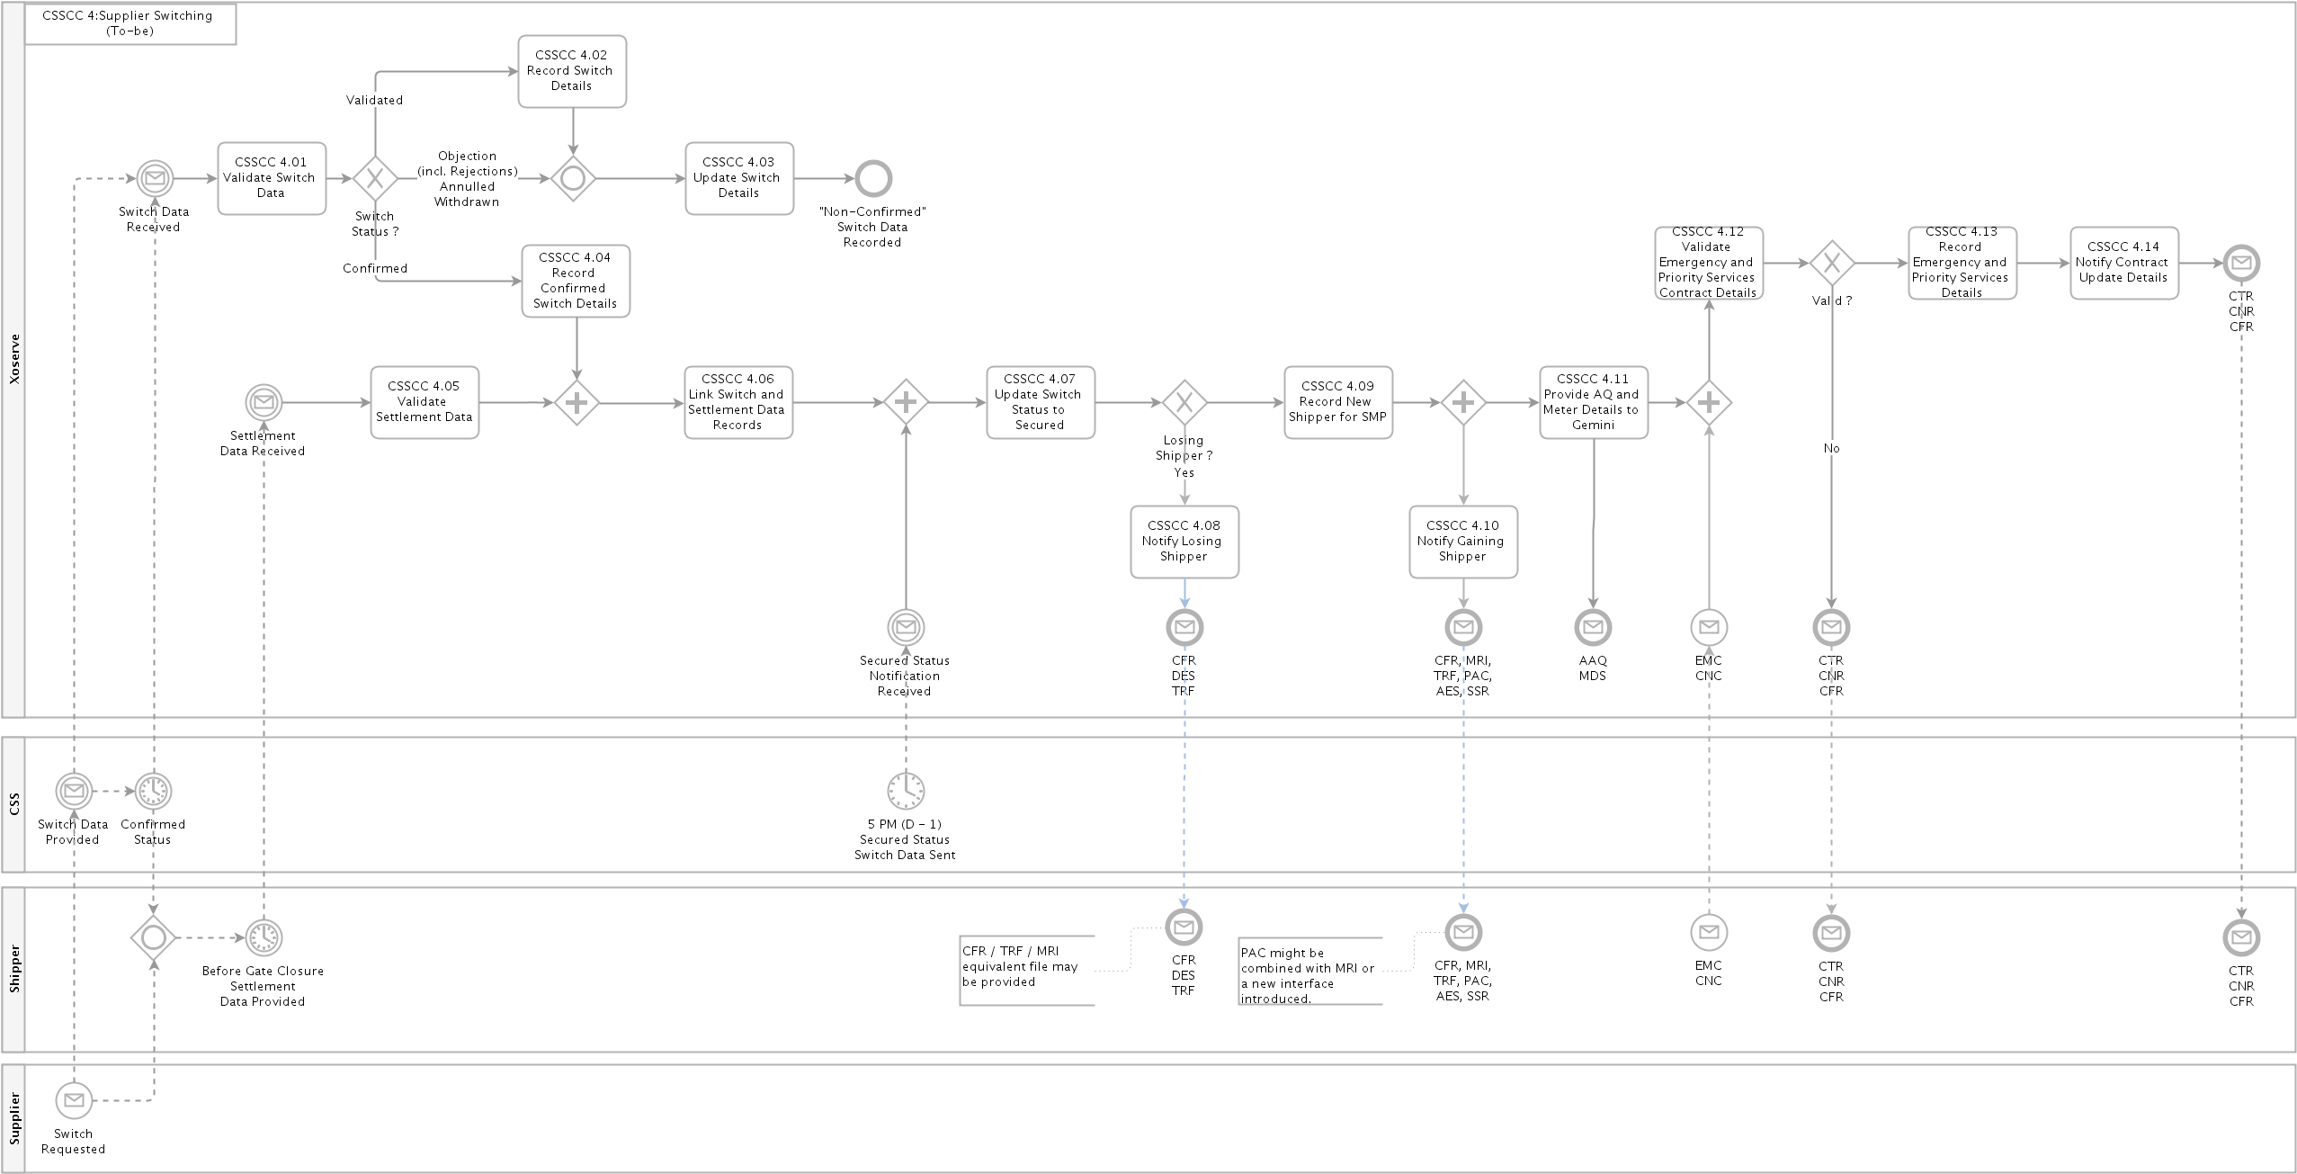

Switching (Non-CSS) Sites (Confirmation)
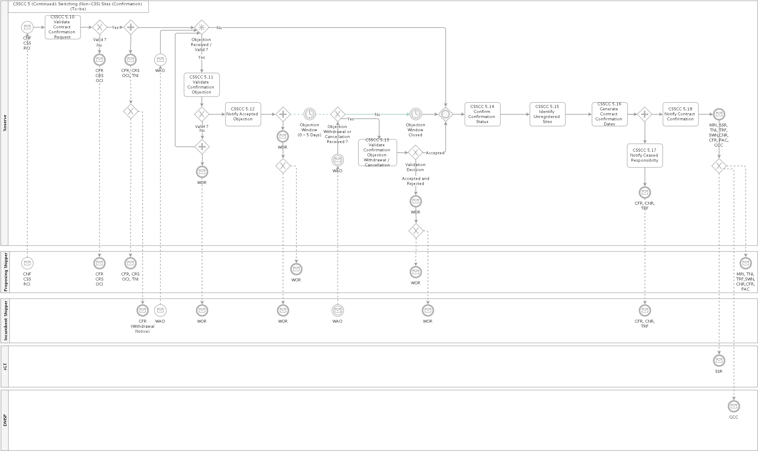

Switching Sites (Enquiry and Nomination)
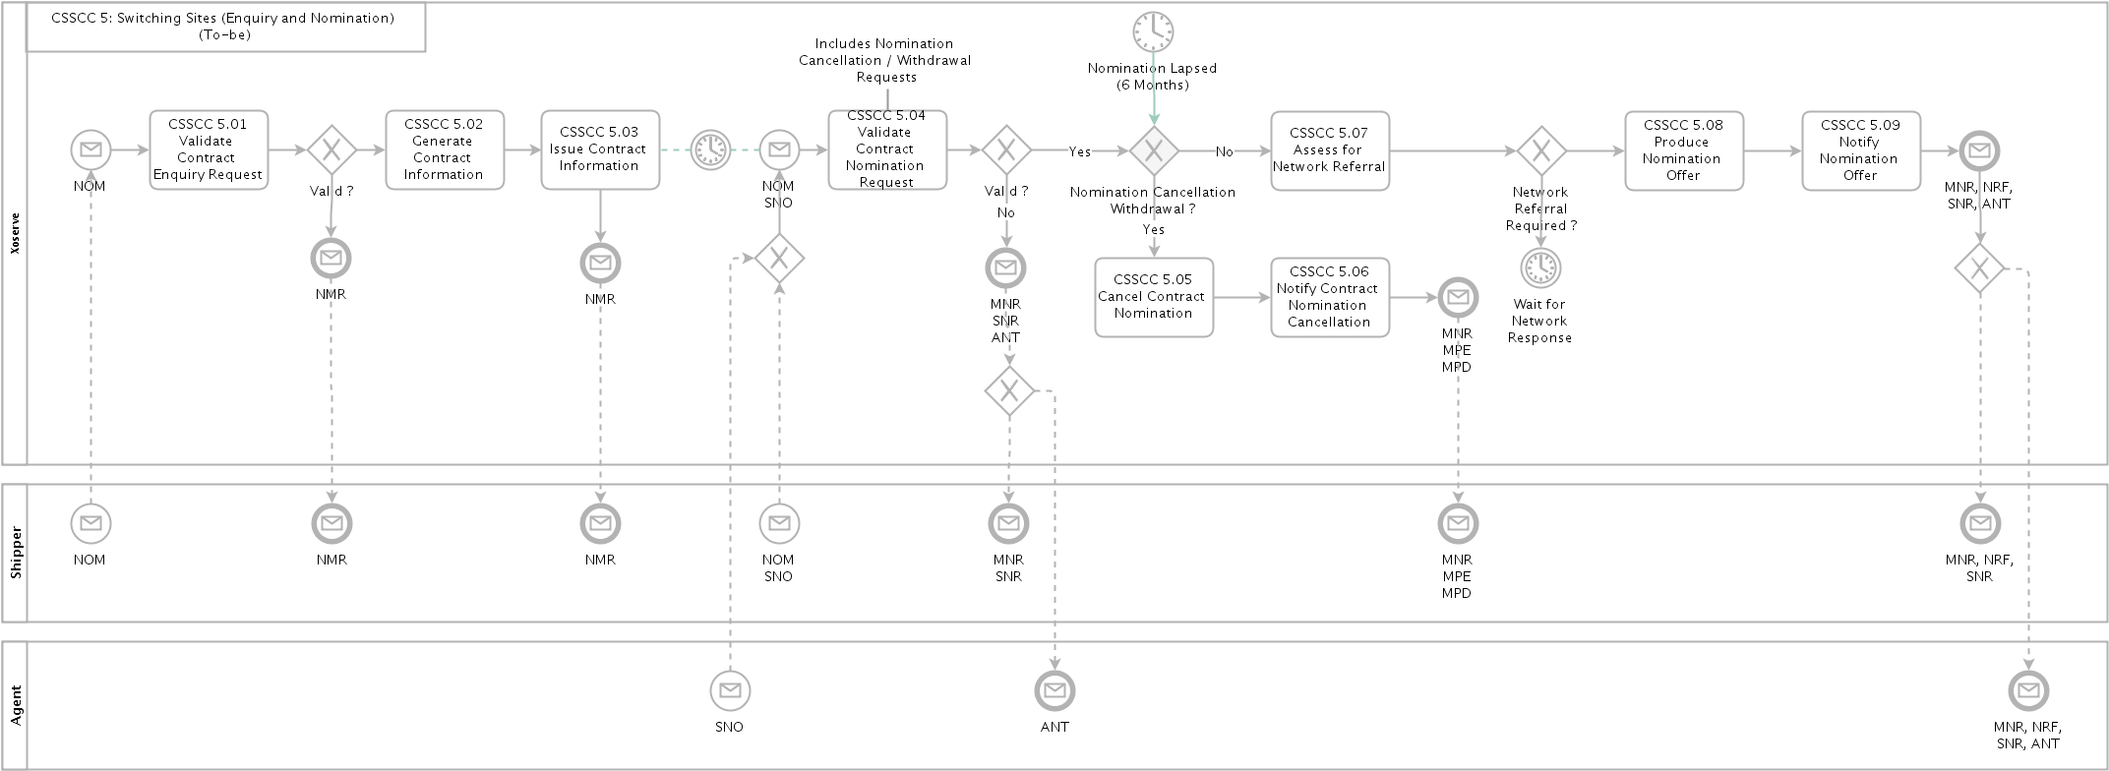

Manage Supply Meter Point Updates
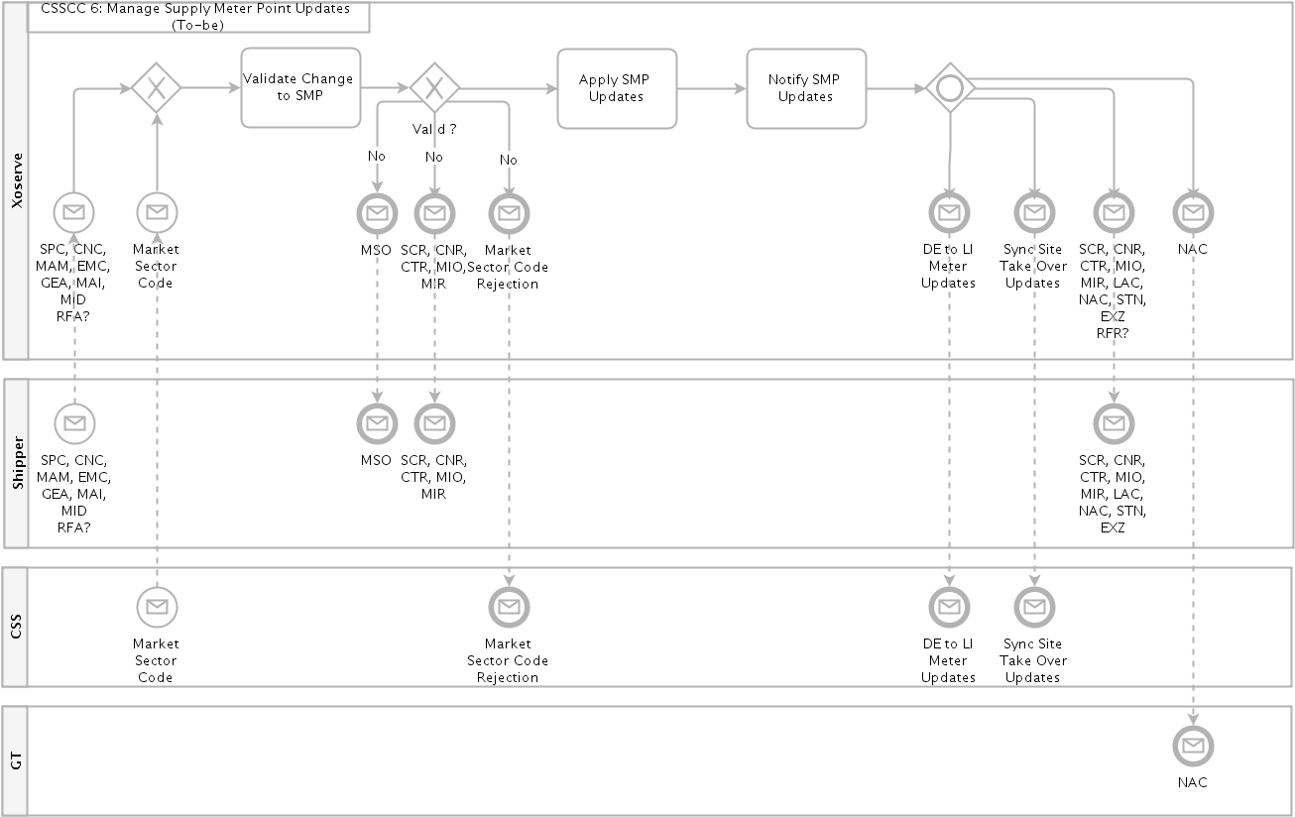

Manage Meter Assets
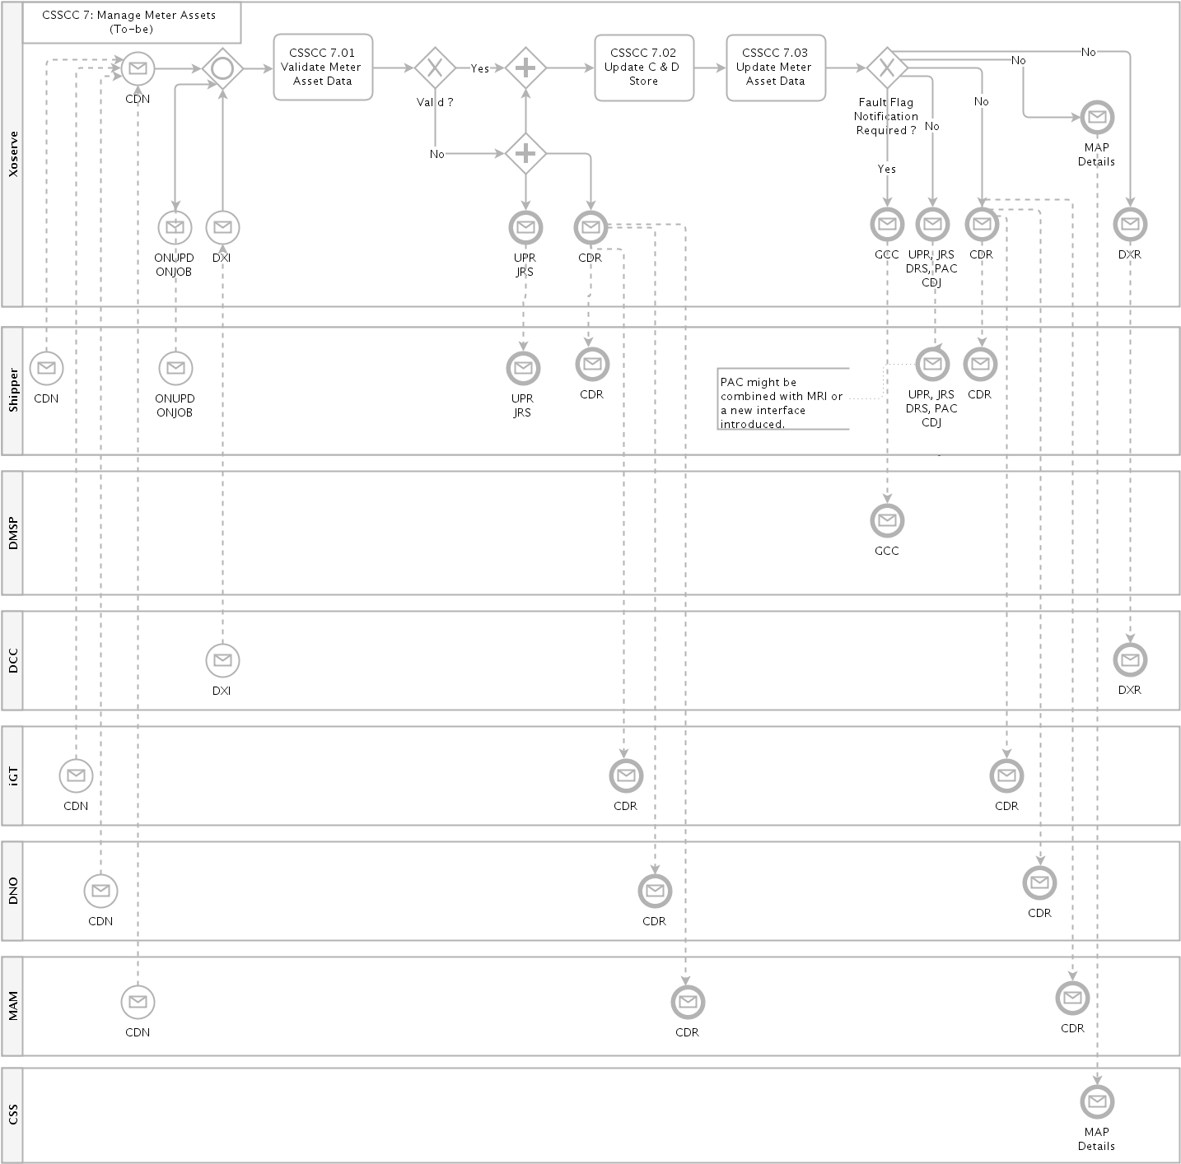

Registration Sequence Diagram
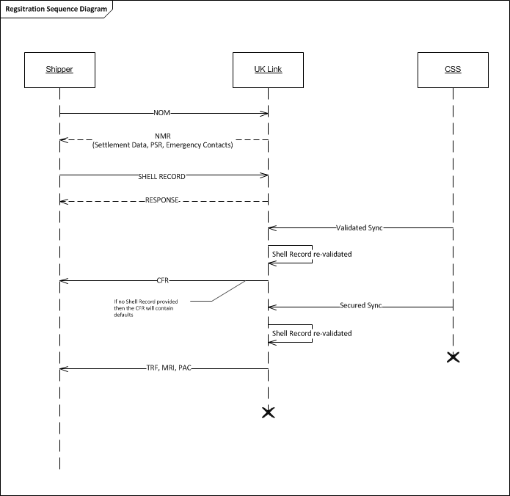

Business Requirements Definition
The following sections of the document provide a summary of the requirements that are a direct consequence of the implementation of the new switching regime; these are broken down into the areas of change and are derived requirements from the Ofgem Switching Programme Design Baseline 4 set of documentation.

Stakeholder Management

The CDSP shall master the gas market participant data, details of which are defined within the new Retail Energy Code (REC), and will be responsible for the provision and maintenance of the gas stakeholder data to the new CSS service provider and REC code manager. This will continue to include the following role types that are required to support the new switching processes:
- Gas Shippers
- Gas Suppliers
- Gas Transporters (including gas distribution network operators, independent gas transporters, etc.)
- Meter Asset Managers (MAMs)
- Meter Asset Providers (MAPs)

The CDSP shall be responsible for maintaining the MDD Market Participant List.

A Market Participant (MP) can apply to amend or delete their entry in the MDD MP List, applications to amend / delete a MDD MP will be via a [monthly process]. The Shipper is responsible for notifying the CDSP of any Suppliers who may make a Switch Request via the CSS on the Shipper’s behalf. The Shipper may also revoke the Supplier from doing so on their behalf.

The CDSP will hold and maintain details of Shipper and gas Supplier relationships/alliances within UK Link, and will notify the Central Switching Service provider of any revisions.

The CDSP will hold and maintain details of Shipper and Gas Transporters (GT/iGT) relationships/alliances within UK Link, and will notify the Central Switching Service provider of any revisions.

Where the Gas Transporter applies sanctions to a Shipper organisation (via the current process) then the CDSP will provide the details to central switching service as a “real-time” message.

Supply Meter Point Creation and Maintenance

The Supply Meter Point creation process will continue to operate within UK Link as per the current processes.

The CDSP will be responsible for the synchronisation of all required Supply Meter Point data elements to the new CSS provider for all meter points that are within scope of the Central Registration Service. This will be over the new Supply Meter Point Sync interface message, and is expect to contain the following data elements:
- MPRN
- Meter Point Address
- RMP Status (this will be derived from the Supply Meter Point and Meter Isolation statuses)
- Network Owner
- MAP ID (where a meter is installed)
- DCC Service Flag

Nomination Process - Request for Transportation Offers / Network Assessment

An equivalent of the current Nomination process will continue to be utilised to support requests for Network Assessment (i.e. Referrals) for large supply points. Network Assessment is required for changes/requests for the following example scenarios:
    - Capacity requests/changes (SOQ and SHQ)
    - Seasonal capacity requests
    - Supply Meter Points requests for Optional Commodity Tariffs (e.g. Shorthaul)
    - Network Exit Agreements (NExAs)

The nomination process will no longer be a mandatory requirement for large supply points and this process will operate independently to a CSS registration.

For large supply points Shippers will continue to obtain Transportation Offers on the back of the nomination process in the same way as today. In addition a new data service will be made available as an alternative route to obtain this information.

Any Network Assessment Requests will be issued through to the Gas Transporters for their approval in that same way as today. The Network Assessment Request Responses (Referral) response timescales are not expected to change as a consequence of CSS. The chronology of this in relation to a Registration Request via CSS is not mandated, but due to Referral response timings it is expected that this shall be submitted by a Proposing Shipper ahead of the submission of a CSS Registration Request.

Currently Shippers may submit more than one Network Assessment Request; this is expected to endure.

The existing Nomination process is expected to be retained unchanged for the Supply Meter Points out of scope of the CSS.

Initial Registration of a Shipper and Supplier

The initial / first registration of a Supply Meter Point will follow a similar process to the change of Shipper and Supplier process described below.

Change of Shipper and Change of Supplier

The Shipper and Supplier registration process will transfer to CSS for meter points managed by the new Central Registration Service. As a result the current Confirmation process will cease to be available for these meter points and all changes of Shipper and/or Supplier will be instigated by the gas Supplier via the new CSS processes.

The CDSP will receive both Shipper and Supplier ownership updates for individual meter points via a new interface with CSS. The Registration Sync message received from the CSS is expected to provide the following information which will be used to update UK Link:
- MPRN
- Supplier
- Shipper
- Registration Identifier (generated by CSS)
- Registration Effective Date
- Registration Status
- Domestic Premises Indicator (Market Sector Code)

Further updates are expected to be received from the CSS as the status progresses through the registration lifecycle, as indicated below:

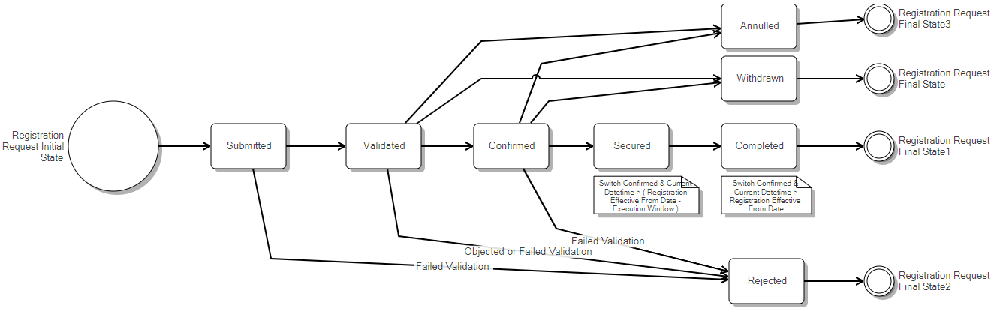

Source: Abacus / Switching State Diagram

In order to ensure that a unique confirmation reference number is maintained within UK Link for each Shipper confirmation period a unique reference number will still be generated by UK Link and issued to Shippers for each change of Supplier and/or Shipper event. This is expected to remain in the same format as the current Confirmation Reference Number, and is expected to be a different value to any Registration Identifier that is generated by CSS as part of the new Supplier registration process.

The gaining Shipper will retain responsibility for the provision of emergency contacts and end consumer / Priority Service Register details to UK Link in line with the current processes. This is covered in more detail in the following sections.

The gaining Shipper will still be responsible for the provision of settlement data (as per the UNC requirements) to UK Link. This is covered in more detail in the following sections.

Once the new Shipper registration become active (i.e. at the start of the gas day for the effective data provided by CSS) the Settlement Details associated to the Registration Request will be applied to the supply meter point.

The daily delta files will continue to provide details of the Gaining Shipper and Supplier details for an individual Supply Meter Point in the same way as today.

The CDSP will no longer be responsible for the provision of Supplier portfolio data over to DCC (including the provision of elected Supplier details) as this will transfer over to the new CSS provider as part of the new switching arrangements.

The gaining Shipper will continue to provide opening reading data on the back of a secured switch, and where not provided UK Link shall continue to generate an estimated reading.

Change of Shipper Only – No change of Supplier

As described above the Shipper registration process will transfer to CSS for meter points managed by the new Central Registration Service, and will no longer follow the current confirmation process.

The new switching processes followed by CSS is Supplier orientated and changes to the registered Shipper will not follow the same registration lifecycle within CSS as a change of Supplier, they are treated as a registration event (data update).

With the exception of the inbound notifications from the CSS for the Change of Shipper notifications, the same process will be followed as for a Change of Supplier and Shipper (see previous section).

Change of Supplier – No Change of Shipper

The CDSP will receive Gas Supplier ownership updates directly from the CSS through a new registration sync message for all Supply Meter Points being managed by the new CSS service provider. This will no longer be received directly from the registered Shipper, other than updates to any sites that are out of scope of the new switching service.

The same process will be followed as for a Change of Supplier and Shipper (see previous section).

Provision of Settlement Details

The CSS registration process does not include all of the information that is required by UK Link (and currently provided as part of the current Nomination and Confirmation processes, for example Settlement Class, MRF, SOQ and SHQ), as a result the gaining Shipper will still have the responsibility to provide all required Settlement Details for their registration period.

The settlement details will be provided via a new interface / file format to UK Link. The finalisation of the data items will be completed during the detailed design phase of the project, but is expected to include the following:
- MPRN
- Shipper Short Code
- Supplier Short Code
- Settlement Class
- Meter Read Frequency
- Batch Frequency (where Class 3)
- Nomination Response Reference
- MAM ID
- Emergency Contact Details
- End Consumer Details (including Priority Services Register)
- Requested SOQ/SHQ

The Settlement Detail Notification may be submitted by a Shipper in advance of the Supplier submission of the Registration Request to CSS, but should be submitted prior to the registration becoming secured.

The deadline for the submission of the settlement data by the incoming Shipper will be [15:00 hrs] on D-1 in order to be effective at the CSS registration effective from date.

The latest valid settlement detail transaction shall be associated to the Registration Request.

The Shipper may cancel Settlement Detail Notifications provided prior to the CSS registration status becoming Secured. Once cancelled these cannot be associated to any Registration Request. Receipt by the CDSP of a subsequent Settlement Detail Notification will cancel / lapse any previous Settlement Detail Notifications.

A Settlement Details Notification shall have a validity period of [60 calendar days].

Where the CDSP lapse a Settlement Detail Notification the CDSP will not notify the Shipper who submitted the Settlement Detail.

Where there is a mandatory requirement for large site contact details to be provided (e.g. emergency contacts) and these have not be provided within the Settlement Detail Notification, then the notification shall be rejected and the requested settlement data will not be considered.

As a minimum, the association of the settlement data to the CSS registration will be based on the following data items:
- MPRN
- Shipper Short Code
- Supplier Short Code

Where the Settlement Details are not provided by the gaining Shipper, or the CDSP has been unable to create this association, a set of default values will be applied. The proposed business rules for default are defined below:

Settlement Class – If the AQ is above 58,600,000 kWh then the meter point will default to Class 1 else it will be defaulted to Class 4.

DM SOQ / DM SHQ – The previous Shipper’s values will be carried forward.

Meter Read Frequency – This will be derived based on the prevailing AQ value in line with existing UNC rules.

Seasonal LSP Data – Will be carried forward if registration is effective prior to the anniversary of SLSP being effective.

Optional Transportation Rates – This will not be carried forward and will cease to be applied.

PSR / End Consumer Details – This will not be carried forward to the new registration period.

LSP Emergency Contact Details – These will continue to be provided to the Transporter in relation to the new registration, but will not be visible to the incoming Shipper.

UK Link will continue to provide Shipper portfolio updates through to Gemini to support gas nominations, allocations and energy balancing process. This will be triggered following the secured switch notification (or Shipper update notification) received from the CSS after gate closure at 5pm on D-1. Full details of the consequential changes are contained within a separate Gemini specific BRD.

Settlement Details can only be associated to a Registration Request. Any amendment separate to a Registration Request can be undertaken, if allowed, as part of the Supply Point Amendment Process.

For the avoidance of doubt, any Settlement Details provided will become effective at the corresponding CSS registration effective date and would not be applied in advance.

Transporter Forced Registrations

The CDSP will continue to monitor both iGT and GT Supply Meter Points under the current rules to ensure that where required a Shipper Confirmation is in place. This includes, for example, the initial Shipper registration on iGT sites following the first meter installation, and forced confirmations following a gas safety regulations visit undertaken by gas transporters.

The current processes will change to remove the automatic Shipper confirmation of these sites, and will be updated to trigger a Supplier registration within the new Central Registration Service, as per the rules defined in REC.

Supply Point Amendments Updates

UNC defines circumstances where Shippers may update the Supply Point Register by means of a Supply Point Amendment. Any Supply Point Amendments updates that are required to be submitted by the gaining Shipper are only expected to be received into UK Link once the status of the CSS registration has reached a Completed status (unless specifically described below); any request provided prior to this point will be rejected and not applied in UK Link.

Capacity Referrals – The current process to support capacity referrals through to networks via SPC file will continue as is.

Large Site Contact Details - Shippers will be able to send the emergency and interruptible contact details to UK Link outside of the switch event via EMC files as per current process.

Priority Service Register Details - Shippers will be able to send the priority service register details to UK Link outside of the switch event via CNC files as per current process.

MAM Updates – Shippers can continue to provide updates as per the current process, however where the MAM file received from an incoming Shipper in relation to their pending registration can only be provided from the point that the registration status reaches ‘secured’ (equivalent of current world ‘CO’). For meter points out side of the scope of CSS then this process remain unchanged.

Market Sector Code Updates

For the in-scope Supply Meter Points, following the implementation of the CSS, Shippers will no longer be able to submit changes to the market sector code as all updates should to be requested by the Supplier through the new CSS process. Any amendments will be provided to UK Link by CSS as a registration event sync message.

Where there is a change to the Market Sector Code outside of the switching process then an outbound MSO file will be issued to the registered Shipper when the new Market Sector Code become effective (based on the effective date provided by on the CSS registration event sync message.

Where there is a change to the Market Sector Code as part of the switching process no outbound MSO notifications will be issue to Shippers and the update will be provided directly by CSS as part of their registration notification messages.

For all sites out of scope of the new CSS switching process (currently limited to NTS sites) the Market Sector Code will be defaulted to I – Industrial and therefore the existing MSI file will be decommissioned.

RGMA Process

Any RGMA updates received from a gaining Shipper in relation to their pending CSS initial registration prior to it having a “Validated” status (as notified by CSS to UK Link) will be rejected and therefore not applied in UK Link as per the current process. The current rules for sites not being in-scope of the central switching service will remain unchanged.

Any RGMA updates received from a gaining Shipper in relation to their pending registration (switch) request prior to it having a “Secured” (as notified by CSS to UK Link) will be rejected and therefore not applied in UK Link as per the current process. The current rules for sites not being in-scope of the central switching service will remain unchanged.

Shipper Withdrawal Process

For meter points managed by CSS, the Shipper withdrawal process will cease and a deactivation of the registration will need to be requested by the registered gas Supplier via the new CSS processes. These updates will then be synchronised to UK Link by CSS.

Following the receipt of a synchronisation message form CSS, the Shipper and Supplier registration updated will be process a per the current Shipper withdrawal process.

The Losing Shipper will continue to be notified of their ceased responsibility as per the current process.

The daily delta files will continue to provide details of the changes to the Shipper and Supplier registration details for individual Supply Meter Points in the same way as today.

Address Updates

No changes will be made to the current meter point address update process.

Where there is a change to the meter point address held for a meter point in UK Link the changes will be synchronised to CSS.

CSS will be synchronising Retail Energy Location address details to UK Link for individual Supply Meter Points. This will be cascaded to individual networks potentially via the existing daily delta files (this will be finalised during detailed design).

Reporting

As yet no specific reporting requirements have been identified to support the implementation of CSS, however changes made to the UK Link data model may need to be reflected within existing industry reports. This will be revisited during the detailed design phase of the programme.

Transitional Requirements

There is a transitional requirement from the Switching Programme to support the transition from the current Shipper Confirmation process to the new Supplier Registration process the objection window for all gas confirmations will need to be aligned to the electricity objection window of 5 working days.

In line with the switching programme transition plan the submission of confirmation requests from Shipper will cease and will be rejected by UK Link for all sites that are transitioning over to the new central switching service. The date for this is still to be finalised but is expected to be around twelve days prior to CSS go-live.

In line with the switching programme transition plan the submission of SPA update requests for data elements that will be part of the new CSS processes (for example Market Sector Code and Supplier updates) will be rejected by UK Link for all sites that are transitioning over to the new central switching service. The date for this is still to be defined.

Perceived File Format Changes
The following provides an indicative view of the file format changes that might be required to support the consequential changes being made to support the implementation of CSS. This list may change as further analysis is undertaken during detailed design.
File Type | Impact Type | Impact Summary
DDS | Candidate for Change | Change might be required to incorporate the provision of the new Retail Energy Location details, this will be finalised during detailed design
DDU | Candidate for Change | Change might be required to incorporate the provision of the new Retail Energy Location details, this will be finalised during detailed design
EDL | Candidate for Change | Change might be required to incorporate the provision of the new Retail Energy Location details, this will be finalised during detailed design
EQL | Candidate for Change | Change might be required to incorporate the provision of the new Retail Energy Location details, this will be finalised during detailed design
EWS | Candidate for Change | Change might be required to incorporate the provision of the new Retail Energy Location details, this will be finalised during detailed design
IIL | Candidate for Change | Change might be required to incorporate the provision of the new Retail Energy Location details, this will be finalised during detailed design
IDL | Candidate for Change | Change might be required to incorporate the provision of the new Retail Energy Location details, this will be finalised during detailed design
IQL | Candidate for Change | Change might be required to incorporate the provision of the new Retail Energy Location details, this will be finalised during detailed design

Non-Functional Business Requirements
A number of non-functional requirements have been defined by the switching programme that will have a direct impact on Xoserve’s systems. Full details of these can be found in the switching programme E2E Non-Functional Requirements document on Ofgem’s website (link).

Document Control

Version History
Version | Status | Date | Author(s) | Summary of Changes
0.1 | Initial Draft | Oct 2018 | Xoserve | N/A
0.2 | Final Draft | 22/03/2019 | Xoserve | Updated to reflect CSSC DSG meeting outputs

