**Business Requirements Document**

**Ofgem Switching Programme**

**Shipper Consequential Change Requirements Overview**



|  |  |
| --- | --- |
| Author (for this version): | Xoserve |
| Version: | 0.7 |
| Status: | Final Draft |
| Date: | 19th March 2019 |

This document contains confidential or privileged information; it should not be copied or disclosed to any third party without the express permission of Xoserve Ltd. All rights reserved.

Copyright © 2019 Xoserve Ltd



Contents

1 Introduction 4

1.1 Document Purpose 4

1.2 Related Documents 4

2 Executive Summary 5

2.1 Introduction to the Change 5

2.2 Change Background 5

2.3 Process Issues 5

2.4 Scope 6

3 Design Considerations 8

4 To-Be Business Process 9

4.1 Create Supply Meter Point 9

4.2 SMP Updates including Initial Registration 10

4.3 Forced Registrations 11

4.4 Supplier Switching 12

4.5 Switching (Non-CSS) Sites (Confirmation) 13

4.6 Switching Sites (Enquiry and Nomination) 14

4.7 Manage Supply Meter Point Updates 15

4.8 Manage Meter Assets 16

4.9 Registration Sequence Diagram 17

5 Business Requirements Definition 18

5.1 Stakeholder Management 18

5.2 Supply Meter Point Creation 19

5.3 Nomination Enquiries 19

5.4 Nomination Process - Request for Transportation Offers / Network Assessment 19

5.5 Initial Registration of a Shipper and Supplier 20

5.6 Change of Shipper and Change of Supplier 20

5.7 Change of Shipper Only – No change of Supplier 22

5.8 Change of Supplier – No Change of Shipper 23

5.9 Provision of Settlement Details 24

5.10 Transporter Forced Registrations 26

5.11 Opening Meter Read Provision 26

5.12 Supply Point Amendments Updates 28

5.13 Market Sector Code Updates 28

5.14 RGMA Process 29

5.15 Meter Asset Provider Details 29

5.16 Shipper Withdrawal Process 29

5.17 Address Updates 30

5.18 Reporting 30

5.19 Transitional Requirements 30

5.20 Perceived File Format Changes 30

6 Non-Functional Business Requirements 33

7 Document Control 34

7.1 Version History 34

# Introduction

## Document Purpose

The purpose of this business requirements document (BRD) is to ensure that the high level business requirements associated with the design baseline 4 phase of the switching programme changes have been captured, and to clearly specify these requirements to DSG to provide an understanding of the consequential change impacts.

To provide adequate information to enable the industry to undertake analysis of the impacts to Shipper systems and business processes. The contents refer to the business scope of the change and provide descriptions of the business requirements and the relevant ‘To Be’ process maps.

## Related Documents

The underlying source documents and further details about the Switching Programme can we found on Ofgem’s website:

<https://www.ofgem.gov.uk/gas/retail-market/market-review-and-reform/smarter-markets-programme/switching-programme>

# Executive Summary

## Introduction to the Change

This document defines the consequential changes that are required to be undertaken for gas Shipper facing processes to support the implementation of the new Central Switching Service.

The details contained within the document are currently based on the Ofgem switching programme E-2-E design products that have been produced to support faster and more reliable switching within the energy market and provide a high level view of the changes that will be required within Xoserve’s systems to support.

## Change Background

This change relates to the consequential changes to the gas Shipper / Supplier switching process required to support the wider Ofgem Switching Programme. This programme is an Ofgem initiative within a broader set of energy market reforms that aim to encourage consumers engagement with the energy market (especially switching), and to improve their experiences of doing so through a faster more reliable centralised set of industry processes.

The overarching ambition of the Switching Programme is to “improve customers' experience of switching, leading to greater engagement in the retail energy market by designing and implementing a new switching process that is reliable, fast and cost-effective. In turn this will build consumer confidence and facilitate competition, delivering better outcomes for consumers”.

UNC modification review workgroup (630R) was formed back in October 2017 to conduct a review and assessment of the consequential impacts to the UNC, DSC and associated UK Link processes as a result of the Ofgem Switching Programme (OSP). This workgroup has now concluded and its output has been used to inform this Business Requirements Document (please note that this document supersedes the version created under this workgroup).

## Process Issues

The implementation of the new central switching service leads to a number of consequential changes having to be made within UK Link, as summarised below:

* Moving to a Supplier led switching process via CSS and removing the Shipper led confirmation process within UK Link for in-scope Supply Meter Points
* Provision and capture of settlement parameters for an incoming Supplier registration from the incoming Shipper
* Stakeholder changes required to support new CSS processes
* Synchronisation of meter point and registration data between UK Link and CSS
* Capture of Meter Asset Provider details for all installed meters
* SPA data updates for Supply Meter Points

Below is a heat map which represents the areas of Xoserve that are impacted by the Ofgem Switching Programme. This provides a visual view of the scope and scale of change across the current CDSP value chain / processes. This has been updated to reflect the position at the end of the high level consequential design phase of the project.

The sections that are highlighted red within this heat map signify high complexity impact changes to his area; the yellow areas will create medium impact, minimal impacts have been identified within the green areas and grey indicates that no impact.

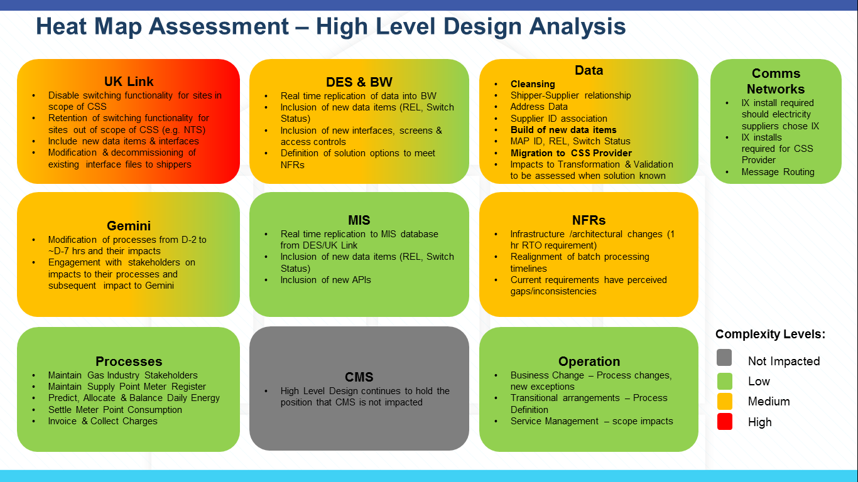

## Scope

### In Scope

The following areas are included with the scope of this requirements document:

* Consequential changes to the interactions between Shippers and the CDSP resulting from the implementation of the new Central Switching Service

### Out of Scope

Requirements relating to the following areas have been deemed as out of scope of this document:

* Consequential change to the Gemini system (this will be covered by a separate BRD)
* Consequential changes to Data Enquiry (this will be covered by a separate BRD)
* Changes to any interfaces or interactions between Shippers and gas Suppliers as a result of the switching programme
* Any process being managed or maintained by the new CSS
* Any processes that are not impacted by the implementation of the new CSS
* Any other areas of change that are not a direct consequence of the new CSS implementation
* Supply Meter Points that are deemed out of scope of the new Central Registration Service, this is currently expected to include the following Supply Meter Point site types:
  + Sites directly connected to the National Transmission System (NTS Sites)

*Please note that the current Nomination and Confirmation processes and associated file formats will continue to be used for these sites operating under the current processes.*

# Design Considerations

Design considerations will continue to be captured as industry design continues to progress.

The following are currently being considered as part of our design:

* Utilise API functionality for the provision of industry data, for both new data provision and alongside traditional file formats.
* Rationalising impacted file formats i.e. combining multiple impacted files into one.
* Continued use of traditional batch processing and consequential file format provision.

# To-Be Business Process

## Create Supply Meter Point

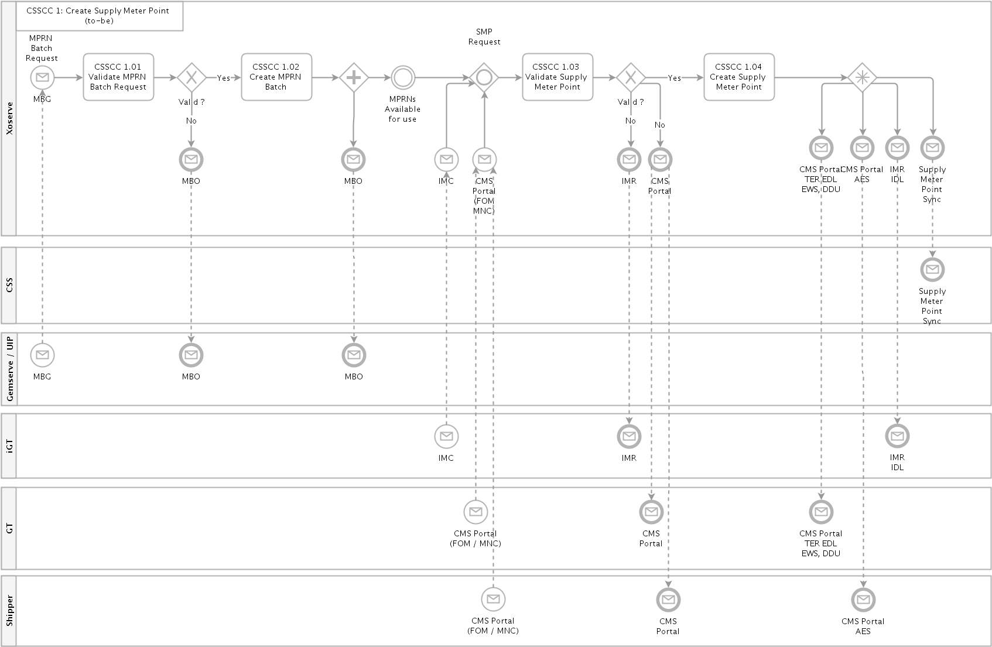

## SMP Updates including Initial Registration

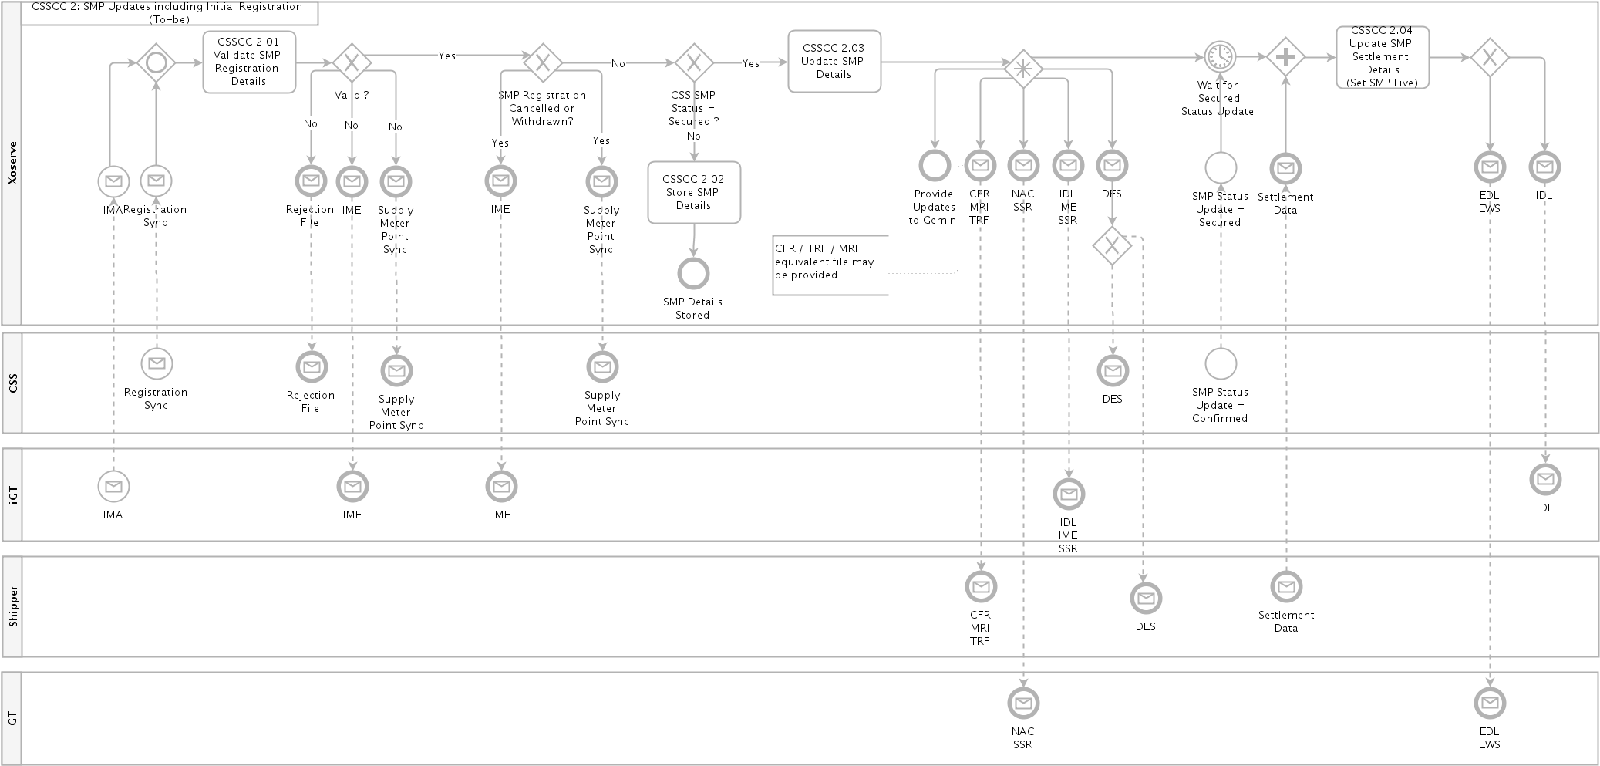

## Forced Registrations

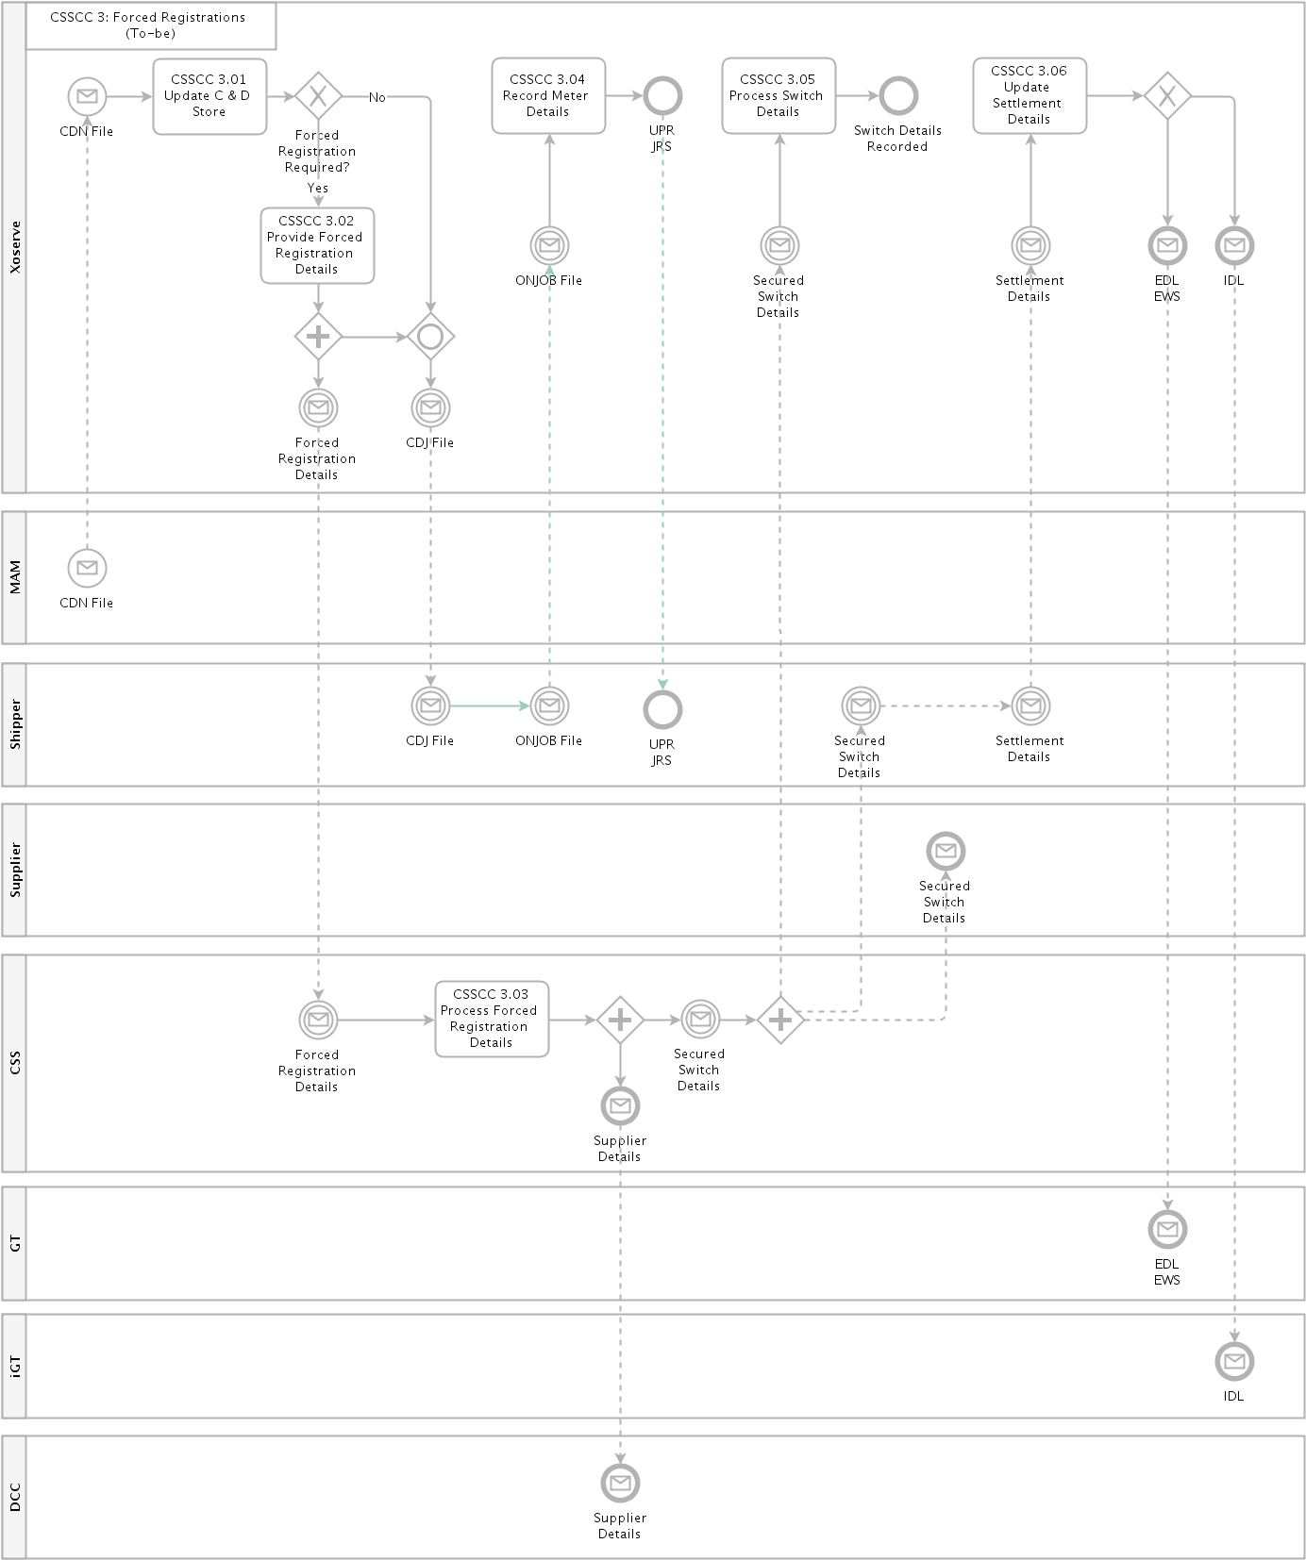

## Supplier Switching

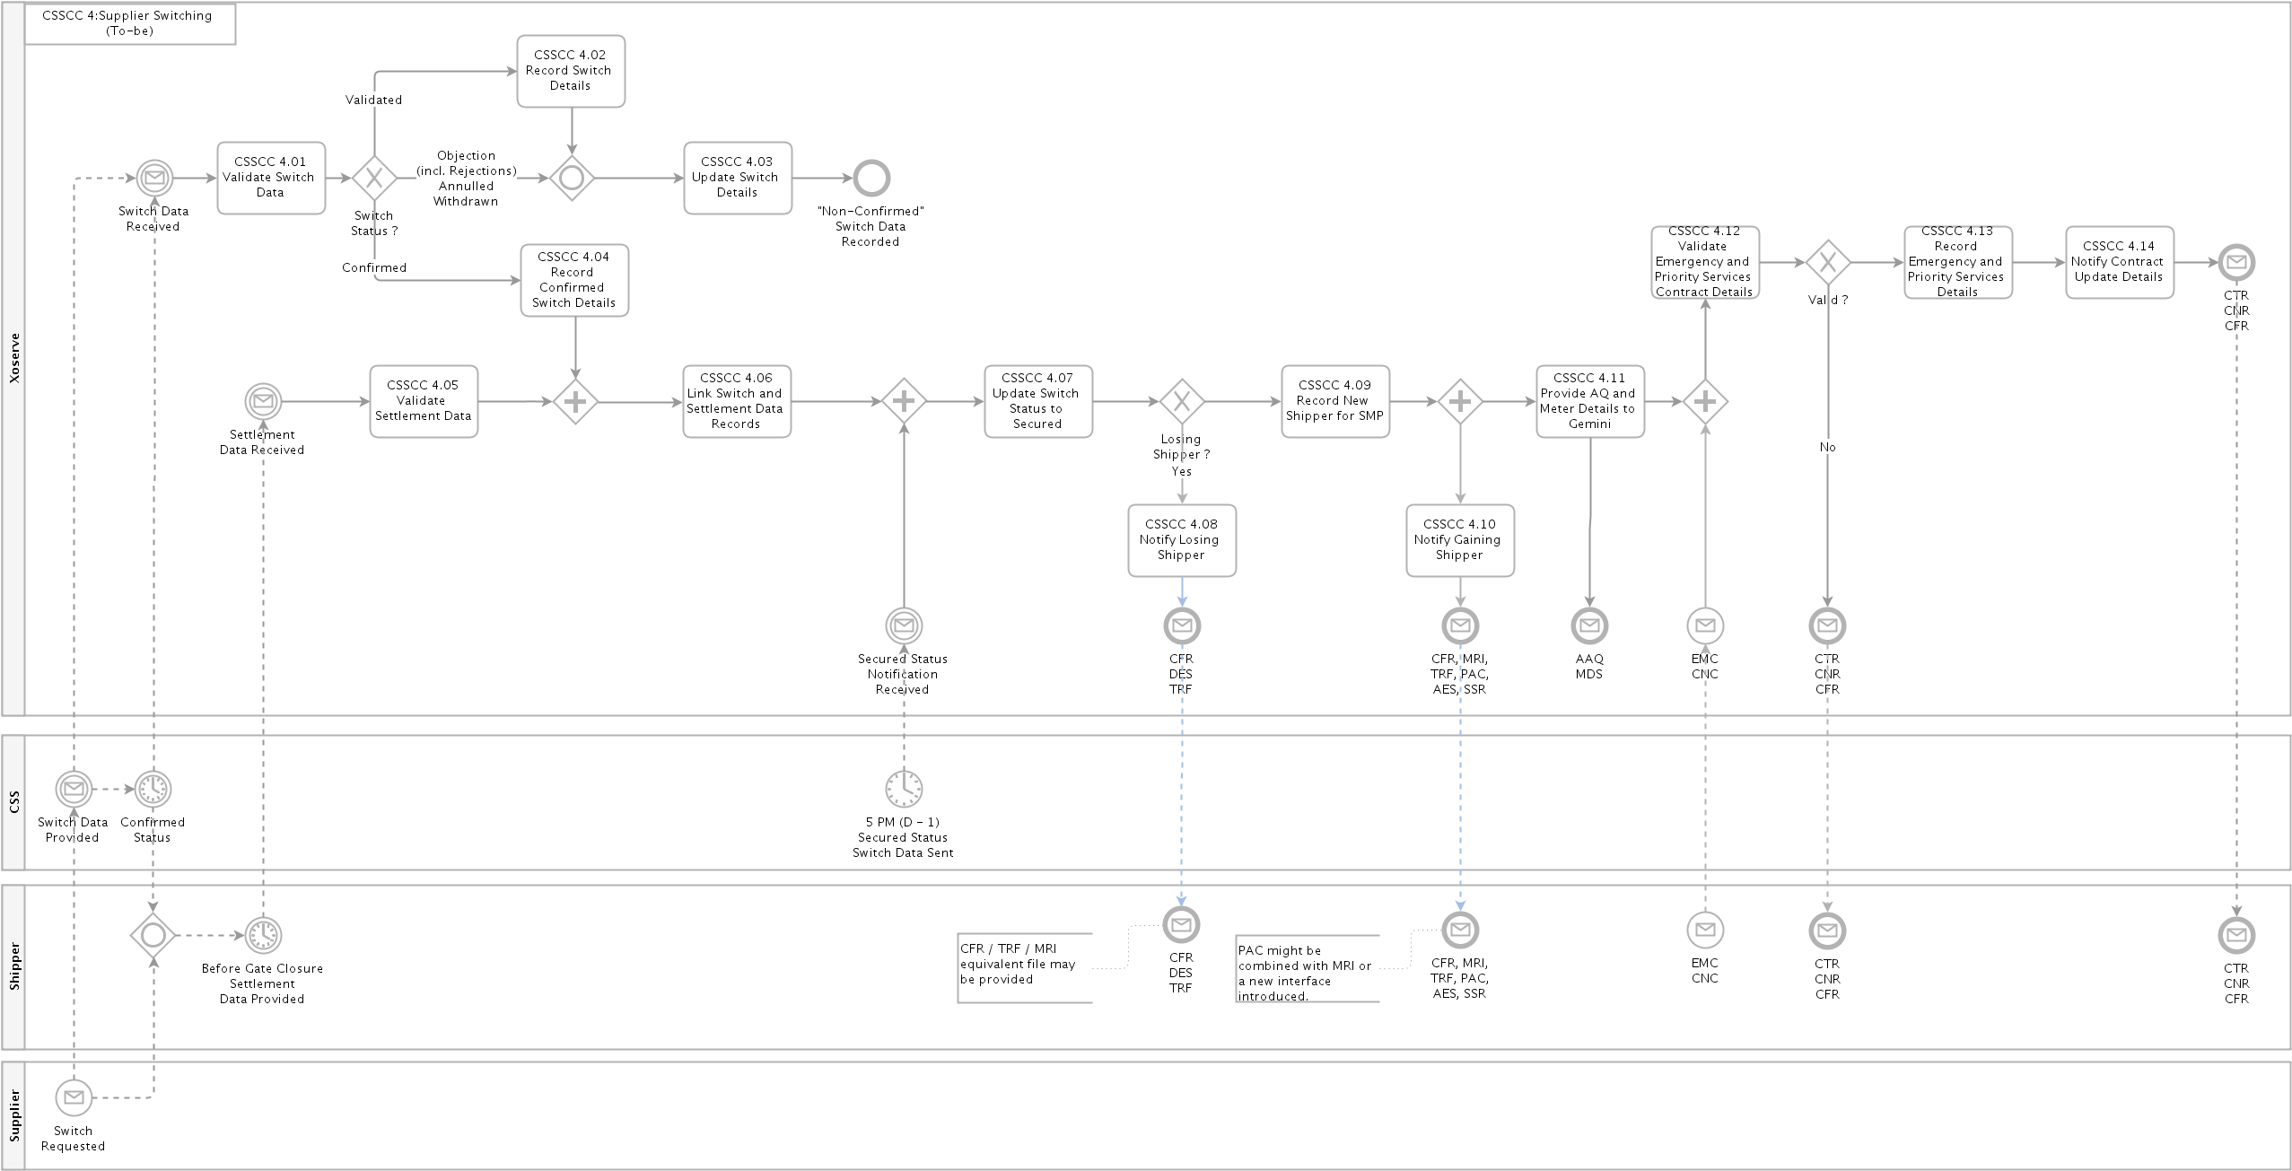

## Switching (Non-CSS) Sites (Confirmation)

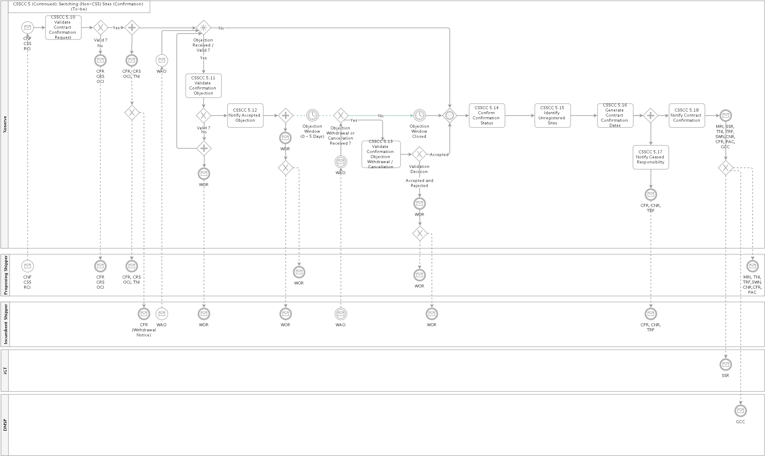

## Switching Sites (Enquiry and Nomination)

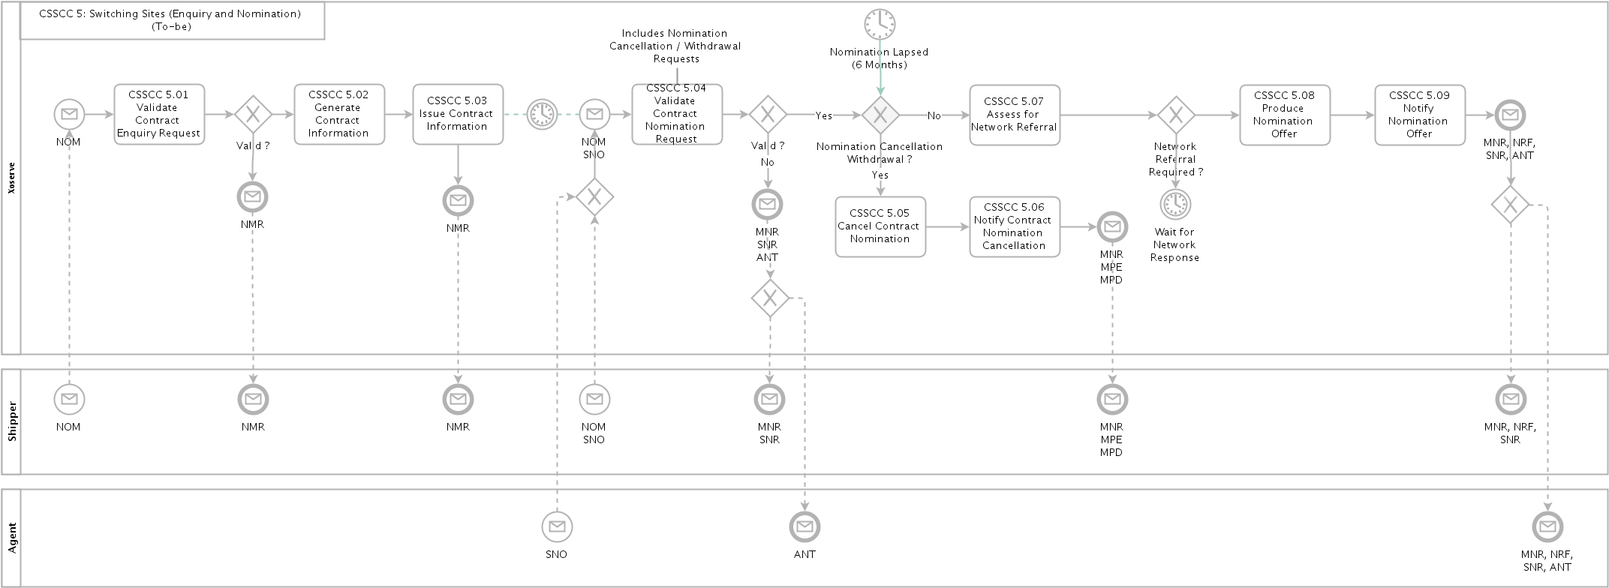

## Manage Supply Meter Point Updates

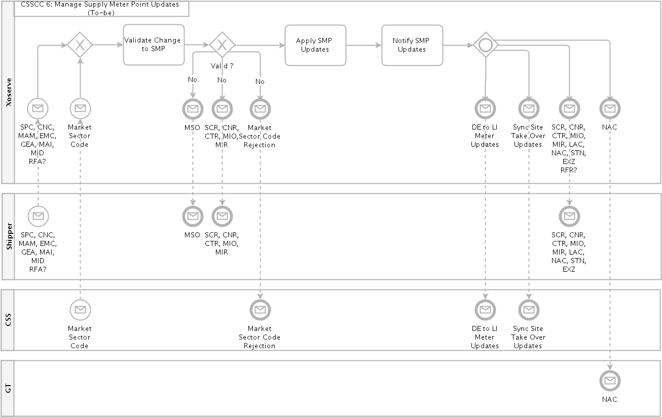

## Manage Meter Assets

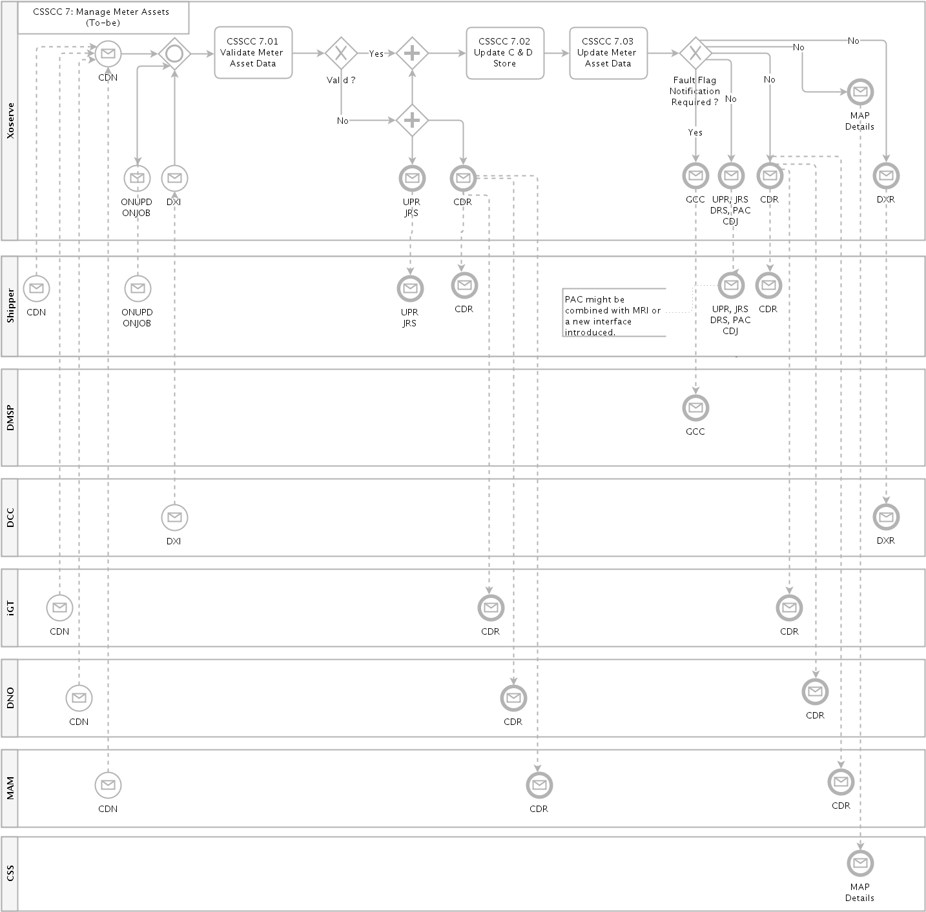

## Registration Sequence Diagram

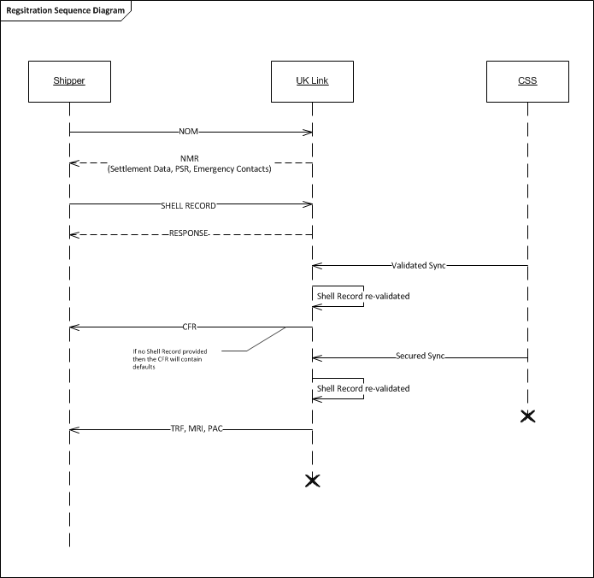

# Business Requirements Definition

The following sections of the document provide a summary of the requirements that are a direct consequence of the implementation of the new switching regime; these are broken down into the areas of change and are derived requirements from the Ofgem Switching Programme Design documentation. A full list of the source documents analysed can be found in Appendix 7.1. These have been enhanced following industry discussion at the extraordinary CSSC DGS sub group meetings and the 630R workgroup.

## Stakeholder Management

The CDSP shall master the gas market participant data, details of which are defined within the new Retail Energy Code (REC), and will be responsible for the provision and maintenance of the gas stakeholder data to the new CSS service provider and REC code manager. This will continue to include the following role types that are required to support the new switching processes:

* Gas Shippers
* Gas Suppliers
* Gas Transporters (including gas distribution network operators, independent gas transporters, etc.)
* Meter Asset Managers (MAMs)
* Meter Asset Providers (MAPs)

The CDSP shall be responsible for maintaining the MDD Market Participant List.

A Market Participant (MP) can apply to amend or delete their entry in the MDD MP List, applications to amend / delete a MDD MP will be via a [monthly process]. The Shipper is responsible for notifying the CDSP of any Suppliers who may make a Switch Request via the CSS on the Shipper’s behalf. The Shipper may also revoke the Supplier from doing so on their behalf.

The CDSP will hold and maintain details of Shipper and gas Supplier relationships/alliances within UK Link, and will notify the Central Switching Service provider of any revisions.

The CDSP will hold and maintain details of Shipper and Gas Transporters (GT/iGT) relationships/alliances within UK Link, and will notify the Central Switching Service provider of any revisions.

Where the Gas Transporter applies sanctions to a Shipper organisation (via the current process) then the CDSP will provide the details to central switching service as a “real-time” message.

## Supply Meter Point Creation

The Supply Meter Point creation process will continue to operate within UK Link as per the current processes.

The CDSP will be responsible for the synchronisation of all required Supply Meter Point data elements to the new CSS provider for all meter points that are within scope of the Central Registration Service. This will be over the new Supply Meter Point Sync interface message, and is expect to contain the following data elements:

* MPRN
* Meter Point Address
* RMP Status (this will be derived from the Supply Meter Point and Meter Isolation statuses)
* Network Owner
* MAP ID (where a meter is installed)
* DCC Service Flag

## Nomination Enquiries

A proposing Shipper may continue to submit a Nomination Enquiry Request, as per the current process and file, independently to a CSS registration to enable them to obtain information for a Supply Meter Point.

In addition to the existing file based process a new data service will be made available as an alternative route to obtain this information.

## Nomination Process - Request for Transportation Offers / Network Assessment

An equivalent of the current Nomination process will continue to be utilised to support requests for Network Assessment (i.e. Referrals) for large supply points. Network Assessment is required for changes/requests for the following example scenarios:

* + - Capacity requests/changes (SOQ and SHQ)
    - Seasonal capacity requests
    - Supply Meter Points requests for Optional Commodity Tariffs (e.g. Shorthaul)
    - Network Exit Agreements (NExAs)

Changes to the NOM file format will be required and will be finalised during detailed design.

The nomination process will no longer be a mandatory requirement for large supply points and this process will operate independently to a CSS registration.

For large supply points Shippers will continue to obtain Transportation Offers on the back of the nomination process in the same way as today. In addition a new data service will be made available as an alternative route to obtain this information.

### Any Network Assessment Requests will be issued through to the Gas Transporters for their approval in that same way as today. The Network Assessment Request Responses (Referral) response timescales are not expected to change as a consequence of CSS. The chronology of this in relation to a Registration Request via CSS is not mandated, but due to Referral response timings it is expected that this shall be submitted by a Proposing Shipper ahead of the submission of a CSS Registration Request.

### Currently Shippers may submit more than one Network Assessment Request; this is expected to endure. Where multiple Referral responses are live for a given Supply Meter Point the proposing Shipper will advise which approved response will be applied to their registration via the settlement file submission.

### Where a Shipper has not provided an explicit Referral Response Reference for the CSS Registration/Switch, then the prevailing defaults will be used.

### The existing Nomination process is expected to be retained unchanged for the Supply Meter Points out of scope of the CSS.

## Initial Registration of a Shipper and Supplier

The initial / first registration of a Supply Meter Point will follow a similar process to the change of Shipper and Supplier process described below, with the exception that notifications are only issued to the incoming Shipper.

## Change of Shipper and Change of Supplier

The Shipper and Supplier registration process will transfer to CSS for meter points managed by the new Central Registration Service. As a result the current Confirmation process will cease to be available for these meter points and all changes of Shipper and/or Supplier will be instigated by the gas Supplier via the new CSS processes.

The CDSP will receive both Shipper and Supplier ownership updates for individual meter points via a new interface with CSS. The Registration Sync message received from the CSS is expected to provide the following information which will be used to update UK Link:

* MPRN
* Supplier
* Shipper
* Registration Identifier (generated by CSS)
* Registration Effective Date
* Registration Status
* Domestic Premises Indicator (Market Sector Code)

Further updates are expected to be received from the CSS as the status progresses through the registration lifecycle, as indicated below:

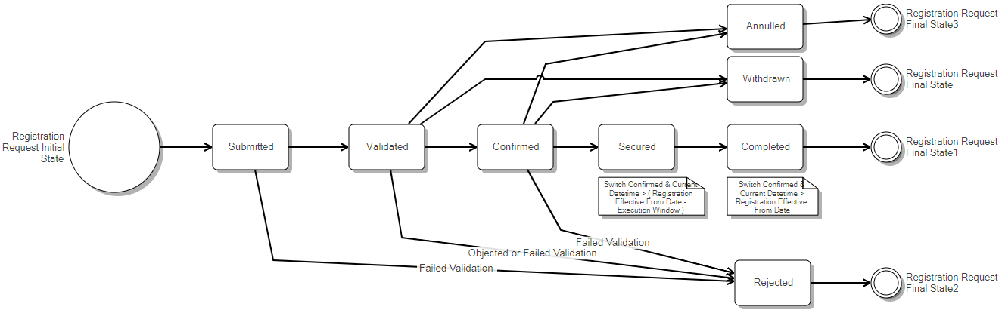

Source: Abacus / Switching State Diagram

In order to ensure that a unique confirmation reference number is maintained within UK Link for each Shipper confirmation period a unique reference number will still be generated by UK Link and issued to Shippers for each change of Supplier and/or Shipper event. This is expected to remain in the same format as the current Confirmation Reference Number, and is expected to be a different value to any Registration Identifier that is generated by CSS as part of the new Supplier registration process.

Following the receipt of a registration sync message with a “validated” registration status from the CSS, the CDSP will issue a new notification to the incoming / Proposing Shipper. The notification issued is expected to be similar to the current CFR file format; the actual content of this notification will be finalised during the detailed design phase of the project.

Following the receipt of a registration sync message with a “secured” registration status from CSS, post 5pm on D-1, the CDSP will issue a new notification to the incoming / proposing Shipper. The notification issued is expected to be a consolidation of the current TRF, MRI and PAC file formats; the actual content of this notification will be finalised during the detailed design phase of the project.

Following the receipt of a registration sync message with a “secured” registration status the CDSP will continue to issue a file to the outgoing / losing Shipper, this is expected to be similar to the current TRF file; the actual content of this notification will be finalised during the detailed design phase of the project.

Please note that the gaining and losing Shippers and Suppliers will also receive notifications from CSS when a registration request progresses to a registration status of Validated, Confirmed and Secured.

In additional to the existing file based process a data service will be made available as an alternative route for the prospective Shipper to obtaining the relevant information from the outbound notifications, which will reflect the current data position of the meter point data and the data available to the prospective Shipper as defined in the UNC.

The gaining Shipper will retain responsibility for the provision of emergency contacts and end consumer / Priority Service Register details to UK Link in line with the current processes. This is covered in more detail in the following sections.

The gaining Shipper will still be responsible for the provision of settlement data (as per the UNC requirements) to UK Link. This is covered in more detail in the following sections.

Once the new Shipper registration become active (i.e. at the start of the gas day for the effective data provided by CSS) the Settlement Details associated to the Registration Request will be applied to the supply meter point. This is covered in more detail in the following sections.

The gaining Shipper will continue to provide opening reading data on the back of a secured switch, and where not provided UK Link shall continue to generate an estimated reading. This is covered in more detail in the following sections of the documents.

## Change of Shipper Only – No change of Supplier

As described above the Shipper registration process will transfer to CSS for meter points managed by the new Central Registration Service, and will no longer follow the current confirmation process.

The new switching processes followed by CSS is Supplier orientated and changes to the registered Shipper will not follow the same registration lifecycle within CSS as a change of Supplier, they are treated as a registration event (data update).

With the exception of the trigger for the Shipper notifications (as described below) the same process will be followed as for a Change of Supplier and Shipper (see previous section).

Following the receipt of a registration sync message for a change of Shipper registration event from the CSS, the CDSP will issue a new notification to the Prospective Shipper in line with the validate registration sync notification for a change of Supplier. The notification issued is expected to be similar to the current CFR file format; the actual content of this notification will be finalised during the detailed design phase of the project.

Post 5pm on D-1, the CDSP will issue a new notification to the incoming Shipper in line with the secured registration sync notification for a change of Supplier. This notification is expected to be a consolidation of the current TRF, MRI and PAC file formats; the actual content of this notification will be finalised during the detailed design phase of the project.

Post 5pm on D-1, the CDSP will continue to issue a file to the outgoing / losing Shipper, this is expected to be similar to the current TRF file; the actual content of this notification will be finalised during the detailed design phase of the project.

## Change of Supplier – No Change of Shipper

As the CDSP will receive the Gas Supplier ownership details throughout the registration sync messages for all Supply Meter Points being managed by the new Central Registration Service directly from the new CSS service provider and will no longer receive this information directly from the registered Shipper.

As the Supplier switching process will be mastered and managed by CSS and therefore should no longer be undertaken as a process by UK Link, other than updates to any sites that are out of scope of the new switching service.

Where a registration Sync message received from the CSS relates to a Change of Supplier only (i.e. the is no change to the current registered Shipper) these message will be processed in the same way as with the Change of Supplier and Shipper process (aligned to the current re-confirmation method used to change a Supplier).

In order to ensure that a unique confirmation reference number is maintained within UK Link for registration period a unique reference number will still be generated by UK Link and issued to Shippers for each change of Supplier and/or Shipper event. This is expected to remain in the same format as the current Confirmation Reference Number, and is expected to be a different value to any Registration Identifier that is generated by CSS as part of the new Supplier registration process.

The same outbound notification with be issued to the current Shipper in line with the Change of Supplier & Shipper process described in the previous sections.

In this registration scenario, the Shipper Settlement Details will not be rolled forward from the previous Confirmation in the UK Link system and the current Shipper will need to provide the settlement details as with the Change of Shipper process to avoid any default values being applied.

As a consequence of the above, for any CSS managed sites the S96 record (submitted as part of the GEA - Generic Organisation Entity Amendment file) would no longer support the provision or amendment of Supplier details that is associated to a Supply Meter Point. The S96 record will continue for all other allowable organisation updates.

The CDSP will no longer be responsible for the provision of Supplier portfolio data over to DCC (including the provision of elected Supplier details) as this will transfer over to the new CSS provider as part of the new switching arrangements.

## Provision of Settlement Details

The CSS registration process does not include all of the information that is required by UK Link (and currently provided as part of the current Nomination and Confirmation processes, for example Settlement Class, MRF, SOQ and SHQ), as a result the gaining Shipper will still have the responsibility to provide all required Settlement Details for their registration period.

The settlement details will be provided via a new interface / file format to UK Link. The finalisation of the data items will be completed during the detailed design phase of the project, but is expected to include the following:

* MPRN
* Shipper Short Code
* Supplier Short Code
* Settlement Class
* Meter Read Frequency
* Batch Frequency (where Class 3)
* Nomination Response Reference
* MAM ID
* Emergency Contact Details
* End Consumer Details (including Priority Services Register)
* Requested SOQ/SHQ

The Settlement Detail Notification may be submitted by a Shipper in advance of the Supplier submission of the Registration Request to CSS, but should be submitted prior to the registration becoming secured.

The deadline for the submission of the settlement data by the incoming Shipper will be [15:00 hrs] on D-1 in order to be effective at the CSS registration effective from date.

The latest valid settlement detail transaction shall be associated to the Registration Request.

The Shipper may cancel Settlement Detail Notifications provided prior to the CSS registration status becoming Secured. Once cancelled these cannot be associated to any Registration Request. Receipt by the CDSP of a subsequent Settlement Detail Notification will cancel / lapse any previous Settlement Detail Notifications.

A Settlement Details Notification shall have a validity period of [60 calendar days].

Where the CDSP lapse a Settlement Detail Notification the CDSP will not notify the Shipper who submitted the Settlement Detail.

Where there is a mandatory requirement for large site contact details to be provided (e.g. emergency contacts) and these have not be provided within the Settlement Detail Notification, then the notification shall be rejected and the requested settlement data will not be considered.

In response to Settlement Details, the CDSP shall provide the submitting Shipper with a data set similar to the current Confirmation response file. The finalisation of the data items will be completed during the detailed design phase of the project, and may vary depending on whether they can be associated to a CSS registration.

As a minimum, the association of the settlement data to the CSS registration will be based on the following data items:

* MPRN
* Shipper Short Code
* Supplier Short Code

Where the Settlement Details are not provided by the gaining Shipper, or the CDSP has been unable to create this association, a set of default values will be applied. The proposed business rules for default are defined below:

**Settlement Class** – If the AQ is above 58,600,000 kWh then the meter point will default to Class 1 else it will be defaulted to Class 4.

**DM SOQ / DM SHQ** – The previous Shipper’s values will be carried forward.

**Meter Read Frequency** – This will be derived based on the prevailing AQ value in line with existing UNC rules.

**Seasonal LSP Data** – Will be carried forward if registration is effective prior to the anniversary of SLSP being effective.

**Optional Transportation Rates** – This will not be carried forward and will cease to be applied.

**PSR / End Consumer Details** – This will not be carried forward to the new registration period.

**LSP Emergency Contact Details** – These will continue to be provided to the Transporter in relation to the new registration, but will not be visible to the incoming Shipper.

UK Link will continue to provide Shipper portfolio updates through to Gemini to support gas nominations, allocations and energy balancing process. This will be triggered following the secured switch notification (or Shipper update notification) received from the CSS after gate closure at 5pm on D-1. Full details of the consequential changes are contained within a separate Gemini specific BRD.

Settlement Details can only be associated to a Registration Request. Any amendment separate to a Registration Request can be undertaken, if allowed, as part of the Supply Point Amendment Process.

For the avoidance of doubt, any Settlement Details provided will become effective at the corresponding CSS registration effective date and would not be applied in advance.

## Transporter Forced Registrations

The CDSP will continue to monitor both iGT and GT Supply Meter Points under the current rules to ensure that where required a Shipper Confirmation is in place. This includes, for example, the initial Shipper registration on iGT sites following the first meter installation, and forced confirmations following a gas safety regulations visit undertaken by gas transporters.

The current processes will change to remove the automatic Shipper confirmation of these sites, and will be updated to trigger a Supplier registration within the new Central Registration Service, as per the rules defined in REC.

## Opening Meter Read Provision

A gaining Shipper will continue to provide opening reading data on the back of a secured switch (change of Supplier and Shipper or change of Supplier only) or a change of Shipper event, and where not provided UK Link shall continue to generate an estimated reading.

The provision of the Last valid Reading to the Gaining Shipper will continue and will be provided as part of the new notification issued on the back of the Secured switch update from CSS.

No changes are expected in relation to the provision of opening readings for Settlement Class 1 and Class 2 meter points, and the existing rules will prevail.

The Inner Tolerance validation applied to readings will not be applied to the Opening Meter Reading (or the reading provided that would be used to generate an estimated opening reading) submitted by the Gaining Shipper within the read submission window.

Where a valid reading is received with a reading date that is not equal to D, the reading provided will be used to estimate a reading for D.

For Settlement Class 3 and Class 4 meter points the Incoming Shipper may obtain a reading from D-5 which will be used to estimate a reading for D.

If a reading is received from a subsequent Shipper the reading value will not be considered or used to inform the estimated reading.



In the event that multiple concurrent switches / shipper changes occur (as shown in the above diagram) the reading provision window for a transfer between Shippers is expected to remain open (using the opening read window for Shipper A as an example) until the earliest of:

* An Opening Reading is received from the Incoming Shipper (Shipper A);
* A Valid Reading is received from the subsequent Incoming Shipper (Shipper B), at which point the Opening Reading will be derived for D A (Shipper A’s Registration Effective Date and also where required for Shipper B’s Registration Effective Date);
* A valid Opening Reading is received from a further subsequent Incoming Shipper (Shipper C), at which point the Opening Reading will be derived for D A (Shipper A’s Registration Effective Date, and in addition for Shipper B’s Registration Effective Date – D B, plus where required for Shipper C’s Registration Effective Date – D C);
* A valid transaction is received with an effective date after D A that requires a Reading (e.g. RGMA transaction) from a subsequent Incoming Shipper (Shipper B), at which point the Opening Reading will be derived for D A (and if required for Shipper B’s Registration Effective Date – D B);
* A valid transaction is received with an effective date after D A that requires a Reading (e.g. RGMA transaction) from a further Subsequent Incoming Shipper (Shipper C), at which point the Opening Reading will be derived for D A (Shipper A’s Registration Effective Date, and in addition for Shipper B’s Registration Effective Date – D B, plus where required for Shipper C’s Registration Effective Date – D C);
* Creation of the Estimated Opening Meter Reading at Read Submission Deadline (where the opening read hasn’t otherwise been fulfilled at D+10).

When an Estimated Opening Meter Reading is generated as a result of an opening reading not be provide then the current estimation rules will continue to be utilised.

No separate rules are proposed for Smart and Traditional Meters.

## Supply Point Amendments Updates

UNC defines circumstances where Shippers may update the Supply Point Register by means of a Supply Point Amendment. Any Supply Point Amendments updates that are required to be submitted by the gaining Shipper are only expected to be received into UK Link once the status of the CSS registration has reached a Completed status (unless specifically described below); any request provided prior to this point will be rejected and not applied in UK Link.

**Capacity Referrals** – The current process to support capacity referrals through to networks via SPC file will continue as is.

**Large Site Contact Details** - Shippers will be able to send the emergency and interruptible contact details to UK Link outside of the switch event via EMC files as per current process.

**Priority Service Register Details** - Shippers will be able to send the priority service register details to UK Link outside of the switch event via CNC files as per current process.

**MAM Updates** – Shippers can continue to provide updates as per the current process, however where the MAM file received from an incoming Shipper in relation to their pending registration can only be provided from the point that the registration status reaches ‘secured’ (equivalent of current world ‘CO’). For meter points out side of the scope of CSS then this process remain unchanged.

## Market Sector Code Updates

For the in-scope Supply Meter Points, following the implementation of the CSS, Shippers can no longer be able to submit changes to the market sector code as all updates should to be requested by the Supplier through the new CSS process. Any amendments will be provided to UK Link by CSS as a registration event sync message.

Where there is a change to the Market Sector Code outside of the switching process then an outbound MSO file will be issued to the registered Shipper when the new Market Sector Code become effective (based on the effective date provided by on the CSS registration event sync message.

Where there is a change to the Market Sector Code as part of the switching process no outbound MSO notifications will be issue to Shippers and the update will be provided directly by CSS as part of their registration notification messages.

For all sites out of scope of the new CSS switching process (currently limited to NTS sites) the Market Sector Code will be defaulted to I – Industrial and therefore the existing MSI file will be decommissioned.

## RGMA Process

Any RGMA updates received from a gaining Shipper in relation to their pending CSS initial registration prior to it having a “Validated” status (as notified by CSS to UK Link) will be rejected and therefore not applied in UK Link as per the current process. The current rules for sites not being in-scope of the central switching service will remain unchanged.

Any RGMA updates received from a gaining Shipper in relation to their pending registration (switch) request prior to it having a “Secured” (as notified by CSS to UK Link) will be rejected and therefore not applied in UK Link as per the current process. The current rules for sites not being in-scope of the central switching service will remain unchanged.

## Meter Asset Provider Details

The registered/gaining Shipper can provide the identification of the Meter Asset Provider (MAP) as part of the standard RGMA transactions.

MAP IDs for an individual meter can also be provided directly by the owning Meter Asset Provider to the CDSP.

Where the MAP is provide this shall be recorded against the meter asset record within UK Link and the details will be synchronised to CSS.

## Shipper Withdrawal Process

For meter points managed by CSS, the Shipper withdrawal process will cease and a deactivation of the registration will need to be requested by the registered gas Supplier via the new CSS processes. These updates will then be synchronised to UK Link by CSS.

Following the receipt of a synchronisation message form CSS, the Shipper and Supplier registration updated will be process a per the current Shipper withdrawal process.

The Losing Shipper will continue to be notified of their ceased responsibility as per the current process.

## Address Updates

No changes will be made to the current meter point address update process.

Where there is a change to the meter point address held for a meter point in UK Link the changes will be synchronised to CSS.

## Reporting

As yet no specific reporting requirements have been identified to support the implementation of CSS, however changes made to the UK Link data model may need to be reflected within existing industry reports. This will be revisited during the detailed design phase of the programme.

## Transitional Requirements

There is a transitional requirement from the Switching Programme to support the transition from the current Shipper Confirmation process to the new Supplier Registration process the objection window for all gas confirmations will need to be aligned to the electricity objection window of 5 working days.

In line with the switching programme transition plan the submission of confirmation requests from Shipper will cease and will be rejected by UK Link for all sites that are transitioning over to the new central switching service. The date for this is still to be finalised but is expected to be around twelve days prior to CSS go-live.

In line with the switching programme transition plan the submission of SPA update requests for data elements that will be part of the new CSS processes (for example Market Sector Code and Supplier updates) will be rejected by UK Link for all sites that are transitioning over to the new central switching service. The date for this is still to be defined.

## Perceived File Format Changes

The following provides an indicative view of the file format changes that might be required to support the consequential changes being made to support the implementation of CSS. This list may change as further analysis is undertaken during detailed design.

|  |  |  |  |
| --- | --- | --- | --- |
| **File Type** | **Record Type** | **Impact Type** | **Impact Summary** |
| CFR | S07, S09, S16, S10 | Change | The CHANGE_OF_TENANCY_IND can no longer be a mandatory data item as this will not be provided to UK Link from the CSS (remain as is for NTS sites) |
| CFR equivalent |  | New | CFR equivalent to Shippers on the validated sync from CSS |
| CNF |  | Change | This file can no longer be used to support a change of Shipper request as this activity will be undertaken by the CSS (however the process may need to remain for any out of scope sites) |
| CRS |  | Candidate for Change | SSMP files. More clarity will be provided at the time of detail design |
| CSS |  | Candidate for Change | SSMP files. More clarity will be provided at the time of detail design |
| DCF |  | No Change | This file can no longer be used to support a change of Shipper request as this activity will be undertaken by the CSS (however the process may need to remain for any out of scope sites) - This will be only sent in case of NTS sites |
| GEA |  | Change | Cannot be used to update UK Link with updated Supplier Details as this will be managed via the CSS processes |
| MPD |  | No Change | No change to the file format but logic to generate this file is expected to change. This will be sent at the back of Deactivation sync for Shipper withdrawals |
| MPE |  | No Change | No change to the file format but logic to generate this file is expected to change. This will be sent at the back of Deactivation sync for Shipper withdrawals |
| MRI |  | Change | For in scope sites this is expected to be amalgamated with the TRF and PAC files, and may be issued earlier in the switching process |
| MSI |  | Decommission | The amendment of the Market Sector Code will be undertaken by the CSS and not via UK Link |
| MSO |  | No Change | No change to the file format but logic to generate this file is expected to change. This will be sent at the back of Registration Sync for change of domestic indicator event sync |
| NMR | S59 | Change | Withdrawal Status field is currently Mandatory, however we will not be able to populate for CSS managed sites so will may need to change to optional or defaulted to "N" (or another value) |
| NOM |  | Change | Structure and validation rules may change to support the new process requirements |
| NRF |  | Change | Withdrawal Status field is currently Mandatory, however we will not be able to populate for CSS managed sites so will may need to change to optional or defaulted to "N" (or another value) |
| ONJOB / ONUPD |  | No Change | New file needed to capture MAP ID, this could be via the RGMA files |
| PAC |  | Change | For in scope sites this is expected to be amalgamated with the TRF and MRI files, and may be issued earlier in the switching process |
| Settlement Details |  | New | New file for Settlement details from Shippers |
| Settlement Details Response |  | New | New response file for Settlement details to Shippers |
| SNO |  | Candidate for Change | SSMP files. More clarity will be provided at the time of detail design |
| SNR |  | Candidate for Change | SSMP files. More clarity will be provided at the time of detail design |
| TRF |  | Change | For in scope sites this is expected to be amalgamated with the MRI and PAC files, and may be issued earlier in the switching process. Changes may also be required for the losing shipper notification |
| TRF/MRI/PAC Equivalent |  | New | TRF/MRI equivalent to Shippers during the CSS registration process |
| TRS |  | Candidate for Change | SSMP files. More clarity will be provided at the time of detail design |
| WAO |  | No Change | No change to the file format but additional rejection for sites in scope of CSS |
| WOR |  | No Change | No change to the file format but additional rejection for sites in scope of CSS |
| MAP ID |  | New | Notification to Shippers on updates to assets with MAP IDs |

# Non-Functional Business Requirements

A number of non-functional requirements have been defined by the switching programme that will have a direct impact on Xoserve’s systems. Full details of these can be found in the switching programme E2E Non-Functional Requirements document on Ofgem’s website ([link](https://www.ofgem.gov.uk/publications-and-updates/e2e-design-products)).

No additional non-functional requirements have been defined outside of the Switching Programme.

# Document Control

## Version History

|  |  |  |  |  |
| --- | --- | --- | --- | --- |
| **Version** | **Status** | **Date** | **Author(s)** | **Summary of Changes** |
| 0.1 | Initial Draft | Oct 2018 | Xoserve | N/A |
| 0.2 | Draft | 06/11/2018 | Xoserve | 5.7.4 added regarding ceasing the provision of Supplier portfolio data to the DCC  Process models added |
| 0.3 | Draft | 05/12/2018 | Xoserve | Version for discussion for 6th December 2018 |
| 0.4 | Draft | 07/12/2018 | Xoserve | Updates following 6th December workgroup. NB: Workshop covered sections 5.3 – 5.9 inclusive. |
| 0.5 | Draft | 01/03/2019 | Xoserve | Updated to reflect the CSSC DGS workgroup discussions |
| 0.6 | Draft | 04/03/2019 | Xoserve | Updated following internal Xoserve review |
| 0.7 | Final Draft | 15/03/2019 | Xoserve | Updated following extraordinary CSSC DSG meeting on 7th March |