Business Requirements Document

Ofgem Switching Programme
Gemini Consequential Change Requirements Overview

Author (for this version): | Xoserve
Version: | 0.2
Status: | Final Draft
Date: | 19th March 2019

This document contains confidential or privileged information; it should not be copied or disclosed to any third party without the express permission of Xoserve Ltd. All rights reserved.

Copyright © 2019 Xoserve Ltd
Contents
1 Introduction 3
1.1 Document Purpose 3
1.2 Related Documents 3
2 Executive Summary 4
2.1 Introduction to the Change 4
2.2 Change Background 4
2.3 Process Issues 4
2.4 Scope 5
3 Design Considerations 7
4 Business Process 8
4.1 Existing Process Overview 8
4.2 Proposed To-Be Process Overview 9
4.3 Proposed To-Be Process UK Link to Gemini Portfolio Updates on D-1 of Effective Date 10
5 Business Requirements Definition 11
5.1 Shipper Portfolio Changes 11
5.2 Other Gemini Updates 11
6 Non-Functional Business Requirements 13
7 Document Control 14
7.1 Version History 14

Introduction

Document Purpose
The purpose of this business requirements document (BRD) is to ensure that the high level business requirements associated with the design baseline 4 phase of the switching programme changes have been captured, and to clearly specify these requirements to DSG to provide an understanding of the consequential change impacts.
To provide adequate information to enable the industry to undertake analysis of the impacts to their systems and business processes. The contents refer to the business scope of the change and provide descriptions of the business requirements and the relevant ‘As Is’ and ‘To Be’ process maps.

Related Documents
The underlying source documents and further details about the Switching Programme can we found on Ofgem’s website:
https://www.ofgem.gov.uk/gas/retail-market/market-review-and-reform/smarter-markets-programme/switching-programme

Executive Summary

Introduction to the Change
This document defines the consequential changes that are required to be undertaken for gas Shipper facing processes to support the implementation of the new Central Switching Service.
The details contained within the document are currently based on the Ofgem switching programme E-2-E design products that have been produced to support faster and more reliable switching within the energy market and provide an indicative view of the changes that will be required within Xoserve’s systems to support.

Change Background
This change relates to the consequential changes to the gas shipper / supplier switching process required to support the wider Ofgem Switching Programme. This programme is an Ofgem initiative within a broader set of energy market reforms that aim to encourage consumers engagement with the energy market (especially switching), and to improve their experiences of doing so through a faster more reliable centralised set of industry processes.
The overarching ambition of the Switching Programme is to “improve customers' experience of switching, leading to greater engagement in the retail energy market by designing and implementing a new switching process that is reliable, fast and cost-effective. In turn this will build consumer confidence and facilitate competition, delivering better outcomes for consumers”.
UNC modification review workgroup (630R) was formed back in October 2017 to conduct a review and assessment of the consequential impacts to the UNC, DSC and associated UK Link processes as a result of the Ofgem Switching Programme (OSP). This workgroup has now concluded and its output has been used to inform this Business Requirements Document (please note that this document supersedes the version created under this workgroup).

Process Issues
The implementation of the new central switching service leads to a number of consequential changes having to be made within UK Link, as summarised below:
- Moving to a Supplier led switching process via CSS and removing the Shipper led confirmation process within UK Link for in-scope Supply Meter Points
- Provision and capture of settlement parameters for an incoming Supplier registration from the incoming Shipper
- Stakeholder changes required to support new CSS processes
- Synchronisation of meter point and registration data between UK Link and CSS
- Capture of Meter Asset Provider details for all installed meters
- SPA data update for Supply Meter Points
Below is a draft heat map which represents the areas of Xoserve that are impacted by the Ofgem Switching Programme. This provides a visual view of the scope and scale of change across the current CDSP value chain / processes. This has been updated to reflect the position at the end of the high level consequential design phase of the project.
The sections that are highlighted red within this heat map signify considerable substantial, high impact changes to his area; the yellow areas will create medium impact and no impacts have been identified within the green areas.
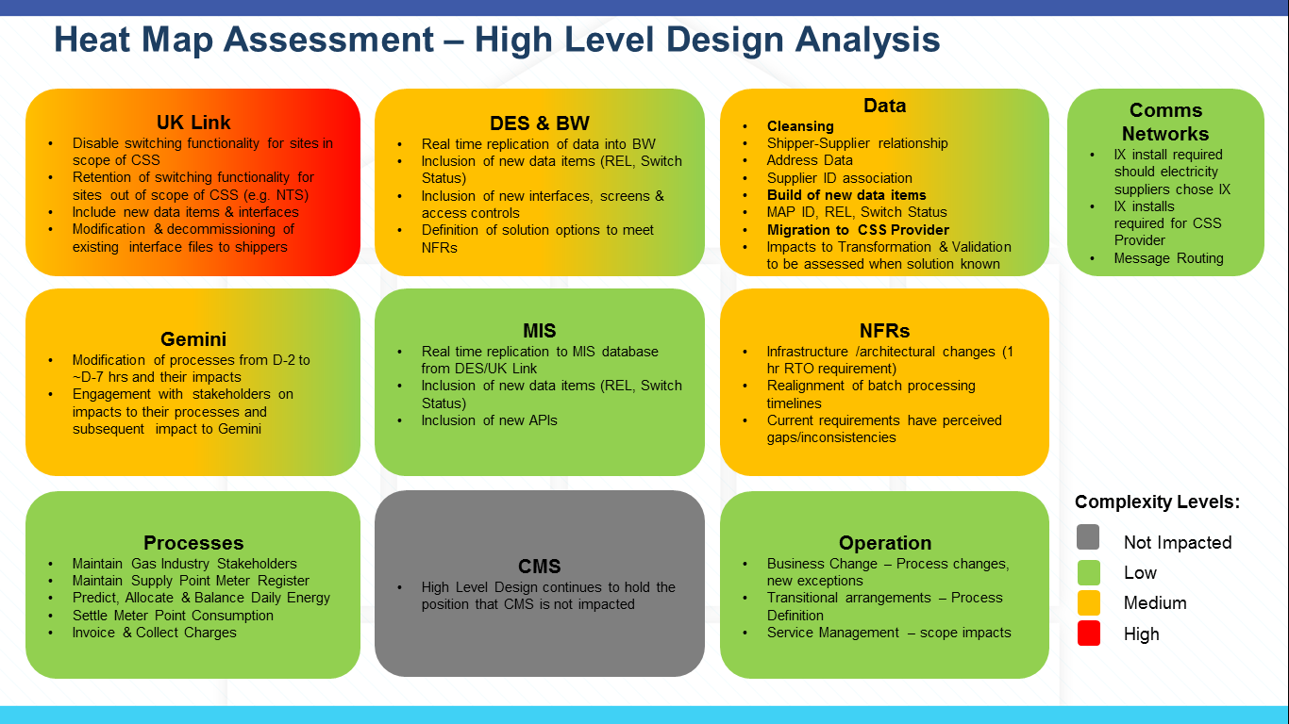

Scope

In Scope
The following areas are included with the scope of this requirements document:
- Consequential changes to the Gemini system resulting from the implementation of the new Central Switching Service

Out of Scope
Requirements relating to the following areas have been deemed as out of scope of this document:
- Consequential change to the UK Link system (this is be covered by a separate BRD)
- Consequential changes to Data Enquiry (this will be covered by a separate BRD)
- Changes to any interfaces or interactions between Shippers and gas Suppliers as a result of the switching programme
- Any process being managed or maintained by the new CSS
- Any processes that are not impacted by the implementation of the new CSS
- Any other areas of change that are not a direct consequence of the new CSS implementation
- Supply Meter Points that are deemed out of scope of the new Central Registration Service, this is currently expected to include the following Supply Meter Point site types:
  - Sites directly connected to the National Transmission System (NTS Sites)
Please note that the current Nomination and Confirmation processes and associated file formats will continue to be used for these sites operating under the current processes.

Design Considerations
Design considerations will be captured as industry design continues to progress.

Business Process

Existing Process Overview
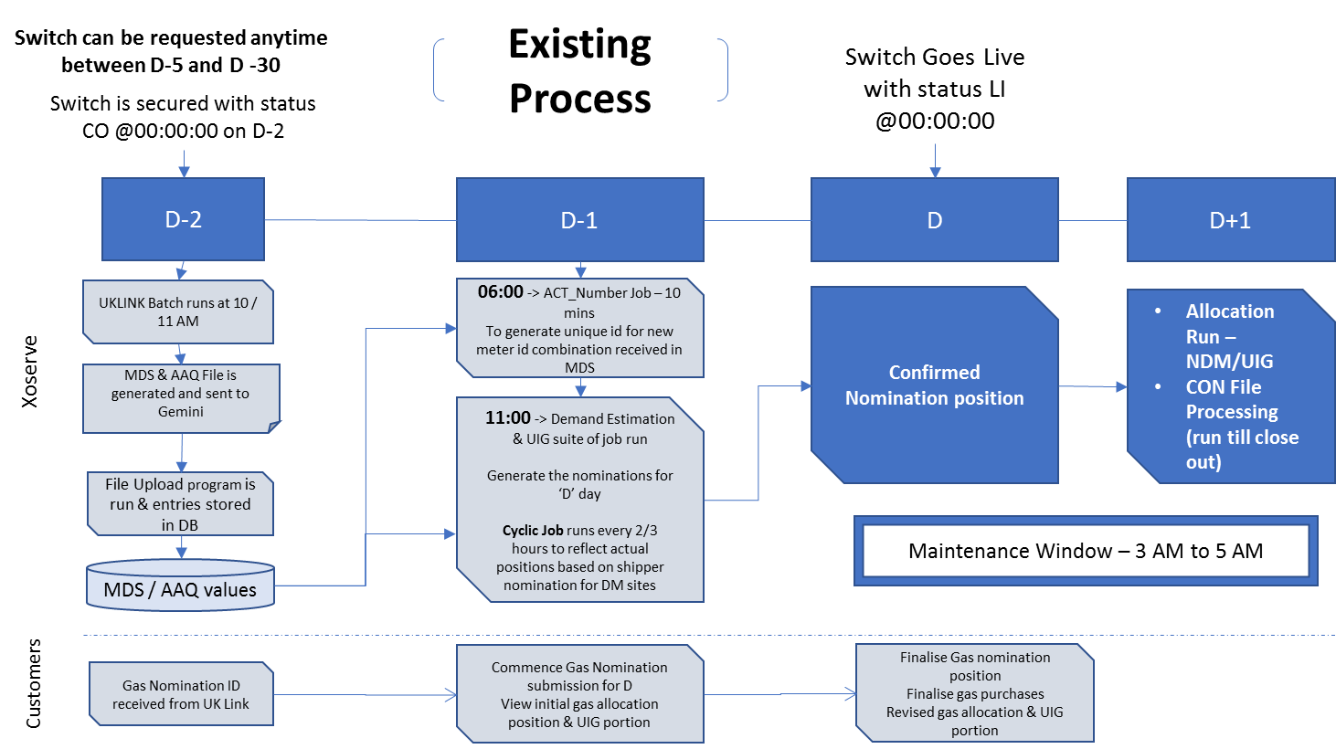

Proposed To-Be Process Overview
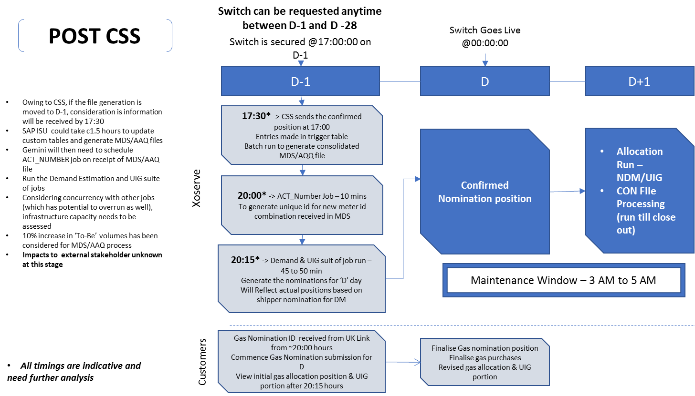

Proposed To-Be Process UK Link to Gemini Portfolio Updates on D-1 of Effective Date
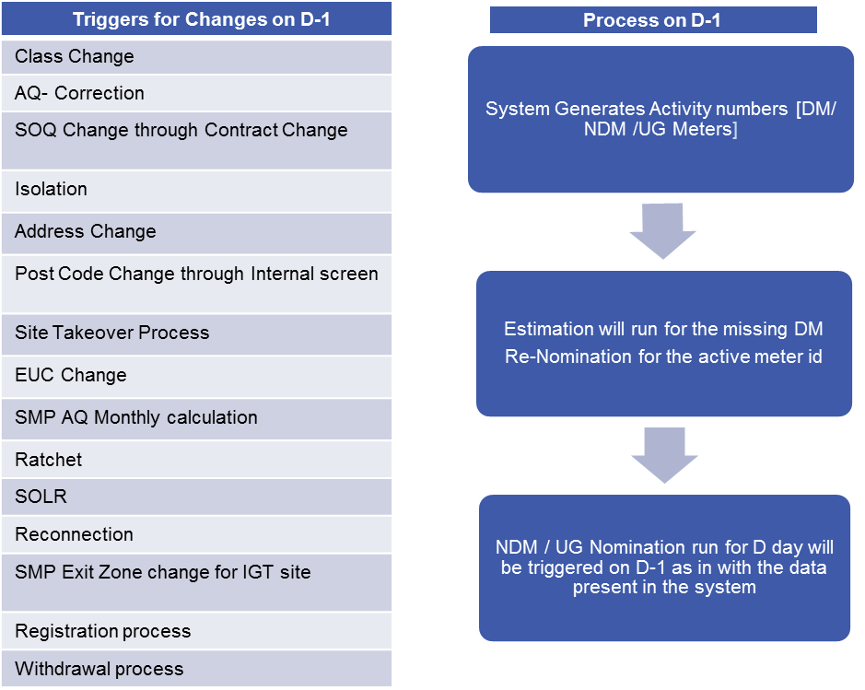

Business Requirements Definition
The following sections of the document provide a summary of the requirements that are a direct consequence of the implementation of the new switching regime; these are broken down into the areas of change and are derived requirements from the Ofgem Switching Programme Design Baseline 4 set of documentation.

Shipper Portfolio Changes

Following the processing of a change to the shipper’s portfolio, as a result of either a CSS originated switch (change of supplier), a change of shipper event, or a change to Supply Meter Point data this is provided to Gemini (for example a Class Change, AQ correction, EUC change, etc.), UK Link will continue to aggregate the shipper’s portfolio, issue the relevant gas nomination identifier to the shipper and generate the MDS and AAQ files as per the current process.

With the implementation of the new Central Switching Service the timing for the generation of the MDS and AAQ files will need to change, it is currently anticipated that UK Link will pass these files over to Gemini at around [20:00 hrs] on D-1 of the shipper portfolio change becoming effective.

No functional or data changes are expected to be required within any file interfaces between UK Link and Gemini.

No changes are expected to be made to support the switching of sites out of scope of the new switching service (e.g. NTS sites) as these will continue to be managed within UK Link under the existing nomination and confirmation processes, which will remain unchanged.

Other Gemini Updates

Updates to Gemini for the start of the Gas Year (e.g. annual EUC changes) will continue to occur on current timescales (D-2).

Changes will be made to the timing and processing of current activates / batch jobs as required and is expected to cover the following areas:
    - Creation of activity numbers following the processing of portfolio updates. This is for both Directly connected sites & LDZ non-standard sites;
    - DM Nomination estimation batch job to be triggered after loading of MDS / AAQ file. This is for both Directly connected sites & LDZ non-standard sites;
    - Provision of data (e.g. Meter Details, Shipper Nominations etc.) to external systems (e.g. GCS Fusion, MIS, MIPI, DNs);
    - Management of existing manual work items for all SSMP confirmations and non-standard LDZ sites;
    - Cancelation of any existing approved Gas Nominations for future days for sites that are no longer in the Users/shippers ownership. This includes the DM estimation & creation of activities processes.

No other changes have been identified as a direct consequence of the implementation of the new switching service.

Non-Functional Business Requirements
A number of non-functional requirements have been defined by the switching programme that will have a direct impact on Xoserve’s systems. Full details of these can be found in the switching programme E2E Non-Functional Requirements document on Ofgem’s website (link).
No additional non-functional requirements have been defined outside of the Switching Programme.

Document Control

Version History
Version | Status | Date | Author(s) | Summary of Changes
0.1 | Initial Draft | Jan 2019 | Xoserve | N/A
0.2 | Final Draft | 19/03/2019 | Xoserve | Updated to reflect the discussions following the extraordinary CSSC DSG meetings

