DSC Business Evaluation Report (BER)

Change Title | PAC DDP delivery
Xoserve reference number (XRN) | XRN4876
Xoserve Project Manager | David Newman
Email address | David.newman@xoserve.com
Contact number | 0121 229 2141
Target Change Management Committee date | 04/02/2021
Section 1: In Scope
In 2019 Xoserve implemented the Data Discovery Platform (DDP), a Business Intelligence (BI) technology to monitor and analyse internal data. The opportunity to leverage this CDSP capability provides customers a new and more visual way to receive and interpret the data services we are able to provide. The data can be visualised in the form of charts, graphs and dashboards to easily identify key metrics, trends and outliers and then to drill down into the points of interest to focus on the key information.

To support Performance Assurance Committees (PAC) monitoring of key metrics across the industry, they have requested a number of sprints to further develop the DDP proposition to aid their ability to monitor industry performance. PAC plan to utilise their existing change budget of £75k to fund 3 sprints. PAC has built up an extensive backlog and following the workshop on the 6th January has prioritised the user stories. Delivery will be based on agile principles and thus time and quality can not change, only the scope can. Any undelivered user stories (from a sprint) will be carried forward to be considered as part of the next sprints prioritisation. Sprint 2 and 3 have indicatives scopes which will be reprioritised after each sprint and prior to commencing the next to ensure each delivery is aligned to value.

Scope of Delivery for sprint 1 (£25k funded from PAC Change Budget)
PAC will get the following:
- Access to new bespoke DDP dashboards including;

AQ Corrections

- As PAC I want to see the number of AQ corrections that are rejected per reason code so I can monitor how many AQ corrections are being rejected by UKLink so that I understand the reasons why AQs are being rejected.

Read Performance

- As PAC I want a report that shows read performance split at class, MRF (meter read freq), Associated AQ (% of AQ that has been read) and number of MPRNs (for negative performance) so that I better understand the materiality associated with performance.

- As PAC I want a report that shows meter type, number of reads submitted, number of reads accepted & number of reads rejected for all classes per month.

(since last accepted read)

A breakdown is needed of why the read was not received:
a) Failed validation = rejected
b) Read not submitted

PAC - Aggregation view would give as the minimum viable product (MVP) low level detail can be delivered within a later sprint.

No Reads

- As PAC I want to see when the AQ last changed on each site in the no reads category so I can see if Shippers are doing AQ corrections and not sending reads so that I better understand materiality associated with performance.

Sprint 2 indicative scope:

AQ Corrections

- 2B.8 PAC I want to see the amount (volume) AQs are changing as a result of AQ Corrections so that I can assess whether the process is being used correctly. The dashboard should depict the direction of AQ movement, and the volumes involved.

Replaced Meter Reads

- As PAC I want to see whether replacement reads are replacing actual reads or estimates so that I can monitor if actual reads are being replaced to understand whether the process is being used primarily to reduce AQs and receive credit reconciliations.

Estimated Reads

- As PAC I want to view the total estimated consumption per shipper, per month, per product class (1 and 2) So that I can determine the consumption percentage of each Shippers portfolio that is resulting from estimated reads and assess the related settlement risk.

No Meter Recorded Asset

- As PAC I want the ability to view the data in No Meter Recorded dashboard by Product Class so that I am provided with greater context. I want the report to include the AQ roll for each MPRN by product class and a view to show the total AQ at a summary level.

No Asset

- As PAC I want the report to show the time lapsed between confirmation date and the current date (where a meter has never been attached) or the time lapsed between meter removal date and the current date (where meter has been removed). Report needs to show an age breakdown of data monthly starting from 6 months after confirmation date or removal date (6/7/8/9/10+).

No Reads

- As PAC I want to see the associated AQ of sites in the no reads category and be able to filter on MRF and product class.

Sprint 3 scope:

Current scope is not defined but will be based on the PAC committees’ priorities of outstanding user stories (defined in the workshop on the 6th January) and or any user stories not delivered as part of sprint 1 and 2:

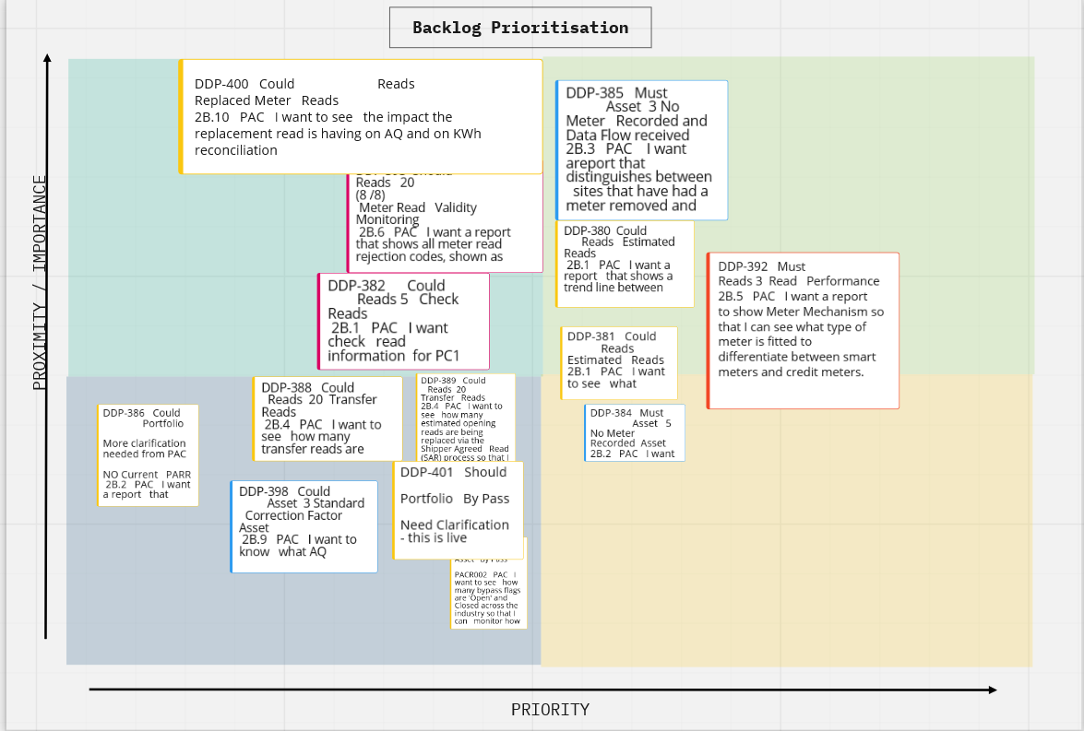

Timeline:

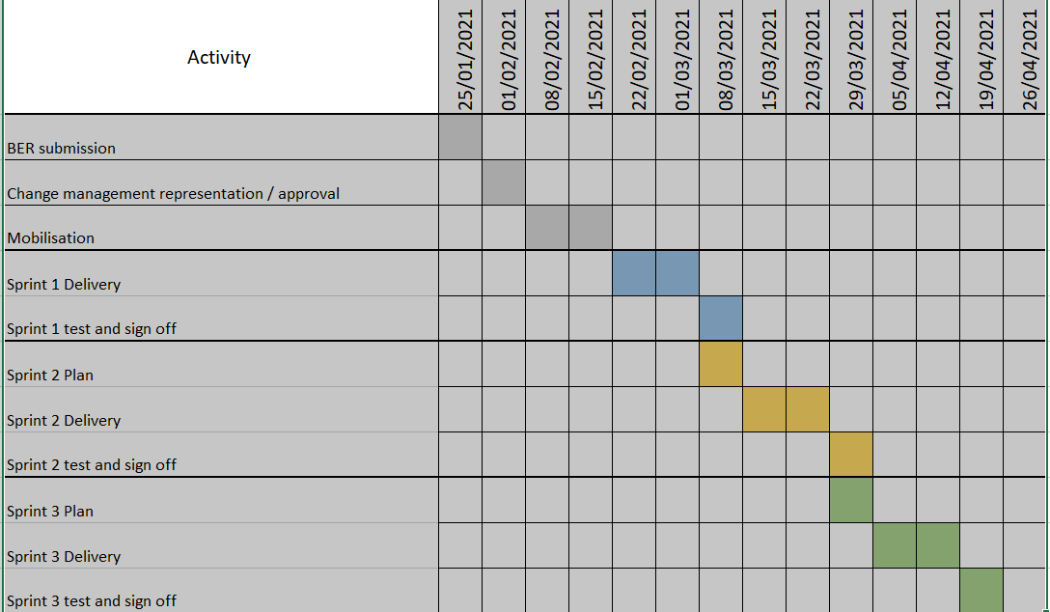

Section 2: Out of Scope
Anything which can not be delivered within the 3 sprints.

Section 3: Funding required to deliver the change
Gas Industry Participant | % Share of Cost | Cost Value
PAC | 100% | £75,000
Shippers
iGT’s
DNO’s
Transmission
DN
Total Cost |  | £75,000

Section 4: Estimated impact of the service change on service charges
Xoserve Service Area | Xoserve Service Line | (+/-) Projected Change in Annual Cost
Data Discovery Platform | Non-currently identified | Non-currently identified
In addition, detail any change in functionality of the Xoserve service areas/service lines associated with this change. Use the following link as a reference to the Xoserve service areas:
Service Description Table
Section 5: Project plan for delivery of the change
The Data Discovery Platform is being run as an Agile Project methodology – Utilising a 2 week development sprint cycle. Governance will look at the sprints combined, using governance and the agreed artefacts for delivery. Any User Stories not delivered as part of this Sprint, will go back into the Product Backlog and delivered at a later sprint.
Section 6: Additional information relevant to the proposed service change

Please send completed form to: box.xoserve.portfoliooffice@xoserve.com

Document Version History
Version | Status | Date | Author(s) | Summary of Changes

Template Version History
Version | Status | Date | Author(s) | Summary of Changes
1.0 | Approved | 15/06/18 | Rebecca Perkins | Document approved at CHMC External Workgroup
2.0 | Approved | 19/12/18 | Heather Spensley | Moved onto Xoserve’s new Word template in line with new branding

