DSC Business Evaluation Report (BER)

Change Title | UK Link November 21 Major Release
Xoserve reference number (XRN) | 5289
Correla Project Manager | Tara Ross
Email address | tara.ross@correla.com
Contact number | 0121 229 2075
Target Change Management Committee date | 12th May 2021
Section 1: In Scope
This BER requests approval for funding the full delivery of this UK Link Release, which consists of 6 XRNs, and is proposed to be implemented in November 2021. The delivery cost of £1,305,931 includes the EQR and a risk margin (specific per-change risks as listed below).

XRN | Title | Type | Description | Link to Change Proposal | Impacts
4941 | MOD0692 – Auto updates to meter read frequency | Regulatory | MOD - 0692 - Instructs the CDSP to change the meter read frequency of sites with non monthly Meter Read Frequency (MRF) to monthly where either  A. The AQ increases to 293,000 KWH or above  B. AMR installed  C. DCC flag of active  An activity post implementation and XRN5142 data cleanse, will be completed where all the non monthly MRF are assessed and updated to Monthly where one of the criteria is met – this is likely to cause an increase to Must Reads. | https://www.xoserve.com/change/change-proposals/xrn-4941-auto-updates-to-meter-read-frequency-mod0692/?return=/change/change-proposals/?customers=&statuses=&search=4941 | Shipper
5007 | Enhancement to reconciliation process where prevailing volume is zero | Non-regulatory | Where a period has been reconciled to a zero position and then a valid read related to that period is received, re-reconciliation takes place.  As the prevailing metered volume is zero an MN09 exception is generated for Class 3 and Class 4 sites.  In these scenarios we will use the deemed volume instead of the prevailing volume when calculating the reconciliation factor which will prevent an MN09 exception being created. | https://www.xoserve.com/change/change-proposals/xrn-5007-correction-in-the-reconciliation-process-when-volume-is-zero/?return=/change/change-proposals/?customers=&statuses=&search=5007 | Shipper
5072 | Application and derivation of TTZ indicator and calculation of volume and energy (all classes) | Non- regulatory | Where there is at least one read with a Through The Zero's (TTZ) count the system doesn’t always calculate the volume correctly.  The system calculation will be amended so that the volume is calculated correctly.  An activity will be completed where all historical calculations with a TTZ count are assessed. The volume and AQ will be corrected where necessary. | https://www.xoserve.com/change/change-proposals/xrn-5072-application-and-derivation-of-ttz-indicator-and-calculation-of-volume-and-energy-all-classes/?return=/change/change-proposals/?customers=&statuses=&search=5072 | Shipper
5142 | SEC (MOD) -New allowable values for DCC service flag in DXI file from DCC | Regulatory | The DCC Service flag values of 'S' (suspended) and 'W' (withdrawn) will be removed and new service flag values of 'N' (non-active) and 'I' (installed not commissioned) will be created. 'A' (active) will remain.  An activity, completed by the DCC, will assess and update any values where necessary. The DCC will then provide these updates so that UK Link reflects the same values. | https://www.xoserve.com/change/change-proposals/xrn-5142-new-allowable-values-for-dcc-service-flag-in-dxi-file-from-dcc/?return=/change/change-proposals/?customers=&statuses=&search=5142 | DN/IGT
5180 | Inner tolerance validation for replacement reads and read insertions | Non- regulatory | When a read is replaced or inserted, in between two reads, the replaced/inserted read is validated against both reads and energy tolerances are performed for each period i.e. backwards as well as forwards.  When an override flag is only required for one of the periods (backwards or forwards) the read is rejected even when an override flag is provided. | https://www.xoserve.com/change/change-proposals/xrn-5180-inner-tolerance-validation-for-replacement-reads-and-read-insertions/?return=/change/change-proposals/?customers=&statuses=&search=5180 | Shipper

Section 2: Out of Scope
- Any additional changes
- Market Trials - unless requested by customers
Changes to Data Discovery Platform
Section 3: Funding required to deliver the change
The following section outlines the proposed costs for XRN5289, including the previously agreed EQR for Design. Costs highlighted in amber are for approval.

BER Costs

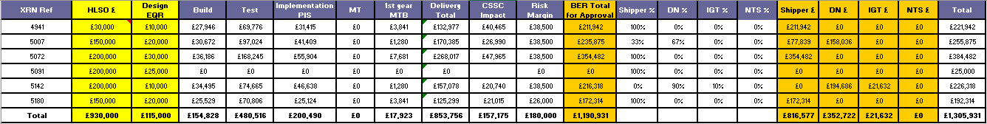
Key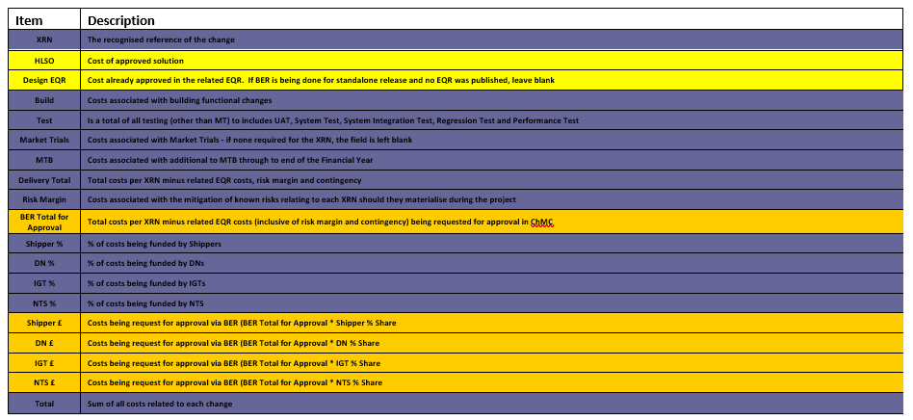
Section 4: Estimated impact of the service change on service charges
Impacts to Ongoing Costs

XRN | Xoserve Service Area | Impact | (+/-) Projected Change in Annual Cost
4941 | Service area 1: Manage Shipper Transfers  DS-CS SA1 – 56 | Technical Operations additional Monitoring | £5,101.20
5007 | Service Area 4 - Meter Read/Asset processing | Technical Operations additional Monitoring | £1,700.40
5072 | Service Area 4 - Meter Read/Asset processing | Technical Operations additional Monitoring | £10,202.40
5142 | TBC | Technical Operations additional Monitoring | £1,700.40
5180 | Service Area 4 - Meter Read/Asset processing | Technical Operations additional Monitoring | £5,101.20
Total |  |  | £23,805

Section 5: Project plan for delivery of the change
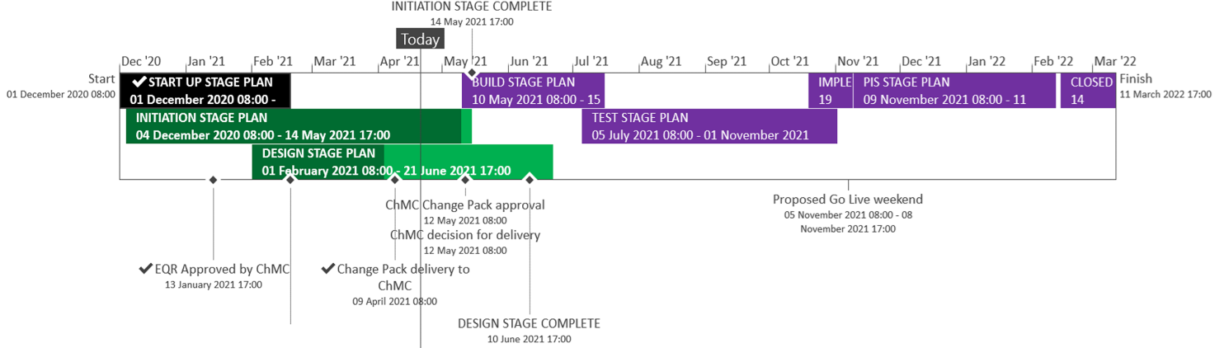
Complete
On Track
Planning (will not be baselined until delivery scope confirmed)

Section 6: Additional information relevant to the proposed service change
Risk Margin

XRN Ref | Risk Margin | Description
All changes | £75,000 | Change to requirements - timebound to end of PIS
All changes | £45,000 | Extension to testing timelines due to upstream delays or defects - timebound to end of testing
4941/5007/5072/5142 | £50,000 | Data Cleanse activities may take longer than planned due to production availability and currently unknown volumes - timebound from Implementation to end of PIS
All changes | £5,000 | MTB Costs could increase or decrease as we go through the release and more understanding of the MTB work post implementation is available - timebound from implementation to end of PIS
All changes | £5,000 | There is a risk that additional CPU and or storage required as a result of RT and PT testing which could lead to degradation of the BAU service - timebound from testing to PIS

Please send completed form to: box.xoserve.portfoliooffice@xoserve.com

Document Version History
Version | Status | Date | Author(s) | Summary of Changes
0.1 | Draft | 26/04/2021 | Laura Chambers | Initial draft

Template Version History
Version | Status | Date | Author(s) | Summary of Changes

