DSC Business Evaluation Report (BER)

Change Title | PAC DDP delivery
Xoserve reference number (XRN) | XRN5321
Correla Project Manager | Charlie Haley
Email address | Charlie.Haley@correla.com
Contact number | 0121 229 2105
Target Change Management Committee date | 11/08/2021
Section 1: In Scope
In 2019 Xoserve implemented the Data Discovery Platform (DDP), a Business Intelligence (BI) technology to monitor and analyse internal data. The opportunity to leverage this CDSP capability provides customers a new and more visual way to receive and interpret the data services we can provide. The data can be visualised in the form of charts, graphs and dashboards to easily identify key metrics, trends and outliers and then to drill down into the points of interest to focus on the key information.

To support the Performance Assurance Committees (PAC) monitoring of key metrics across the industry, they previously requested a number of releases to further develop the DDP proposition, to aid their ability to monitor industry performance. Three of these Releases were delivered as part of XRN4876 with four remaining that require PAC to utilise their 2021-22 change budget funding of £100k. Delivery will continue to be based on agile principles and thus time and quality can not change, only the scope can. Any undelivered user stories (from a release) will be carried forward to be considered as part of the next release’s prioritisation.

Scope of Delivery for 3 releases (Indicative Scope based on current prioritisation)

PAC will get the following:
- Access to new bespoke DDP dashboards including;

Release 1

- As PAFA I want to see how many transfer reads are being submitted, accepted / rejected each month and as a rolling 12-month view so that I can assess shipper's intent (DDP-388)
- As PAFA I want a view of AQ split by age bands for each Shipper so that I can get a view of how old the AQs are in their Portfolio (DDP-195)
- As PAFA, for all Shippers, I want the AQ corrections dashlet to display the Reason codes for AQ correction so that I have a better understanding of the AQ correction information and the reason behind the corrections (DDP-198)

Release 2 &3 will focus on the below backlog items which will be prioritised by customers prior to entering each sprint:

- As PAFA I want visibility of Meter Read Validity Monitoring, at Shipper & MPRN level, to provide further insight as to whether Shippers are meeting the required UNC expectations. This should provide a history of previous failures and AQ data so that the AQ "at Risk" can be determined. (DDP-193)
- As PAFA I want to see how many estimated opening reads are being replaced via the Shipper Agreed Read (SAR) process so that I can assess shipper's intent. (DDP-389)
- As PAFA I want to see the Isolation status on the detail view of the PAFA dashboard, so I can see if an MPRN is isolated. (DDP-401)

- As PAFA I want to see how many bypass flags are 'Open' and 'Closed' across the industry so that I can monitor how many sites are using the bypass and are not paying for gas so that I understand whether this is a risk. (DDP-402)

We aim to deliver all depicted user stories but following agile principles the BER seeks approval to buy capacity to deliver prioritised backlog items for PAC not commit to an exhaustive scope.

There will be an 8 week mobilisation period following approval of this change.

Section 2: Out of Scope
Anything which can not be delivered within the 3 Releases detailed above.

Section 3: Funding required to deliver the change
XRN Ref | HLSO £ | Design EQR | Build £ | Test £ | Implementation PIS £ | MT £ | 1st Year MTB £ | Delivery Total | CSSC Imact £ | Risk Margin £ | BER Total for Approval £ | Shipper £ | DN £ | IGT £ | NTS £ | Total
XRN5321 | £112,000 |  |  |  |  | £112,000 |  | £112,000

Key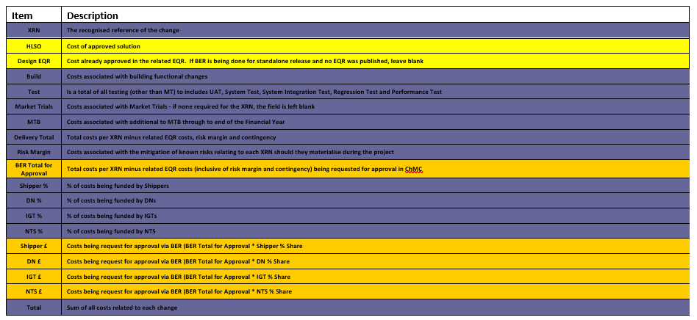

Section 4: Estimated impact of the service change on service charges
Please detail any projected increase or decrease in cost to any of Xoserve’s service areas, and within them any service lines, as a result of this change.
Impacts to Ongoing Costs Example

XRN | Xoserve Service Area & Line | Impact | (+/-) Projected Change in Annual Cost
5321 | Data Discovery Platform | Non-currently identified | Non-currently identified
Total |  |  | £0.00

Section 5: Project plan for delivery of the change
The Data Discovery Platform is being run as an Agile Project methodology. Governance will look at the Releases combined, using governance and the agreed artefacts for delivery. Any User Stories not delivered as part of this Release, will go back into the Product Backlog and delivered at a later Release.

Section 6: Additional information relevant to the proposed service change
Risk Margin

XRN Ref | Risk Margin | Description
XXXX | £XXXX | Change to requirements - timebound to end of PIS
Please advise of any:
Constraints (any restriction that defines the project’s limitations)

Risks (any events that, should they occur, will have an effect on achieving the project’s objectives)

Issues (any problems which have already occurred and either have a positive or negative effect on the project’s ability to meet its objectives)

Assumptions (any statements that are taken as being true for the purposes of planning, but are subject to change)

Please indicate if any of the above will have external involvement. Who will be involved? When will they be involved, and how?

Please send completed form to: box.xoserve.portfoliooffice@xoserve.com

Document Version History
Version | Status | Date | Author(s) | Summary of Changes

Template Version History
Version | Status | Date | Author(s) | Summary of Changes
2.0 | Approved | 17/07/18 | Rebecca Perkins | Template approved at ChMC on 11th July
3.0 |  | 23/06/2021 | James Rigby | Table added to section 1  More detailed table in section 3  More detailed table in section 4  Inserted a project plan example in section 5  Table added in section 6

