DSC Business Evaluation Report (BER)

Change Title | XRN5231 Flow Weighted Average CV (FWACV)
Xoserve reference number (XRN) | 5231
Correla Project Manager | Tom Lineham
Email address | Thomas.lineham@correla.com
Contact number | 0121 229 2075
Target Change Management Committee date | 08th December 2021
Section 1: In Scope
National Grid has announced it is to withdraw from providing the Distribution Network Operators (DNs) with the daily LDZ Flow-Weighted Average CV calculation (FWACV) service. As a consequence, the DNs will become responsible for calculating their own daily LDZ FWACVs and, publishing the information to Shippers. The associated 0719R Workgroup has assessed several options that might support the DNs in meeting their FWACV calculation/information provision obligations and through DSC governance the agreed solution option has been taken through the detailed design phase of the project as approved within the EQR.

National Grid have now raised a Change Variation to include 2 consequential changes required to Gemini into the scope of the project to ensure that the new FWACV service design delivers the changes required to ensure the services provided to the wider industry continue to operate successfully.

- Gemini consequential change part A - PRCMS validation/processing
- Gemini consequential change part B - LDZ Stock Change and Embedded LDZ Unique Sites

The DNs have agreed that Xoserve should take the FWACV calculation role over in its entirety from National Grid and Xoserve are working to develop a single option solution. This BER is to approve the firm costs for the full delivery project to deliver the agreed solution option and the ongoing Manage The Business (MTB) Costs for the service to be operated.

Activities covered by this BER include:
- Full costs to deliver the agreed Flow Weighted Average CV solution under XRN5231.
- Indicative 1st Year MTB costs that will be confirmed at the end of the build stage following outstanding clarifications/service transition dependencies with National Grid and DNs being finalised.

XRN | Title | Type | Description | Link to Change Proposal | Impacts
5231 | Provision of a FWACV Service | CP | Provision of a Flow Weighted Average CV service on behalf of the Distribution Networks to calculate daily LDZ FWACVs and, publishing the information to Shippers. | Link | DNs

Section 2: Out of Scope
- Any additional changes not defined in Section 1 – In Scope will be subject to change control.

Section 3: Funding required to deliver the change
The following section outlines the costs to deliver the project for XRN5231 and the 1st Year MTB costs to run the service (please note that finalisation of the MTB costs will be confirmed at the end of the build phase once outstanding clarifications/service transition dependencies with National Grid and Distribution Networks (DNs) are finalised).

BER Costs

XRN Ref | HLSO | Design | Build | Test (inc Market Trials & Dual Run) | Imp / PIS | 1st Year MTB | Risk Margin | BER Delivery Total | Shipper % | DN% | IGT% | NTS %
XRN5231 Flow Weighted Average CV | £600,000 | £50,400 | £123,608 | £314,871 | £160,681 | £67,019 | £101,121 | £817,700 |  | 100%
Gemini consequential changes | £250,000 | £15,000 | £19,000 | £45,800 | £27,615 | £0 | £10,742 | £118,157 |  |  |  | 100%

The Design cost of £50,400 was approved via an EQR at the August 2021 ChMC for XRN5231.

Key
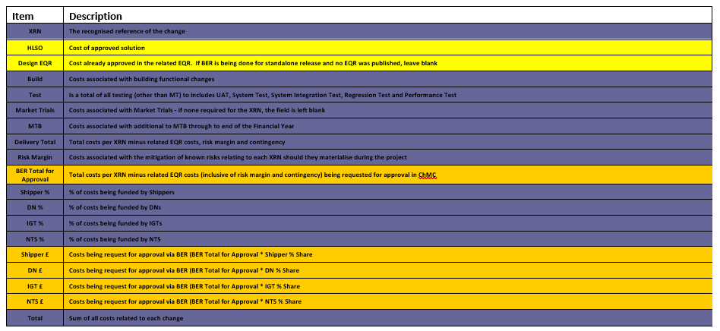
Section 4: Estimated impact of the service change on service charges
Manage The Business (MTB) Costs

XRN | Xoserve Service Area & Line | Impact | (+/-) Projected Change in Annual Cost
5231 | Service Area 10 - Invoicing Customers | New Service Line being included within the Service Area | £67,019 (1st Year MTB)
5231 | Service Area 14 – Gemini Services | New Service Line being included within the Service Area | £0
Total |  |  | £67,019

Section 5: Project plan for delivery of the change
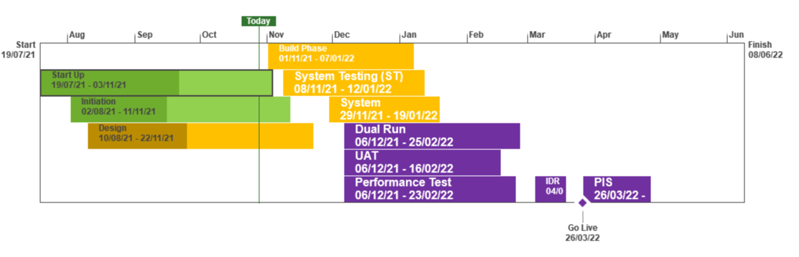
Not Baselined
Overdue
At Risk
On Track
Complete

Section 6: Additional information relevant to the proposed service change
XRN Ref | Risk Margin | Description
5231 | £24,000 | There is a risk that changes are identified to the baselined business requirements that require rework and incur additional costs. Timebound to end of PIS
5231 | £57,500 | There is a risk that PIS is required for 3 months to ensure coverage of the FWACV service following transition from National Grid to Xoserve which is dependent on agreement of the transition & cutover plan being agreed by Xoserve, National Grid & DNs
5231 | £19,621 | MTB Costs could increase or decrease as we go through the release and more understanding of the MTB work post implementation is available - timebound from implementation to end of PIS
5231 | £10,742 | There is a risk that changes are identified for XRN5282 & 5383 Gemini Consequential Change that results in additional costs being incurred

Specific Project Risks

Risk Description | Impact | Mitigation | Owner
There is a risk that the transition approach to be agreed between Xoserve, National Grid & DNs results in a Post Implementation Support period that will be required for 3 months | Cost increase for project resources | Agree transition & cutover approach with National Grid & DNs | Xoserve
There is a risk that National Grid have served notice to terminate the current FWACV service on the 01st March 2022 and the project cannot deliver the new service from the 01st April 2022 leading to a need to consider an extension by National Grid | Cost impact | Xoserve, National Grid and DNs to define cutover & transition approach with specific exit criteria  Agreement of implementation date to be a key decision point at the end of the build phase of the project | Xoserve, National Grid & DNs
There is a risk that the addition of the Gemini Consequential Changes - Part A - PRCMS validation/processing & Part B (LDZ Stock Change and Embedded LDZ Unique Sites) into scope of the project may impact the overall FWACV delivery plan | Cost & Time impact | Detailed end to end plan will be defined to identify all dependencies and align the Gemini delivery plan into the overall FWACV plan | Xoserve & National Grid

Please send completed form to: box.xoserve.portfoliooffice@xoserve.com

Document Version History
Version | Status | Date | Author(s) | Summary of Changes
0.1 | Draft | 24/09/2021 | Tom Lineham | Initial draft
0.2 | For Review | 27/09/2021 | Tom Lineham / Lee Chambers | Revisions from draft review
1 | For Review | 30/09/2021 | Lee Chambers | Version to seek approval at October 2021 Change Management Committee
2 | For Review | 29/10/2021 | Lee Chambers | Updated version to incorporate the National Grid Change Variation and costs into XRN5231

Template Version History
Version | Status | Date | Author(s) | Summary of Changes
2.0 | Approved | 17/07/18 | Rebecca Perkins | Template approved at ChMC on 11th July
3.0 |  | 23/06/2021 | James Rigby | Table added to section 1  More detailed table in section 3  More detailed table in section 4  Inserted a project plan example in section 5  Table added in section 6

