DSC Business Evaluation Report (BER)

Change Title | XRN5231 Flow Weighted Average CV (FWACV)
Xoserve reference number (XRN) | 5231
Correla Project Manager | Tom Lineham
Email address | Thomas.lineham@correla.com
Contact number | 0121 229 2075
Target Change Management Committee date | 13th July 2022
Section 1: In Scope
National Grid has announced it is to withdraw from providing the Distribution Network Operators (DNs) with the daily LDZ Flow-Weighted Average CV calculation (FWACV) service. As a consequence, the DNs will become responsible for calculating their own daily LDZ FWACVs and, publishing the information to Shippers. The associated 0719R Workgroup has assessed several options that might support the DNs in meeting their FWACV calculation/information provision obligations and through DSC governance the agreed solution option has been taken through the detailed design phase of the project as approved within the EQR.

The full project delivery costs were approved in the BER.

The scope includes 2 consequential changes required for Gemini to ensure that the new FWACV service design delivers the changes required to ensure the services provided to the wider industry continue to operate successfully.

- Gemini consequential change part A - PRCMS validation/processing
- Gemini consequential change part B - LDZ Stock Change and Embedded LDZ Unique Sites

A number of scope and requirement issues have been identified during the delivery of the project that has resulted in a need to complete an impact assessment on the impacts to the plan, design, transition & cutover, and costs to deliver the project. This BER is to approve the revised firm costs for the full delivery project to deliver the changes to the agreed solution design and also the revised ongoing Manage The Business (MTB) Costs for the service to be operated.

Activities covered by this BER include:
- The revised full costs to deliver the agreed Flow Weighted Average CV solution under XRN5231 and .
- Delivery of the agreed Gemini consequential changes.
- 1st Year MTB costs for the ongoing operation of the new FWACV service.

XRN | Title | Type | Description | Link to Change Proposal | Impacts
5231 | Provision of a FWACV Service | CP | Provision of a Flow Weighted Average CV service on behalf of the Distribution Networks to calculate daily LDZ FWACVs and, publishing the information to Shippers. | Link | DNs

Section 2: Out of Scope
- Any additional changes not defined in Section 1 – In Scope will be subject to change control.

Section 3: Funding required to deliver the change
The following section outlines the revised costs to deliver the project for XRN5231 and the 1st Year MTB costs (up to March ’23) to run the service.

BER Costs

XRN Ref | HLSO | Design | Build | Test (inc Market Trials & Dual Run) | Imp / PIS | 1st Year MTB | Risk Margin | BER Delivery Total | Shipper % | DN% | IGT% | NTS %
XRN5231 Flow Weighted Average CV | £600,000 | £50,400 | £179,392 | £429,375 | £215,104 | £131,014 | £74,750 | £1,080,035 |  | 100%
Gemini consequential changes | £250,000 | £5,583 | £5,583 | £66,857 | £20,134 | £0 | £20,000 | £118,157 |  |  |  | 100%

- The Design cost of £50,400 was approved via an EQR at the August 2021 ChMC for XRN5231
- The full project delivery costs were approved via a BER at the November 2021 ChMC:
- XRN5231 – Flow Weighted Average CV - £817,700
- Gemini Consequential Changes - £118,157

Key
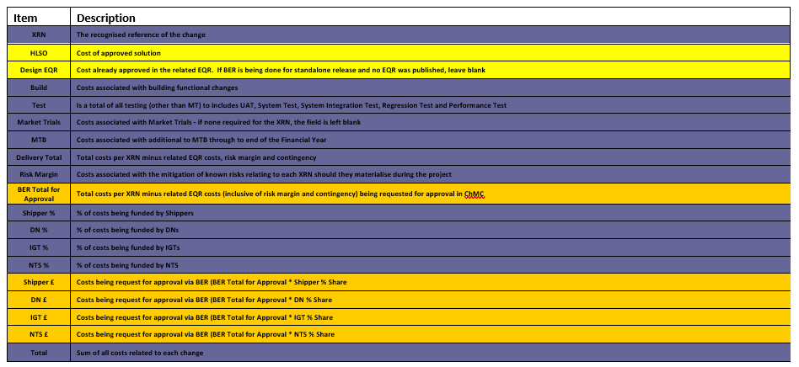

Section 4: Estimated impact of the service change on service charges
Manage The Business (MTB) Costs (Ongoing annual cost from April ’23)

XRN | Xoserve Service Area & Line | Impact | (+/-) Projected Change in Annual Cost
5231 | Service Area 10 - Invoicing Customers | New Service Line being included within the Service Area | £225,544 (MTB)
5231 | Service Area 14 – Gemini Services | New Service Line being included within the Service Area | £0 (MTB)
Total |  |  | £225,544

Section 5: Project plan for delivery of the change
The revised plan to deliver the new FWACV Service and dependent Gemini Consequential changes

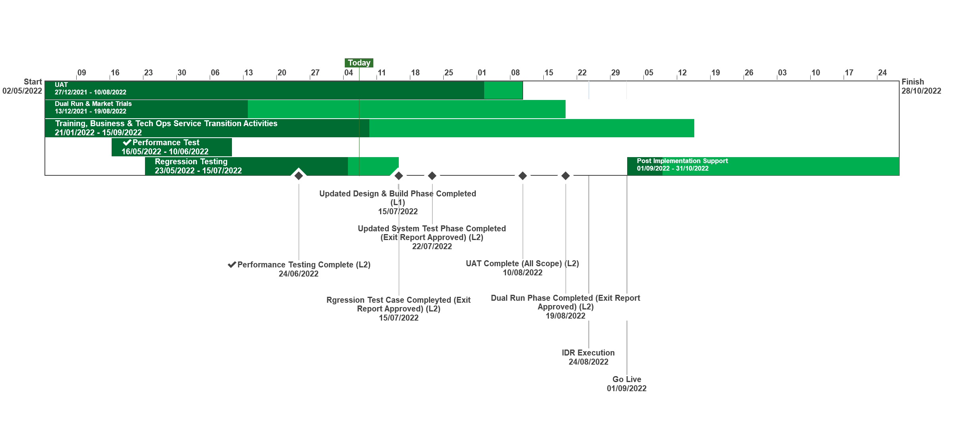

Section 6: Additional information relevant to the proposed service change
XRN Ref | Risk Margin | Description
5231 | £26,000 | There is a risk that changes are identified to the baselined business requirements will require rework and incur additional costs. Timebound to end of PIS
5231 | £28,750 | There is a risk that PIS is required for 3 months to ensure coverage of the FWACV service following transition from National Grid to Xoserve which is dependent on agreement of the transition & cutover plan being agreed by Xoserve, National Grid & DNs
5231 | £20,000 | MTB Costs could increase if any additional requirements are identified through the remaining phases with the delivery of the Project - timebound from implementation to end of PIS
5231 | £20,000 | There is a risk that changes are identified to the Gemini Consequential Change workstream that results in additional costs being incurred

Specific Project Risks

Risk Description | Impact | Mitigation | Owner
There is a risk that the transition approach to be agreed between Xoserve, National Grid & DNs results in a Post Implementation Support period that will be required for 3 months | Cost increase for project resources | Agree transition & cutover approach with National Grid & DNs | Xoserve
There is a risk that DNs do not meet the agreed customer outcomes in the Dual Run/Market Trials approach and the Go No Go criteria to complete and exit Market Trials | Cost & Time impact | DNs to manage their plans to complete the required End to End connectivity and to provide the dependent files for the Dual Run & Market Trials phases of this testing phase | DNs

Please send completed form to: box.xoserve.portfoliooffice@xoserve.com

Document Version History
Version | Status | Date | Author(s) | Summary of Changes
0.1 | Draft | 24/09/2021 | Tom Lineham | Initial draft
0.2 | For Review | 27/09/2021 | Tom Lineham / Lee Chambers | Revisions from draft review
1 | For Review | 30/09/2021 | Lee Chambers | Version to seek approval at October 2021 Change Management Committee
2 | Approved | 05/11/2021 | Lee Chambers | Updated version to incorporate the National Grid Change Variation and costs into XRN5231
2 | Approved | 10/11/2021 | ChMC | Approved by ChMC on 10th November 2021
3.0 | For Review | 10/06/2022 | Lee Chambers | For Review BER for Scope & Requirement changes and supporting replan
3.1 | For Review | 05/07/2022 | Tom Lineham | MTB costs updated
4.0 | For Review | 06/07/2022 | Tom Lineham | For Review
4.1 | For Review | 07/07/2022 | Rachel Addison | For Review

Template Version History
Version | Status | Date | Author(s) | Summary of Changes
2.0 | Approved | 17/07/18 | Rebecca Perkins | Template approved at ChMC on 11th July
3.0 |  | 23/06/2021 | James Rigby | Table added to section 1  More detailed table in section 3  More detailed table in section 4  Inserted a project plan example in section 5  Table added in section 6

