DSC Business Evaluation Report (BER)

Change Title | UK Link February 23 Major Release
Xoserve reference number (XRN) | 5533
Correla Project Manager | Surfaraz Tambe
Email address | surfaraz.tambe@correla.com
Contact number | 0121 229 2693
Target Change Management Committee date | 22nd July 2022
Section 1: In Scope
This BER requests approval for funding of the February 23 UK Link Major Release.

The total delivery cost, including risk margin, to be approved in this BER is £409,359.
This is to be drawn down from the DSC General Change Budget.

The scope, approved at ChMC on July 13th 2022, for the release contains the following four XRNs that are to be funded from this BER:

XRN | Title | Type | Description | Link to Change Proposal | Impacts
4978 | Notification of Rolling AQ Value (following Transfer of Ownership between M-5 and M) | Regulatory | Provide the new Shipper a view of the amended AQ/SOQ when there is a change of Shipper after the NRL file has been issued. | https://www.xoserve.com/change/change-proposals/xrn-4978-notification-of-rolling-aq-value-following-transfer-of-ownership-between-m-5-and-m/ | Shipper
4989B | Residual AMT Activities | Non - Regulatory | Residual AMT activities to complete 4989B. File format changes to prevent the need of a work around. | N/A | Shipper
4990 | MOD0664 –Transfer of Sites with Low Read Submission Performance from Class 2 and 3 into Class 4 | Regulatory | Provide reporting to Shippers where they are not meeting their read obiligations and remediation when they continue to not meet there read oboligations. | https://www.xoserve.com/change/change-proposals/xrn-4990-transfer-of-sites-with-low-read-submission-performance-from-class-2-and-3-into-class-4-mod0664/ | Shipper
4992B | Shipper - Mod 687 SOLR | Regulatory | Updating capacity invoice and supporting information to include SOLR charges. | https://www.xoserve.com/change/change-proposals/xrn-4992-modification-0687-creation-of-new-charge-to-recover-last-resort-supply-payments/ | Shipper

Also included in the approved scope for the February 23 Release, are 2 additional changes that will be funded separately to this BER, by the Decarbonisation Programme:

XRN | Title | Type | Description | Link to Change Proposal | Impacts
4900 | Biomethane Sites with Reduced Propane Injection | Non - Regulatory | Supports the Decarbonisation Programme by removing carbon intensive propane from biomethane by facilitating the correct energy balancing / billing and transportation charging (use of a site-specific CV and energy adjustments) for Class 1 and 2. | https://www.xoserve.com/change/change-proposals/xrn-4900-biomethane-sites-with-reduced-propane-injection/ | Shippers  Distribution Networks
5298 | H100 Fife Project - Phase 1 (Initial Assessment) | Regulatory | Supporting SGN Trial for 100% Hydrogen by providing reporting on consurmers taking part in the trial. | https://www.xoserve.com/change/change-proposals/xrn-5298-h100-fife-project-phase-1-initial-assessment/ | Shippers  Distribution Networks

NOTE: Because these changes are funded from Decarbnisation Programme, no costs for them are reflected in Section 3 of this BER or in the total cost for approval above. The details are shown in this section only for information and transparency of the full scope for the release.

Section 2: Out of Scope
- Any additional changes
- Market Trials

Section 3: Funding required to deliver the change
The following section outlines the proposed costs for XRN5533, including the previously agreed EQR for Design.

The BER costs for approval are highlighted in amber, the total for which is £409,359.

BER Costs

XRN  Ref | HLSO  £ | Design  EQR | Build | Test | Implement’n  PIS | MT | 1st Year  MTB | Delivery  Total | Risk  Margin | BER Total for  Approval | Shipper  % | DN  % | IGT  % | NTS  % | Shipper  £ | DN  £ | IGT  £ | NTS  £ | Total
4978 | £150,000 | £3,700 | £12,078 | £52,160 | £20,553 | £0 | £0 | £84,791 | £2,111 | £86,902 | 100% | 0% | 0% | 0% | £86,902 | £0 | £0 | £0 | £90,602
4989B | n/a | £0 | £0 | £0 | £0 | £0 | £0 | £0 | £0 | £0 | 100% | 0% | 0% | 0% | £0 | £0 | £0 | £0 | £0
4990 | £150,000 | £7,250 | £87,187 | £106,288 | £27,492 | £0 | £0 | £220,967 | £3,844 | £224,811 | 100% | 0% | 0% | 0% | £224,811 | £0 | £0 | £0 | £232,061
4992B | £150,000 | £11,100 | £33,617 | £42,456 | £9,413 | £0 | £0 | £85,486 | £12,160 | £97,646 | 100% | 0% | 0% | 0% | £97,646 | £0 | £0 | £0 | £108,746
Total | £450,000 | £22,050 | £132,882 | £200,904 | £57,458 | £0 | £0 | £391,244 | £18,115 | £409,359 |  |  |  |  | £409,359 | £0 | £0 | £0 | £431,409

Note: XRN4989b is included in the scope of delivery for the release. XRN4989 was previously delivered and the work in this release is to remove an existing operational workaround. So there are no delivery costs to be funded by this BER for that work.

Key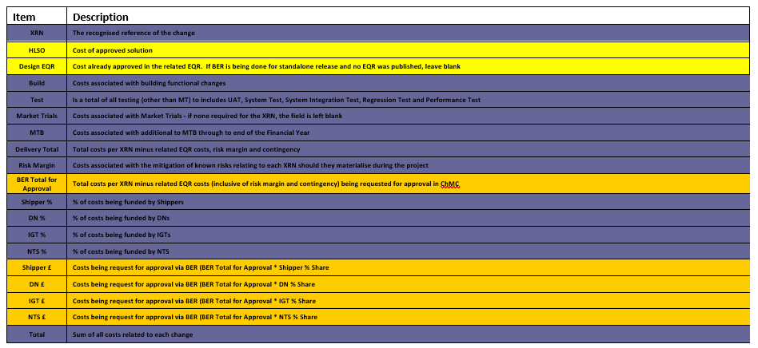

Section 4: Estimated impact of the service change on service charges
Impacts to Ongoing Costs

XRN | Xoserve Service Area | Impact | (+/-) Projected Change in Annual Cost
4978 | n/a | n/a | £0
4989 | n/a | n/a | £0
4990 | Service Area 1:  Manage Shipper Transfers | Additional storage for new DDP to ISU interface | £6,000
4992B | n/a | n/a | £0
Total |  |  | £6,000

Section 5: Project plan for delivery of the change
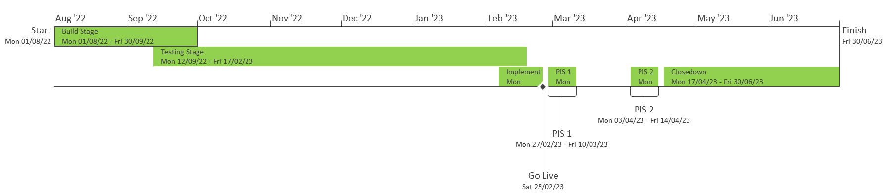

Post Implementation Support (PIS) will be split into 2 to cover the First Usage scenarios for XRN4990

Section 6: Additional information relevant to the proposed service change
Risk margin included for approval in this BER:

XRN Ref | Risk Margin | Description
XRN4992B | £11,550 | Change to requirements as a design change pack is expected on the back of the Change Request to include IGT's (MOD No 809) – Risk Margin timebound to end of PIS
All | £6,565 | MTB Costs could increase or decrease as we progress through delivery as more understanding of the MTB work post implementation is available- Risk Margin timebound from implementation to end of PIS

Delivery risks to be monitored throughout the delivery of this release:

- There is a risk that code changes made for different XRNs within the release will become interdependent because they will be affecting commons objects in the system(s). This could lead to delays to other XRNs if one particular change is deferred or descoped as the code objects will have to be reworked.
- CSSC PIS will be continuing alongside the build and test phase for the February 23 release. This could lead to changes being made that could impact the underlying code set on which the release is being built which will lead to rework and retest activity for the release and therefore possible delivery delays.
- Following the go live of REC, urgent changes may well be raised that could be added into this release prior to go live. Whilst these additions would result in an updated BER being presented, so there would be no cost impact to what has been approved, they could cause delays to the release as a whole.
- This is the first significant UK Link release that has been delivered in February and so it will have to accommodate in its timeline the impact of Christmas holidays on resource availability and also the Christmas systems moratorium that could delay progression into the BAU and pre-production environments in January/February 2023.
- There is significant instability within the current market and as winter approaches there is a risk of further crisis in the industry or significant events that could impact the delivery of this release.

None of the above have a quantifiable cost that can be included in the risk margin for this delivery but all have been recorded here for visibility and acknowledgement of ChMC. They will be reported on through the monthly project progress reports to ChMC

Please send completed form to: box.xoserve.portfoliooffice@xoserve.com

Document Version History
Version | Status | Date | Author(s) | Summary of Changes
0.1 | Draft | 01/07/2022 | Surf Tambe | Draft of BER
0.2 | Stakeholder Review | 07/07/2022 | Surf Tambe | Internal review of BER
0.3 | For Xoserve review | 08/07/2022 | Surf Tambe | Clean copy for Xoserve review
0.4 | For Xoserve approval | 14/07/2022 | Surf Tambe | Updated copy for Xoserve approval
1.0 | Submitted to ChMC for approval

