DSC Business Evaluation Report (BER)

Change Title | XRN5565 Appointment of CDSP as the Scheme Administrator for the Energy Price Guarantee (EPG) for Domestic Gas Consumers (Gas) (UNC0824)
Xoserve reference number (XRN) | 5565
Xoserve / Correla Project Manager | Dave Turpin (Xoserve) / Alex Stuart (Correla)
Email address | Dave.Turpin@xoserve.com  Alex.Stuart@correla.com
Contact number | 0121 229 2022
Target Change Management Committee date | December 2022
Section 1: In Scope
The Government has proposed the EPG (Gas) Scheme, for domestic customers, to secure reductions in the energy bills of domestic customers within Great Britain. The intention is for the Central Data Service Provider (CDSP) to perform the function of the EPG (Gas) Scheme (the ‘Scheme’) Administrator and that the scheme to be implemented by 1st October 2022.

Modification 0824 confirms the role of the CDSP as the Scheme Administrator for the EPG (Gas) and gives them the relevant powers to make changes under the DSC in order to facilitate implementation and administration of this Scheme, from 1st October 2022, in line with the Government direction.

This change proposal seeks to design, build and implement the relevant functionality and processes in order for the CDSP to fulfil its role as the Scheme Administrator.

Activities covered by this BER include:
- Full costs to design, build and implement the Gas EPG solution.
- First 6-months of MTB costs for Xoserve and Correla resources to run the scheme on a weekly basis so that gas suppliers eligible for support payments under the government’s EPG scheme receive such payments. Costs for the remaining duration of the scheme (i.e. 14-months of gas reconciliation) will be covered within Xoserve’s Business Plan for 23/24 and 24/25.

XRN | Title | Type | Description | Link to Change Proposal | Impacts
5565 | Appointment of CDSP as the Scheme Administrator for the EPG scheme | CP | Mobilisation and operation of a solution capable of calculating and issuing out weekly EPG support payments to Gas Suppliers on behalf of the government. | Link | Shippers

Section 2: Out of Scope
- Any additional changes [and associated costs] required to the CDSP Gas EPG solution in-light of recent government announcements that the current EPG scheme will not operate in it’s current guise from April’23, instead becoming a more ‘targeted’ scheme to the poorest households within Great Britain.

- Any operational run costs associated with the 14-months of reconciliation, as per the government’s EPG scheme design, from April’23.

Section 3: Funding required to deliver the change
The following section outlines the costs to deliver the project for XRN5565 and the MTB costs to run the service within the remainder of the current 2022/23 CDSP financial year. Previous discussion on funding of the EPG scheme have set out that funding will be from domestic shippers.

BER Costs

XRN Ref | HLSO | Design | Build | Test (inc Market Trials & Dual Run) | Imp / PIS | 1st Year MTB | Risk Margin | BER Delivery Total | Shipper (domestic only) % | DN  % | IGT  % | NTS %
XRN5565 Appointment of CDSP as the Scheme Administrator for Domestic EPG scheme | £0 | £0 | £0 | £0 | £362,071.56 | £422,867.24 | £15,061.20 | £800,000.00 | 100%

Key
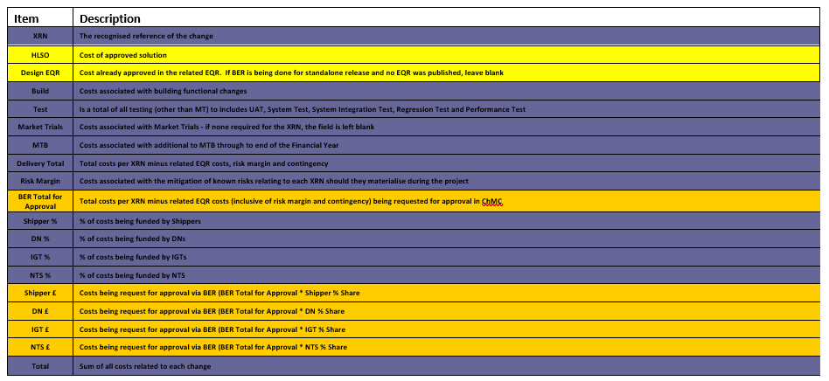
Section 4: Estimated impact of the service change on service charges
Manage The Business (MTB) Costs

N/A – no impacts to existing DSC service lines, and no additional DSC services to be added to represent the CDSP’s involvement in the government’s domestic EPG scheme .

XRN | Xoserve Service Area & Line | Impact | (+/-) Projected Change in Annual Cost

Section 5: Project plan for delivery of the change
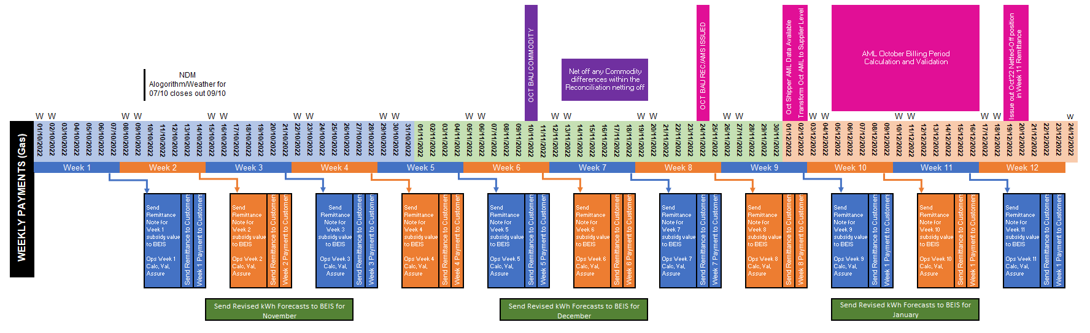

Section 6: Additional information relevant to the proposed service change
XRN Ref | Risk Margin | Description
5565 | £15,061.20 | Contingency that may be required from January 2023 onwards if increased resources are required due to increased EPG query volumes and/or complexity following the first run of Amendment EPG reconciliation.

Specific Project Risks

Risk Description | Impact | Mitigation | Owner
There is a risk there may be further development costs required from April 2023 should BEIS requirements change the scope of the scheme. | Increased costs | Further funding required from the DSC Change budget from 2023/24. | Dave Turpin/Alex Stuart

Please send completed form to: box.xoserve.portfoliooffice@xoserve.com

Document Version History
Version | Status | Date | Author(s) | Summary of Changes
0.1 | Draft | 28/11/2022 | Alex Stuart | Initial draft
0.2 | For Review | 28/11/2022 | Dave Turpin
1
2

Template Version History
Version | Status | Date | Author(s) | Summary of Changes
2.0 | Approved | 17/07/18 | Rebecca Perkins | Template approved at ChMC on 11th July
3.0 |  | 23/06/2021 | James Rigby | Table added to section 1  More detailed table in section 3  More detailed table in section 4  Inserted a project plan example in section 5  Table added in section 6

