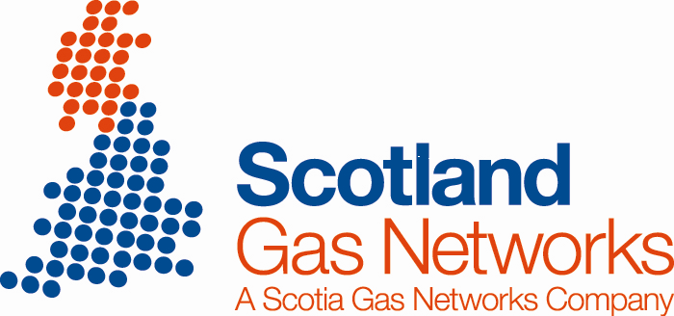

Aberdeen AGI – Offtake Metering Error

Introduction
Aberdeen Above Ground Installation (AGI) is an offtake from the National Transmission System (NTS) located within the NTS Compressor Station in the North East of Scotland and is the sole supply to approximately 163,000 consumers via an isolated Local Transmission System operating at pressures up to 70barg.

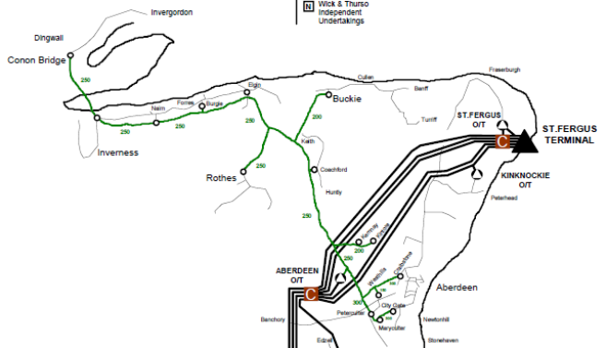
Aberdeen AGI

The current maximum capacity of the offtake is 4.8mscm/day.

The flow of gas through the site is measured using a single orifice plate contained within a dual chamber orifice carrier within a metering tube of 10” nominal bore.
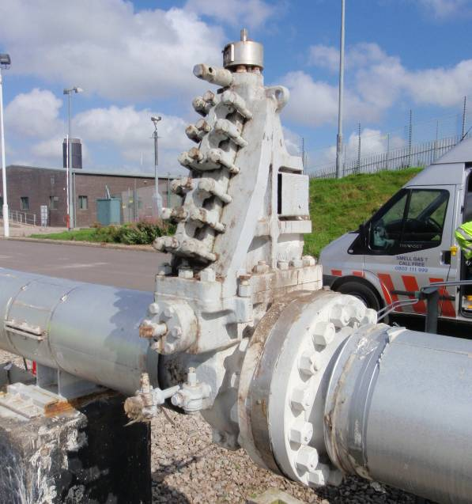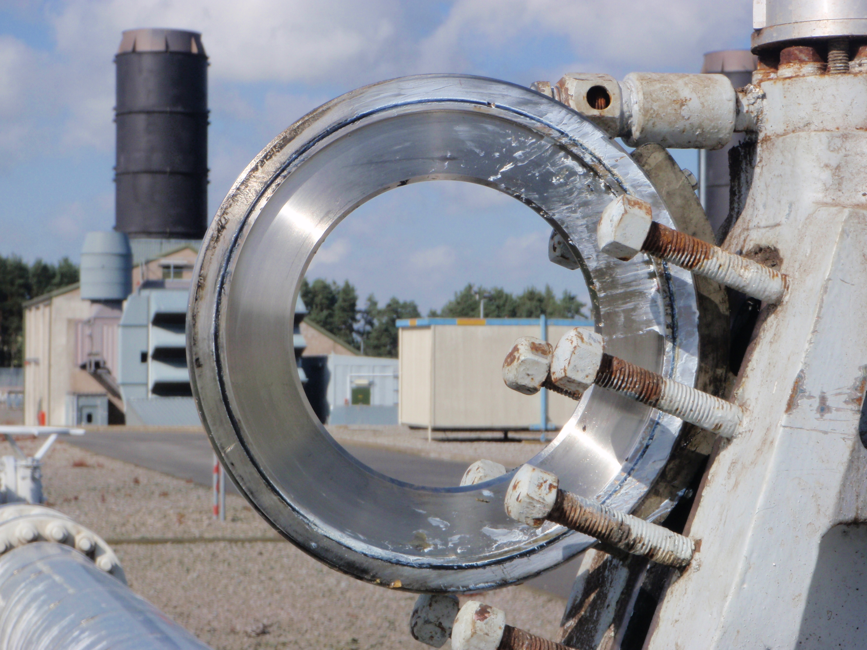
Orifice carrier Orifice plate removed for inspection

Flow through the restricted orifice generates a differential pressure across the plate. This differential pressure is used along with gas temperature, composition and density to calculate the mass flow rate through the site.

Details of the Meter Error
On 21st July 2009, the orifice plate was changed as part of the annual validation of the metering system in accordance with the industry standard ME/2. On re-insertion back into the metering tube, the plate was not properly located. As a result, an error was induced, which has been calculated to be within the range 30.34% and 46.66%.

A subsequent validation of the metering system was undertaken in July 2010 with the orifice plate being changed on 27th July 2010. Improved monitoring and verification processes implemented within SGN in response to metering errors elsewhere earlier in 2010 allowed the metering error to be identified and operatives returned to site on 7th and 10th August to undertake investigations. The cause of the error was identified and corrected on the second visit.

In energy terms the error is estimated to be in the order of 3.2TWh.

