UK LINK MANUAL

file transfer DEFINITION

May 2017

Version 13 For Approval

VERSION CONTROL

Version | COR | Date of change | Changes | Author
8 Approved | CORs: 1000.1  2355 | July 2014 | Changes to:  - Reflect introduction of EFT  - Deferred Audit Log Writes | Chris Fears
9.2 Live | COR3538 / COR3151.1 | August 2015 | Changes to:  - Section 6: Audit logs  - Section 9: Summary  - Section 10: Questions & answers (Q3)  Changes to:  - Section 7: Housekeeping  - Section 9: Summary | Mark Pollard / Jon Follows
10 Live | - | November 2015 | Updates to:  - Section 5: UK Link User Sending non UK Link user a file  - Section 6: UK Link User receiving a file from non UK Link user | Tahera Choudhury
11 Live |  | December 2015 | Updates to:  - Section 14: Appendix B File Name Values | Rachel Hinsley
12 Live | COR3143 | August 2016 | Removed the references of XFTM  Updates to:  Contents  - Section 1: Addition to Glossary  - Section 2: Insertion of Naming Convention section from UK Link Standards Guide. Highlighted text denotes additional text above what was extracted from the Standards Guide.  - Section 3. Amended wording & insertion of new formatted diagram  - Section 4: Amended diagram.  - Section 5: Amended diagram  - Section 6: Amended wording and diagram.  - Section 7: Disaster Recovery Services  - Section 8&9: Amended wording  - Section 11: Amended wording  - Section 12: Questions removed as will be managed in a separate document. | Harish Karanam / Dawn Griffiths
13 For Approval |  | May  2017 | Amendments to:  - General review in line with revised governance (UNC Modification 0565A refers).  - Remove references to EFT, IXN, I’X. UK Link Network.  - CDSP referenced.  - Insert Appendices for each User Organisation Type | David Addison

Table of Contents

1. Introduction 6
1.1 Purpose and Scope of Document 6
1.2 Structure of Document 6
1.3 Terminology 7
2. Configuration 9
2.1 File Transfer Arrangements 9
2.2 User Gateway Configuration 10
2.3 User Data Directories – e.g. e:\ORG01 11
2.4 File Naming 12
2.4.1 Summary of File Naming 12
2.4.2 File Naming Structure 13
2.4.3 File Naming Conventions for Files passed between Organisation Types 14
2.4.3.1 Communication Type 1 15
2.4.3.2 Communication Type 2 15
2.4.3.3 Communication Type / Organisation Type 15
2.4.4 Delivery Receipts 16
3. Sending a file 17
3.1 Sending a Communication Type 1 File 17
3.2 Sending a Communication Type 2 File 18
4. Receiving a file 20
4.1 Receiving a Communication Type 1 file 21
4.2 Receiving a Communication Type 2 22
5. Disaster Recovery Processes 29
5.1 Requirements when registering Disaster Recovery Arrangements 29
5.2 Responsibilities in the event that DR Arrangements are invoked 29
5.3 Loss of Service without DR Processes 30
6. Audit Logs 31
6.1 Audit Log of Successful File Transfers 31
6.1.1 File Naming Convention for Successful Files in the Audit Log 31
6.2 Audit Log of Unsuccessful File Transfers 31
6.2.1 File Naming Convention for Unsuccessful Files in the Error Log 31
7. Housekeeping 33
8. Help 33
9. Summary 33
10. Appendix A Treatment specific to User Organisation Type 34
A1 - User Organisation Type – Shipper Users 34
A2 - User Organisation Type – Trader Users 34
A3 - User Organisation Type – Distribution Networks 34
A4 - User Organisation Type – Transmission Networks 34
A5 - User Organisation Type – Independent Gas Transporters 34
A6 - User Organisation Type – Daily Metered Service Provider 34
A7 - User Organisation Type – Suppliers 34
A8 - User Organisation Type – Meter Asset Managers 35
A9 - User Organisation Type – Interconnector Agents / Market Operator 35
A10 – Data Communications Company 35
11. Appendix B Key to Variables 36
12. Appendix C File Name Values 37
13. Appendix D - Glossary 38
14. Appendix E - Moving a file to the export directory with a Local Area Network (LAN) connection 40
E1 - Using File Transfer Product (ftp) 40
E2 - Shared Drive Facility 40
15. Appendix F - Moving from the import directory with a LAN Connection 41
F1 - Using ftp 41
F2 - Shared Drive Facility 41

Introduction

1.1 Purpose and Scope of Document

The purpose of this document is to describe the method for Users (UK Link Users and External UK Link Users) exchange files with other Users, including the Central Data Services Provider (CDSP), using the UK Link Network.

The guide assumes some familiarity with Microsoft® Windows and the running of DOS commands on the part of the user.

This guide describes the principles of the UK Link Network and the procedures that Users should follow when

conveying a Communication to and from another User using the UK Link Network. Such Communications and messages include Code Communications between UK Link Users and UK Link Communications between External UK Link Users and UK Link Users.

Any exclusions, or where specific treatment is necessary for a particular User Organisation Type, are defined in Appendix A.

This document covers External UK Link Users who may use the UK Link Network as a consequence of entering into a UK Link User Agreement or accessing Third Party Services with the CDSP.

1.2 Structure of Document

Section 2 describes the overall hardware/software configuration and file naming convention supporting file transfers.

Sections 3 and 4 discuss how a User sends and receives files.

Subsequent sections discuss contingency and housekeeping arrangements, audit logs, and where to go for help.

Appendix A defines treatment specific to a User that interacts with the CDSP via the UK Link Network.

Appendix B lists the variables involved if Users use the TCP/IP-based file transfer protocol (ftp).

Appendix C lists the values of the environment and priority indicators in the file name.

Appendix D provides the Glossary of terms used specifically in this document.

Appendix E and F provide Users with guidance in respect to moving files to export and import directories using recognised file transfer protocols. This is provided to assist Users. This does not form part of the UK Link Manual.

1.3 Terminology

This user guide adopts the terminology used in General Terms Section D of the Uniform Network Code for UK Link. Terms used within this document are as defined in the Uniform Network Code and the Data Services Contract. Additional terms are defined in the Glossary forming Appendix D of this document to assist the reader.

- Configuration

2.1 File Transfer Arrangements

Each User (UK Link User and External UK Link User) has a [User Gateway (Gateway)] located at their premises or has a hosting agreement in place. Each Gateway has relevant directories loaded onto it by the CDSP and these directories are accessed as shown in the following diagram.

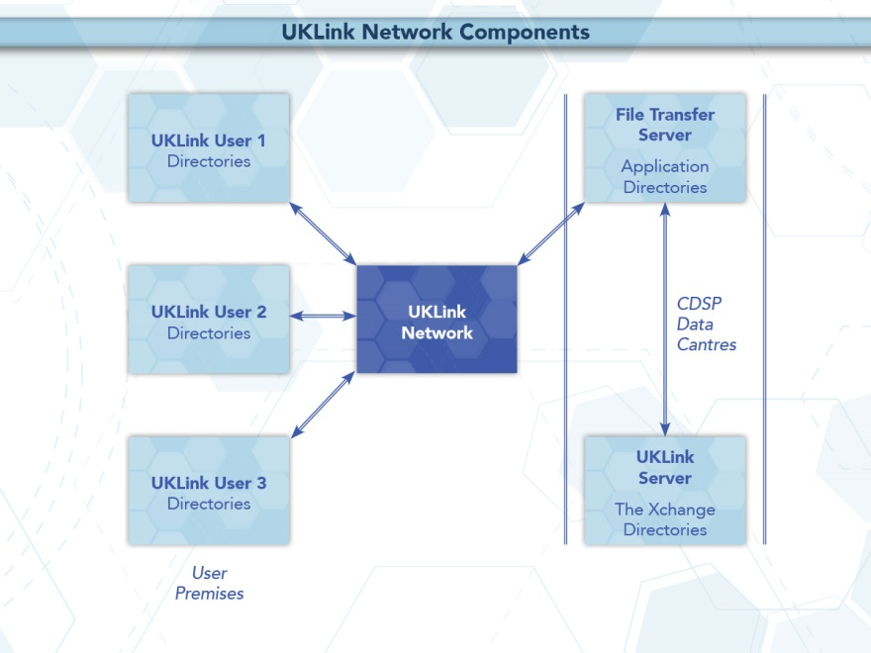

Figure 1: UK Link Network Context

Audit logs generated on a daily basis on the Gateway will record details of all file transfers performed through the UK Link Network. These are explained in more detail in Section 6.

2.2 User Gateway Configuration

There are a number of directories configured onto each User Gateway. The structure of these directories is shown in the following diagram and further explained in section 2.3.

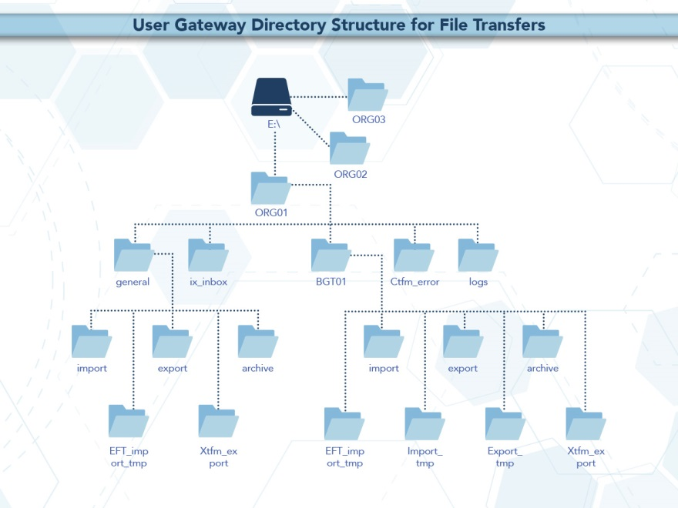

Figure 2: User Gateway Configuration

2.3 User Data Directories – e.g. e:\ORG01

The directories for sending and receiving files are located on the E: drive of the User Gateway under e:/ORG01. ORG will be the 3 letter User short code assigned by the CDSP, and 01 is a number assigned to the node by the CDSP for unique identification purposes. Throughout this document ORG01 is used as the example node.

These directories will hold the incoming (import), outgoing (export), and archived (archive) files. There is also a directory (cftm_error) to hold invalid files that the User has attempted to send.

All activities performed by the file transfer mechanism will be recorded in audit logs in the logs directory. The content of the daily audit logs are discussed in more detail in Section 6.

In addition, there is a staging directory, the ix_inbox. Files to be sent should be copied to the ix_inbox directory, then must be moved or renamed to the export directory. This latter step is required to prevent transferring a file that has only been partially created. Refer to Section 3 for further details.

The interrelationship of these directories will be shown in subsequent sections. Access to the directories, and to the files within them, are shown within the following table.

Directory | directory:  read/exec | file:  Read | file:  Write | file:  delete
e:\ORG01 | Y | Y
\cftm_error | Y | Y |  | Y
\ix_inbox | Y | Y | Y | Y
\logs | Y | Y
\BGT01 | Y
\import | Y | Y |  | Y
\export | Y | Y | Y | Y
\archive | Y | Y
\eft_import_tmp | Y
\general | Y
\import | Y | Y |  | Y
\export | Y | Y | Y | Y
\archive | Y | Y

- 2.4 File Naming

This section defines the naming convention of the file as it needs to be conveyed over the UK Link Network – i.e. when a User places on, or retrieves a file from, the User Gateway.

This section identifies those constituent data items that form the significant addressing information required to enable the successful routing of files to and from other Users.

2.4.1 Summary of File Naming

The file name is used to route files across the UK Link Network. The UK Link file naming standards are as follows:-

< level_1 >.< level_2 >.< level_3 >
ORGnn.EPNNNNNN.SFX

This is referred to as 5.8.3 naming convention.

level_1 This level is the destination / originator code in the format ORGnn where ORG is the User's Short Code, and nn is the node (example '01'). A <level_1> directory exists for each recipient Gateway that is to receive/send files via the UK Link Network.

This element of the file name will be appended by the file transfer mechanism for certain Organisation Types. Please refer to Section 2.4.3 which sets out specific treatment by Organisation Type.

Organisation Types that must observe the 5.8.3 naming convention must use UKL01 when sending a file to the CDSP. Files to such Organisation Types from the CDSP will appear in a User’s import directory as UKL01.

level_2 This level is 8 characters in length, in the format epnnnnnn. Where E indicates the environment, e.g. test or production, p is the priority, and nnnnnn is a 6-digit generation number.

level_3 This 3-character suffix identifies the file type as defined in the Interface Documents relevant to each Organisation Type.

NOTE: All file names should be in UPPERCASE.
Files not consistent with the naming convention shall be rejected.

Example file names:

PN123456.NOM
UKL01.PN012345.SIF
PN000001.MBR
TN100123.MBR (Please note the Environment reference not denoting Production)

For further information on file suffixes and file formats please refer to the relevant Organisation Type Interface Document contained in the UK Link Manual.

Format key:

A - Alphabetic
N - Numeric
X - Alphanumeric

2.4.2 File Naming Structure
Level_1
<level_1> data items identify the addressing information of the correct import or export location.

Data Item | Format | Fixed / Variable Length | Description
<routing_id> / Short Code  (*) | AAA | Fixed | Short Code denoting:  - the gateway identity of the recipient gateway for User (exported) files.  - the gateway identity of the sending gateway for User imported files.  Synonyms: (<shipper short code>|<business associate abbreviation>|<user id>|<routing id>)
<routing_loc> / Node  (*) | NN | Fixed | Identifies the location node on the gateway for files transmitted to or from the CDSP via the UK Link Network.  Enables up to 99 multiple nodes per <routing_id>; range 01 -> 99.  Synonyms: (<routing loc>|<node>|<location>)

Level_2
<level_2> data items identify the addressing information. This number must be unique to the organisational node and suffix to stop duplicate files being processed. The currently supported environment and priority values are listed in Appendix B.

Data Item | Format | Fixed / Variable Length | Description
<environment_ind> | A | Fixed | Environment indicator.  "P" => Production;  Other characters may imply a Test file, there could be a number of Test environments which may need to be differentiated between.  Users must not place a test file on the UK Link Network without prior notice and authorisation.  The environment indicator can be used to control the routing of Test files received from outside the CDSP (e.g. Shipper Users) across the UK Link Network to an application environment. All files will be received into the same gateway.
<priority> | A | Fixed | Priority code.  "N" => Normal; Transfer in sequence of submission (default). Currently only the default will be used in the File Name.
<generation_number> | NNNNNN | Fixed | Unique reference when read in conjunction with level 3. Used to provide a unique qualifier to the file name.  It is the responsibility of the generating application to ensure that this data item is unique per <file_type>. If the data item is not unique then there is the possibility that the file could be overwritten by another file of the same type.  Non unique file names will be rejected.

Level 3
<level_3> data item identifies the type of file being transmitted.

Data Item | Format | Fixed / Variable Length | Description
<file_type> | XXX | Fixed | Identifies the File being transmitted.

The <level_3> data item signifies the type of file transmitted between gateways of a sender/recipient. These file types are defined within the Interface Documents.

The file name (i.e. all constituent parts – level 1, 2 and 3) has to be unique. Where Users exhaust unique file names the <generation number> records must be deleted by file type by Organisation. It would be expected that the <generation number> would restart from 000001. The CDSP will contact the User in the event that this is identified as being required, alternatively Users may contact the CDSP Service Desk.

2.4.3 File Naming Conventions for Files passed between Organisation Types

The Organisation Type defines whether an organisation is required to provide, or will receive, the <level_1> element of the file naming convention or whether the file transfer mechanism will determine this.

The file transfer mechanism will be configured by Organisation Type. Any exceptions must be explicitly registered and will be defined in Appendix A.

The two Communication Types have been developed to support distinct and separate requirements. It is not expected that a Communication Type 1 User will interact with a Communication Type 2 User. Any exceptions to this rule will be defined in Appendix A.

The CDSP is able to support both Communication Types.

2.4.3.1 Communication Type 1

For Communication Type 1 the gateway will address the files appropriately without the need for the <level_1> element of the file naming convention. Typically these types of files are exchanged between a User and the CDSP.

These files will be presented to Users in the BGT01\import directory.

The table below shows which Organisation Types will use this convention.

Any exceptions to this principle are defined by Organisation Type by file type in Appendix A.

2.4.3.2 Communication Type 2

For Communication Type 2 the User is required to use <level_1> within the naming convention – i.e. this will use 5.8.3 naming convention.

When the originating Organisation places the file onto the UK Link Network the characters forming < level_1> of the file name (i.e. the ‘5’ in the 5.8.3 format) will be the Short Code and node of the Recipient User.

The UK Link Network will process the incoming file and change the Short Code and Node of the Recipient User to that of the Originating User before placing the file in the recipient’s import directory.

These files will be presented to Users in the general\import directory.

The table below shows which Organisation Types will use this convention.

Any exceptions to this principle are defined by Organisation Type by file type in Appendix A.

The following table sets out which naming convention a User shall apply when sending or receiving files from another User.

2.4.3.3 Communication Type / Organisation Type

The following table denotes whether Communication Type 1 or 2 is used for files exchanged between each User Organisation Type.

Organisation Type | Communication Type | Comments
Network Operator (Distribution Network) | 1
Network Operator (Transmission Network) | 1
Market Operator | 1
Interconnector | 1
Trader User | 1
Shipper User | 1
Supplier | 2
Meter Asset Manager | 2
Independent Gas Transporter (iGT) | 2

Any organisation acting as a User Agent need to utilise the Organisation Type on whose behalf they are sending any communication to determine whether it is classified as Type 1 or 2.

Any exceptions to this principle are set out in the Appendix A - Treatment specific to User Organisation Type.

2.4.4 Delivery Receipts

Organisations who provide Communication Type 2 will receive delivery receipts. The delivery receipt will be in a flat file format, i.e. it will not be processed through the CSV utility.

The delivery receipt file name will be the same as the file being receipted but with a <delivery_receipt_type> appended to the original file name of:

.DEL for all files which could not be/were not sent and for files which were successfully sent to the external organisation.

The relevant applications are able to identify the file as a delivery receipt and process accordingly – e.g. record or to delete the file without reading.

Example Delivery Receipt file names:

XYZ01.PN999999.XXX.DEL – Example DEL file where initial file was a Type 2 file.

Sending a file

Users are responsible for placing a file in the ix_inbox, then moving (or renaming) the file into the export directory. Note that copying the file directly into the export directory may pick up the file before all the data has been copied and result in a partial file being transferred.

The file transfer mechanism is responsible for remotely monitoring the export directory and downloading all the files.

The User Gateway Configuration as described above in Figure 2 shows two export directories – one subordinate to BGT01 and the other subordinate to General.
The Organisation Type of an Organisation will define which folder will be polled.

If the file is valid it will be submitted for export and sends them over the UK Link Network to the import directory on the Gateway. If the file name is invalid or the file is of zero bytes, upon detection the file will be moved to the cftm_error directory on the originating User’s Gateway.

3.1 Sending a Communication Type 1 File

Users should place a Communication Type 1 file in the export directory subordinate to BGT01.

Any exceptions to this principle are set out in the Appendix A - Treatment specific to User Organisation Type.

The following diagram summarises the process of sending a Communication Type 1 file:

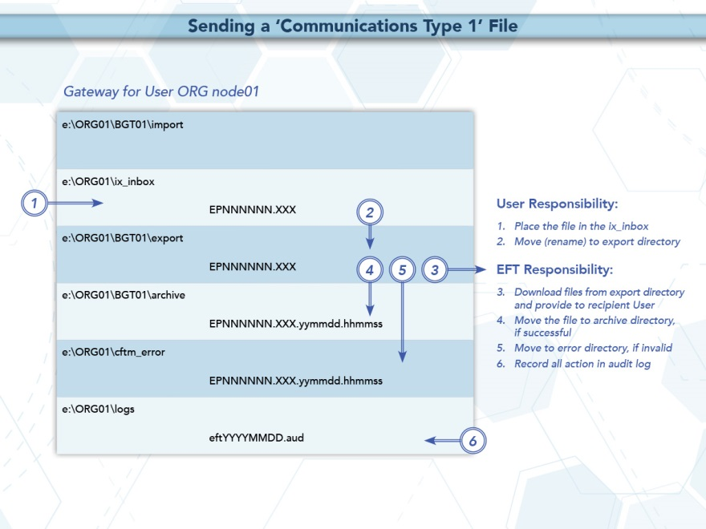

Figure 3: Sending a Communication Type 1 File

3.2 Sending a Communication Type 2 File

Users should place a Communication Type 2 file in the export directory subordinate to general.

Any exceptions to this principle are set out in the Appendix A - Treatment specific to User Organisation Type.

The following diagram summarises the process of sending a Communication Type 2 file:

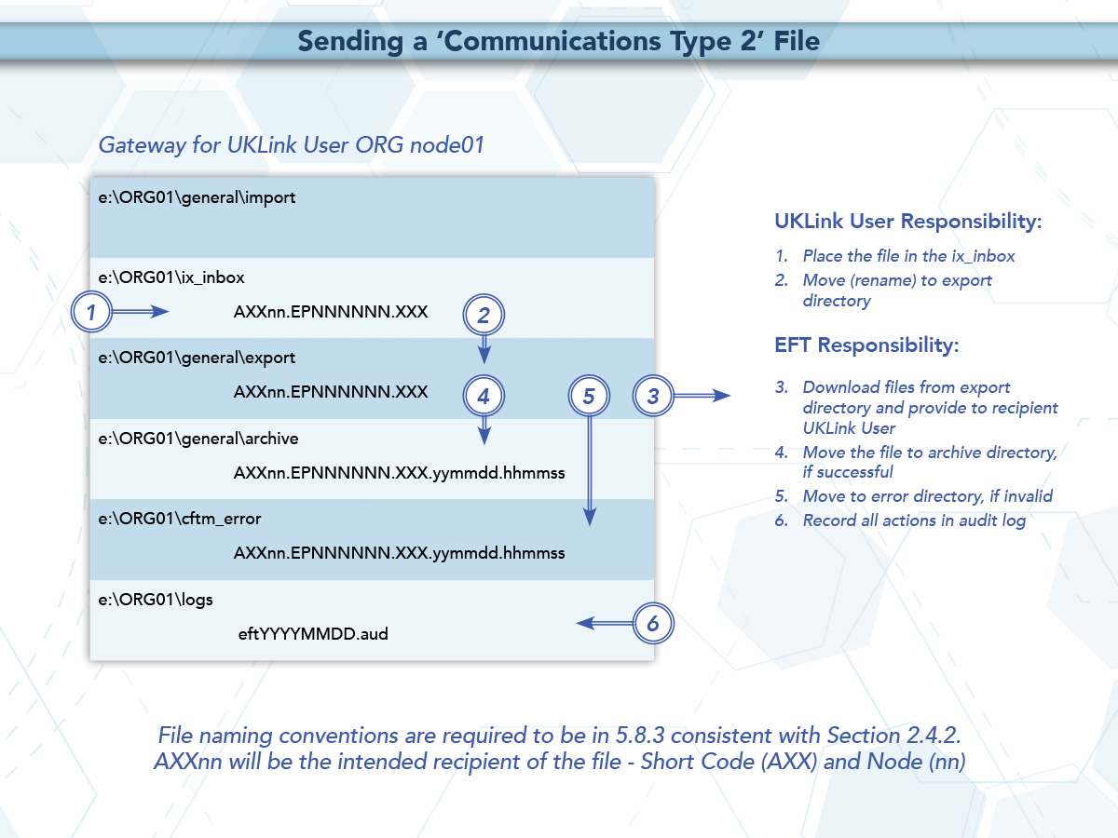

Figure 4: Sending a Communication Type 2 File

C:\ftp ixn-xxx-01
Connected to ixn-xxx-01.
220-Microsoft FTP Service
Do not proceed unless you are an authorised user.
Failure to comply may result in prosecution under the Computer Misuse Act 1990.
User (ixn-xxx-01:(none)): xxxuser
331 Password required for xxxuser.
Password:
230 User xxxuser logged in.

ftp> put PN123456.NOM /ORG01/ix_inbox/PN123456.NOM
200 PORT command successful
150 Opening ASCII mode data connection for /ORG01/ix_inbox/PN123456.NOM
226 Transfer complete
x bytes sent in x seconds (x Kbytes/sec)

ftp> rename /ORG01/ix_inbox/PN123456.NOM /ORG01/bgt01/export/PN123456.NOM
350 File exists, ready for destination name
250 RNTO command successful.

ftp> bye
221
C:\>

- Receiving a file

Files sent to the User Gateway will be delivered into the import directory either within the BGT01 or General directory.

4.1 Receiving a Communication Type 1 file

Communication Type 1 files will be placed into the BGT01/import directory. These files will not have the <level_1> addressing convention.

Any exceptions to this principle are set out in the Appendix A - Treatment specific to User Organisation Type.

Users will use ftp or shared disk facility to transfer the data into their own applications. Users have the facility to remove files from the import directory.

The following diagram summarises the process of receiving a file from the CDSP:

Figure 6: Receiving a Communication Type 1 File

4.2 Receiving a Communication Type 2

Where a User receives a Communication Type 2 file from another User this will be placed in the general/import directory.

The file will include the <level_1> addressing convention described above. The <level_1> convention will show the Short Code and Node of the originating Organisation of the file.

Any exceptions to this principle are set out in the Appendix A - Treatment specific to User Organisation Type.

Figure 7: Receiving a Communication Type 2 File

- Disaster Recovery Processes

The Disaster Recovery Process can be invoked if a User experiences a loss of the file transfer service. This is only applicable to those who have arranged for access to a secondary Gateway for the purposes of Disaster Recovery. This Disaster Recovery equipment must be located at an alternative location. It can be either at alternative premises of that User, or located at another premises where a Gateway is installed – this could also be another User’s or a User Agent’s premises.

5.1 Requirements when registering Disaster Recovery Arrangements

When a User specifies that it has Disaster Recovery arrangements, that User must provide at least one (but no more than three), Disaster Recovery Representatives (DR Representative).

The following contact details must be provided:
- DR Representative Name(s) or Role – e.g. User Service Desk Manager
- Telephone number for each DR Representative
- A valid email address for each DR Representative

The DR Representative is a person (or persons) available 24 hours a day / 7 days a week.

Where a User is using another User’s Gateway for the purposes of Disaster Recovery, both Users must provide evidence that they have agreed to these arrangements. Where a User intends to utilise a User Agent’s premises, the User must provide a User Agent Agreement to the CDSP at the time that they register the Disaster Recovery Arrangements.

It is the User’s responsibility to inform the CDSP of any changes to DR Arrangements including DR Representative contact details. Any changes must be notified to the CDSP Customer Life Cycle Team at: customerlifecycle.spa@xoserve,com

The CDSP shall contact User DR Representatives every 6 months to ensure contact details are up to date and will validate the details the CDSP holds on file.

5.2 Responsibilities in the event that DR Arrangements are invoked

If a loss of service is identified by the User, a representative of that User must raise a call with the CDSP Service Desk.
- If the User raises a call, the CDSP Service Desk will advise if the User has registered Disaster Recovery arrangements and provide the caller with the DR Representative contact details.
- The CDSP Service Desk will refer the call to the CDSP Duty Manager (CDSP DM) who will liaise with the DR Representative.

- If a proactive alert is identified by the CDSP, the CDSP will contact the DR Representative accordingly.

- The DR Representative must be available 24 hours a day / 7 days a week. In the event that DR Arrangements are invoked and the CDSP DM is unable to contact the User DR Representative then a telephone message will be left at each of the contact telephone numbers registered where the number is in service and a messaging service is available. The CDSP DM will take no further action until a DR Representative contacts them.

- The DR Representative will liaise with the CDSP DM to agree a way forward.

- The CDSP will attempt to provide an alternate file delivery service within 48 hours of the failure OR as agreed with the DR Representative.

- Updates will be provided by the CDSP DM to DR Representative as and when available.

5.3 Loss of Service without DR Processes

In the event of complete file transfer failure, the CDSP will attempt to provide an alternate file delivery service within 48 hours of the failure. In the event a User experiences a loss of the file transfer service please contact the CDSP Service Desk. Contact details are defined in the UK Link Overview Manual.

Audit Logs

6.1 Audit Log of Successful File Transfers

The CDSP is responsible for ensuring that an Automatic Audit Trail Facility is maintained. The audit logs are maintained in the e:\ORG01\logs area on the Gateway, which are labelled as follows:

- ‘EFTYYYYMMDD.aud’ (Daily audit log)
- Where eft denotes the file transfer mechanism

- YYYY is a four digit year

- MM is a two digit month

- DD is a two digit date

e.g. EFT20150601.aud would be the log file for 1st June 2015

Users have read ONLY access to this log. The audit log holds details of all successful file transfers to and from the CDSP, together with details of retries and failed transfers. The information is in text format and is self-explanatory. On a daily basis data in the current audit log will be archived by the CDSP. The information in these audit logs is archived for seven years.

The CDSP will collate writes to the file transfer log in order to reduce administrative IX traffic. The frequency of writes will be reviewed from time to time to determine the most effective period. Any changes to the ‘write time’ will be notified to Users to confirm that this does not impact their processes or systems. Write time is currently set at 5 minutes.

Currently all previous daily and monthly audit logs are available on the Gateway. Users are advised to use these files as part of their own audit strategy.
It is important that no software is used which ‘locks’ the audit logs when reading these audit files.

6.1.1 File Naming Convention for Successful Files in the Audit Log

When files are written within the daily directory these are written with the following naming convention:

File names in the archive directory are appended with the date and time they are moved to those directories. These would be shown as:
EPNNNNNN.SFX.YYYYMMDD.HHMMSS

Where the file is Communication Type 1 this will not include <level 1> in the file naming convention.

Where the file is Communication Type 2 it shall include the <level 1> in the file naming convention.

6.2 Audit Log of Unsuccessful File Transfers

Unsuccessful files shall be written to the cftm_error directory.

6.2.1 File Naming Convention for Unsuccessful Files in the Error Log

File names in the archive and error directories are appended with the date and time they are moved to those directories. These would be shown as:
EPNNNNNN.SFX.YYYYMMDD.HHMMSS

The error log will represent the file name as generated by the originating User, including where this included <level 1> in the file naming convention.

Housekeeping

Data files remaining in any directories on the e: drive, other than the log directories, will be deleted after 10 calendar days. If any non-standard, unauthorised directories exist on the e: drive, they, and any files within them, may also be deleted. Files are deleted irrespective of whether the files have been read or not. Audit logs of the housekeeping actions are kept in the logs directory and will be updated daily with the name EFTyyyymmdd.del e.g. EFT20130301.del would be the housekeeping log for 1st March 2013. This log shows the names and the dates on which files were deleted.

Help

If Users have any queries or problems relating to file transfers over the UK Link Network, they should contact the CDSP Service Desk. Contact details are defined in the UK Link Overview Manual.

- Summary

With respect to the UK Link Network, Users will have responsibility for:

- creating files whose names conform to the standards defined within the UK Link Manual

- sending files to their ix_inbox, followed by a move (or rename) to the relevant export directory

- processing files received into the import directory, using them as required within 10 days of receipt. File resends may incur a charge

- reviewing the audit log held on their Gateway to ensure that IX file transfers have been successful

The CDSP, through EFT software, will have responsibility for:

- the timely and complete transfer of data across the IX Network

- creating archive and cftm_error files at source

- housekeeping (deleting) all files on the Gateway that are over 10 calendar days old

Appendix A Treatment specific to User Organisation Type

A1 - User Organisation Type – Shipper Users

Shipper Users may receive the following exception files:

<file type> | From | To | Folder | Format | File Description
SMR | iGT | Shipper | BGT01/import | 5.8.3 | Smart Metering Update file. This file type will be withdrawn from Project Nexus Implementation Date.
BBR | DMSP | Shipper | BGT01/import | 5.8.3 | Within Day Daily Meter Readings File

Shipper Users may send the following exception files:

<file type> | From | To | Folder | Format | File Description
SMU | Shipper | iGT | BGT01/export | 5.8.3 | Smart Metering Update file. This file type will be withdrawn from Project Nexus Implementation Date.

A2 - User Organisation Type – Trader Users

No exception file types are registered.

A3 - User Organisation Type – Distribution Networks

No exception file types are registered.

A4 - User Organisation Type – Transmission Networks

No exception file types are registered.

A5 - User Organisation Type – Independent Gas Transporters

No exception file types are registered.

Note: SMU files issued / received by the iGTs will be issued / received via import / export directories in the general directory respectively consistent with Communication Type 2.

A6 - User Organisation Type – Daily Metered Service Provider

No exception file types are registered.

Note: BBR files are issued by the DMSP via import / export directories in the general directory respectively consistent with Communication Type 2.

A7 - User Organisation Type – Suppliers

No exception file types are registered.

A8 - User Organisation Type – Meter Asset Managers

No exception file types are registered.

A9 - User Organisation Type – Interconnector Agents / Market Operator

No exception file types are registered.

A10 – Data Communications Company

The Smart Registration Data Provider files sent to the DCC by Xoserve under Section E2 of the Smart Energy Code are transmitted via the DCC User Gateway. The formats and specifications of the messages are defined in the REGIS (Registration Interface Spec.) and CoCo (Code of Connections) documentation. The DCC itself is responsible for the provision and maintenance of the supporting infrastructure.

Appendix B Key to Variables

Field | Description.
<IP_address> | IP address of User's Gateway
<user_id> | Format xxxuser, where xxx is the 3 character short code (contact the CDSP Service Desk. Contact details are defined in the UK Link Overview Manual.)
<password> | ******
<local_file_name>,  <transient_file_name> | User-determined file name on local platform. Typically, the User may choose to use a directory structure to maintain local file names (e.g. on DOS <level_1>\<level_2>.<level_3>).
<ORG> | Three character User shortcode.
<level_1> | Destination service name - "ORGnn".
<level_2> | Unique file name (reference section 2.4)
<level_3> | 3-character file suffix , e.g. "NOM" for the input site nominations

Appendix C File Name Values

This chart lists the possible values of the environment (e) and priority (p) fields within the file name epnnnnnn.sfx:

Environment (e) | T | Test environment prefix
Environment (E) | X | Alternate Test environment prefix
Production (E) | P | Production environment
Priority (p) | N | Normal (default) priority

Test files should only be sent upon agreement with source and destination system. Users should not send the Test files without prior notice and agreement.

Example file names: PN123456.NOM
TN123567.CFR
PN123789.SC9

- Appendix D - Glossary

Where a reference is stated this document shall have the same meaning as the source reference. In such circumstances this is reproduced to assist the reader, but readers must not rely upon the definition stated.

Term | Synonyms | Reference | Definition / Expansion | Comments
Automatic Audit Trail Facility |  |  | a facility forming part of the UK Link System installed at premises designated by the CDSP, which will automatically record the sending or the receipt by the CDSP of the message comprised in such UK Link Communication and log the date and time of such sending or receipt.
CDSP |  | GTD 1.2.1a | Central Data Services Provider
CDSP Service Desk | Service Desk | UK Link Manual Terms and Conditions 10 | Provision by the CDSP of a Service Desk function as defined in the UK Link Overview Manual
CDSP Duty Manager | CDSP DM |  | A representative of the CDSP that will engage with a User in the event of a DR Arrangement
Code Communication |  | GTD 5.1e | A communication required in the UNC, IGT UNC or the IGTAD
Communication |  |  | A generic term used within this document to signify a Code Communication, a UK Link Communication or a message conveyed by the UK Link Network
Core Customer |  | GTD 1.2.1d | Means a party to the Code (other than a Trader User) in the capacity of a party to the DSC
DSC |  | GTD 1.2.1c | Data Services Contract
DR Arrangements |  |  | Disaster Recovery Arrangements
DR Representative |  |  | This nominated person(s) responsible for managing Disaster Recovery processes when a complete file transfer failure occurs.
External UK Link User |  |  | An Organisation (other than UNC parties) who is entitled to use UK Link Systems consistent with the UK Link Terms and Conditions 2.2, including as a result of entering into an additional services contract with the CDSP.
File Transfer server |  |  | CDSP provided server on User premises used to send & receive files
FTP |  |  | File Transfer Protocol
GTD |  |  | General Terms Section D of Uniform Network Code
LAN |  |  | Local Area Network
Organisational Node |  |  | Destination code in the format ORGnn, where ORG is the User's shortcode, and nn is the node
message |  |  | A discrete transmission sent by a User
TCP/IP |  |  | Transmission Control Protocol / Internet Protocol
Third Party Services |  | GTD 3.7 | Services provided consistent with policy described in GTD 3.7.
UK Link Communication | message | GTD 5.1d | A communication transmitted by a User, in this document, exclusively by file sent via the UK Link Network.
UK Link Network | IXN / I’X |  | An information exchange system, allowing the electronic transfer of information between the CDSP and Users and certain access (as described in the UK Link Manual) by Users to the UK Link System.
UK Link User |  |  | Persons acting as an Organisation authorised to have access to and use of UK Link System, including the UK Link Network. This definition excludes External UK Link Users unless specified to the contrary.
UK Link User Agreement |  | GTD 5.1.2 f | A third part agreement allowing access to relevant elements of the UK Link System.
Users |  |  | Term to refer to both UK Link Users and External UK Link Users.
User Gateway |  |  | A "Gateway" is a computer server forming part of the UK Link Network, installed at premises designated by the CDSP and of each User (and in the case of a User forming part of the User Equipment and including Licensed Software).
User Organisation Type | Organisation Type |  | A type of organisation authorised to use the UK Link Network by being a party to the Data Services Contract or a contract that otherwise allows access including, but not limited to, Customer Class as defined in GTD 1.2 – e.g. Shipper Users, DMSPs, MAMs
User Short Code |  |  | A three character code assigned to each User. These are maintained by the CDSP and published within the UK Link Manual.

Appendix E - Moving a file to the export directory with a Local Area Network (LAN) connection

The following two sections describe ways in which Users can send files via the UK Link Network. The example shown considers a Communication Type 1.

Network communication between the Users LAN and the Gateway uses the TCP/IP protocol. To connect using either FTP or Shared drive, the User will require the following information (where ORG will be the 3 letter organisation short code assigned by the CDSP):

Gateway Name: ORG01
IP Address: xxx.xxx.xxx.xxx (this will be assigned by the CDSP)
Username: Orguser (where ORG denotes the Users short code)

The <password> is provided to the Authorised Representative of the User as defined in the UK Link Manual Supplementary Document – Security Policy.

If technical information or assistance is required please contact the CDSP Service Desk. Contact details are defined in the UK Link Overview Manual.

Two methods are suggested for Users who have connected the UK LINK NETWORK to their own internal LAN, either FTP or Shared drive facility.

E1 - Using File Transfer Product (ftp)

Assuming ftp is installed and configured on Users' systems, a typical session might be as follows:

Note: the text in bold is what Users would code in their local environment; the normal text shows the prompts and responses. The variables within the code, designated by < > are, described in Appendix A.

C:\ftp ixn-xxx-01
Connected to ixn-xxx-01.
220-Microsoft FTP Service
Do not proceed unless you are an authorised user.
Failure to comply may result in prosecution under the Computer Misuse Act 1990.
User (ixn-xxx-01:(none)): xxxuser
331 Password required for xxxuser.
Password:
230 User xxxuser logged in.

ftp> put PN123456.NOM /ORG01/ix_inbox/PN123456.NOM
200 PORT command successful
150 Opening ASCII mode data connection for /ORG01/ix_inbox/PN123456.NOM
226 Transfer complete
x bytes sent in x seconds (x Kbytes/sec)

ftp> rename /ORG01/ix_inbox/PN123456.NOM /ORG01/bgt01/export/PN123456.NOM
350 File exists, ready for destination name
250 RNTO command successful.

ftp> bye
221
C:\>

Figure 9: Example of FTP text to add a file

E2 - Shared Drive Facility

If UK Link Users are running MS Windows Operating Systems on their PCs it is possible for the PC to be configured to have a shared drive to the Gateway. The UK Link User needs to use the ‘Map Network Drive’ facility within Windows Explorer to connect to the UK Link User Gateway located on their premises. Enter \\ORG01s1\ORG01 as the Path and connect as orguser with the required password. Windows Explorer can then be used to "drag and drop" files from the shared drive to the local environment as required.

Appendix F - Moving from the import directory with a LAN Connection

Two methods are suggested here for Users that have connected their Gateway to their own internal LAN, either using FTP or the use of a Shared Drive facility. The example shown considers a Communication Type 1.

F1 - Using ftp

Assuming ftp is installed and configured on Users' systems, then a typical session might be as follows. Note: the text in bold is what Users would code in their local environment; the normal text shows the prompts and responses.

Figure 10: Example of FTP text to move to the User LAN
C:\ftp ixn-xxx-01
Connected to ixn-xxx-01.
220-Microsoft FTP Service
Do not proceed unless you are an authorised user.
Failure to comply may result in prosecution under the Computer Misuse Act 1990.
User (ixn-xxx-01:(none)): xxxuser
331 Password required for xxxuser.
Password:
230 User xxxuser logged in.

ftp> prompt off
Interactive mode off

ftp> mget /ORG01/bgt01/import/*.*
200 Type set to A.
200 PORT command successful.
150 Opening ASCII mode data connection for /ORG01/bgt01/import/*.* (x bytes).
226 Transfer complete.
x bytes received in x seconds (x Kbytes/sec)

ftp> get /ORG01/bgt01/import/PN000111.SC9
200 PORT command successful.
150 Opening ASCII mode data connection for /ORG01/bgt01/import/PN000111.SC9 (x bytes).
226 Transfer complete.
x bytes received in x seconds (x Kbytes/sec)

ftp> bye
221
C:\>

F2 - Shared Drive Facility

If Users are running MS Windows Operating Systems on their PCs it is possible for the PC to be configured to have a shared drive to the Gateway. The User needs to use the ‘Map Network Drive’ facility within Windows Explorer to connect to the User Gateway located on their premises. Enter \\ORG01s1\ORG01 as the Path and connect as orguser with the required <password>. Windows Explorer can then be used to copy files from the import directory onto User’s local environment as required for storage of the files.

