  Stage 02: Workgroup Report |  |  | At what stage is this document in the process?
0432:  Project Nexus – gas settlement reform |  | u | 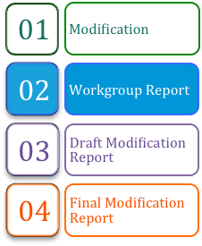
This modification is one of a number of complementary modifications seeking to implement the requirements identified under Project Nexus. This modification identifies fundamental changes to the Gas Allocation, Settlement, Reconciliation, Annual Quantity, Invoicing and Supply Point Register elements of the UNC regime.

 | The Workgroup recommends that this modification should now proceed to consultation.
 | High Impact:  Users and Transporters

Contents  1 Summary 3  2 Why Change? 6  3 Solution 8  4 Relevant Objectives 21  5 Implementation 23  6 Legal Text 24  7 Recommendation 25  About this document:  This report will be presented by the Workgroup to the panel on xx xxx 2013.  The panel will consider whether the modification is sufficiently developed to proceed to Consultation and to submit any further recommendations in respect of the definition and assessment of this modification. | 
 | Any questions?
Contact:
Joint Office
 | enquiries@gasgovernance.co.uk
 | 0121 623 2115
Proposer:
Chris Warner
 | chris.warner@nationalgrid.com
 | 07778 150668
Transporter:
National Grid Distribution
Xoserve:
Andy Miller
 | commercial.enquiries@xoserve.com
 | 0121 623 2348
 | commercial.enquiries@xoserve.com

- Summary

Is this a Self-Governance Modification
The Modification Panel determined that self-governance procedures were not appropriate for this modification.

Why Change?
As part of the outcome of the last Gas Distribution price control review, it was agreed that funding should be available to support a major IT systems investment programme by the Transporters agent, Xoserve. This major systems investment for UK-Link Replacement provides an opportunity to consider whether the existing UNC requirements remain appropriate. Rather than asking Xoserve to procure replacement systems that deliver the existing functionality, there is an expectation that introducing regime enhancements at this stage would be the most economic time to implement any such change. This is particularly opportune since it is coincident with the development of smart metering, such that requirements can be specified that recognise changes to metering arrangements rather than any changes to accommodate smart metering being retrofitted in due course. The requirements gathering exercise for the enhancements is entitled Project Nexus. This Modification Proposal is one of [6] which reflects the requirements. Complementary Modification Proposals are anticipated to be raised shortly in the following areas:

- Retrospective adjustment
- iGT Single Service Provision
- Demand estimation
- Non functional
- Implementation (including non-business/non effective days)
Ofgem stated with its Gas Distribution Price Control (GDPCR1) Final Proposals that GDNs’ allowed revenues for 2008-13 include funding for the replacement of UK LINK on a like for like basis.

During the GDPCR1 consultation process, Ofgem proposed an industry dialogue leading to an agreement between Users and Transporters on what central information system services would be required from Xoserve in its capacity as the Transporters’ agent and how the associated costs should be met. Ofgem prepared a Terms of Engagement for the dialogue, which took place under the auspices of a Xoserve Services Workgroup.

The Workgroup’s activities included consideration of the potential high level features of UK-LINK replacement and identified that the contractual and governance framework would be developed by the GTs and Shippers in agreement with Ofgem. The group identified that following this agreement the Transporters would, through the UNC Modification Process, raise and progress the required UNC Modification.

Entitled ‘Project Nexus’ the gathering of requirements for the contractual framework was undertaken under UNC governance and a dedicated Workgroup established for this purpose. The Workgroup is nearing completion of its work and has identified that it is now timely that relevant UNC Modification Proposals be raised.

Solution
The UNC Modification Panel established a Workgroup to support the development of potential UNC Modification Proposals that may be beneficial at the time of systems replacement. Building on responses to an Xoserve consultation exercise, the Project Nexus Workgroup has considered a range of potential changes, and the output from these considerations have been published as a suite of Business Requirement Documents (BRDs). The key proposals are:

- Settlement (Submission of Meter Readings and use in daily allocation)

- Users continue to be responsible for obtaining, validating and submitting Meter Readings (other than those pertaining to ‘mandatory’ Daily Metered (DM) Supply Points)
- The Gas Transporters (GT)’ agent performs validations on the Meter Reading against data held on the Transporters’ Supply Point Register
- Choice of four ‘Products’ for allocation and settlement
- Users would have access to a daily settlement service for all Supply Meter Points
- Introduction of an industry-wide ‘smear’ for Unidentified Gas and any other gas not accounted for through initial measurements or allocations

- Individual Meter Point Reconciliation

- Individual Meter Point Reconciliation for all Supply Meter Points
- Removal of Reconciliation by Difference (RbD) and replacement with an industry-wide scaling adjustment
- No change to reconciliation principles and calculations
- Introduction of the concept of read equipment ‘resynchronisation’ for Non-Daily Metered (NDM) Supply Meter Points where Meter Readings are derived using certain types of automated reading equipment

- Annual Quantity (AQ)

- Monthly re-calculation of AQ
- If Meter Readings have previously passed validation against data held on the Supply Point Register they are deemed suitable for all processes, including AQ
- Removal of the amendment and appeals phases of the AQ review
- 2 measures of Daily Supply Point Capacity (SOQ) – one for Allocation and another ‘fixed SOQ’ which applies for 6 or 12 months for transportation charging purposes.
- Minimum duration of the reference period for AQ calculation is 9 months (compared to current 6 months + 1 day)
- Supply Point Register

- GT monitoring of Users’ compliance with the DM Check Read requirement
- Provision of 12 months’ consumption data (where available in the GTs’ systems) to any potential new User
- Improved management of priority and vulnerable customers

Changes to the Transporters’ invoicing arrangements have also been identified. However, UNC modification is not necessary in this case. The invoicing BRD is added to information.
Relevant Objectives
Relevant Objectives a), b) and c) being reviewed by participants for relevance and evidence.
Implementation of the changes identified within this modification would further relevant objective d) as it is expected to facilitate the securing of effective competition between Users as accurate cost allocations are a fundamental underpinning for effective competition and the changes are expected to lead to more accurate allocation of costs between Users.

It would also be expected to increase the predictability of cost allocations for individual Users. This would result from the use of more accurate and up to date consumption data, such that costs allocated to a given portfolio would more accurately reflect actual consumption that the User would expect to be aware of.

In addition to facilitating competition for existing Users, the reduction in risk and uncertainty would reduce barriers to entry for new market entrants.

Increased predictability and certainty of allocations would be expected to allow Users to purchase energy that more closely matches true requirements. This will reduce costs for Users and support the development of effective competition.

Implementation
No implementation date for the measures identified within this modification is identified at this stage

Why Change?

Background to Project Nexus
At the time of the current Gas Distribution Price Control Xoserve anticipated the need for a major IT systems investment programme. Stakeholder consultation was initiated, under the banner of ‘Project Nexus’ to inform the scope and nature of Xoserve’s future services that IT systems would need to support – the detailed Business Requirement Documents that support this document form a key input to the design of that investment programme.

The initial phase of Project Nexus was a consultation exercise, in which interested parties were asked for their views on the long-term strategic requirements for Xoserve’s services. The consultation also developed a preferred approach to further definition of stakeholder requirements.

Following the consultation phase of Project Nexus, an Initial Requirements Register (IRR) was compiled, identifying all the topics that respondents to the Consultation had raised.

Topics were grouped into three broad categories:
- UNC changes
- Independent Gas Transporter (iGT) services
- Data management

A UNC Workgroup was established to consider the UNC topics and develop requirements.

Development of Requirements
In 2009 the UNC Modification Panel agreed a Workgroup should be set up to define industry requirements for the development and enhancement of the UNC in areas that are relevant to Xoserve’s services. The Initial Requirements Register (IRR) formed the basis of the discussions. Consultation responses were grouped into related topics and relevant as-is process models were reviewed and agreed. The Project Nexus Workgroup discussed the responses and reached a consensus on whether to carry forward or close the requirement. The outputs from the Workgroup Topic meetings were baselined Business Requirements Documents (BRDs) and to-be process models (i.e. future state processes).

Areas of Requirements Development
The following diagram shows the approximate relationship between seven topic areas:

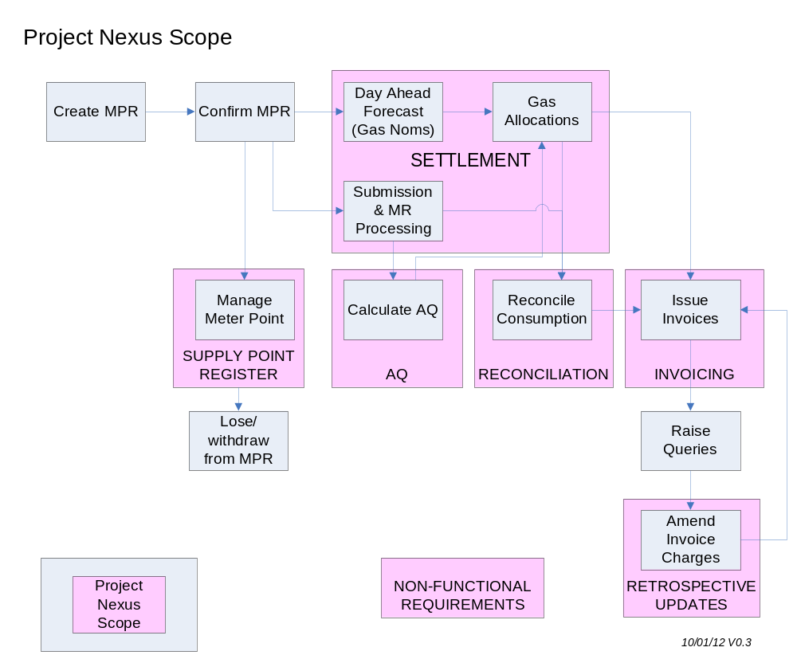

Overview of Business Requirements
The original comments in the IRR were grouped into a number of topics, loosely based on existing industry process areas. These topics were tackled in sequential order, to minimise the amount of re-work. The 8 topic areas covered under the UNC Project Nexus Workgroup were:

- Settlement (i.e. submission of Meter Readings and use in Daily Allocation)
- Annual Quantity
- Reconciliation
- Invoicing
- Supply Point Register
- Retrospective Updates
- Non-Functional requirements
- iGT Agency Services

Business requirements documents (BRDs) have been documented for each of these topics and have been reviewed by stakeholders.

The scope of this Modification is limited to the following BRDs:

- Settlement
- Annual Quantity
- Reconciliation
- Supply Point Register
- Invoicing

Solution
The BRDs identify detailed business rules, which form the foundation for the necessary changes to the UNC. The following BRDs are relevant to this Modification Proposal:

Document Name | Version and Date | Current Location (29/06/12)
Business Requirements Document for Meter Read Submission and Processing and Settlement Arrangements (“Settlement BRD”) | v1.0 02/11/2011 | www.gasgovernance.co.uk/nexus/brd
Business Requirements Definition for Reconciliation (“Reconciliation BRD”) | v1.0 24/11/2011 | www.gasgovernance.co.uk/nexus/brd
Business Requirements Definition for Annual Quantity (“AQ BRD”) | V2.0 30/03/2012 | www.gasgovernance.co.uk/nexus/brd
Business Principles for Supply Point Register (“Supply Point BRD”) | v1.0 16/01/2012 | www.gasgovernance.co.uk/nexus/brd
Business Principles For Invoicing (“Invoicing BRD”) | v1.0 13/01/2012 | www.gasgovernance.co.uk/nexus/brd

BRDs are being updated – should this be a link to the latest versions rather than indicate a version?

The following information identifies the proposed regime for which Modification of the UNC is required.

Settlement (Submission of Meter Readings and Use in Daily Allocation)

Key Proposals
- Users would continue to be responsible for obtaining, validating and submitting Meter Readings
- Gas Transporters would perform validations on the Meter Reading against data held on the Supply Point Register
- A choice of four future ‘Products’ for allocation of daily gas off-taken
- Users would have access to a daily settlement service for all Supply Meter Points
- Introduction of an industry-wide “smear” for Unidentified Gas and any other gas not accounted for through initial measurements or allocations

Overview of the 4 Products
It is proposed to introduce 4 ‘Products’ which would be available to all Supply Meter Points (with the exception of DM ‘mandatory’ Supply Meter Points).

Each product is described below.

Product 1 – Time Critical DM (Settlement BRD Section 5.5)
This would be a mandatory service for Supply Meter Points subject to the Daily Read Requirement.

Meter Readings are procured by the Transporter and must be submitted by 10am on Gas Flow Day (GFD)+1. Where no Meter Readings are received, the Transporter would calculate an estimated Meter Reading based on the recorded consumption from 7 days earlier (a “D-7” estimate). Estimated Meter Readings can be replaced without restriction up to D+5, at which point the latest accepted Meter Reading will be used for Energy Balancing and Commodity billing purposes.

Product 2 – Non-Time Critical DM (Settlement BRD Section 5.6)
This would be an elective service available to any Supply Meter Point with an AQ below 58.6m kWh.

Users may elect to use this service for any Supply Meter Point other that one subject to the Daily Read Requirement.

Meter Readings must be submitted within 24 hours of the end of the Gas Day i.e. by 05:59 the following morning. The Transporter will use a “D-7” estimate in any allocation runs, until an actual Meter Reading is received.

Where no Meter Readings are received by D+5, the D-7 estimate will prevail. Estimated Meter Readings can be replaced without restriction up to D+5, at which point the latest accepted Meter Reading will be used for Energy Balancing and Commodity billing purposes.

Product 3 – Batched Daily Readings (Settlement BRD Section 5.7)
This would be a voluntary service available to any Supply Meter Point with an AQ below 58.6m kWh.

The Supply Meter Point would be subject to NDM allocation each day based on its AQ and an allocation algorithm. The need for change to the allocation algorithm is considered below. Gas usage is subsequently reconciled for each day’s individual consumption, by the User submitting a batch of daily readings. The proposed read frequencies for batch submission are weekly, fortnightly and monthly.

Product 4 – Periodic Readings (Settlement BRD Section 5.8)
This would be a voluntary service available to any Supply Meter Point with an AQ below 58.6m kWh.

The Supply Meter Point would be subject to NDM allocation each day based on its AQ and an allocation algorithm. Gas usage would be subsequently reconciled when the User submits a periodic Meter Reading, which must be a Valid Meter Reading. The reconciliation quantities and values are derived using the original allocation profile.

Key features of the four Products (Summary of Settlement BRD Sections 5.5 – 5.8)

Process Description | Basis of energy Allocation | Basis of Energy Balancing | Shipper Read Submission | Missing read arrangements for energy allocation
Product 1: Daily Metered Time Critical Readings | Daily Read | Daily Read | Daily by 10 am on GFD+1 | D-7 estimate
Product 2: Daily Metered not Time Critical Readings | Daily Read | Daily Read | Daily by end of GFD+1 | D-7 estimate
Product 3: Batched Daily Readings | Allocation Profiles | Allocation Profiles | Periodically in batches of daily readings | Not applicable – not used in allocation
Product 4: Periodic Readings | Allocation Profiles | Allocation Profiles | Periodically | Not applicable – not used in allocation

Mapping of the future Products to current services
The four proposed products can be mapped approximately to the existing services as shown below.

Current services | Future “product”
DM Mandatory | Product 1 – Time Critical DM | DM
DM Voluntary/  DM Elective | Product 2 – Non-Time Critical DM | DM
Non-Daily Metered | Product 3 – Batched Daily Readings | NDM
Non-Daily Metered | Product 4 – Periodic Readings | NDM

Treatment of ‘Unidentified Gas’ (Settlement BRD Section 5.4)
An initial estimate of unidentified gas will be calculated each day as part of the daily gas allocation process.

Step 1
Daily Meter Readings are received from Products 1 and 2. (Note: for Product 2, D-7 estimates are used until an actual Meter Reading is received; or where there is no Meter Reading for Product 1).

Step 2
The NDM algorithm calculates an initial allocation for all Product 3 and 4 Supply Meter Points. This will require an improved estimation methodology. It is anticipated that this will still be based on AQ, but will be more responsive to other factors, such as weather. Further work on reviewing NDM algorithms is underway within the Demand Estimation Sub-Committee (DESC). It is expected that this work will be complete by December 2012 and would require a further UNC Modification Proposal.

Step 3
Total LDZ Throughput less Shrinkage, less Step 1 and Step 2 = Unidentified Gas for the LDZ.

Step 4
Unidentified gas in each LDZ is shared out to all portfolio Users in the LDZ based on their total Step 1 and Step 2 measurements for the day. The charge would be at portfolio level by User by LDZ, not at Supply Meter Point level.

This process is referred to as an Allocation Scaling Adjustment. Unidentified Gas would be amended subsequently and re-shared as Individual Meter Point Reconciliations occur. See Reconciliation section below.

Submission of Meter Readings (Settlement BRD Section 8)
Limited change is envisaged to the Meter Reading submission arrangements. Submission of Meter Readings would remain the responsibility of the User.

Meter Reading Validation (Settlement BRD Sections 5.13, 5.14)
Users would continue to have responsibility for validating Meter Readings prior to submission to the Transporter. The proposals include a new two-step validation process. Users would validate Meter Readings using the current AQ/SOQ for the Supply Meter Point:

- For DM Supply Meter Points (Products 1 to 3), by comparing the energy that the Meter Reading would generate to the SOQ for the Supply Meter Point
- For periodically read Supply Meter Points (Product 4), by comparing the energy that the Meter Reading would generate to the AQ for the Supply Meter Point, applied pro-rata for the number of days in the read period

If the proposed energy passes the first test, it can be loaded to the Transporters system and used in all subsequent processes.

The Transporter would replicate the User validations and in certain circumstances would reject Meter Readings if they fail the tests. This enhanced validation is essential to support the changes to downstream AQ calculation and reconciliation processes, which rely on these Meter Readings.

If the energy fails the first test but passes the second test, it can only be loaded if it has been submitted with an ‘override’ flag. By using this flag the User would confirm that they have checked the Meter Reading (and the energy generated) and acknowledges that the energy is unusually large or small, but confirms that it is correct. The ‘flag’ could be populated at first attempt at submission, or at a subsequent re-submission following a rejection by the Transporter.

Reads where the energy fails the second test cannot be loaded. This second test is sometimes referred to as the ‘market breaker’ test. Transactions outside of this test would risk ‘breaking’ the market, and so cannot be allowed to load.

As a safeguard, if the ‘override flag’ is set for a Meter Reading which according to the Transporters calculation would pass both tests, the Meter Reading would be rejected. This is to protect all downstream processes from erroneous use of the flag, e.g. trying to ‘force’ Meter Readings through without performing full validation.

Read validation tolerances
The interaction of the two tests is shown below.

The working values of the tests can be found in the detailed Settlement BRD. It is intended that the actual values will be determined through further analysis at a later stage, and that there should be sufficient flexibility to amend the values after implementation if the industry agrees changes.

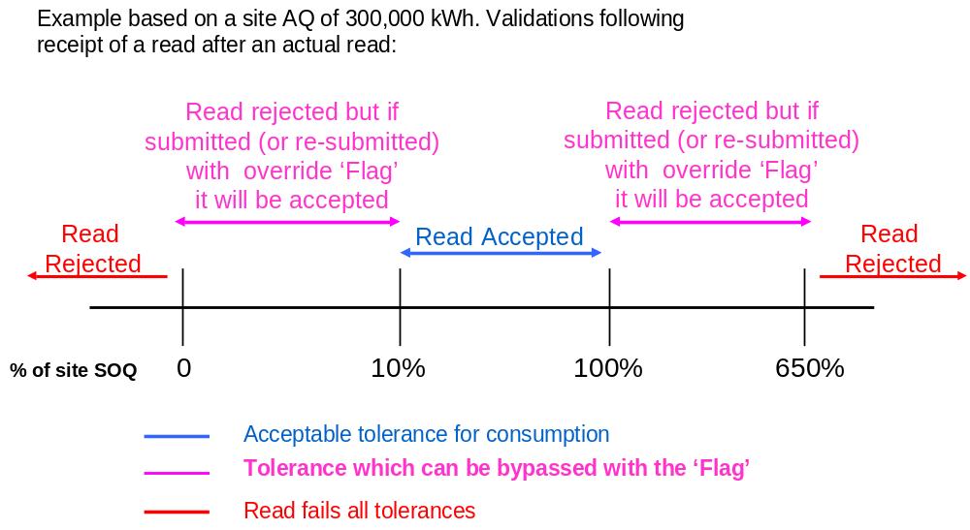

Interaction with Smart Metering Programme/Data Comms Co (DCC) arrangements
None of the proposals for Meter Reading submission are directly dependent on roll-out of smart meters or introduction of DCC, although it is expected that use of Products 1-3 would necessitate use of automated Meter Reading facilities.

Product 4 is likely to be the ‘default’ service for a current NDM Supply Meter Point.

Day Ahead Gas Nomination Processes (Settlement BRD 5.1)
One of the Workgroup’s objectives was to maintain or improve the alignment of ‘day ahead’ NDM Gas Nominations with NDM Allocations (after the Gas Day). The proposal is to mirror the new NDM Allocation arrangements and to remain fairly close to the current principles for Day Ahead Gas Nominations:

- For the future equivalent of DM Supply Meter Points (Products 1 and 2), the User would nominate the next day’s gas consumption
- Where the User does not submit a gas nomination for Product 1 or 2 Supply Meter Points (either for the interim or final runs of the nomination process) the Transporter would use a D-7 estimate (based on recorded consumption from 7 days earlier)
- For the future equivalent of daily non-metered Supply Meter Points (Products 3 and 4), by estimating the next day’s gas consumption, in a consistent manner to the ‘after the day’ allocations
- Within each LDZ, the sum of DM nominations plus the sum of the NDM estimates is deducted from the LDZ forecast consumption (as predicted by the Gas Control Room – unchanged from current arrangements)
- The difference between total LDZ forecast and the sum of all the Supply Meter Point level forecasts is equal to forecast Unidentified Gas, and would be shared out to all portfolio Users in the LDZ based on their total forecast measurements for the day. As with the Allocation Scaling Adjustment the charge would be at portfolio level by User by LDZ, not at Supply Meter Point level
- This process is referred to as Nominations Scaling Adjustment in the Business Requirements Document.

Access to Settlement Products (Settlement BRD 5.11)
Except as detailed in above, any Supply Meter Point can access any of the 3 Products (Product 2, 3 & 4). Users would be required to designate a Product in advance for a Supply Meter Point, and give future notice (providing [x] days’ notice) of a change of Product.

Reconciliation

Key Proposals

- Individual Meter Point Reconciliation for all Supply Meter Points
- Removal of RbD and replacement with an industry-wide scaling adjustment
- No change to reconciliation principles and calculations
- Introduction of the concept of Resynchronisation for NDM Supply Meter Points where Meter Readings are derived using certain types of automated reading equipment

Reconciliation services by Settlement Product (Reconciliation BRD 8.3, 8.4)
The four Settlement Products would be subject to Individual Meter Point Reconciliation as follows:

Process Description | Basis of initial Allocation | Basis of Energy Balancing | Shipper Read Submission | Reconciliation
Product 1: Daily Metered Time Critical Readings | Daily Read | Daily Read | Daily by 10 am on GFD+1 | Meter Point level following a re-synch or estimate
Product 2: Daily Metered not Time Critical Readings | Daily Read | Daily Read | Daily by end of GFD+1 | Meter Point level following a re-synch or estimate
Product 3: Batched Daily Readings | Allocation Profiles | Allocation Profiles | Daily Reads in Batches | Daily Reconciliation at Meter Point level on receipt of a batch of reads
Product 4: Periodic Readings | Allocation Profiles | Allocation Profiles | Periodically | Meter Point level at receipt of read

Reconciliation would still be based on a reconciliation energy amount (kWh) and would consist of Energy at System Average Price (SAP) and Transportation Commodity costs at the applicable rates.

The three key reconciliation scenarios which exist in the current regime would continue to exist:

- DM Reconciliation on receipt of an actual Meter Reading following a series of estimated Meter Readings
- Resynchronisation reconciliation on receipt of a resynchronisation Meter Reading, back to the previous resynchronisation read
- NDM reconciliation, where periodic Meter Readings are received and reconciliation energy is attributed to the days since the last reading based on the allocation profile

In addition, Product 3 would introduce the concept of daily reconciliation when a batch of Daily Meter Readings is received. The resulting reconciliations would be a series of one-day NDM reconciliations.

Individual Meter Point Reconciliation would apply to all Supply Meter Points and would be triggered by the submission of a Meter Reading.

Reconciliation Safeguards (Settlement BRD 5.15 – 5.18)
There will be a number of safeguards to ensure that Individual Meter Point reconciliation takes place in a timely manner. These safeguards all exist in the current regime, but the rules have been reviewed as part of this Proposal. The safeguards include:

- Rules on which Products or Meter Reading frequencies can be adopted, based on Supply Meter Point AQ
- Performance standards for Meter Reading submission (i.e. requirement to submit Meter Readings for a certain proportion of the portfolio each day/month/year
- Where the Meter Readings are derived by automated Meter Reading equipment such as a datalogger, a requirement to obtain a check reading to a specified frequency. Note that Meter Reading equipment which captures and transmits the actual index of the meter, rather than relying on meter pulses or similar technology, would not require a check read.
- A ‘must read’ requirement if Meter Readings are not submitted for a standard interval, whereby the Transporter would obtain a single Meter Reading and use it to trigger a reconciliation

The proposed trigger levels are set out below:

Process Description | Qualification criteria | Performance standard | Must Read Requirement | Check Read Requirement  (where applicable)
Product 1: Daily Metered Time Critical Readings | Mandatory for all meter points with AQ >58.6m kWh | [99%] of required reads submitted each day | [4] months since last reading | Every [12] months
Product 2: Daily Metered not Time Critical Readings | Any meter point | [97.5%] of required reads submitted each day | [4] months since last reading | Every [12] months
Product 3: Batched Daily Readings | Any meter point | Reads submitted for [90%] of meter points each month | [4] months since last reading | Every [24] months
Product 4: Periodic Readings – Monthly Read | Product 4 meter points with AQ >[293,000] | Reads submitted for [90%] of meter points each year | [4] months since last reading | Every [24] months
Product 4: Periodic Readings – Annually Read | Any meter point | Reads submitted for [70%] of meter points each year | [24] months since last reading | Every [24] months

Impact of Reconciliation on Unidentified Energy (Reconciliation BRD 8.8)
Each reconciliation, re-reconciliation and resynchronisation changes the measurement at an individual Supply Meter Point, and therefore changes the amount of unidentified energy for the reconciliation period in the LDZ.

All Individual Meter Point reconciliations (of all three types listed above) would trigger an equal and opposite amendment to Unidentified Gas. This would result in debits or credits to all Users in the relevant LDZ in line with their original measurements for the day. These amendments to Unidentified Gas would consist of energy charges only; there would be no Transportation Commodity element. These amendments are referred to as Reconciliation Scaling Adjustments and it is envisaged that they would be processed monthly on the Reconciliation Invoice, at portfolio level only, not attributable to individual Supply Meter Points.

LDZ Measurement Errors would be treated in the same way, with the opposite entry being included in the Reconciliation Scaling Adjustment.

Resynchronisation (Reconciliation BRD 8.5)
The concept of resynchronisation already exists for DM Supply Meters, where ‘drift’ between the datalogger readings and physical readings is accounted for and billed/credited in energy and transportation commodity terms.

The Proposals introduce the concept of resynchronisation for an NDM Supply Meter (Products 3 and 4) alongside DM Resynchronisation. Where the Meter Readings are derived, e.g. through a datalogger or other automated Meter Reading equipment, those Meter Readings can be used for daily or periodic reconciliation. However, there would be the capacity for drift between datalogged derived readings and physical readings at the Supply Meter. The minimum requirements for resynchronisation frequencies are set out above.

There would be a new requirement to perform resynchronisation within a set timeframe and for the Transporter to be advised of the outcome, including any new Meter Readings. Resynchronisation would cause a re-reconciliation back to the date of the last resynchronisation. The same principles as for current DM resynchronisation would apply, with the drift treated as arising equally across the period.

There would be no requirement for resynchronisation on smart meters or other equipment which transmits the actual index of the Supply Meter.

AUGE (Allocation of Unidentified Gas Expert) (Reconciliation BRD 8.14)
The introduction of an industry wide energy smear (Allocation Scaling Adjustment) would supersede the current RbD arrangements. The allocation gas expert (AUGE's) role would need to change as a result.

It is proposed that the role of the AUGE be retained and the AUGE continues to review the level and causes of Unidentified Gas. The AUGE may determine that the amounts apportioned to different sectors via Allocation Scaling Adjustments and Reconciliation Scaling Adjustments should be altered to reflect differing levels of contribution to Unidentified Gas. This alteration could be in the form of an amount of energy to be transferred between sectors or a % transfer between market sectors.

Impacts on other Processes (Reconciliation BRD 8.9)
The Meter Reading validation described above is intended to remove the need for the current User Suppressed Reconciliation Value (USRV) (‘NDM filter failure’) and Suppressed Reconciliation Value (SRV) processes given that all Meter Readings which pass the User and Transporter validations are deemed suitable for use in downstream processes, e.g. reconciliation and AQ. It is anticipated that the current ‘queues’ of USRVs awaiting attention from Users would be likely to be replaced by rejected Meter Readings awaiting investigation and correction/resubmission by Users. The volume of rejected Meter Readings would depend on a large number of factors, including the accuracy and efficiency of the User’s processes, the frequency of read submission and also on the level at which the read tolerances are set. The tolerance values would be a matter for future industry agreement.

In exceptional circumstances there may be a need for the Transporter to remove items from the reconciliation invoice for further investigation, where they produce excessively large debit or credit charges. This will protect the individual User and all other Users in the LDZ from the impact of the charges. Following investigation (by the User and/or Transporter), the item would be either released or amended. The wider the read validation tolerances the greater the need for a ‘fail safe’ mechanism. Its use could be expected to be infrequent, given the increased emphasis on validation of Meter Readings.

Annual Quantity (AQ)

Key Proposals
- Monthly re-calculation of AQ; if a new Meter Reading has been received in the last month
- If Meter Readings have previously passed validation against data held on the Supply Point Register they are deemed suitable for all processes, including AQ
- Removal of amendment and appeals phases of the AQ review
- 2 x SOQs – one for Allocation and another ‘fixed SOQ’ which applies for 6 or 12 months for transportation charging purposes
- Minimum duration of the reference period for AQ calculation is 9 months (compared to current 6 months + 1 day)

Monthly AQ calculation process (AQ BRD 8.2)
Each month new AQs would be calculated for all Supply Meter Points where a Meter Reading has been loaded since the last calculation run. If no new Meter Reading has been received, the AQ would not be recalculated. For a Meter Reading to have loaded to the Transporters’ system, it must have passed the validations described above. Where more than one Meter Reading has been received in the month, only the latest dated Meter Reading would be used. Where one or more replacement Meter Reading has been supplied for the latest date, only the last provided reading will be used.

The AQ calculation will use the current approach of a WAALP (Weather Adjusted Annual Load Profile), to covert the actual consumption to a seasonal normal consumption. The exact formulation of future WAALPs will depend on the outcome of the Demand Estimation Sub-Committees (DESC’s) deliberations on changes to the NDM Algorithm. This will be subject to a separate UNC Modification Proposal.

New AQs would automatically go live with effect from the 1st of the following month.

Process Description | Timing of AQ calculation | Reads used for AQ calculation | Read Type used for the AQ calculation | SOQ Calculation
Product 1: Daily Metered Time Critical Readings | Monthly | 2 reads a minimum of 9 months & max of 36 months apart | Actual read | Shipper Nominates
Product 2: Daily Metered not Time Critical Readings | Monthly | 2 reads a minimum of 9 months & max of 36 months apart | Actual read | Shipper Nominates
Product 3: Batched Daily Readings | Monthly | 2 reads a minimum of 9 months & max of 36 months apart | Actual read | GT Derives
Product 4: Periodic Readings | Monthly | 2 reads a minimum of 9 months & max of 36 months apart | Actual read | GT Derives

AQ Calculation for Products 1 and 2 (AQ BRD 8.3)
The optimum read period for AQ calculation would be 52 weeks, with a minimum of 9 months and maximum of 36 months.

AQ Calculation for Products 3 and 4 (AQ BRD 8.3)
The optimum read period for AQ calculation would be 52 weeks. In all cases the minimum reference period is 9 months and the maximum is 36 months.

Validation of AQs (AQ BRD 8.4)
As all reads used in the calculation of AQs have been subject to both User and Transporter validation as described in above, there would be no User review and challenge phase prior to their application. A communication file would be issued to Users, detailing all re-calculated AQs. These AQs would go live automatically, and there would not be an “Amendment Window”, unlike the current regime.

Correction of AQs (AQ BRD 8.6)
If a User identifies an erroneous AQ, e.g. due to incorrect Meter Readings or Meter Information, they must correct the erroneous data and/or submit a further Meter Reading. The next AQ calculation would use the revised data and would calculate an improved AQ. There will be no retrospective correction of AQs. The new arrangements should allow the User to correct their AQ for the following month.

Any mis-allocation of energy during the period that the AQ was erroneous would be corrected by the normal workings of reconciliation (which would apply to all Supply Meter Points individually).

There would be a mechanism to amend AQs, to be used in exceptional circumstances, e.g. following a significant change in gas usage at a Supply Meter Point. The User would need to submit a request to the Transporter, which would be validated prior to acceptance/rejection.

Calculation and Use of SOQs (AQ BRD 8.8)
Users would continue to nominate SOQs and SHQs for Product 1 and 2 Supply Meter Points.

For Products 3 and 4, the Transporter would continue to calculate the SOQ, using Load Factors or a similar approach. As the AQ varies each month (assuming that monthly Meter Readings are received) so the SOQ and associated EUC for NDM Allocation would also vary. A change in AQ from the 1st of the month would result in a change to NDM Allocation level and patterns from that date.

In addition for Products 3 and 4, SOQs at a snapshot date (date to be determined) would continue to apply for a period of [12 or 6] months for Transportation charging rate purposes. This would give certainty of costs/income to both User and Transporter. Regular monthly AQ updates would not affect this SOQ, although an AQ correction (as described in above) would change this SOQ and therefore Transportation charging rates.

Communication of amended AQs (AQ BRD 8.12)
Users would be issued with a monthly update of their revised AQs, SOQs and EUCs (where applicable), which shows existing and revised values or the reason why an AQ was not calculated. Note; this communication would only be received where a Valid Meter Reading was loaded i.e. not a rejected Meter Reading.

There will be a separate report of all rolled over (i.e. unchanged) AQs and the reason for non-calculation.

Reporting (AQ BRD 8.13)
It is envisaged that there would be a need for monthly reporting of AQ movements and non-movements, although the exact contents have yet to be finalised.

The same safeguards that ensure that Individual Meter Point Reconciliation takes place at a reasonable frequency should ensure that AQs are updated with reasonable frequency, depending on the AQ of the Supply Meter Point.

Impacts on other Processes (AQ BRD 9.2)
If monthly AQ calculation were implemented at the same time as or after ‘universal’ Individual Meter Point Reconciliation, then the ‘End of Year AQ Reconciliation’ for AQ Threshold Crossers (UNC E7.4.3) would no longer be required. If implemented earlier, then End of Year AQ Reconciliation would still be required for a transitional period.

These proposals remove the current AQ Amendment process, as the new values would go live automatically the following month. The AQ Appeal process would also be replaced, as the User would have the ability to amend the AQ at any time by submission of an up-to-date Meter Reading.

Supply Point Register

Key Proposals
- Transporter monitoring of Users’ compliance with the check read requirement
- Provision of 12 months’ consumption data (where available in the Transporters’ systems) to any potential new User
- Improved management of priority and vulnerable customers
- Extension of the scope of the Supply Point Register

The proposals developed by the Workgroup have been documented as ‘business principles’, as they are generally at a higher level than for the preceding topics.

Monitoring of check read submission (Supply Point BRD 8.1)
The Transporter would develop processes to record, monitor and report Users’ performance in obtaining and submitting check reads. Obtaining the check read would remain the User’s responsibility: the Transporter would not become the ‘Check Read provider of last resort’.

Provision of historic consumption data (Supply Point BRD 8.4)
A User contemplating a Supply Point Nomination would have the facility to obtain 12 months of consumption history, to assist in understanding the consumption levels and patterns of the Supply Meter Point. The completeness of the read history would be dependent on the Meter Reading submission performance of the User(s) owning the site for the previous 12 months. Daily consumption history is only likely to be available for Products 1 to 3, and may not be complete if the Supply Meter Point has only recently been moved to that Product from Product 4, or if there has been an equipment failure.

Improved management of priority and vulnerable customers (Supply Point BRD 8.6)
The Transporter would develop improved processes to record and manage data relating to Vulnerable and Priority Consumers, so that any incoming User can be advised of the current status of the Supply Meter Point. Responsibility for maintaining these data items would remain with the User.

Invoicing

It is not anticipated that Modification of the UNC is necessary to implement the changes identified within the Invoicing BRD. However, this is included for completeness.
User Pays
Classification of the modification as User Pays, or not, and the justification for such classification
Since substantial changes to central systems are envisaged in this modification, and those changes involve enhancements to the existing UNC regime, this modification falls with the definition of a User Pays Modification. Xoserve has indicated that the additional costs of implementing this modification, over and above the cost of replacing UK Link systems on a like for like basis with existing functionality, amount to about £20m. The actual difference in costs between a like for like and enhanced systems development will never be known since only one procurement and development exercise will be undertaken, based on the identified requirements.
Ofgem believe that all reasonably foreseen costs arising from the UK Link replacement have been considered when price controls were set, and funding provided. If significant additional costs beyond this can be demonstrated and justified, these should be considered in the context of the arrangements for funding which are in place following the review of Xoserve’s governance and funding. On this basis, the modification has not been put forward as a User Pays Modification by the Proposer.
The transporters nonetheless wish to emphasise that not all costs have been identified and some, such as the cost of changing Gemini to be consistent with the modification, were clearly not included in price control submissions. As such, additional cost recovery form Shippers is likely to be required in future.
Identification of Users, proposed split of the recovery between Gas Transporters and Users for User Pays costs and justification
Not applicable
Proposed charge(s) for application of Users Pays charges to Shippers
Not applicable
Proposed charge for inclusion in ACS – to be completed upon receipt of cost estimate from Xoserve
Not applicable

Relevant Objectives
Impact of the modification on the Relevant Objectives:
Relevant Objective | Identified impact
a) Efficient and economic operation of the pipe-line system. | None
b) Coordinated, efficient and economic operation of  (i) the combined pipe-line system, and/ or  (ii) the pipe-line system of one or more other relevant gas transporters. | None
c) Efficient discharge of the licensee's obligations. | None
d) Securing of effective competition:  (i) between relevant shippers;  (ii) between relevant suppliers; and/or  (iii) between DN operators (who have entered into transportation arrangements with other relevant gas transporters) and relevant shippers. | Positive
e) Provision of reasonable economic incentives for relevant suppliers to secure that the domestic customer supply security standards… are satisfied as respects the availability of gas to their domestic customers. | None
f) Promotion of efficiency in the implementation and administration of the Code | None
g) Compliance with the Regulation and any relevant legally binding decisions of the European Commission and/or the Agency for the Co-operation of Energy Regulators | None

NB: Modification 0432 and 0453 are linked. If Modification 0453 were not implemented, implementation of Modification 0432 as a standalone modification would not further the Relevant Objectives.
Relevant Objective d) being reviewed by participants for relevance and evidence – none identified as significant Insert benefit case linked to ROs
Refer to D) Implementation of the changes identified within this modification is expected to facilitate the securing of effective competition between Users. Accurate cost allocations are a fundamental underpinning for effective competition and the changes are expected to lead to more accurate allocation of costs between Users. This results from making use of an increased number of Meter Readings, such that information is more accurate and up to date; increasing the number of Supply Meter Points that are reconciled individually rather than in aggregate. This should not only increase the accuracy of costs allocated to those allocated on a daily basis but also the remaining Supply Meter Points since the total allocated to those Supply Meter Points would be expected to be more accurate.

Implementation of the proposed changes would also be expected to increase the predictability of cost allocations for individual Users. This would result from the use of more accurate and up to date consumption data, such that costs allocated to a given portfolio would more accurately reflect actual consumption that the User would expect to be aware of. Increased predictability would reduce the risk and uncertainty faced by Users, and consequently could be expected to reduce risk premiums that may be reflected in tariffs and/or prices. This would therefore facilitate the securing of effective competition among existing Users.

In addition to facilitating competition for existing Users, the reduction in risk and uncertainty would reduce barriers to entry. Entrants could come to the market with greater confidence that they could align their costs and revenues, and greater confidence that any changes they bring to the market through innovative approaches would be reflected in the costs allocated to themselves – for example, if consumption reducing initiatives are brought to the market, the reduced consumption would result in reduced costs more quickly than if the existing approach were to be retained. This has the potential to facilitate competition by reducing a barrier to entry for those seeking to come to the market with innovative ideas, but would also remove a barrier to existing Users developing new offerings and encouraging customers to switch to their products.

Increased predictability and certainty of allocations would be expected to allow Users to purchase energy that more closely matches true requirements. This will reduce costs for Users and support the development of effective competition.

Implementation
[This modification could be implemented within the UNC immediately following Ofgem direction.]
It is expected that the system changes supporting this modification will be implemented during 2015. This coincides with a number of other significant industry changes, i.e. EU Third Package requirements and smart metering rollout. This scale of change will need to be coordinated and an industry wide agreement reached regarding the implementation timeline incorporating all of these programmes and the supporting modules. A Nexus implementation plan has been developed as follows, and it is essential this is adhered to in the interests of efficiency for all:
[insert project plan]
Xoserve need indications of likely product take up such that they can ensure that the initial system is scaled appropriately and able to meet demand efficiently, and receiving indications from the largest players is critical in this respect. However, the Workgroup emphasised that scalability is essential for future take up such that any change in use of products is not curtailed by systems capacity. DECC publishes expectations of smart meter rollout that defines the potential population that can access the higher granularity products, and so constrains the potential scale of take up. The latest available indication is:
[insert DECC data]

Legal Text

Text
[The Text for this modification has been prepared by National Grid Distribution and is published along side this report, and no issues were raised by the Workgroup regarding its content.]

Recommendation

The Workgroup invites the Panel to:
- AGREE that this modification should be submitted for consultation.

http://www.gasgovernance.co.uk/nexus/brd

