  Stage 02: Workgroup Report |  |  | At what stage is this document in the process?
0432:  Project Nexus – Gas Demand Estimation, Allocation, Settlement and Reconciliation reform |  | u | 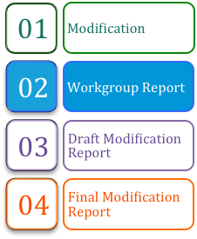
This modification is one of a number of complementary proposals seeking to implement the requirements identified under Project Nexus. This modification identifies fundamental changes to the Gas Allocation, Settlement, Reconciliation, Demand Estimation, Annual Quantity, Invoicing and Supply Point Register elements of the UNC regime.
 | The Workgroup recommends that this modification should now proceed to consultation.
 | High Impact:  Users and Transporters

Contents  1 Summary 3  2 Why Change? 6  3 Solution 8  4 Relevant Objectives 23  5 Implementation 25  6 Legal Text 27  7 Recommendation 28  About this document:  This report will be presented by the Workgroup to the panel on 21 November 2013.  The panel will consider whether the modification is sufficiently developed to proceed to Consultation and to submit any further recommendations in respect of the definition and assessment of this modification. | 
 | Any questions?
Contact:
Joint Office
 | enquiries@gasgovernance.co.uk
 | 0121 623 2115
Proposer:
Chris Warner
 | chris.warner@nationalgrid.com
 | 07778 150668
Transporter:
National Grid Distribution
Xoserve:
Andy Miller
 | commercial.enquiries@xoserve.com
 | 0121 623 2348
 | commercial.enquiries@xoserve.com

- Summary

Is this a Self-Governance Modification
The Modification Panel determined that self-governance procedures were not appropriate for this modification.

Why Change?
As part of the outcome of the last Gas Distribution price control review, it was agreed that funding should be available to support a major IT systems investment programme by the Transporters agent, Xoserve. This major systems investment for UK-Link Replacement provides an opportunity to consider whether the existing UNC requirements remain appropriate. Rather than asking Xoserve to procure replacement systems that deliver the existing functionality, there is an expectation that introducing regime enhancements at this stage would be the most economic time to implement any such change. This is particularly opportune since it is coincident with the development of smart metering, such that requirements can be specified that recognise changes to metering arrangements rather than any changes to accommodate smart metering being retrofitted in due course. The requirements gathering exercise for the enhancements is entitled Project Nexus. This modification is one of a number, which reflects these requirements. Complementary Modification Proposals are anticipated to be raised shortly in the following areas:

- Retrospective adjustment
- iGT Single Service Provision
- Non functional
- Implementation (including non-business/non effective days)

Solution
The UNC Modification Panel established a Workgroup to support the development of potential UNC Modification Proposals that may be beneficial at the time of systems replacement. Building on responses to an Xoserve consultation exercise, the Project Nexus Workgroup has considered a range of potential changes, and the output from these considerations have been published as a suite of Business Requirement Documents (BRDs). The key proposals are:

- Settlement (Submission of Meter Readings and use in daily allocation)

- Users continue to be responsible for obtaining, validating and submitting Meter Readings (other than those pertaining to ‘mandatory’ Daily Metered (DM) Supply Points)
- The Gas Transporters (GT)’ agent performs validations on the Meter Reading against data held on the Transporters’ Supply Point Register
- Choice of four ‘Products’ for allocation and settlement
- Users would have access to a daily settlement service for all Supply Meter Points
- Introduction of an industry-wide ‘smear’ for Unidentified Gas and any other gas not accounted for through initial measurements or allocations

- Individual Meter Point Reconciliation

- Individual Meter Point Reconciliation for all Supply Meter Points
- Removal of Reconciliation by Difference (RbD) and replacement with an industry-wide scaling adjustment
- No change to reconciliation principles and calculations
- Introduction of the concept of read equipment ‘resynchronisation’ for Non-Daily Metered (NDM) Supply Meter Points where Meter Readings are derived using certain types of automated reading equipment

- Annual Quantity (AQ)

- Monthly re-calculation of AQ
- If Meter Readings have previously passed validation against data held on the Supply Point Register they are deemed suitable for all processes, including AQ
- Removal of the amendment and appeals phases of the AQ review
- 2 measures of Daily Supply Point Capacity (SOQ) – one for Allocation and another ‘fixed SOQ’ which applies for 6 or 12 months for transportation charging purposes.
- Minimum duration of the reference period for AQ calculation is 9 months (compared to current 6 months + 1 day)
- Supply Point Register

- GT monitoring of Users’ compliance with the DM Check Read requirement
- Provision of 12 months’ consumption data (where available in the GTs’ systems) to any potential new User
- Improved management of priority and vulnerable customers
- Extension of the scope of the Supply Point Register

- Demand Estimation

This Modification Proposal (0432) proposes a number of changes to Gas Settlement arrangements, including the removal of Reconciliation by Difference (RbD) and its replacement with a universal ‘Allocation Scaling Adjustment’. This would require a new approach to gas allocation to reduce the likelihood of cross-subsidies arising at the point of allocation. The current NDM allocation algorithm (as defined in UNC TPD H2.2.1) would not be sustainable under Project Nexus arrangements. Consequently National Grid Distribution (NGD) raised UNC Modification Proposal 0453 ‘Project Nexus – Demand Estimation’ to address this matter.

A Technical Working Group (TWG) under the supervision the Demand Estimation Sub-Committee (DESC) identified and assessed a range of options for the future Non-Daily Metered (NDM) estimation algorithm. A preferred model was subsequently developed. This is an adaptation of the current NDM estimation algorithm. In particular the Scaling Factor (SF) would be removed from the algorithm and the Weather Correction Factor (WCF) would be amended to be based on the difference between actual and seasonal normal weather.

Noting that this work is complete it has been determined that UNC Modification Proposal 0453 is no longer required and consequently its contents have incorporated within this Modification Proposal. 0453 will be withdrawn shortly.

It is proposed that the UNC be modified to describe the NDM Demand Estimation process at a high level, but that the specific details and methodologies, including any formulae, are set out in a UNC Related Document, which would require the approval of Uniform Network Code Committee (UNCC) for any subsequent amendments.

- Invoicing

- No wholesale change to current “thin invoice” and “thick supporting information” structure
- Requirement for all supporting information to be itemised at meter point level wherever possible
- All supporting information to be sent by electronic transfer
- Reduction in the number of ‘Adhoc’ invoices
- Alignment of charges to core transportation invoices

Relevant Objectives
Implementation of the changes identified within this modification would further relevant objective d) as it is expected to facilitate the securing of effective competition between Users as accurate cost allocations are a fundamental underpinning for effective competition and the changes are expected to lead to more accurate allocation of costs between Users.

It would also be expected to increase the predictability of cost allocations for individual Users. This would result from the use of more accurate and up to date consumption data, such that costs allocated to a given portfolio would more accurately reflect actual consumption that the User would expect to be aware of.

In addition to facilitating competition for existing Users, the reduction in risk and uncertainty would reduce barriers to entry for new market entrants.

Increased predictability and certainty of allocations would be expected to allow Users to purchase energy that more closely matches true requirements. This will reduce costs for Users and support the development of effective competition.

Implementation
01 October 2015 if an Authority decision is made by 31 March 2014
01 April 2016 if an Authority decision is made by 30 September 2014
With a backstop lead time of 18 months (549 calendar days) should the Authority makes its decision after 30 September 2014. This is noting that no implementation would take place during the winter operations period for the Gemini system being 01 October – 31 March and any implementation must be on the first of the month.
If Ofgem issues a direction that this modification should be made, this text would take effect on the Project Nexus Implementation Date. Consequently, following Authority direction (should this occur) the modified text would need to be monitored and amended as necessary as part of any relevant modification which may arise to ensure that it remains in line with the version of the Code applicable at any one time.

Why Change?

Background to Project Nexus
At the time of the current Gas Distribution Price Control Xoserve anticipated the need for a major IT systems investment programme. Stakeholder consultation was initiated, under the banner of ‘Project Nexus’ to inform the scope and nature of Xoserve’s future services that IT systems would need to support – the detailed Business Requirement Documents that support this document form a key input to the design of that investment programme.

The initial phase of Project Nexus was a consultation exercise, in which interested parties were asked for their views on the long-term strategic requirements for Xoserve’s services. The consultation also developed a preferred approach to further definition of stakeholder requirements.

Following the consultation phase of Project Nexus, an Initial Requirements Register (IRR) was compiled, identifying all the topics that respondents to the Consultation had raised.

Topics were grouped into three broad categories:
- UNC changes
- Independent Gas Transporter (iGT) services
- Data management

A UNC Workgroup was established to consider the UNC topics and develop requirements.

Development of Requirements
In 2009 the UNC Modification Panel agreed a Workstream (later renamed Workgroup) should be set up to define industry requirements for the development and enhancement of the UNC in areas that are relevant to Xoserve’s services. The Initial Requirements Register (IRR) formed the basis of the discussions. Consultation responses were grouped into related topics and relevant as-is process models were reviewed and agreed. The Project Nexus Workgroup discussed the responses and reached a consensus on whether to carry forward or close the requirement. The outputs from the Workgroup Topic meetings were baselined Business Requirements Documents (BRDs) and to-be process models (i.e. future state processes).

Solution
The BRDs identify detailed business rules, which form the foundation for the necessary changes to the UNC. The following BRDs are relevant to this Modification Proposal:

The following information identifies the proposed regime for which Modification of the UNC is required.

Document Name | Version and Date | Current Location (29/06/12)
Business Requirements Document for Meter Read Submission and Processing and Settlement Arrangements (“Settlement BRD”) | V4.0 31/10/2013 | www.gasgovernance.co.uk/nexus/brd
Business Requirements Definition for Reconciliation (“Reconciliation BRD”) | V3.0 25/10/2013 | www.gasgovernance.co.uk/nexus/brd
Business Requirements Definition for Annual Quantity (“AQ BRD”) | V5.0 25/10/2013 | www.gasgovernance.co.uk/nexus/brd
Business Principles for Supply Point Register (“Supply Point BRD”) | V3.0 25/10/2013 | www.gasgovernance.co.uk/nexus/brd
Business Principles For Invoicing (“Invoicing BRD”) | V2.0 25/10/2013 | www.gasgovernance.co.uk/nexus/brd

Settlement (Submission of Meter Readings and Use in Daily Allocation)

Key Proposals
- Users would continue to be responsible for obtaining, validating and submitting Meter Readings
- Gas Transporters would perform validations on the Meter Reading against data held on the Supply Point Register
- A choice of four future ‘Products’ for allocation of daily gas off-taken
- Users would have access to a daily settlement service for all Supply Meter Points
- Introduction of an industry-wide “smear” for Unidentified Gas and any other gas not accounted for through initial measurements or allocations

Overview of the 4 Products
It is proposed to introduce 4 ‘Products’ which would be available to all Supply Meter Points (with the exception of DM ‘mandatory’ Supply Meter Points).

Each product is described below.

Product 1 – Time Critical DM (Settlement BRD Section 5.5)
This would be a mandatory service for Supply Meter Points subject to the Daily Read Requirement.

Meter Readings are procured by the Transporter and must be submitted by 11am on Gas Flow Day (GFD)+1. Where no Meter Readings are received, the Transporter would calculate an estimated Meter Reading based on the recorded consumption from 7 days earlier (a “D-7” estimate). Estimated Meter Readings can be replaced up to D+5, at which point the latest accepted Meter Reading will be used for Energy Balancing and Commodity billing purposes.

Product 2 – Non-Time Critical DM (Settlement BRD Section 5.6)
This would be an elective service available to any Supply Meter Point with an AQ below 58.6m kWh.

Users may elect to use this service for any Supply Meter Point other that one subject to the Daily Read Requirement.

Meter Readings must be submitted within 24 hours of the end of the Gas Day i.e. by 05:59 the following morning. The Transporter will use a “D-7” estimate in any allocation runs, until an actual Meter Reading is received.

Where no Meter Readings are received by D+5, the D-7 estimate will prevail. Estimated Meter Readings can be replaced up to D+5, at which point the latest accepted Meter Reading will be used for Energy Balancing and Commodity billing purposes.

Product 3 – Batched Daily Readings (Settlement BRD Section 5.7)
This would be a voluntary service available to any Supply Meter Point with an AQ below 58.6m kWh.

The Supply Meter Point would be subject to NDM allocation each day based on its AQ and an allocation algorithm. The need for change to the allocation algorithm is considered below. Gas usage is subsequently reconciled for each day’s individual consumption, by the User submitting a batch of daily readings. The proposed read frequencies for batch submission are weekly, fortnightly and monthly.

Product 4 – Periodic Readings (Settlement BRD Section 5.8)
This would be a voluntary service available to any Supply Meter Point with an AQ below 58.6m kWh.

The Supply Meter Point would be subject to NDM allocation each day based on its AQ and an allocation algorithm. Gas usage would be subsequently reconciled when the User submits a periodic Meter Reading, which must be a Valid Meter Reading. The reconciliation quantities and values are derived using the original allocation profile.

Key features of the four Products (Summary of Settlement BRD Sections 5.5 – 5.8)

Process Description | Basis of energy Allocation | Basis of Energy Balancing | Shipper Read Submission | Missing read arrangements for energy allocation
Product 1: Daily Metered Time Critical Readings | Daily Read | Daily Read | Daily by 11 am on GFD+1 | D-7 estimate
Product 2: Daily Metered not Time Critical Readings | Daily Read | Daily Read | Daily by end of GFD+1 | D-7 estimate
Product 3: Batched Daily Readings | Allocation Profiles | Allocation Profiles | Periodically in batches of daily readings | Not applicable – not used in allocation
Product 4: Periodic Readings | Allocation Profiles | Allocation Profiles | Periodically | Not applicable – not used in allocation

Mapping of the future Products to current services
The four proposed products can be mapped approximately to the existing services as shown below.

Current services | Future “product”
DM Mandatory | Product 1 – Time Critical DM | DM
DM Voluntary/  DM Elective | Product 2 – Non-Time Critical DM | DM
Non-Daily Metered | Product 3 – Batched Daily Readings | NDM
Non-Daily Metered | Product 4 – Periodic Readings | NDM

Treatment of ‘Unidentified Gas’ (Settlement BRD Section 5.4)
An initial estimate of unidentified gas will be calculated each day as part of the daily gas nomination and allocation process.

Step 1
Daily Meter Readings are received from Products 1 and 2. (Note: for Product 2, D-7 estimates are used until an actual Meter Reading is received; or where there is no Meter Reading for Product 1).

Step 2
The NDM algorithm calculates an initial allocation for all Product 3 and 4 Supply Meter Points. This will require an improved estimation methodology. This will still be based on AQ, but will be more responsive to other factors, such as weather. Work on reviewing NDM algorithms has been completed within the Demand Estimation Sub-Committee (DESC). The agreed approach to NDM Demand Estimation has been included within this Proposal.

Step 3
Total LDZ Throughput less Shrinkage, less Step 1 and Step 2 = Unidentified Gas for the LDZ.

Step 4
Unidentified gas in each LDZ is shared out to all portfolio Users in the LDZ based on their total Step 1 and Step 2 gas nominations and measurements for the day. The charge would be at portfolio level by User by LDZ, not at Supply Meter Point level.

Unidentified Gas would be amended subsequently and re-shared as Individual Meter Point Reconciliations occur. See Reconciliation section below.
Note: It is not proposed to include a capability for intervention in the gas nomination, allocation and reconciliation sharing processes by an Allocation of Unidentified Gas Expert (AUGE). However provision is required that should such a requirement be forthcoming at any future date, this can be readily accommodated at the nomination, allocation and reconciliation stages of gas settlement. It is proposed that this be facilitated through the incorporation of an Unidentified Gas Allocation Adjustment Factor. Given that no provision for AUGE intervention is proposed, the Factor will be set at 1 (one) for all categories of System Exit Points.

Submission of Meter Readings (Settlement BRD Section 8)
Limited change is envisaged to the Meter Reading submission arrangements. Submission of Meter Readings would remain the responsibility of the User.

Meter Reading Validation (Settlement BRD Sections 5.13, 5.14)
Users would continue to have responsibility for validating Meter Readings prior to submission to the Transporter. The proposals include a new two-step validation process. Users would validate Meter Readings using the current AQ/SOQ for the Supply Meter Point:

- For DM Supply Meter Points (Products 1 to 3), by comparing the energy that the Meter Reading would generate to the SOQ for the Supply Meter Point
- For periodically read Supply Meter Points (Product 4), by comparing the energy that the Meter Reading would generate to the AQ for the Supply Meter Point, applied pro-rata for the number of days in the read period

If the proposed energy passes the first test, it can be loaded to the Transporters system and used in all subsequent processes.

The Transporter would replicate the User validations and in certain circumstances would reject Meter Readings if they fail the tests. This enhanced validation is essential to support the changes to downstream AQ calculation and reconciliation processes, which rely on these Meter Readings.

If the energy fails the first test but passes the second test, it can only be loaded if it has been submitted with an ‘override’ flag. By using this flag the User would confirm that they have checked the Meter Reading (and the energy generated) and acknowledges that the energy is unusually large or small, but confirms that it is correct. The ‘flag’ could be populated at first attempt at submission, or at a subsequent re-submission following a rejection by the Transporter.

Reads where the energy fails the second test cannot be loaded. This second test is sometimes referred to as the ‘market breaker’ test. Transactions outside of this test would risk ‘breaking’ the market, and so cannot be allowed to load.

As a safeguard, if the ‘override flag’ is set for a Meter Reading which according to the Transporters calculation would pass both tests, the Meter Reading would be rejected. This is to protect all downstream processes from erroneous use of the flag, e.g. trying to ‘force’ Meter Readings through without performing full validation.

Read validation tolerances
The interaction of the two tests is shown below.

The working values of the tests can be found in the detailed Settlement BRD. It is intended that the actual values will be determined through further analysis at a later stage, and that there should be sufficient flexibility to amend the values after implementation if the industry agrees changes.

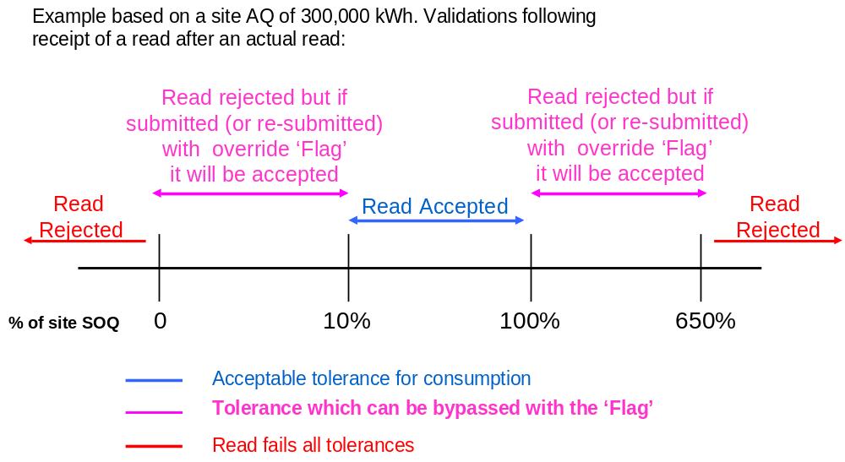

Interaction with Smart Metering Programme/Data Comms Co (DCC) arrangements
None of the proposals for Meter Reading submission are directly dependent on roll-out of smart meters or introduction of DCC, although it is expected that use of Products 1-3 would necessitate use of automated Meter Reading facilities.

Product 4 is likely to be the ‘default’ service for a current NDM Supply Meter Point.

Day Ahead Gas Nomination Processes (Settlement BRD 5.1)
One of the Workgroup’s objectives was to maintain or improve the alignment of ‘day ahead’ NDM Gas Nominations with NDM Allocations (after the Gas Day). The proposal is to mirror the new NDM Allocation arrangements and to remain fairly close to the current principles for Day Ahead Gas Nominations:

- For the future equivalent of DM Supply Meter Points (Products 1 and 2), the User would nominate the next day’s gas consumption
- Where the User does not submit a gas nomination for Product 1 or 2 Supply Meter Points (either for the interim or final runs of the nomination process) the Transporter would use a D-7 estimate (based on recorded consumption from 7 days earlier). A zero value would be used for scheduling purposes
- For the future equivalent of NDM Supply Meter Points (Products 3 and 4), by estimating the next day’s gas consumption, in a consistent manner to the ‘after the day’ allocations
- Within each LDZ, the sum of DM nominations plus the sum of the NDM estimates is deducted from the LDZ forecast consumption (as predicted by the Gas Control Room – unchanged from current arrangements)
- The difference between total LDZ forecast and the sum of all the Supply Meter Point level forecasts is equal to forecast Unidentified Gas, and would be shared out to all portfolio Users in the LDZ based on their total forecast measurements for the day. The charge would be at portfolio level by User by LDZ, not at Supply Meter Point level

Access to Settlement Products (Settlement BRD 5.11)
Except as detailed in above (Product 1), any Supply Meter Point can access any of the 3 Products (Product 2, 3 & 4). Users would be required to designate a Product in advance for a Supply Meter Point, and give future notice (providing a minimum of 5 days’ notice) of a change of Product.

Reconciliation

Key Proposals

- Individual Meter Point Reconciliation for all Supply Meter Points
- Removal of RbD and replacement with an industry-wide scaling adjustment
- No change to reconciliation principles and calculations
- Introduction of the concept of Resynchronisation for NDM Supply Meter Points where Meter Readings are derived using certain types of automated reading equipment

Reconciliation services by Settlement Product (Reconciliation BRD 8.3, 8.4)
The four Settlement Products would be subject to Individual Meter Point Reconciliation as follows:

Process Description | Basis of initial Allocation | Basis of Energy Balancing | Shipper Read Submission | Reconciliation
Product 1: Daily Metered Time Critical Readings | Daily Read | Daily Read | Daily by 11 am on GFD+1 | Meter Point level following a re-synch or estimate
Product 2: Daily Metered not Time Critical Readings | Daily Read | Daily Read | Daily by end of GFD+1 | Meter Point level following a re-synch or estimate
Product 3: Batched Daily Readings | Allocation Profiles | Allocation Profiles | Daily Reads in Batches | Daily Reconciliation at Meter Point level on receipt of a batch of reads
Product 4: Periodic Readings | Allocation Profiles | Allocation Profiles | Periodically | Meter Point level at receipt of read

Reconciliation would still be based on a reconciliation energy amount (kWh) and would consist of Energy at System Average Price (SAP) and Transportation Commodity costs at the applicable rates.

The three key reconciliation scenarios which exist in the current regime would continue to exist:

- DM Reconciliation on receipt of an actual Meter Reading following a series of estimated Meter Readings
- Resynchronisation reconciliation on receipt of a resynchronisation Meter Reading, back to the previous resynchronisation read
- NDM reconciliation, where periodic Meter Readings are received and reconciliation energy is attributed to the days since the last reading based on the allocation profile

In addition, Product 3 would introduce the concept of daily reconciliation when a batch of Daily Meter Readings is received. The resulting reconciliations would be a series of one-day NDM reconciliations.

Individual Meter Point Reconciliation would apply to all Supply Meter Points and would be triggered by the submission of a Meter Reading.

Reconciliation Safeguards (Settlement BRD 5.15 – 5.18)
There will be a number of safeguards to ensure that Individual Meter Point reconciliation takes place in a timely manner. These safeguards all exist in the current regime, but the rules have been reviewed as part of this Proposal. The safeguards include:

- Rules on which Products or Meter Reading frequencies can be adopted, based on Supply Meter Point AQ
- Performance standards for Meter Reading submission (i.e. requirement to submit Meter Readings for a certain proportion of the portfolio each day/month/year
- Where the Meter Readings are derived by automated Meter Reading equipment such as a datalogger, a requirement to obtain a check reading to a specified frequency. Note that Meter Reading equipment which captures and transmits the actual index of the meter, rather than relying on meter pulses or similar technology, would not require a check read.
- A ‘must read’ requirement if Meter Readings are not submitted for a standard interval, whereby the Transporter would obtain a single Meter Reading and use it to trigger a reconciliation

The proposed trigger levels are set out below:

Process Description | Qualification criteria | Performance standard | Must Read Requirement | Check Read Requirement  (where applicable)
Product 1: Daily Metered Time Critical Readings | Mandatory for all meter points with AQ >58.6m kWh | 97.5% of required reads submitted each day | N/A | Every 12 months
Product 2: Daily Metered not Time Critical Readings | Any meter point | 97.5% of required reads submitted each day | 4 months since last reading | Every 12 months
Product 3: Batched Daily Readings | Any meter point | Reads submitted for 90% of meter points each month | 4 months since last reading | Every 12 months
Product 4: Periodic Readings – Monthly Read | Product 4 meter points with AQ >293,000 | Reads submitted for 90% of meter points each year | 4 months since last reading | Every 12 months
Product 4: Periodic Readings – Annually Read | Product 4 meter points with an AQ <293,000 | Reads submitted for 70% of meter points each year | 24 months since last reading | Every 24 months

Impact of Reconciliation on Unidentified Energy (Reconciliation BRD 8.8)
Each reconciliation, re-reconciliation and resynchronisation changes the measurement at an individual Supply Meter Point, and therefore changes the amount of unidentified energy for the reconciliation period in the LDZ.

All Individual Meter Point reconciliations (of all three types listed above) would trigger an equal and opposite amendment to Unidentified Gas. This would result in debits or credits to all Users in the relevant LDZ in line with their measurements for the day. These amendments to Unidentified Gas would consist of energy charges only; there would be no Transportation Commodity element. These amendments would be processed monthly, at portfolio level only, not attributable to individual Supply Meter Points.

LDZ Measurement Errors would be treated in the same way, with the opposite entry being included in the Reconciliation Scaling Adjustment.

Resynchronisation (Reconciliation BRD 8.5)
The concept of resynchronisation already exists for DM Supply Meters, where ‘drift’ between the datalogger readings and physical readings is accounted for and billed/credited in energy and transportation commodity terms.

The Proposals introduce the concept of resynchronisation for an NDM Supply Meter (Products 3 and 4) alongside DM Resynchronisation. Where the Meter Readings are derived, e.g. through a datalogger or other automated Meter Reading equipment, those Meter Readings can be used for daily or periodic reconciliation. However, there would be the capacity for drift between datalogged derived readings and physical readings at the Supply Meter. The minimum requirements for resynchronisation frequencies are set out above.

There would be a new requirement to perform resynchronisation within a set timeframe and for the Transporter to be advised of the outcome, including any new Meter Readings. Resynchronisation would cause a re-reconciliation back to the date of the last resynchronisation. The same principles as for current DM resynchronisation would apply, with the drift treated as arising equally across the period.

There would be no requirement for resynchronisation on smart meters or other equipment which transmits the actual index of the Supply Meter.

AUGE (Allocation of Unidentified Gas Expert) (Reconciliation BRD 8.14)
The introduction of an industry wide energy smear (Allocation Scaling Adjustment) would supersede the current RbD arrangements. The allocation gas expert (AUGE) would no longer be required.

Impacts on other Processes (Reconciliation BRD 8.9)
The Meter Reading validation described above would remove the need for the current User Suppressed Reconciliation Value (USRV) (‘NDM filter failure’) and Suppressed Reconciliation Value (SRV) processes given that all Meter Readings which pass the User and Transporter validations are deemed suitable for use in downstream processes, e.g. reconciliation and AQ. It is anticipated that the current ‘queues’ of USRVs awaiting attention from Users would be likely to be replaced by rejected Meter Readings awaiting investigation and correction/resubmission by Users. The volume of rejected Meter Readings would depend on a large number of factors, including the accuracy and efficiency of the User’s processes, the frequency of read submission and also on the level at which the read tolerances are set. The tolerance values would be a matter for future industry agreement.

Annual Quantity (AQ)

Key Proposals
- Monthly re-calculation of AQ; if a new Meter Reading has been received in the last month
- If Meter Readings have previously passed validation against data held on the Supply Point Register they are deemed suitable for all processes, including AQ
- Removal of amendment and appeals phases of the AQ review
- 2 x SOQs – one for Allocation and another ‘fixed SOQ’ which applies for 12 months for transportation charging purposes
- Minimum duration of the reference period for AQ calculation is 9 months (compared to current 6 months + 1 day)

Monthly AQ calculation process (AQ BRD 8.2)
Each month new AQs would be calculated for all Supply Meter Points where a Meter Reading has been loaded since the last calculation run. If no new Meter Reading has been received, the AQ would not be recalculated. For a Meter Reading to have loaded to the Transporters’ system, it must have passed the validations described above. Where more than one Meter Reading has been received in the month, only the latest dated Meter Reading would be used. Where one or more replacement Meter Reading has been supplied for the latest date, only the last provided reading will be used.

The AQ calculation will use the current approach of a WAALP (Weather Adjusted Annual Load Profile), to covert the actual consumption to a seasonal normal consumption.

New AQs would automatically go live with effect from the 1st of the following month.

Process Description | Timing of AQ calculation | Reads used for AQ calculation | Read Type used for the AQ calculation | SOQ Calculation
Product 1: Daily Metered Time Critical Readings | Monthly | 2 reads a minimum of 9 months & max of 36 months apart | Actual read | Shipper Nominates
Product 2: Daily Metered not Time Critical Readings | Monthly | 2 reads a minimum of 9 months & max of 36 months apart | Actual read | Shipper Nominates
Product 3: Batched Daily Readings | Monthly | 2 reads a minimum of 9 months & max of 36 months apart | Actual read | GT Derives
Product 4: Periodic Readings | Monthly | 2 reads a minimum of 9 months & max of 36 months apart | Actual read | GT Derives

AQ Calculation for Products 1 and 2 (AQ BRD 8.3)
The optimum read period for AQ calculation would be 365 days, with a minimum of 9 months and maximum of 36 months.

AQ Calculation for Products 3 and 4 (AQ BRD 8.3)
The optimum read period for AQ calculation would be 365 days. In all cases the minimum reference period is 9 months and the maximum is 36 months.

Validation of AQs (AQ BRD 8.4)
As all reads used in the calculation of AQs have been subject to both User and Transporter validation as described above, there would be no User review and challenge phase prior to their application. A communication file would be issued to Users, detailing all re-calculated AQs. These AQs would go live automatically, and there would not be an “Amendment Window”, unlike the current regime.

Correction of AQs (AQ BRD 8.6)
If a User identifies an erroneous AQ, e.g. due to incorrect Meter Readings or Meter Information, they must correct the erroneous data and/or submit a further Meter Reading. The next AQ calculation would use the revised data and would calculate an improved AQ. There will be no retrospective correction of AQs. The new arrangements should allow the User to correct their AQ for the following month.

Any mis-allocation of energy during the period that the AQ was erroneous would be corrected by the normal workings of reconciliation (which would apply to all Supply Meter Points individually).

There would be a mechanism to amend AQs, to be used in exceptional circumstances, e.g. following a significant change in gas usage at a Supply Meter Point. The User would need to submit a request to the Transporter, which would be validated prior to acceptance/rejection.

Calculation and Use of SOQs (AQ BRD 8.8)
Users would continue to nominate SOQs and SHQs for Product 1 and 2 Supply Meter Points.

For Products 3 and 4, the Transporter would continue to calculate the SOQ, using Load Factors or a similar approach. As the AQ varies each month (assuming that monthly Meter Readings are received) so the SOQ and associated EUC for NDM Allocation would also vary. A change in AQ from the 1st of the month would result in a change to NDM Allocation level and patterns from that date.

In addition for Products 3 and 4, SOQs at a snapshot date would continue to apply for a period of 12 months for Transportation charging rate purposes. This would give certainty of costs/income to both User and Transporter. Regular monthly AQ updates would not affect this SOQ, although an AQ correction would change this SOQ and therefore Transportation charging rates.

Communication of amended AQs (AQ BRD 8.12)
Users would be issued with a monthly update of their revised AQs, SOQs and EUCs (where applicable), which shows existing and revised values or the reason why an AQ was not calculated. Note; this communication would only be received where a Valid Meter Reading was loaded i.e. not a rejected Meter Reading.

There will be a separate report of all rolled over (i.e. unchanged) AQs and the reason for non-calculation.

Reporting (AQ BRD 8.13)
It is envisaged that there would be a need for monthly reporting of AQ movements and non-movements, although the exact contents have yet to be finalised.

The same safeguards that ensure that Individual Meter Point Reconciliation takes place at a reasonable frequency should ensure that AQs are updated with reasonable frequency, depending on the AQ of the Supply Meter Point.

Impacts on other Processes (AQ BRD 9.2)
If monthly AQ calculation were implemented at the same time as or after ‘universal’ Individual Meter Point Reconciliation, then the ‘End of Year AQ Reconciliation’ for AQ Threshold Crossers (UNC E7.4.3) would no longer be required. If implemented earlier, then End of Year AQ Reconciliation would still be required for a transitional period.

These proposals remove the current AQ Amendment process, as the new values would go live automatically the following month. The AQ Appeal process would also be replaced, as the User would have the ability to amend the AQ at any time by submission of an up-to-date Meter Reading.

Supply Point Register

Key Proposals
- Transporter monitoring of Users’ compliance with the check read requirement
- Provision of 12 months’ consumption data (where available in the Transporters’ systems) to any potential new User
- Improved management of priority and vulnerable customers
- Extension of the scope of the Supply Point Register

The proposals developed by the Workgroup have been documented as ‘business principles’, as they are generally at a higher level than for the preceding topics.

Monitoring of check read submission (Supply Point BRD 8.1)
The Transporter would develop processes to record, monitor and report Users’ performance in obtaining and submitting check reads. Obtaining the check read would remain the User’s responsibility: the Transporter would not become the ‘Check Read provider of last resort’.

Provision of historic consumption data (Supply Point BRD 8.4)
A User contemplating a Supply Point Nomination would have the facility to obtain 12 months of consumption history, to assist in understanding the consumption levels and patterns of the Supply Meter Point. The completeness of the read history would be dependent on the Meter Reading submission performance of the User(s) owning the site for the previous 12 months. Daily consumption history is only likely to be available for Products 1 to 3, and may not be complete if the Supply Meter Point has only recently been moved to that Product from Product 4, or if there has been an equipment failure.

Improved management of priority and vulnerable customers (Supply Point BRD 8.6)
The Transporter would develop improved processes to record and manage data relating to Vulnerable and Priority Consumers, so that any incoming User can be advised of the current status of the Supply Meter Point. Responsibility for maintaining these data items would remain with the User.

Extension of the scope of the Supply Point Register (Supply Point BRD 8.2)
Single, consistent Supply Point Register services are required, including improvements to:

- Unique Sites
- NTS Supply Meter Points
- LPG Supply Meter Points
- Interconnectors

Invoicing

The requirements are identified as ‘Business Principles’ as they are generally set out at a higher level than for the preceding topics.

The principles include:

- No wholesale change to current ‘thin invoice’ and ‘thick supporting information’ structure
- Requirement for all supporting information to be itemised at Supply Meter Point level wherever possible
- Additional fields may be added to invoice supporting information to allow Users to sort/segment their invoices according to their own needs
- Aspiration for all Adhoc supporting information to be sent by electronic transfer
- Aspiration for a single supporting information format for Adhoc invoices
- Aspiration to reduce the number of Adhoc invoice
- Invoicing Structure (Invoicing BRD Section 8.6)
  - one invoice for all Supply Point initial Capacity charges,
  - one invoice for all Supply Meter Point Commodity charges and
  - an invoice for all Reconciliation and adjustment charges.
Ratchet charges to be issued on the Capacity invoice. Due to timing of the Capacity invoice this would mean that the Supply Point Ratchet charge would be issued on Month +2 after the Ratchet was incurred.

Demand Estimation

The impact of the proposed Project Nexus changes is that a new approach to NDM allocation is required. Allocation processes would need to derive a more robust bottom-up estimate of daily Demand for NDM Supply Points. These estimates would be combined with DM measurements to derive an initial estimate of Unidentified Gas for the LDZ for the day.

The current NDM allocation algorithm would not be sustainable in the new environment as it includes a SF to ensure that all remaining NDM Energy is allocated. It would not be feasible to simply remove the SF from the current formula, as the WCF uses actual LDZ NDM Energy as its start point. NDM Energy is the balancing figure in today’s allocation, whereas in the future world a stand-alone estimate of NDM Energy is required. Therefore a new NDM estimation formula for Supply Point Demand is required, which is a better estimate of Demand under the prevailing weather conditions. It is proposed that the current NDM allocation algorithm be replaced by an NDM estimation algorithm. This has been developed by DESC and supports the arrangements identified within this Modification Proposal.

It is proposed that the UNC be modified to describe the NDM Demand Estimation process at a high level, but that the specific details and methodologies other than the NDM Demand Estimation formula itself are set out in a UNC Related Document, which would require the approval of the UNCC for any subsequent amendments.

UNC TPD Sections H2.2 to H2.5 currently set out the details of the key parameters used in NDM Demand Estimation. It is proposed that relevant sections be removed from UNC and form the basis of a UNC Related Document which describes the parameters and high level data sources and processes.

The intention is that TPD Section H, as amended would provide a high level overview which explains to current and future market participants what the key inputs are, and directs the user to the relevant document(s) to gain a fuller understanding. The aim is to balance flexibility for DESC in defining the estimation algorithm (subject to system requirements) with transparency for other market participants. It will be noted that the current proposal is expected to be only a temporary arrangement and that DESC expects the flexibility to introduce a new algorithm after a few years.

The determination of the values of the parameters (ALP, DAF, CWV, SNCWV) would remain the responsibility of DESC.

UNC TPD Section H2.2.2 currently sets out the formula for defining NDM Demand when estimating a ‘change of User’ Meter Reading for use in NDM Individual Meter Point Reconciliation. That formula is somewhat simpler than the full estimation formula. It is envisaged that the H2.2.2 formula is aligned more closely with the new estimation algorithm.

UNC TPD Section H3 currently sets out the process and formula for setting an NDM AQ. It is proposed that the formula for AQ be amended to use WCF in the denominator as it would be based on actual weather data. EWCF would no longer be needed for AQ calculation.

UNC TPD Section H4 presently sets out the formulae for defining NDM Capacity. The proposed estimation algorithm would continue to allow for the calculation of a peak day Demand, so it is proposed that this section is not changed.

Much of current UNC TPD Sections H2.2 to H2.5 would form the basis of the proposed UNC Related Document, with amendment as necessary to reflect the requirements of the solution identified within this Modification Proposal

In summary:
SPDt (NDM Supply Meter Point Demand for a Day) = ((AQ/365) * ALPt * (1 + (DAFt * WCFt)))
Where, WCF = CWVt – SNCWVt (Seasonal Normal CWV for a Day)
And, DAFt = WSENSt / SNDt

The formula for the ALP would be unchanged.

The derivation of the new Allocations Scaling Adjustment and Reconciliation Scaling Adjustment would no longer be (directly) a part of Demand Estimation and would be defined within TPD Sections E and H of the UNC.

UNC C1.5 (NDM Output Nominations) currently refers to Section H2 for the determination of Demand ahead of the Gas Day (i.e. Nominations). For the purpose of Nominations, the UNC Related Document would specify that NDM Supply Point predicted Demand for a day would be determined using the Supply Point Demand formula, substituting a forecast value for CWV for the day:

SPDt = ((AQ/365) * ALPt * (1 + (DAFt * WCFt))) Where, WCF = Forecast CWVt – SNCWVt

User Pays
Classification of the modification as User Pays, or not, and the justification for such classification
Since substantial changes to central systems are envisaged in this modification, and those changes involve enhancements to the existing UNC regime, this modification technically could fall within the definition of a User Pays Modification. Xoserve has indicated that the additional costs of implementing this modification, over and above the cost of replacing UK Link systems on a like for like basis with existing functionality, amount to about £18m. The actual difference in costs between a like for like and enhanced systems development will never be known since only one procurement and development exercise will be undertaken, based on the identified requirements. Ofgem believes that all reasonably foreseen costs arising from the UK Link replacement have been considered when price controls were set, and funding provided. If significant additional costs beyond this can be demonstrated and justified, these should be considered in the context of the arrangements for funding which are in place following the review of Xoserve’s governance and funding. On this basis, given this change is embedded with a wider system replacement, is not proposed to include a User Pays element in the funding equation.
Identification of Users, proposed split of the recovery between Gas Transporters and Users for User Pays costs and justification
Not applicable
Proposed charge(s) for application of Users Pays charges to Shippers
Not applicable
Proposed charge for inclusion in ACS – to be completed upon receipt of cost estimate from Xoserve
Not applicable

Relevant Objectives
Impact of the modification on the Relevant Objectives:
Relevant Objective | Identified impact
a) Efficient and economic operation of the pipe-line system. | Positive
b) Coordinated, efficient and economic operation of  (i) the combined pipe-line system, and/ or  (ii) the pipe-line system of one or more other relevant gas transporters. | None
c) Efficient discharge of the licensee's obligations. | None
d) Securing of effective competition:  (i) between relevant shippers;  (ii) between relevant suppliers; and/or  (iii) between DN operators (who have entered into transportation arrangements with other relevant gas transporters) and relevant shippers. | Positive
e) Provision of reasonable economic incentives for relevant suppliers to secure that the domestic customer supply security standards… are satisfied as respects the availability of gas to their domestic customers. | None
f) Promotion of efficiency in the implementation and administration of the Code | Positive
g) Compliance with the Regulation and any relevant legally binding decisions of the European Commission and/or the Agency for the Co-operation of Energy Regulators | None

Implementation of the changes identified within this modification is expected to facilitate Relevant Objective d) Securing of effective competition between Users as follows:
Accurate cost allocations are a fundamental underpinning for effective competition and the changes are expected to lead to more accurate allocation of costs between Users. This results from making use of an increased number of Meter Readings available, such that information is more accurate and up to date; enabling the more frequent calculation of AQs and increasing the number of Supply Meter Points that are reconciled individually rather than in aggregate. This should not only increase the accuracy of costs allocated to those allocated on a daily basis but also the remaining Supply Meter Points since the total allocated to those Supply Meter Points would be expected to be more accurate. It should be noted that this benefit would be enhanced due to the increasing number and timely availability of meter reads following the implementation of SMART metering.

Implementation of the proposed changes would also be expected to increase the predictability of cost allocations for individual Users. This would result from the use of more accurate and up to date consumption data, such that costs allocated to a given portfolio would more accurately reflect the actual consumption that the User would expect to be aware of. Increased predictability would reduce the risk and uncertainty faced by Users, and consequently could be expected to reduce risk premiums that may be reflected in tariffs and/or prices. This would therefore facilitate the securing of effective competition among existing Users.
Implementation would allow AQs to be updated on a more frequent basis allowing meter reads to correct AQs that are not reflective of actual consumption and would ensure Users benefit from accurate costs based on consumption sooner than possible in the existing regime. Increased predictability of costs may be reflected in tariffs and/or prices. This would therefore facilitate the securing of effective competition among existing Users.
With AQs tracking more closely to actual consumption there would be benefits associated with a reduction in energy balancing risk as a result of improvements to allocation, which would result in reductions to reconciliation variance. This is likely to increase the predictability of costs that may be reflected in tariffs and/or prices. This would therefore facilitate the securing of effective competition among existing Users
Increased predictability and certainty of allocations would be expected to allow Users to purchase energy that more closely matches their true requirements. This would also lead to improvements in system balancing and should reduce the likelihood of interventions by the system operator. This will reduce costs for Users and support the development of effective competition and further relevant objective a) Efficient and economic operation of the pipe-line system

In addition to facilitating competition for existing Users, the reduction in risk and uncertainty would reduce barriers to entry. Entrants could come to the market with greater confidence that they could align their costs and revenues, and greater confidence that any changes they bring to the market through innovative approaches would be reflected in the costs allocated to themselves – for example, if consumption reducing initiatives are brought to the market, the reduced consumption would result in reduced costs more quickly than if the existing approach were to be retained. This has the potential to facilitate competition by reducing a barrier to entry for those seeking to come to the market with innovative ideas, but would also remove a barrier to existing Users developing new offerings and encouraging customers to switch to their products.
The introduction of settlement products and removal of reconciliation by difference should lead to the volume of unidentified gas being more visible to the industry. This may prompt measures to identify and address the causes and potentially lead to reductions in unidentified gas and which should improve the targeting of costs. This would therefore facilitate the securing of effective competition among existing Users.
Implementation is likely to lead to benefits in the implementation of Code, such as the smoothing out the AQ process over the year rather than the summer peak of work and removal of the USRV and “Mod 640” processes would reduce the administrative complexity and uncertainty, which arises from existing reconciliation processes, furthering relevant objective f) Promotion of efficiency in the implementation and administration of the Code,

Implementation
01 October 2015 if an Authority decision is made by 31 March 2014.

01 April 2016 if an Authority decision is made by 30 September 2014.

With a backstop lead time of 18 months (549 calendar days) should the Authority makes its decision after 30 September 2014. It is assumed that any implementation date would be outside the winter operations period for the Gemini system, being 02 October – 31 March in any year and that it should be on the first day of the month.
If Ofgem issues a direction that this modification should be made, this text would take effect on the Project Nexus Implementation Date. Consequently, following Authority direction (should this occur) the modified text would need to be monitored and amended as necessary as part of any relevant modification which may arise to ensure that it remains in line with the version of the Code applicable at any one time.
It should be noted that the industry may be working at risk should a decision be made after 31 March 2014, as system development may be undertaken with no certainty that the modification is to be approved. Xoserve intends to a let a contract for the design and build work by 01 April 2014.
The Workgroup notes that there are a number of industry risks that may impact the implementation date for this modification, these include:

- Changes to European Legislation and Regulations – these may include potential impacts on the Gemini system and/or similar implementation timescales which would put the Project Nexus effective date at risk;
- Project Nexus impacts on Gemini – at this time the impacts on the Gemini System due to changes in the settlement regime are unknown. An impact assessment is to be undertaken once Xoserve have put in place a design and build contractor.

For the proposed Demand Estimation component of this modification, there is no expectation of any immediate change to other Demand Estimation processes. For instance, the current NDM sample of Supply Meter Points should still be fit for purpose and not require any immediate change to support the new approach.

A lead time of approximately 12 months would be required to enable DESC to agree the detailed approach to developing the new algorithms (similar to the current Spring Approach document) prior to the new algorithm going live. For example, agreement in principle by 30 September 2014 for a 01 October 2015 implementation would be necessary.

Impact on the Demand Estimation processes

The solution identified within this Modification Proposal would require a process very similar to the current arrangements to develop the new NDM estimation parameters.
- Data is gathered from a geographically distributed sample of Supply Points, across the full range of AQs
- Once validated, data is aggregated by EUC and statistical relationships to weather in the LDZ are determined
- The current weather data items are temperature and wind speed, but future arrangements may include additional weather items, so the UNC and its Related Document must give the flexibility to expand the list of weather items
- The impacts of holidays and weekends on typical behaviours are also evaluated
- The statistical relationships between demand and weather (plus holidays and weekends) would be combined with the values for weather under seasonal normal conditions to derive the following parameters (to support the new approach):
- Daily values of the Annual Load Profile (ALP) for each EUC (including Winter to Annual ratio (WAR) Band EUCs if DESC determines that these are still required)
- Daily values of the Daily Adjustment Factor (DAF) for each End User Category, expressed as a sensitivity to changes in the CWV away from seasonal normal
- Peak Load Factor, to predict peak day consumption, derived from a long run of actual Great Britain weather experience, mapped against current relationships to demand
Consideration of Wider Industry Impacts
Smart Metering
The measures identified within this modification would provide a mechanism by which the full opportunities and benefits of smart metering and automated meter reading can be realised.

Legal Text

Text
[The Text for this modification has been prepared by National Grid Distribution and is published along side this report, and no issues were raised by the Workgroup regarding its content.]

Recommendation

The Workgroup invites the Panel to:
- AGREE that this modification should be submitted for consultation.

Appendix A

Modification 0432 Project Nexus Gas Demand Estimation, Allocation, Settlement and Reconciliation Reform, benefits case consultation report

A report provided to the Modification 0432 Workgroup for inclusion in the relevant Modification Report.

Final version 1st November 2013

Contents

- Cost benefit case summary
- Introduction
- Overview of Modification 0432
- Consultation approach and overview
- Consultation responses
- Consultation response summary
- Additional cost information identified at the Modification 0432 workgroup 15th October 2013
- Cost benefit assessment

Appendix 1 The original consultation document for reference
Appendix 2 National Grid Gas Transmission response in full
Appendix 3 Waters Wye Ltd report - Impact of UNC Modification 0432 (project Nexus) on GB gas market

- Cost benefit case summary

From the information provided by Shippers, and following discussions with Ofgem on the treatment of some of the benefits presented, the Shipper benefits identified in this report equate to £2.9m per annum (at 2013 values) ongoing benefits which is £14.5m over 5 years. The 5 year period is considered to be a prudent view of the accrual of benefits following implementation of the modification planned for 1st October 2015.

Two Shippers have provided their financial response to Ofgem only, so other benefits may be identifiable by Ofgem. In addition, some benefits provided by Shippers have been excluded from this report as it has not been made clear how these would be achieved. It is likely there are further benefits available but it is not possible to quantify them.

Shippers provided many non-quantifiable benefits and these are included in this report.

The National Grid Transmission response is included in full in Appendix 2, a summary of the topic areas is included in section 6.6. Some matters raised are not for resolution within this cost benefit consultation report.

Other than Xoserve’s high level cost estimate of £18m (at 2010/11 values) for modification 0432, no other cost information is available from the consultation exercise.

Note: Xoserve has provided (in 2011 based upon the requirements as known at the time) a high level cost estimate of £20m for the suite of Nexus modifications – 0432, 0434 – Project Nexus Retrospective Adjustment and 440 Project Nexus iGT Single Service Provision, for delivery as a single change. However, as requested by Ofgem, Xoserve has provided a “stand alone” cost for each modification for the purpose of completing the modification development. There are a number of economies of scale for the development / implementation of Nexus requirements as a single change over deliver as discreet individual changes. For example, each stand alone cost includes its project management costs. If the suite of functionality is to be delivered as one change the project management costs are more economical. The same principle is true for Shippers for example; they only need to incur one industry testing cost rather than several.

- Introduction

This report has been prepared during the development of modification 0432 for inclusion in the draft and final modification reports.

The purpose of the report is to document the responses to the cost benefit consultation and present the benefits case for modification 0432.

A draft of this report was presented to the Nexus Workgroup on September 30, 2013 and review comments made at this meeting have been included within the report.

The consultation document is shown in Appendix 1.

- Overview of the Modification 0432

Modification 0432 provides for three significant changes to the gas industry settlement activities, these are:
- Individual meter point reconciliation
- Periodic AQ calculation
- 4 classes of supply point

The current settlement regime that uses the Reconciliation by Difference (RbD) mechanism for smaller supply points will cease to exist and the gas usage for each supply meter point will be subject to individual reconciliation (this effectively returns the settlement regime to its original design in 1996).

The current process for recalculating AQs at a single point in the year will change so that AQs are re-calculated as reads are received (subject to the rules in the modification).

There are other changes to the industry settlement regime such as the use of gas nomination, allocation and reconciliation scaling processes for the allocation of gas. The full details of the changes can be found on the Joint Office website in the modification 0432 documentation and the Nexus Workstream documentation.

- Consultation approach and overview

The consultation document was prepared with the industry, including Ofgem, at the Project Nexus UNC (PNUNC) meetings.

The consultation document was issued to the industry through the Joint Office on 4th January 2013 with responses initially due back by mid-February although this was extended to 31st March to provide industry parties with more time to prepare and submit their response. In addition Shipper specific information on reconciliation variance was provided individually to each relevant Shipper.

The consultation posed 5 key questions:

- Do you consider that more frequent AQ calculations will lead to better targeted allocation of energy on the Day? If so, can you identify and quantify the benefits this may achieve for your business.
- Do you consider that the creation of the four settlement products will improve the granularity of transportation and energy charges? If so, can you identify and quantify the benefits this may achieve for your business.
- Do you consider the four settlement products will enable the supplier business to offer improved services to end consumers? If so, can you identify and quantify the benefits this may achieve for your business.
- Do you consider the periodic AQ process will enable organisations to operate a more efficient (flatter) resource profile over the year? If so, can you identify and quantify the benefits this may achieve for your business.
- Do you believe that proposed Allocation Scaling Adjustment and Reconciliation Scaling Adjustment provide a more appropriate and transparent means of accounting for unidentified gas? If so, could you identify and quantify the benefits of this for your business.

The consultation invited respondents to consider two types of benefit:

- benefits that don’t depend upon User behaviour e.g. periodic AQ calculation.
- benefits that are an enabler to usage of the settlement products and so do depend upon User behaviour / initiative.

The consultation invited respondents to consider opportunities in the “wholesale” and “retail” markets. Costs and benefits were to be categorised into “one-off” and “ongoing”.

The consultation contained sections for each of the changes associated with the modification. These were:
- General
- Periodic AQ calculation
- Settlement products 1,2,3 and 4
- Allocation
- Settlement
- Reconciliation
- Future services

The consultation invited respondents to provide benefits and costs for each section and to provide any additional information that is relevant to Modification 0432.

- Consultation responses

The following organisations submitted a written response to the consultation:

Shipper organisations:

British Gas
Dong
EDF Energy*
Eon*
Npower
Scottish and Southern Energy
Scottish Power
Utilita

Gas Transporters
National Grid Gas Transmission

*responses provided directly to Ofgem, any financial information provided by these organisations has not been provided to the authors of this report nor included in this report.

In addition Waters Wye Ltd provided a report published with the 10th April 2013 0432 Workgroup meeting documents on the Joint Office website.. This report is in Appendix 3.

All responses provided by Shippers directly to Xoserve have been forwarded to Ofgem to ensure Ofgem has a full view of the industry responses are able to verify this report.

- Consultation response summary

All respondents were supportive of the principles of modification 0432. More specific response details are summarised below.

  - General comments

Shipper respondents considered the move to individual meter point reconciliation and periodic AQ calculation was necessary to take advantage of the read services to be available through smart and AMR meters. The services to be provided by modification 0432 were consistent with the general industry requirements for greater granularity of settlement data which would then enable the development of improved tariff products to customers. In addition it was considered that this greater granularity would enable Shippers to tracks costs and trading positions more closely.

Shippers considered that as this aspect of the market it yet to be developed they could not provide any benefit details but all respondents strongly considered there to be significant benefits to them and their customers.

A number of Shippers considered a performance assurance framework is required to ensure the industry delivers on its obligations.

Explanation of the performance assurance framework reference above. The cost benefit consultation spanned the period of the formation of the Performance Assurance Workgroup (see Joint Office website under Network Code, Workgroups). This workgroup was established in January 2013 (and at the time of this report is still established) to consider a Performance Assurance Framework (PAF) for the gas industry to ensure settlement accuracy across the gas market. In their responses to the 0432 cost benefit consultation a number of Shippers, whilst welcoming the industry requirements, wish to see the PAF developed in such a way that incentivises robust industry performance to ensure the delivery of the expected Project Nexus benefits.

  - Periodic AQ calculation

Shipper respondents considered that with AQs tracking more closely to actual consumption there were benefits associated with:
- improved short and long terms gas purchasing activities
- a reduction in energy balancing risk

Shipper respondents considered that the availability and submission of more frequent reads would lead to improved accuracy of the AQ, leading to improved allocation, leading to reduced reconciliation variance.

Shipper respondents considered that there were operational benefits to smoothing out the AQ process over the year rather than the summer peak of work.

One respondent considered that the periodic AQ service would provide greater assurance / integrity of the AQ regime as a whole as the AQ. The current AQ amendment process will cease to exist and so the AQ process will only use reads held on UK Link systems.

  - Settlement Products

    - Settlement Products

Shipper respondents considered the 4 settlement products (with the associated benefits of smart and AMR meters) would enable them to create and offer new services for consumers / consumer groups.

Shipper respondents considered individual meter point reconciliation will provide greater transparency of costs for each supply point. They also considered that this is a significant benefit over the current settlement mechanism of AQ values.

Shipper respondents considered the removal of the USRV and “Mod 640” processes would reduce operational costs.

    - Unidentified Gas

A number of Shipper respondents considered that the settlement products would lead to the volume of unidentified gas being more visible to the industry. This may prompt measures to identify and address the causes of unidentified gas. The current industry costs associated with the AUGE would no longer be incurred.

Update: following Modification 0432 Workgroup meeting 22nd October 2013. The Workgroup concluded that a role for an expert (similar to the AUGE) may be required to better target the allocation of unidentified energy by Class (1,2,3 or 4) and by supply point type.

  - Allocation

A number of Shipper respondents considered that with the availability of readings the demand estimation models could be improved.

  - Future Services delivered through UK Link system

Shipper respondents considered there would be benefits from a future UK Link system that can accommodate change more quickly and efficiently.

  - National Grid Gas Transmission response

The full National Grid Gas Transmission response is in Appendix 2

At a high level their response raises the following topics / matters

- commitment to support the industry in its developments
- recognition of the benefit areas to Shippers
- observation that the level of benefit is dependent upon shipper take up of the settlement products
- impacts to the Gemini system and the need for more detailed cost assessment for these changes
- recognition of the need to balance Shipper demand and system capacity
- requirement for all costs associated with implementation to be provided to the industry
- the need for a statement from Ofgem on the funding of gas settlement reform costs
- reference to Ofgem’s funding, governance and ownership of Xoserve and its timing
- reference to the congested change programme for Q4 2015 with UK and European Code developments

  - Cost areas

    - Xoserve costs
During the development of the industry requirements, in December 2012, Xoserve provided a high level estimate of £18m for the 0432 functionality. This was based upon the BRDs prepared at that point in time.

    - Shipper costs

Some Shipper respondents provided information on areas where they would incur costs. These are all associated with their systems development changes required to operate the new functionality. There was limited information provided and it has not been possible to assess the industry costs for the implementation of this modification.

- Additional cost information identified at the Modification 0432 workgroup 15th October 2013

Modification 0434 Project Nexus Retrospective Updates, workgroup considered the implications of the implementation of Modification 0432 Project Nexus Gas Demand Estimation, Allocation, Settlement and Reconciliation Reform with regards to the potential increase in consumption adjustments.

A number of consumption adjustments are raised at present for the larger supply point market to correct consumption created by the submission of incorrect reads or to correct historic consumption as a result of the late /none update of the meter asset record.

It was considered by the Workgroup 0434 that with the planned replacement of all “traditional” meters with smart meters there would, on occasions, be a late or incorrect update of asset details. Each occasion may give rise to a retrospective update, which in current arrangements would be treated as a consumption adjustment, but which under modification 0434 would be treated as a retrospective update. It was considered that if the number of retrospective updates could be determined this could demonstrate a potential risk for modification 0432 and would create the manual costs (shipper and Xoserve) associated of raising and processing consumption adjustment queries.

Xoserve has assessed the number of consumption adjustments presently processed for the larger supply point market. The results are shown below:

Contact Type Average Annual Volume

Request for Adjustment (RFA) 550
Consumption Dispute Query (CDQ) 330
Filter Failure Consumption Adjustments 7,000

Total 7,880

The main scenarios that factor into the generation of Consumption Adjustments are:

Meter Asset Incorrect
Late Meter Attached
Negative Volume
Through the Zero’s Incorrect

The figures above represent a consumption adjustment rate of 2.07% of the population of 380,000 larger supply points. If extrapolated to 23 million meter points this would equate to approx 475,000 consumption adjustment requests per annum. However, new read validation functionality may stop the majority of the read submissions that lead to the requirement for a consumption adjustment occurring.

It may not be considered that this data will be reflective of the future volume of meter exchanges. For this assessment the starting position is the exchange of 23 million meters over the next 5 years. Currently, meter asset notifications (RGMA ONJOB records) are operating at a 94% success rate, leaving 6% rejections, requiring re-work and re-submission. This figure suggests that 1,380,000 meter asset notifications would reject at their first attempt. If it was not possible to successfully re-submit the asset notification before any subsequent action is recorded on UK Link system e.g. the submission and acceptance of a meter reading, a change of supplier event, then a consumption adjustment would be required. However, it cannot be assumed that the meter asset notification rejection rate will remain at 6%, it may go up or down and it cannot be assessed how many subsequent actions (meter read or change of supplier event) may occur before the asset can be updated.

It is not possible to determine a future figure for consumption adjustments that would require processing if modification 0432 were implemented. But it can be reasonably assumed that with the introduction of individual meter point reconciliation and the volume of future meter exchanges, there is a risk of increase in consumption adjustments.

- Cost benefit assessment

The cost benefit assessment was a more difficult exercise for respondents. A number of respondents suggested significant benefits (tens of millions) from the introduction of individual meter point reconciliation although they did not explain how these benefits would actually be achieved. There is also a consideration that whilst one organisation may see some benefit in a reduction in energy allocated to them, the energy must be allocated somewhere, so there is no industry-wide benefit. Following discussions with Ofgem is was decided to exclude these benefits from this report.

Some Shippers commented and / or provided an assessment of the benefit of the reduced risk of future gas purchases. It is not reasonable to attempt to extrapolate these benefits as it cannot be demonstrated these apply equally to all Shippers. Using the information provided, for the purpose of this report an industry-wide value of £2m per annum has been derived for this activity.

Enough Shipper respondents provided information on operational savings to enable a “simple” extrapolation to determine an industry-wide benefit. Using the information provided, for the purpose of this report, an industry-wide value of £900,000 per annum has been derived for operational savings. This has been determined by assigning a benefit of £100,000 per annum to each of the “top six” organisations and £20,000 per annum for to 15 of the medium sized Shippers.

This equates to benefits of £2.9m pa or £14.5m over 5 years.

Note: the estimate provided by Xoserve was submitted in early 2011 at 2011 values, the benefits values were submitted in 2013 at 2013 values.

Appendix 1 Original consultation request

Settlement Reform cost benefit assessment

This is an information gathering exercise for Modification 0432 Project Nexus Gas Settlement Reform.

Industry participants are requested to provide responses to any of:

Xoserve at commercial.enquiries@xoserve.com

Ofgem at smartermarkets@ofgem.gov.uk

Responses are required by 15th February 2013

In order to support the Project Nexus Settlement Reform Modification http://www.gasgovernance.co.uk/00432 this document has been prepared to enable industry participants to provide information in a common format to enable this to be aggregated for inclusion in the modification report.

Industry participants may have further areas of cost and benefits not covered in this document and these can be provided during the development of the modification report.

The table below outlines the potential benefit areas for the industry requirements of Settlement Reform, developed at the Project Nexus UNC workgroup. Respondents are welcome to provide information on any other benefit areas they can identify.

Some of the benefits may only achievable from the use of reads from Smart and AMR meters. It should also be noted that the increased read frequency provided by Smart and AMR meters may have less benefit for the “wholesale” market without the associated Settlement Reform products.

Questions to consider:

- Do you consider that more frequent AQ calculations will lead to better targeted allocation of energy on the Day? If so, can you identify and quantify the benefits this may achieve for your business.
- Do you consider that the creation of the four settlement products will improve the granularity of transportation and energy charges? If so, can you identify and quantify the benefits this may achieve for your business.
- Do you consider the four settlement products will enable the supplier business to offer improved services to end consumers? If so, can you identify and quantify the benefits this may achieve for your business.
- Do you consider the periodic AQ process will enable organisations to operate a more efficient (flatter) resource profile over the year? If so, can you identify and quantify the benefits this may achieve for your business.
- Do you believe that proposed Allocation Scaling Adjustment and Reconciliation Scaling Adjustment provide a more appropriate and transparent means of accounting for unidentified gas? If so, could you identify and quantify the benefits of this for your business.

Respondents may consider two types of benefit:

- benefits that don’t depend upon user behaviour e.g. periodic AQ calculation.
- benefits that are an enabler to usage of the settlement products and so do depend upon User behaviour / initiative.

The business requirements documents prepared at the Project Nexus UNC workgroup can be found at:
http://www.gasgovernance.co.uk/nexus/2012

The following table attempts to consolidate the views expressed through PN UNC workgroup discussions. The table should be seen as a guide and not an exhaustive list of benefit areas, respondents are welcome to provide addition cost and benefit information.

Settlement Reform functionality | Impact | “Wholesale” market opportunity | “Retail” market opportunity | One-off benefit | Annual benefit
General | Provides a framework whereby Shippers would be able to better understand ‘site specific’ costs through increased data granularity  Provides an opportunity to maximise the benefits of SMART/AMR technology through the ability to submit more frequent and accurate data to Transporters  Facilitates full availability of choice as to which type of product Shippers wish to use. Any Supply Point can be DM or NDM (subject to UNC rules for ‘mandatory’ DM)  Systematises activities which are currently manually administered e.g Unique sites leading to less ‘off line’ interaction with Shippers  Supply Point Register – availability of consumption data for period prior to ownership | More efficient administration for all parties | Ability for Suppliers to accurately calculate and understand Supply Point specific costs particularly in the Smaller Supply Point market  Enables new marketing opportunities to be identified together with ability to differentiate these  Enables Suppliers to meet their customers precise requirements across all market sectors
Periodic AQ calculation | Improved allocation leading to reduced reconciliation variance* | Improved data to inform short and long term gas purchasing
Periodic AQ calculation | Improved read validation process leading to the ability to use services with no exception processes required. E.g. the current AQ process has an AQ amendment process, the proposed AQ process (because of the greater frequency of AQ calculation and expected better read quality) does not require thus | Streamlined processes with minimal exception management processes.
 | Facilitates greater level of Shipper confidence in the integrity and accuracy of the AQ arrangements through minimising opportunities for manual intervention
Product 1 | Daily nomination, daily balancing |  | New products for consumers
 | Facilitates ability for reading arrangements for ‘mandatory’ daily read sites to be ‘unbundled’ at a future point | Opportunities for Shippers to identify new products for large end users
Product 2 | Daily nomination, daily balancing |  | New products for consumers
 | Enables any Supply Point to be subjected to Daily Read arrangements
Product 3 | Daily reconciliation |  | New products for consumers
Product 4 | Meter point reconciliation |  | Greater granularity of costs.
 | All Supply Meter Points would be individually reconciled enabling full transparency of energy allocation
All products | The volume of unidentified gas will be more visible, likely to result in greater initiatives to resolve this.  Removes the need for intervention in the allocation of unidentified gas through an AUGE | Over time will reduce the costs of unidentified gas. In the 2011/12 AUGS the total volume of unidentified gas was provided as 6033 GWh**  Reduction in costs | Reduced unidentified gas costs to be passed through.
Allocation | Opportunity for improved demand estimation methodologies leading to more accurate allocation of energy
Settlement | Greater capacity for significantly more Meter Readings to be passed to the Transporter leading to optimisation of Annual Quantity calculation  Up front validation of Meter Readings eliminates USRVs and SRVs thereby facilitating certainty of outcome at an early stage in the process
Reconciliation | Removes uncertainties arising from aggregate reconciliation in the Smaller Supply Point market. Enables ‘genuine’ reconciliation values to be identified
 | Eliminates need for RbD audit and verification processes
Future services | The replacement of UK Link will result in a new system with a greater flexibility and capacity for future change | Potential for new products and services. | Potential for new products and services.

* Xoserve is working on the provision of information for each Shipper detailing their reconciliation variance for LSP sites. This will enable each Shipper to assess what benefit may be available.

** http://www.gasgovernance.co.uk/sites/default/files/AUGS%202011%20Version%204.pdf page 65

Cost areas

Industry participants are requested to provide an assessment of the costs of implementing the Project Nexus Gas Settlement Reform functionality.

Appendix 2 National Grid Gas Transmission response in full

Mr Andy Miller  Service Development Manager  Xoserve Ltd  31 Homer Rd  Solihull  B91 3LT | Julie Varney  Commercial Analyst  Transmission Network Service  National Grid  Tel: 01926 653230  julie.varney@nationalgrid.com
 | www.nationalgrid.com
15th February 2013

Modification 00432 Project Nexus – Gas Settlement Reform
- Cost Benefit Assessment

Dear Andy,

Thank you for your invitation to participate in the Cost Benefit Assessment for the above Modification Proposal. National Grid NTS is committed to supporting the industry with its aims of improving the efficiency and competitiveness of the Non-Daily Metered market via Gas Settlement Reform and of progressing the replacement of the UK–Link suite of IS systems.

As requested in your covering letter for the Cost Benefit Assessment of 4th January 2013, this response will summarise National Grid NTS’ views on benefits, costs and concerns related to Modification Proposal 00432.

- Benefits

1.1 National Grid NTS expects that it will not receive any material benefit from this Modification as we consider that benefits associated with this Modification Proposal will be realised in the Shipper and Gas Distribution Network communities.

1.2 From listening to industry debate National Grid NTS understands that the proposed changes have the potential to deliver a range of benefits to Shippers in respect of;
- Providing the opportunity to maximise the benefits of the Smart/AMR technology through the submission of more frequent and accurate reads.
- Delivering increased data granularity and thus enhanced clarity of “site specific” costs.
- Improved accuracy in the allocation of energy and reduced reconciliation variance through the periodic calculation of Annual Quantity, thus reducing costs for Users by enabling energy to be purchased that more closely matches their true requirements.
- Following the full roll-out of Smart Meters, the removal of uncertainties arising from aggregate reconciliation in the Smaller Supply Point market; with individual meter point reconciliation enabling full transparency of energy allocation.
- Increasing the predictability of costs, thus reducing the risk and uncertainty faced by users; consequently reducing risk premiums and reducing barriers to entry.
- Providing a more appropriate and transparent method for the allocation of unidentified gas.

1.3 National Grid NTS understands that the value of benefits realised is dependent on the Shippers’ behaviour and initiative, with regard to the take up and implementation of the four available products. We note that no indication has been provided by the Shipper community as to their planned level of take up of the different products.

- Costs

National Grid NTS has concerns regarding the estimated costs provided to the industry which are under consideration in this Cost Benefit Assessment.

  - National Grid NTS has a concern that the estimated cost provided by Xoserve, for development of the UK-Link systems to deliver the requirements of this Modification, specifically excluded the cost of required changes to the Gemini suite of systems, which would be necessary in order for the two systems to continue to operate together and deliver the services requested by Shippers and DNOs.

Due to an increase in the original scope of the UK-Link Replacement Programme, some material elements of the proposed changes do now relate to functionality within the Gemini suite of systems.

National Grid NTS considers that the additional changes required to the Gemini systems require funding if they are to be completed.

We also believe that an estimate for the cost for the required changes to the Gemini system should be provided to the industry, to facilitate due consideration of all costs associated with this Modification Proposal. Without such costs being communicated the consultation process would be incomplete and any responses therefore invalid.

  - The aspiration of Shippers is for no limits or system constraints on the daily volume of reads that could be submitted. Xoserve estimated costs have assumed a level of potential volumes for each product. National Grid NTS is concerned that a more accurate view of volumes, incorporating the full range of Shipper aspirations is required to provide accurate system design costs.

Without such information there is an acute risk that any system functionality built would either under estimate the customers’ requirement leading to customer frustration and dissatisfaction or to claims over “gold-plating”. Neither situation is desirable and both would lead to the creation of avoidable costs.

- Concerns

National Grid NTS remains committed to supporting the industry in the economic and efficient delivery of Gas Settlement Reform. We therefore believe that the following additional areas of concern should be fully considered during this Cost Benefit Assessment.

3.1 In order to ensure this Cost Benefit Assessment is completed with the appropriate level of rigor, full and detailed accounts of all costs associated with the implementation of Gas Settlement Reform should be provided to the industry.

3.2 The timely provision of an explicit statement from Ofgem on the funding of Gas Settlement Reform is required to provide clarity and transparency to the industry during its consideration of this Modification Proposal.

3.3. National Grid NTS is concerned that full account must be taken of the potential impact of Ofgem’s Funding, Governance and Ownership (FGO) review of Xoserve. The FGO review may well result in a root and branch restructuring of arrangements for Xoserve. A decision on the revised FGO arrangements is not expected until Q3 2013. This review has significant potential to cause delay and confusion in the delivery and funding of the changes required to implement Gas Settlement Reform.

  - National Grid NTS wishes to highlight a risk to the planned delivery of Gas Settlement Reform functionality by mid 2015, caused by other regulatory and statutory change drivers.

With a range of UK and European Code developments, the industry is already progressing changes which will require a substantial UK-Link and Gemini change programme between now and 2015.

Full account of potential resource and system constraints must be taken by the industry, to produce a credible road map for implementation of the Gas Settlement Reform. This road map must appropriately prioritise the implementation of Gas Settlement Reform system changes, alongside all other regulatory change Requirements. It must also safeguard the enduring stability and availability of systems, to ensure that all users’ ongoing needs are met.

Furthermore these concurrent regulatory change drivers have the potential to necessitate amendments to this Modification Proposal. The specification of the system and process changes required to implement Gas Settlement Reform, must take full account of these regulatory change drivers, to remove the potential for costly reworks.

For example; the EU Gas Day change will move the start of Gas Day from 06:00 to 05:00. Does this mean that the meter read submission deadline for Product 1 should be moved from 10:00 am on GFD+1 to 09:00 am on GFD+1?

National Grid NTS is happy for all parts of this response to be put in the public domain.

We look forward to receiving Xoserve’s Consultation Report summarising the points raised in this and the other industry participants’ responses.

Please let me know if you require any further information to enable preparation of the Gas Settlement Reform Cost Benefit Consultation Report.

Yours sincerely
Julie Varney

Appendix 3 Waters Wye Report



Impact of UNC Modification 00432 (Project Nexus) on GB gas market

A report for I&C Shippers & Suppliers (ICoSS)

Prepared by Waters Wye Associates Ltd

Version 1.0
1st March 2013

Revision History
Version | Date | Revision Description
1.0 | 1st March 2013 | Creation of documents

All rights reserved

No part of this report may be reproduced without explicit written consent of Waters Wye Associates.

Disclaimer

While Waters Wye Associates considers that the information and analysis contained in this report are sound all parties must rely on their own judgements when using the information contained in this report. Waters Wye Associates does not make any representation or warranty, expressed or implied, as to the accuracy or completeness of such information. Waters Wye Associates will not accept any liability to any party for any loss or damage arising out of the provision of this report.

1. Background 52
2. Data Analysis 53
3. Conclusions 56

Background
Project Nexus is the collective term given to the project to replace central industry systems. To take advantage of the lower implementations costs this technology replacement has afforded, a series of market improvements have been identified by shippers. The foremost of these are reforms to the current settlement processes used by the industry. These changes are collectively set out in UNC Modification 00432: Project Nexus – gas settlement reform.

New processes
The most significant of these improvements is the replacement of current settlement classifications of DM, LSP NDM & SSP NDM with four new settlement products as summarised below:
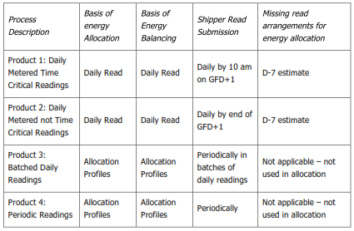
Source: Xoserve

The movement to these new products has three main impacts on the settlement framework:
- Significant increase in the number of daily settled sites, coupled with removal of restrictions on what sites can be daily settled.
- All sites, as a minimum, will be individually settled and reconciled, i.e. treated as current LSP NDM.
- The RbD process will no longer exist and so Unidentified Gas will be allocated evenly on a portfolio basis.

In addition it is proposed to move from the current static AQ calculation process and instead re-calculate AQ for each site on a monthly basis if sufficient meter readings exist.

Cost Benefit Analysis
It is widely expected that this new settlement framework will bring significant improvements in the operation and efficiency of the market, not least a significant reduction in the costs that shippers incur through inaccurate allocation up to and on the Gas Day. This report attempts to quantify some of those benefits to enable Ofgem to weigh up the value to the customer.

Data Analysis
There is general agreement that the new settlement process will improve the efficiency of the market. The total identified costs of the market improvements requested by shipper has an estimated total cost of £20m, approximately an additional £1 on every household bill. This report sets out the benefits that these changes will bring by reducing the volatility between initial allocation for a site and its final reconciled position.

Scope
This report looks at the impact that allocation adjustment has on shippers, focussing on their wholesale gas costs. A series of other factors (such as time value of money) are not examined.

System Price of Gas
The underlying principle behind the wholesale allocation process is to ensure that shippers seek to purchase the gas that their suppliers’ customers will use. This should mean the System Marginal Buy Price and the System Marginal Sell Price should always be higher and lower respectively of wholesale market prices. An idealised representation of this process is shown below:

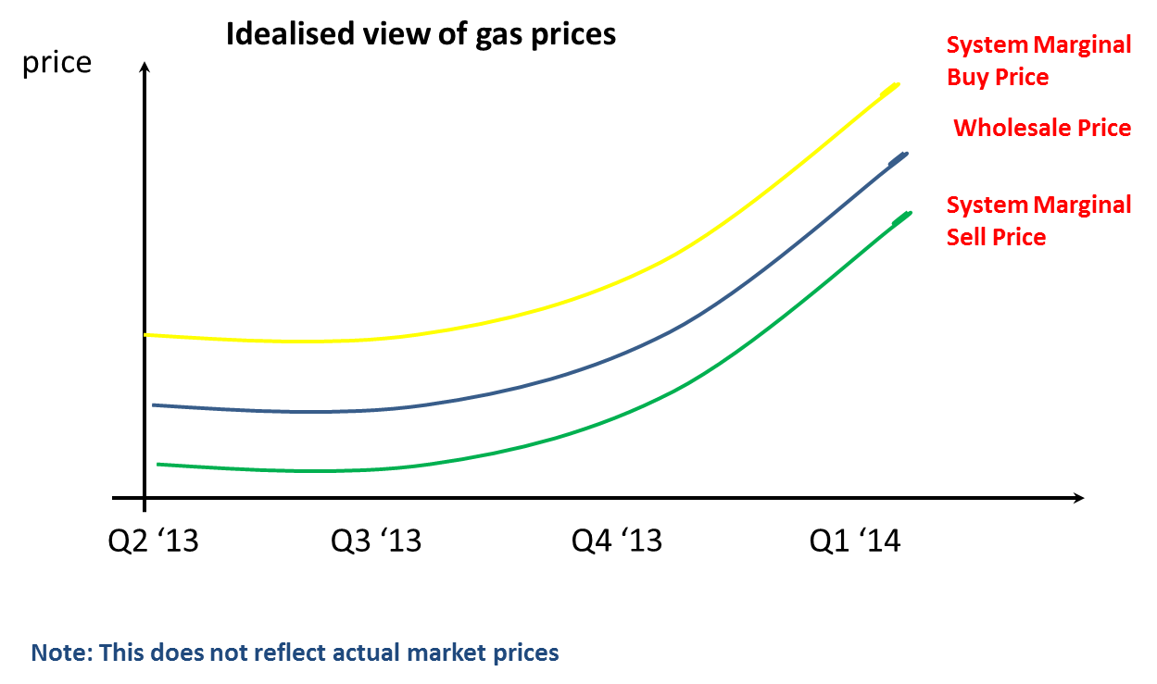

Reflecting this underlying principle, the System Marginal Sell Price (SMSP) is defined as the lesser of the lowest Balancing Action Offer Price on a Day or System Average Price - 0.0324 p/kWh. System Marginal Buy Price (SMBP) is the higher of the highest Balancing Action Offer Price on a Day or SAP + 0.0287 p/kWh.

This unpredictable price divergence has financial implications for shipper as they will be either be charged SMBP or be paid the uneconomical SMSP for any imbalance between what they were allocated and the gas they put into the system.

In reality the system marginal prices not always align with market prices. As can be seen below historically the System Marginal Buy Price can be lower than the market price and the System Marginal Sell Price can be higher than the market price:

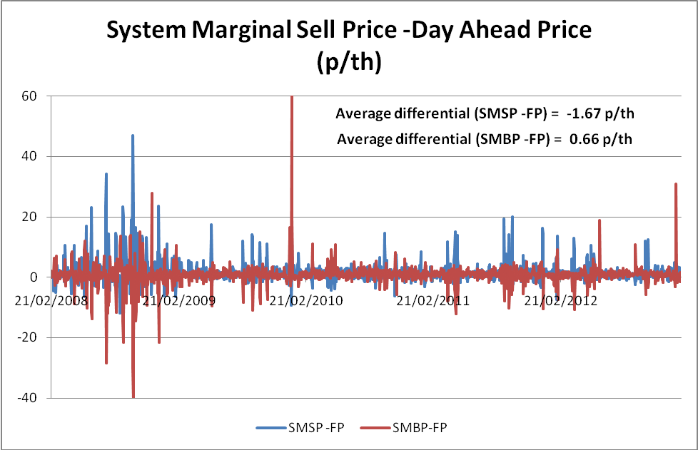

Reconciliation Process
In Project Nexus all sites will be individually reconciled and so be effectively treated as LSP NDM sites are currently. For LSP NDM customers a shipper will be assigned an amount of gas using an estimation process based on the site’s AQ. As meter reads are received then the site’s consumption will be adjusted (reconciled) to allocate to the shipper the correct gas use for that site. This means that over time the view of the site’s consumption will shift. The agreggrate impact of these changes will mean that a shipper will potentially be liable for SMBP or eligible to receive SMSP as their total allocation shifts towards the final volume. It has been communicated by Xoserve that generally ther energy allocated to LSP NDM sites reduces as the sites are reconcilied and so there is a downward trend.

For a shipper whose total volume requirements there can either meet of their gas requirements on the day and then be reimbursed for the gas their customers did not use over a period of time (termed here “Prudent Shipper –going long”), or they attempt to determine their customer’s true gas consumption. In this latter scenario the shipper pays for their short position at SMBP, but this is gradually returned to that shipper as their position is corrected over time, so being at zero position if they are accurate in their estimation (termed “Farsighted Shipper”).

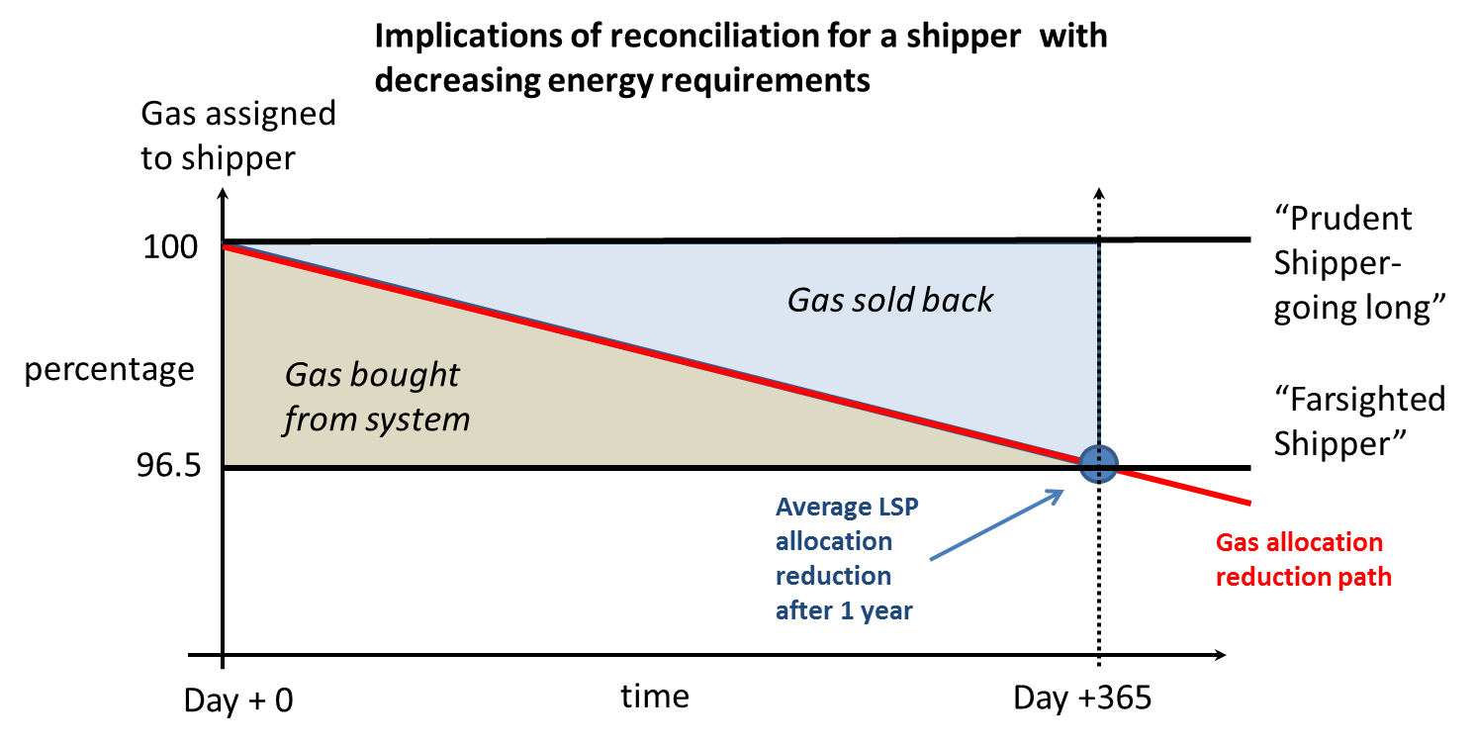

The other scenario is that the shipper experiences an increase in gas requirements. Again the two possible approaches are either to buy the gas allocated on the day and so be exposed to buying gas at SMBP as the allocation increases (“Short Shipper”), or attempt to determine final demand and purchase gas in the market to meet it (“Prudent Shipper – starting long”)

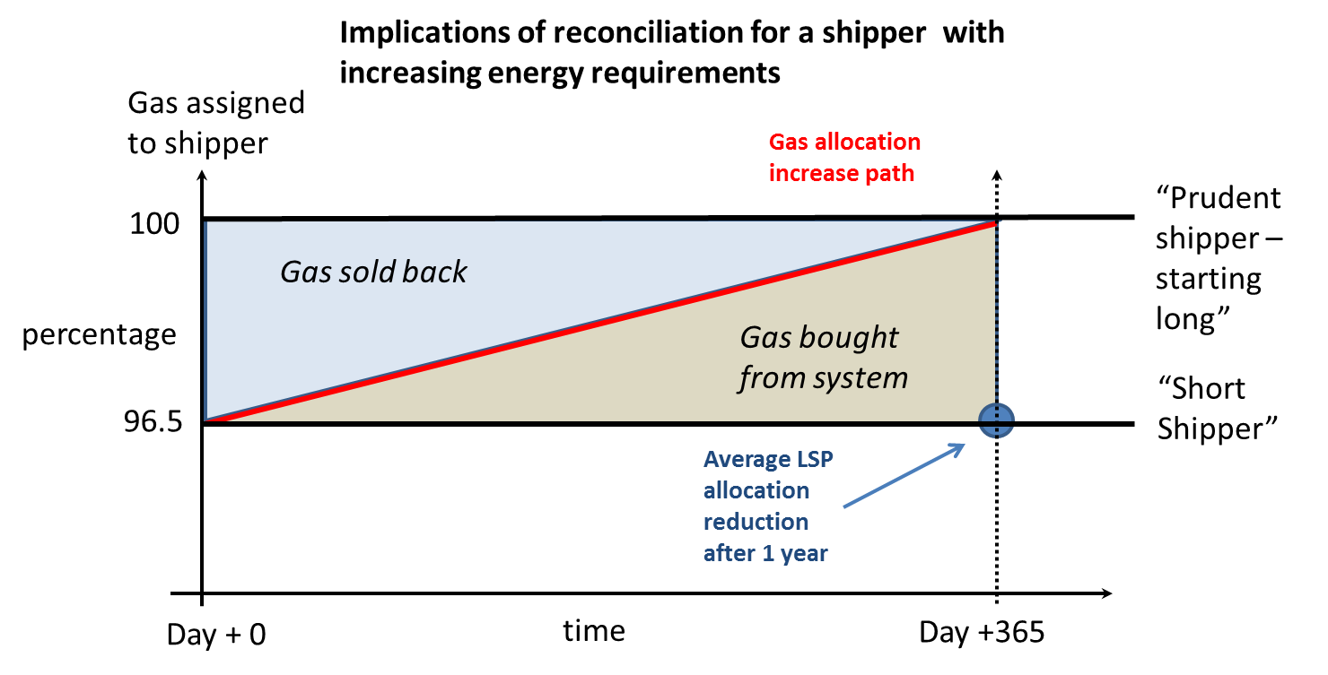

The impact of these possible scenarios, ranked in descending order of unit cost are:

 | Differential | Average Cost (p/th)
Short Shipper | SMBP | 50.36
Prudent Shipper – going long | Market Price -SMSP | 1.67
Prudent Shipper – starting long | Market Price -SMSP | 1.67
Farsighted Shipper | SMBP | 50.36

The last scenario requires the shipper to predict its final gas use on any given day and so demand a level of forecasting (or luck) that is very difficult to achieve in practice with NDM customers and be effectively discounted. In reality a shipper will either ultimately end up short or long depending on the accuracy of their predictions and the position initially taken. Owing to the fact that the SMBP price is penal, the incentive would be for shippers to go long as the cost is much lower and so most shippers would follow the prudent shipper route to some degree, through probably not for their whole portfolio.

Conclusions
At present any energy adjustment caused by reconciliations flows into or out of the SSP market and so there would be a corresponding increase into this market. This will not be the case when Project Nexus is implemented, but as any reductions in gas flow would instead go into Unidentified Gas and smeared across the market this will have the same net impact as RbD. Therefore for a net reduction for a shipper will push up allocated for all other shippers.

Extending the values highlighted above to the whole NDM market then the price impact of a 1% market change would be:

 | Differential | Average Cost (p/th) | Average Cost (p/kWh) | Impact per % drop (NDM market) p.a.
Short Shipper | SMBP | 50.36 | 1.719 | £85.9m
Prudent Shipper | Market Price - SMSP | 1.67 | 0.057 | £2.85m

It has been indicated that the approximate reduction in allocation between July 2011 and July 2012 for the whole LSP NDM sector was approximately 3.5%. This reduction would result in a cost to the market of £9.96m per year, assuming that all shippers were long and so able to absorb such a cost at a substantially lower rate than SMBP. If some shippers were instead short then it would instead be a substantially higher cost for the market as a hwole.

Assuming that a Project Nexus has a lifespan of 10 years then the new settlement changes would have to achieve a reduction in volatility 0.35% to recover its costs.

http://www.gasgovernance.co.uk/nexus/brd
UNC Modification Proposal 0453 Project Nexus - Demand Estimation
Using System Prices February 2008 – January 2013 and Platts day-ahead price for the same period
Using System Prices February 2008 – January 2013 and Platts day-ahead price for the same period
Using System Prices February 2008 – January 2013 and Platts day-ahead price for the same period
Using an NDM market value of 500 TWh a year,

