Operating Guidelines Document (the “Document”)
The purpose of this Document is to set out the guidelines that the CDSP will follow when a request is made to Xoserve, in its roles as the Central Data Services Provider (“CDSP”) for the disclosure of Protected Information to another party.

Contents
- Introduction
- CDSP’s role
- Overview of some relevant legal references
- Role of the DSC Contract Management Committee
- Procedure for submitting information disclosure requests to the CoMC
- Maintenance of the Data Permission Matrix
- Disclosure Request Report
- Disclosure of Protected Information decision determination
- Guidelines for inviting non DSC Parties to CoMC
- Process for making amendments to this Document

Appendix 1 DRR Template
Appendix 2 Link to Utilities Act section 105
Appendix 3 Link to GT Licence Standard Condition 31 Supply Point Information Service

Document owner | DSC Compliance Manager
Version | 1.3 – refined following further industry development  2.0 – amended following discussions at CoMC. Approved at CoMC dated 14/08/19
Date | August 2019

Disclaimer – this Document is a guide to assist in the general understanding of the environment within which Xoserve works. This Document is for guidance only and is not a definitive ruling on whether or not data may be released. If a matter is unclear, legal views must be sought.
Please note: reference to the Uniform Network Code and Independent Gas Transporters Uniform Network Code are both referred to as the UNC. References to Transporters shall include Gas Transporters and independent Gas Transporters.
- Introduction

UNC TPD V5.3 and IGT UNC K 23 define what is meant by Protected Information. This Document provides guidance on the process that will be followed when a request for the disclosure of Protected Information relating to the affairs of a User or Transporter in the performance of the UNC.

This Document describes the principles that the CDSP will apply in the event of a request for disclosure of Protected Information from any party. The principles are designed to; a) ensure that that there is compliance with all contracts when the CDSP shares any Protected Information and b) provide guidance to all parties concerned with the sharing of Protected Information.

In the event that the existing rules are not perceived to permit the disclosure of Protected Information, the CDSP will support the party in seeking to find an equitable solution whilst ensuring any such disclosure meets the relevant principles.

The CDSP has previously supported the industry in raising modifications to the UNC, for example to permit the release of Protected Information to Meter Asset Managers, Meter Asset Providers and Price Comparison Websites.

UNC modification 0649S and IGT UNC modification 115 (Updates to UNC and iGT UNC to formalise the Data Permissions Matrix) were implemented in October 2018.
The approval of these modifications transferred the authority to approve the sharing of Protected Information to existing User Types as set out in the Data Permissions Matrix (“DPM”), from the UNC to the CoMC.
In the event that there is a request to share Protected Information with a new User Type a modification will need to be raised to add that new User Type to the DPM.

Section 5 of this Document sets out the procedure for submitting proposals to the CoMC.

Where disclosure of Protected Information is permitted other activities may be required to enable the service provision. These may include, but are not limited to, establishing the commercial arrangements between Xoserve and the relevant party; and developing the mechanism for delivery.
This Document is limited to the matters associated with the decision regarding the disclosure of Protected Information. Commercial arrangements are a matter for the CoMC, where applicable, delivery arrangements are a matter for the DSC Change Management Committee.
There may be instances where the third party is required to enter into a Confidentiality Agreement with the Transporters. In the event that there is a requirement for a vote in relation to the Confidentiality Agreement at CoMC only the parties to the Confidentiality Agreement will be eligible to vote.

- CDSP’s role

The CDSP operates the UK Link system through which UNC parties transact (send and receive information). UK Link is the source of the data for the CDSP data provision services. As a starting point for the purpose of determining the disclosure of Protected Information for data provision services, all data in UK Link is treated as Protected Information as defined in the UNC. This means, in each case, there is a requirement to prove that any disclosure of Protected Information is permitted.

Xoserve’s DSC Compliance Manager has responsibility for evaluating all requests for the disclosure of Protected Information and will, where required, refer the request to the CoMC.

This activity is set out under Service Lines ASGT-NC SA18-02 and ASiGT NC SA18-03

- Overview of some relevant legal references

This section 3 provides an overview, for guidance only, of the everyday legal references that are relevant to Xoserve in determining whether the disclosure of Protected Information is permissible. Note that this list is not exhaustive and there may be other less familiar legal references that the requester may rely on that need to be considered e.g. the Statistics of Trade Act 1947 obligates certain information disclosure.

  - Utilities Act section 105 (see Appendix 2 for section text)

The Utilities Act section 105 sets out that any information that relates to an individual or business is protected information and cannot be disclosed. It then sets out that disclosure is permitted if required by for example, licence condition, or if agreed between parties for example under a contract such as the UNC.

  - GT Licence Standard Condition 31 (see Appendix 3 for licence text)

GT Licence Standard Condition 31 sets out information disclosure obligations to industry parties to facilitate the competitive market. Many of the CDSP’s existing services stem from this licence condition, for example Data Enquiry Service. Under the Data Services Contract services that support this licence condition are classified as Agency Services GT Non-Code.

  - UNC Section V 5 IGT UNC Section K 24

UNC Section V5 and IGT UNC Section K 24 set out that information passed between Code parties such as Gas Transporters and Users (Shippers) is Protected Information and cannot be disclosed to another party (Code or non-Code) unless the disclosure is set out in either V 5 (GTs) or K 24 (IGTs).

UNC Section V5.5 sets out the exceptions to the obligations on GTs and Users not to disclose Protected Information. UNC V5.5 sets out the permission (and in some cases supporting conditions) to release data to certain consumers (pursuant to GT Standard Licence Condition 31 – see section 3.2) for example: Meter Asset Managers; Meter Asset Providers; and Price Comparison Websites.

UNC Section V5.5 sets out the authority of the CoMC with regard to decisions on disclosure of Protected Information.

UNC Section V5.5 also sets out exceptions to the disclosure of Protected Information to the extent that the disclosing party is required to make such disclosure for example, to meet a legal requirement or in response to a request from a Competent Authority ..

IGT UNC section K 24 sets out the same obligations for IGTs as UNC V5.5 does for GTs.

- Role of the DSC Contract Management Committee (“CoMC”)

The DSC, CDSP Service Document Contract Management Arrangements section 6.3 sets out the circumstances when the CDSP is required to consult with CoMC following a request for information to be provided to a person or organisation who are not customer or third party customers.
Where a disclosure matter is to be referred to the CoMC, Xoserve shall set out the proposal in a Disclosure Request Report (“DRR”), (template set out in Appendix 1) and submit to the CoMC for a decision to be made as to whether or not to approve or reject the DRR. Those present at the CoMC that have voting rights are eligible to vote in favour of or against the DRR. A simple majority will determine the decision to approve or reject the DRR. A voting representative who abstains from voting will not be counted as a vote against the DRR. Any decision that is made by the CoMC will be recorded in the minutes of the CoMC and Xoserve shall notify the relevant parties and act in accordance with that decision.
As stated in the final paragraph of section 1 of this Document, in the event that there is a requirement for a decision to be made in relation to a Confidentiality Agreement only CoMC members that are a party to the Confidentiality Agreement shall be entitled to vote.

- Procedure for submitting information disclosure requests to the CoMC

The CDSP will assess the request for disclosure of Protected Information and where the requesting party is already included on the DPM prepare a DRR (referencing the relevant Change Proposal if applicable) for CoMC to consider.
The DRR will be submitted for either:
a) “development” via the CoMC; or
b) “approval” by the CoMC (decision required).

Where a DRR is submitted for approval, the CoMC will review the DRR and determine that:
- The DRR is rejected and provide the reason(s) for rejection;
- There is insufficient information to determine a decision and specific actions are placed on the relevant party (e.g. Xoserve, the CoMC, request originator) for completion of the DRR and its re-submission; or
- The DRR is approved.
Where the DRR is approved, the decision recorded in the minutes of the meeting will serve as authorisation for Xoserve to amend the DPM accordingly.
If the DRR is requesting permission to disclose Protected Information that has not been previously considered, section 8 of this Document will be updated.
- Maintenance of the Data Permission Matrix

The DPM is published as part of the UK Link Manual suite of documents at https://www.xoserve.com/systems/uk-link/ .
The DPM sets out the data items that are permitted to be shared with a specific user type.

A UNC modification will be required to update the DPM with a new user type.
A DRR approved at CoMC will be required to update the DPM with additional data items that are permitted to be disclosed to an existing user type. The DPM is version controlled and updated versions are published following conclusion of the relevant amendment process.

The DPM details a combination of service and data items within the service. However, it does not detail any conditionality within the data-set. For example, the Price Comparison Website API service only provides access to domestic data (as defined by the market sector code). The Data Permission Matrix Conditionality Document is published alongside the DPM to provide clarity of any conditionality within the data that can be disclosed.

Any Change Proposal or DRR submitted in accordance with the process set out in Section 5 of this Document will include any conditionality statements. When the Change Proposal or Disclosure Request Report is approved, the Data Permission Matrix and Data Permission Matrix Conditionality Document will be amended as required and re-published.

- Disclosure Request Report
A DRR should be raised on the template set out in Appendix 1 of this Document.
The DRR will be completed by Xoserve with some input required from the CoMC members that represent GT/iGT constituents. This may require the CoMC members to consult with the GT/iGT constituents and their legal teams if necessary.
The GT/iGTs are considered to be the Controller of the personal data that is provided to the CDSP (Controller having the same meaning as that set out in the GDPR). As Controllers of the personal data, the GT/iGTs will be expected to determine the lawful basis that will be relied upon for the processing of personal data, in accordance with Article 6 of the GDPR.
The DRR will also include a test to determine whether or not a Privacy Impact Assessment (“PIA”) is required. If a PIA is required this will also form part of the DRR.
- Disclosure of Protected Information decision determination

This Section 8 sets out the process that will be followed when determining whether a request to disclose Protected Information can be permitted in accordance with information provision rules or where consultation may be required with CoMC. Where permission does not exist or a request cannot be met the data cannot be disclosed by Xoserve until such time that permission to disclose the data is given. This may require UNC modification.

The first consideration is to determine between non-Protected Information and Protected Information. Protected Information is information that is provided by parties to UK Link and information generated within UK Link at supply meter point level. Any request for information to be disclosed at supply meter point level would be considered as Protected Information. Aggregate information e.g. reference on Xoserve’s website to there being circa 24m supply meter points in the UK, is not considered as Protected Information. There is always a grey area in these assessments and where there is any doubt between non-Protected Information and Protected Information, the matter will be referred to the CoMC.

Protected Information should not be confused with personal data as defined by the GDPR.

Working on the basis the request is for disclosure of Protected Information the following sections apply.

  - Is the request for disclosure of Protected Information from a UNC party?

The first key decision is to determine whether the party requesting the information disclosure is a UNC party or not. A UNC party is a signatory to the UNC and has certain rights of access to data as a result. The following may be considered when determining if this request may be agreed.

    - Group company arrangements

Some organisations operate with several licenced subsidiary companies under one group company. The group company is not a signatory to the UNC. Only the individual subsidiary is the signatory to the UNC. A request from the group company must be treated as being from a non-UNC party.

    - Organisations who are no longer a UNC party

Organisations who are no longer a party to the UNC may still submit requests for information that relates to them. For example; a request for a copy of an invoice. Where the request is associated with them and the period they were a party to the UNC the request can be treated as being from a UNC party, otherwise they must be treated as a non-UNC party.

    - Disclosure agreements between UNC Party and non-UNC Party(ies)

Under the terms of the UNC, a UNC party (the ‘Disclosing Party’) may permit another organisation to receive information relating to the Disclosing Party. The UNC party will set out its permission in an agreement that is provided to the Xoserve Customer Office. The disclosure agreement will confirm the party/ies with whom Xoserve is permitted to disclose information and the specific type of information it is permitted to disclose, for example; supply point data to validate reconciliations. Where an information disclosure request is received from an authorised party as set out in the agreement, that party will be treated as a UNC party and information may be disclosed to that party in accordance with the agreement.

Two parties may agree a disclosure agreement between themselves. In this circumstance each case needs to be considered individually to determine if the information may be disclosed. Does the party holding the information have the right to disclose it? Does the intended recipient have the right to receive the information? The disclosure agreement should set out specific data items that can be shared, the purpose for sharing the data and be time bound.

There is no requirement to refer decisions on disclosure agreements beyond Xoserve.

    - UNC parties undergoing some commercial change e.g. merger, acquisition, insolvency, etc

In this circumstance each case will need to be considered individually. The key issue is to determine a right to the data considering such things as; who holds the relevant licence at the time; do information disclosure agreements exist between the companies to share information; is a disclosure agreement required?

  - Requests for the disclosure of Protected Information from a UNC party

The following diagram sets out a decision tree for assessing requests for the disclosure of Protected Information.

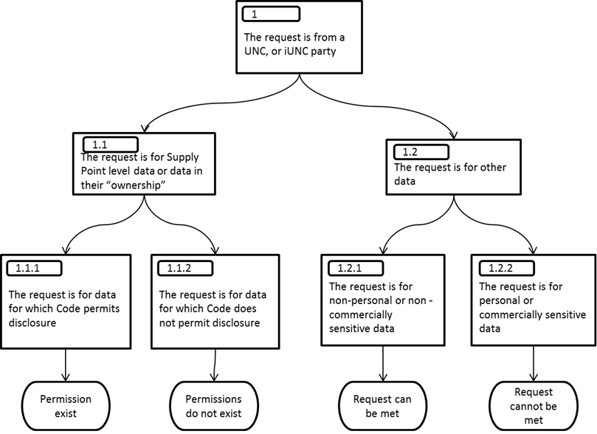

In the case of 1.1.1 it would be expected that the party requesting the disclosure of Protected Information provides the necessary supporting code references to Xoserve. Xoserve will validate the request and if there is any doubt consult the CoMC.

In the case of 1.2.2 personal data is data that identifies a living individual. For the avoidance of doubt an MRPN is considered to be personal data. Information relating to an end user’s AQ is considered to be commercially sensitive data. Xoserve will validate the request and if there is any doubt consult the CoMC.

Case Study 1

In 2006 a Distribution Network requested information for the period prior to the date they procured the network from National Grid. The request was referred to National Grid for approval before the service could be provided.

  - The request for the disclosure of Protected Information is from a Non UNC Party such as a Supplier, MAM or MAP

The following diagram sets out a decision tree for assessing the request for the disclosure of Protected Information disclosure requests.

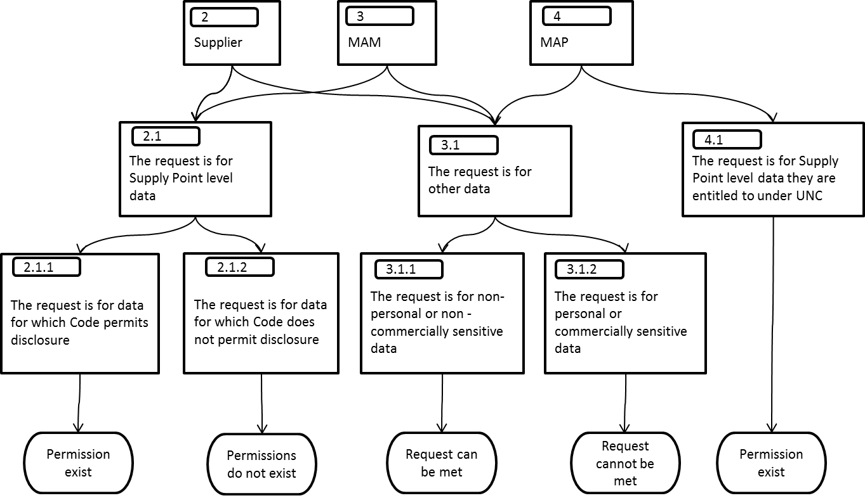

In the case of 2.1.1 it would be expected that the party requesting the disclosure of Protected Information provides the necessary supporting references, it should not be up to Xoserve to find these. Xoserve will review the information used to determine the disclosure of Protected Information in examples 2.1.1 and 2.1.2 and if there is any doubt consult the CoMC.

In the case of 3.1.1 and 3.1.2 personal data is data that identifies a living individual. As such an MRPN is considered to be personal data where the market sector code indicates a domestic premise. Information relating to an end user’s AQ is considered to be commercially sensitive data. Xoserve will review the information used to determine request for the disclosure of Protected Information set out in the examples 3.1.1 and 3.1.2 and if there is any doubt consult the CoMC.

In the case of 4.1 checks are made that the MAP meets the entitlement requirement as set out in UNC, e.g. there is a signed Confidentiality Agreement in place between GTs/IGTs, and the MAP.

  - The request for the disclosure of Protected Information is from Ofgem

The following diagram sets out a decision tree for assessing the request for the disclosure of Protected Information.

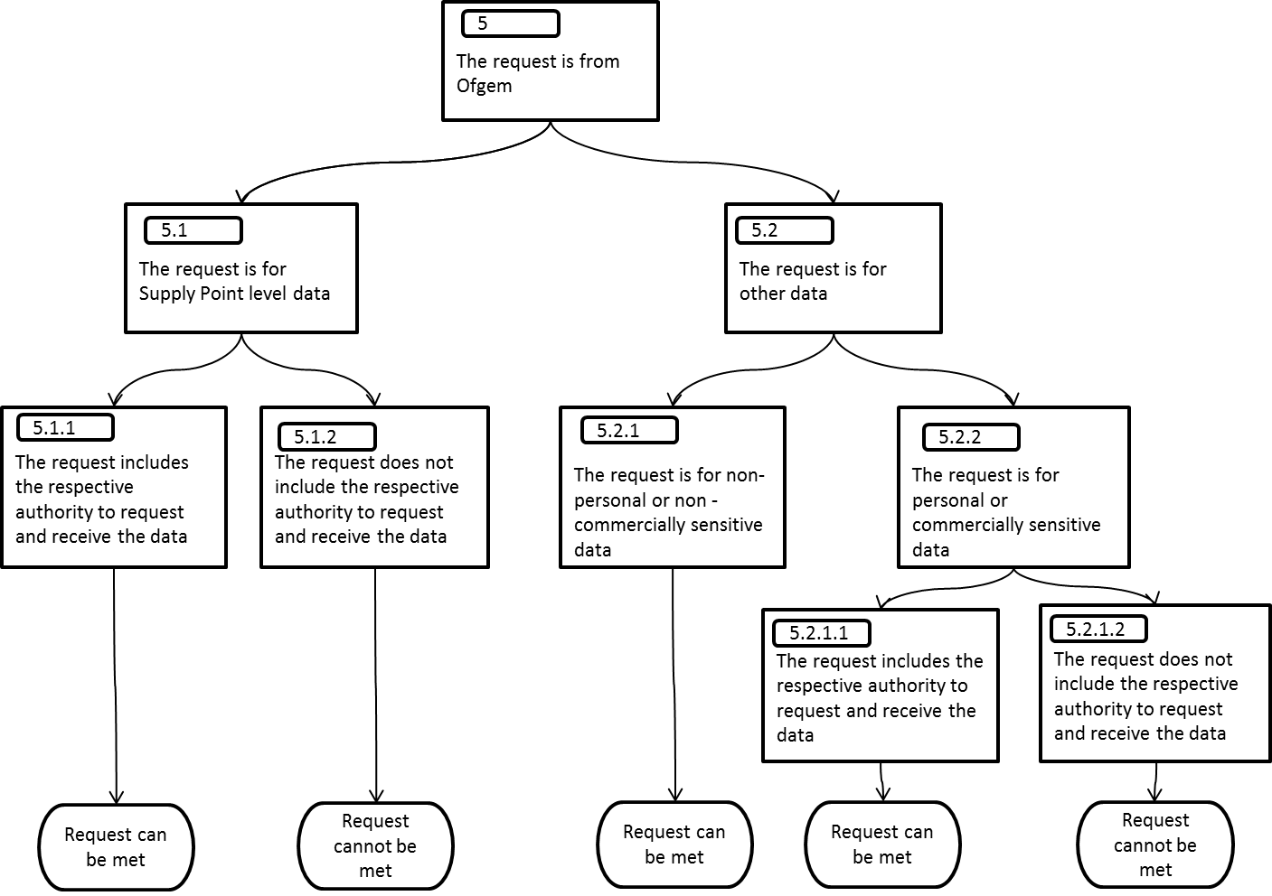

Ofgem has certain powers to request data e.g. under GT Licence Condition 26.

Each request from Ofgem received by Xoserve is shared with the relevant party. Xoserve and the relevant party will work together to either provide the data or explain the reasons why the data cannot be provided at that point in time.

Often where a service cannot initially be provided, with greater understanding of Ofgem’s requirements, the data request can be refined so that it can be satisfied. For example; if there is a request to provide personal data this may be satisfied by anonymising the data set to prevent any individual from being identified; or where commercially sensitive data is requested, the data set may be aggregated to remove any commercially sensitive data.

Where required, Xoserve will send a copy of the data provided to Ofgem to the relevant party.
8.5 The request for the disclosure of Protected Information is from a government department

The following diagram sets out a decision tree for assessing requests for the disclosure of Protected Information.

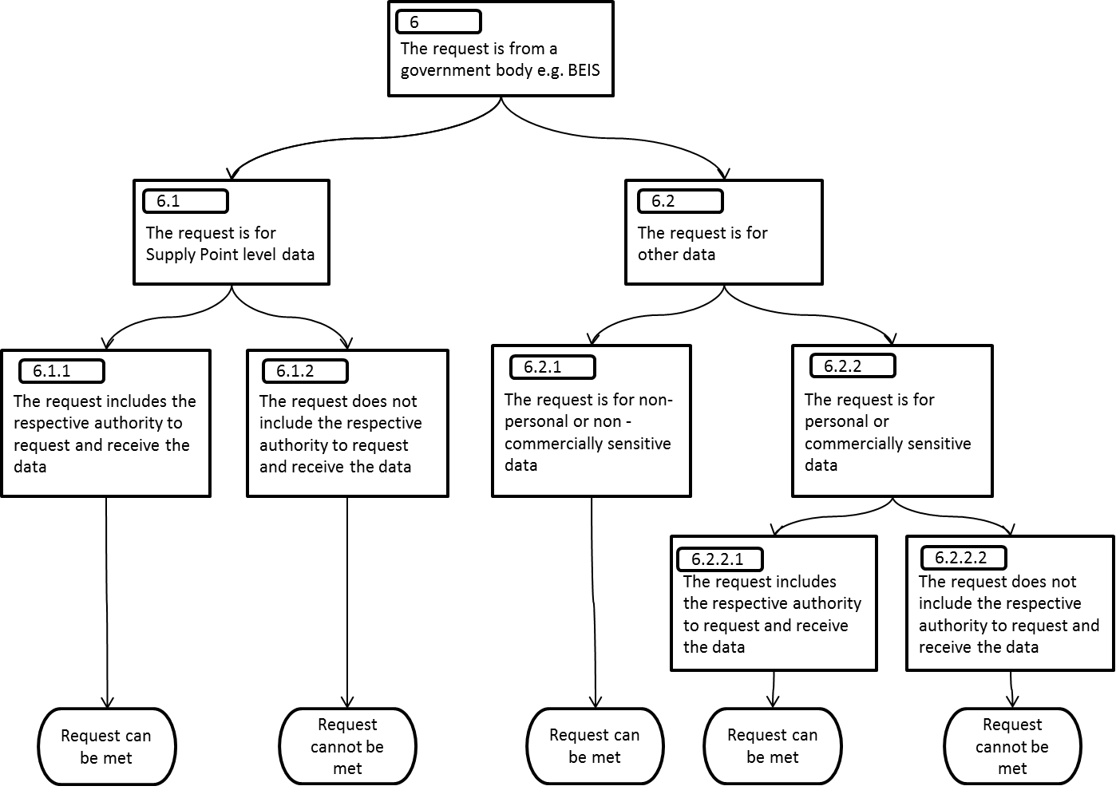

Government departments may meet the UNC definition of Competent Authority and thus have powers to request data.

Each request from a government department received by Xoserve is shared with the relevant party. Xoserve and the relevant party will work together to either provide the data or explain the reasons why the data cannot be provided at that point in time.

Often where a service cannot initially be provided, with greater understanding of the requirements, the data request can be refined so that it can be satisfied. For example; if there is a request to provide personal data this may be satisfied by anonymising the data set to prevent any individual from being identified; or where commercially sensitive data is requested, the data set may be aggregated to remove any commercially sensitive data.

Case Study 2

In June 2018 a government department contacted Xoserve requesting supply point level data for properties around for an urgent purpose). A call to the relevant GT (relevant party) and an internal check confirmed information disclosure rules were satisfied and the data could be provided. The data was provided within 1 hour of the request being received.

8.6 The request for the disclosure of Protected Information is from any other party

The following diagram sets out a decision tree for assessing requests for the disclosure of Protected Information.

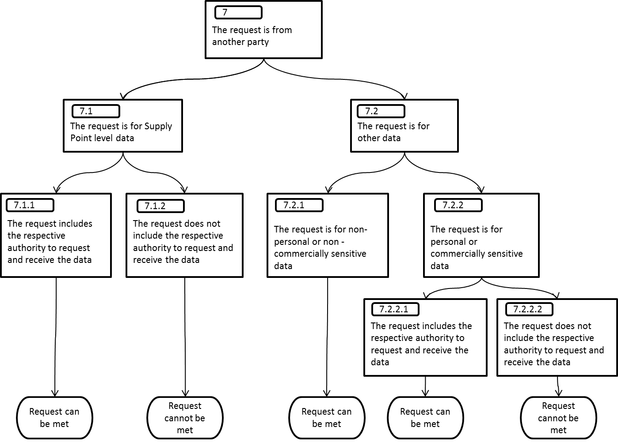

Xoserve will assess each request for the disclosure of Protected Information on a case by case basis and consider whether in its view (in accordance with compliance with these guidelines) the request can be met. Each assessment will consider whether the Protected Information is personal data, in which case relevant Data Protection Legislation or if the data is considered to be commercially sensitive. Where there is any uncertainty the matter will be referred to the relevant party which may be the DSC Contract Management Committee. Xoserve and the relevant party will work together to understand and assess the request and determine whether the disclosure request can be met.

Case Study 3

The provision of supplier data to the PPMIP (Siemens).

Xoserve was requested to provide data to a third party company (Siemens) that identified the Supplier but not any individual supply point data. Xoserve does not have the authority to provide data at the level requested and considered a UNC modification was a step too far, so consulted the CoMC under the Contract Management Arrangements (DSC, Section 6.3.2 (b)). The DSC Contract Management Committee approved the disclosure request and the April 2018 meeting minutes serve as the record for this decision.

9 Guidelines for inviting non DSC Parties to CoMC

It is acknowledged that there may be occasions when a non DSC Party (3rd Party) may be invited to join CoMC to provide clarity around what it intends to do with data that CoMC has approved. For the avoidance of doubt the 3rd Party will not have visibility of any DRR.

In the circumstances set out above the CDSP will notify CoMC 3 business days before a meeting that it intends to invite a 3rd Party to join the meeting. CDSP will provide detail of who will be invited and the purpose of the invitee attending CoMC. CoMC will have the opportunity to object to a 3rd Party attending CoMC but only on grounds that are reasonable.

The 3rd Party will not be invited to join the meeting until a suitable point during the meeting. At no point should a 3rd Party be present when material of a confidential or commercially sensitive nature is being discussed unless it is material that the 3rd Party is already in possession of or aware of.
10 Process for amending this Document
Any amendments to this Document must be approved at CoMC.
A CoMC Representative or the CDSP may propose an amendment to this Document by following the process set out below:
- If the amendment is proposed by a CoMC Representative, details of the proposed amendments can be shared with CDSP with sufficient time to enable CDSP to share with all CoMC Representatives a minimum of 5 business days prior to the CoMC where approval will be sought.
- If CDSP propose the amendments, CDSP will share the amendments with CoMC a minimum of 5 business days prior to the CoMC where approval will be sought.
- Proposed amendments to be added to the agenda for the CoMC where approval will be sought.
- CoMC Representatives and CDSP to review the amendments.
- Any comments relating to the amendments to be discussed at CoMC.
- Approval of any amendments to be given at CoMC.
- Once approved CDSP will:
update the Document with the approved amendments;
update the version control on the front page of this Document; and
arrange for the updated Document to be published on the Joint Office website.

Appendix 1

Appendix 2 Utilities Act Section 105
https://www.legislation.gov.uk/ukpga/2000/27/section/105

Appendix 3 Condition 31: Supply Point Information Service
https://epr.ofgem.gov.uk//Content/Documents/Gas_transporter_SLCs_consolidated%20-%20Current%20Version.pdf

[

